Supplemetary informations:

Table 1: Overview of statistics used in publication.
Figure S1-S2: Bland Altman plots of patient sub-populations BMI < 25 and BMI > 25
Figure S3-S5: Correlation plot of different patient population: All patients (Fig. S3), BMI < 25 (Fig. S4), BMI > 25 (Fig. S5)
Figure S6-S7: Error Grid analysis of febrile detection of patient sub-populations BMI < 25 and BMI > 25

 | BMI  Group | Mean Bias  (SD) [°C] | 95% LOA [°C] | MAE  [°C] | Error 0.5°C [%] | Prop. Bias | LCCC (95% CI) | Sens [%] | Spec [%] | PPV [%] | NPV [%] | DOR, SE, (95% CI) | A  [%] | B  [%] | C  [%]
Lateral chest-Bladder | all | -0.38 (0.43) | -1.23, 0.46 | 0.45 | 64 | -0.05 | 0.56 (0.49-0.64) | 36.5 | 99.0 | 90.0 | 85.2 | 51.7, 0.63 (15.1-177.3) | 90.1 | 0 | 9.9
Clavicular-Bladder | all | -0.40 (0.49) | -1.35, 0.55 | 0.50 | 53 | -0.27 | 0.42 (0.33-0.51) | 16.2 | 98.3 | 96.0 | 79.9 | 10.4, 0.66 (3.5-30.5) | 84.2 | 0.6 | 15.2
Tympanic-Bladder | all | -0.29 (0.33) | -0.94, 0.35 | 0.35 | 80 | -0.04 | 0.72 (0.66-0.78) | 35.1 | 98.6 | 97.6 | 84.2 | 36.4, 0.56 (12.2-109.1) | 93.2 | 0.3 | 5.7
Lateral chest-Bladder | ≤25 | -0.29 (0.40) | -1.07, 0.49 | 0.37 | 73 | -0.11 | 0.63 (0.52-0.75) | 32.4 | 99.1 | 91.6 | 82.6 | 52.1, 1.07 (6.4-423.9) | 90.5 | 0 | 9.5
Clavicular-Bladder | ≤25 | -0.34 (0.41) | -1.15, 0.48 | 0.43 | 61 | -0.15 | 0.58 (0.46-0.70) | 17.6 | 98.2 | 75.0 | 79.4 | 11.6, 0.84 (2.2-60.5) | 83.8 | 0.7 | 15.5
Tympanic-Bladder | ≤25 | -0.35 (0.34) | -1.01, 0.32 | 0.40 | 75 | -0.08 | 0.67 (0.57-0.77) | 29.4 | 99.1 | 90.9 | 82.0 | 45.4, 1.07 (5.5-371.8 | 91.9 | 0 | 6.8
Lateral chest-Bladder | >25 | -0.45 (0.44) | -1.31, 0.41 | 0.50 | 57 | -0.02 | 0.52 (0.42-0.62) | 40.0 | 98.8 | 88.9 | 87.0 | 53.6, 0.78 (11.6-248.2) | 89.9 | 0 | 10.1
Clavicular-Bladder | >25 | -0.45 (0.53) | -1.48, 0.58 | 0.56 | 48 | -0.39 | 0.32 (0.19-0.44) | 15.0 | 98.2 | 66.7 | 82.5 | 9.4, 0.73 (2.2-39.5) | 84.5 | 0.5 | 15.0
Tympanic-Bladder | >25 | -0.25 (0.32) | -0.87, 0.37 | 0.32 | 84 | -0.02 | 0.76 (0.69-0.84) | 40.0 | 98.2 | 84.2 | 87.0 | 35.6, 0.66 (9.6-131.2) | 94.2 | 0.5 | 3.9
Table S1: Data overview of sub-group analysis for different temperature sensor positions compared to bladder temperature as reference. BMI: Body mass index; SD: Standard deviation; LOA: Limit of agreement; MAE: Mean absolute error; Error 0.5°C: Number of measurements within a 0.5°C threshold; Prop. Bias: Proportional bias from the corresponding bland altman plot; LCCC: Lin’s concordance correlation coefficient; CI: Confidence interval; Sens: Sensitivity for detecting fever (T_{b} ≥ 38°C); Spec: Specificity for detecting fever (T_{b} ≥ 38°C); PPV: Positive predictive value for detecting fever (T_{b} ≥ 38°C); NPV: Negative predictive value for detecting fever (T_{b} ≥ 38°C); DOR: diagnostic odds ratio; SE: Standard error; A: Numbers of events in Zone A; B: Numbers of events in Zone B; C: Numbers of events in Zone C;

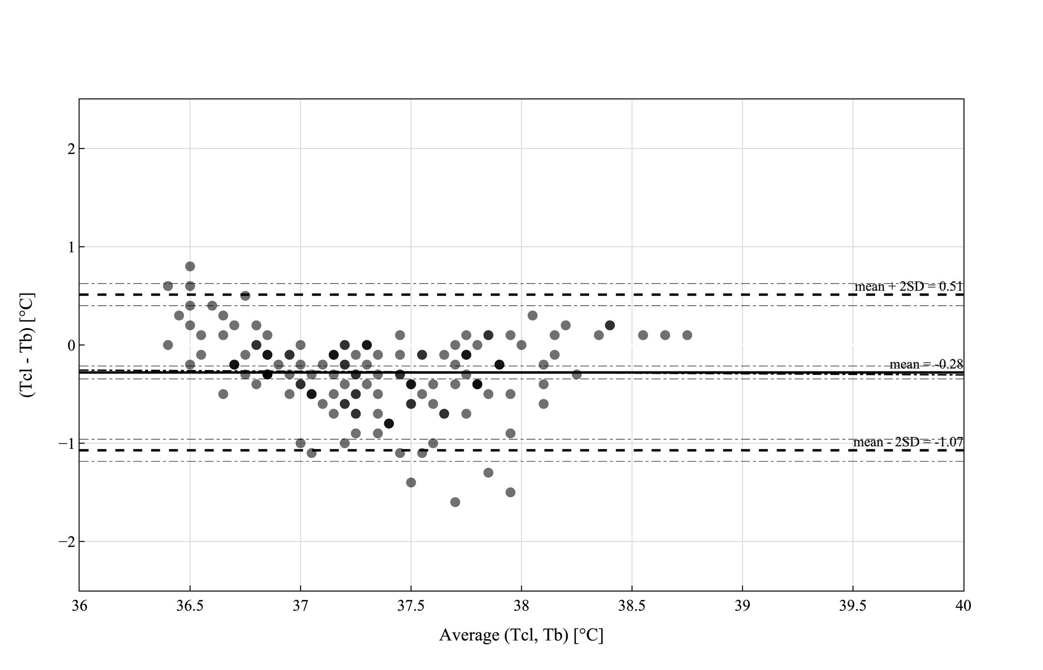
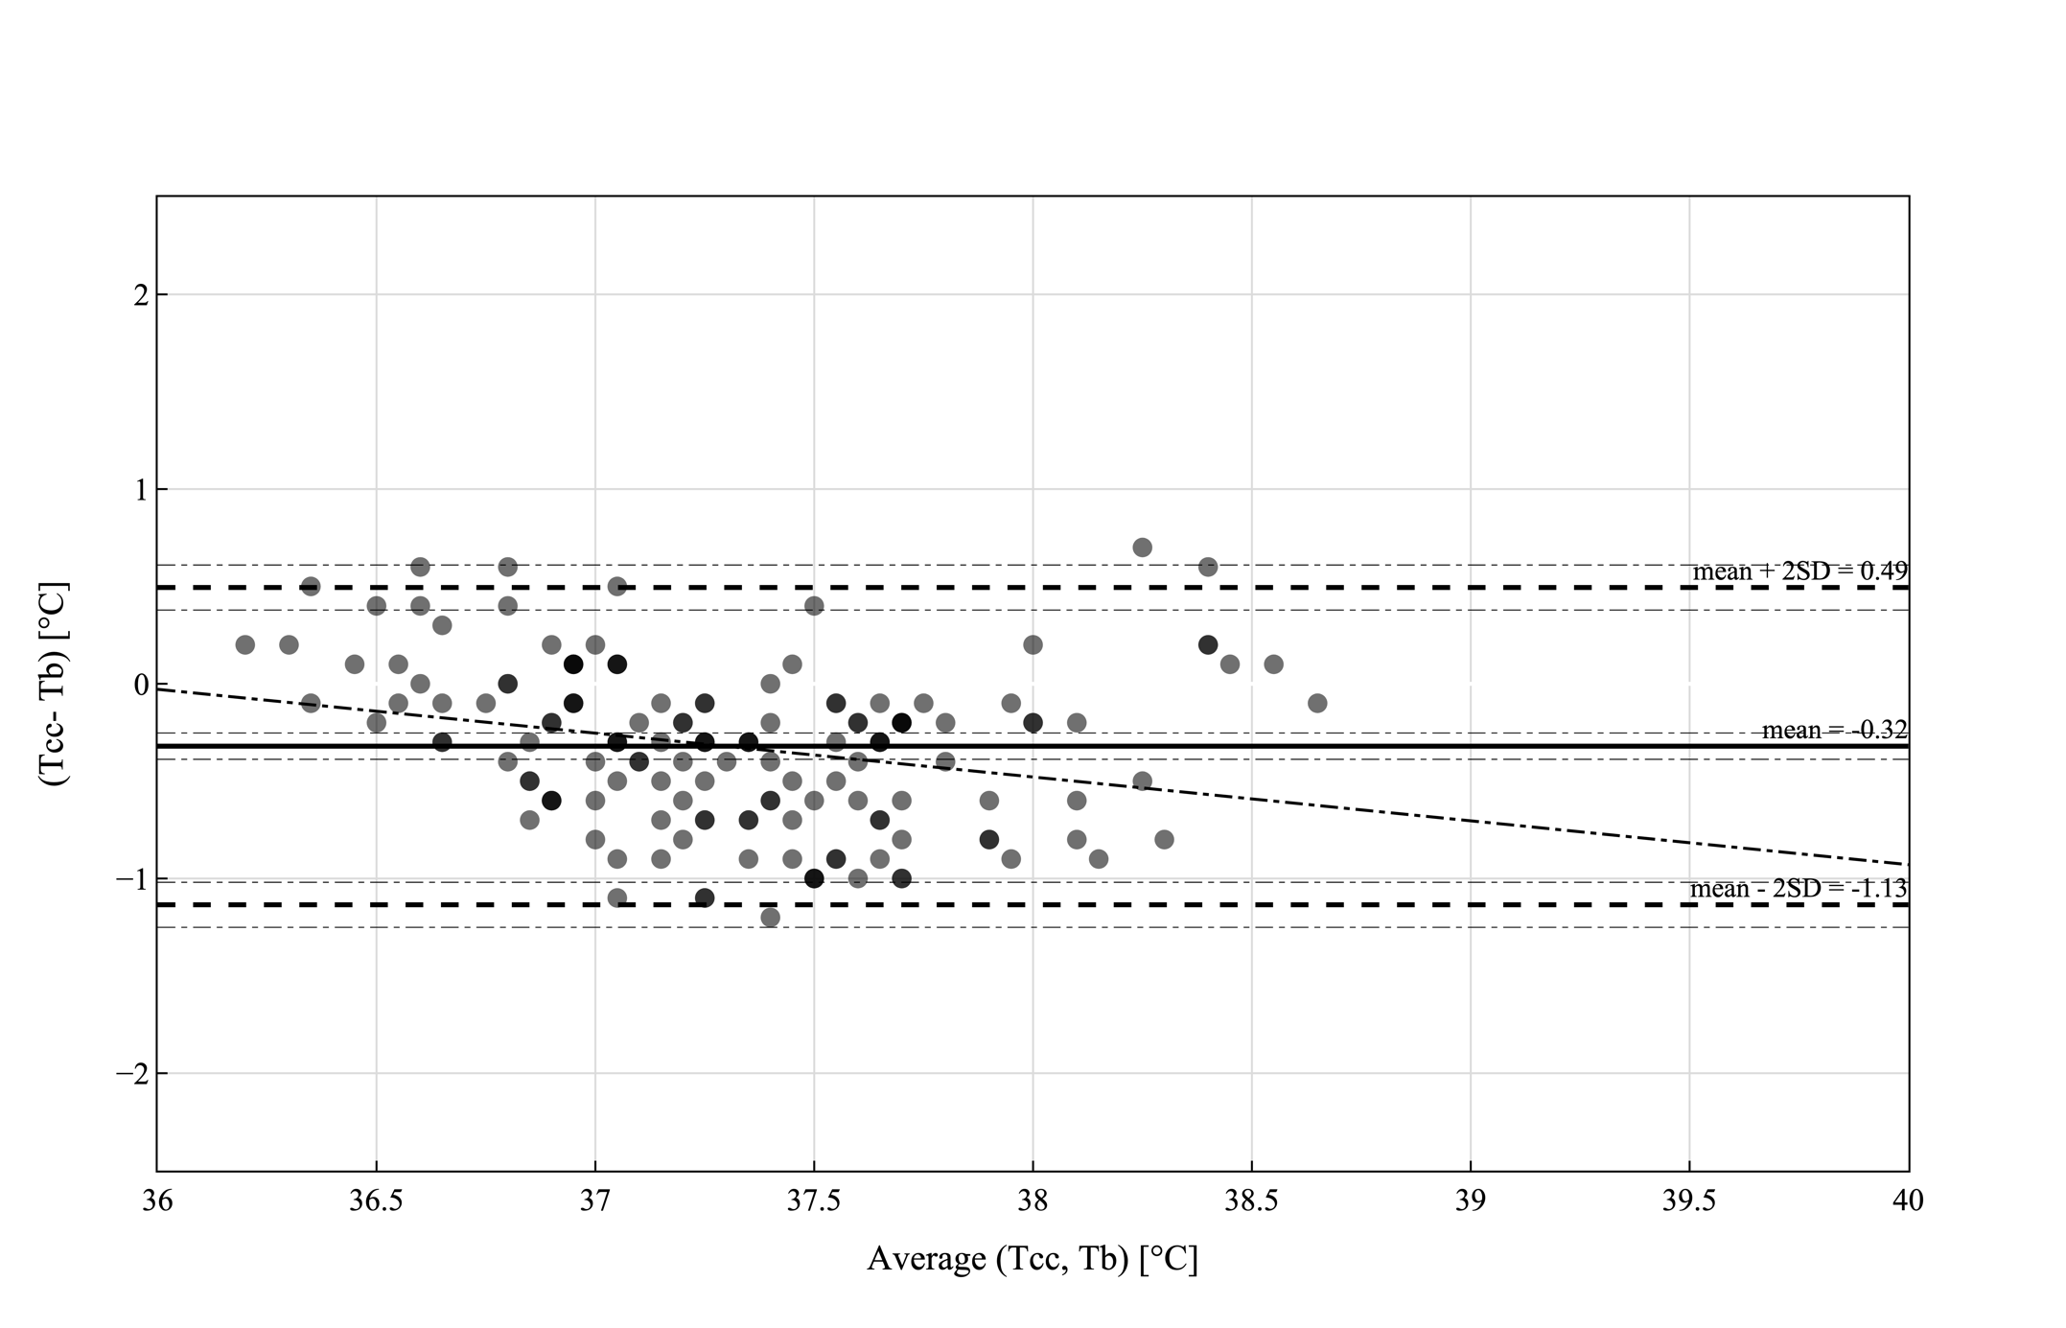
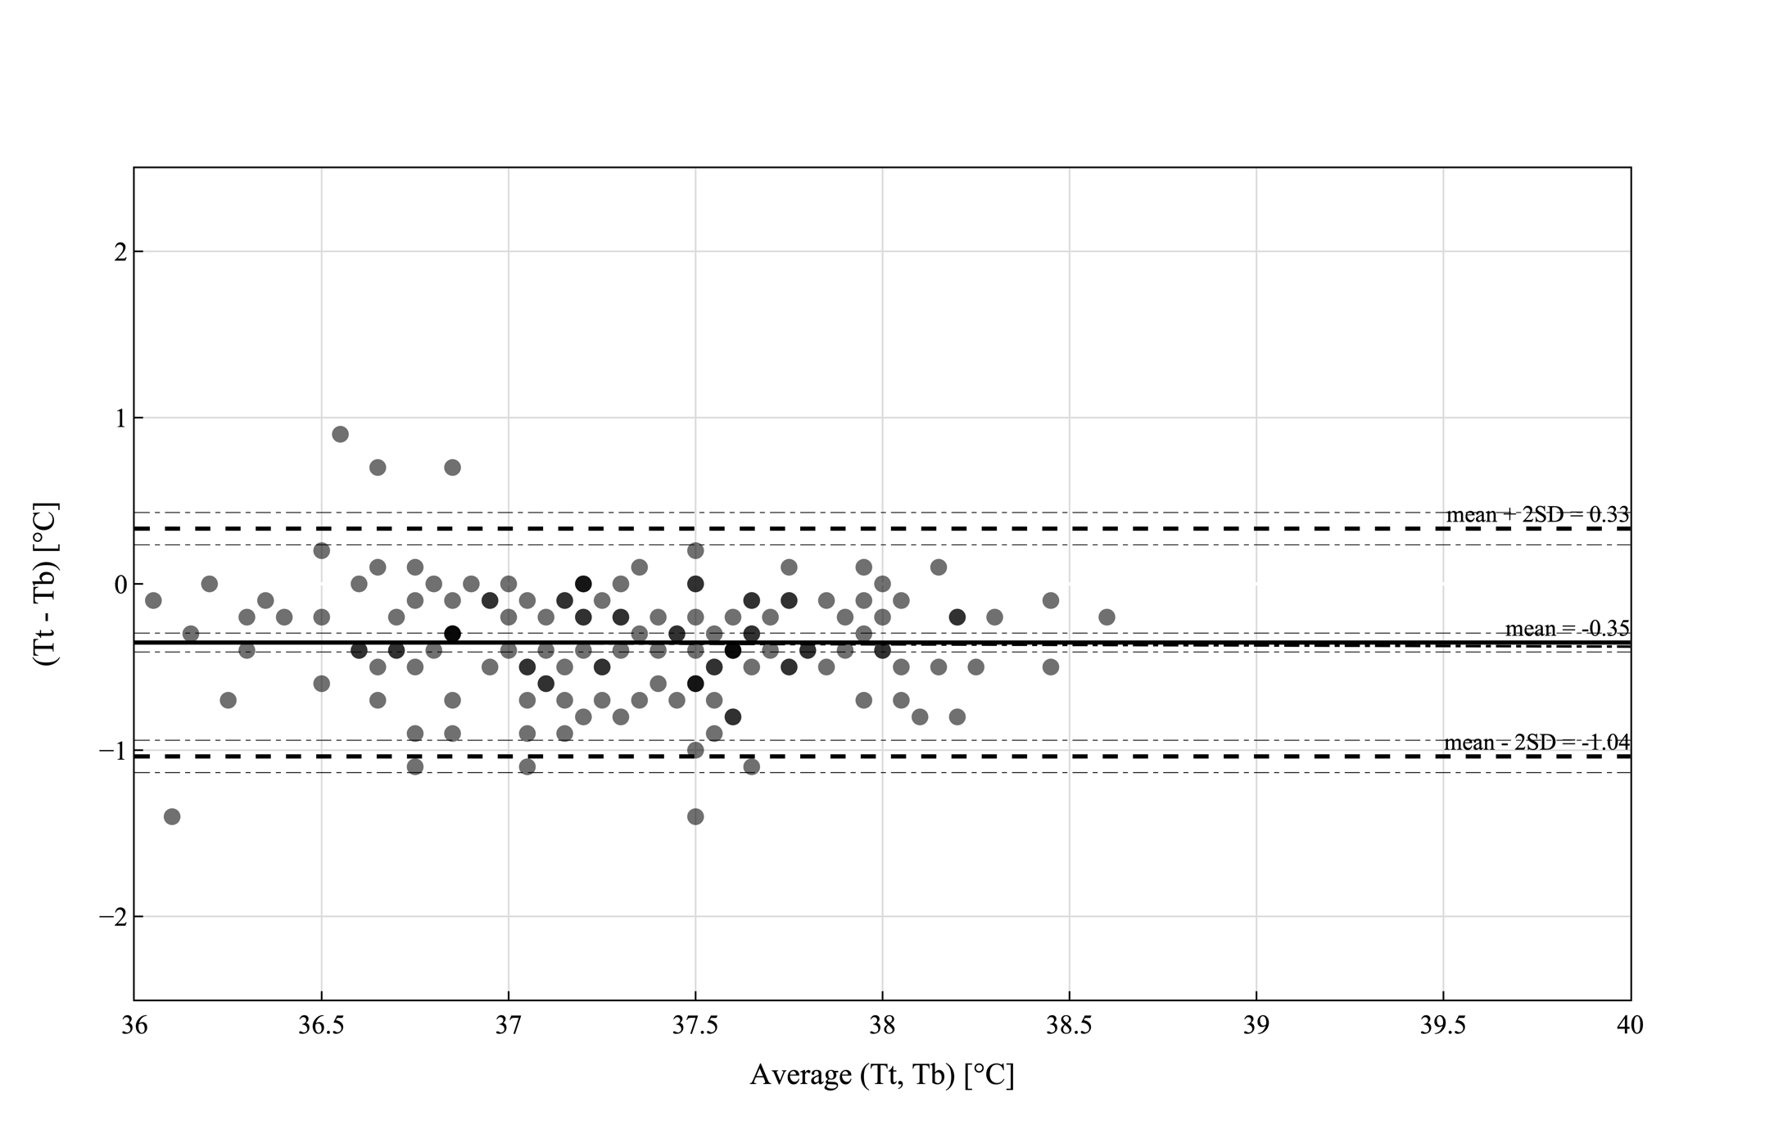
Figure S1: Bland-Altman Plots for temperature probes in lateral chest (T_{cl}), clavicula (T_{cc}) and Tympanic (T_{t}) positions compared to bladder temperatures (T_{b}) in patients with a BMI ≤ 25 excluding hypothermic events. Displayed are the mean values and the 95% upper and lower limits of agreement. In addition, the CI of each parameter are also indicated. Shading of datapoints resembles the amount of datapoint at this temperature. Detailed information’s are summarized in Table S1 in the supplementary information.

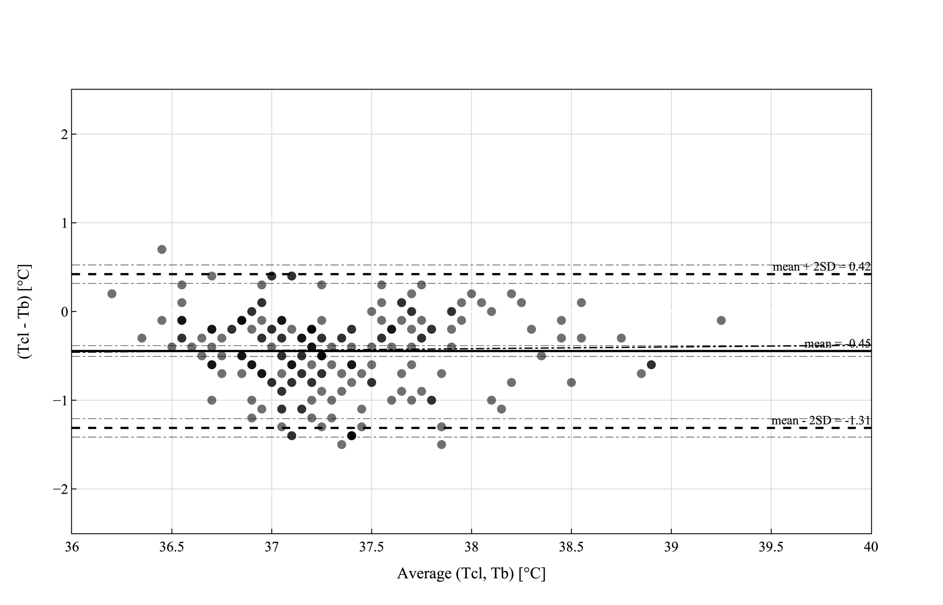
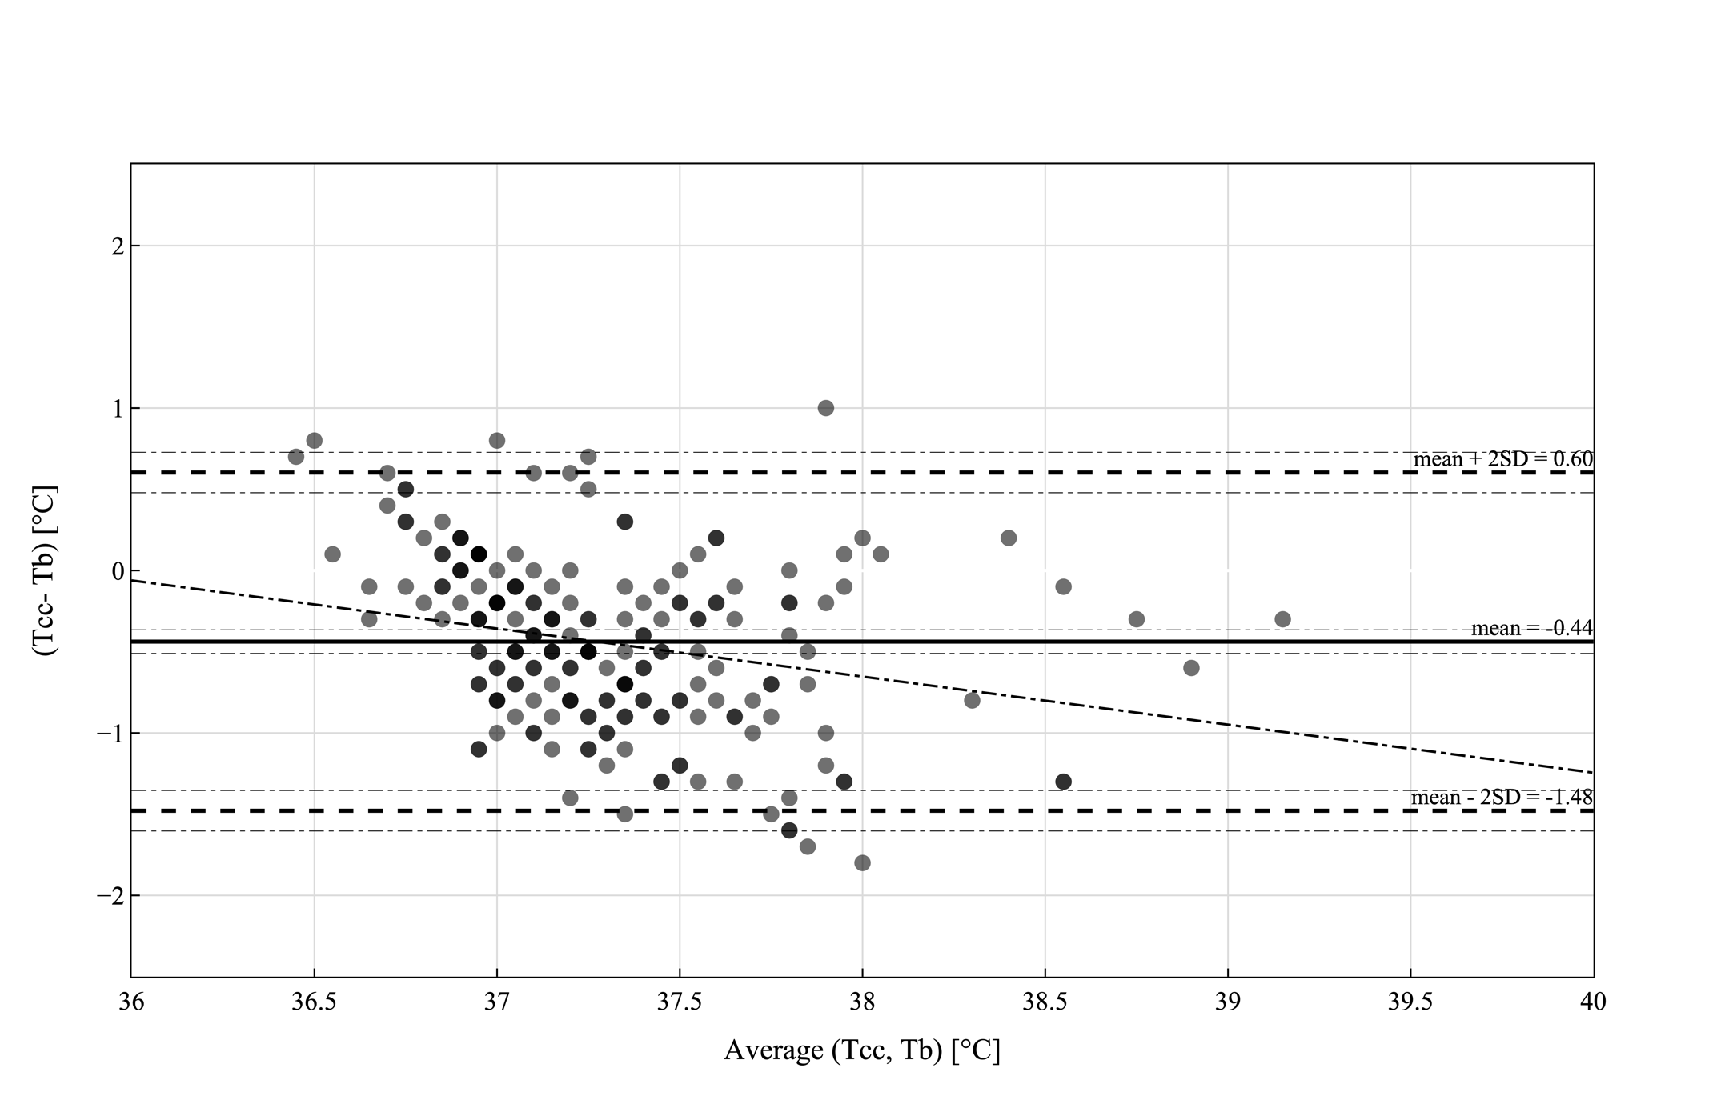
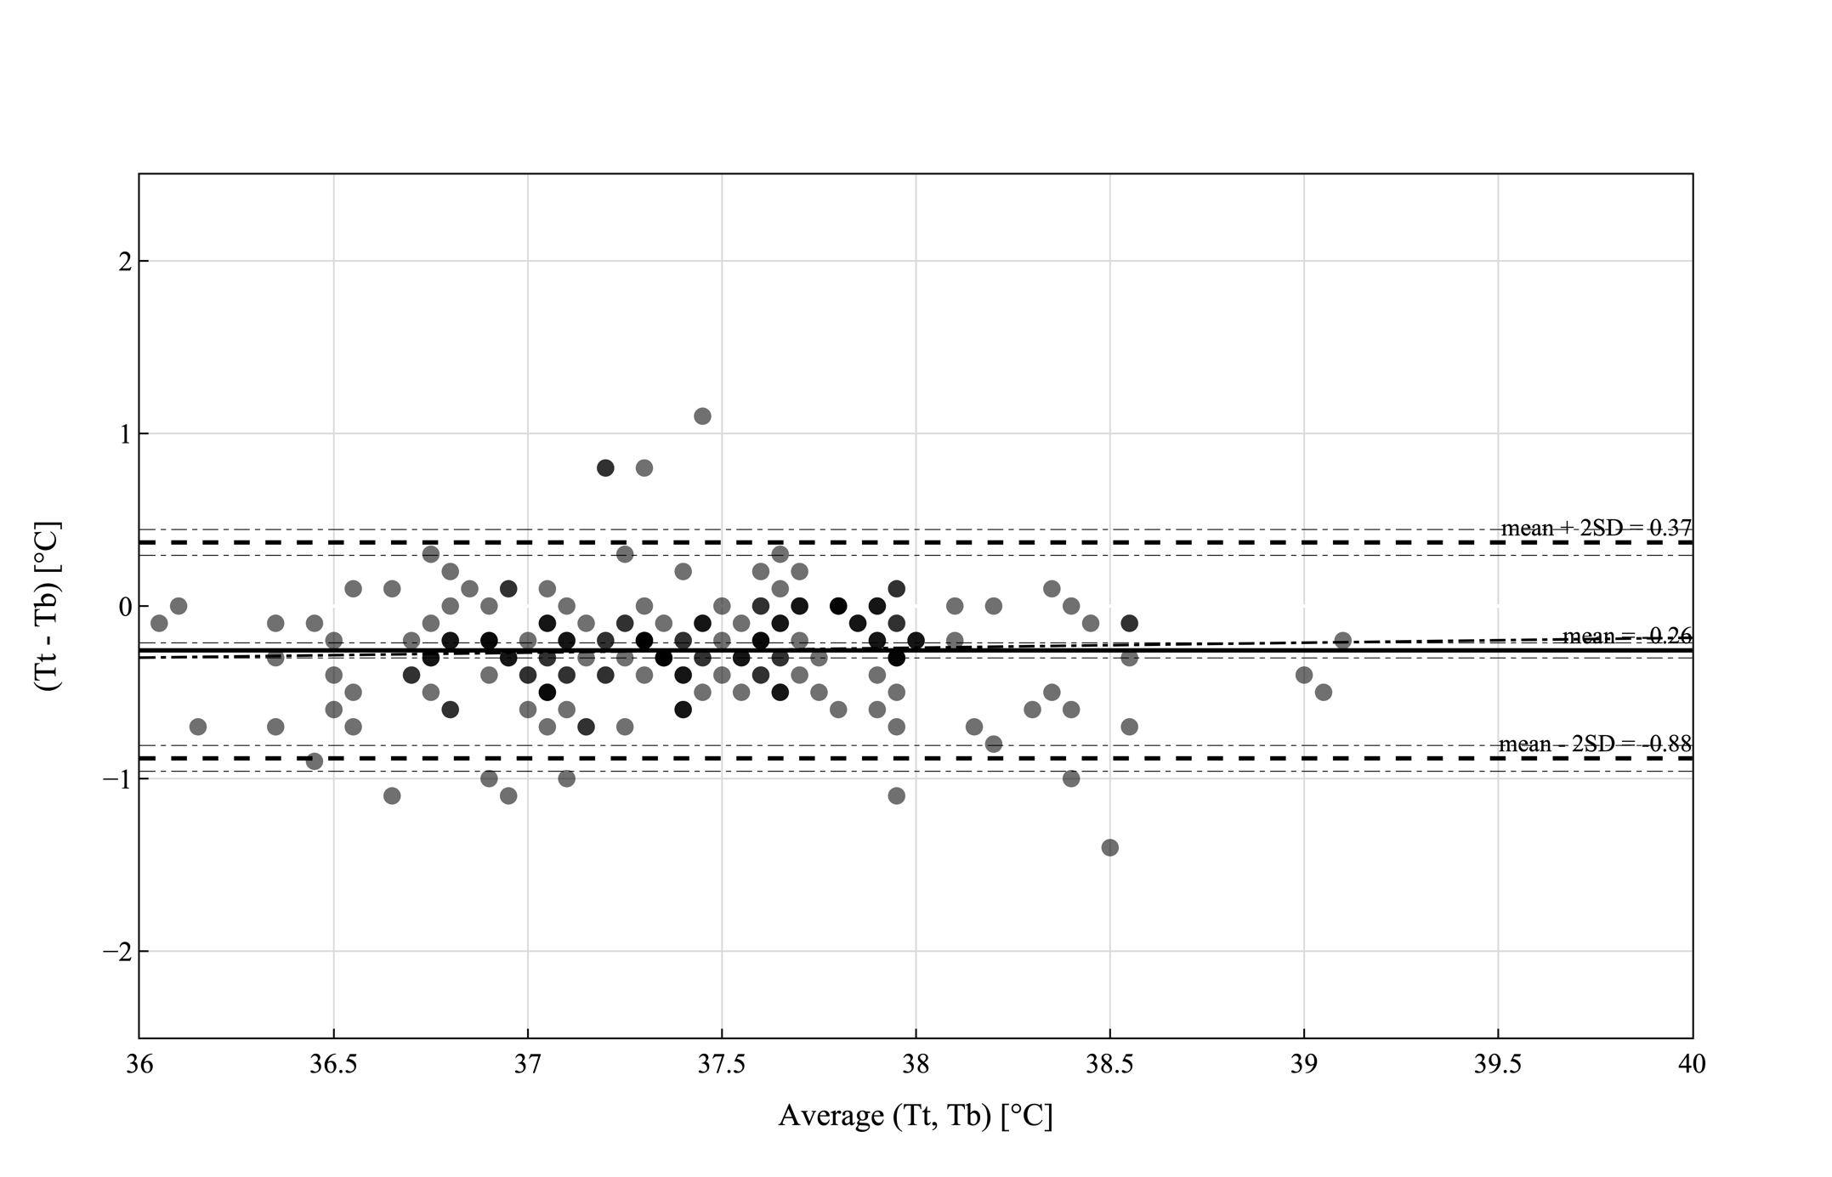
Figure S2: Bland-Altman Plots for temperature probes in lateral chest (T_{cl}), clavicula (T_{cc}) and Tympanic (T_{t}) positions compared to bladder temperatures (T_{b}) in patients with a BMI > 25 excluding hypothermic events. Displayed are the mean values and the 95% upper and lower limits of agreement. In addition, the CI of each parameter are also indicated. Shading of datapoints resembles the amount of datapoint at this temperature. Detailed information’s are summarized in Table S1 in the supplementary information.

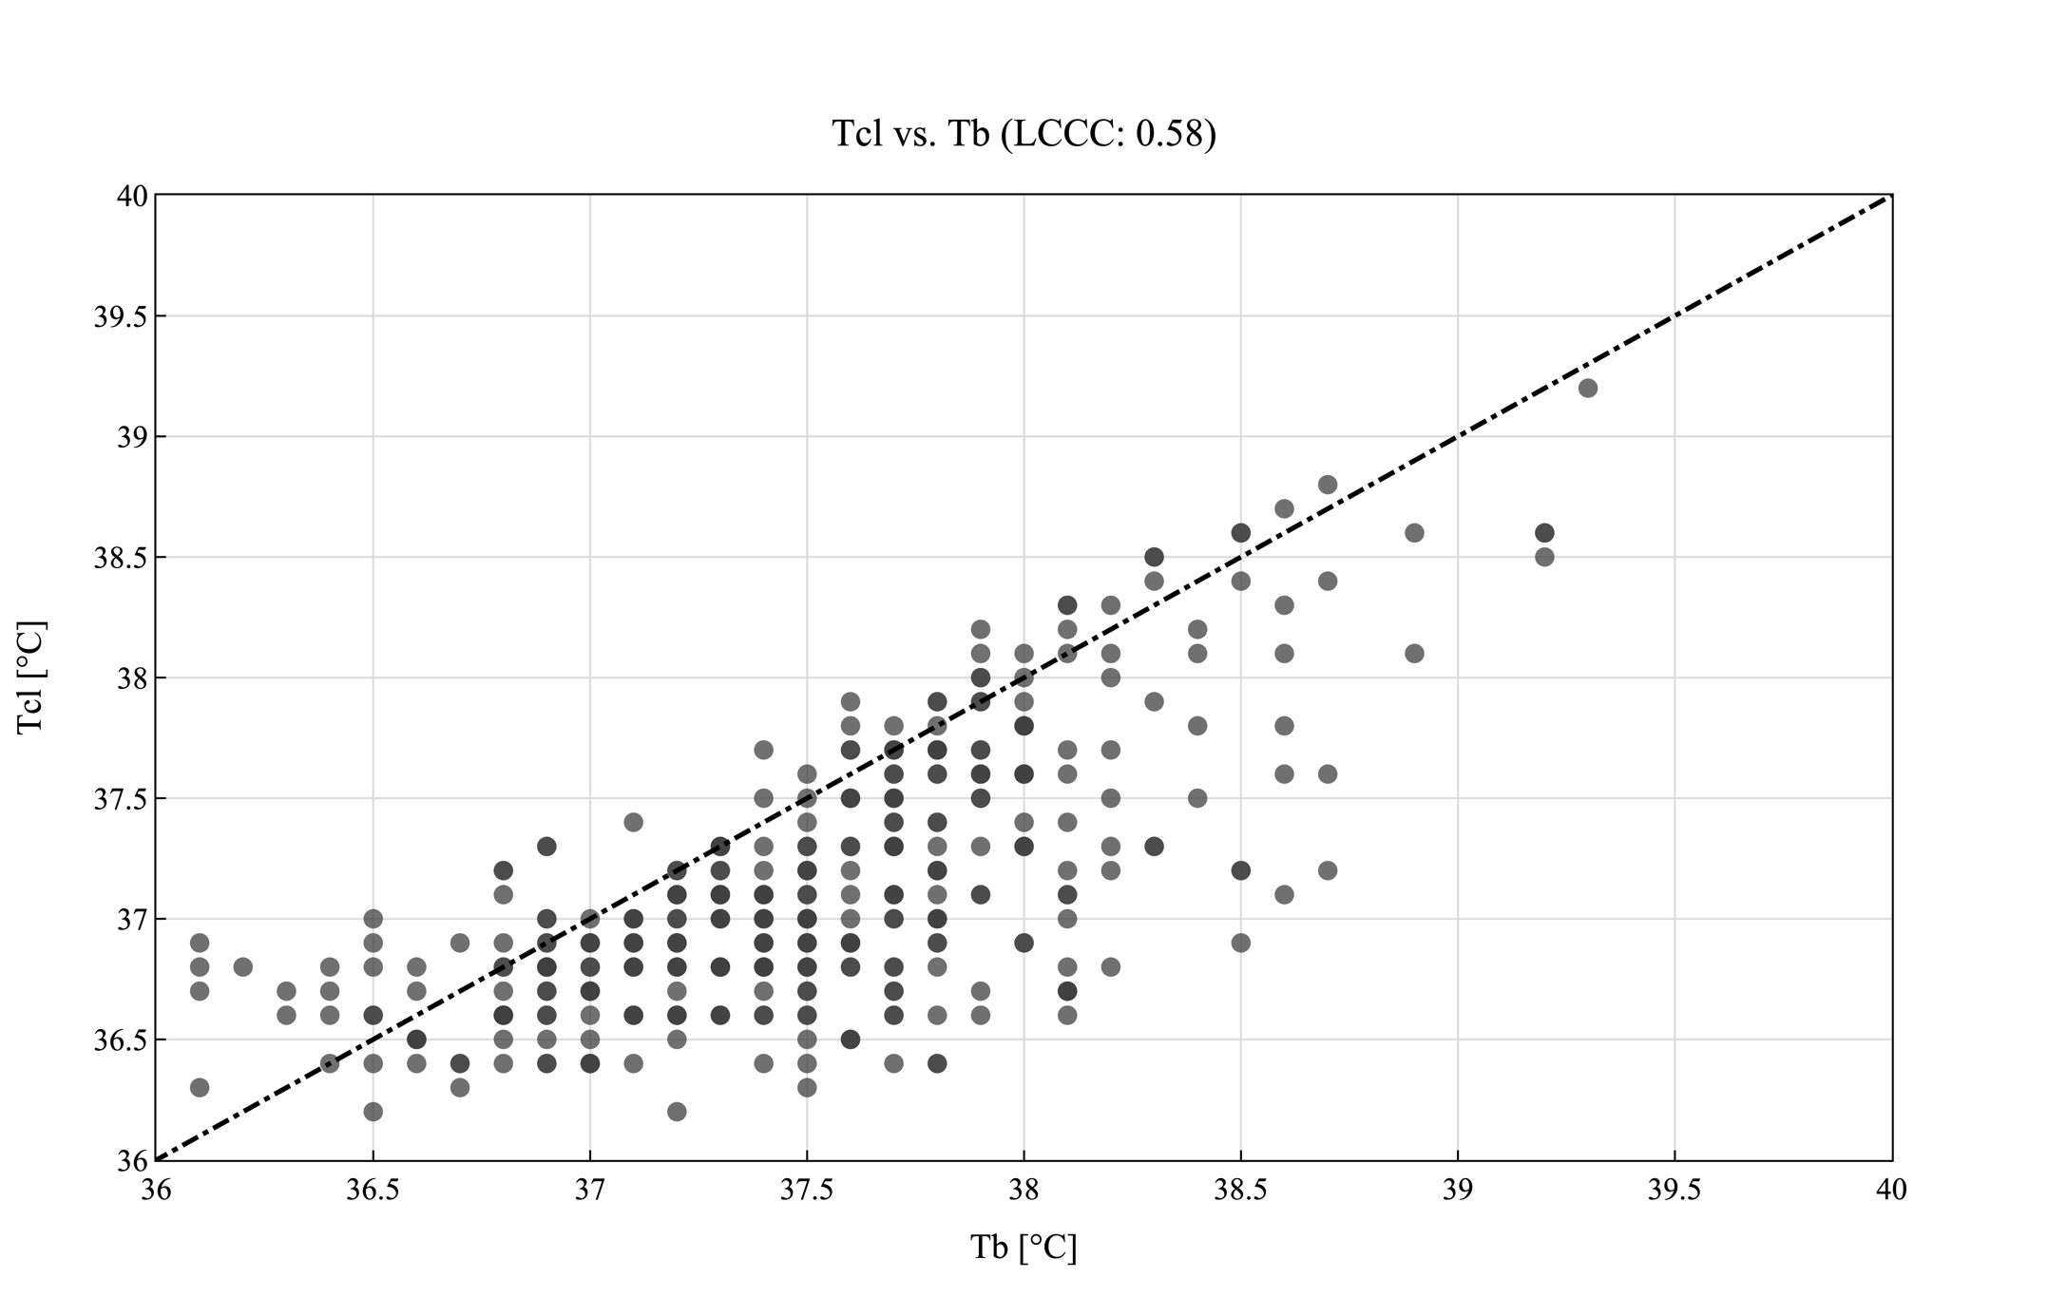
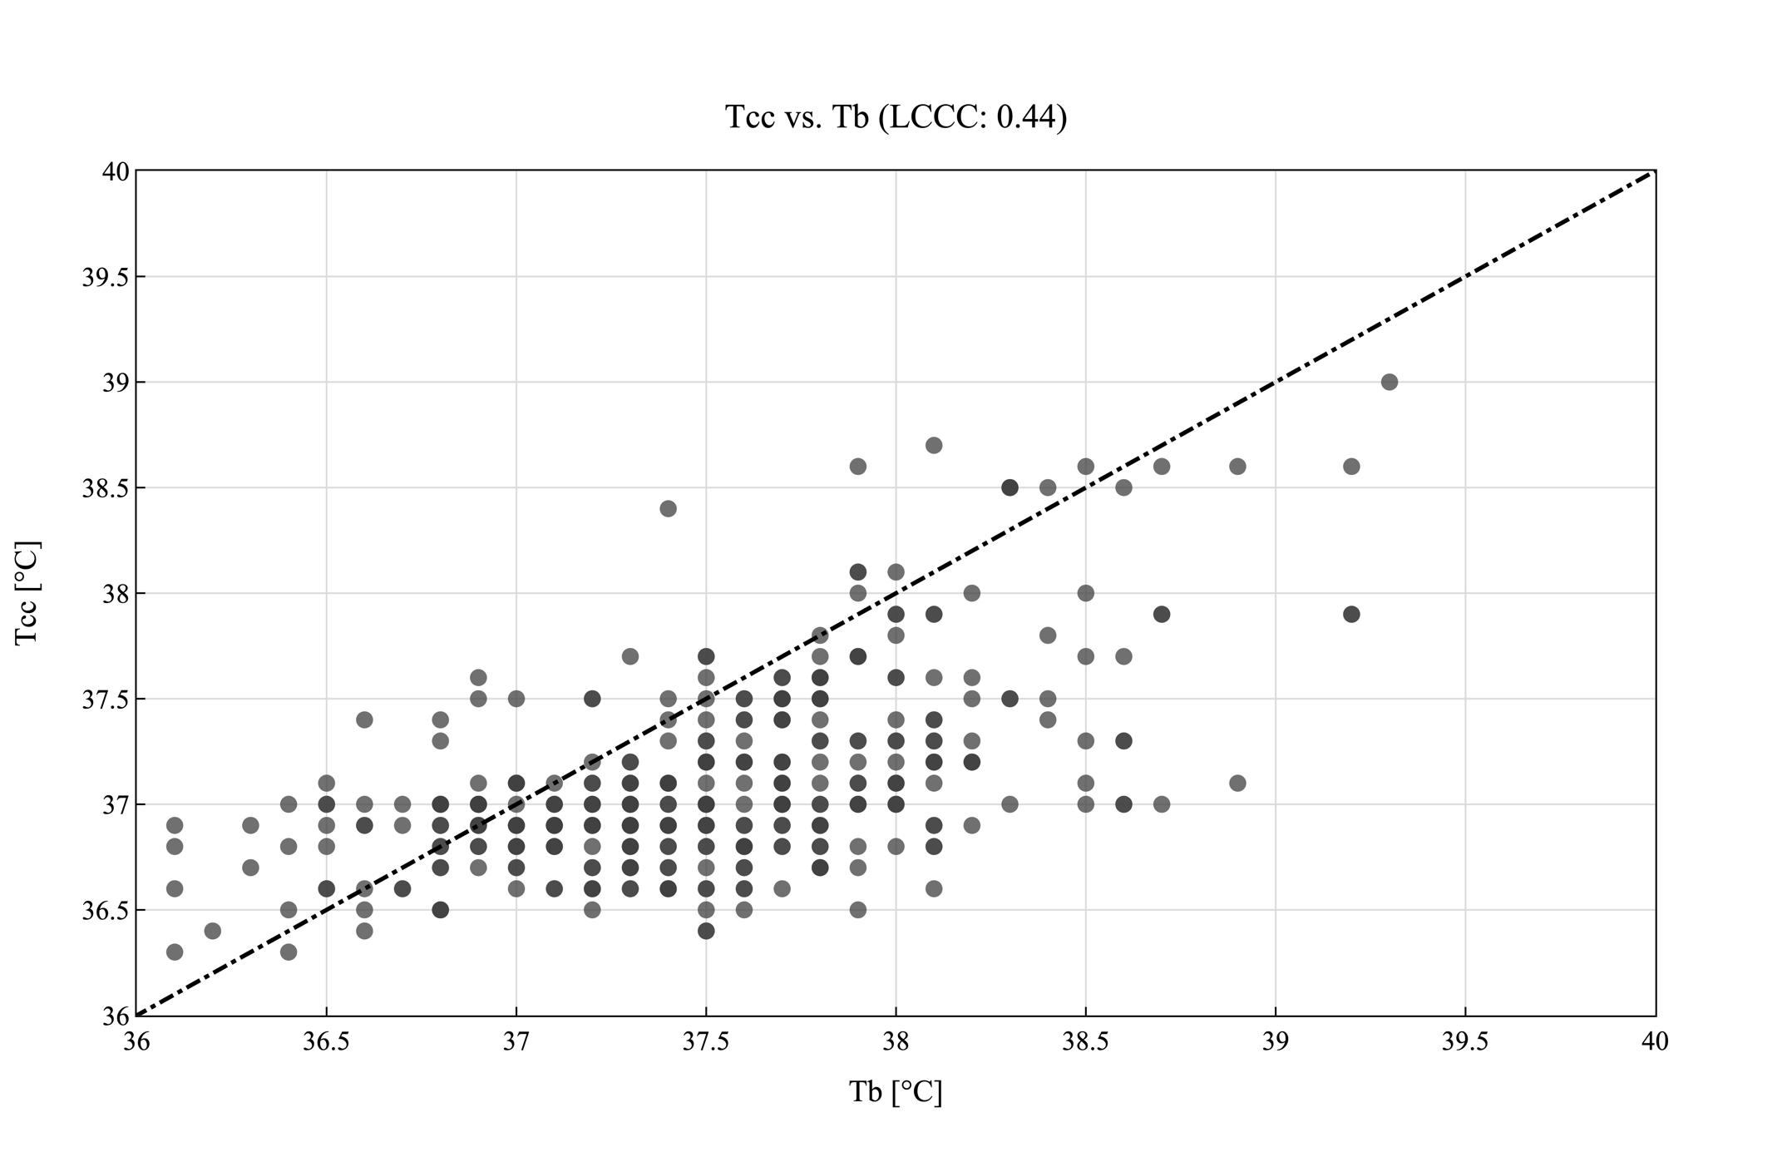
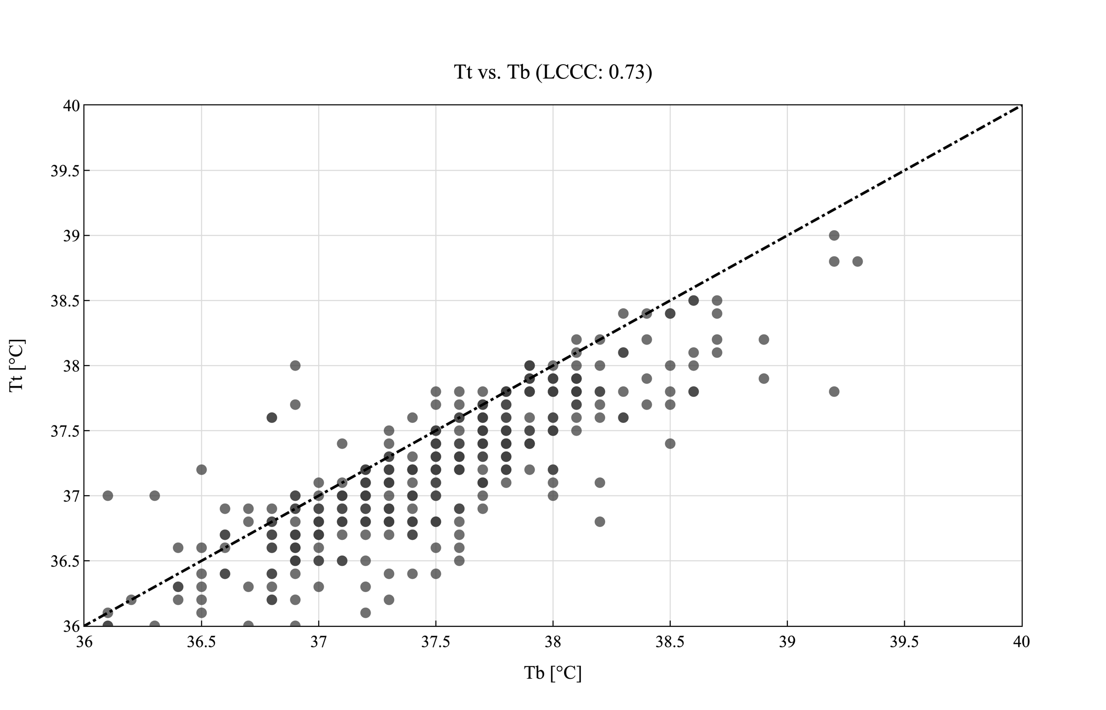
Figure S3: Correlation analysis for temperature probes in lateral chest (T_{cl}), clavicula (T_{cc}) and Tympanic (T_{t}) positions compared to bladder temperatures (T_{b}) in all patients excluding hypothermic events. Displayed are the values of the corresponding sensor in relation to the reference temperature (T_{b}). The line of equality is shown as dashed line. Shading of datapoints resembles the amount of datapoint at this temperature. Detailed information’s are summarized in Table S1 in the supplementary information.

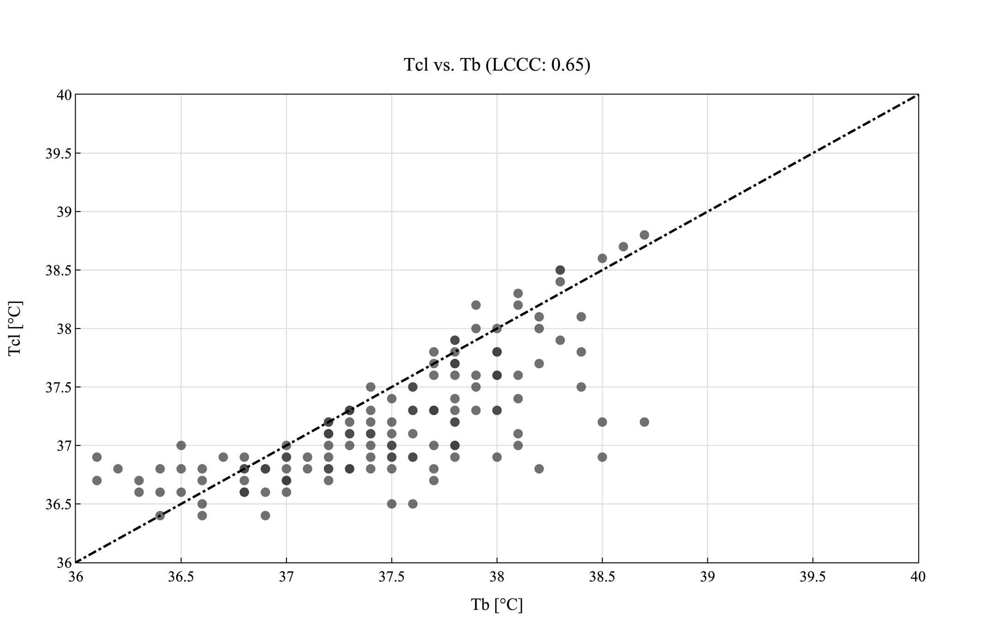
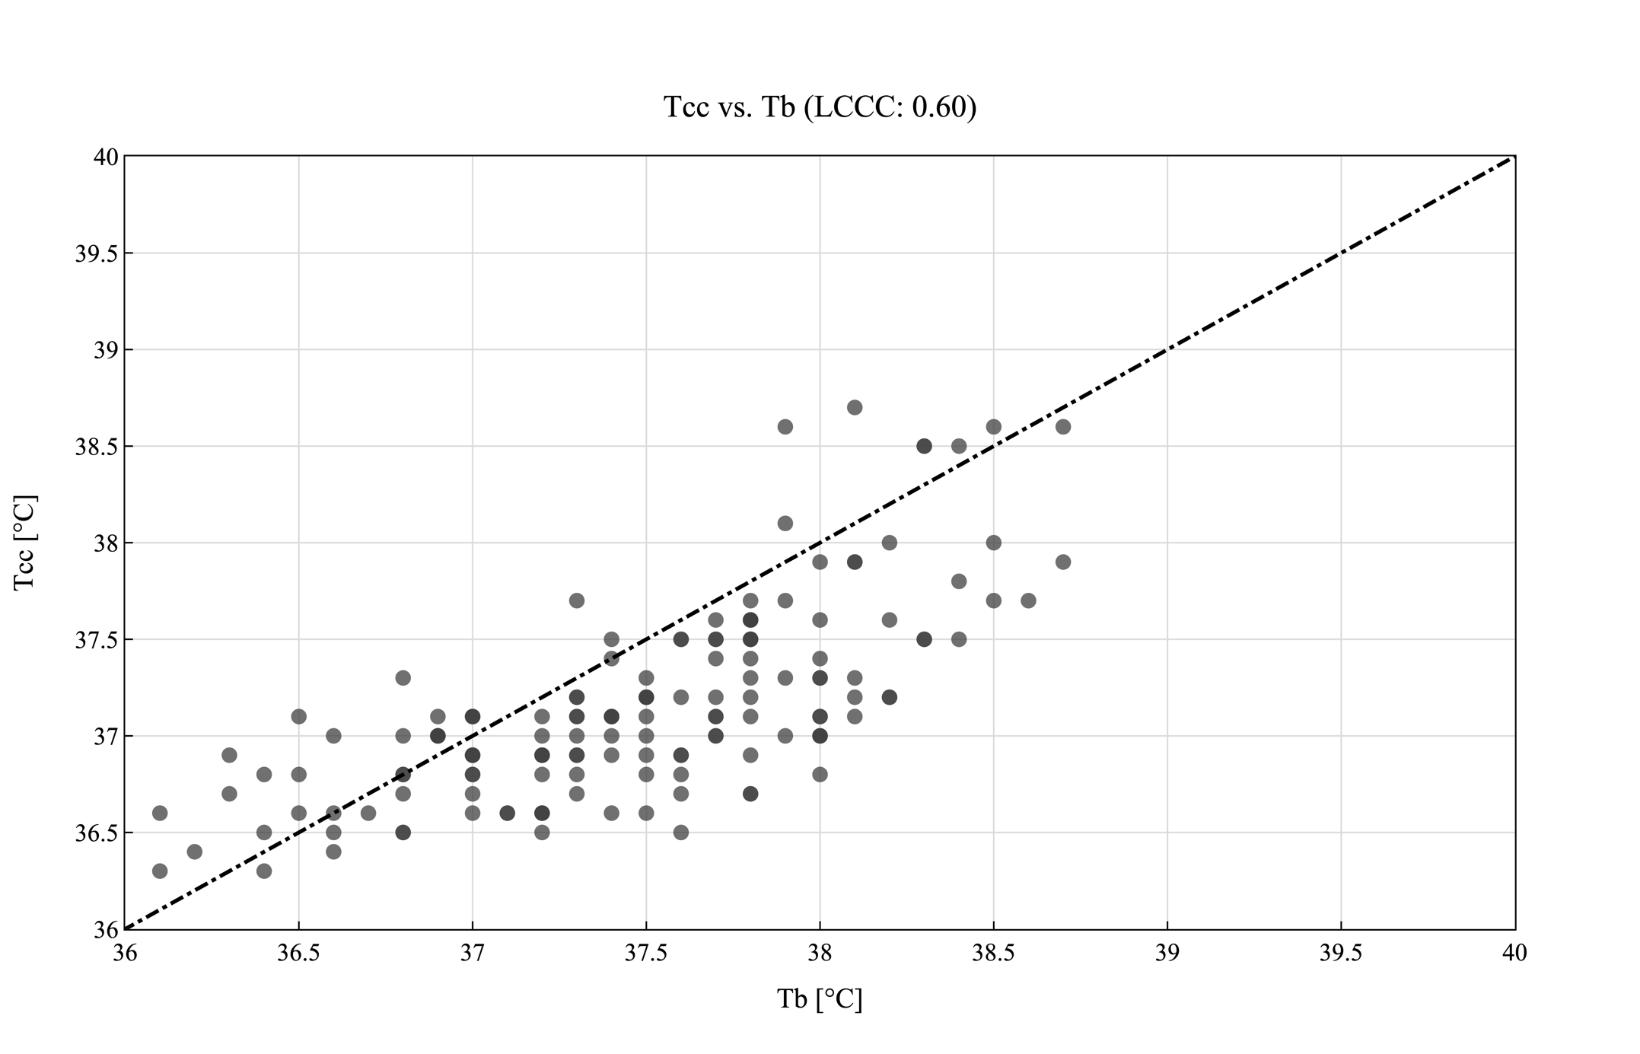
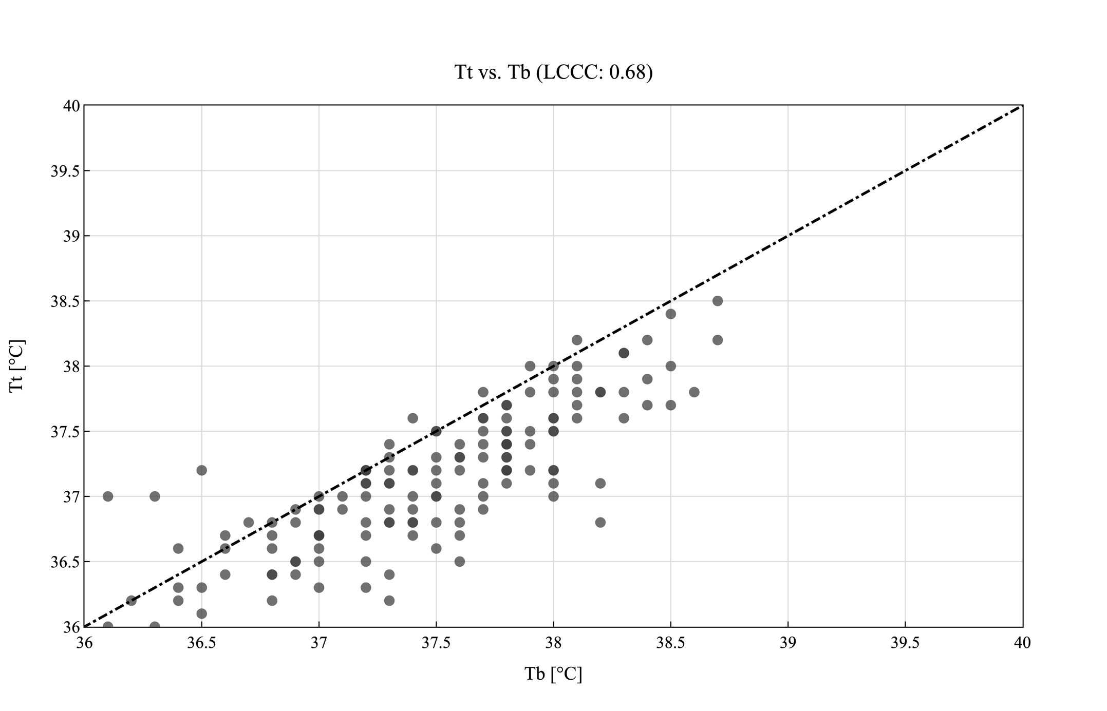
Figure S4: Correlation analysis for temperature probes in lateral chest (T_{cl}), clavicula (T_{cc}) and Tympanic (T_{t}) positions compared to bladder temperatures (T_{b}) in patients with BMI ≤ 25 excluding hypothermic events. Displayed are the values of the corresponding sensor in relation to the reference temperature (T_{b}). The line of equality is shown as dashed line. Shading of datapoints resembles the amount of datapoint at this temperature. Detailed information’s are summarized in Table S1 in the supplementary information.

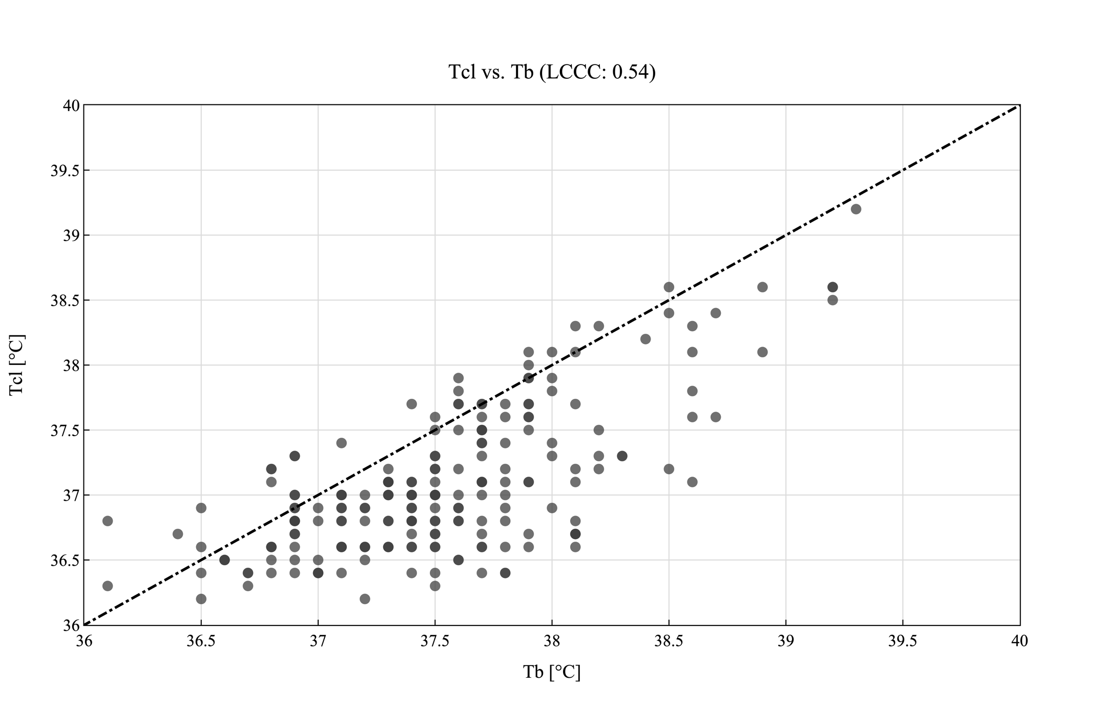
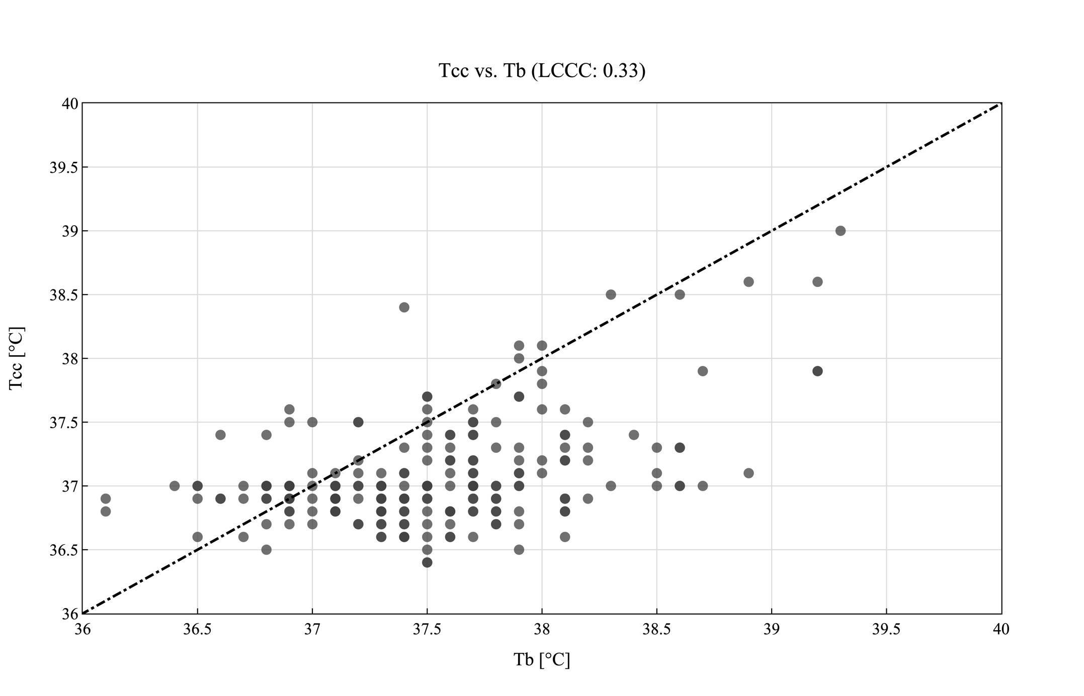
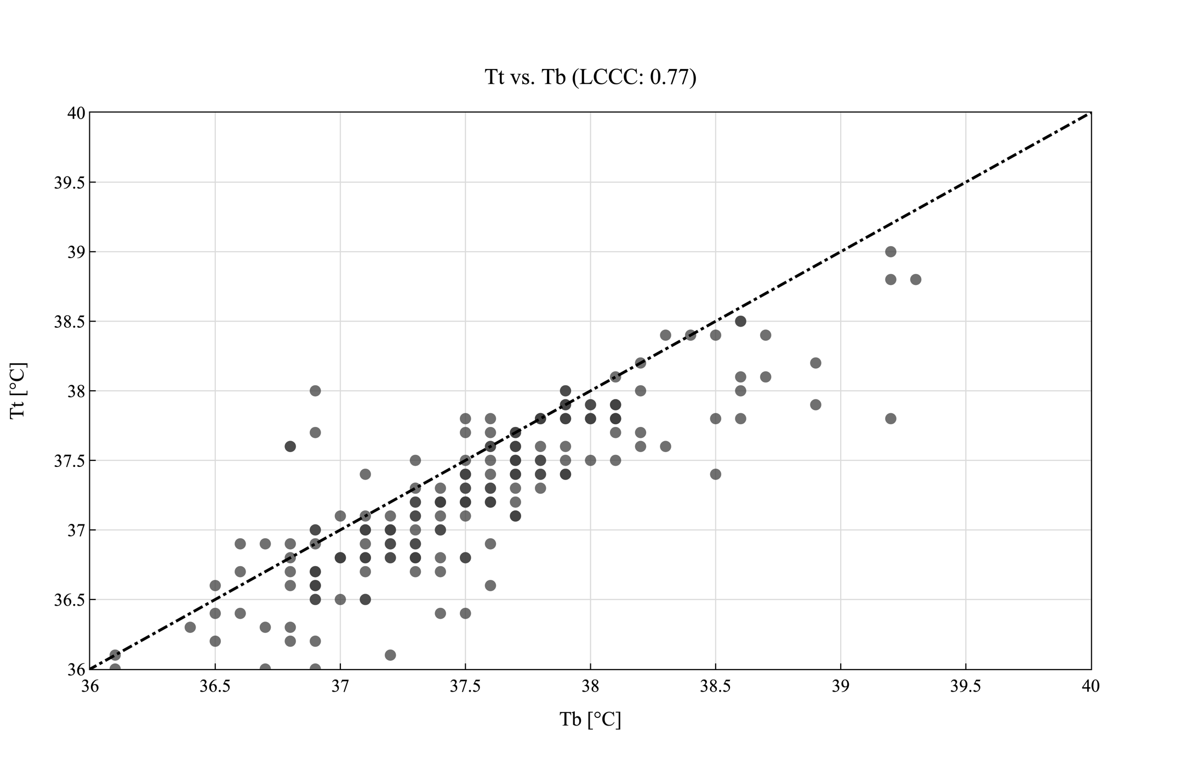
Figure S5: Correlation analysis for temperature probes in lateral chest (T_{cl}), clavicula (T_{cc}) and Tympanic (T_{t}) positions compared to bladder temperatures (T_{b}) in patients with BMI > 25 excluding hypothermic events. Displayed are the values of the corresponding sensor in relation to the reference temperature (T_{b}). The line of equality is shown as dashed line. Shading of datapoints resembles the amount of datapoint at this temperature. Detailed information’s are summarized in Table S1 in the supplementary information.

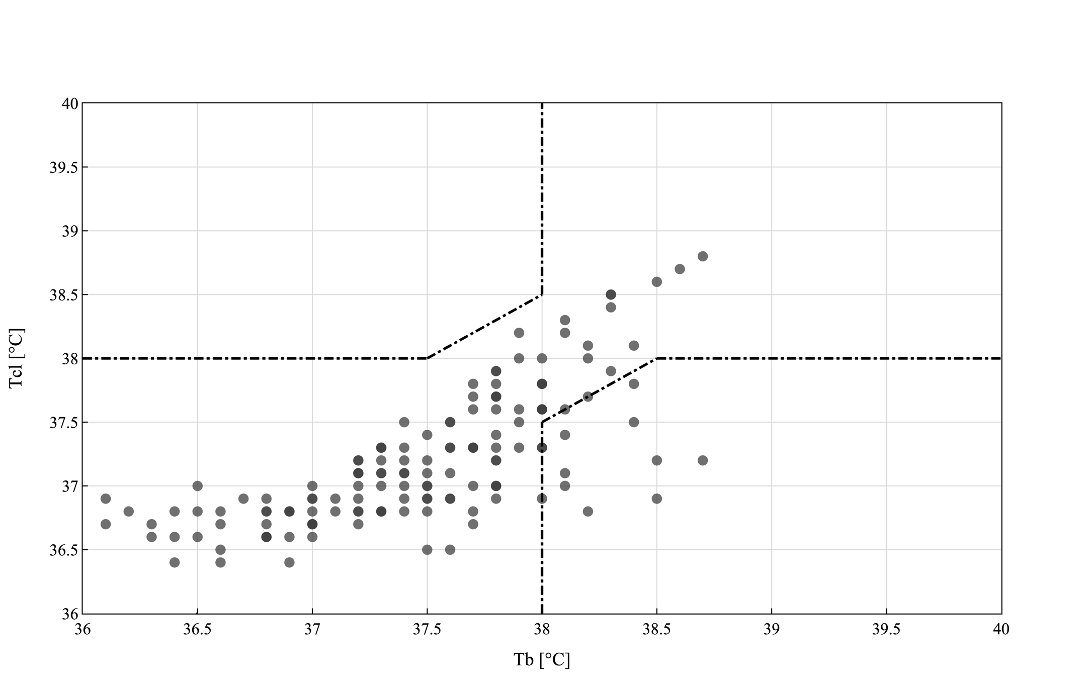
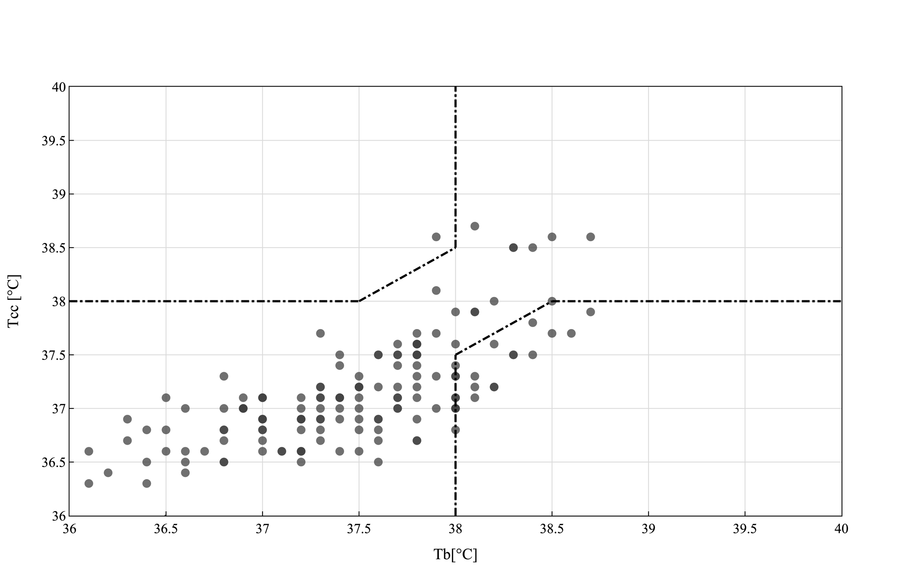
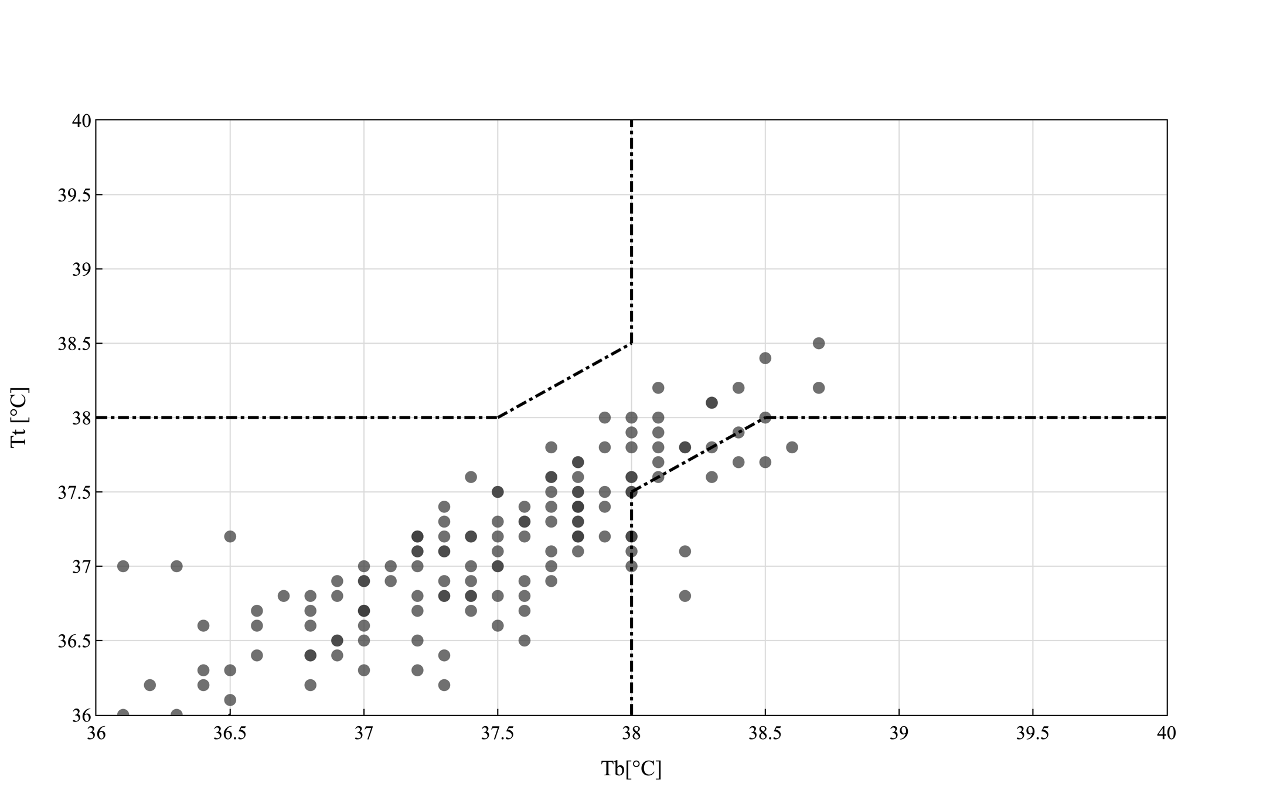
Figure S6: Error grid analysis for temperature probes in lateral chest (T_{cl}), clavicula (T_{cc}) and tympanic (T_{t}) position detecting febrile episodes in patients with BMI ≤ 25 excluding hypothermic events. Zone A represents all episodes where measurements of predicting values (T_{cl}, T_{cc}, T_{t}) and reference value (T_{b}) did not indicate fever and would have resulted in the same clinical decision. Zone B represents all episodes where the predictive values (T_{cl}, T_{cc}, T_{t}) indicated a fever event whereas the reference value did not (false positive). Zone C represents all episodes where the predictive values (T_{cl}, T_{cc}, T_{t}) missed to indicate a fever event (false negative).

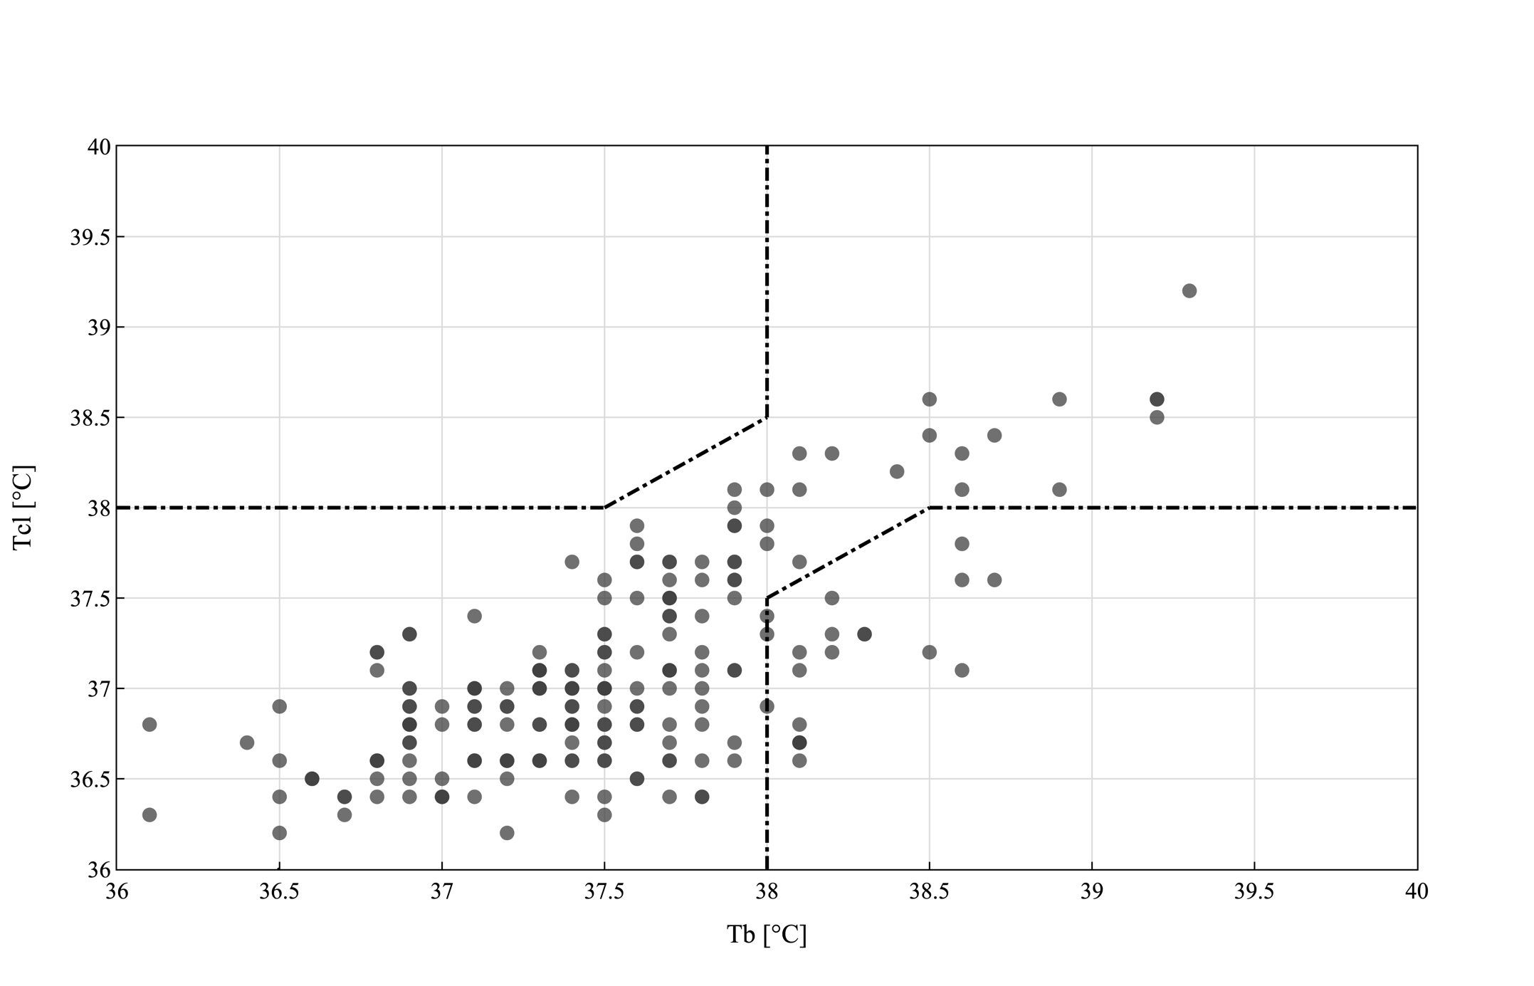
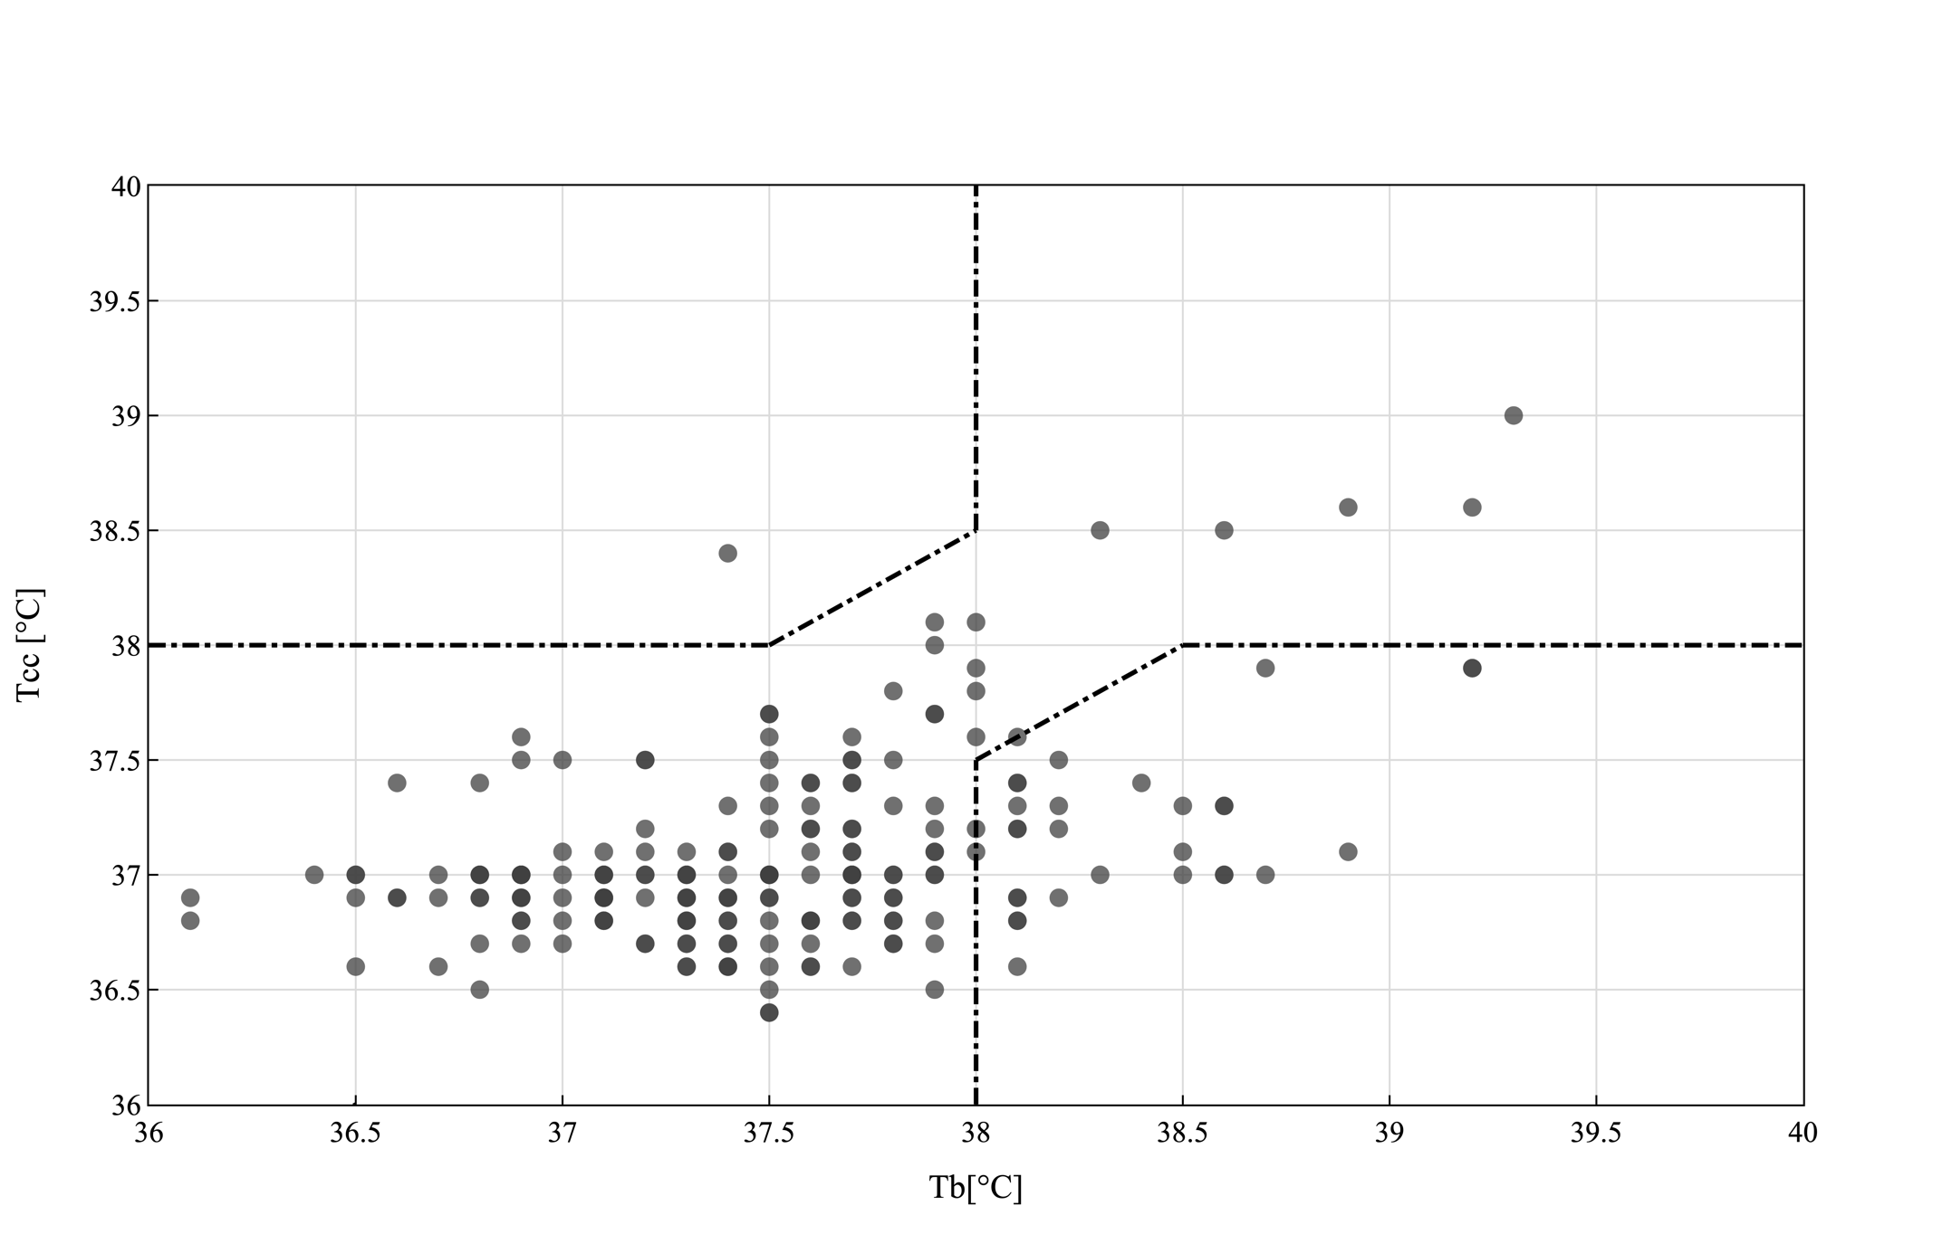
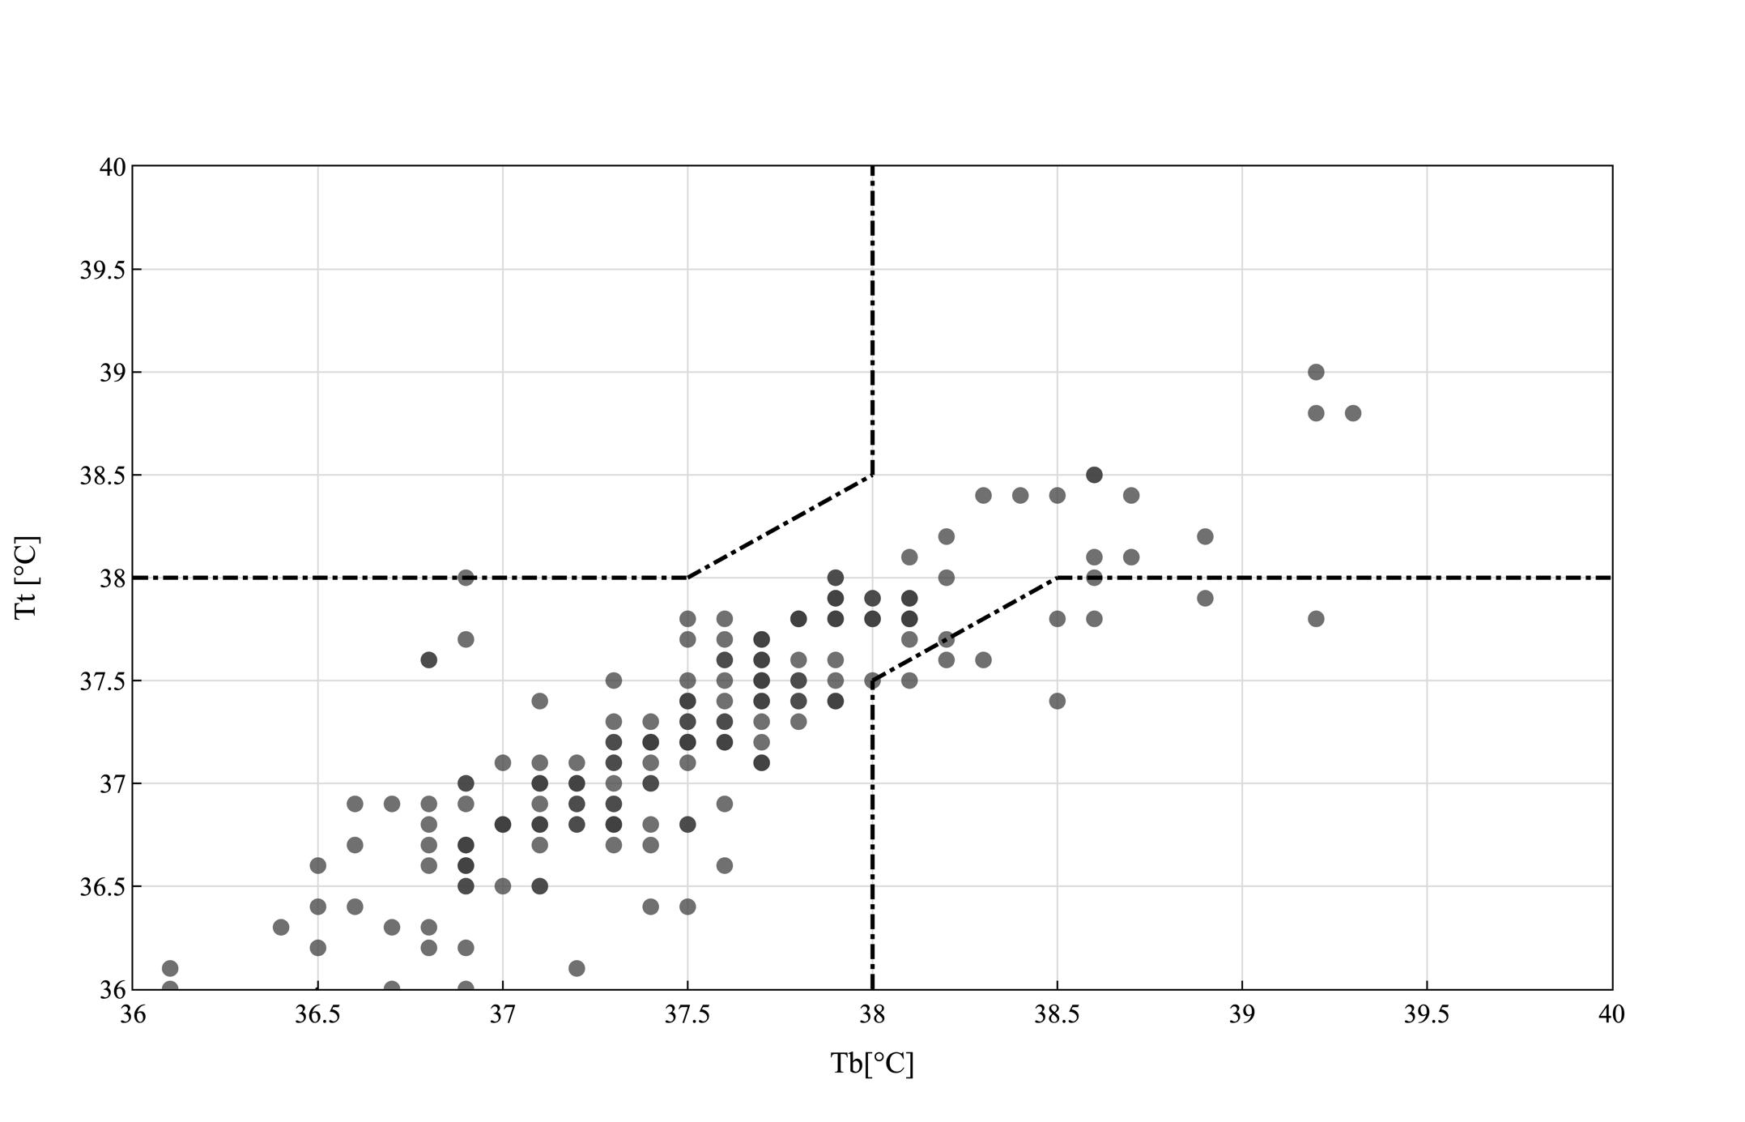
Figure S7: Error grid analysis for temperature probes in lateral chest (T_{cl}), clavicula (T_{cc}) and tympanic (T_{t}) position detecting febrile episodes in patients with BMI > 25 excluding hypothermic events. Zone A represents all episodes where measurements of predicting values (T_{cl}, T_{cc}, T_{t}) and reference value (T_{b}) did not indicate fever and would have resulted in the same clinical decision. Zone B represents all episodes where the predictive values (T_{cl}, T_{cc}, T_{t}) indicated a fever event whereas the reference value did not (false positive). Zone C represents all episodes where the predictive values (T_{cl}, T_{cc}, T_{t}) missed to indicate a fever event (false negative).

