Prognostic and Clinical Heterogeneity of PD1 and PD-L1- Immunohistochemical Scores in Endometrial Cancers

Proppe L^{1,4*}, Jagomast T.², Beume S.¹, Köster, F.¹, Bräutigam, K.¹, Rody A.¹, Perner S.², Ribbat-Idel J.² Hemptenmacher F.¹ Hanker LC¹

¹Department of Gynecology and Obstetrics, University Medical Center Schleswig-Holstein, Campus-Lübeck, Lübeck, Germany ²Department of Pathology, University Medical Center Schleswig-Holstein, Campus-Lübeck, Lübeck, Germany ³Department of Gynecology and Obstetrics, University Medical Center Charité Berlin, Berlin, Germany⁴Department of Gynecology and Gynecologic Oncology, University Medical Center Hamburg-Eppendorf, Germany

Supplemental Information

We aim to provide a comprehensive scientific work, and as such, we have decided to publish the remaining Kaplan-Meier curves pertaining to patient data with PD1-positive tumors based on the TPS score (≥ 1, Fig S1 and S2) and those demonstrating the overall survival based on the IC and CPS scores (Fig S3, S4). Moreover, the clinical data dependent on the different PD1-scores are depicted in Table 1. The statistical validity of these analyses is limited due to the small number of positive tumor samples identified to be PD1-positive (TPS ≥ 1).

Table S1. Data of patients dependent on a positive PD1 status (n = 114).
Characteristic | Classification | Amount of patients with  PD1-IC ≥ 1  (n = 78) | Amount of patients with  PD1-CPS ≥ 5  (n = 31) | Amount of patients with  PD1-TPS ≥ 1  (n = 5)
Age (years) | > 60 | 56 | 21 | 1*
Age (years) | ≤ 60 | 22 | 10 | 4*
FIGO | I-II | 57 | 20 | 4
FIGO | III-IV | 20 | 10 | 1
MMR status | MMR deficient | 47 | 21 | 2
MMR status | MMR proficient | 30 | 10 | 3
p53 status | p53 aberrant | 32 | 15 | 2
p53 status | p53 wild type | 45 | 15 | 3
Ki -67 status | Ki-67 ≥ 25 % | 18 | 6 | 1
Ki -67 status | Ki-67 < 25 % | 52 | 2 | 4
Grading | G1 | 36 | 12 | 2
Grading | G2 or G3 | 41 | 18 | 3
Histopathology | Endometrioid carcinoma | 65 | 26 | 5
Histopathology | Others (e.g. serous or clear cell carcinomas) | 12 | 5 | 0
*statistically significant, p ≤ 0.05

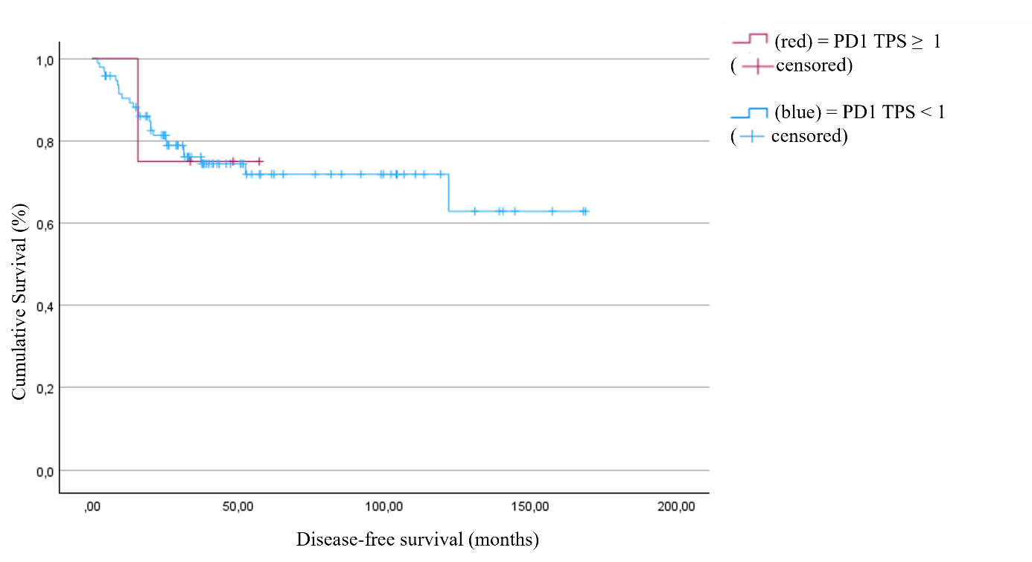
Fig. S1. Disease-free survival as a function of PD1 positivity, defined as TPS ≥ 1 (p = 0.983).

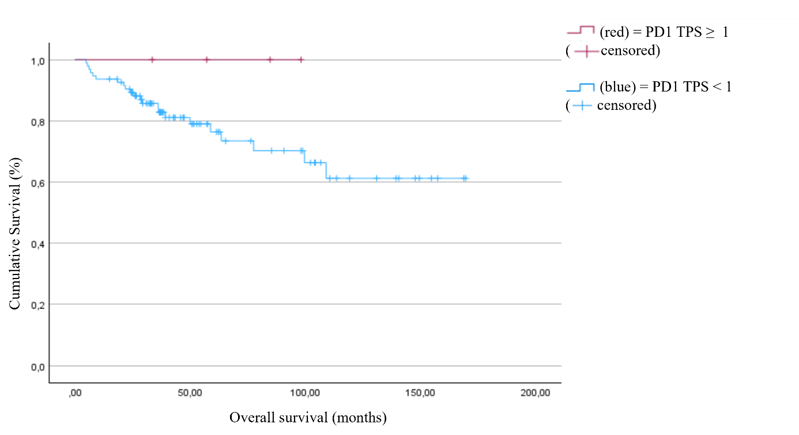
Fig. S2. Overall survival as a function of PD1 positivity, defined as TPS ≥ 1 (p = 0.289).
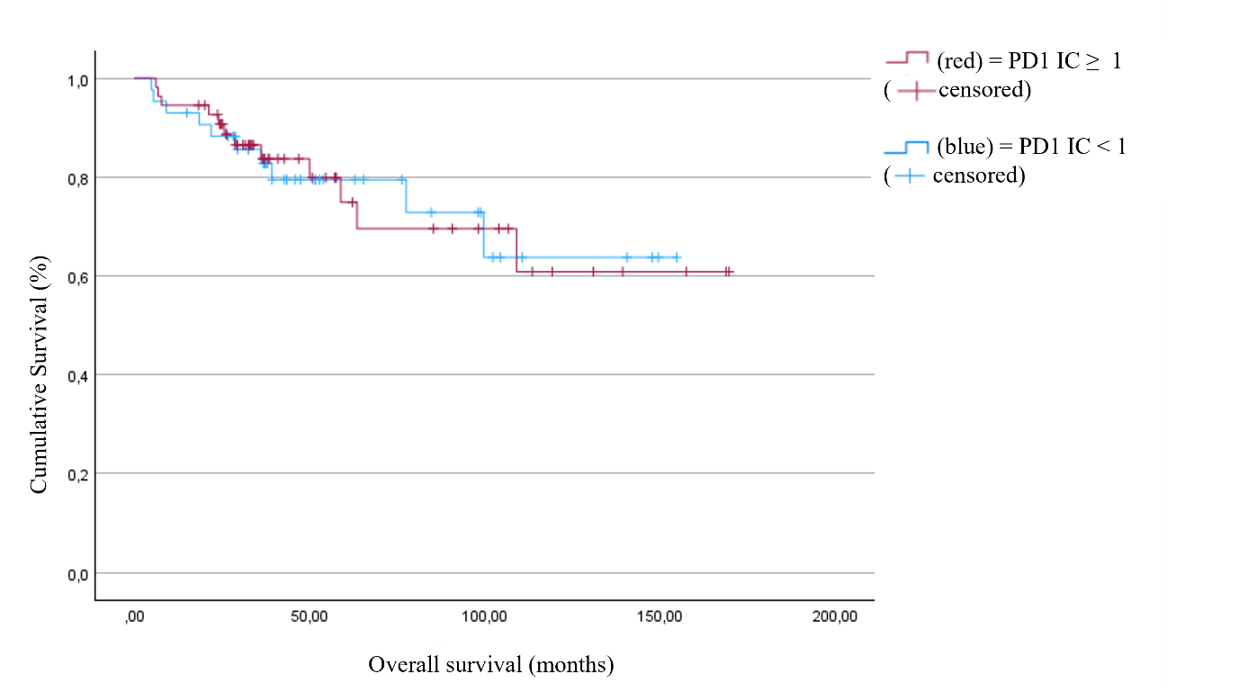
Fig. S3. Overall survival as a function of PD1 positivity, defined as IC ≥ 1 (p = 0.986).
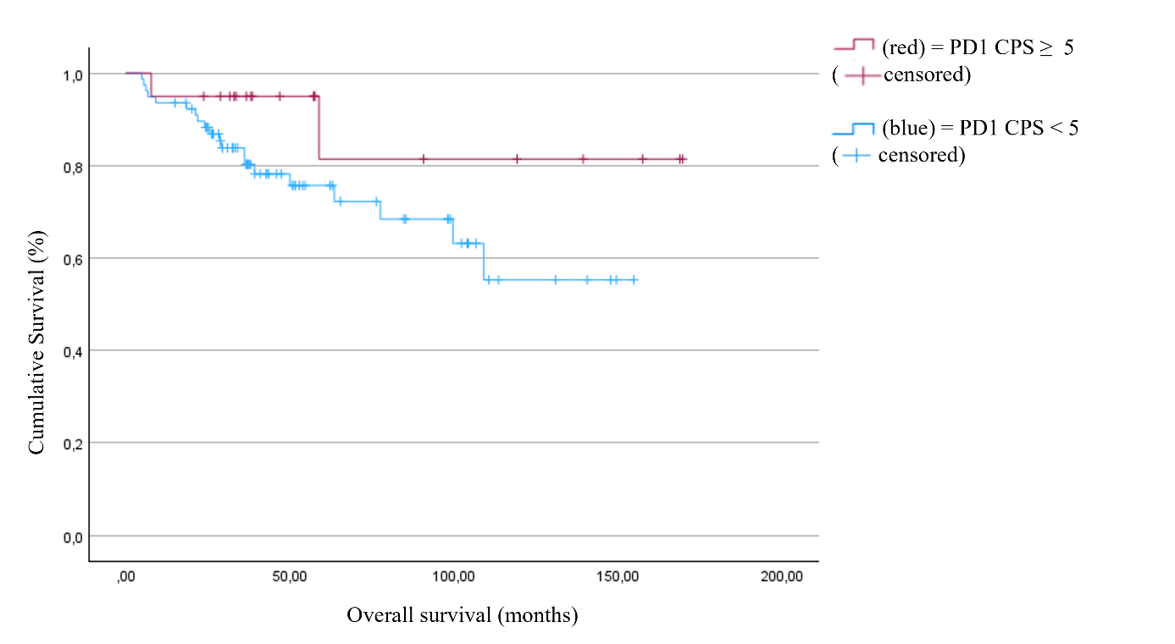
Fig. S4. Overall survival as a function of PD1 positivity, defined as CPS ≥ 5 (p = 0.119).

PD-L1-Positivity
The survival data related to PDL1-positivity are also provided by this supplemental information. These data do not yield significantly different results across the various PD-L1-scores. The Kaplan-Meier curves are illustrated below.
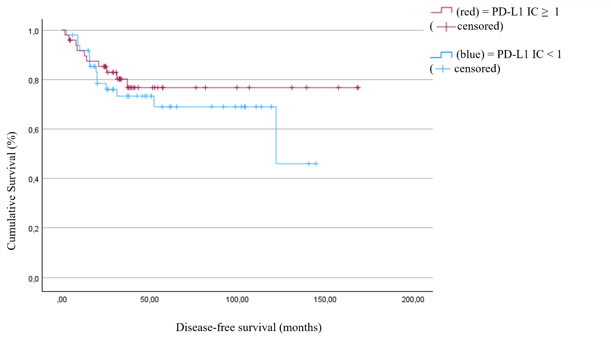
Fig. S5. Disease-free survival as a function of PD-L1 positivity, defined as IC ≥ 1 (p = 0.373).
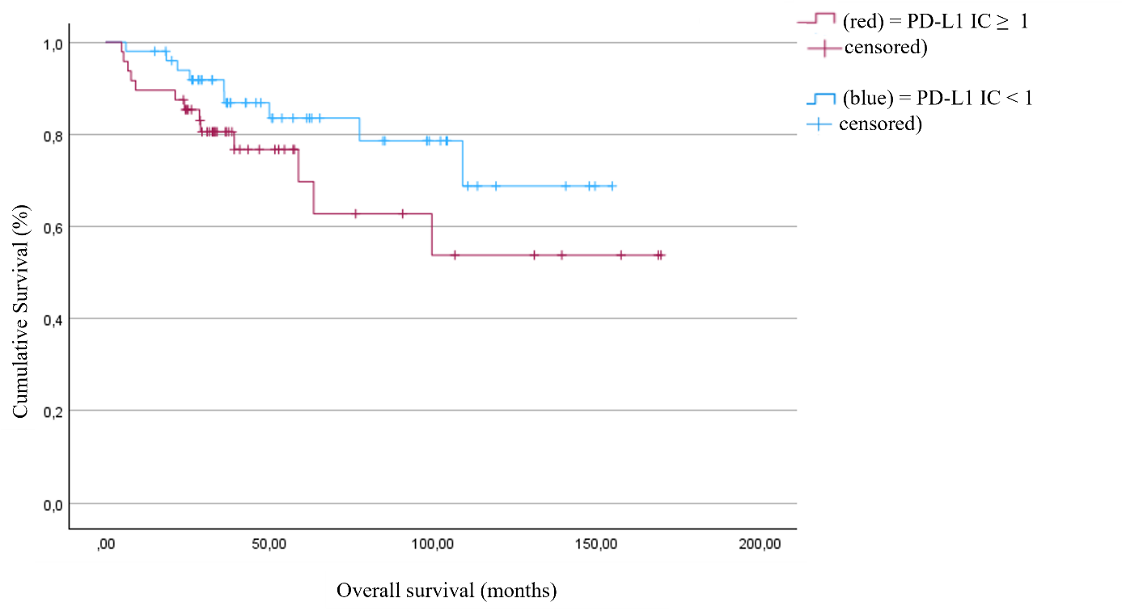
Fig. S6. Overall survival as a function of PD-L1 positivity, defined as IC ≥ 1 (p = 0.135).

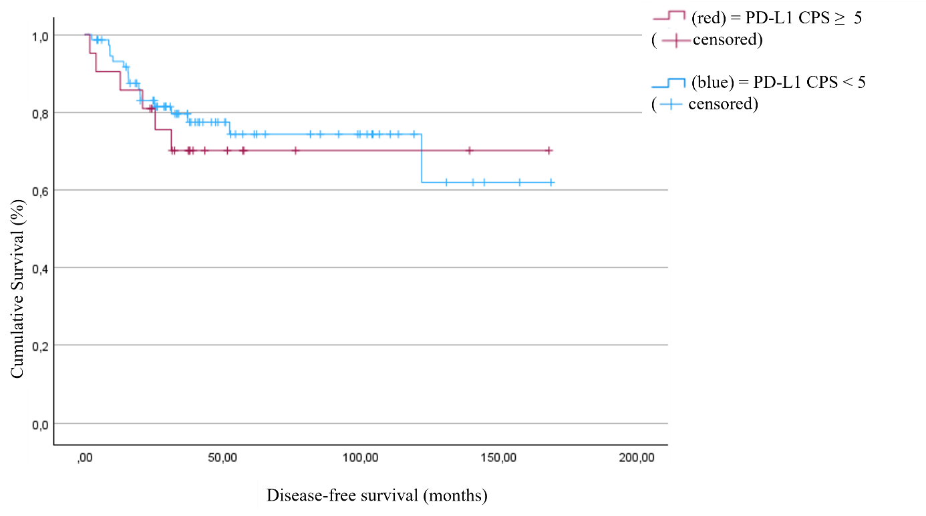
Fig. S7. Disease-free survival as a function of PD-L1 positivity, defined as CPS ≥ 5 (p = 0.660).
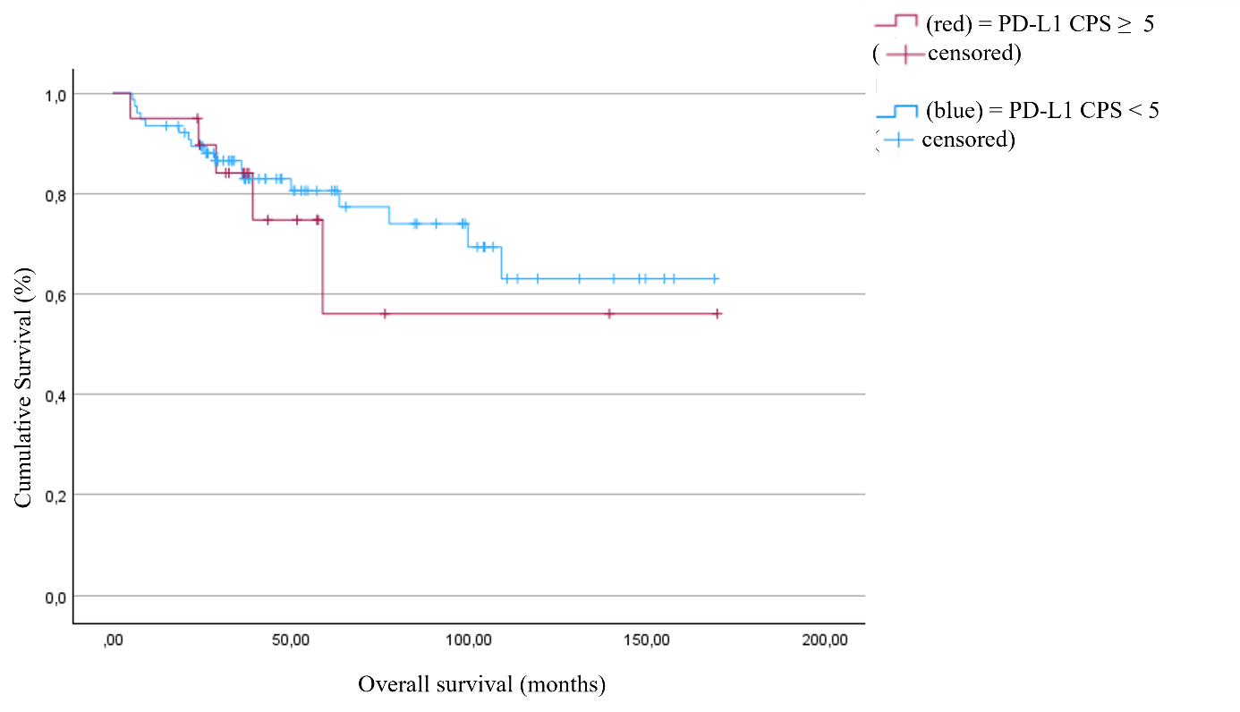
Fig. S8. Overall survival as a function of PD-L1 positivity, defined as CPS ≥ 5 (p = 0.609).
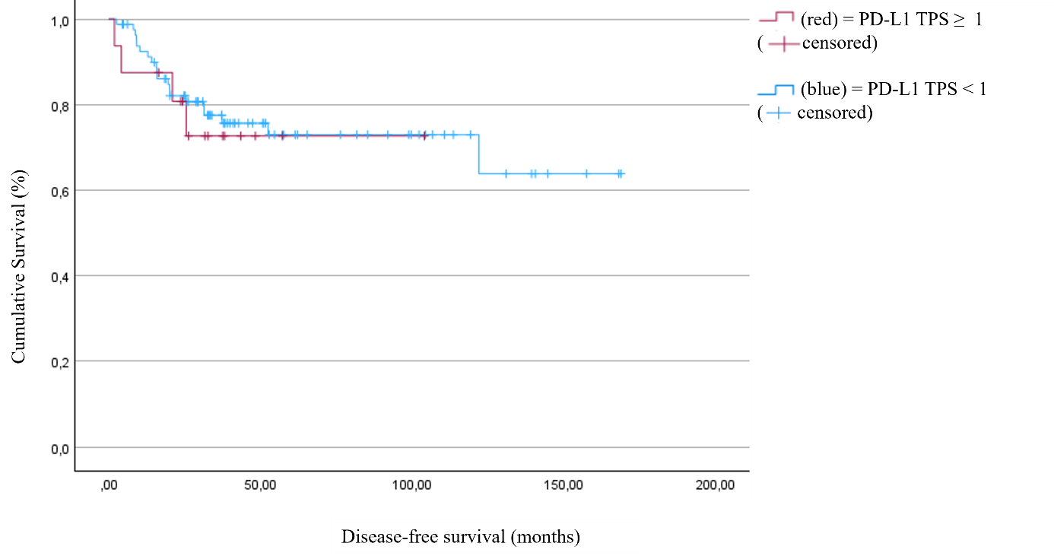
Fig. S9. Disease-free survival as a function of PD-L1 positivity, defined as TPS ≥ 1 (p = 0.780).
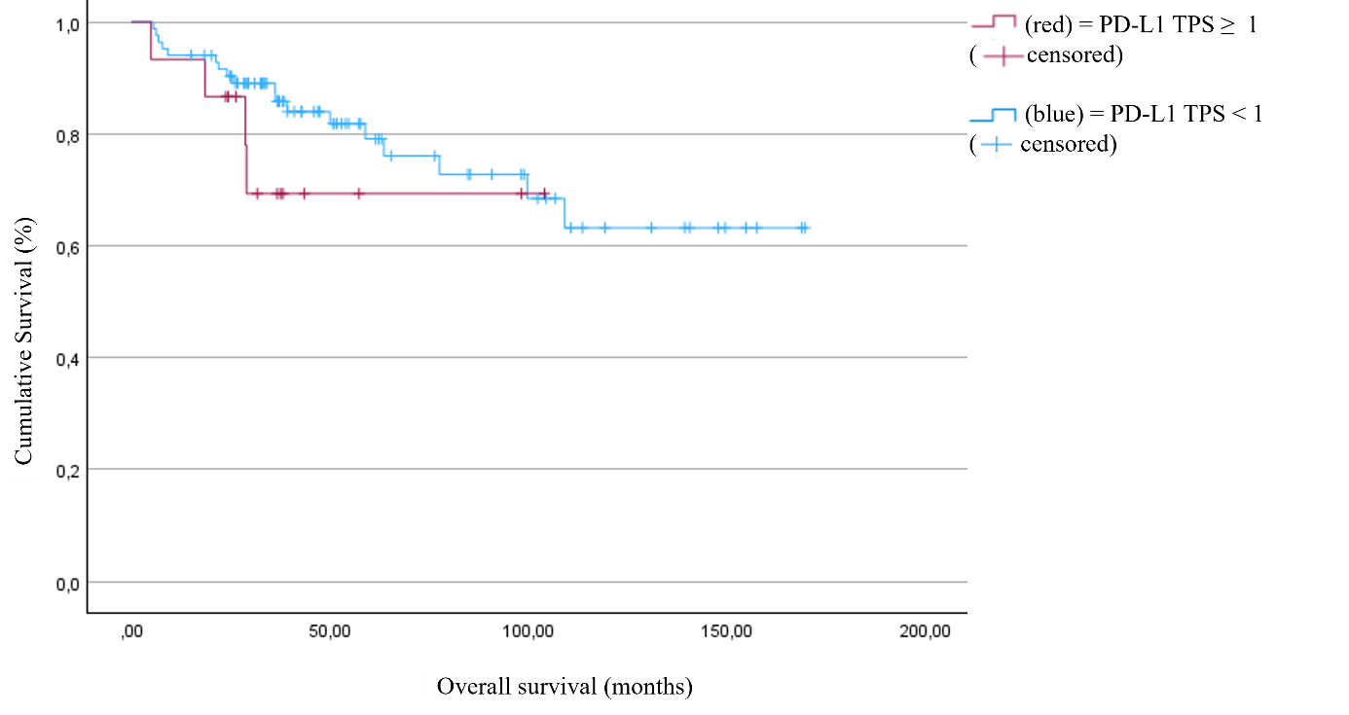
Fig. S10. Overall survival as a function of PD-L1 positivity, defined as TPS ≥ 1 (p = 0.310).

