Waterborne Polyurethane Modified with the Hydroxy Silicone Oils for Improving its Thermal, Water Resistance, and Mechanical Properties

Chao Liu¹, Yujie Wang¹, Wenli Li¹, Yingchun Luo¹, Wei Yan², Guoyong Zhou^{1,*}
¹School of Chemical Engineering, Guizhou Minzu University, Guiyang 550025, PR China
²School of Materials Science and Engineering, Guiyang University, Guiyang 550005, PR China
Table S1 Performance characterization of waterborne polyurethane emulsion
Sample | Particle size（nm） | PDI | Viscosity (mPas) | Mechanical stability
1% (Mn = 3000) | 61.97 | 0.087 | 23.2 | *
5% (Mn = 3000) | 69.40 | 0.094 | 25.5 | *
9% (Mn = 3000) | 82.53 | 0.148 | 28.7 | *
13% (Mn = 3000) | 87.62 | 0.106 | 31.4 | *
17% (Mn = 3000) | 92.37 | 0.135 | 37.2 | *
1% (Mn = 10000) | 73.82 | 0.089 | 23.7 | *
5% (Mn = 10000) | 82.09 | 0.159 | 26.5 | *
9% (Mn = 10000) | 87.94 | 0.820 | 31.3 | *
13% (Mn = 10000) | 94.35 | 0.190 | 33.4 | *
17% (Mn = 10000) | 97.44 | 0.141 | 36.8 | *
1% (Mn = 25000) | 75.14 | 0.078 | 25.5 | *
5% (Mn = 25000) | 82.67 | 0.093 | 29.6 | *
9% (Mn = 25000) | 91.70 | 0.016 | 35.7 | *
13% (Mn = 25000) | 96.16 | 0.046 | 45.0 | *
17% (Mn = 25000) | 103.27 | 0.138 | 47.6 | *
Ps: The molecular weight of the hydroxy silicone oil added to the modification is in parentheses，* indicates that emulsion stable (>6 months).
Fig. S1 Morphology and particle size of Si-WPU emulsion
Fig. S2 Si 2p spectrum of Si-WPU (3000、10000、25000) surface (b)、(d)、(f)
Table S2 Elemental composition of film surface
sample | mole fraction %
sample | C | N | O | Si（actual） | Si（theory）
1% (Mn=3000) | 56.71 | 1.18 | 23.37 | 18.73 | 0.32
5% (Mn=3000) | 62.46 | 1.13 | 23.15 | 13.26 | 1.61
9% (Mn=3000) | 66.61 | 0.79 | 22.78 | 9.82 | 2.88
13% (Mn=3000) | 57.48 | 0.85 | 24.15 | 17.50 | 4.17
17% (Mn=3000) | 53.14 | 0.72 | 23.84 | 22.29 | 5.44
1% (Mn=10000) | 52.77 | 1.35 | 25.08 | 20.78 | 0.53
5% (Mn=10000) | 69.98 | 1.57 | 19.47 | 8.96 | 1.59
9% (Mn=10000) | 52.17 | 1.32 | 25.04 | 21.47 | 4.76
13% (Mn=10000) | 51.73 | 0.94 | 24.69 | 22.63 | 6.89
17% (Mn=10000) | 55.21 | 0.61 | 25.17 | 19.01 | 8.26
1% (Mn=25000) | 60.24 | 1.58 | 23.16 | 15.02 | 0.67
5% (Mn=25000) | 52.82 | 1.27 | 23.73 | 22.17 | 3.35
9% (Mn=25000) | 51.60 | 0.74 | 24.94 | 22.71 | 6.02
13% (Mn=25000) | 61.79 | 0.83 | 21.45 | 15.91 | 7.71
17% (Mn=25000) | 50.59 | 0.66 | 25.00 | 23.75 | 8.79

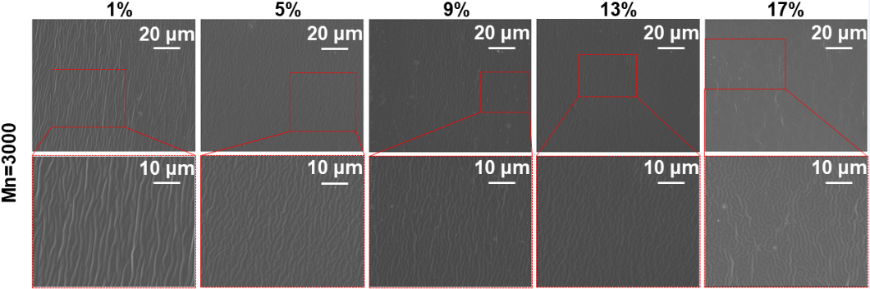
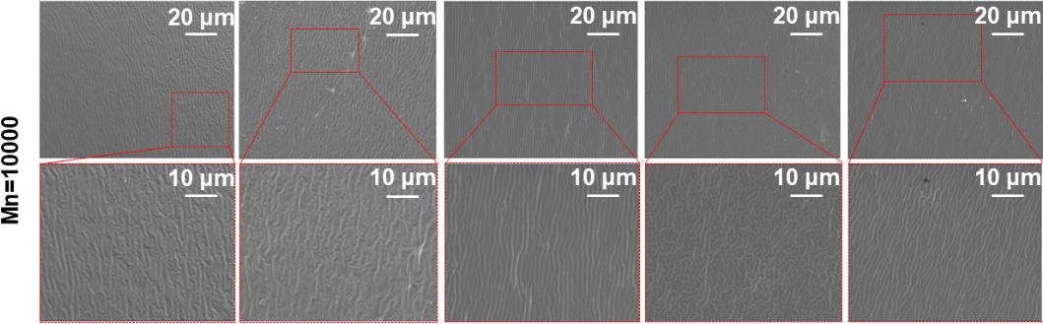
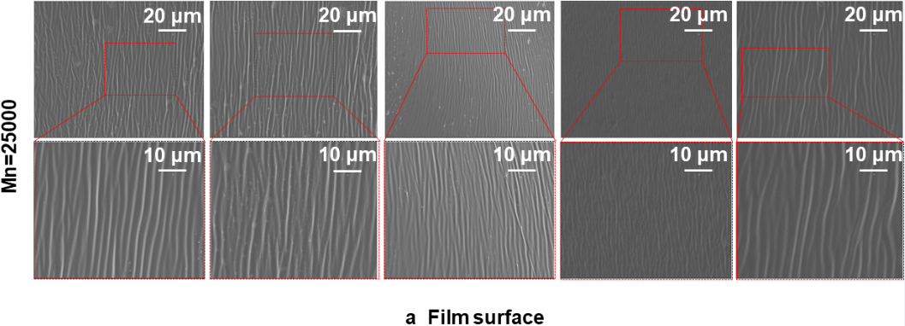
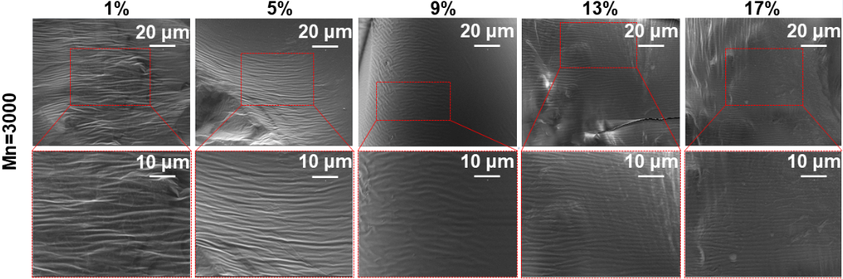
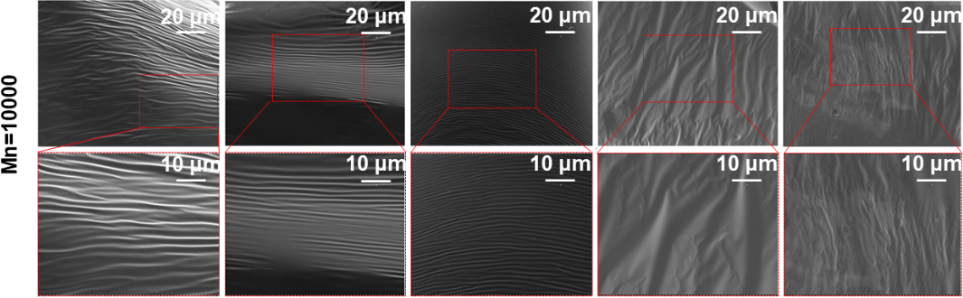
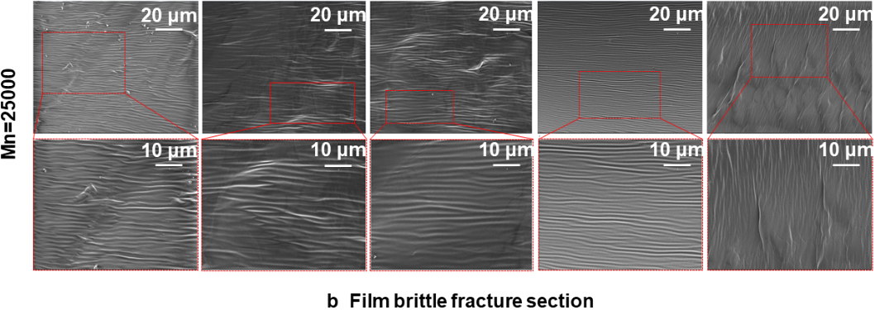
Fig. S3 SEM images of the fracture surfaces of the WPU film surface (a),
the WPU film brittle fracture section (b)

* Corresponding authors. E-mail address: gyzhou@gzmu.edu.cn.

