Supporting Information
Organic-inorganic Hybrid Covalent Superlattice for Temperature Compensated Ratiometric Gas Sensing
Ke-Feng Li^{1,2}, Chen-Hui Yu¹, Guang-Ling Liang¹, Jie Chen¹, Yu Chang¹, Gang Xu^{1,3*}, Guan-E Wang^{1*}
¹ State Key Laboratory of Structural Chemistry, Fujian Institute of Research on the Structure of Matter, Chinese Academy of Sciences, Fuzhou 350002, P.R. China
² College of Chemistry and Materials Science, Fujian Normal University, 32 Shangsan Road, Fuzhou 350007, P. R. China
³ Fujian Science & Technology Innovation Laboratory for Optoelectronic Information of China, Fuzhou, Fujian 350108, P. R. China
Correspondence and requests for materials should be addressed to Gang Xu and Guan-E Wang.
(email: gxu@fjirsm.ac.cn) (email: gewang@fjirsm.ac.cn)

Table of Contents
Supplementary Experimental Procedures 3
Figure S1. The SEM image of AgBDT nanosheets. 5
Figure S2. The TEM image of AgBDT nanosheets (a) and projections of reconstructed 3D reciprocal lattice viewed along the c-axis (b) b-axis (c) and a-axis (d) respectively. 6
Figure S3. EDS images of AgBDT nanosheets. 7
Figure S4. Band structure diagram of AgBDT. 8
Figure S5. High symmetric path for the DFT calculation of AgBDT . 9
Figure S6. The valence band maximum (a) and conduction band minimum (b) of AgBDT. 9
Figure S7. Four consecutive cycles for detecting 10 ppm NO₂ at room temperature. 10
Figure S8. Long-term stability of AgBDT to 10 ppm NO₂ within 20 days (inset curves are the real-time measurement). 10
Figure S9. Time-resolved in-situ DRIFTS difference spectra of AgBDT during oxidation. 11
Figure S10. Relative response of AgBDT sensor to 100 ppb NO₂ after oxidation for different time. 11
Figure S11. TG curve of AgBDT. 12
Figure S12. Calculated and measured (with ICP-AES and EA) elemental mass percentage of AgBDT. 12
Figure S13. Diagram of the homemade gas sensing test system 13
Table S1. Crystallographic data for AgBDT. 14
Table S2. Sensing performance of the no-light irradiation material-based RT chemiresistive NO₂ sensors 15
Table S3. Vibrational assignments of AgBDT DRIFT spectrum during oxidation time. 16
Table S4. Optoelectronic performance of AgBDT-based photodetector compared with other reported Coordination polymers (CPs) 17
References 18

Supplementary Experimental Procedures

Time-resolved in-situ DRIFTS spectra collection
DRIFTS spectra were collected on a Nicolet 6700 FT-IR spectrometer with MCT/A detector cooled by liquid nitrogen. The spectra were displayed in absorbance units and acquired with a resolution of 4 cm⁻¹, using 128 scans. To monitor the real test condition, all the spectra were collected under synthetic air (79% nitrogen, 21% oxygen). Data collection was performed on OMNIC software.
The KBr was heated to 100 °C under a stream of high-purity Ar for 2 h, after which the reaction cell was cooled to room temperature and purged with dry synthetic air. After that, a raw absorbance spectrum was collected as background. The AgBDT sample was processed with the same procedure and the raw spectrum was also collected after that. The sample spectrum was then subtracted by taking the KBr spectrum as background. All spectra were obtained from 650 to 4000 cm⁻¹.
The powder of AgBDT nanosheets was heated to 100 °C under the high-purity Ar flow at a rate of 200 mL/min for 2 h. Then a spectrum of the pristine sample was collected using the aforementioned KBr background. Then under the lifted temperature synthetic air was introduced at a rate of 100 mL/min. Difference spectra were collected every 15 min continuously for 150 min. All spectra were obtained by 128 scans with a resolution of 4 cm⁻¹ from 650 to 4000 cm⁻¹.
DFT calculation
DFT calculations within Cambridge Serial Total Energy Package (CASTEP) module implemented in the Materials Studio package were performed for the electronic band structure of AgBDT. The Generalized Gradient Approximation (GGA) functional with the Perdew-Burke-Ernzerh (PBE) of functional was selected to describe the exchange-correlation interaction. The interactions between the ionic cores and the electrons are described by the norm-conserving pseudopotential, in which the orbital electrons of Ag: 4s²4p⁶4d¹⁰5s¹, S: 3s²3p^{4,} C: 2s²2p² and H: 1s¹ are treated as valence electrons. The primitive lattice was used and the numerical integration of its Brillouin zone was performed utilizing a Monkhorst-Pack mesh of 3×3×4 k-points. A plane-wave cutoff energy of 517 eV was used. The band structure and density of states (DOS) calculations were performed with a plane-wave basis set and OTFG ultrasoft pseudopotential. A Monkhorst-Pack grid of 108×36×225 k-points and 3×3×4 k-points were used for band structure and DOS calculation, respectively. The Fermi level (Ef = 0 eV) was chosen as the reference. The geometrically optimized energy convergence tolerance was 9.4 × 10⁻³ eV/ Å, the maximum force was 2.0 eV/Å, and the maximum displacement was 3.4 × 10⁻² Å. For static electronic structure calculations, the self-consistent field (SCF) tolerance was set to 2 × 10⁻⁶ eV/atom to give us good accuracy in the total energy obtained.
HOMO and LUMO of AgBDT were performed using the Dmol³ code of the Materials Studio package, and the Perdew-Burke-Ernzerhof (PBE) within the generalized gradient approximation (GGA) was used in the module for geometry optimization. The 1 × 1 × 1 cell was built to perform all calculations, consisting of 12 C, 8 H, and 4 Ag/S atoms. 1 × 4 × 1 k-point lattices were sampled for optimization using double numerical atomic orbits enhanced by d-polarization functions (DNP basis sets).
Supporting Figures

Figure S1. SEM image of AgBDT nanosheets.

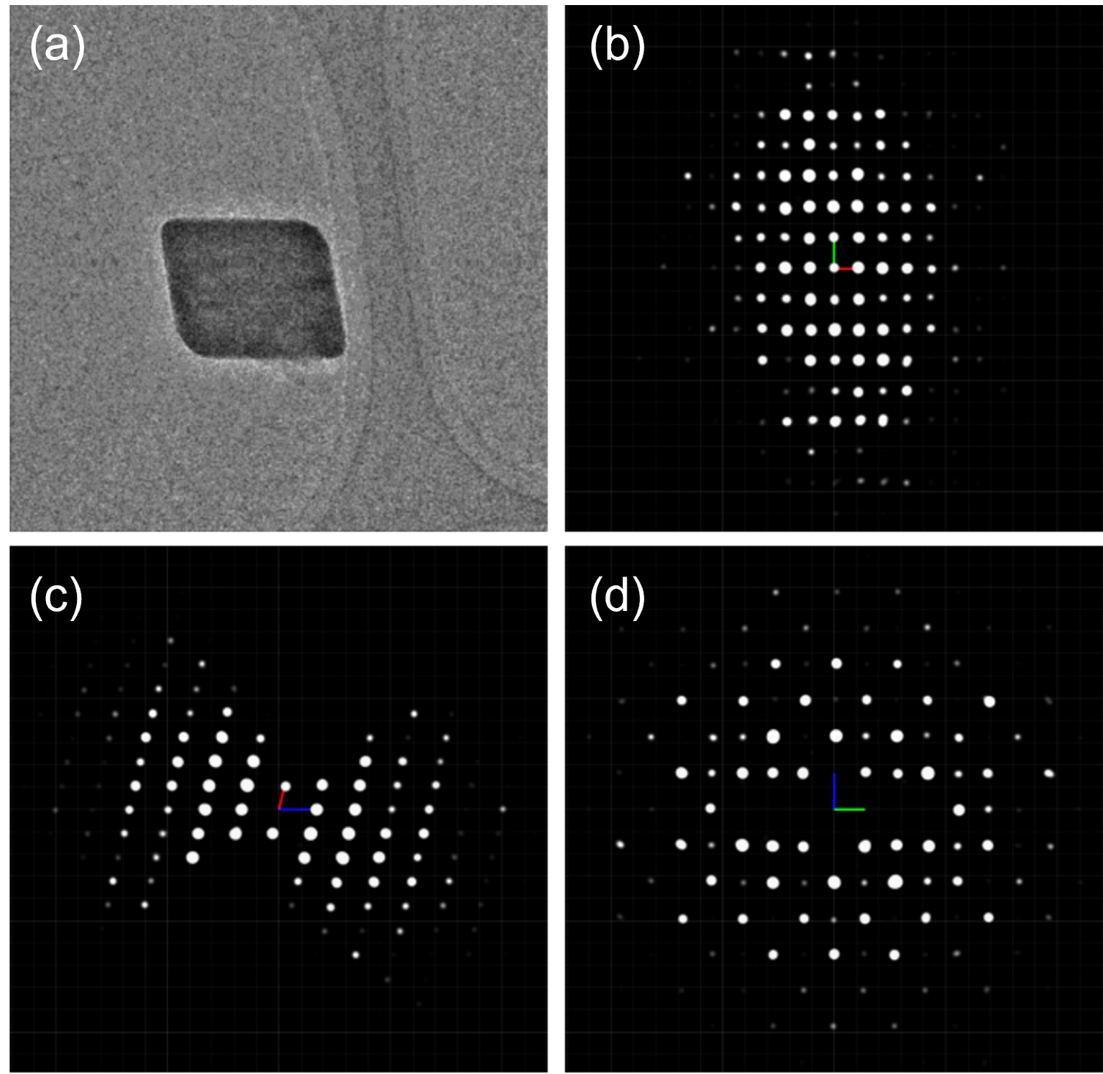

Figure S2. TEM image of AgBDT nanosheets (a) and projections of reconstructed 3D reciprocal lattice viewed along the c-axis (b) b-axis (c) and a-axis (d) respectively. The space group could be assigned P2₁/c.

Figure S3. EDS images of AgBDT nanosheets.

Figure S4. Band structure diagram of AgBDT.

Figure S5. High symmetric path for the DFT calculation of AgBDT (the right figure represents the unit cell in real space).

Figure S6. The valence band maximum (a) and conduction band minimum (b) of AgBDT.

Figure S7. Four consecutive cycles for detecting 10 ppm NO₂ at room temperature.

Figure S8. Long-term stability of AgBDT to 10 ppm NO₂ within 20 days (inset curves are the real-time measurement).

Figure S9. Time-resolved in-situ DRIFTS difference spectra of AgBDT during oxidation.

Figure S10. Relative response of AgBDT sensor to 100 ppb NO₂ after oxidation for different time.

Figure S11. TG curve of AgBDT.

Figure S12. Calculated and measured (with ICP-AES and EA) elemental mass percentage of AgBDT.

Figure S13. Diagram of the homemade gas sensing test system

Table S1. Crystallographic data for AgBDT.
Chemical formula | C₁₂H₈Ag₄S₄
Formula weight | 711.88
Temperature | 15 K
Crystal system | Monoclinic
Space group | P2₁/c
Cell parameters | a = 9.10 Å, b = 7.17 Å, c = 6.07 Å  α = 90°, β = 104.02°, γ = 90°
Cell volume | 392.5 Å³
ρ_{calc} | 9.907 g cm⁻³
F (000) | 211.8
Z | 1
Data reduction | XDS (merged from 3 datasets)
Index ranges | –12 ≤ h ≤ 12, –10 ≤ k ≤ 10, –8 ≤ l ≤ 8
Reflections collected | 7504
Independent reflections | 1038
Completeness | 87.6% (to 0.70 Å)
Solution method | Superflip
Refinement method | Full-matrix least-square on F² in Jana2020
GOF on F² | 1.463
Final R indexes [I>=2σ (I)] | R₁ = 0.1783, wR₂ = 0.4918
Final R indexes [all data] | R₁ = 0.2154, wR₂ = 0.4918
aR1 = Σ ||F0 |–|Fc|| / Σ |F0 |; bwR2 = [Σw(F02–Fc2)2 / Σw(F02)2]1/2

Table S2. Sensing performance of the no-light irradiation material-based RT chemiresistive NO₂ sensors
Material | LOD | Response | t_{res.} | Ref. in main text
Te Nanofibers | 100 ppb | 10 ppm / 6.2% | 84 s @ 10 ppm | 41
LaFeO₃ nanocubes | 317 ppb | 1 ppm / 29.6% | 24 s @ 1 ppm | 42
SnO-SnO₂ | 100 ppb | 100 ppb / 160% | 57 s @ 100 ppb | 43
BP-In₂O₃ | 10 ppb | 100 ppb / 1220% | 130 s @ 5 ppm | 44
MnPS₃ | 50 ppb | 2 ppm / 8% | 96 s @ 2 ppm | 45
WS₂/ZnS | 10 ppb | 5 ppm / 3250% | 4 s @ 5 ppm | 46
MoS₂ film | 120 ppb | 0.5 ppm / 57.5% | 54 s @ 0.5 ppm | 47
Vc-reduced GO | 400 ppt | 10 ppm / 6% | 120 s @ 10 ppm | 48
Cu₂O-rGO | 64 ppb | 2 ppm / 89% | 200 s @ 2 ppm | 49
In(OH)₃-rGO | 1 ppm | 1 ppm / 19.79% | ＜ 180 s @ 5 ppm | 50
Ag(SPh-NH₂) | 0.9 ppb | 10 ppm / 852.6% | 60 s @ 10 ppm | 40
PbBDT | 0.509 ppb | 400 ppb / 5056% | 16.2 s @ 40 ppb | 36
AgBDT | 0.22 ppb | 10 ppm / 5977% | 9.6 s @ 10 ppm | This work

.

Table S3. Vibrational assignments of AgBDT DRIFT spectrum during oxidation time.
Wavenumber (cm⁻¹) | Bond | Reference
833 | ν(S–O(H)) in Ar–SO₂H | 1
900 | ν(S–O(H)) in Ar–SO₃H | 1
951 | ν(S=O) in sulfoxide | 2
993 | ν(S–O) in sulfoxide and sulfone | 3,4
1030 | ν(S–O)sym. in aromatic sulfinates | 1
1072 | ν(S=O) in Ar–SO₂H | 1
1153 | ν(–SO₂–) in sulfone and Ar–SO₃H | 1,3–5
1201 | ν(S–O)asym. in aromatic sulfonates | 1,6

Table S4. Optoelectronic performance of AgBDT-based photodetector compared with other reported Coordination polymers (CPs)

Material | On/Off ratio | Conductivity (RT) | Ref. in main text
Ni-HITP | 0.03 | 7.23 S cm⁻¹ | 51
CdATP | 18.20 | 7.90 ×10⁻¹¹ S cm⁻¹ | 52
[Cd(adc)₂(rctt-4-pncb)]_{n} | 33.12 | 3.91 × 10⁻³ S m⁻¹ | 53
CuHITP | 0.02 | 1.58 × 10³ S cm⁻¹ | 51
CuTCNQ | 0.03 | 0.20 S cm⁻¹ | 51
CuCAT | 0.07 | / | 51
Cu[Cu(pdt)₂] | 0.12 | 1.4 × 10⁻⁴ S cm⁻¹ | 51
CuBHT | 10 | 1580 S cm⁻¹ | 54
[Cu(muco)(3,5-dcp)]_{n} | 14.96 | 6.02 × 10⁻³ S m⁻¹ | 55
Im@CuBTC | 826 | 1.04 × 10⁻⁴ S cm⁻¹ | 56
{Ag(C₅H₄NS)}_{n} | 0.1 | / | 51
PhSeAg | 814 | 2.93 × 10⁻¹¹ S cm⁻¹¹ | 51
AgBDT | 1770 | 1.32 × 10⁻¹⁰ S cm⁻¹⁰ | This work

References

1. Lindberg, B. J. Studies on Sulfinic acids. VI. The IR-spectra of aromatic sodium sulfinates and sulfonates. Acta Chemica Scandinavica 21, 2215-2234 (1967).
2. Cotton, F. A.; Francis, R.; Horrocks, W. D. Sulfoxides as ligands. II. The infrared spectra of some dimethyl sulfoxide complexes. J. Phys. Chem. 64, 1534–1536 (1960).
3. Drago, R. S.; Meek, D. The infrared spectra of some dimethyl sulfoxide complexes. J. Phys. Chem. 65, 1446–1447 (1961).
4. Amstutz, E. D.; Hunsberger, I. M.; Chessick, J. J. Studies in the sulfone series. VIII. Infrared absorption spectra and structure of some substituted diphenyl sulfones and sulfoxides. J. Am. Chem. Soc. 73, 1220–1224 (1951).
5. Schreiber, K. C. Infrared spectra of sulfones and related compounds. Anal. Chem. 21, 1168–1172 (1949).
6. Schoenfisch, M. H.; Pemberton, J. E. Air stability of alkanethiol self-assembled monolayers on silver and gold surfaces. J. Am. Chem. Soc. 120, 4502–4513 (1998).

