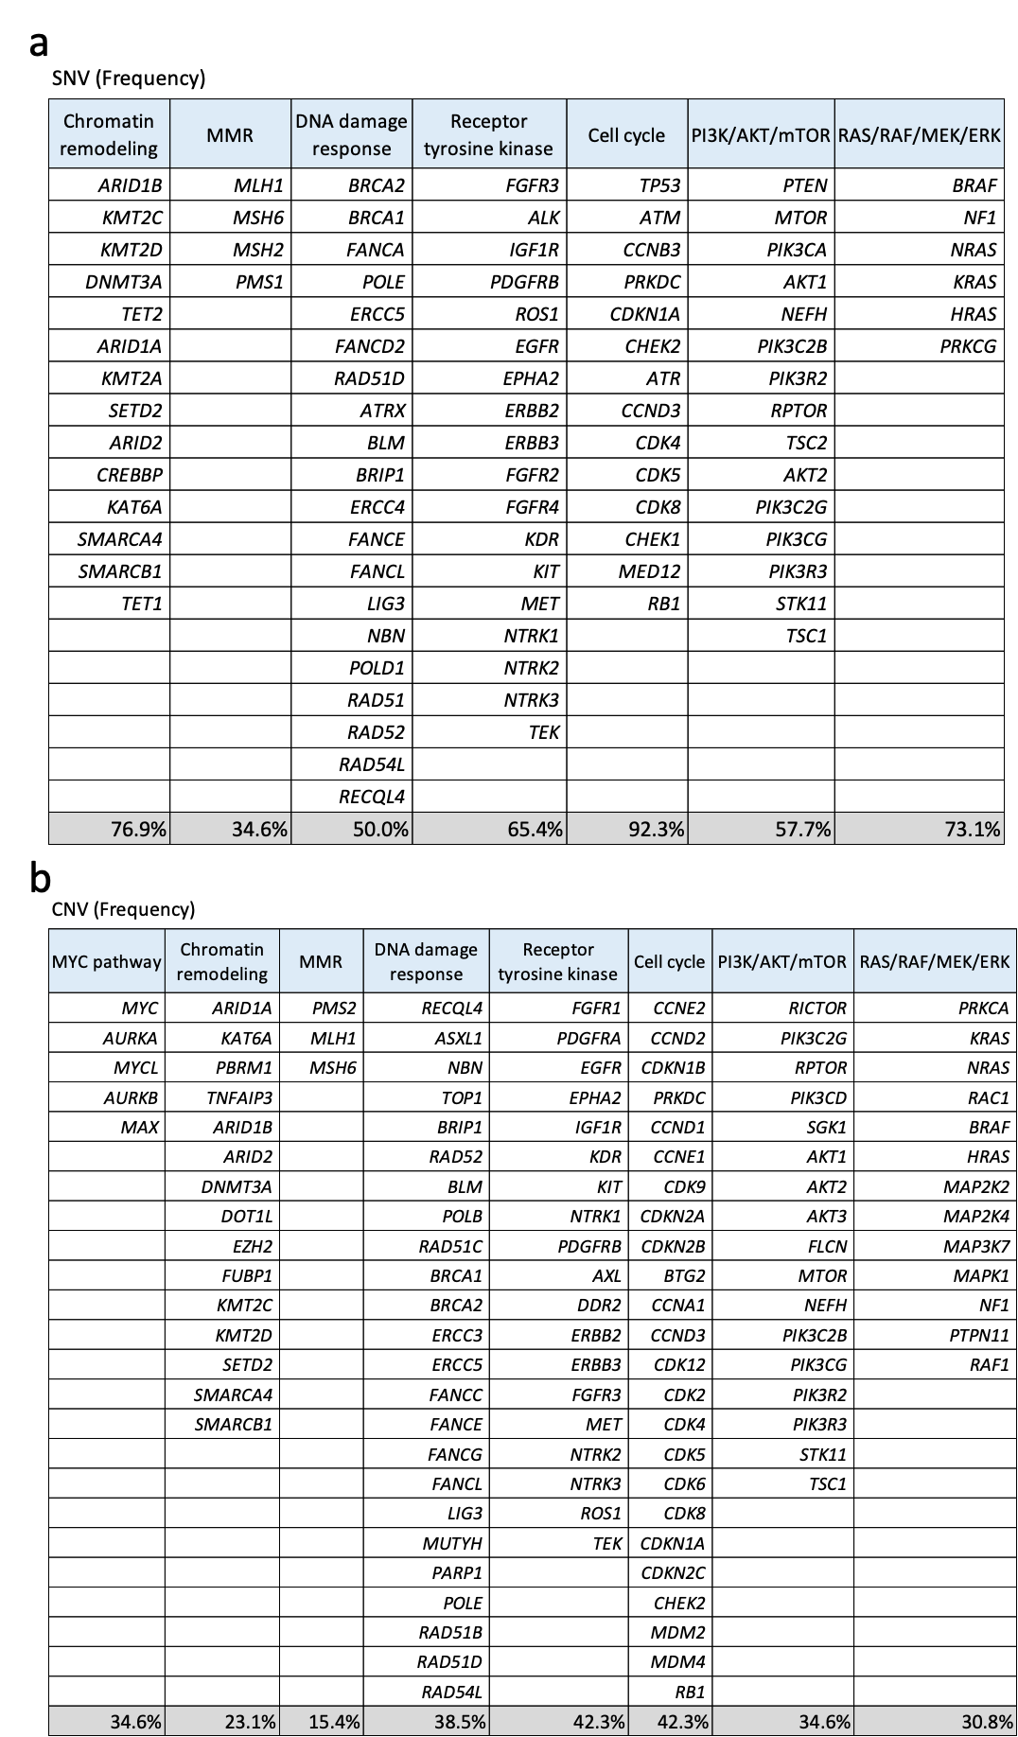
Supplementary Figure 1. The pathways and the genes associated with them, affected by both single nucleotide variants (SNV)(a) and copy number variations (CNV)(b).
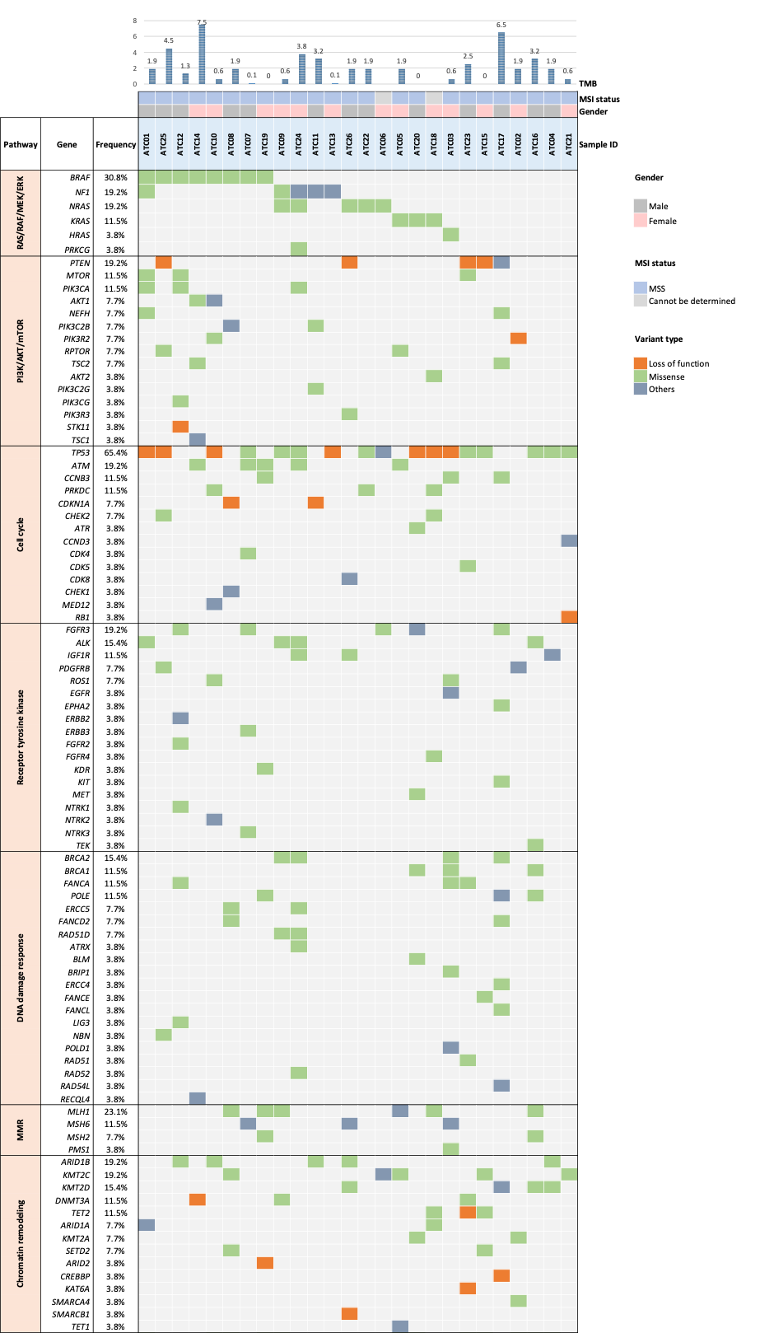
Supplementary Figure 2. Overview of genomic alterations, including single nucleotide variants (SNV) and small insertions and deletions, identified in the tissue NGS of 26 patients with ATC.
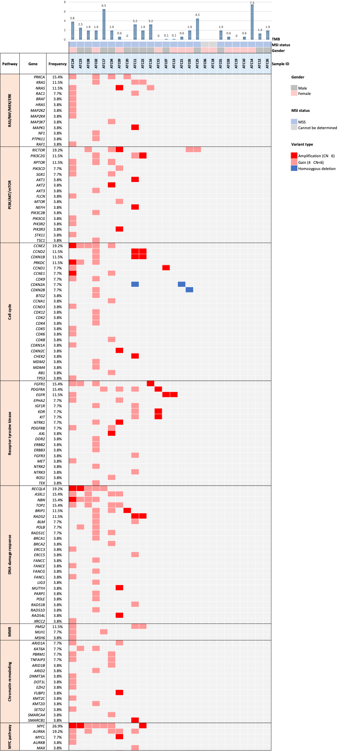
Supplementary Figure 3. Overview of genomic alterations, particularly copy number variations (CNV), identified in the NGS of 26 patients with ATC.

