Linalool essential oil/nanocellulose-based Pickering emulsions: an in-depth investigation of processing parameters
Alana Gabrieli de Souza¹, Jéssica de Souza Marciano¹, Rafaela Reis Ferreira¹, Eder Ramin de Oliveira¹, and Derval dos Santos Rosa¹*

¹ Centro de Engenharia, Modelagem e Ciências Sociais Aplicadas – CECS/ Universidade Federal do ABC (UFABC) – Santo André, SP, Brazil (Avenida dos Estados, 5001; CEP: 09210-580).
*dervalrosa@yahoo.com.br

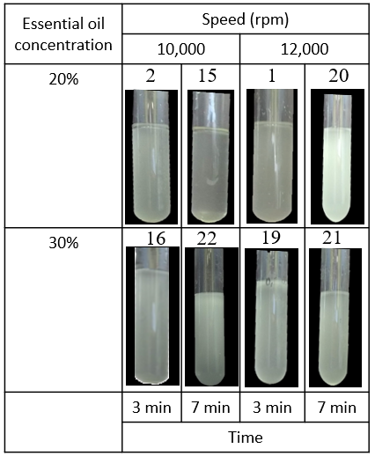
Figure 1S. Digital photographs obtained for oil/water mixtures, in the different process parameters, without stabilizers.

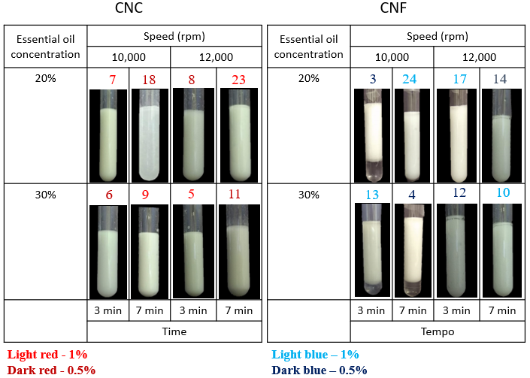
Figure 2S. Digital photographs obtained for oil/water emulsions in the different process parameters stabilized by CNC or CNF.

Samples 3 (0.5% CNF, 10,000 rpm, 20% oil, 3 minutes), 4 (0.5% CNF, 10,000 rpm, 30% oil, 7 minutes) and 13 (1% CNF, 10,000 rpm, 30% oil, 3 minutes) presented phase separation already on the first day, i.e., a fraction of oil and water were not adequately mixed, generating visible separation. Since the separate fraction was observed at the bottom of the test tubes, referring to water, and there was no visually separated oil, possibly for such preparation conditions, higher concentrations of linalool essential oil could have been used. Samples 12 (0.5% CNF, 12,000 rpm, 30 % oil, 3 minutes) and 14 (0.5% CNF, 12,000 rpm, 20% oil, 7 minutes) presented a thin film of essential oil at the top of the test tubes, indicating that, under the process conditions adopted, there was an excess of essential oil, since there was no excess water either.

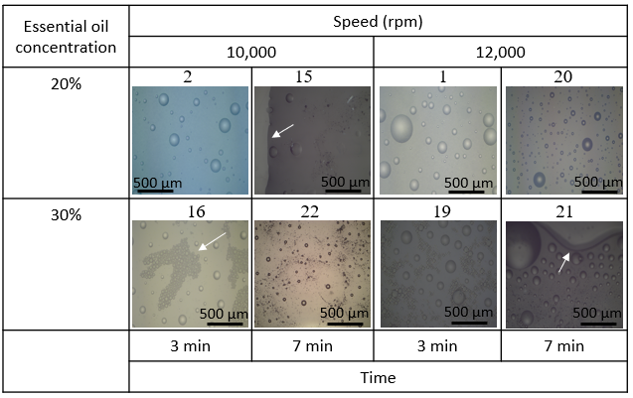
Figure 3S. Representative photomicrographs obtained by optical microscopy for linalool and water mixtures without stabilizer.
In Figure 3S, the white arrows indicate the distinct phases and the tendency of rapid separation. Although some drops are well defined, this property is characteristic of the oily phase and does not indicate a stable mixture. Since this system does not have a surfactant or solid phase, it cannot be considered an emulsion, not having relevant characteristics since it consists of linalool essential oil or water properties, depending on the phase used for the study. According to Lu and collaborators, O/W systems present phase separation visible to the naked eye due to the coalescence of oil domains and the continuous breakdown of smaller particles and their fusion into larger particles.

