Supplementary Information

White-Light-Excited Organic Room-Temperature Phosphorescence for Improved In Vivo Bioimaging

Lutong Zhang^{1‡}, Jisen Li^{2‡}, Yifan Zhang¹, Wenbo Dai^{1,3}*, Yufan Zhang², Xue Gao¹, Miaochang Liu¹, Huayue Wu¹, Xiaobo Huang¹, Yunxiang Lei^{1,3}*, and Dan Ding²*

¹ School of Chemistry and Materials Engineering, Wenzhou University, Wenzhou 325035, P. R. China
² State Key Laboratory of Medicinal Chemical Biology, Key Laboratory of Bioactive Materials, Ministry of Education, and College of Life Sciences, Nankai University, Tianjin 300071, China.
³ Key Lab of Biohealth Materials and Chemistry of Wenzhou, Wenzhou 325035, P. R. China
E-mail: wbdai@wzu.edu.cn (W. Dai); yunxianglei@wzu.edu.cn (Y. Lei); dingd@nankai.edu.cn (D. Ding)
‡ These authors contributed equally.

Supplementary Methods and Instrumentation
¹H, ¹³C and ¹⁹FNMR spectra were carried out by a Bruker ARX500 spectrometer with CDCl₃ as the solvent. UV-vis absorption spectra were measured by a Persee TU-1901 spectroscopy. Fluorescence spectra were measured by a Hitachi F-7000 spectrophotometer. Phosphorescence spectra were measured by a FLS920 lifetime and steady state spectrometer. X-Ray crystal structure analyses were conducted on a Bruker-AXS SMART APEX2 CCD diffractometer. Solid-state emission quantum yields were collected on a FluoroMax-4 (Horiba Jobin Yvon) fluorimeter equipped with integrated sphere. The Pluronic® F127, PEG20000, gelatin and tannic acid were purchased from Aladdin Reagent Ltd. Milli-Q water was supplied by Milli-Q Plus System (Millipore Corporation, Breford, USA). The observation of nanoparticle morphology was investigated using transmission electron microscopy (TEM, JEM-2010FJEOL, Japan). Size distribution of nanoparticles was conducted on dynamic light scattering (DLS) with a particle size analyzer (90 Plus, Brookhaven Instruments Co. USA) at a fixed angle of 90o at room temperature. Afterglow images were acquired using the Xenogen IVIS® Lumina II system under bioluminescence mode.

4-(4,6-diphenyl-1,3,5-triazin-2-yl)-N,N-diphenylaniline (TRZ-1). Green solid (771 mg, 81% yield). ¹H NMR (400 MHz, CDCl3) δ: 8.77 (d, J = 6.8 Hz, 4H), 8.63 (d, J = 8.8 Hz, 2H), 7.63-7.55 (m, 6H), 7.36 (t, J = 7.6 Hz, 4H), 7.23-7.13 (m, 8H) ppm. ¹³C NMR (100 MHz, CDCl3) δ: 171.3, 171.0, 151.8, 146.8, 136.4, 132.3, 130.2, 129.5, 128.8, 128.7, 128.5, 125.6, 124.2, 120.9 ppm. HRMS (ESI) m/z: [M+H]⁺ calculated for C₃₃H₂₅N₄, 477.20737; found, 477.20676.

N-(4-(4,6-diphenyl-1,3,5-triazin-2-yl)phenyl)-N-phenylnaphthalen-1-amine (TRZ-2). White solid (758 mg 72% yield). ¹H NMR (400 MHz, CDCl₃) δ: 8.74 (d, J = 6.8 Hz, 4H), 8.59 (d, J = 8.8 Hz, 2H), 7.96 (t, J = 8.8 Hz 2H), 7.86 (d, J = 8.8 Hz, 1H), 7.60-7.47 (m, 8H), 7.43-7.37 (m, 2H) 7.32-7.24 (m, 4H) 7.10-7.04 (m, 3H) ppm. ¹³C NMR (100 MHz, CDCl₃) δ: 171.2, 171.1, 152.3, 147.1, 136.4, 135.3, 132.2, 131.1, 130.3, 129.4, 128.8, 128.5, 127.9, 127.5, 127.2, 126.7, 126.4, 126.3, 124.0, 123.9, 123.6, 119.0 ppm. HRMS (ESI) m/z: [M+H]⁺ calculated for C₃₇H₂₇N₄, 527.22302; found, 527.22161.

N-(4-(4,6-diphenyl-1,3,5-triazin-2-yl)phenyl)-N-(naphthalen-2-yl)naphthalen-2-amine (TRZ-3). Yellow solid (749 mg 65% yield). ¹H NMR (400 MHz, CDCl₃) δ: 8.78 (d, J = 7.2 Hz, 4H), 8.68 (d, J = 8.4 Hz, 2H), 7.84 (d, J = 8.8 Hz 4H), 7.67-7.57 (m, 10H), 7.48-7.41 (m, 6H), 7.32 (d, J = 8.4 Hz, 2H) ppm. ¹³C NMR (100 MHz, CDCl₃) δ: 171.4, 171.1, 151.7, 144.5, 136.4, 134.3, 132.3, 130.8, 130.3, 129.5, 129.3, 128.9, 128.6, 127.7, 127.2, 126.5, 125.2, 125.1, 122.4, 121.8 ppm. HRMS (ESI) m/z: [M+H]⁺ calculated for C₄₁H₂₉N₄, 577.23867; found, 577.23720.

4-(4,6-diphenyl-1,3,5-triazin-2-yl)-N,N-diphenylnaphthalen-1-amine (TRZ-4). Green solid (726 mg 69% yield). ¹H NMR (400 MHz, CDCl₃) δ: 9.21 (d, J = 8.8 Hz, 1H), 8.79-8.77 (m, 4H), 8.52 (d, J = 7.6 Hz 1H), 8.10 (d, J = 8.4 Hz 1H), 7.64-7.55 (m, 7H), 7.45-7.39 (m, 2H), 7.25-7.21 (m, 4H), 7.10 (d, J = 7.6 Hz, 4H), 7.00 (t, J = 7.2 Hz, 2H) ppm. ¹³C NMR (100 MHz, CDCl₃) δ: 174.1, 171.5, 148.4, 147.6, 136.1, 133.3, 132.6, 131.6, 131.4, 131.3, 129.2, 129.0, 128.7, 127.4, 126.6, 126.4, 126.0, 125.0, 122.6, 122.3 ppm. HRMS (ESI) m/z: [M+H]⁺ calculated for C₃₇H₂₇N₄, 527.22302; found, 527.22327.

4-(4,6-diphenyl-1,3,5-triazin-2-yl)-N-(naphthalen-1-yl)-N-phenylnaphthalen-1-amine (TRZ-5). Green solid (715 mg 62% yield). ¹H NMR (400 MHz, CDCl₃) δ: 9.29 (d, J = 8.4 Hz, 1H), 8.80 (d, J = 6.8 Hz, 4H), 8.46 (d, J = 8.0 Hz 1H), 8.25 (d, J = 8.8 Hz 1H), 8.11 (d, J = 8.4 Hz 1H), 7.92 (d, J = 8.0 Hz 1H), 7.76 (d, J = 8.4 Hz 1H), 7.65-7.57 (m, 7H), 7.50 (t, J = 8.0 Hz, 1H), 7.43-7.36 (m, 4H), 7.29 (d, J = 7.2 Hz 1H), 7.21 (t, J = 8.0 Hz, 2H), 6.99 (t, J = 7.2 Hz, 1H), 6.89 (d, J = 8.0 Hz, 2H) ppm. ¹³C NMR (100 MHz, CDCl₃) δ: 174.1, 171.5, 150.4, 148.9, 144.9, 136.2, 135.3, 133.3, 132.7, 131.5, 130.8, 130.2, 129.2, 129.1, 128.8, 128.6, 127.3, 126.7, 126.5, 126.3, 126.2, 126.1, 126.0, 125.4, 125.2, 124.3, 123.6, 121.7 ppm. HRMS (ESI) m/z: [M+H]⁺ calculated for C₄₁H₂₉N₄, 577.23867; found, 577.23752.
4-(4,6-diphenyl-1,3,5-triazin-2-yl)-N,N-di(naphthalen-2-yl)naphthalen-1-amine (TRZ-6). Yellow solid (701 mg 56% yield). ¹H NMR (400 MHz, CDCl₃) δ: 9.27 (d, J = 8.4 Hz, 1H), 8.84 (d, J = 6.8 Hz, 4H), 8.57 (d, J = 7.6 Hz 1H), 8.21 (d, J = 8.4 Hz 1H), 7.81 (t, J = 9.2 Hz 4H), 7.67-7.53 (m, 10H), 7.44-7.36 (m, 9H) ppm. ¹³C NMR (100 MHz, CDCl₃) δ: 174.1, 171.6, 147.5, 146.1, 136.1, 134.8, 133.3, 132.7, 131.9, 131.5, 131.2, 130.0, 129.1, 129.0, 128.7, 127.6, 127.5, 127.0, 126.6, 126.4, 126.1, 125.0, 124.5, 123.5, 119.1 ppm. HRMS (ESI) m/z: [M+H]⁺ calculated for C₄₅H₃₁N₄, 627.25432; found, 627.25252.

Supplementary Figures
Supplementary Fig. 1. | Synthetic routes of guests. Synthetic routes of guests TRZ-1, TRZ-2, TRZ-3, TRZ-4, TRZ-5 and TRZ-6.
Supplementary Fig. 2. | Single crystals. Single crystals of four guests (a) TRZ-1, (b) TRZ-2, (c) TRZ-3, (d) TRZ-4 (CCDC number: 2350703 for TRZ-1; 2350806 for TRZ-2; 2350706 for TRZ-3; 2350704 for TRZ-4).

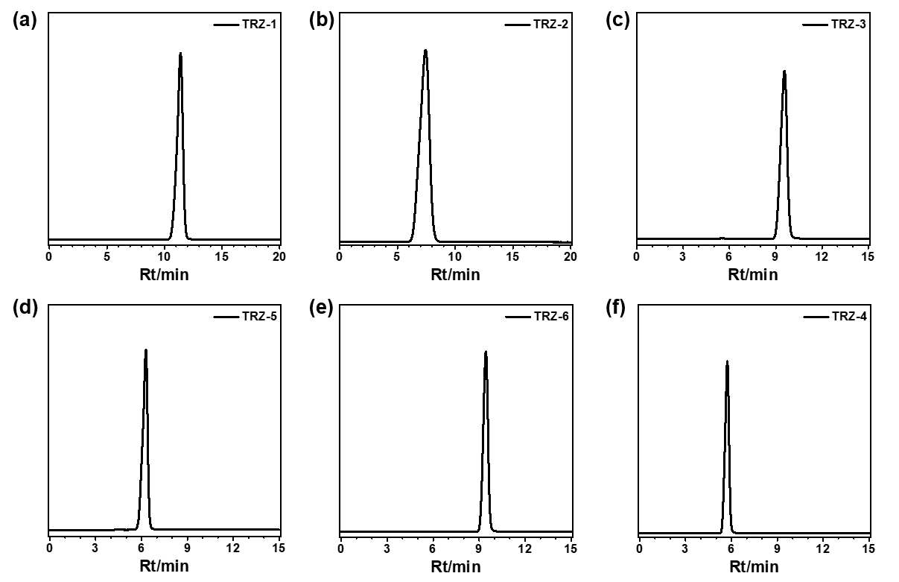
Supplementary Fig. 3. | HPLC spectra. HPLC spectra of six guests (a) TRZ-1, (b) TRZ-2, (c) TRZ-3, (d) TRZ-4, (e) TRZ-5, and (f) TRZ-6 (CH₃OH/H₂O = 95%: 5%).

Supplementary Fig. 4. | Absorption spectra. Absorption spectra of six guests (THF as solvent, Concentration: 1.0*10⁻⁵ mol/L).

Supplementary Fig. 5. | Afterglow images. Afterglow images of six guests after white-light excitation. (77 K, Dimethyltetrahydrofuran as solvent, Concentration: 1.0*10⁻⁵ mol/L).

Supplementary Fig. 6. | Emission spectra. Delayed emission spectra of the doped material TRZ-1/BPO with different amounts of TRZ-1 (Delayed time: 1 ms, Ex.: 365 nm).
Supplementary Fig. 7. | Afterglow images. Afterglow images of six doped materials after 365 nm excitation.

Supplementary Fig. 8. | Emission spectra. Delayed emission spectra of six doped materials (Delayed time: 1 ms, Ex.: 365 nm).
Supplementary Fig. 9. | Kinetic attenuation curves. Kinetic attenuation curves of six doped materials (Ex.: 365 nm).
Supplementary Fig. 10. | Emission spectra. Delayed emission spectra of three doped materials (a) TRZ-4/BPO, (b) TRZ-5/BPO, (c) TRZ-6/BPO at different temperatures (Delayed time: 1 ms, Ex.: 365 nm).

Supplementary Fig. 11. | Emission spectra. Delayed emission spectra of three doped materials (a) TRZ-1/BPO, (b) TRZ-2/BPO, (c) TRZ-3/BPO at different temperatures (Delayed time: 1 ms, Ex.: 365 nm).

Supplementary Fig. 12. | Afterglow images. Afterglow images of six doped materials after white-light excitation.

Supplementary Fig. 13. | Emission spectra. Delayed emission spectra of six doped materials (a) TRZ-1/BPO, (b) TRZ-2/BPO, (c) TRZ-3/BPO, (d) TRZ-4/BPO, (e) TRZ-5/BPO, (f) TRZ-6/BPO at different excitation wavelength (Delayed time: 1 ms).
Supplementary Fig. 14. | Kinetic attenuation curves. Kinetic attenuation curves of six doped materials (a) TRZ-1/BPO, (b) TRZ-2/BPO, (c) TRZ-3/BPO, (d) TRZ-4/BPO, (e) TRZ-5/BPO and (f) TRZ-6/BPO at different excitation wavelength.
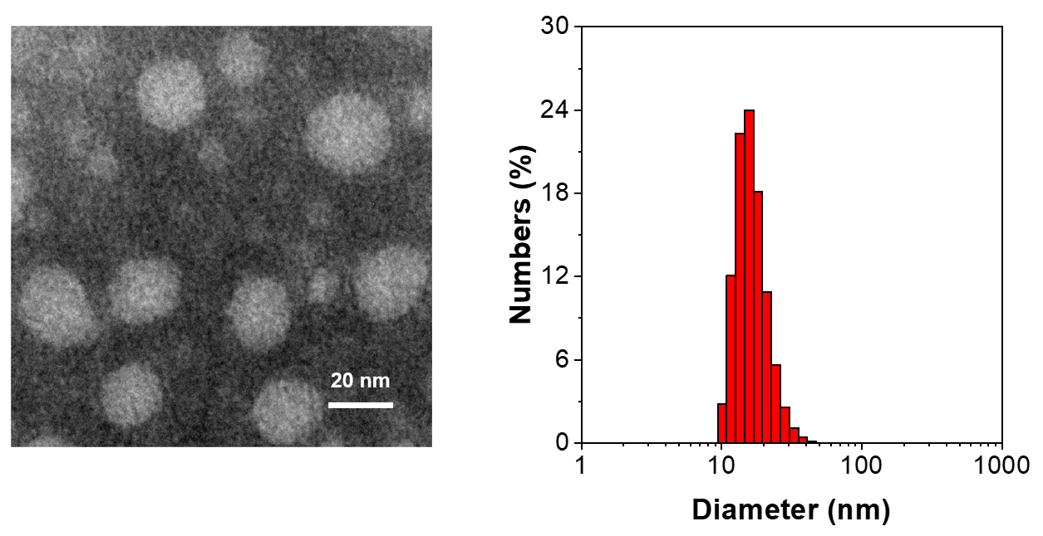
Supplementary Fig. 15. | TEM image and hydrodynamic diameter. TEM image of TRZ-1/BPO NPs (left); hydrodynamic diameter of TRZ-1/BPO NPs determined by DLS (right), scale bar = 20 nm
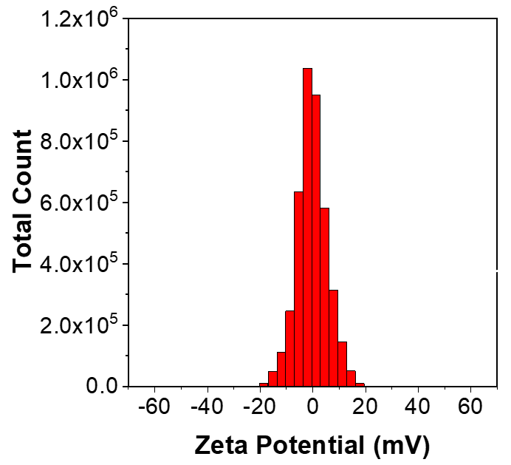
Supplementary Fig. 16. | Zeta potential. Zeta potential of TRZ-1/BPO NPs determined by DLS
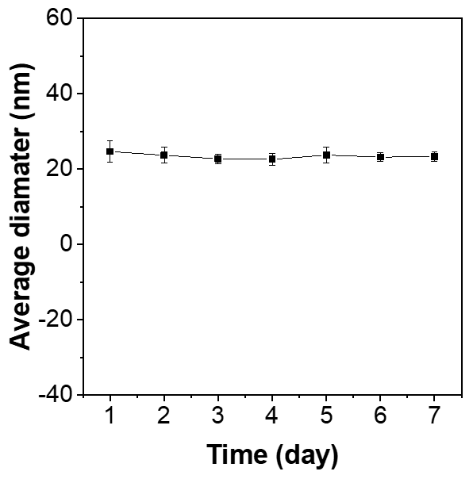
Supplementary Fig. 17. | Hydrodynamic diameter changes. Hydrodynamic diameter changes of the TRZ-1/BPO NPs during one-week study duration measured by DLS, data mean ± SD (n = 3)

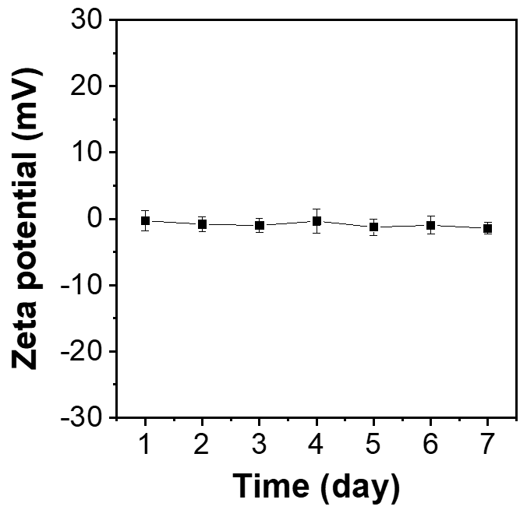
Supplementary Fig. 18. | Zeta potential changes. Zeta potential changes of TRZ-1/BPO NPs during one week measured by DLS, data mean ± SD (n = 3)
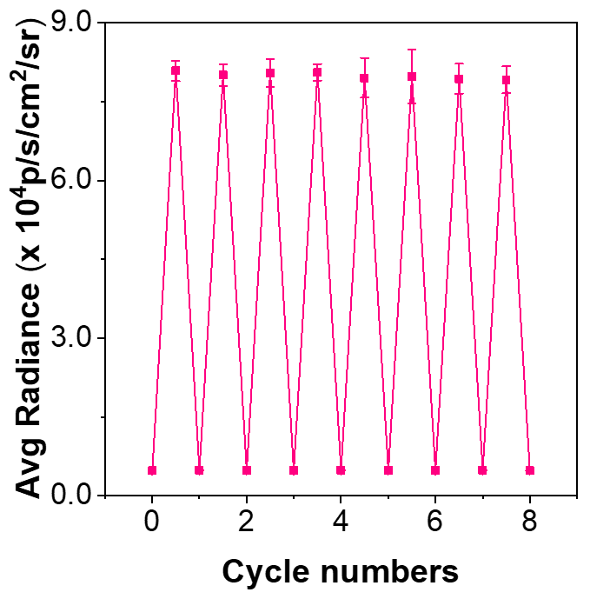
Supplementary Fig. 19. | Phosphorescence intensities. Phosphorescence intensities of TRZ-1/BPO NPs as a function of cycle number of UV light irradiation, data mean ± SD (n = 3)
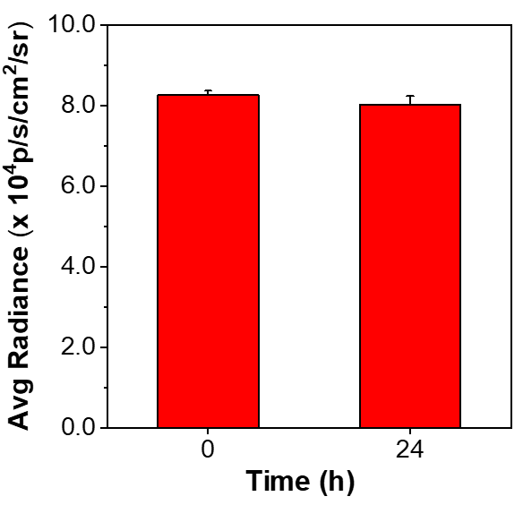
Supplementary Fig. 20. | Afterglow intensity. Afterglow intensity of the TRZ-1/BPO NPs after preservation at -20 ºC for 0 and 24 h, after white light pre-irradiation, data mean ± SD (n = 3)

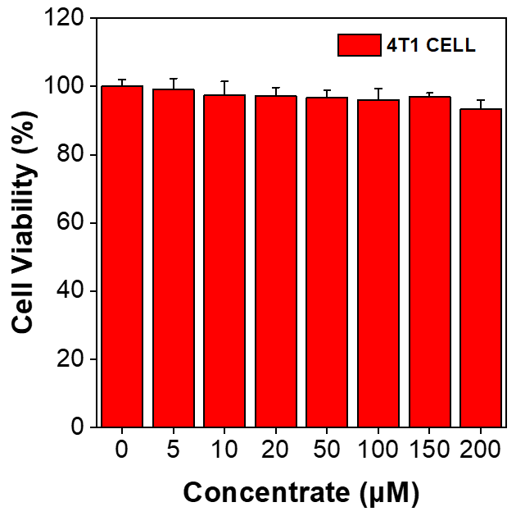
Supplementary Fig. 21. | Cell viabilities. Cell viabilities of 4T1 cancer cells after incubation with different concentrations of TRZ-1/BPO NPs for 24 h, respectively, data mean ± SD (n = 5)

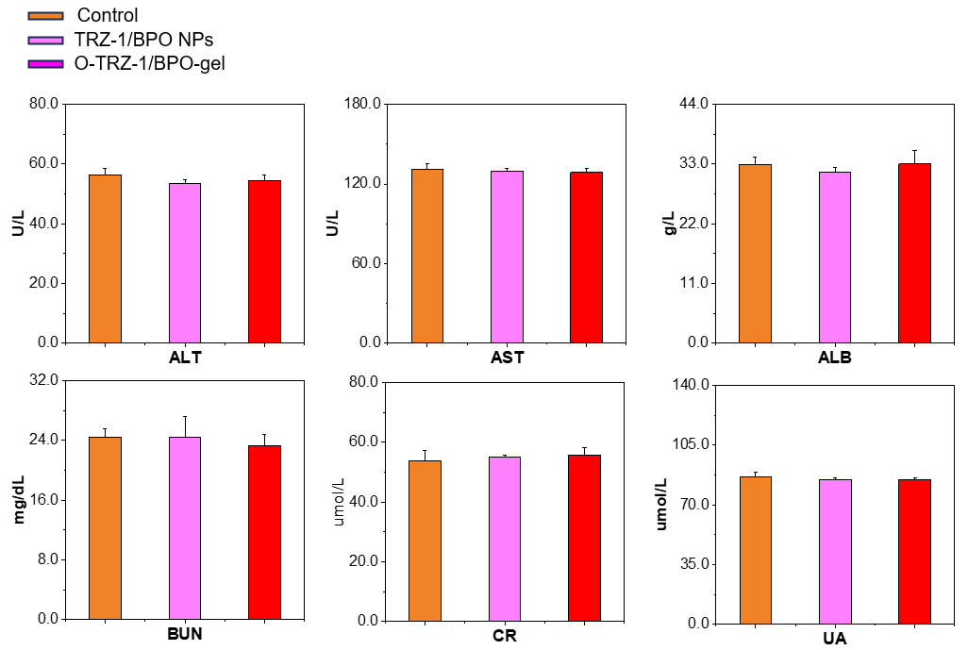
Supplementary Fig. 22. | Liver function. The evaluation of biosafety of TRZ-1/BPO NPs and O-TRZ-1/BPO-gel in BALB/c mice (ALT: Alanine aminotransferase; AST: Aspartate aminotransferase; ALB: Albumin; BUN: Blood urea nitrogen; CR: Creatinine; UA: Uric acid), data mean ± SD (n = 3).

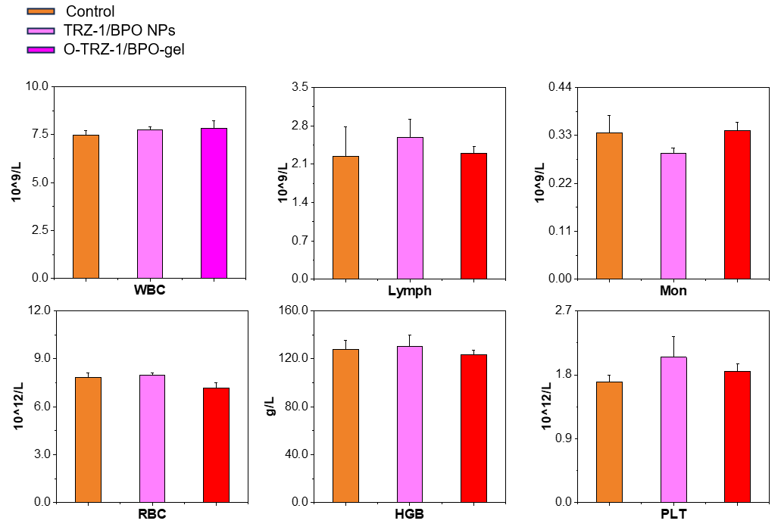
Supplementary Fig. 23. | Blood routine. The evaluation of biosafety of TRZ-1/BPO NPs and O-TRZ-1/BPO-gel in BALB/c mice (WBC: White blood cell; Lymph: Lymphocyte; Mon: Monocyte; RBC: Red blood cell; HGB: Hemoglobin; PLT: Platelet), data mean ± SD (n = 3).

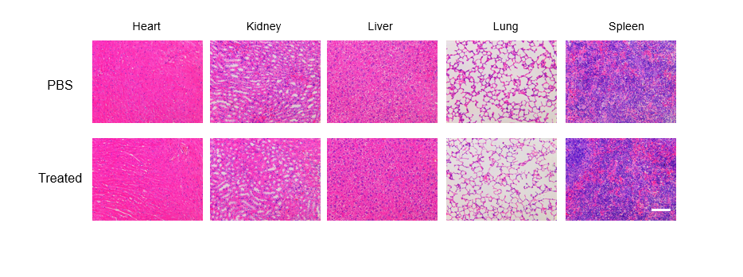
Supplementary Fig. 24. | H&E staining. H&E staining of heart, kidney, liver, lung and spleen slices from untreated or TRZ-1/BPO NPs treated healthy mice, scale bar = 100 μm.

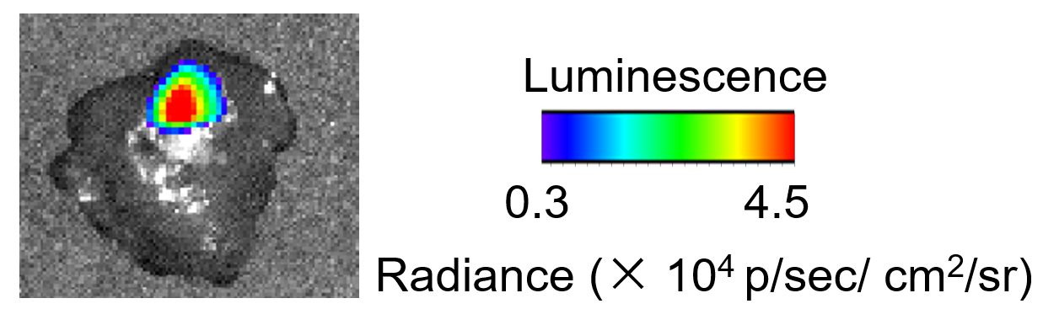
Supplementary Fig. 25. | Phosphorescent images. Phosphorescent images of isolated liver tissue from a mouse model of liver cancer
Supplementary Fig. 26. | Laser confocal scanning microscopy characterization. Laser confocal scanning microscopy characterization of O-TRZ-1/BPO-gel profiles.
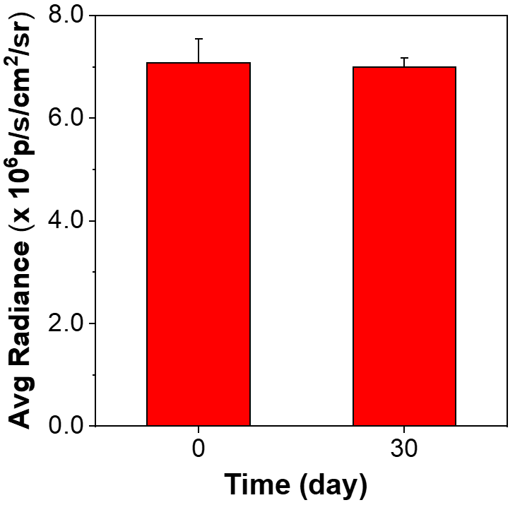
Supplementary Fig. 27. | Afterglow intensity. Afterglow intensity of the O-TRZ-1/BPO-gel after preservation at room temperature for 0 and 30 days, after white light pre-irradiation, data mean ± SD (n = 3)
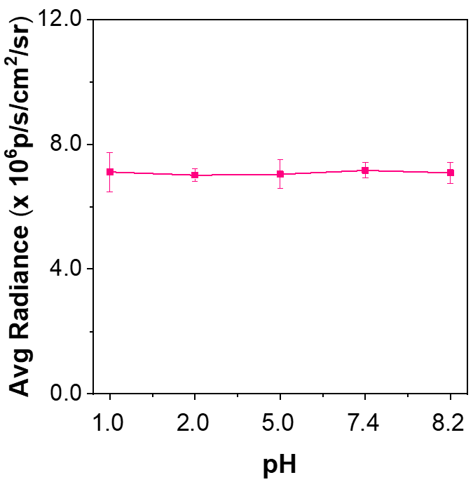
Supplementary Fig. 28. | Afterglow intensity. Afterglow intensity of O-TRZ-1/BPO-gel at different pH after white light pre-irradiation, data mean ± SD (n = 3)

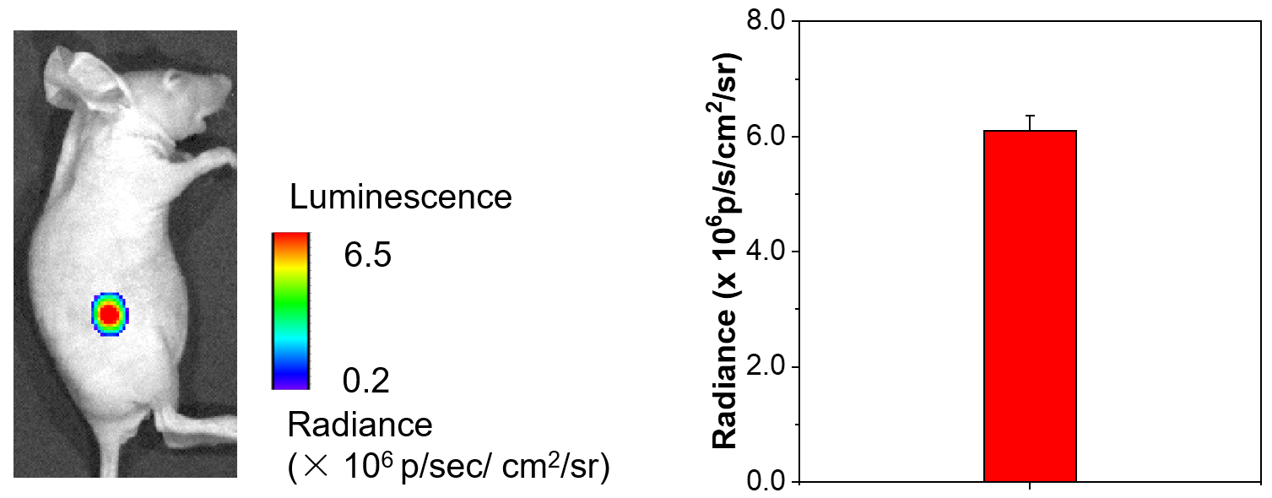
Supplementary Fig. 29. | Afterglow images. Afterglow images of O-TRZ-1/BPO-gel placed subcutaneously in mice (left) and quantitative analysis of afterglow images (right), data mean ± SD (n = 3)

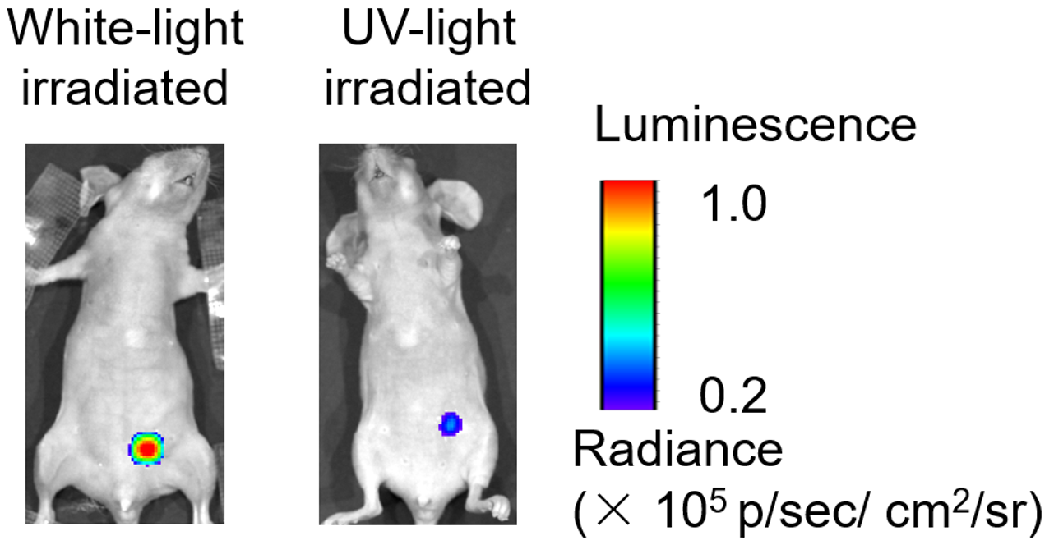
Supplementary Fig. 30. | Afterglow images. Afterglow images for white light and UV excitation observation of the cecum of unopened mice

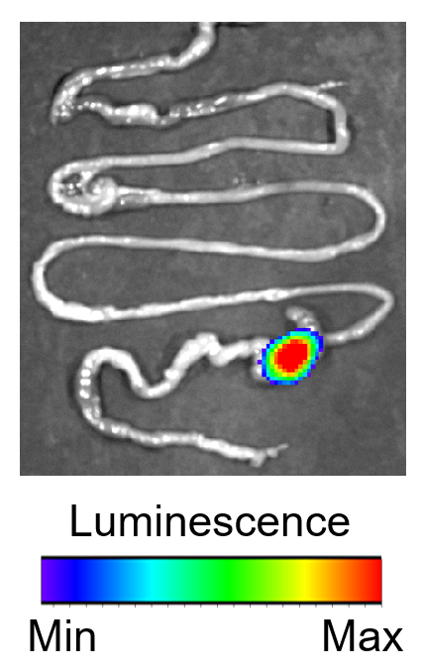
Supplementary Fig. 31. | Afterglow imaging. Afterglow imaging of isolated mouse intestine
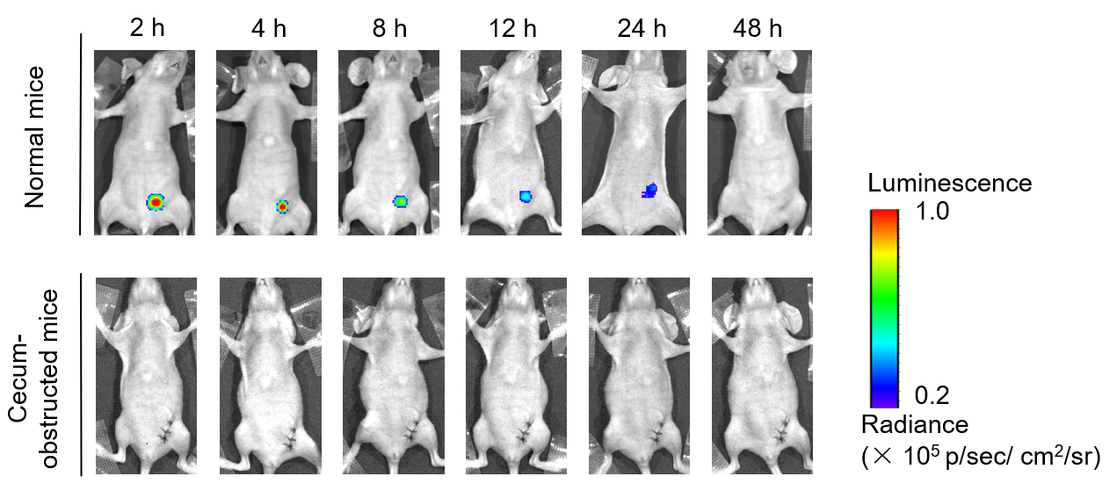
Supplementary Fig. 32. | Afterglow images. Afterglow images of O-TRZ-1/BPO-gel at the cecum of mice 2-48 h after gavage

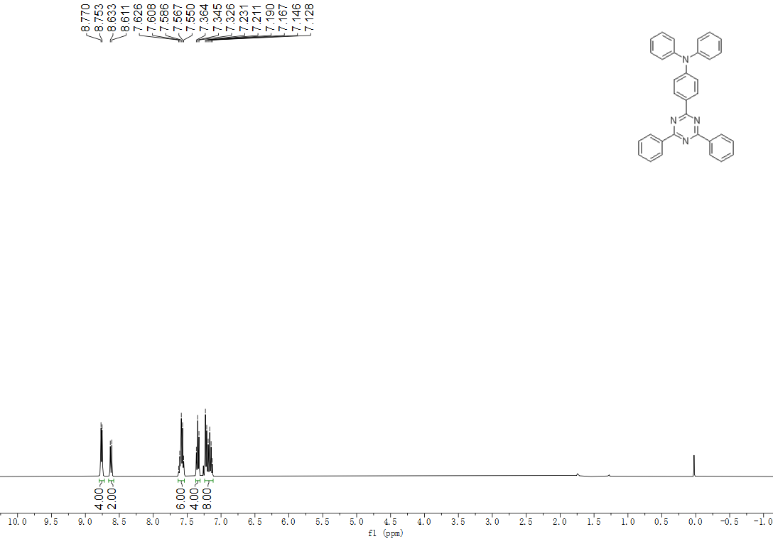
Supplementary Fig. 33. | NMR spectra. ¹H NMR of TRZ-1 (CDCl₃, 400 MHz).

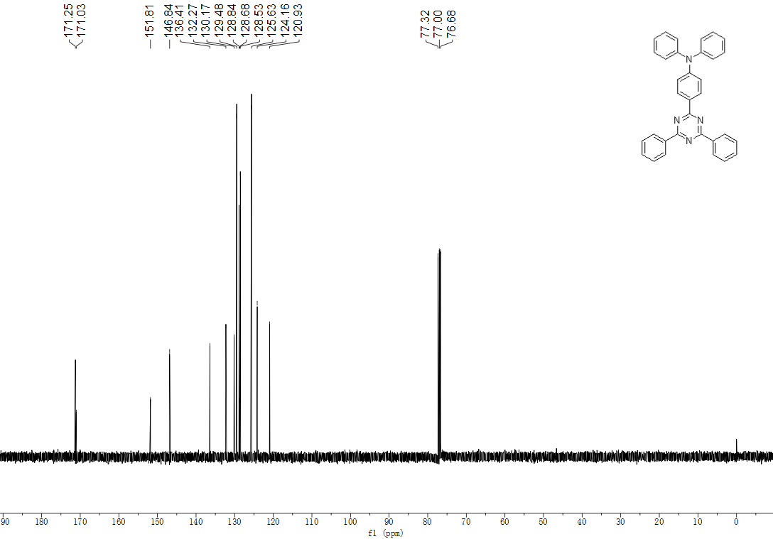
Supplementary Fig. 34. | NMR spectra. ¹³C NMR of TRZ-1 (CDCl₃, 100 MHz).
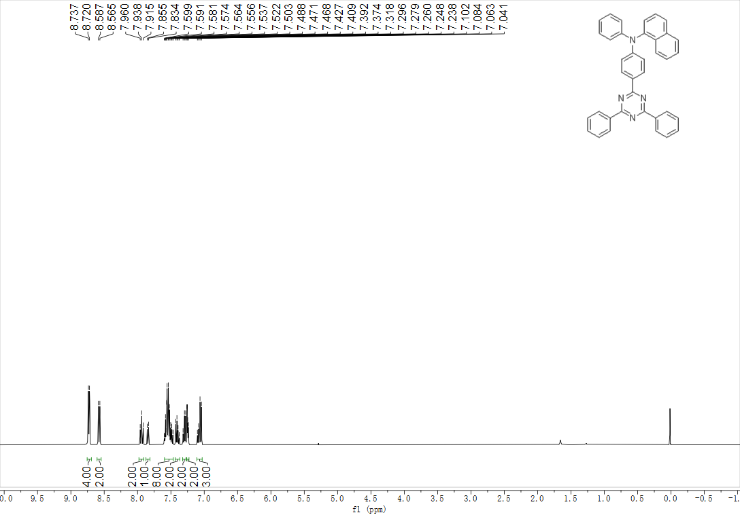
Supplementary Fig. 35. | NMR spectra. ¹H NMR of TRZ-2 (CDCl₃, 400 MHz).

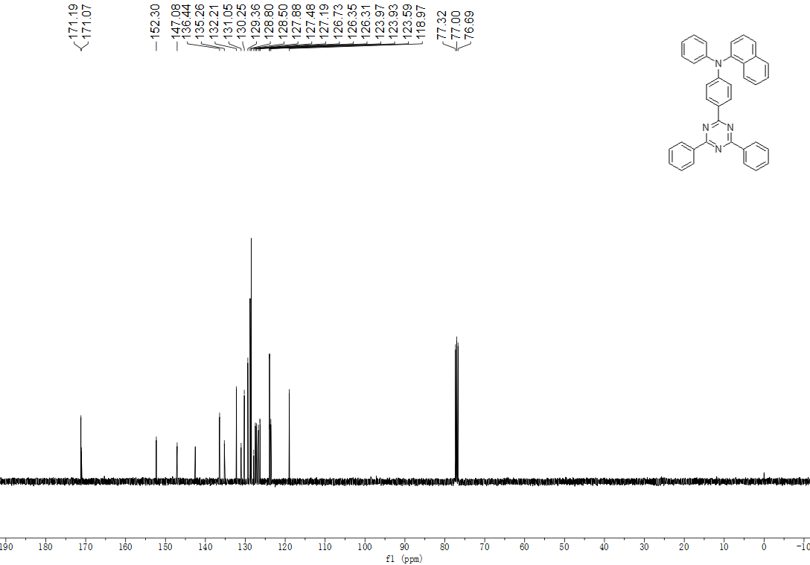
Supplementary Fig. 36. | NMR spectra. ¹³C NMR of TRZ-2 (CDCl₃, 100 MHz).
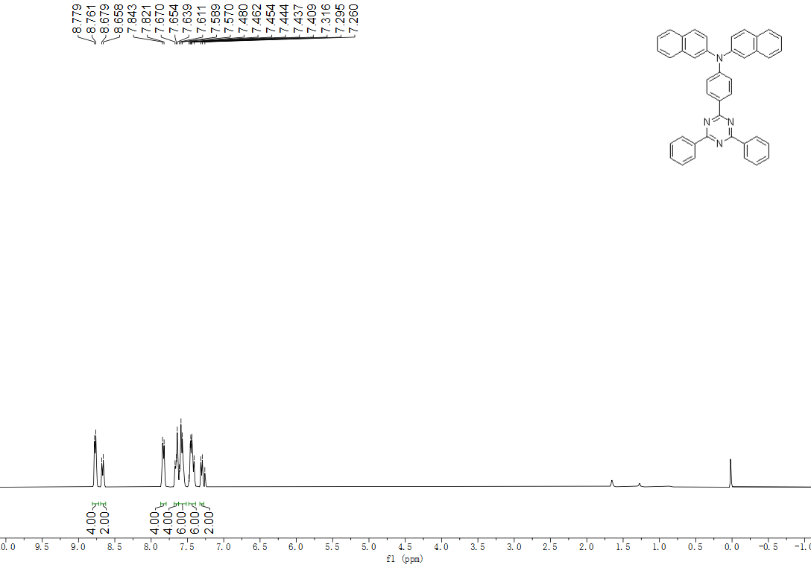
Supplementary Fig. 37. | NMR spectra. ¹H NMR of TRZ-3 (CDCl₃, 400 MHz).

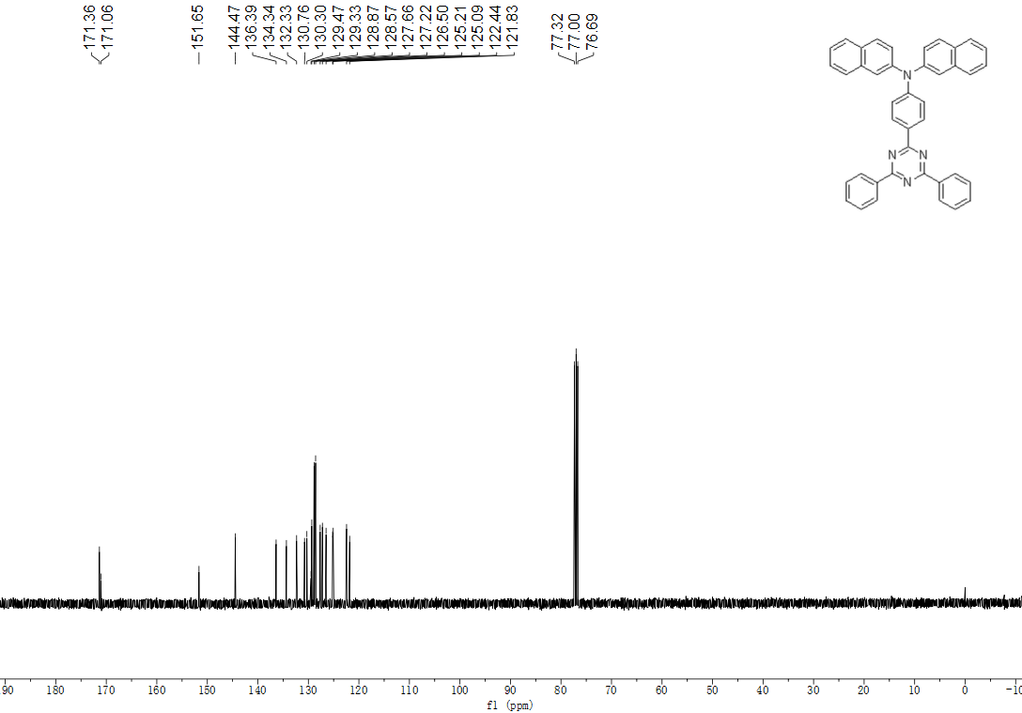
Supplementary Fig. 38. | NMR spectra. ¹³C NMR of TRZ-3 (CDCl₃, 100 MHz).
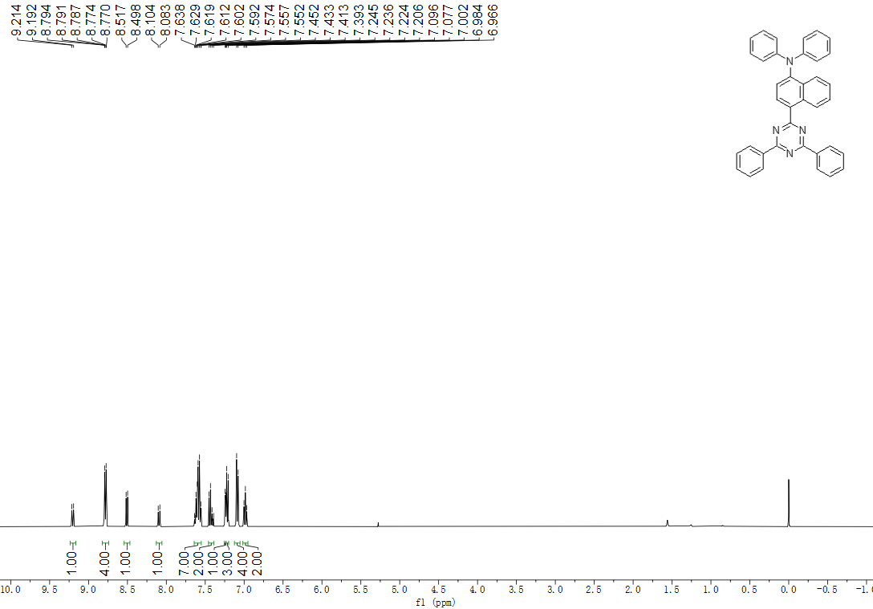
Supplementary Fig. 39. | NMR spectra. ¹H NMR of TRZ-4 (CDCl₃, 400 MHz).

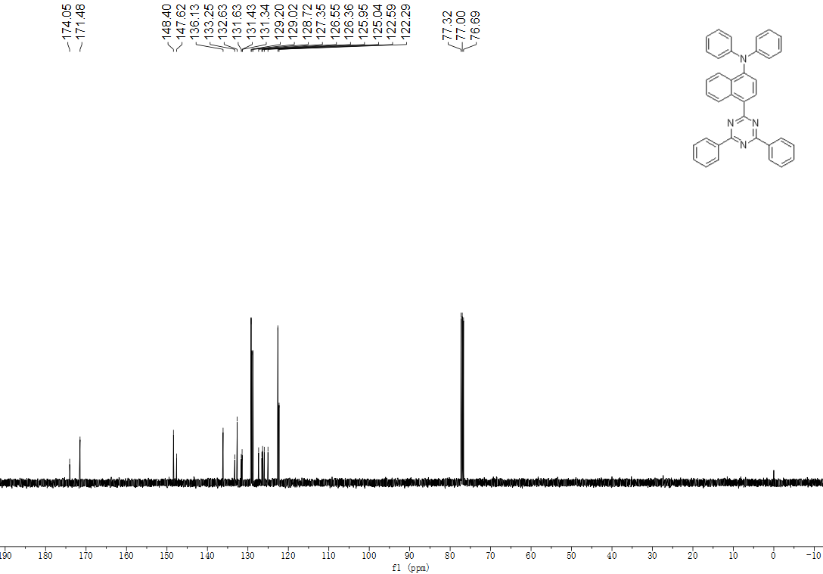
Supplementary Fig. 40. | NMR spectra. ¹³C NMR of TRZ-4 (CDCl₃, 100 MHz).
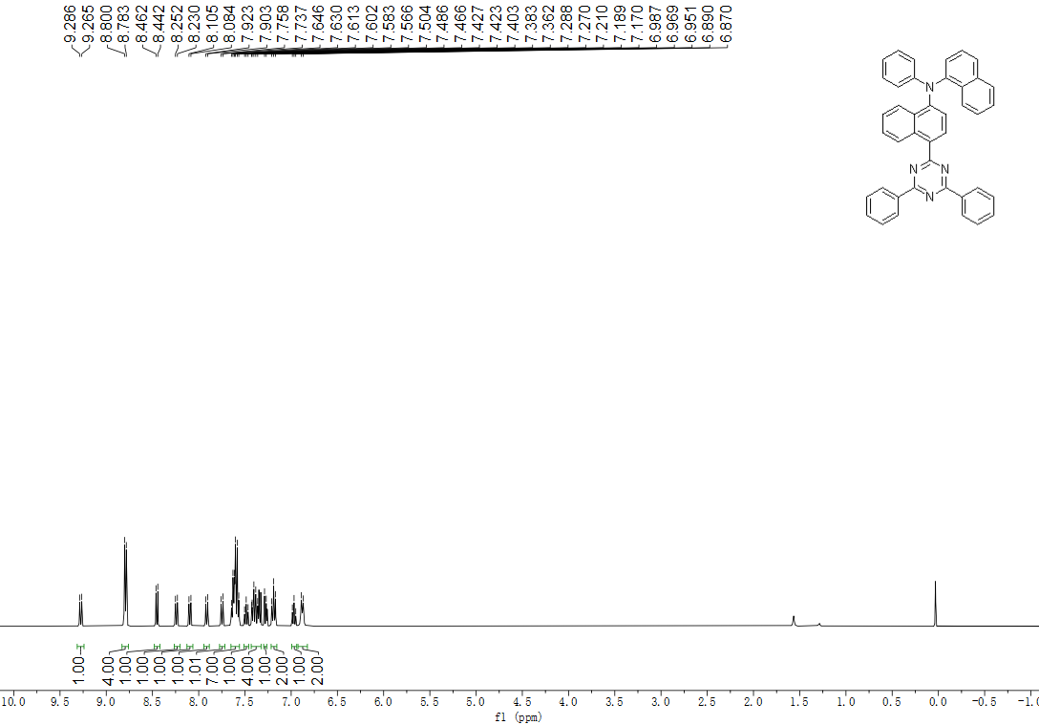
Supplementary Fig. 41. | NMR spectra. ¹H NMR of TRZ-5 (CDCl₃, 400 MHz).

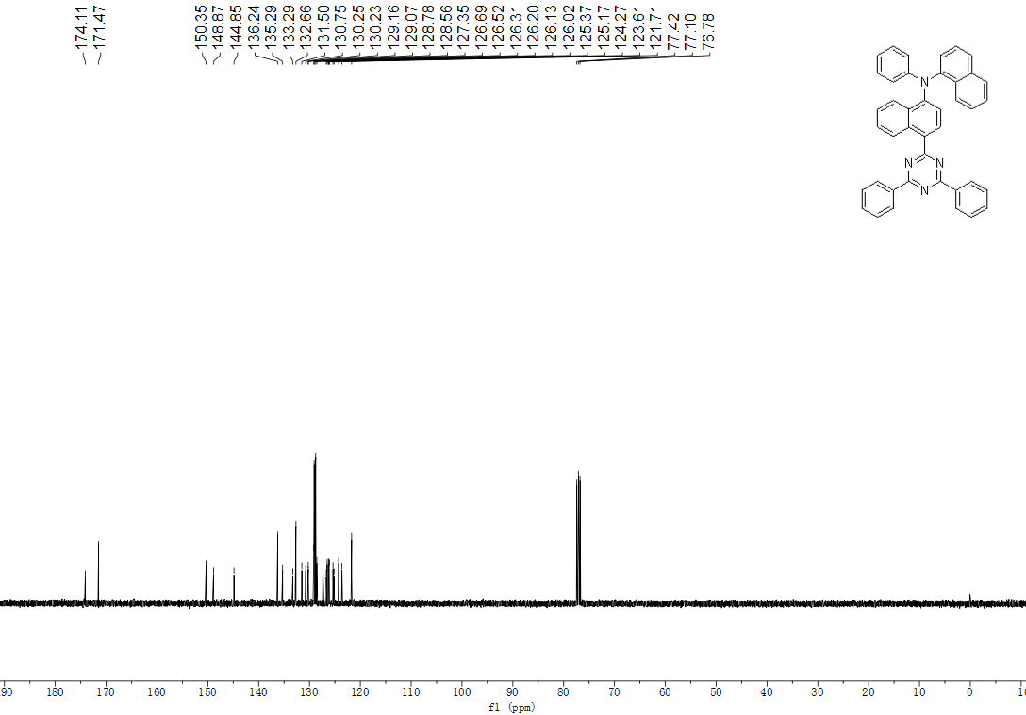
Supplementary Fig. 42. | NMR spectra. ¹³C NMR of TRZ-5 (CDCl₃, 100 MHz).
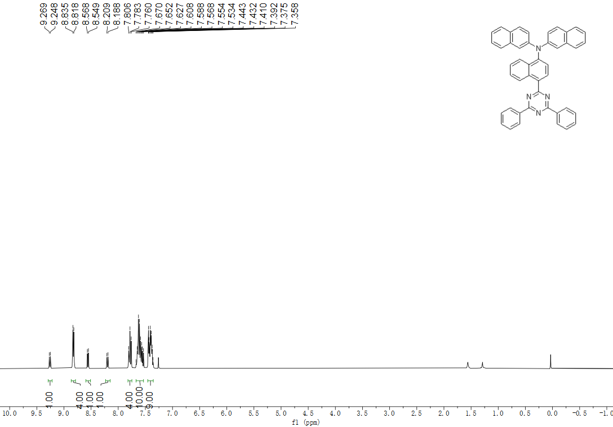
Supplementary Fig. 43. | NMR spectra. ¹H NMR of TRZ-6 (CDCl₃, 400 MHz).

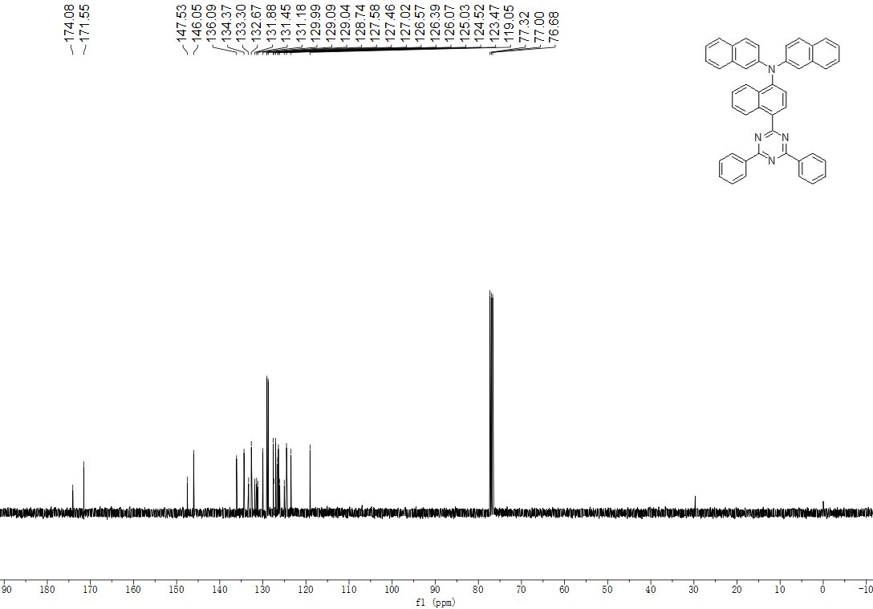
Supplementary Fig. 44. | NMR spectra. ¹³C NMR of TRZ-6 (CDCl₃, 100 MHz).
Supplementary Fig. 45. | HRMS spectra. High-resolution mass spectrometry of TRZ-1.
Supplementary Fig. 46. | HRMS spectra. High-resolution mass spectrometry of TRZ-2.
Supplementary Fig. 47. | HRMS spectra. High-resolution mass spectrometry of TRZ-3.
Supplementary Fig. 48. | HRMS spectra. High-resolution mass spectrometry of TRZ-4.
Supplementary Fig. 49. | HRMS spectra. High-resolution mass spectrometry of TRZ-5.
Supplementary Fig. 50. | HRMS spectrum. High-resolution mass spectrometry of TRZ-6.

