Oxidative Valorization of Spruce Bark to Yield Vanillin

Suthawan Muangmeesriª, Daria Lebedevaª, Lala Ramazanovaª, Sarah Liu^{b}, Houssine Khalili^{c}, Aji P. Mathew^{c}, John Ralph^{b}, Joseph S. M. Samecª.

ª Department of Organic Chemistry, Stockholm University, Stockholm 106 91, Sweden
^{b} U.S. Department of Energy Great Lakes Bioenergy Research Center, University of Wisconsin-Madison, Madison, 53726, USA
^{c} Department of Materials and Environmental Chemistry, Stockholm University, 106 91,
Stockholm Sweden

Supplementary Materials

Contents

1. General information 1
2. Checklist of characterization data for synthesized products 1
3. Feedstock analysis (chemical characterization) 2
4. Pre-treatment of material 3
5. Thioacidolysis 3
6. Nitrobenzene oxidation 4
7. Soda pulping 5
8. RCF 5
9. OCF 5
10. Mass balance 6
11. Proposed cyclic lignin model compound 8
12. Model compound synthesis 11
13. NMR Spectra 15
14. Upgrading of pulp 21
15. Nanocellulose 22
16. ISO-Brightness test 24
17. Viscosity measurement 24
18. References 25

1. General information
The stainless-steel reactors utilized in process, with volumes of 7 mL and 25 mL, were purchased from Swagelok Company. The biomass feedstock was sourced from Skogforsk. All chemical reagents were purchased from Fischer Chemicals, CCS Healthcare AB Sweden, Sigma-Aldrich, Honeywell, and VWR Chemicals, and were used as received.
Sugar analysis was conducted using an Agilent 1200 Series HPLC system equipped with Biorad Aminex HPX-87P column (300 mm × 7.8 mm) coupled with refractive index detector.
GC-MS and GC-FID analyses were performed using a QP2020 system (SHIMADZU, Japan) equipped with two parallel HP-5MS columns (30 m × 0.25 mm × 0.25 μm).
GPC analysis was executed on a Prominence-i, LC-2030C system (SHIMADZU, Japan) featuring a UV detector set at 280 nm.
The HSQC-NMR spectrum was recorded on a Bruker Advance instrument operating at 500 MHz and equipped with a 5 mm TCI Z–Gradient cryoprobe with a gradient strength of 53.0 G⋅cm⁻¹.
Disintegration of the pulp was achieved using the T-25 digital ULTRA-TURRAX® Homogenizer.

2. Checklist of characterization data for synthesized products

Entry | Code | Compound | ¹H-NMR | ¹³C-NMR | HRMS
1 | I1 | 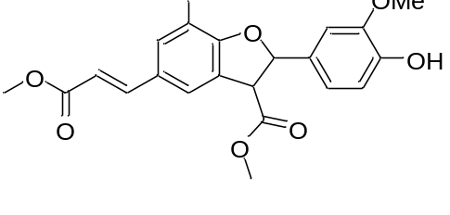 | / | / | /
2 | I2 | 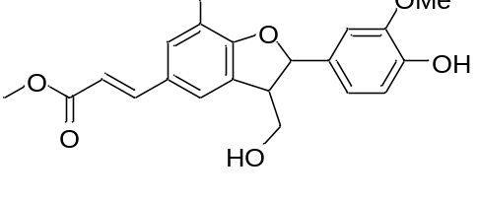 | / | / | /
3 | I3 | 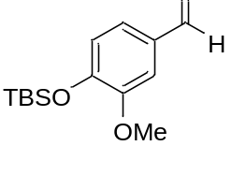 | / | / | /
4 | I4 | 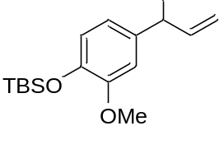 | / | / | /
5 | I5 | 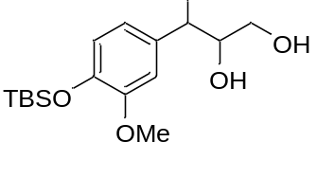 | / | / | /
6 | I6 | 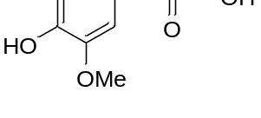 | / | / | /

3. Feedstock analysis (chemical characterization)
The comprehensive chemical analyses encompassed the assessment of ash content, extractables solubility in dichloromethane, ethanol, and water, Klason lignin quantification, holocellulose content determination, and the monomeric composition analysis of polysaccharides.
Ash content was determined according to NREL/TP-510-42622 using 2.0 g of material that were incinerated at 575°C overnight and the residues weighed.
The extraction procedure using organic solvents and water was conducted employing a Soxhlet extractor. Sequentially, the extraction was carried out with dichloromethane for 6 hours, followed by ethanol for 16 hours, and then water for another 16 hours. After the extraction process, the solvents were recovered, and the content of extractives was determined by measuring the mass of the solid residue remaining after drying at 100°C. The extractives content was then reported as a percentage relative to the initial sample.
The determination of Klason lignin and carbohydrate contents followed the NREL/TP-510-42618 method for the extracted materials. A total of 0.3 grams of the material sample was mixed with 3.0 mL of 72% sulfuric acid. This mixture was then placed in an oil bath at 30°C for 1 hour. Afterward, the sample was diluted to a 3% H₂SO₄ concentration and hydrolyzed for 1 hour at 120°C. Subsequently, the sample underwent vacuum filtration and was washed with water. The Klason lignin content was quantified gravimetrically after drying at 100°C. The quantification of monomeric sugars was carried out using HPLC with an injection volume of 20 µL. HPLC grade water was employed as the mobile phase, with a flow rate set at 0.6 mL/minute. The column temperature was maintained at 80°C.

4. Pre-treatment of material
A total of 10 g of bark underwent pre-treatment through a series of extraction steps in an autoclave reactor. Initially, 200 mL of ethyl acetate was employed for a 6-8 hours extraction at 100°C, followed by another extraction with 200 mL of water at 120°C for 2 hours. These sequential extractions aimed to remove lipophilic compounds and sugars (Figure S1). After each extraction, vacuum filtration was performed, and the resulting liquid was concentrated under vacuum. The resulting oil was subjected to analysis using GC-MS. The solid residue was subsequently dried and further analyzed for its chemical composition.
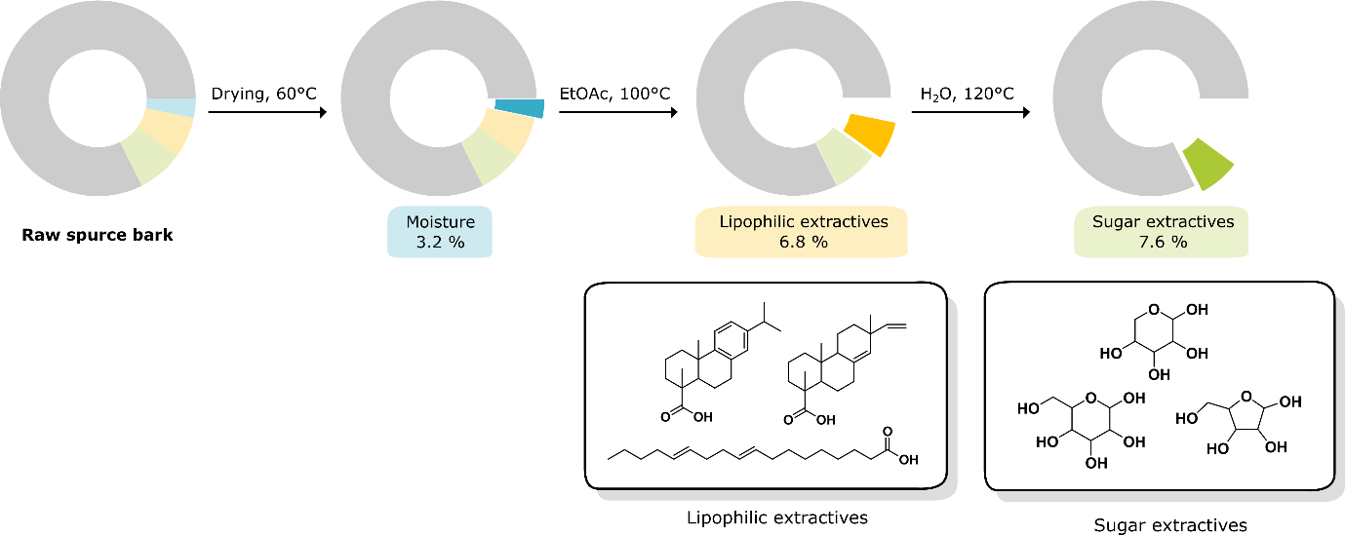
Figure S1. Chemical composition of pre-treated spruce bark.

5. Thioacidolysis
The thioacidolysis reagent was prepared using: EtSH: BF₃·Et₂O: Dioxane in a ratio of 2.5 mL: 0.7 mL: 20 mL, and then dioxane was added to reach a final volume of 25 mL. In a sealed tube, 40 mg of biomass was combined with 4 mL of the thioacidolysis reagent. The reaction was carried out at 100°C for 4 hours and then cooled in an ice bath. Saturated NaHCO₃ was added to the reaction mixture, followed by the addition of 1M HCl until the mixture reached a pH range of 1-3. The resulting mixture was extracted successively with DCM, water, and brine, and then dried using anhydrous Na₂SO₄. The organic phase was filtered, and the solvent was removed under reduced pressure. A 5 mL EtOAc was used to dissolve the resulting crude material. Subsequently, 0.5 mL of the dissolved crude and 0.1 mL of a tetracosane in EtOAc solution (used as an internal standard) were transferred to a 5 mL glass vial. The solvent was evaporated, and the vial was then subjected to a silylation reaction by adding 0.1 mL of BSTFA and 0.1 mL of pyridine, followed by incubation at 60°C for 30 minutes. The resulting solution mixture was subsequently analyzed using GC-MS/FID. The outcome of the thioacidolysis experiment is presented in Figure S2, revealing the presence of 0.7 wt% of G-unit.

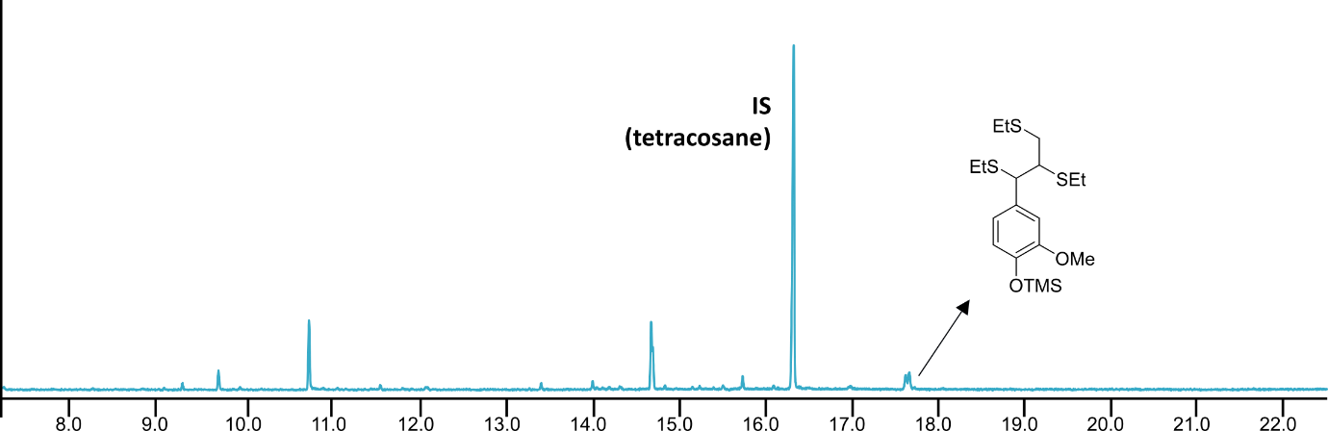
Figure S2. GC mass spectrometry results for lignin-sourced thioacidolysis monomers along with the internal standard are presented. The base peak fragment ion structures are depicted.

6. Nitrobenzene oxidation
In an autoclave, 0.1 g of biomass was added with 7 mL of 2M NaOH and 0.4 mL of 6.8% nitrobenzene. The reaction took place at 170°C for a duration of 2 hours. Upon completion, the reaction mixture underwent extraction with DCM (15 mL×3). The aqueous layer was acidified using 2M HCl until the pH reached below 3.0. Subsequently, the aqueous phase was subjected to additional extractions with DCM (20 mL×2) and 20 mL of Et₂O. The organic phase underwent further purification by washing with water, followed by drying over anhydrous Na₂SO₄, filtration, and concentration under reduced pressure. The resulting crude was dissolved in EtOAc, and an internal standard, 3’,5’-dimethoxy-4’-hydroxyacetophenone in EtOAc solution (100 µL of 1 g/L solution), was added. The mixture was then analyzed by GC-MS/FID, with the resulting peaks displayed in Figure S3, indicating the absence of S/G monomers.

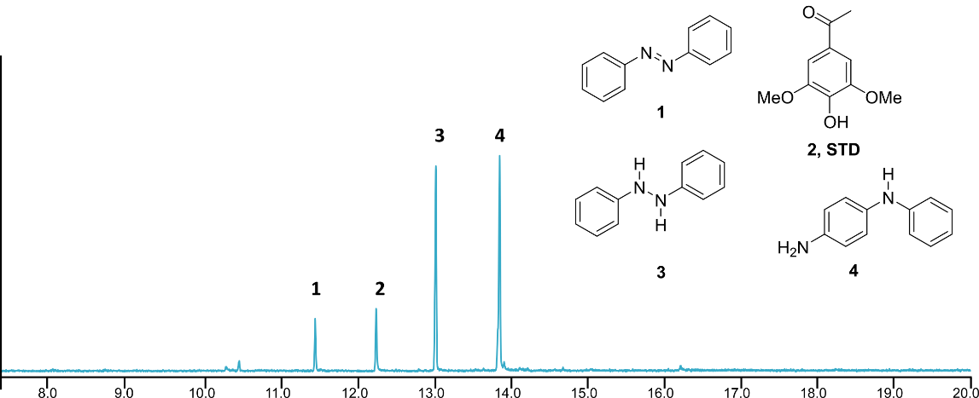

Figure S3. The GC-MS spectrum illustrates the results of the nitrobenzene oxidation of bark, showing the presence of compounds derived from nitrobenzene, as well as an internal standard.

7. Soda pulping
To a pre-treated 5g of bark, 200 mL of 10g/L NaOH was added into an autoclave. The reaction was conducted at 200°C for 2 hours. Upon completion, the reaction mixture underwent filtration, with the collected liquor subsequently precipitated using H₂SO₄ to isolate the lignin. The resulting precipitate was either filtered or, in the case of small-scale operations, subjected to centrifugation. Following this step, the precipitate was analyzed using GPC. The solid pulp was thoroughly washed with water and then dried in an oven at 60°C overnight. Subsequently, the pulp was prepared for chemical composition analysis.

8. RCF
In a 7 mL steel reactor, 0.2 g of pre-treated bark, 20 mg of Pd/C 5%, and 4 mL of MeOH: H₂O (7:3) containing 1.1 g/L p-TSA were added with 80 mg of formic acid. The reaction was carried out at 200°C. The resulting lignin oil was extracted using DCM, washed with water, and dried with anhydrous Na₂SO₄. The catalyst was filtered through celite, and the collected organic phase was concentrated under reduced pressure. The crude was then dissolved in 10 mL of EtOAc, and tetracosane was added as an internal standard for GC-MS/FID analysis. The results, depicted in Figure S4, indicate a 7.8 wt% yield of total monophenolic compounds.

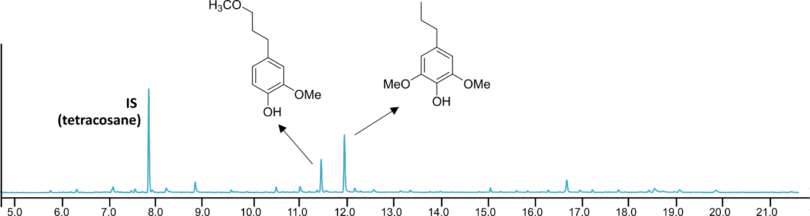
Figure S4. GC mass spectra and monolignols from RCF.

9. OCF
In a 15 mL Swagelok stainless steel reactor equipped with a gas inlet, 0.2 g of pre-treated bark was placed. Subsequently, 10 mL of 7.5 wt% NaOH, 40 mg of Cu(II)O, and 10 bars of O₂ were added to the reactor. The reaction was conducted at temperatures ranging from 160 to 200°C for durations of 10 to 90 minutes. After the reaction, the mixture was filtered, washed with water, and the aqueous phase was acidified until reaching a pH below 3. It was then extracted with MeTHF, dried with anhydrous Na₂SO₄, filtered, and concentrated under vacuum. The resulting product was subjected to GC-MS/FID analysis, with dodecane serving as an internal standard.

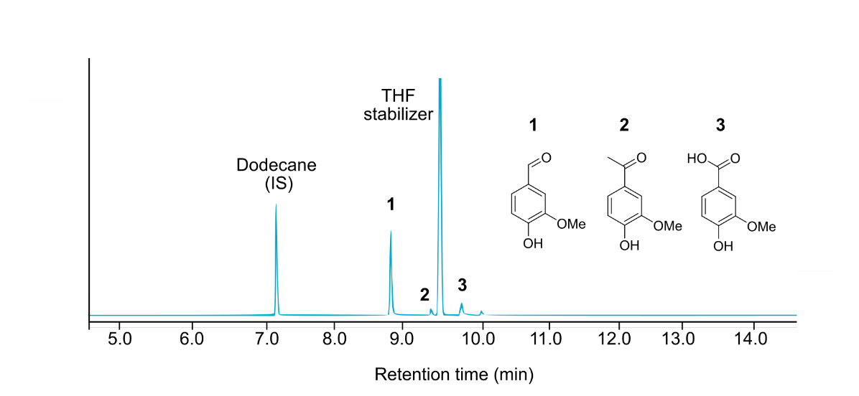
Figure S5. Gas chromatography of oxidized monophenols from OCF at 180°C for 60min.

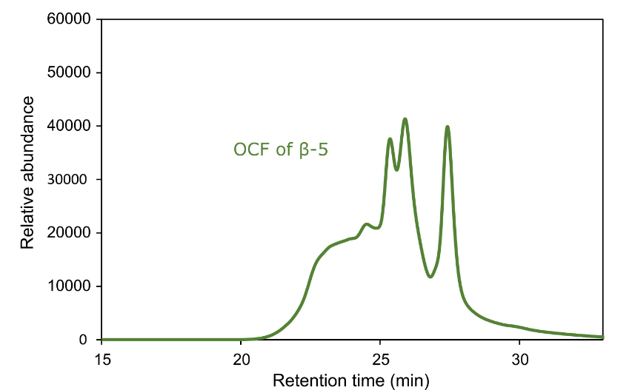
Figure S6. GPC chromatogram of the crude mixture of the β-5 model compound after OCF.

10. Mass balance
To evaluate the efficiency of the developed value chain from spruce bark to mainly monophenols and pulp, biomass mass balances were calculated (Figure S7). A total of 6.8 wt% lipophilic compounds was isolated, comprising terpenes and some fatty acids. Aqueous extraction gave sugars in 7.6 wt% yield that could either be fermented or used to produce heat and power to run the operation. OCF resulted in 53.2% delignification and gave 5.5 wt% monophenols, of which 4.0 wt% was vanillin. The resulting residue was bleached to produce a pulp in 35.7% yield that was successfully converted to nanocellulose (see the SI). Thus, starting from 1 kg of bark, 357 g of pulp, 40 g of vanillin, and 68 g of terpenes could be isolated.
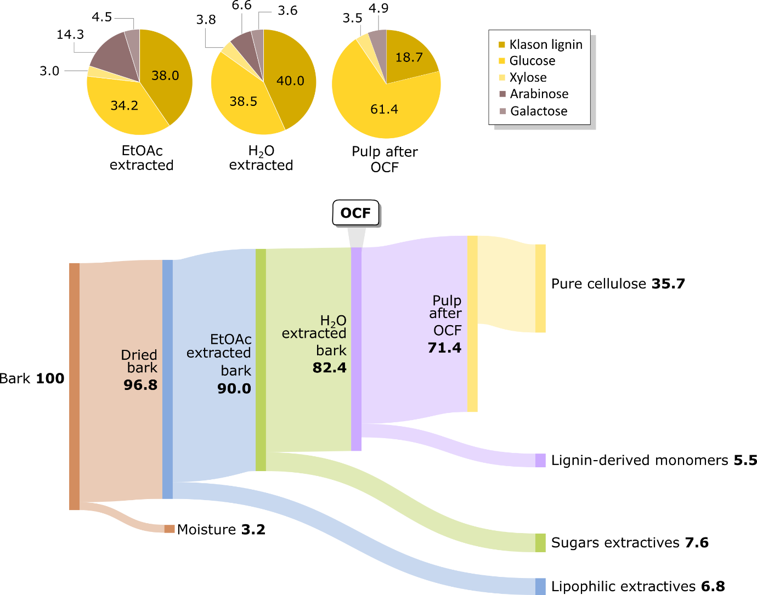

Figure S7. Mass balance (Sankey diagram) and pulp chemical composition of spruce bark after fractionation and OCF.

11. Proposed cyclic lignin model compound
A. Structural Assumptions and Constraints in Modeling Bark Lignin: Integrating Experimental Observations with Mechanistic Insights
To elucidate the intricate structure of bark lignin and reconcile it with yield observations from various analytical methods, we employed a meticulous approach guided by specific criteria. Here, we outline the structural assumptions and constraints integral to our modeling efforts:
Aromatic Units:
We endeavored to construct a model comprising ten aromatic units, a selection driven by the desire to facilitate the calculation of molar percentages. Within this framework, we included eight guaiacyl (G) units and one p-hydroxyphenyl (H) unit. The inclusion of the H unit stemmed from its prominence, accounting for 10% of the lignin composition as determined by 2D NMR volume-integration. Notably, we also incorporated one ferulate (FA) unit, identified at a low level in NMR spectra, despite its challenging integration into our model's compact size.
Dimeric Units:
We delineated dimeric units based on ten interunit linkage types, aligning them with observations from 2D NMR integrals. These included three β-ethers (β–O–4), two phenylcoumarans (β–5), one resinol (β–β), indicative of dimers initiating polymer chains, one biphenyl/dibenzodioxocin (5–5/4–O–β), and one biphenyl ether (H4–O–5G). Notably, the inclusion of the biphenyl ether necessitated careful consideration of the H unit's correlations, prompting its 4–O-linkage. We acknowledge that while 5-O–4-linked G-units may not typically undergo further etherification, we opted to include this modification in our model.
The model initiation centers on the formation of the 1–1' pinoresinol dimer, reflecting a pivotal step in lignin polymerization. Subsequently, extension from the phenolic end at 1' proceeds via the conventional 4–O–β coupling, giving rise to unit 2'. Concurrently, another chain initiates with β–5 coupling between two coniferyl alcohol monomers, yielding 1"–2", followed by 4–O–β coupling to the lone p-coumaryl alcohol unit, resulting in unit 3". At the 1-end of pinoresinol, 5–O–4 coupling to the H unit at 3" yields the H4–O–G5 unit 1–3".
Unit 1, retaining its free-phenolic moiety, subsequently undergoes 4–O–β coupling, leading to the formation of unit 2. Successive coupling events ensue, with unit 2 coupling to 5–β, resulting in unit 3, which then couples to 4–O–β, ultimately yielding unit 4. The convergence of the two phenolic ends in moieties 4 and 2' culminates in a 5–5 linkage, while coniferyl alcohol adds β–O–4 to form the dibenzodioxocin 4–2'–3'. Notably, moiety 3' remains unaltered, refraining from further etherification.
The integration of a macrocyclic component into our model, while insightful, poses challenges due to deviations from optimal bond angles, typically constrained to 120° in all but 5- and 8-membered rings. This departure from ideal geometry introduces strain, particularly evident in aromatic ring systems, as revealed through energy-minimization via 3D modeling. Despite these limitations, it is important to emphasize that the macrocyclic structure serves as a conceptual tool rather than a definitive representation of the native architecture.

Our model, while not without its imperfections, offers valuable insights into the enigmatic yield data obtained from diverse analytical methods, especially when compared to yields from wood lignin. By incorporating the macrocyclic feature, we provide a plausible explanation for these aberrant yet intriguing observations, underscoring the utility of our model in unraveling the intricacies of lignin structure and behavior. However, it is pertinent to acknowledge that with the constraints imposed by the model's size, certain experimental data, notably gel permeation chromatography (GPC) data, may not be fully accommodated. This limitation underscores the need for continued refinement and expansion of our modeling approaches to capture the full spectrum of lignin behavior.

B. Explanation of yield ‘predictions’ from the model
The model was constructed to reasonably predict the monomer yields from various degradative methods.
0 Monomers from Thioacidolysis: Thioacidolysis cleaves β-ethers but does not typically affect dibenzodioxocin structures. Cleaving the four common β-ethers does not release single monomers; all released units are dimers or trimers.
1 Monomer from RCF: Reductive catalytic fractionation (RCF) also cleaves β-ethers, including those in dibenzodioxocin structures, usually resulting in high monomer yields. However, in this case, all fragments except the 3'-monomer are C–C-linked dimers or trimers. The side chains are depicted as propanes but may also be propanols, especially due to Pd/C hydrogenolysis.
6 Monomers from Full OCF: Oxidative catalytic fractionation (OCF) has the potential to cleave all units except the 5–5 and 4–O–5 linkages. Other C–C-linked β–5 units may cleave but will leave an additional formyl or carboxylate group on the ring at C-5 in monomers 2 and 1". β–β-Units can fully cleave to form monomers.
3+ Monomers from Mild OCF: Similar to full OCF, mild oxidative conditions will not cleave the 5–5 and 4–O–5 units and may struggle to yield monomers from both moieties in a β–5 unit. Units 2 and 1" are theoretically releasable but are not detected at significant levels in this OCF process. The β–β-unit 1-1' is also questionable; while moiety 1' (unlike the 5–O–4-linked moiety 1) should produce a monomer, it may not always cleave. Therefore, while three monomers are typically formed, it is possible that up to four monomers could be produced.
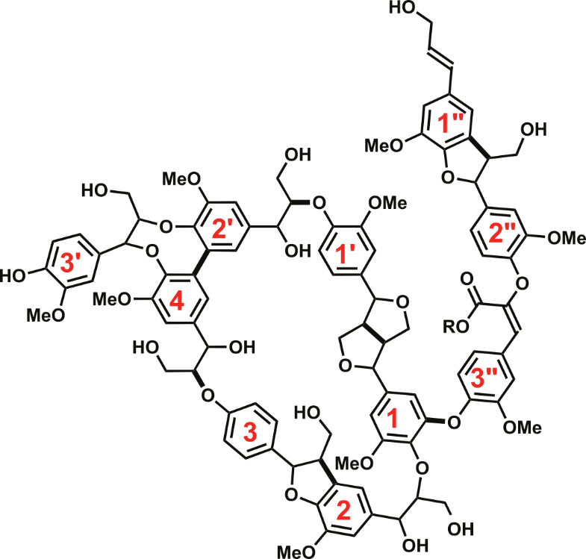
Figure S8. Proposed cyclic bark lignin.

12. Model compound synthesis

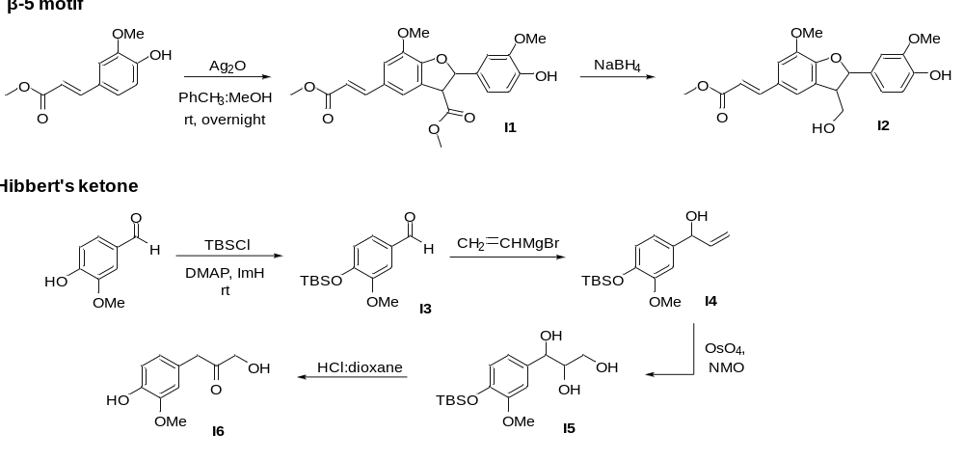
Figure S9. Synthetic pathways for model compounds (β-5 and Hibbert’s ketone).

Synthesis of 3-Benzofurancarboxylic acid, 2,3-dihydro-2-(4-hydroxy-3-methoxyphenyl)-7-methoxy-5-(3-methoxy-3-oxo-1-propen-1-yl)-, methyl ester (I1)¹
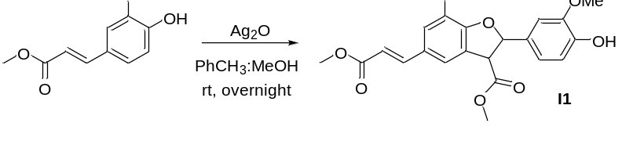
Methyl ferulate (2.1 g, 10.0 mmol) was dissolved in toluene/methanol (2:1, 30 mL) followed by addition of Ag₂O (1.4 g, 6.0 mmol). After stirring at room temperature, the mixture was filtered, concentrated, and purified via silica gel chromatography (eluting with hexane−EtOAc, 3:1) to yield I1 (1.5 g, 36% yield) as a white solid. ¹H NMR (400 MHz, CDCl₃) δ 7.65 (d, J = 15.9 Hz, 1H), 7.18 (s, 1H), 7.02 (s, 1H), 6.94 – 6.86 (m, 3H), 6.32 (d, J = 15.9 Hz, 1H), 6.11 (d, J = 8.2 Hz, 1H), 4.34 (d, J = 8.1 Hz, 1H), 3.92 (s, 3H), 3.87 (s, 3H), 3.83 (s, 3H), 3.80 (s, 3H). ¹³C NMR (101 MHz, CDCl₃) δ 170.7, 167.6, 149.9, 144.7, 131.3, 128.6, 125.7, 119.4, 117.9, 115.5, 114.4, 112.1, 108.7, 87.5, 56.1, 56.0, 55.5, 52.9, 51.6; m/z [M+Na]⁺ calcd. for C₂₂H₂₂NaO₈: 437.1207; found: 437.1266

Synthesis of 2-Propenoic acid, 3-[2,3-dihydro-2-(4-hydroxy-3-methoxyphenyl)-3-(hydroxymethyl)-7-methoxy-5-benzofuranyl]-, methyl ester (I2)
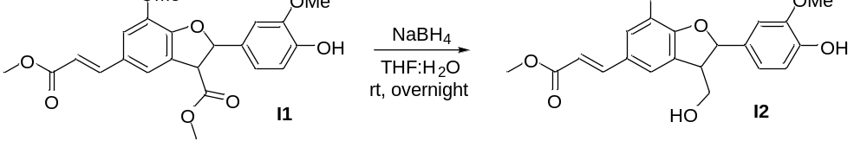
Compound I1 (1.0 g, 2.4 mmol) was dissolved in a mixture of 20 mL of THF/H₂O (4:1) and stirred at room temperature. NaBH₄ (455 mg, 12.0 mmol) was then added to the reaction mixture and allowed to stir overnight. Following this, the reaction mixture was acidified using 1 M HCl until reaching a pH of 3. Extraction with DCM followed, and the combined organic layers were subjected to drying with anhydrous Na₂SO₄. Evaporation of the solvent was carried out using a rotary evaporator. Purification of the target compound was achieved through column chromatography using hexane−EtOAc (4:1) as the eluent to afford I2 (0.8 g, 86% yield) as a white solid. ¹H NMR (400 MHz, CDCl₃) δ 7.65 (d, J = 15.9 Hz, 1H), 7.07 (s, 1H), 7.01 (d, J = 1.6 Hz, 1H), 6.93 – 6.86 (m, 3H), 6.31 (d, J = 15.9 Hz, 1H), 5.62 (s, 1H), 4.04 – 3.93 (m, 2H), 3.92 (s, 3H), 3.87 (s, 3H), 3.80 (s, 3H), 3.66 (q, J = 6.0 Hz, 1H). ¹³C NMR (101 MHz, CDCl₃) δ 167.7, 150.6, 146.7, 145.8, 144.9, 144.6, 132.4, 128.6, 128.5, 119.4, 117.2, 115.2, 114.4, 111.8, 108.7, 88.7, 63.9, 56.0, 56.0, 53.1, 51.6; m/z [M+Na]⁺ calcd. for C₂₁H₂₂NaO₇: 409.1258; found: 409.1247

Synthesis of 4-tert-Butyldimethylsilyloxy-3-methoxybenzaldehyde (I3)²
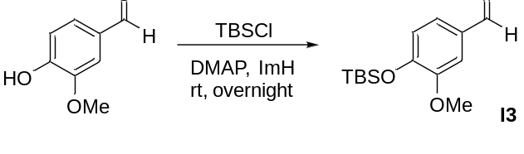
A reaction mixture was prepared by adding vanillin (5 g, 32.9 mmol), imidazole (5.4 g, 36.1 mmol), and DMAP (0.19 g, 1.6 mmol) in DCM (170 ml). To this stirred solution, TBS-Cl (5.4 g, 36.1 mmol) was added. The resulting mixture was stirred at room temperature overnight until complete consumption of the starting material was observed. The reaction was quenched with saturated NH₄Cl. The organic layer was then sequentially washed with water, brine, and dried over anhydrous Na₂SO₄. After concentrated under reduced pressure, compound I3 (8.3 g, 95% yield) was obtained as a light-yellow oil. This product was used in the subsequent step without further purification. ¹H NMR (400 MHz, CDCl₃) δ 9.85 (s, 1H), 7.42 – 7.34 (m, 2H), 6.97 (d, J = 8.0, 1.8 Hz, 1H), 3.87 (s, 3H), 1.00 (s, 9H), 0.20 (s, 6H). ¹³C NMR (101 MHz, CDCl₃) δ 191.0, 151.6, 151.3, 130.9, 126.2, 120.7, 110.1, 55.4, 25.6, -4.55; m/z [M+Na]⁺ calcd. for C₁₄H₂₂NaO₃Si: 289.1230; found: 289.1229

Synthesis of 1-[4-[(tert-Butyldimethylsilyl)oxy]-3-methoxyphenyl]prop-2-en-1-ol (I4)
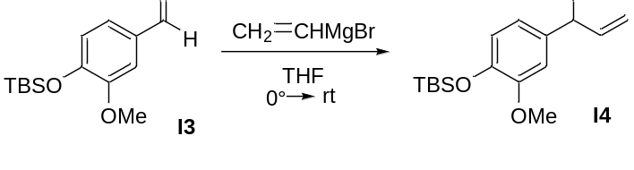
To a stirred solution of I3 (8.7 g, 32.7 mmol) in dry THF at 0 °C was added vinylmagnesium bromide solution (1.0 M in THF, 1.2 eq, 39.2 mmol). The reaction mixture was then warmed to room temperature and stirred until all starting material was consumed. Subsequently, the reaction was quenched with a saturated NH₄Cl solution. Afterward, the solution underwent extraction with ethyl acetate and sequential washing with saturated NH₄Cl, water, and brine. The organic layer was then dried over Na₂SO₄ and concentrated under reduced pressure. Compound I4 (8.5 g, 88% yield) was obtained as a light-yellow oil. This product was utilized in the subsequent step without undergoing further purification. ¹H NMR (400 MHz, CDCl₃) δ 6.88 (s, 1H), 6.82 – 6.79 (m, 2H), 6.11 – 6.00 (m, 1H), 5.34 (dt, J = 17.1, 1.5 Hz, 1H), 5.19 (dt, J = 10.3, 1.4 Hz, 1H), 5.14 (dt, J = 5.8, 1.5 Hz, 1H), 3.81 (s, 3H), 0.99 (s, 10H), 0.15 (s, 6H). ¹³C NMR (101 MHz, CDCl₃) δ 151.0, 144.6, 140.3, 136.1, 120.7, 118.8, 114.8, 110.2, 55.4, 25.7, -4.6; m/z [M+Na]⁺ calcd. for C₁₆H₂₆NaO₃Si: 294.1651; found: 294.1650

Synthesis of 1-[4-[[(1,1-Dimethylethyl)dimethylsilyl]oxy]-3-methoxyphenyl]-1,2,3-propanetriol (I5)
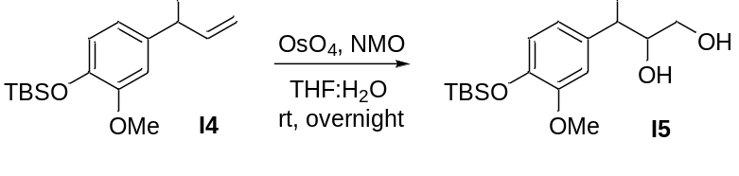
To a stirred solution of I4 (4.6 g, 15.6 mmol) and NMO (1.5 eq, 2.7 g, 23.4 mmol) in 40 mL THF/H₂O (9:1) was added OsO₄ (2.5% by wt. in t-Butanol, 1 mol%, 0.156 mmol). The reaction was stirred until all starting material was consumed before quenching with saturated aqueous Na₂SO₃ solution. The mixture was extracted with ethyl acetate and washed sequentially with saturated aqueous Na₂SO₃ solution, water, and saturated brine solution. The organic layer was dried over Na₂SO₄ and concentrated in vacuo. The crude product was purified on silica (50-60% ethyl acetate in petroleum ether) to afford the desired product I5 (3.2 g, 64.1% yield) as yellow oil. ¹H NMR (400 MHz, CDCl₃) δ 6.87 (d, J = 5.3, 1.9 Hz, 1H), 6.85 – 6.72 (m, 2H), 4.75 (d, J = 5.2 Hz, 1H), 3.77 (s, 3H), 3.72 – 3.58 (m, 2H), 3.56 – 3.39 (m, 1H), 0.98 (s, 9H), 0.13 (s, 6H). ¹³C NMR (101 MHz, CDCl₃) δ 151.1, 151.1, 144.7, 133.8, 120.8, 118.6, 110.0, 74.7, 62.9, 55.5, 25.7, 18.4, -4.6; m/z [M+Na]⁺ calcd. for C₁₆H₂₈NaO₅Si: 328.1706; found: 328.1710

Synthesis of 3-Hydroxy-1-(4-hydroxy-3-methoxyphenyl)-2-propanone (I6)
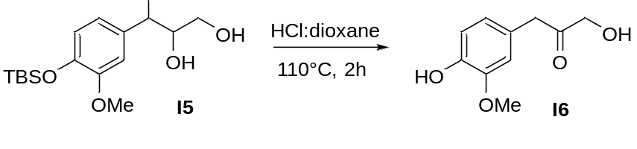
A solution containing compound I5 (4.1 g, 12.4 mmol) in 120 mL of dioxane/2M HCl (9:1) was subjected to reflux for 2 hours. Subsequently, the reaction mixture was cooled and concentrated under reduced pressure. Purification via silica gel chromatography (utilizing 25‐50 % ethyl acetate in petroleum ether) led to the isolation of product I6 as a brown oil (1.57 g, 64.6% yield). ¹H NMR (400 MHz, CDCl₃) δ 6.88 (d, J = 8.5 Hz, 1H), 6.73 – 6.69 (m, 2H), 4.29 (s, 2H), 3.88 (s, 3H), 3.65 (s, 2H). ¹³C NMR (101 MHz, CDCl₃) δ 207.8, 146.9, 145.2, 124.5, 122.3, 114.8, 111.6, 67.5, 56.0, 45.5; m/z [M+Na]⁺ calcd. for C₁₀H₁₂NaO₄: 196.0736; found: 196.0730

13. NMR Spectra
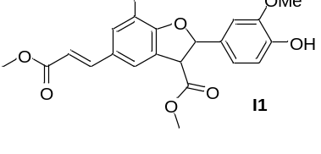
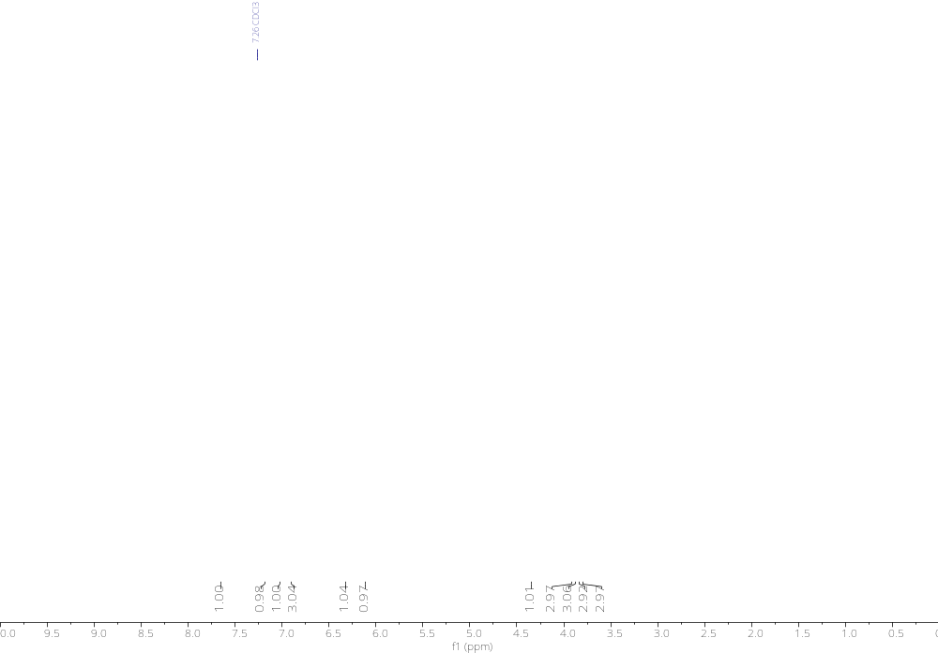

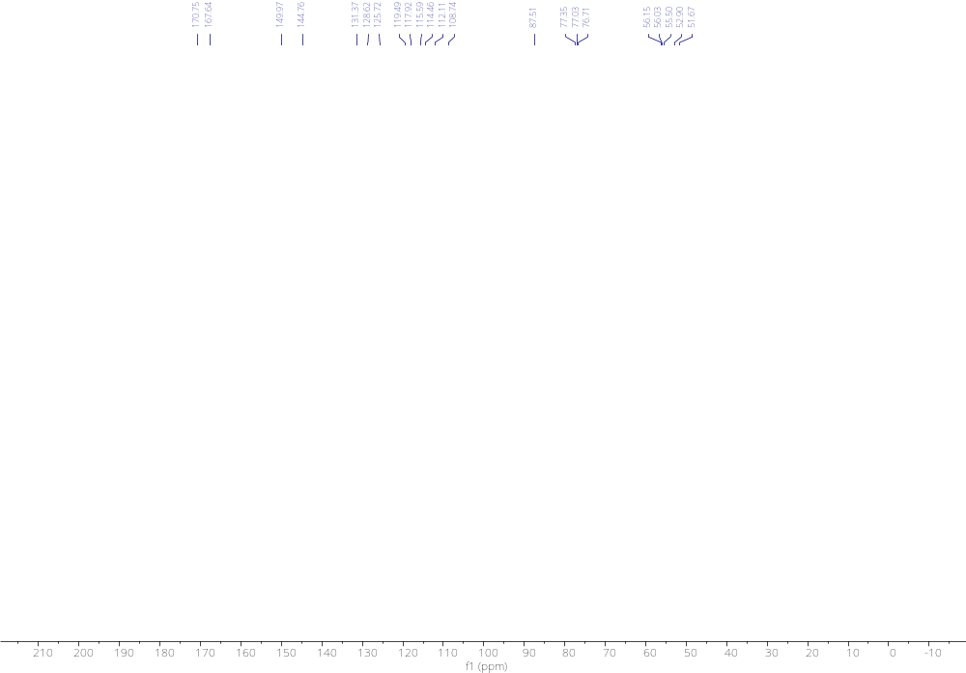
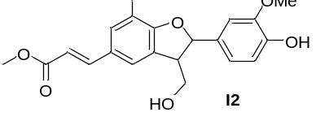
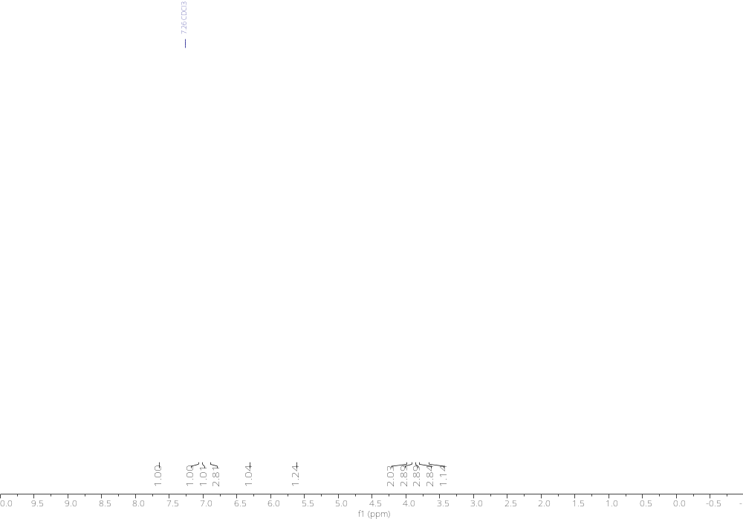

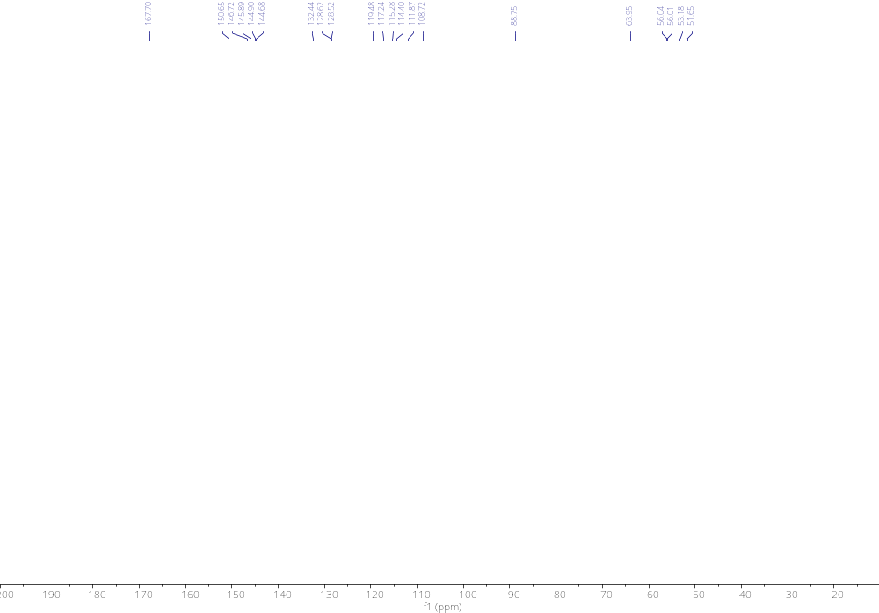

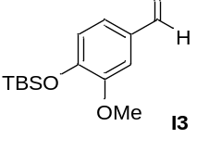
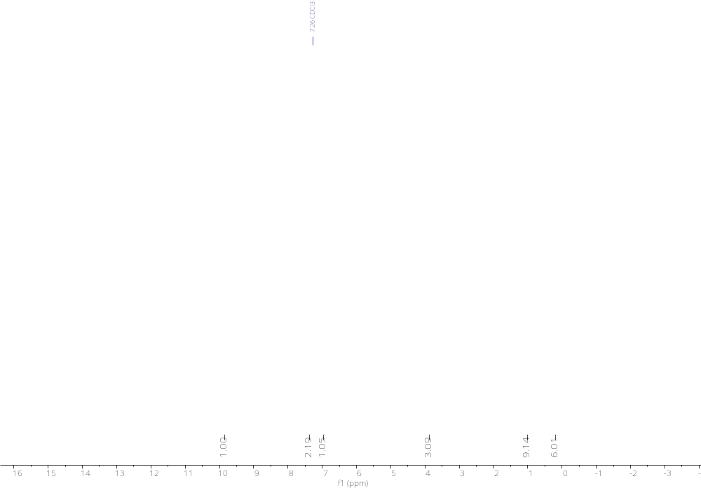

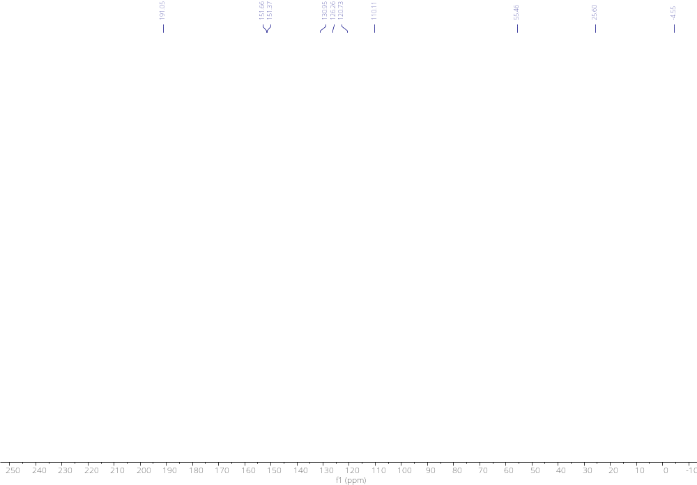
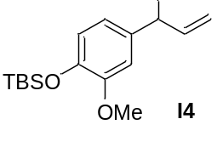
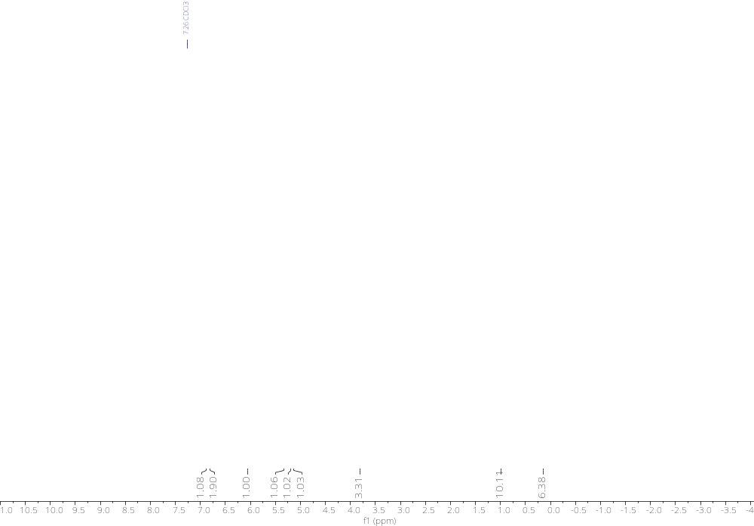

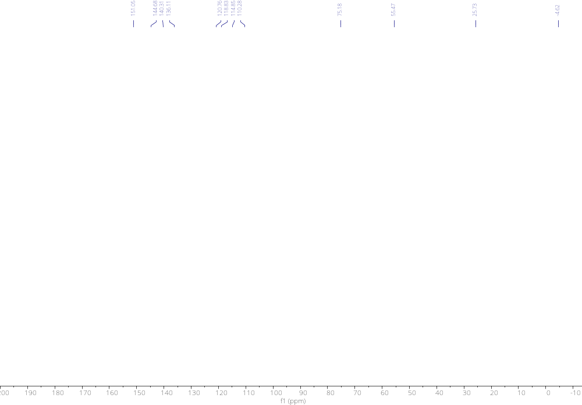
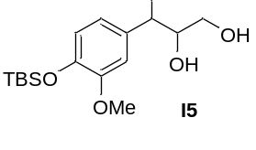
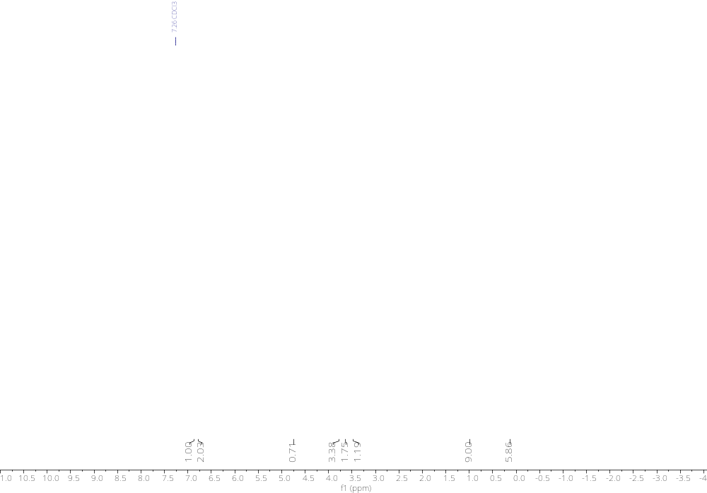

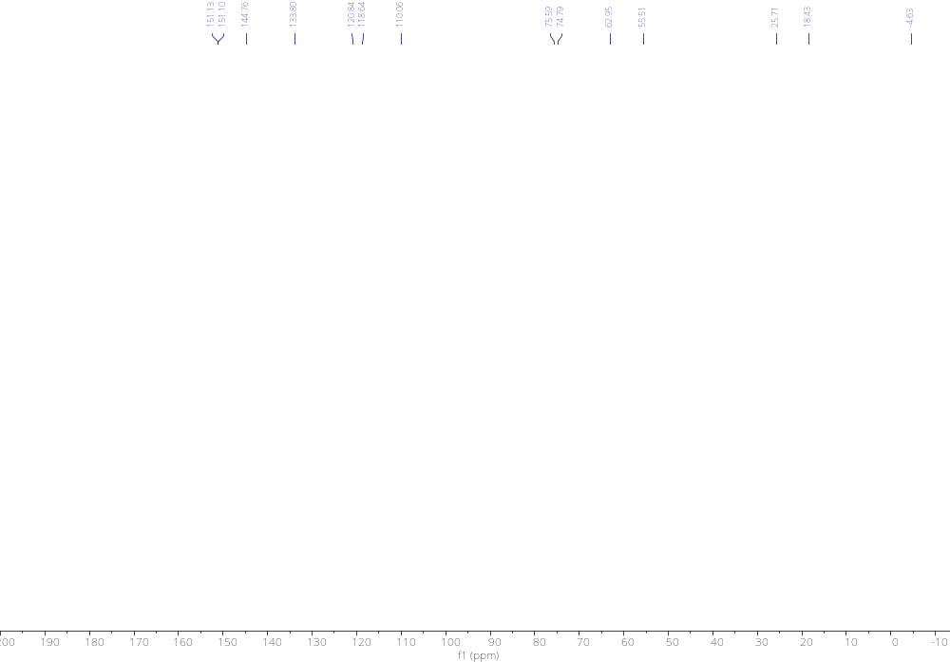

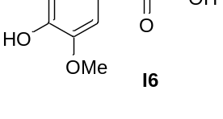
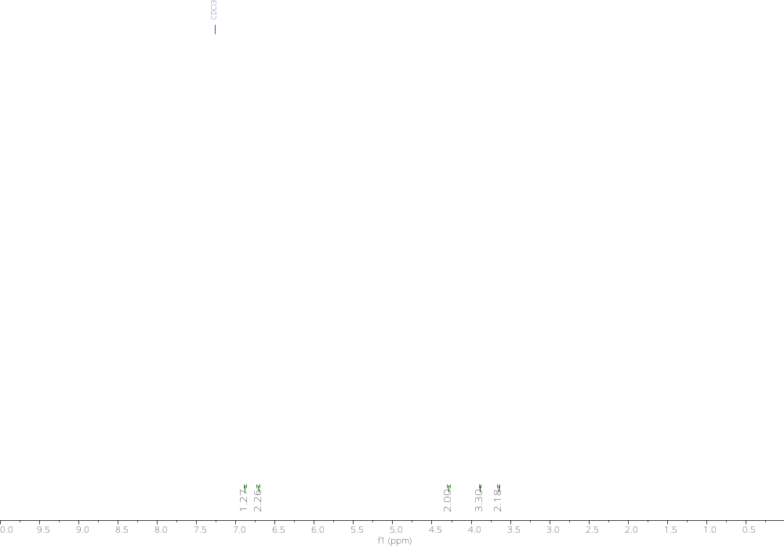



14. Upgrading of pulp
After the OCF reaction, the solid pulp obtained underwent an EDTA washing process to remove trace metals. Initially, the pulp was disintegrated using a homogenizer. Subsequently, a 0.25 wt% EDTA solution was prepared in 500 mL of water. NaOH was added to the solution until it became clear, and then the pH was adjusted to the range of pH 5-6 using HCl. Next, 10 g of pulp was added to the solution, and it was heated to 60°C for 1 hour, repeating this process twice. The washing was continued until little or no green solution was observed. Then the pulp was filtered, washed with water, and subjected to the next process.
To enhance brightness, chlorite bleaching was applied. The bleaching solution was prepared by taking 10 g of pulp and using a total volume of 1 L, with 500 mL of each of the following solutions: i) 1.7% NaClO₂ and ii) 2.7% NaOH along with 7.5% AcOH. The reaction was heated to 80°C for 2-3 hours, and this process was repeated 2-3 times. After completion, the pulp was filtered, washed with water, and then subjected to the next process.
To narrow the polydispersity index, an alkaline washing process was implemented. 10 g of pulp were added with 250 mL of 2M NaOH. The reaction was carried out at 65°C for 1 hour and repeated 2-3 times. After completion, the pulp was filtered, washed, air-dried, and subsequently subjected to brightness and viscosity analysis. (Figure S10)

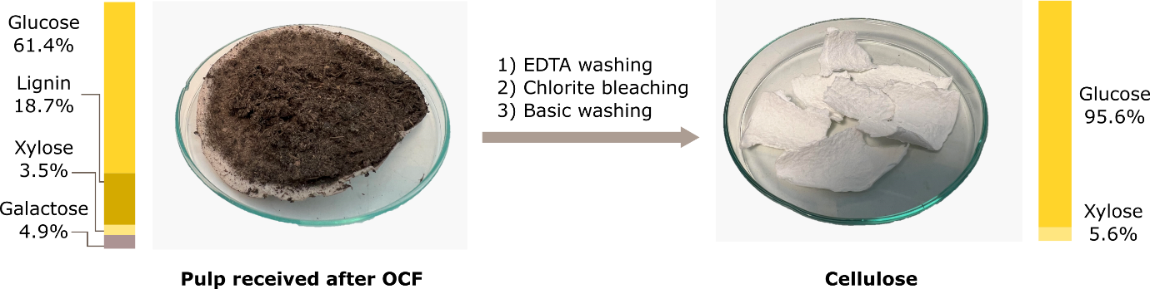
Figure S10. Upgrading of pulp.

15. Nanocellulose
The CNF prepared was analyzed using Fourier-Transform infrared spectroscopy (FTIR) employing a Varian 670-IR spectrometer with an attenuated total reflectance (ATR) accessory. Spectra were obtained in the 4000 to 500 cm⁻¹ range, with a resolution of 4 cm⁻¹ and averaging 32 scans. The semi-crystalline nature and crystallinity of the cellulose were investigated using an X-ray diffractometer, specifically the D8 Discover Power Diffractometer by Bruker, operating at 40 kV and 40 mA, utilizing monochromatic CuKα radiation (λ = 0.154 nm). The crystallinity index (CrI) was calculated using Segal's equation. Thermal degradation was studied by heating CNF samples from 25 °C to 600 °C under a nitrogen atmosphere at 30 ml/min with a heating rate of 10 °C/min, using the Discovery TGA by TA Instruments. Atomic force microscopy (AFM) was employed for fiber imaging, utilizing the Dimension Fast Scan AFM instrument with the Nanoscope controller by Bruker in Santa Barbara, California.
Cellulose nanofibers (CNFs) were derived from bleached pulp through a mechanical treatment procedure. Prior to this treatment, the pulp underwent a 30-minute mixing stage using an ultra-turax mixer. Subsequently, the mechanical processing was carried out using a microfluidizer (LM10 Microfluidizer) equipped with a 100 µm channel and operating at 1500 bar, with the pulp maintained at a solid content of 0.5wt%. After 20 passes through the microfluidizer, CNFs were successfully produced. The morphology of these fibers was examined using atomic force microscopy, as depicted in Figure S11. The images revealed a distribution in sizes, with larger fractions averaging around (70±9.91nm) and smaller fractions averaging (29±11.28 nm). The film-forming capability of the CNFs was evaluated, and the resulting film is shown in Figure S12.
Figure S11. AFM image of CNF from wood bark.

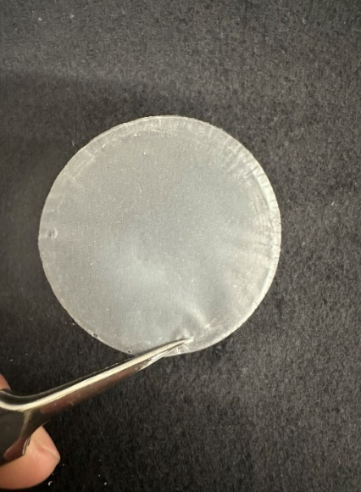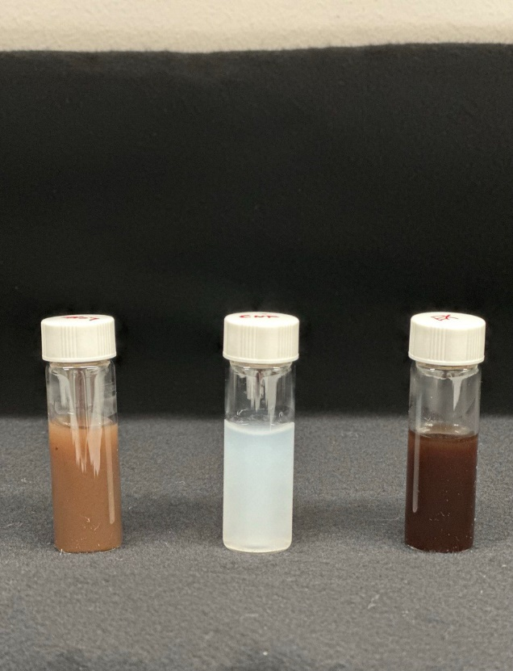
Figure S12. CNF film of wood bark.

The FTIR spectrum (Figure S13) of the prepared CNF exhibits typical peaks of cellulose, including a broad peak between 3600-3200, representing the stretching vibration of O-H bonds in cellulose materials. Additionally, peaks at 2911 correspond to C-H symmetrical stretching, while 1031 is associated with the β-(1–4) glucosidic ether linkages (C-O-C), reflecting vibration modes of the anhydro-glucopyranose ring skeleton. Notably, the absence of the 1515 band in CNF spectra confirms complete lignin removal following bleaching.42,43 The X-ray diffraction (XRD) data displayed in Figure xb reveal the characteristic peaks associated with cellulose type I. These peaks are observed at 2θ angles of 15.1°, 16.9°, and 23.0°, corresponding to the crystallographic planes (1 ̅10), (110), and (200) of cellulose I, respectively. The crystallinity index, determined using the Segal equation, was found to be 77%, a characteristic value for woody biomass.
Figure S13. Characterization of CNF from Spruce bark (a) FTIR and (b) XRD.

16. ISO-Brightness test
A white pulp sheet weighing 2.5 g was created through filtration using Whatman filter paper (with a pore size of 3 mm and a diameter of 90 mm). This sheet was then compressed and left to dry at room temperature for 2 days, resulting in a thin white pulp sheet with a thickness of 5 mm. The ISO-brightness measurement was conducted using a Minolta Spectrophotometer CM─3630 following the standard method ISO 2470-1 and was conducted externally at MoRe Research.

17. Viscosity measurement
The viscosity analysis was conducted externally at MoRe Research, following the standard method ISO 5351:2010.

18. References

1. Saito, Y., Kobayashi, Y., Yoshida, N., Goto, M. & Nakagawa-Goto, K. Synthesis of Thio-lignan Analogues, Bioequivalent Salvinal without Unfavored Aldehyde. J. Org. Chem. 86, 7092–7106 (2021).
2. Miles-Barrett, D. M. et al. The synthesis and analysis of lignin-bound Hibbert ketone structures in technical lignins. Org. Biomol. Chem. 14, 10023–10030 (2016).

