Supplementary Information
Machine learning interatomic potential with DFT accuracy for general grain boundaries: Analysis of grain boundary energy and atomic structure in α-Fe polycrystals
Kazuma Ito ^{a,}*, Tatsuya Yokoi ^{b}, Katsutoshi Hyodo ^{c}, Hideki Mori ^{d}

ª Advanced Technology Research Laboratories, Nippon Steel Corporation, 20-1, Shintomi, Futtsu city, Chiba 293-8511, Japan
^{b} Department of Materials Physics, Nagoya University, Nagoya 464-8603, Japan
^{c} Steel Research Laboratories, Nippon Steel Corporation, 20-1, Shintomi, Futtsu city, Chiba 293-8511, Japan
^{d} Department of Mechanical Engineering, College of Industrial Technology, 1-27-1 Nishikoya, Amagasaki, Hyogo 661-0047, Japan
* Corresponding author.
E-mail address: ito.nn3.kazuma@jp.nipponsteel.com (K. Ito)

Supplementary Note 1: Calculation accuracy of the constructed MTP for physical properties and lattice defects of α-Fe
In the manuscript, the computational accuracy of the constructed MTP for α-Fe grain boundaries was discussed in detail. In this section, we discuss the calculation accuracy of the constructed MTP for physical properties and the other lattice defects of α-Fe. Supplementary Figure 1 shows the energies and atomic forces calculated using DFT and MTP for the training and testing datasets. The RMSEs for the energies of the training dataset and the testing dataset are 14.11 and 14.79 meV/atom, respectively. The RMSEs for the atomic forces for the training and testing datasets are 71.88 and 75.42 meV/Å, respectively. The small difference in RMSE between the training and testing datasets indicates that serious overfitting did not occur. The RMSEs for the atomic forces were comparable to those of the previous study of NNIP for Fe-H [1]. On the other hand, the RMSEs for the energies were about 4 times larger than those of the NNIP of Fe-H in the previous study. This is related to the fact that the training datasets generated by the RANDSPG method contain a very wide variety of atomic structures, and the similar trend was confirmed in the construction of the MTP for Mg [3]. In fact, as shown in Table 1 in the manuscript, the RMSE for the domain expertise dataset was comparable to the NNIP for Fe-H.
Supplementary Table 1 shows the lattice constants, elastic moduli, vacancies, vacancy clusters, self interstitial atoms, and low-index surface energies in α-Fe calculated using the constructed MTP and DFT. As a comparison, values calculated using NNIP [1], MEAM [2], and EAM [4] are also shown. The values calculated from the MTP are closer to the DFT results than the EAM and MEAM. The computational accuracy is comparable to that of the NNIP, which explicitly includes these defect structures in the training dataset.
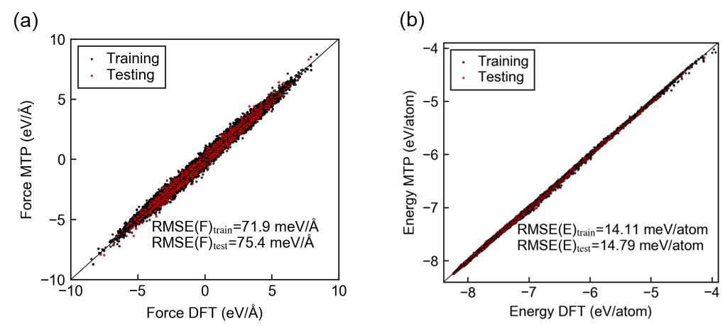
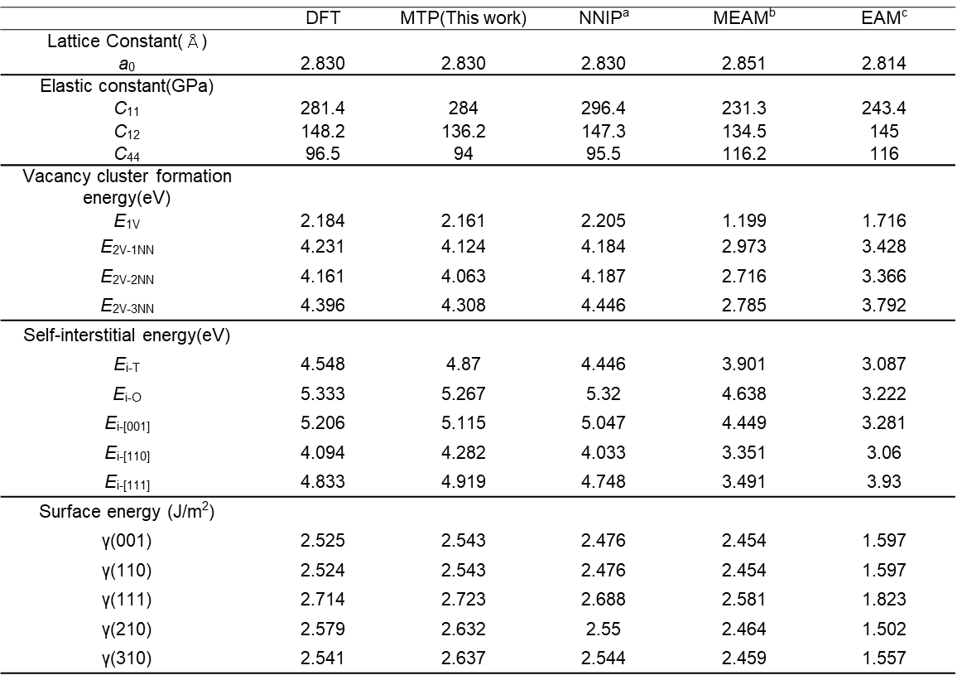
Supplementary Figure 1: MTP training results. (a) Energies and (b) atomic forces for the training and testing datasets calculated using DFT and MTP.
Supplementary Table 1: Calculation accuracy for physical properties and defect formation energies. Comparison of physical properties and defect formation energies of α-Fe calculated from the constructed MTP and DFT and other interatomic potentials. ªMeng et al.[1], ^{b}Asadi et al.[2], ^{c} Proville et al. [4].
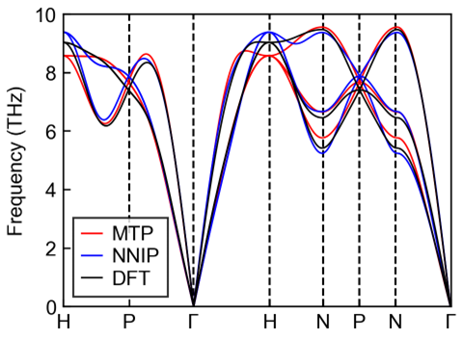
Supplementary Figure 2 shows the phonon dispersion in the equilibrium lattice constant condition calculated using a 4 × 4 × 4 supercell of α-Fe primitive cells. The MTP reproduces the DFT result with the same accuracy as the NNIP. This accuracy was also comparable to those of other MLIPs [5-7].
Supplementary Figure 2: Computational accuracy for phonon dispersion. Phonon dispersion of α-Fe for equilibrium lattice constants calculated by DFT, MTP, and NNIP

Supplementary Note 2: Effect of cut-out area size from nano-polycrystal on atomic forces
In the manuscript, to evaluate the accuracy of the MTP for general grain boundaries, the energies and atomic forces were calculated using DFT for a large number of cells cut out from a 15.0 × 15.0 × 15.0 Å³ region near grain boundaries in a nano-polycrystal. The atomic forces at the cell boundaries are different from those in the nano-polycrystal due to the periodic boundary condition, but the atomic forces near the center of the cell should be approximately the same as those in the nano-polycrystal. Therefore, we investigated the effect of the size of the cutout region on the atomic forces near the center of the cell.
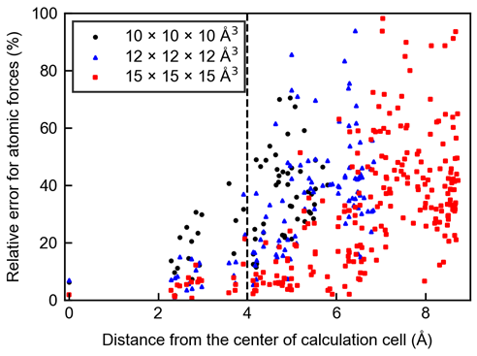
Supplementary Figure 3 shows the relative errors of the atomic forces for the cutout regions of 10.0 × 10.0 × 10.0 Å³, 12.0 × 12.0 × 12.0 Å³, and 15.0 × 15.0 × 15.0 Å³. The relative errors are based on the case where the size of the cutout region is 18.0 × 18.0 × 18.0 Å³. Here, the results are for one case where the cell was cut out from the vicinity of the grain boundary of the nano-polycrystal at 0.1 ns annealing at 300 K because of the large computational cost of one reference 18.0 × 18.0 × 18.0 A³ calculation cell. These results show that when the cutout region is 15.0 × 15.0 × 15.0 A³, the majority of the forces acting on the atomic forces within 4.0 Å of the center of the calculation cell are maintained within 10% relative error. Note that as a verification of the accuracy of the interatomic potentials, it is not necessary that the forces acting on the atoms in the nano-polycrystal are perfectly maintained.
Supplementary Figure 3: Relationship between the size of the cutout region and the error for atomic forces. Relative errors of the atomic forces for the cutout regions of 10.0 × 10.0 × 10.0 Å³, 12.0 × 12.0 × 12.0 Å³, and 15.0 × 15.0 × 15.0 Å³. The relative errors are based on the case where the size of the cutout region is 18.0 × 18.0 × 18.0 Å³. The results are for one case where the cell was cut out from the vicinity of the grain boundary of the nano-polycrystal at 0.1 ns annealing at 300 K.
Supplementary Note 3: Dependence of local atomic environment on nano-polycrystals
In the manuscript, the accuracy of the constructed MTP was verified using randomly oriented nano-polycrystals created using the Voronoi tessellation. More specifically, we used a nano-polycrystal with an initial structure of 28.3 × 28.3 × 28.3 nm³ and consisting of eight crystal grains. Here we show that the local atomic environment near the grain boundaries in this nano-polycrystal is almost unaffected by the random seed for initial structure creation and by the increase in model size (i.e., grain size). The Voronoi volume and coordination number of each atom is investigated as the local atomic environment. This was further verified by examining the atomic energies determined as a result of the local atomic environment.
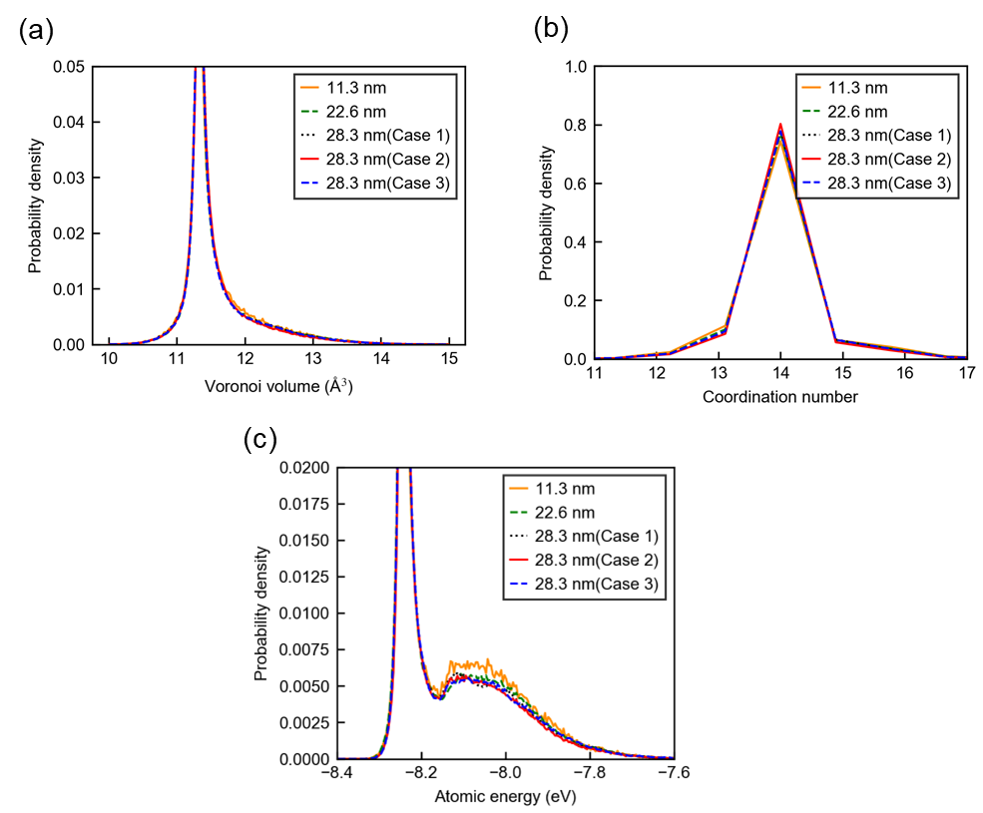
Supplementary Figure 4 shows the probability densities of Voronoi volume, coordination number, and energy for each atom in the 7.35 Å region from the grain boundary center of nano-polycrystals with initial model sizes of 11.3 × 11.3 × 11.3 nm³, 22.6 × 22.6 × 22.6 nm³, and 28.3 × 28.3 × 28.3 nm³, relaxed under the conditions in the manuscript. Three cases with varying random seed are also shown for nano-polycrystals with an initial model size of 28.3 × 28.3 × 28.3 nm³. Only for the 11.3 × 11.3 × 11.3 × 11.3 nm³ nano-polycrystal are both probability densities slightly different from the others, but there is little change between the 22.6 × 22.6 × 22.6 nm³ and 28.3 × 28.3 × 28.3 nm³ nano-polycrystals. Furthermore, the probability densities between the three cases of 28.3 × 28.3 × 28.3 nm³ nano-polycrystals is also almost unchanged. These results indicate that the local atomic environment in a nano-polycrystal consisting of eight grains with an initial structure size of 28.3 × 28.3 × 28.3 nm³ is little affected by the increase in model size and random seed. Furthermore, the local atomic environment in this nano-polycrystal model provides a good sampling of the local atomic environment of real polycrystals with larger grain number and grain size.
Supplementary Figure 4: Relationship between the initial structure of nano-polycrystals and the local atomic environment after relaxation. Probability densities of Voronoi volume, coordination number, and energy for each atom in the 7.35 Å region from the grain boundary center of nano-polycrystals with initial model sizes of 11.3 × 11.3 × 11.3 nm³, 22.6 × 22.6 × 22.6 nm³, and 28.3 × 28.3 × 28.3 nm³, relaxed under the conditions in the manuscript. Three cases with varying random seed are also shown for nano-polycrystals with an initial model size of 28.3 × 28.3 × 28.3 nm³.

Supplementary Note 4: Accuracy of the MTP for plastic deformation and fracture
In this section, we evaluate the computational accuracy of the constructed MTP for plastic deformation and fracture in α-Fe. First, we evaluated the accuracy of calculations for the ${a_{0}}/2〈111〉\left\{110\right\}$ screw dislocation core structure and its energetics, which are particularly important in the plastic deformation behavior of α-Fe. Specifically, the Peierls potential and 2D Peierls potential of the screw dislocation were calculated. The 2D Peierls potential is the potential energy profile as a function of the screw dislocation core position. For these calculations, we adopted the calculation model and conditions used by Mori et al. in their previous study [6]. Specifically, we used a 22$\left[11\overline{2}\right]$ × 38$\left[1\overline{1}0\right]$ × $1/2\left[111\right]$ bcc bulk model that is periodic only along the [111] direction. The total number of atoms in this model is 5016. To create the dislocation core structure at the center of the (111) plane of the model, we applied to all the atoms the anisotropic elastic solution of the displacement field. The atomic positions of the model were then optimized, except for atoms located more than 6 nm away from the dislocation core.
Supplementary Figure 5 shows the Peierls potential of the ${a_{0}}/2〈111〉\left\{110\right\}$ screw dislocation core in α-Fe calculated using the constructed MTP and the nudged elastic band method. For comparison, the results calculated using ANN [6], which reproduces the dislocation dynamics extremely well, and EAM [8] are also shown. The energy profile calculated using the MTP is in good agreement with that of the ANN. Furthermore, they are in good agreement with those obtained by previous DFT [9-11].
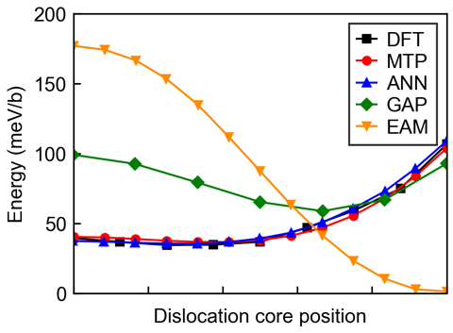
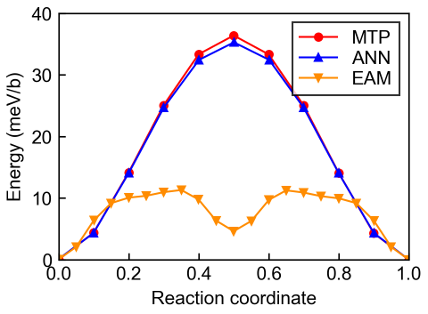
Next, we evaluated the computational accuracy of the constructed MTP for the 2D Peierls potential. The 2D Peierls potential not only determines the Peierls barrier and migration path of the dislocation core, but also controls the energetics of double kink formation, which plays an important role in the mobility of the screw dislocation at a finite temperature [12, 13]. For the threefold symmetry of the bcc lattice, the 2D Peierls potentials are characterized by the energy profile along the cross-sectional line between the hard core and split core positions [9-11]. Supplementary Figure 6 shows the energy profile along the cross-sectional line between the hard core and split core positions calculated using the constructed MTP. As a comparison, those calculated using DFT [11], ANN [6], GAP [14], and EAM [8] in previous studies are also shown. The energy profiles calculated by the MTP are in good agreement with those calculated by DFT and ANN. The GAP results make it clear that machine-learning interatomic potentials do not necessarily reproduce 2D Peierls potentials.
Supplementary Figure 6: Calculation accuracy for 2D Peierls potential. Energy profile along the cross-sectional line between the hard core and split core positions calculated using the constructed MTP. As a comparison, those calculated using DFT, ANN, GAP, and EAM in previous studies are also shown.
Supplementary Figure 5: Calculation accuracy for Peierls potential. Peierls potential of the ${a_{0}}/2〈111〉\left\{110\right\}$ screw dislocation in α-Fe calculated using the constructed MTP. As a comparison, those calculated using the ANN and EAM in previous studies are also shown.
To further evaluate the computational accuracy of the constructed MTP for crack propagation, a generalized stacking fault energy (GSF) curve along ⟨110⟩ on {110} under no strain and tensile strain application was calculated [15]. We created a supercell model of $\left[001\right]$ × 12$\left[110\right]$ × $\left[1\overline{1}0\right]$. A model with 5.0% equiaxial strain in the [110] and [110] directions was also created. Supplementary Figure 7 shows the GSFE of the (110) glide plane in the $\left[1\overline{1}0\right]$ direction for no external strain and 5% external equi-biaxial strain in the $\left[1\overline{1}0\right]$ direction calculated using the constructed MTP and DFT. As a comparison, results calculated by the EAM and ANN in a previous study [16] are also shown. The conditions for the DFT calculations are the same as in the manuscript. The GSFE curve under tensile strain computed using the EAM have unphysical local minima. This causes false plasticity near the crack tip, making it impossible to reproduce accurate brittle fracture [15]. On the other hand, the GSFE curve calculated by the MTP does not observe any unphysical local minima and agrees well with those calculated by the ANN and DFT.
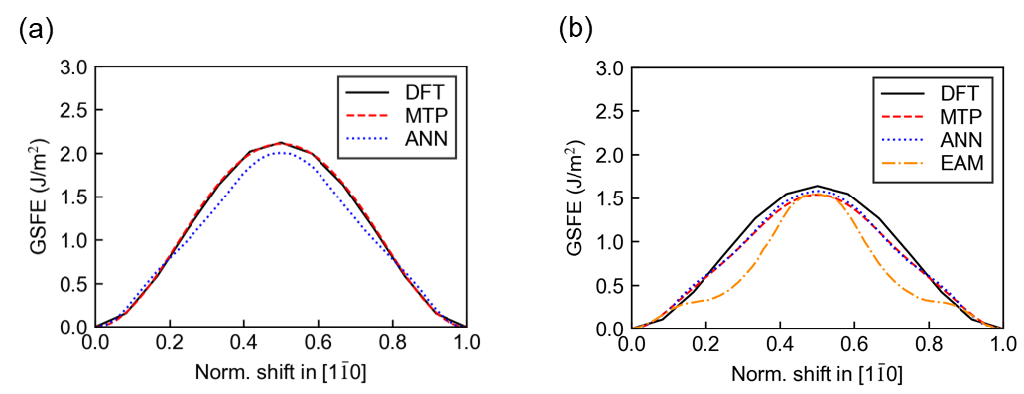
Thus, the constructed MTP has excellent accuracy for plastic deformation and fracture behavior. It should be noted that the MTP does not directly incorporate the training dataset related to the plastic deformation and fracture behavior, suggesting that the accuracy is not limited to the types of dislocations and generalized stacking energies evaluated in this study.
Supplementary Figure 7: Calculation accuracy for general stacking fault energy. General stacking fault energy (GSFE) of the (110) glide plane in the $\left[1\overline{1}0\right]$ direction for (a) no external strain and (b) 5% external equi-biaxial strain in the $\left[1\overline{1}0\right]$ direction calculated using the constructed MTP and DFT. As a comparison, those calculated using the ANN and EAM in previous studies are also shown.
References
[1] F.-S. Meng, J.-P. Du, S. Shinzato, H. Mori, P. Yu, K. Matsubara, N. Ishikawa, S. Ogata, General-purpose neural network interatomic potential for the α-iron and hydrogen binary system: Toward atomic-scale understanding of hydrogen embrittlement, Phys. Rev. Mater. 5(11) (2021) 113606.
[2] E. Asadi, M. Asle Zaeem, S. Nouranian, M.I. Baskes, Quantitative modeling of the equilibration of two-phase solid-liquid Fe by atomistic simulations on diffusive time scales, Phys. Rev. B 91(2) (2015) 024105.
[3] M. Poul, L. Huber, E. Bitzek, J. Neugebauer, Systematic atomic structure datasets for machine learning potentials: Application to defects in magnesium, Phys. Rev. B 107(10) (2023) 104103.
[4] L. Proville, D. Rodney, M.-C. Marinica, Quantum effect on thermally activated glide of dislocations, Nature Materials 11(10) (2012) 845-849.
[5] K.C. Pitike, W. Setyawan, Accurate Fe–He machine learning potential for studying He effects in BCC-Fe, J. Nucl. Mater. 574 (2023) 154183.
[6] H. Mori, T. Ozaki, Neural network atomic potential to investigate the dislocation dynamics in bcc iron, Phys. Rev. Mater. 4(4) (2020) 040601.
[7] Matrix Methods: Theory, Algorithms and Applications, WORLD SCIENTIFIC, 2010, p. 604.
[8] M.I. Mendelev, S. Han, D.J. Srolovitz, G.J. Ackland, D.Y. Sun, M. Asta, Development of new interatomic potentials appropriate for crystalline and liquid iron, Philos. Mag. 83(35) (2003) 3977-3994.
[9] L. Dezerald, L. Ventelon, E. Clouet, C. Denoual, D. Rodney, F. Willaime, Ab initio modeling of the two-dimensional energy landscape of screw dislocations in bcc transition metals, Phys. Rev. B 89(2) (2014) 024104.
[10] L. Ventelon, F. Willaime, E. Clouet, D. Rodney, Ab initio investigation of the Peierls potential of screw dislocations in bcc Fe and W, Acta Mater. 61(11) (2013) 3973-3985.
[11] M. Itakura, H. Kaburaki, M. Yamaguchi, First-principles study on the mobility of screw dislocations in bcc iron, Acta Mater. 60(9) (2012) 3698-3710.
[12] K. Edagawa, T. Suzuki, S. Takeuchi, Motion of a screw dislocation in a two-dimensional Peierls potential, Phys. Rev. B 55(10) (1997) 6180-6187.
[13] K. Edagawa, T. Suzuki, S. Takeuchi, Plastic anisotropy in b.c.c. transition metals, Mater. Sci. Eng., A 234-236 (1997) 1103-1105.
[14] D. Dragoni, T.D. Daff, G. Csányi, N. Marzari, Achieving DFT accuracy with a machine-learning interatomic potential: Thermomechanics and defects in bcc ferromagnetic iron, Phys. Rev. Mater. 2(1) (2018) 013808.
[15] J.J. Möller, M. Mrovec, I. Bleskov, J. Neugebauer, T. Hammerschmidt, R. Drautz, C. Elsässer, T. Hickel, E. Bitzek, {110} planar faults in strained bcc metals: Origins and implications of a commonly observed artifact of classical potentials, Phys. Rev. Mater. 2(9) (2018) 093606.
[16] T. Suzudo, K. Ebihara, T. Tsuru, H. Mori, Emergence of crack tip plasticity in semi-brittle α-Fe, J. Appl. Phys. 135(7) (2024) 075102.

