SUPPORTING INFORMATION

Halochromic cellulose textile obtained via dyeing with biocolorant isolated from Streptomyces sp. strain NP4
Ana D. Kramar^{1,2*}, Tatjana R. Ilić-Tomić³, Jelena M. Lađarević⁴, Jasmina B. Nikodinovic-Runic³, Mirjana M. Kostic¹
*Corresponding author
email: akramar@tmf.bg.ac.rs

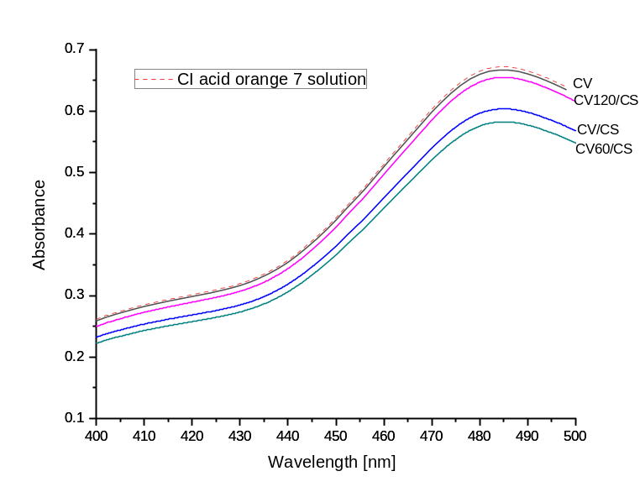
Fig. S1 Absorbance of CI acid orange 7 dye solution with pristine (CV) and samples with chitosan (CV/CS pristine viscose with chitosan, CV60/CS and CV120/CS oxidized viscose with chitosan)

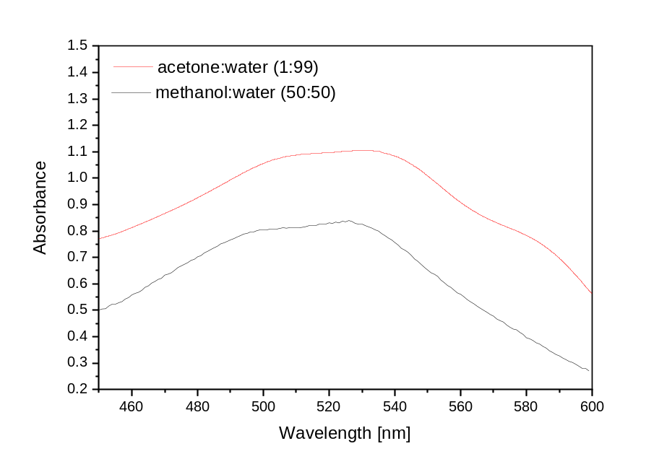
Fig. S2 Solutions of crude bacterial extract from Streptomyces sp. NP4 in acetone:water and methanol:water (200 mg L⁻¹ concentration)

