Author Summary
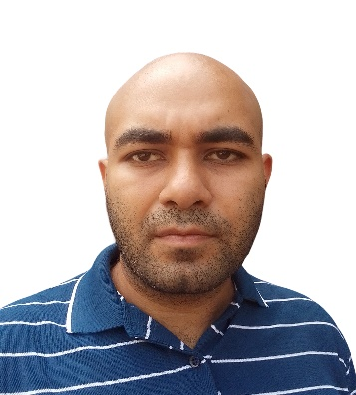
Nehal Kalita is a programmer who is currently collaborating on projects with college professors. He holds a bachelor’s degree in Science from Bangalore University and a master’s degree in Computer Science from University of Mumbai. His research interests include digital image processing, computer graphics and natural language processing. He is committed to furthering research in his areas of interest and is continually seeking new challenges and opportunities to expand his knowledge and skills.

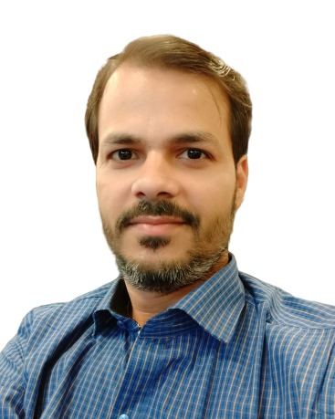
Dr. Rajesh Kumar Maurya is an established Author, Academician, Researcher, Corporate Trainer, and IT Consultant with rich experience across domains. He is an alumnus of the University of Mumbai, Ph.D degree in Computer Science from university department besides holding five master's degrees including M.Phil(IT), MSc(Comp Sc), MCA, M.Tech (CSE), and M.B.A.(IS) from various esteemed Institutions. He is currently working with Usha Pravin Gandhi College of ASC with the Department of Information Technology affiliated to University of Mumbai. His research interests include Spatial computing, Computer vision, Augmented Reality, and Contextual Machine Learning. His current work focusses on deep learning and contextual mining and has been guiding projects in allied areas.

