Supplemental information
Methods: Histotripsy Lesion Quantification by Entropy Analysis (HLQE)
The following text describes a step-by-step approach on how the lesion quantification algorithm was utilized to quantify the tissue damage.
Step 1: Selecting the ROI:
- An unprocessed image (entire slide scan of a Masson’s trichrome stained tissue slice) to be analyzed was loaded into MATLAB, and a region of interest (ROI) X2 was chosen based on the therapy grid size delivered.
Step 2: Entropy filtering:
- The entropy filter was independently applied to a 25x25 pixel neighborhood across the three red, green and blue channels of the original ROI image. This neighborhood size was chosen to possess sufficient resolution for differentiating lesion vs intact tissue with minimal loss of accuracy.
- The resulting arrays contained the calculated entropy value in the neighborhood around the corresponding pixel from the ROI across the three channels. The arrays were then multiplied to get the overall entropy map.
Step 3: Binarization:
- From the entropy map image, a binarization reference frame was chosen to encapsulate regions containing both lesion and intact tissue.
- A threshold value was calculated from a modified image chosen from the binarization reference, using Otsu’s method (graythresh function in MATLAB) to separate the pixels into the two classes. Otsu’s method calculates a single intensity threshold for classifying the foreground from the background by minimizing the intra class variance or in other words maximizing the inter-class variance. In our case this threshold was for separating the lesion and intact tissue.
- The image was then binarized using the imbinarize function with the calculated threshold value from above. The final binary image is a representation of the lesion (black pixels) and intact tissue (white pixels).

Step 4: Calculating the tissue destroyed by sub sampling:
- To quantify the % tissue destroyed, a total of 48 randomized circular areas of radii=20 pixels were sampled from within the lesion. This was done to account for the tissue shrinkage that happens with fixation in formaldehyde. The fraction of destroyed tissue, which is a quantitative estimation of the completeness of the treatment was then calculated by summing the black pixels and dividing by the total area within the ROI. The average value across the 48 sub sampled sites were then calculated. The whole process from the selection of a binarization reference to the final tissue fraction calculation was then repeated thrice with different reference frames chosen and the final reported value was an average of the three measurements.
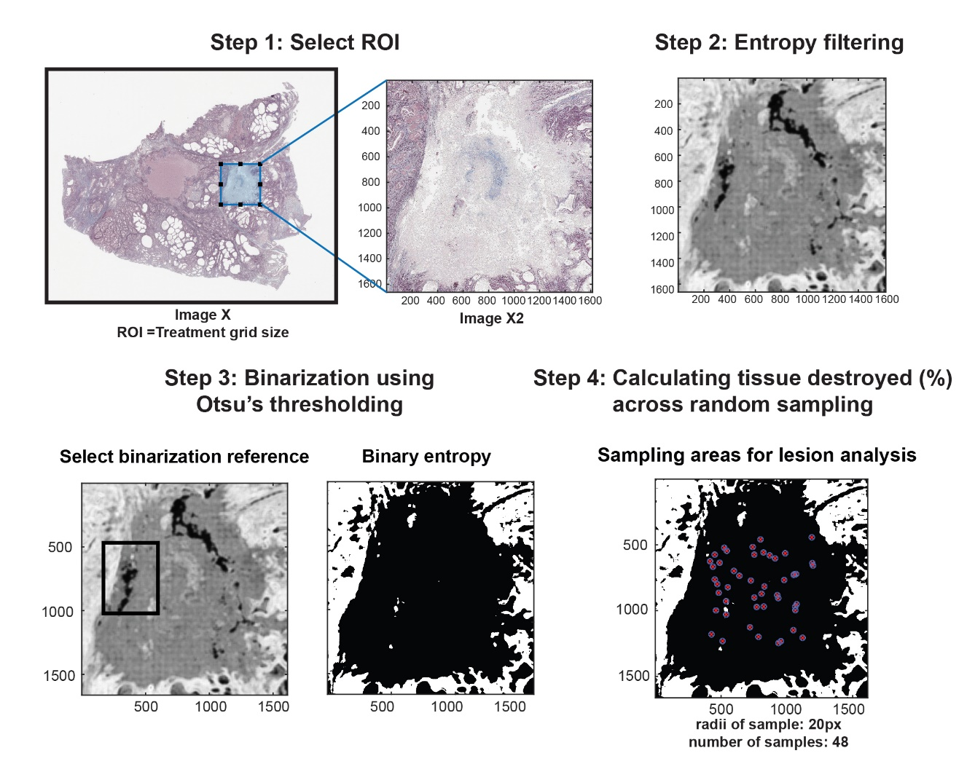
Supplemental Figure 1: Workflow depicting the outcome of the various steps in the histology slide processing by HLQE algorithm.

Methods: Performance of the HLQE model against manual segmentation
The performance of the HLQE algorithm was compared against that of manually identified histotripsy lesions (baseline) via histology. A total of 10 random Masson’s trichrome histological samples containing lesions treated by the different modalities were chosen.
- Preprocessing of images: The images were standardized using an automated tone control tool that set the exposure, clarity and vibrance of the image by analyzing the color histogram in Lightroom (Adobe Inc., San Jose, CA).
- Histologic analysis – Manual segmentation: All the processed samples were manually segmented in ImageJ with a freeform tool to identify the lesion area which was manually deleted from the final image. The following criteria were used to determine what is a lesion in the tissue for uniform processing: (1) clear homogenization with cellular debris and smooth boundaries with untreated tissue; (2) glands filled with cell debris but with disrupted cuboidal/columnar epithelial lining was still considered a lesion. Post segmentation, the RGB images were converted to grayscale and binarized using Otsu’s method in ImageJ to apply the comparison metrics.
- HLQE processing: The HLQE algorithm was applied to all the preprocessed samples across the entire image, and binary images were produced as described in the section above.
- Metrics used for measuring performance: A series of standard statistical metrics (accuracy, false positive rate, sensitivity, precision, Sorensen Dice coefficient and Jaccard similarity index) based on these studies^{1,2} were then used to assess the performance of the HLQE against the ground truth. A 2x2 confusion/error matrix, a concept derived from machine learning, was used here to classify the pixels of the binary image with its two classes “lesion” and “intact tissue” into the 4 possible outcomes to apply these metrics. True Positive (TP): All intact tissue pixels are correctly identified as ‘1’. False Positive (FP): Lesion pixels identified as ‘1’. True Negative (TN): All lesion pixels are correctly identified as ‘0’. False Negative (FN): Intact tissue pixels identified as ‘0’.
Results: Performance of the HLQE algorithm
We compared the results from the HLQE algorithm against the manually segmented baseline image. The results tabulated in Supplementary Table 1 show that the HLQE algorithm performs well across all the metrics measured. With a low false positive rate and a higher score across the remaining metrics, the validity of the HLQE algorithm in accurately quantifying lesions was established. Supplemental Figure 2 depicts the original histology image, followed by the superimposed lesion image identified manually segmented (baseline) and by the HLQE algorithm.

Supplementary Table 1: Different metrics summarizing the performance of the HLQE against manual segmentation (baseline) across n=10 samples.
Accuracy | False Positive Rate | Sensitivity | Precision | Sorensen Dice Coefficient | Jaccard similarity index
0.85±0.04 | 0.15±0.09 | 0.84±0.06 | 0.82±0.11 | 0.83±0.07 | 0.71±0.09
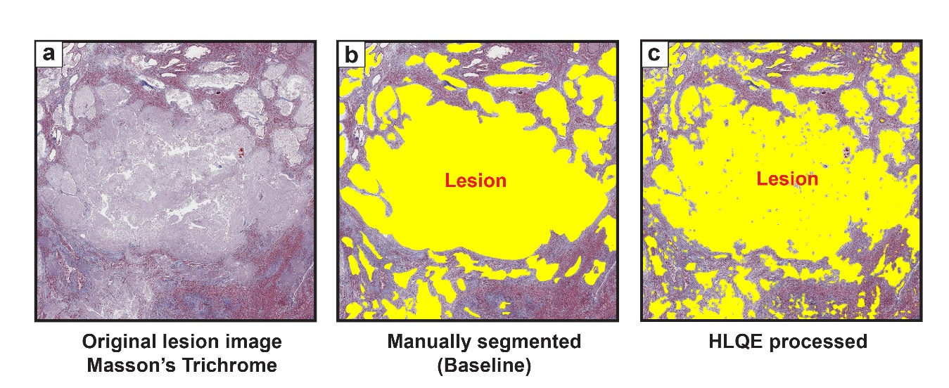
Supplemental Figure 2: Performance of the HLQE algorithm in detecting lesions. (a) Original histology image (b) Manually segmented lesion baseline image superimposed onto the histology slice. (c) Lesion detected by the HLQE and superimposed on to the histology slice.

References
1. Thanh, D. N. H., Thanh, L. T., Erkan, U., Khamparia, A. & Prasath, V. B. S. Dermoscopic image segmentation method based on convolutional neural networks. Int. J. Comput. Appl. Technol. 66, 89–99 (2021).
2. Crum, W. R., Camara, O. & Hill, D. L. G. Generalized Overlap Measures for Evaluation and Validation in Medical Image Analysis. IEEE Trans. Med. Imaging 25, 1451–1461 (2006).

