Table 1. Classification Attributes of Banana Plant Health"

S.No. | Attribute | S.No. | Attribute
1 | Black sigatoka | 2 | Healthy

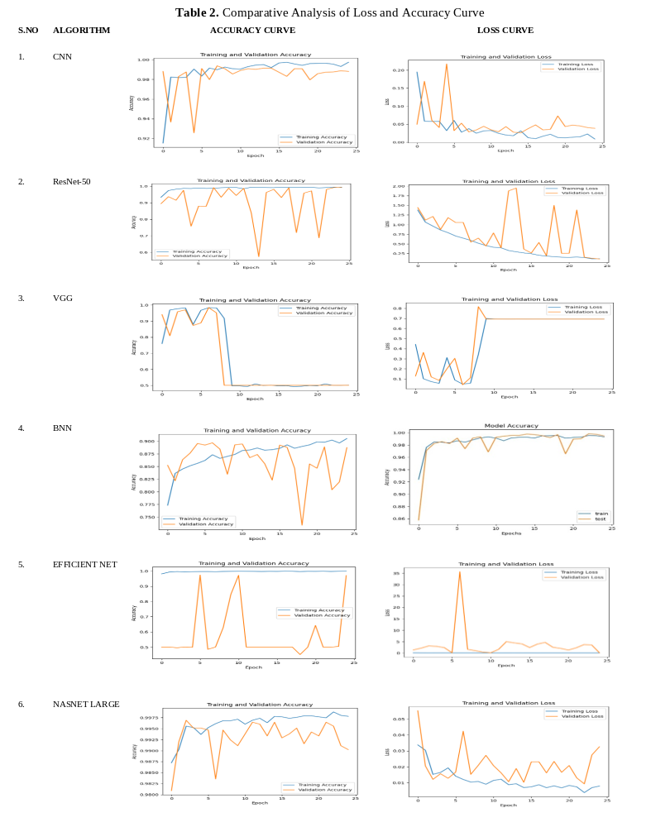

Table 3. Comparative Analysis of Algorithms Accuracy

S.NO | ALGORITHM | ACCURACY
1. | CNN | 98.8%
2. | VGG-16 | 50%
3. | BNN | 88.76%
4. | RESNET 50 | 99.4%
5. | EFFICIENT NET | 97.07%
6. | NASNET | 99.2%

