Supporting Information

Stretchable multimodal photonic sensor for wearable healthcare monitoring

Jingjing Guo^{1,2,†,}*, Jialin Tuo^{1,†}, Zhuozhou Li¹, Xiaoyan Guo¹, Yanyan Chen³, Rong Cai³, Jing Zhong^{1,2}, Lijun Xu^{1,}*

¹School of Instrumentation and Optoelectronic Engineering, Beihang University, Beijing 100191, China
²Ministry of Education Key Laboratory of Precision Opto-Mechatronics Technology, Beihang University, Beijing 100191, China
³School of Engineering Medicine, Beihang University, Beijing, 100191, China
*guojj13@buaa.edu.cn; lijunxu@buaa.edu.cn
†These authors contributed equally to this work.

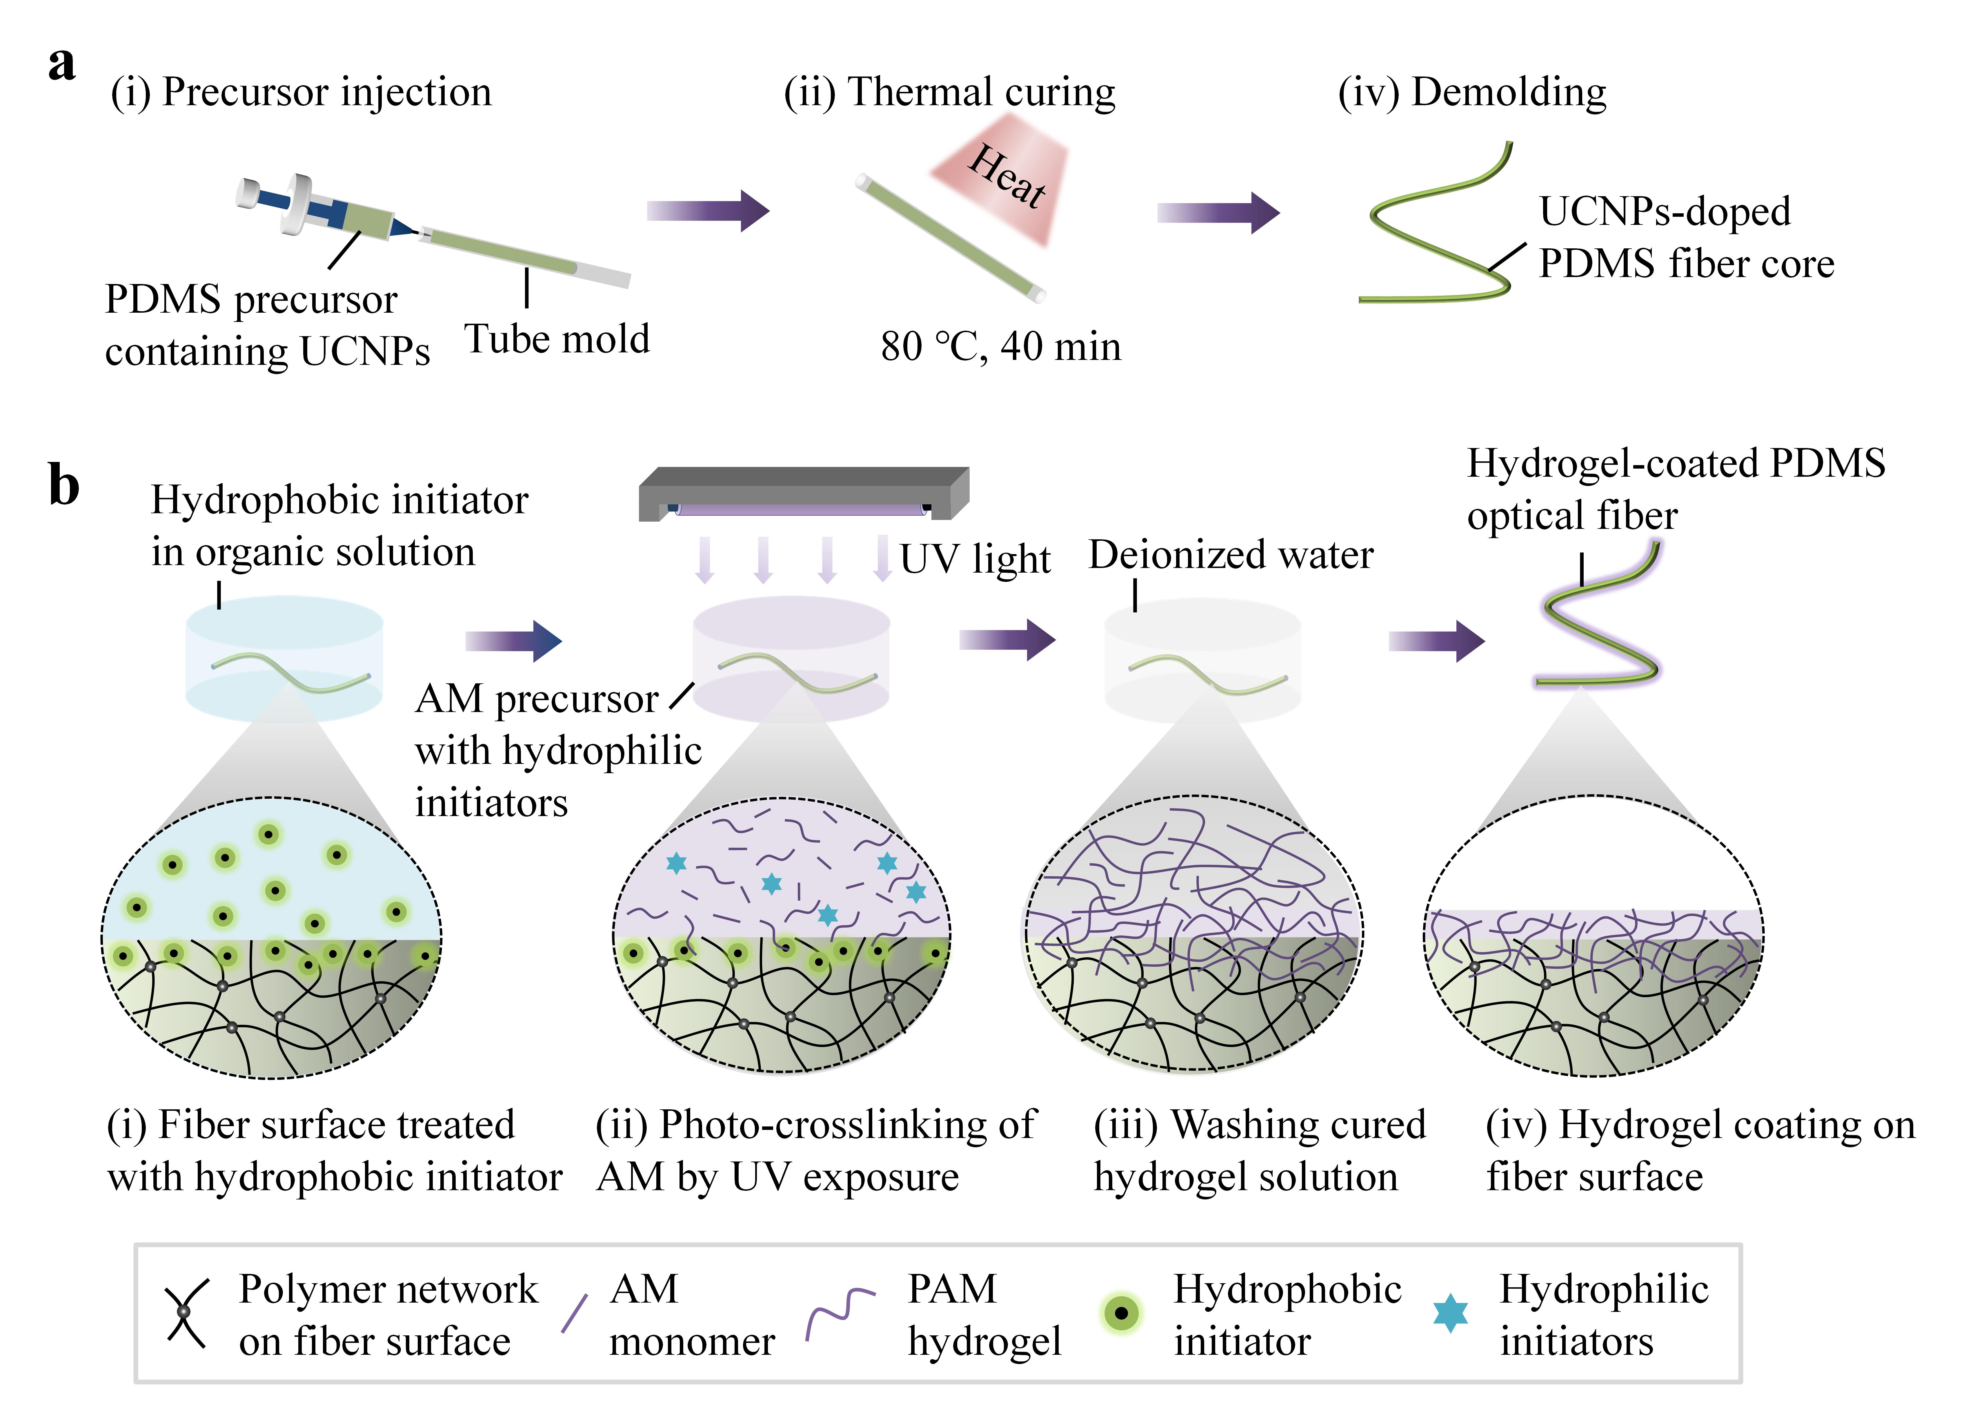
Figure S1. Fabrication of the hydrogel-coated polydimethylsiloxane (PDMS) optical fiber (HPOF). a, Fabrication steps of the HPOF core. PDMS precursor containing UCNPs was injected into a polyethylene tube mold via a syringe. After thermal curing at 80 °C for about 40 min, the polymerized fiber core was ejected through water pressure. b, Fabrication of the hydrogel coating. The fiber core was first treated with an ethanol solution of hydrophobic initiator (benzophenone), which swelled the PDMS, and induced diffusion and absorption of the photoinitiators into the core surface. Afterwards, the treated core was immersed in acrylamide (AM) precursor that contains hydrophilic photoinitiators (Irgacure 2959). Upon ultraviolet (UV) exposure, hydrogel monomer was polymerized and covalently bonded on the fiber core, and the obtained HPOF was washed with deionized water to remove additional unreacted regents.

Figure S2. Mechanical robustness of the hydrogel coating. Microscope images of the HPOF upon vigorous stretching (a) or scratching (b), indicating no visible crack or delamination of the hydrogel coating after recovery.

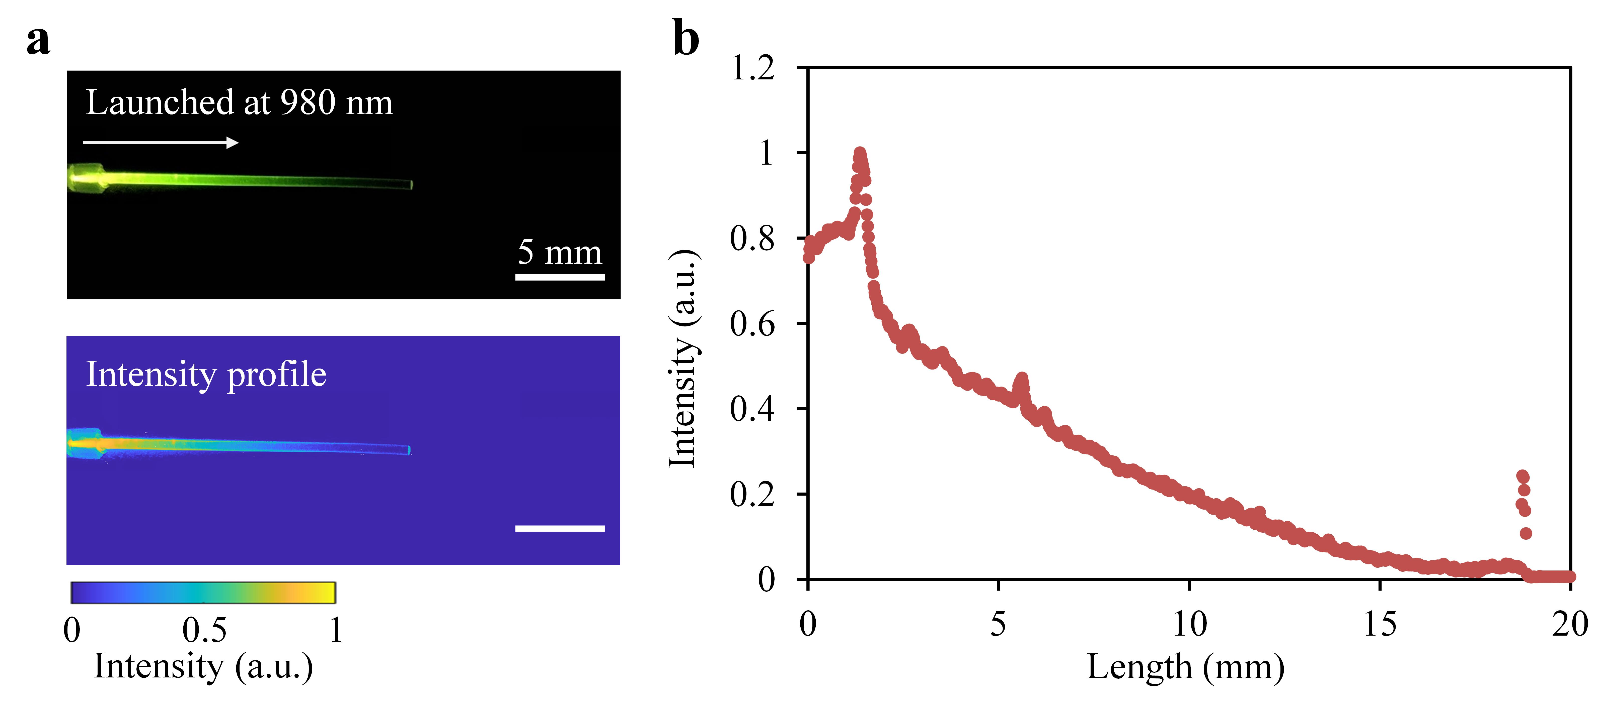
Figure S3. Emission profile of the HPOF upon excitation of a 980 nm laser. a, Photograph and intensity profile of the HPOF. b, Emission intensity along the fiber length.

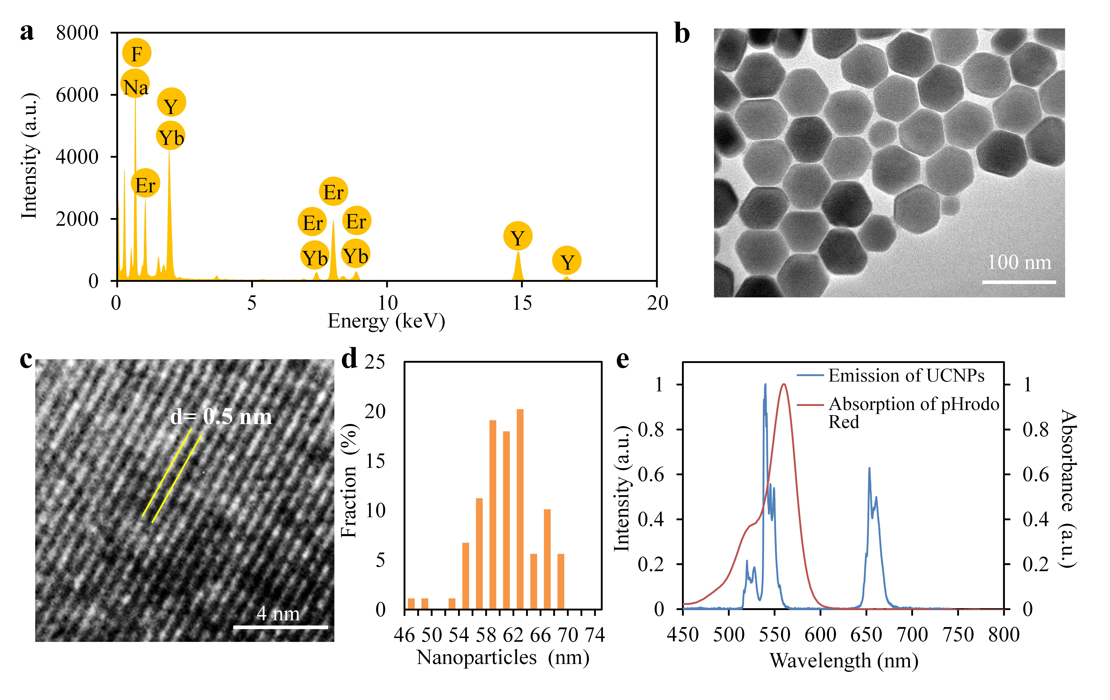
Figure S4. a, Energy-Dispersive X-ray Analysis (EDXA) of the UCNPs, which confirmed the existence of elements including Na, Y, F, Er, and Yb. b, TEM image of the core-shell UCNPs. c, Magnified lattice fringes with d-spacing. d, Size distribution of the core-shell UCNPs. e, Emission and absorption spectra of the UCNPs and pHrodo Red, respectively.

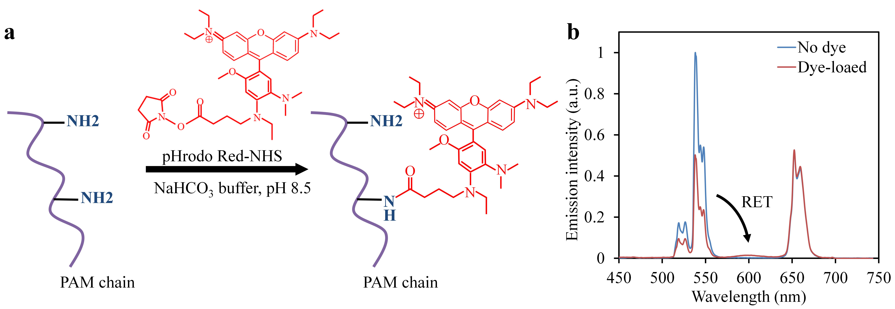
Figure S5. Immobilization of pHrodo Red into hydrogel coating of the HPOF. a, Scheme showing covalent bonding of the pHrodo Red-NHS to amino groups of the hydrogel matrix. b, Emission spectra of the HPOF before and after dye loading, indicating energy transfer from the green emissions of the UCNPs to the pHrodo Red emitting at 600 nm.

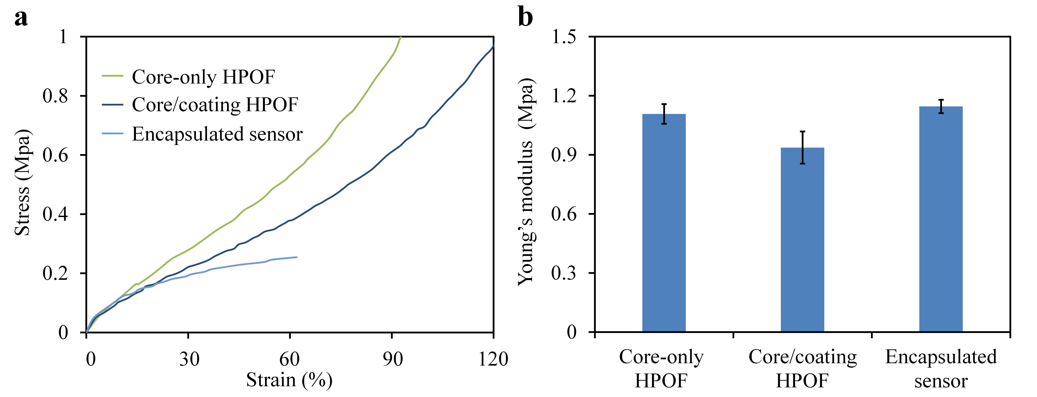
Figure S6. Mechanical properties of the multimodal sensor. a, Stress-strain curves of the core-only HPOF, core/coating HPOF, and the sensor after encapsulation. The encapsulated sensor exhibited a high stretchability beyond 60%. b, Young’s modulus calculated from the stress-strain curves. The encapsulated sensor indicated a low Young’s modulus of 1.14 Mpa, comparable to that of the HPOFs before encapsulation.

Figure S7. Biocompatibility test. a, Cell viability assays after co-incubation of SK-N-SH cells with the multimodal sensor for 24 h, 48 h, and 72 h. Blue: live cells; red: dead cells. b, Quantitative analysis of cell viability.

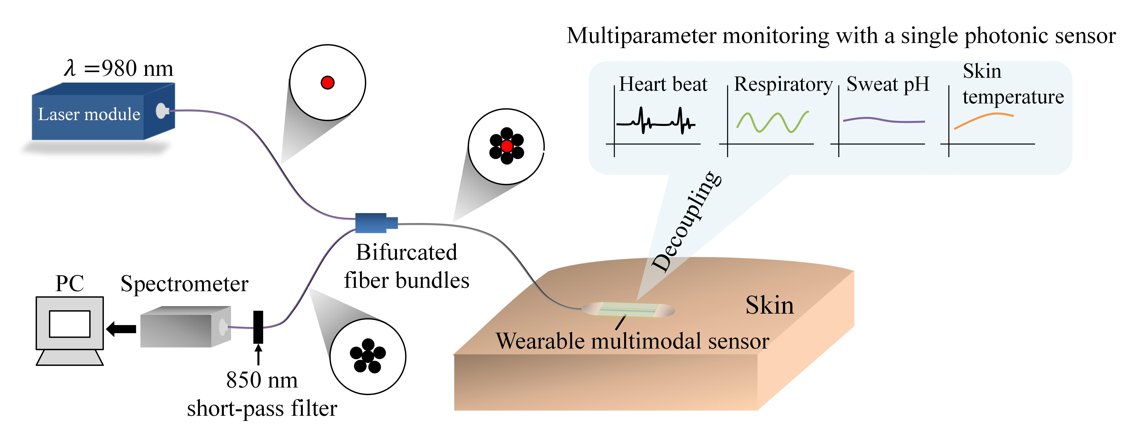
Figure S8. Interrogation Setup. A fiber-coupled laser at 980 nm was launched into the multimodal sensor as the excitation source. The sensor was pigtailed with a bundled silica MMFs, which consisted of a single central fiber for laser excitation and six receiving fibers surrounding the central fiber for emission collection. Such a configuration of the pigtailed MMFs was beneficial in improving the collected emission intensity, allowing excitation of the sensor at low laser power. The emissions from the multimodal sensor were collected by the six receiving fibers and guided to a compact spectrometer for spectral analysis. To suppress the residual 980-nm laser, a short-pass filter at 850 nm was inserted prior to the spectrometer.

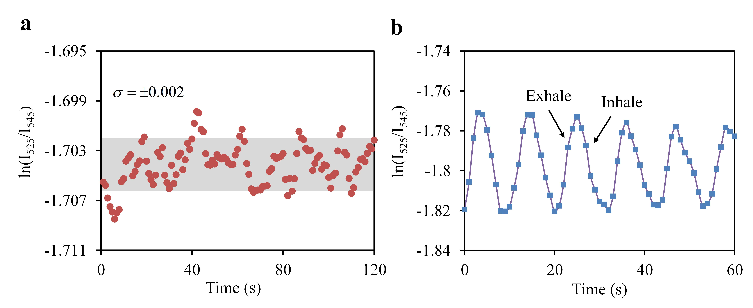
Figure S9. a, Fluctuations of the temperature readout over time at the constant temperature of 37 °C. b, Nose breathing signals captured by the multimodal sensor. The sensor was placed under a volunteer’s nose to detect subtle thermal signals produced by exhaling and inhaling.

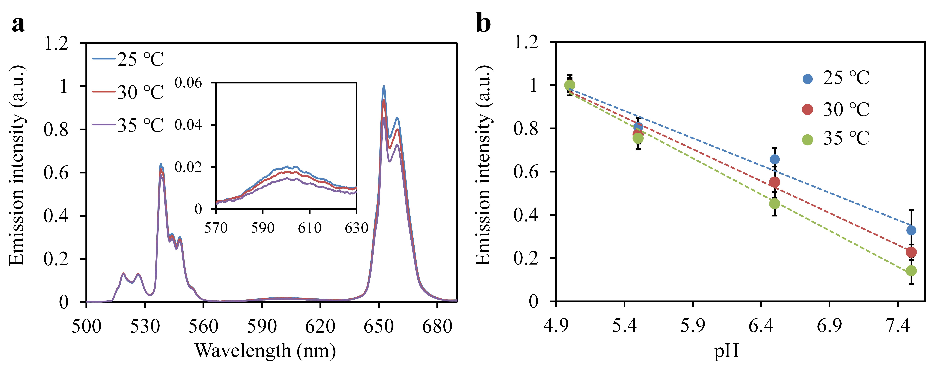
Figure S10. pH response of the sensor at different temperatures. a, Emission spectra of the multimodal sensor at different temperatures. The inset shows temperature dependence of the pHrodo red emission at 600 nm. b, Calibration of the pH response at different temperatures.

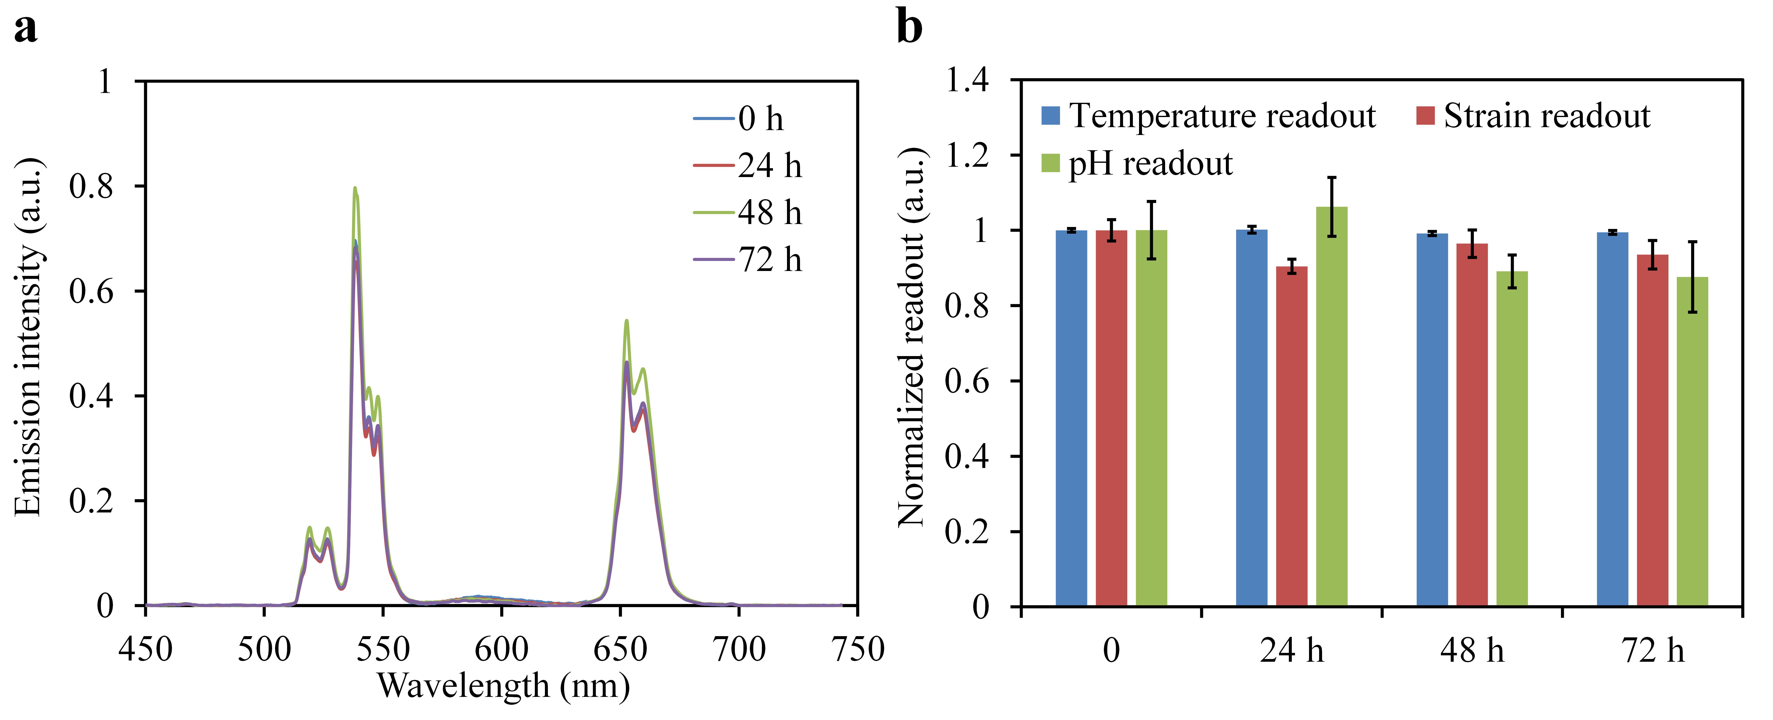
Figure S11. Long-term stability of the multimodal sensor. a, Emission spectra of the multimodal sensor monitored every 24 h for 72 h. The sensor was kept at constant strain (0%), temperature (26 ℃), and pH levels (pH 4.0). b, Normalized temperature, strain, and pH readout of the sensor over time. Despite the changes of the emission intensities, no obvious degradation was observed in all readouts of the sensor in 72 h, indicating a high stability in long-term operation.

Table S1. Summary of recently reported wearable multimodal sensors compared with our work.
Ref. | Mechanisms | Sensing modalities |  |  | Structure | Stimuli decoupling | Flexible/ Stretchable | Biocompatibility | EMI immunity | Applications
Ref. | Mechanisms | Mechanical | Thermal | Chemical
Nat. Electron.1, 596, 2018 | Electrochemical and resistive | / | Temperature | pH | Multiple sensors | Yes | Flexible | Not mentioned | No | Simultaneous monitoring of skin temperature and sweat pH
Science 370, 848, 2020 | Optical | Stretch, Bend, Press | / | / | Single sensor | Yes | Stretchable | Not mentioned | Yes | Human motion detection
Nat. Electron.1, 314, 2018. | Capacitive | Strain, Pressure | / | / | Multiple sensors | Yes | Stretchable | Yes | No | Orthopaedic rehabilitation monitoring
Adv. Mater.34, 2107309, 2022 | Resistive | Strain | Temperature | / | Single sensor | No | Stretchable | Not mentioned | No | Human motion/skin temperature detection
Sci. Adv.1, e1500661, 2015 | Resistive | Pressure | Temperature | / | Multiple sensors | Yes | Flexible | Not mentioned | No | Simultaneous monitoring of artery pulse pressure and temperature.
Nano Energy 80, 105559, 2021 | Resistive | Strain, Twist | / | / | Single sensor | No | Stretchable | Not mentioned | No | Human motion detection
Nat. Biotechnol.38, 217, 2019 | Electrochemical and resistive | Strain | Temperature | Uric acid, tyrosine | Multiple sensors | Yes | Flexible | Not mentioned | No | Simultaneous monitoring of skin temperature, respiration, and uric acid and tyrosine in sweat
Adv. Sci.9, 2104635, 2022 | Electrochemical | / | / | pH, Glucose, Na⁺ | Multiple sensors | Yes | Flexible | Yes | No | Simultaneous monitoring of pH, glucose, Na⁺ in sweat
Nat. Commun.5, 3132, 2014 | Resistive | Strain, Pressure | / | / | Single sensor | No | Stretchable | Not mentioned | No | Artery wrist pulses and acoustic vibrations
Our work | Optical | Strain | Temperature | pH | Single sensor | Yes | Stretchable | Yes | Yes | Simultaneous monitoring of heartbeat, respiration, skin temperature, and sweat pH

Table S2. Sensing performances in comparison with recent publications.
Ref. | Temperature |  |  |  | Strain |  |  |  | pH
Ref. | Sensing range | Response time | Sensitivity | LOD | Sensing range | Response time | Sensitivity | LOD | Sensing range | Response time | Sensitivity | LOD
Nat. Electron. 1, 596, 2018 | 25-45 ℃ | Not mentioned | 0.46% ℃⁻¹ | Not mentioned | / | / | / | / | 3.0-11.0 | 27 s | 240 mV pH⁻¹ | Not mentioned
Science 370, 848, 2020 | / | / | / | / | 0-150% | Not mentioned | 2-5 dB ɛ⁻¹ | 1% | / | / | / | /
ACS Appl. Mater. Interfaces 14, 43844, 2022 | 20-40 ℃ | 27 s | 0.95%℃⁻¹ | 0.2 ℃ | / | / | / | / | / | / | / | /
Adv. Mater. 34, 2107309, 2022 | 30-100 °C | 10 s | 1.63% ℃⁻¹ | Not mentioned | 0-170% | 200 ms | 424% ɛ⁻¹ | 1% | / | / | / | /
Biosens. Bioelectron. 196, 113685, 2022 | 20-50 °C | Not mentioned | 0.25% ℃⁻¹ | / | / | / | / | / | 4.0-7.0 | Not mentioned | Not mentioned | 0.05
ACS Appl. Mater. Interfaces 9, 9015, 2017 | / | / | / | / | / | / | / | / | 4.0-10.0 | 58 s | 53 mV pH⁻¹ | Not mentioned
Adv. Funct. Mater. 33, 2214907, 2023 | 0-55 ℃ | 0.9 s | Not mentioned | 0.1 ℃ | 0-30% | 180 ms | 171% ɛ⁻¹ | 0.05% | / | / | / | /
Nature 516, 222-226, 2014 | / | / | / | / | 0-2% | ~5 ms | Not mentioned | <0.5% | / | / | / | /
Sens. Actuator B Chem. 287, 338, 2019 | / | / | / | / | / | / | / | / | 2.0-12.0 | 60 s | 61 mV pH⁻¹ | Not mentioned
Nat. Biotechnol. 38, 217, 2019 | 25-50 ℃ | Not mentioned | 0.06% ℃⁻¹ | 0.05 ℃ | 0-0.25% | Not mentioned | 360% ɛ⁻¹ | <0.05% | / | / | / | /
Our work | 25-45 ℃ | 3 s | 0.8% ℃⁻¹ | 0.19 ℃ | 0-20% | 23 ms | 5.8 dB ɛ⁻¹ | 0.07% | 4.0-9.5 | 34 s | 27% pH⁻¹ | 0.09

