Supporting Information

Absorption of Ajwain Essential Oil on Chitosan to Enhance Antibacterial Activity of Polyethylene-based Composite Food Packaging Films

Kasra Shiva^{1,2}, Adel Soleimani^{1,2}, Jalil Morshedian¹, Farhid Farahmandghavi^{2,}, and Fatemeh Shokrolahi³

¹Department of Polymer Processing, Faculty of Processing, Iran Polymer and Petrochemical Institute, P.O. Box: 14965/115, Tehran, Iran
²Department of Novel Drug Delivery Systems, Faculty of Science, Iran Polymer and Petrochemical Institute, P.O. Box: 14965/115, Tehran, Iran
³Department of Biomaterials, Faculty of Science, Iran Polymer and Petrochemical Institute, P.O. Box: 14965/115, Tehran, Iran

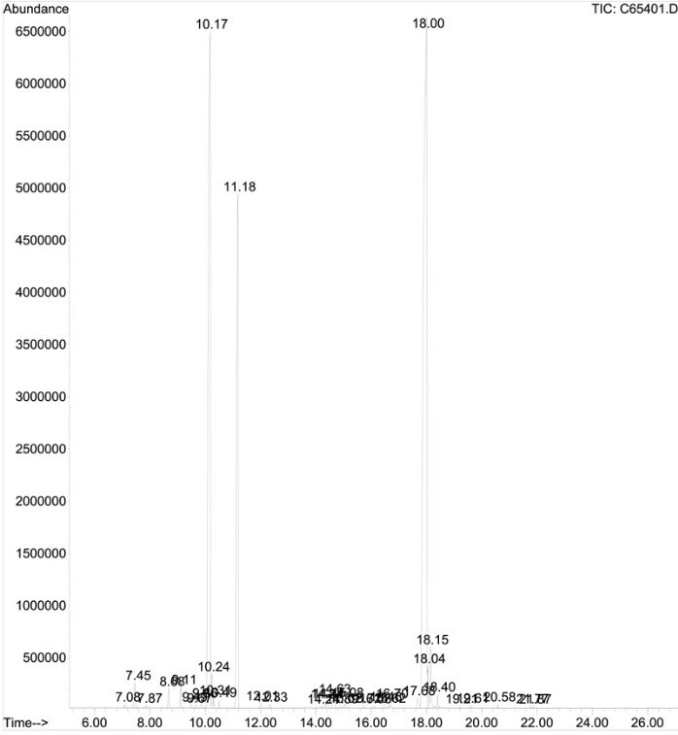
1
2

3
4
Figure S1. GC-Mass chromatogram of AEO. Main components designated: (1) ρ-cymene (10.17min ), (2) $γ$-terpinene (11.18 min), (3) thymol (18 min), (4) carvacrol (18.15 min).

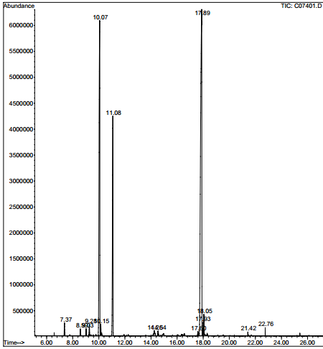
Figure S2. GC-MS chromatogram of extracted essential oil after 60 min exposure to chitosan

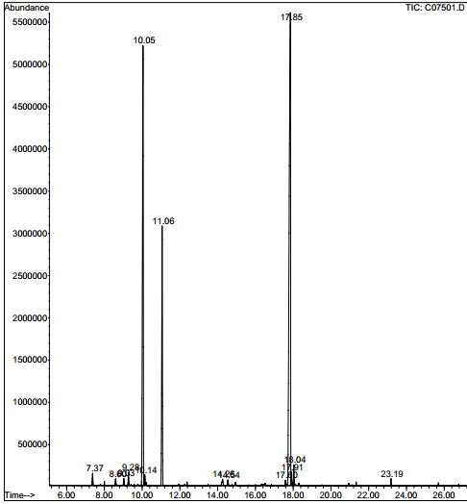
Figure S3. GC-MS chromatogram of extracted essential oil after 90 min exposure to chitosan

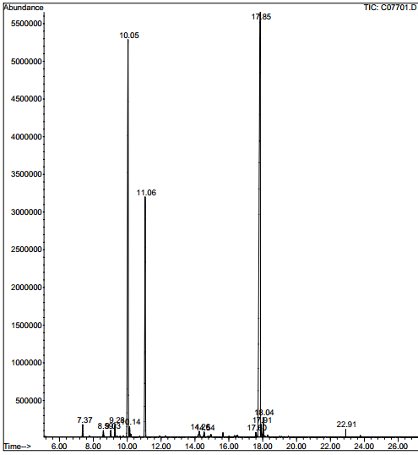
Figure S4. GC-Mass chromatogram of extracted essential oil after 360 min exposure to chitosan

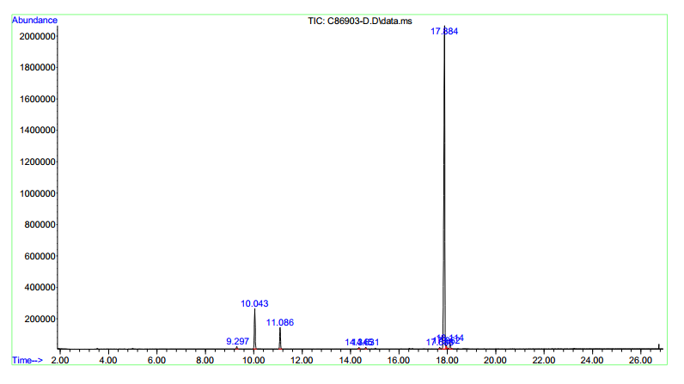
Figure S5. GC-Mass Chromatogram Sample 7.5-7.5

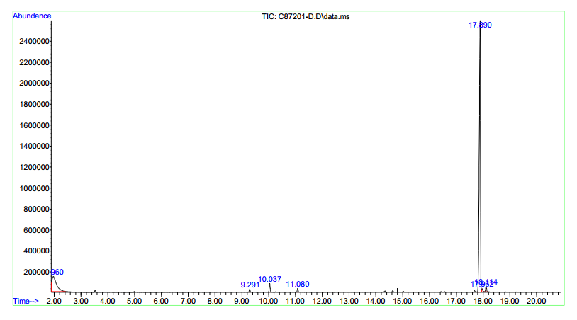
Figure S6. GC-Mass Chromatogram Sample PE-7.5-10

Corresponding author: E-mail address: F.Farahmand@ippi.ac.ir (F.Farahmandghavi).

