For the TOC

Absorption of Ajwain Essential Oil on Chitosan to Enhance Antibacterial Activity of Polyethylene-based Composite Food Packaging Films

Kasra Shiva^{1,2}, Adel Soleimani^{1,2}, Jalil Morshedian¹, Farhid Farahmandghavi^{2,}, and Fatemeh Shokrolahi³

¹Department of Polymer Processing, Faculty of Processing, Iran Polymer and Petrochemical Institute, P.O. Box: 14965/115, Tehran, Iran
²Department of Novel Drug Delivery Systems, Faculty of Science, Iran Polymer and Petrochemical Institute, P.O. Box: 14965/115, Tehran, Iran
³Department of Biomaterials, Faculty of Science, Iran Polymer and Petrochemical Institute, P.O. Box: 14965/115, Tehran, Iran
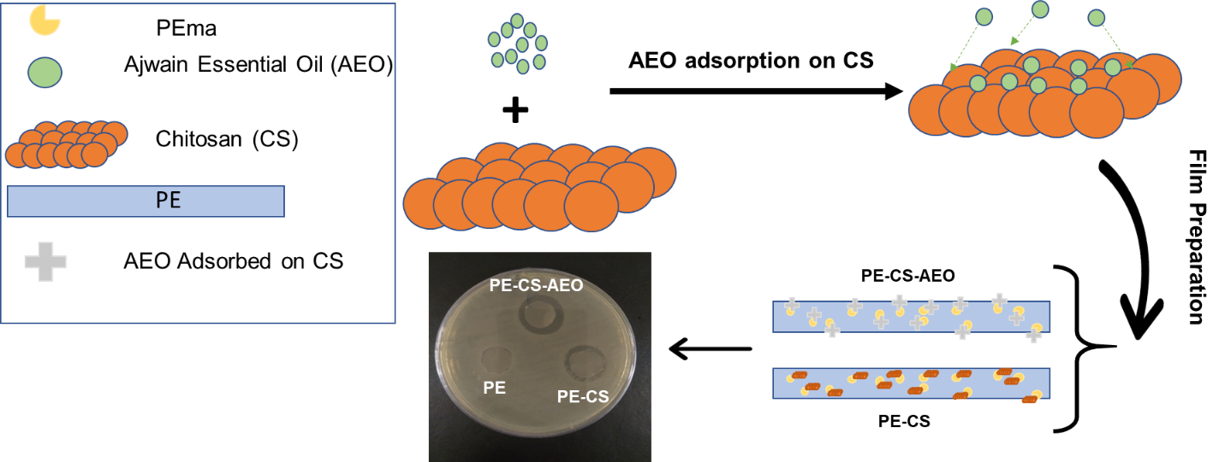

Corresponding author: E-mail address: F.Farahmand@ippi.ac.ir (F.Farahmandghavi).

