Supplementary Information
Supplementary Information

Supplementary material 1. ((CD44 expression in Endometrial cancer models. (a) representative immunofluorescence images showing CD44 expression (FITC, green) in Ishikawa and Hec50 cells. Nuclei where stained with DAPI (blue). (b) Relative fluorescence units (RFU) values obtained from ImageJ analysis of immunofluorescence images.))
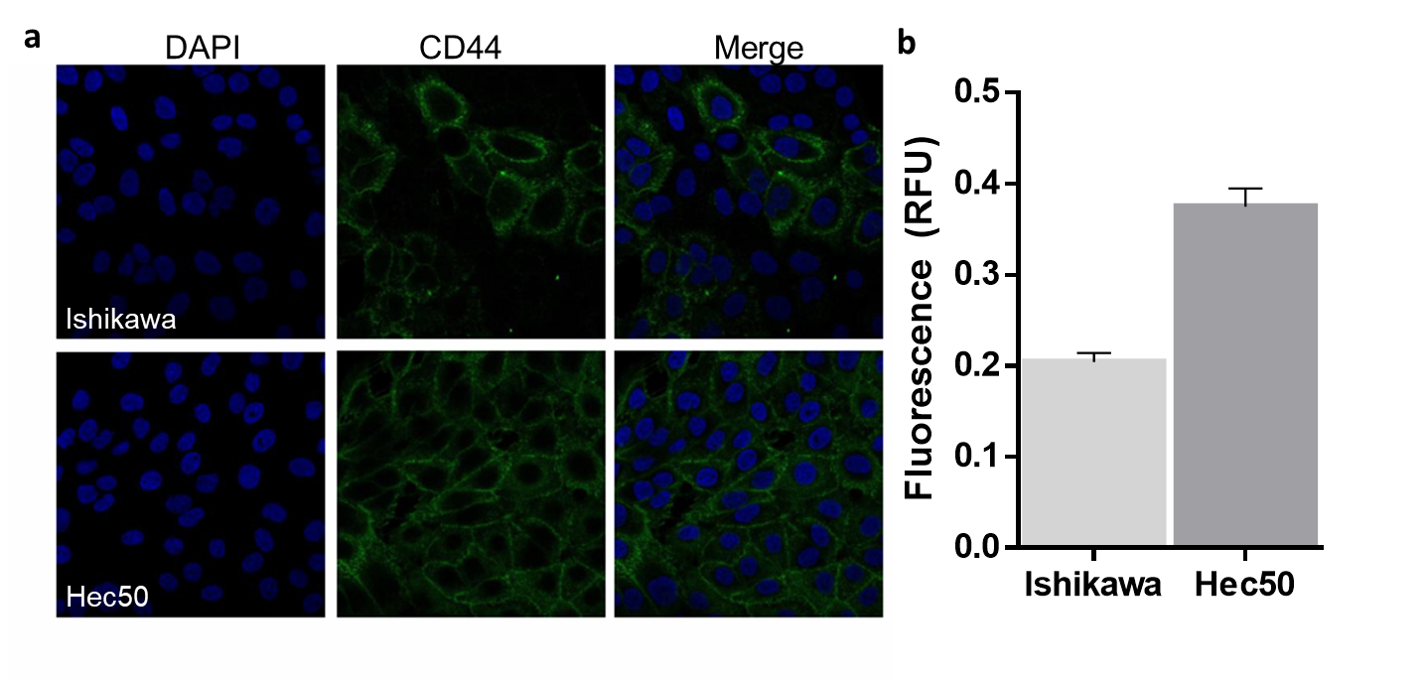
Confocal laser microscopy analysis
Cells (2x10⁴ cells per well) were grown in 8 wells imaging chamber with microscope slides (Labtek) and grown to 80% confluency. Cells were washed with PBS and fixed with 4% paraformaldehyde (PFA) for 20 min at 4°C. Fixing solution was extensively washed out with PBS and 0.1% of Triton-X100 was added to the well and incubated for 5 min at 4°C. After a wash step with PBS, a block buffer (3% BSA in PBS) was added and the plate incubated for 30 min. Wells were washed with PBS and then the primary antibody, which is diluted in block buffer was added to the plate and incubated 1 h or overnight at 4°C. The primary antibody used was a rat anti-human monoclonal antibody CD44/H-Cam (Cat-No MA4400, Thermo Fisher Scientific, UK)(1:300 dilution). Primary antibody was washed out with 4 washes with PBS, then the secondary antibody was added and incubated for 1 h at room temperature. For the secondary antibody Goat anti-Rat IgG-FITC (Cat-N0 sc-2011, Santa Cruz, UK) was used. Following 4 washes with PBS, DAPI (Cat-No R37606, Thermo Fisher Scientific, UK) was added to the well and the plate analyzed using a Zeiss LSM 710 confocal microscope. Zen lite 2012 imaging software (Carl Zeiss Ltd, UK) was used for imaging analysis. For each antibody used in the experiments, specific parameters were set in the confocal microscopy, such as time of exposure and gain, to ensure that each slide were analyzed in the same way. Confocal quantification was performed using ImageJ software.
Ishikawa and Hec50 cell lines were used as in vitro models of EC subtypes I and II respectively.^{[49]} ER negative, Type II endometrial carcinomas often present as high-grade serous or clear cell histology, with poor outcome, accounting for 40% of all endometrial cancer associated mortality.^{[5,11]} We therefore explored whether cell-specific targeting could improve the effectiveness of Pluronic NPs in Hec50 cells. CD44 protein expression was characterized in both Ishikawa and Hec50 cell lines, using confocal laser scanning microscopy (CSLM; see Figure S1). CD44 expression was shown to be consistent throughout the Hec50 population with a relative fluorescence units (RFU) of 0.375 or a cellular RFU of 7.5x10⁻³, demonstrating its potential for NP-HA targeting (SF1). In comparison only 43% of Ishikawa cells assessed were shown to be CD44+, with a whole population RFU of 0.204.Notably, this heterogenous expression is highlighted by the increased RFU per cell (10.7x10⁻³).

Supplementary material 2. ((Propidium Iodide (PI) - NP uptake by Ishikawa cell line.
Z stack images taken using confocal microscopy (a) Individual channels and merge showing presence of intercellular PI (b) PI localization, images are all channels merged. Images of Ishikawa cells (c) treated with 0.4μM PI following permeabilization, 0.4μM PI, 0.4μM PI nanoparticles. DAPI = Blue, Red = Propidium Iodide. Scale bar 50μm. Frequency of Propidium Iodide presence in Ishikawa cell line model treated with 70% methanol followed with free PI (permeabilized positive control; PC – black); free PI (control; PI – grey) and PI en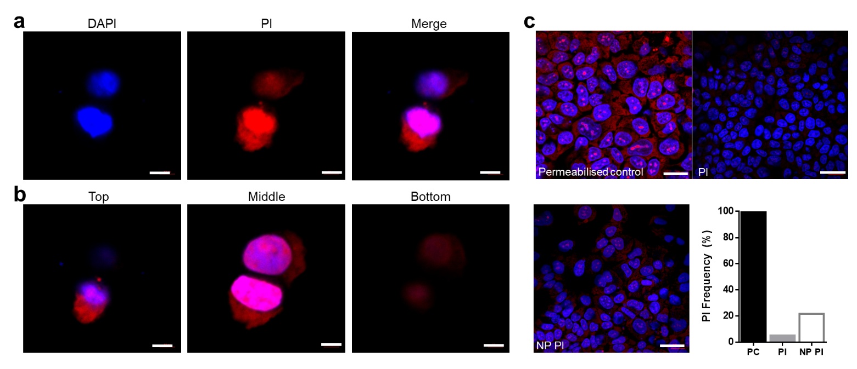capsulated (NP PI – white).))

Immunofluorescence analysis
Cells (2x10⁴ cells per well) were grown in 8 wells imaging chamber with microscope slides (Labtek) and analyzed using a Zeiss LSM 710 confocal microscope or IN CELL analyzer 2200 (GE Healthcare, UK). Propidium iodide (Sigma-Aldrich) free and encapsulated in the micelle were used as treatments at a concentration of 0.4 mg/mL. After 48 h incubation at 37°C, 70% methanol were added for 5 mins to a well containing only cells and used as a positive control. After treatment, the wells were washed with PBS and fixed with 4% PFA (paraformaldehyde) for 10 min at 4°C. All fixative was removed, and the cells stained with DAPI (Life Technologies; 0.5 μg/ml) for 10 min before analysis. Image data was recorded in two emission spectra channels; DAPI nuclear (Channel 1 ʎ 470 nm) and Texas Red for propidium iodide (Channel 2 ʎ 620nm). A total of 3x10⁴cells (30 images of approx. 1x10³ cells) were obtained using a 20x objective, across a random distribution of the fields, excluding regions of the centre or edge of the well. Image analysis was performed using IN Cell Analyzer Workstation 3.5 software (IN Cell Investigator, GE Healthcare, UK). Briefly, an object segmentation feature masked the nuclei by segmenting on the basis of intensity in the DAPI channel. The high contrast in fluorescence output between the nuclear material and background facilitated efficient separation of nuclei against background. The masked bitmap was eroded in order to separate clumped nuclei prevalent in the monolayer and initial segmentation repeated as above, to separate nuclei in close proximity as individual objects using the eroded mask from the previous step. A 10 μm collar drawn around the nuclear mask isolated the cytoplasmic region of each cell. Fluorescence output in absolute grey levels was recorded pixel by pixel across the cell area mask and each cell was assigned a value for the propidium iodide expression based upon the average pixel fluorescence in the area. The software allows for calculation of total cellular fluorescence and the frequency of appearance was plotted for each treatment.
Confocal laser microscopy analysis
Cell samples were prepared and treated as above. The plate analyzed using a Zeiss LSM 710 confocal microscope. Zen lite 2012 imaging software (Carl Zeiss Ltd, UK) was used for imaging analysis. Confocal quantification was performed using ImageJ software.
In vitro stability and uptake of NP- F-127 was assessed using propidium iodide uptake assays. Propidium iodide was encapsulated to the F-127 micelle during fabrication, and these fluorescent micelles used to quantify cellular internalisation. Propidium iodide cannot penetrate intact membranes without the F-127 carrier therefore the fluorescence is only observed following NPs were fabricated as described, substituting SAHA for propidium iodide to enable NP tracking, cellular internalisation and uptake.
The presence of propidium iodide across the whole cell was initially determined by confocal microscopy (Figure S2a), and clearly demonstrated the effective internalisation of NPs, with staining observed in both nuclear (counter stained with DAPI) and cytoplasmic areas. While single cell analysis is important for monitoring particle sub cellular localisation, cancer cells in culture demonstrate cross population heterogeneity in terms of cell cycle progression, levels of viability/apoptosis ^{[96]}. High content analyses was used to monitor F-127 internalisation across the cellular population using the automated multiple field of view capabilities of the In Cell 2000 microscope ^{[61]}. Akin to an adherent tumour cell FACS analysis, the In Cell 2000 enabling the analysis of a minimum of 1x10⁵ cells/condition, while bypassing the need to disrupt the adherent tumour cell model ^{[61,63]}. Propidium iodide fluorescence was observed in 22% NP treated cells; a four-fold increase in frequency of fluorescence compared to propidium iodide alone (5%) (Figure 2b), demonstrating NP internalisation and retention.

Supplementary Information 3. ((Assessment of mechanism of action of SAHA encapsulated vs free SAHA drug in in vitro EC models. Representative example of Western Blot protein analysis (AcH3 and H3) to access SAHA mechanism of action in Ishikawa (a) and Hec50 cells (b), followed by protein density analysis of AcH3 (c) following 48hr treatments (N=3). The different treatments tested were empty nanoparticle (black), free SAHA (light grey) and SAHA-NP (dark grey), all at the concentration of 2.5uM. All data are normalized to the untreated control cells.
Effect of SAHA on AcH3 binding to the P21 promoter (d) and P53 promoter (e) in EC cells and promoter methylation. ChIP experiments, SAHA effect on binding of AcH3 antibody to the p21 and to the p53 promoter. Hec50 and Ishikawa cells were treated with empty nanoparticle (black), free SAHA (light grey) and SAHA-NP (dark grey) N=3. All ‘%real signal’ values are calculated from the average of triplicate antibody and negative IgG signals.))
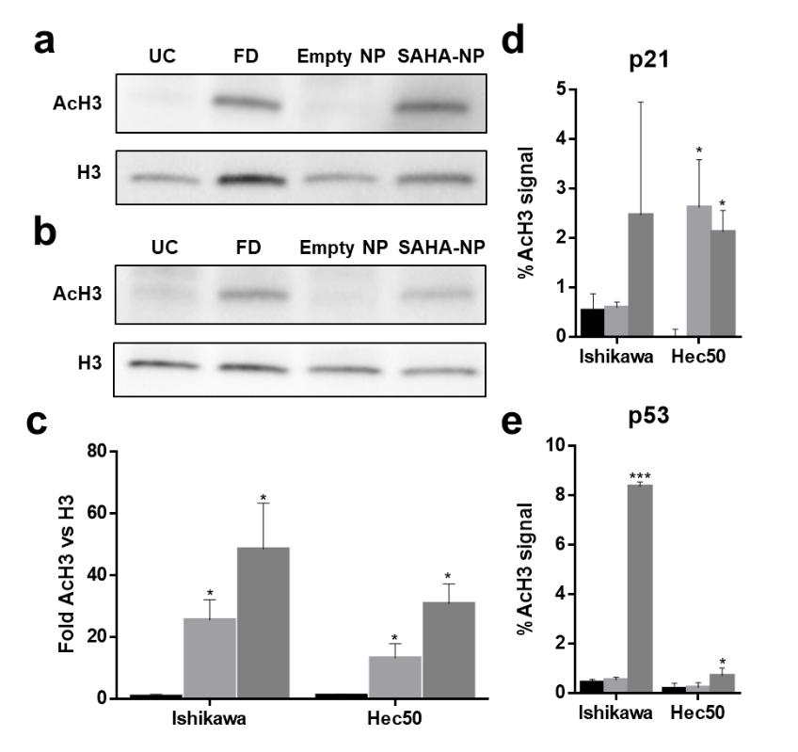
Chromatin immunoprecipitation (ChIP)
Ishikawa and Hec50 cells were grown with stripped media for 24h in T25 flask. SAHA treatments at 2.5μM were added for 48 h. Following that time, approximatively 5x10⁶ cells for each cell line were processed for ChIP analyses following manufacturer’s instructions. (Chromatrap® ChIP-seq).^{[97]} The following antibodies were used; Active Motif, AcH3 (#39140, ChIP-seq); Sigma-Aldrich, IgG Rabbit (#12-370, ChIP-seq), IgG Mouse (#12-371, ChIP). PCR was used as the endpoint assay to analyze the ChIP DNA, using a BioRad CFX real time PCR machine (BioRad, UK). The primers sequences used were P21 Forward 5’-CCCACAGCAGAGGAGAAAGAA-3’, P21 Reverse 5’-CTGGAAATCTCTGCCAGACA-3’; P53 Forward 5’-AGACCAGCCTGACCAATA-3’, P53 Reverse 5’-GCTCCCGGAAACATCTCAC-3’. The human GAPDH primers present in the Chromatrap® ChIP-seq kit was used as a positive control. The ratios of the signals in immunoprecipitated DNA versus input DNA was calculated as previously shown.^{[98]}
SAHA has been shown to affect Ishikawa and Hec50 cell cycle progression through restoration of p21 expression ^{[24]}. Similarly SAHA treatment results in the reduction of p53 expression in type I Ishikawa cells ^{[66,67]}. Type II Hec50 cells are known to be p53 null in ^{[99]}. Locus specific epigenetic analysis revealed that SAHA-NP treatment resulted in five-fold increased H3 acetylation levels at the p21 gene promoter when compared to the free drug control (Figure S3e), indicative of increased SAHA exposure following encapsulation. No significant alterations in acH3 signal were observed at the p21 gene locus in Hec50 cells treated with SAHA-NP (p>0.05). H3 acetylation at the p21 locus was not altered following exposure to the empty F-127 NPs, when compared to the untreated control.
Similarly, SAHA-NP treatment resulted in a significant 15-fold increase in acH3 signal at the p53 promoter in Ishikawa cells compared to free SAHA (p<0.001). This again is supportive of encapsulation increasing the cellular exposure to SAHA, with free drug SAHA only resulting in a 1.3-fold increase in acH3 signal at the p53 locus (Figure 4f). As expected, significantly lower acH3 signal was observed at the p53 locus in the p53 null Hec50 cells when compared to Ishikawa (p<0.05). Treatment with SAHA-NP and free drug SAHA resulted in 4-fold (p<0.05) and 3-fold increased acH3 signal compared to the untreated control.

Supplementary Information 4. ((Images of Endometrial cancer model spheroids taken at 40X magnification. Time series images of Ishikawa (a) and Hec50 (b) spheroids formed using 2x10³, 4x10³ and 6x10³ cells in ultra-low adhesion (ULA) plates over a 72h time period. Images include a 50µm scale bar.))
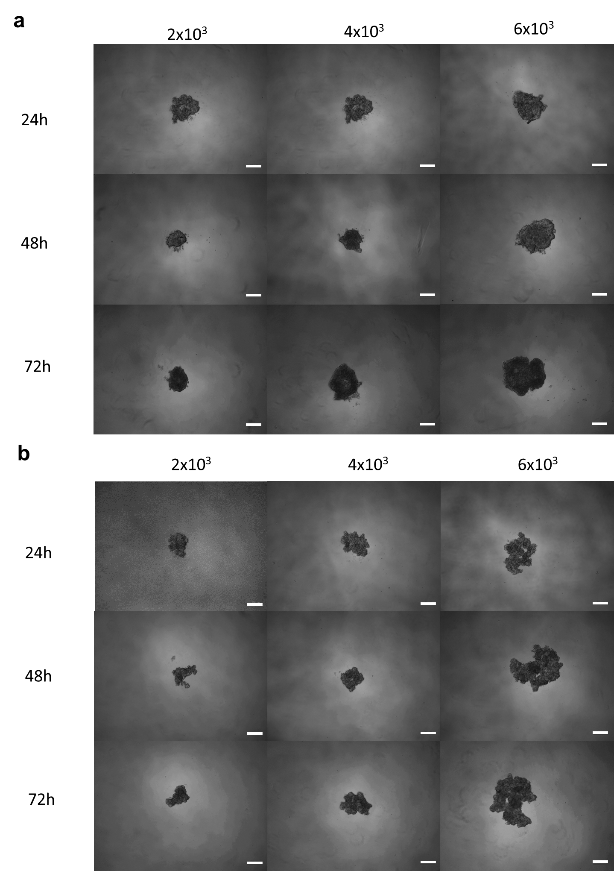
Ishikawa and hec50 Spheroid culture optimisation. Spheroid optimization was conducted to determine an appropriate seeding density that would allow spheroid formation with the desired shape and mass (Figure S4). Spheroids grown from 2x10³ gave poor initial association, did not show any change in shape or size between 24h and 72h. Hec50 spheroids grown from 6x10³cells resembled cellular agglomerates and did not follow the same radial growth or morphology as that seen in Ishikawa. As both these densities gave unfavourable spheroids, 4x10³ cells were used for all spheroids.

Supplementary Information 5. ((Images of Endometrial cancer model spheroids following treatment taken at 40X magnification. Images of Ishikawa (a) and Hec50 (b) spheroids treated with SAHA free, SAHA-NP and SAHA-NP-HA, at both 48 and 72h timepoints.))
Brightfield images of Ishikawa (a) and Hec50 (b) spheroids treated with SAHA free, SAHA-NP and SAHA-NP-HA, at both 48 and 72h timepoints. Images were used for spheroid metric assessments.

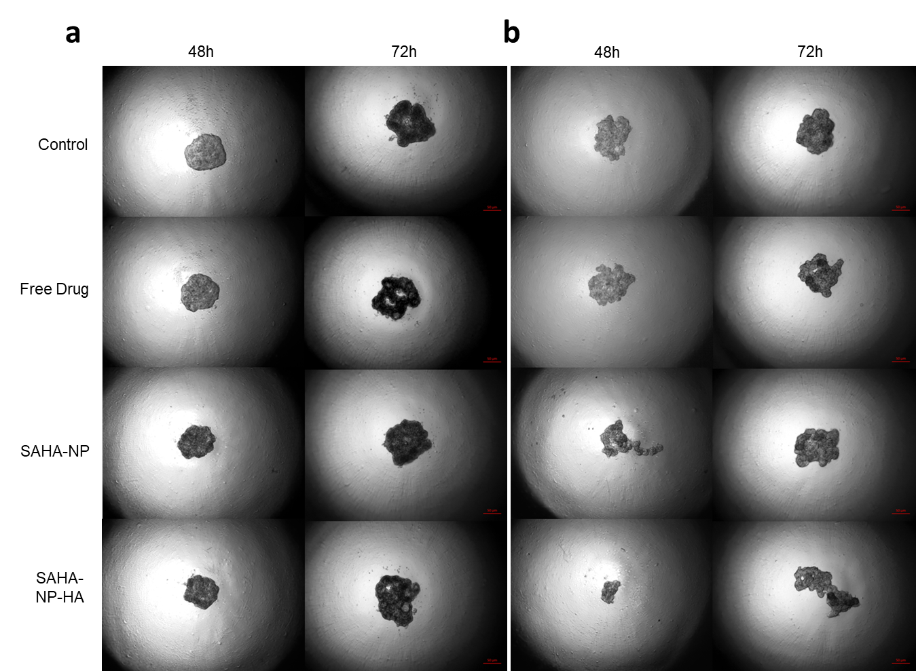

Supplementary Information 6. ((Effect of SAHA, SAHA-NP and SAHA-NP-HA drug systems on cell cycle progression and molecular phenotype from endometrial cancer cell line models in 3D. Representative example of Western Blots taken from Ishikawa (a) and Hec50 (b) spheroid protein isolates.))
Representative example of Western Blots used for densitometry work in Figure 7.

