Supplementary Information
Elucidating the impacts of municipal and industrial organic waste components on the kinetics and potentials of biomethane production via anaerobic digestion
Yaojing Qiu¹, Lillian Lower¹, Vanessa Rondon Berrio¹, Julia Cunniffe¹, Praveen Kolar¹, Jay Cheng¹, & William Joe Sagues^{1*}
¹Department of Biological and Agricultural Engineering, North Carolina State University, 3110 Faucette Dr., Raleigh, NC 27695, USA.

*Corresponding author
E-mail address: wjsagues@ncsu.edu (William J. Sagues)

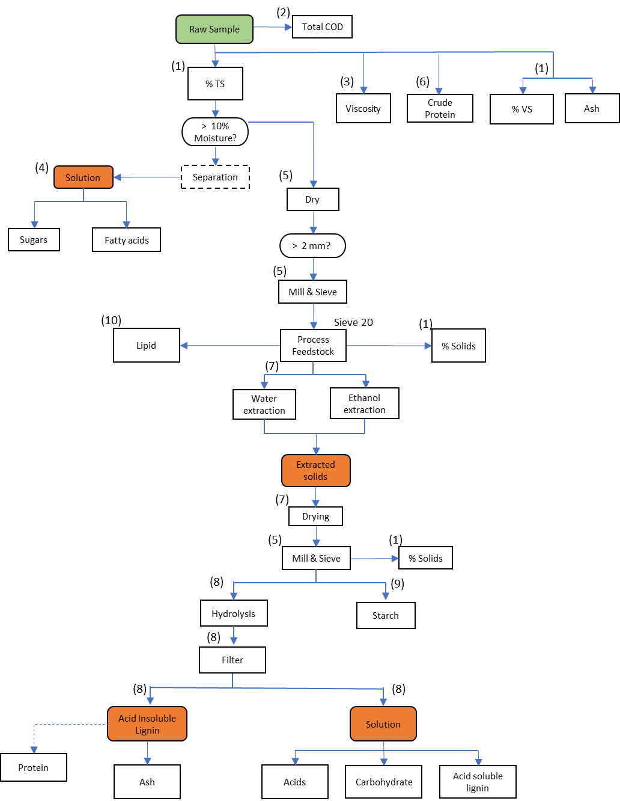
Fig. S1. The flow chart of samples preparation and analysis 1) determination of TS, VS, and ash of samples 2) determination of total COD of samples 3) determination of viscosity of samples 4) determination of sugars and fatty acids in samples (liquid phase) by HPLC 5) preparation of samples for compositional analysis 6) determination of protein content in samples 7) determination of extractives in samples 8) determination of carbohydrates and lignin in samples 9) determination of starch in samples 10) determination of lipid in samples.

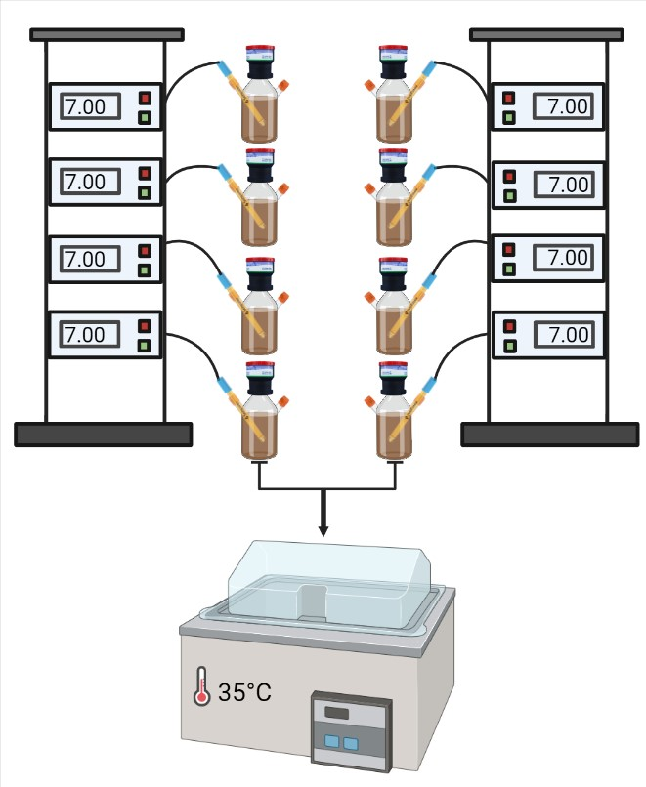
Fig. S2. Schematic diagram of BMP test by using ANKOM reactors.

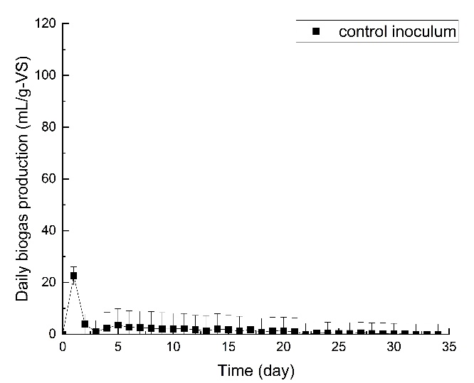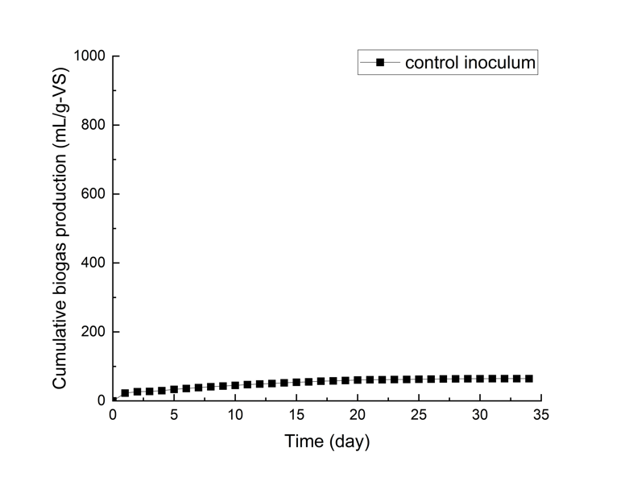
(b)
(a)
Fig. S3. Biogas production of control inoculum: (a) daily biogas production (b) cumulative biogas proudction

