Supplementary appendix to: The impact of the COVID-19 epidemic on all-cause attendances to emergency departments in two large London hospitals: an observational study

Auto Regressive Integrated Moving Average (ARIMA) model construction
To forecast a counterfactual scenario of the number of ED attendances at Imperial College Healthcare NHS Trust (ICHNT), by England region and nationally, we created autoregressive integrated moving average (ARIMA) timeseries models. Albeit ICHNT data was pseudonymised and accessed through secure servers, only aggregate data (e.g. graphs, tables and summary statistics presented in this publication) was extracted, as records presented patient-level information and General Data Protection Regulations thus proscribe their public availability. Data for England regions, on the other hand was obtained from publicly available monthly situation reports between June 2015 and May 2020 by NHS Trust.[1] The input file from this data source and an example source code for the ARIMA model for the London region can be accessed in https://github.com/MonkeyfaceMx/aae_attendances.git.

Trusts were categorised into four regions, London, North, South and Midlands. For each trust we extracted the number of ‘type 1’ attendances and emergency admissions per month and inputted into a timeseries format. In the English NHS context, a type 1 ED is a 24-hour hospital-based ED that is managed by clinical consultants.[1]

We used the time series data by region from June 2015 to December 2019 to parameterise and train the ARIMA models. Numerous ARIMA model selection algorithms have been described.[2] To minimise subjectivity in model selection criteria, we used the automatic forecasting algorithm function auto.arima from the R package forecast. This returns the automatic univariate ARIMA algorithm from Hyndman and Khandakar.[3] We assessed stationarity and differencing in the data with the augmented Dickey-Fuller test and Kwiatkowski, Phillips, Schmidt, & Shin test, respectively, as recommended in Hyndman and Athanasopoulos.[2]

All analyses were performed using R studio Version 1.2.5033. Figure S1 below presents the outputs from the fitted forecast by England region in 2020. Disaggregated trends of ED attendances at ICHNT are presented in Figure S2 and S3. Please see main manuscript for discussion of these additional analyses.

Figure S1. Monthly timeseries of attendances to ED services by region. Red lines represent mean forecast from ARIMA model, with shadowed area representing the confidence interval (light purple 95% and dark purple 80%) and are compared against observed data (light blue line) from NHS Digital.

a. Attendances by age
b. Attendances by gender
c. Attendances by mode of arrival
Figure S2. Daily ED attendances to ICHNT by age, gender and mode of arrival

a. St Mary’s Hospital
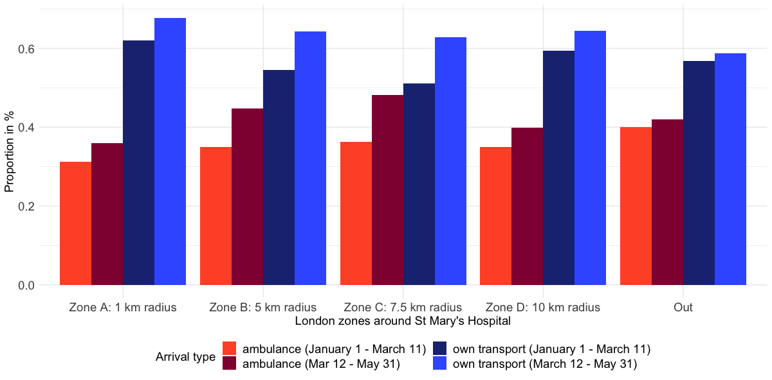
b. Charing Cross Hospital
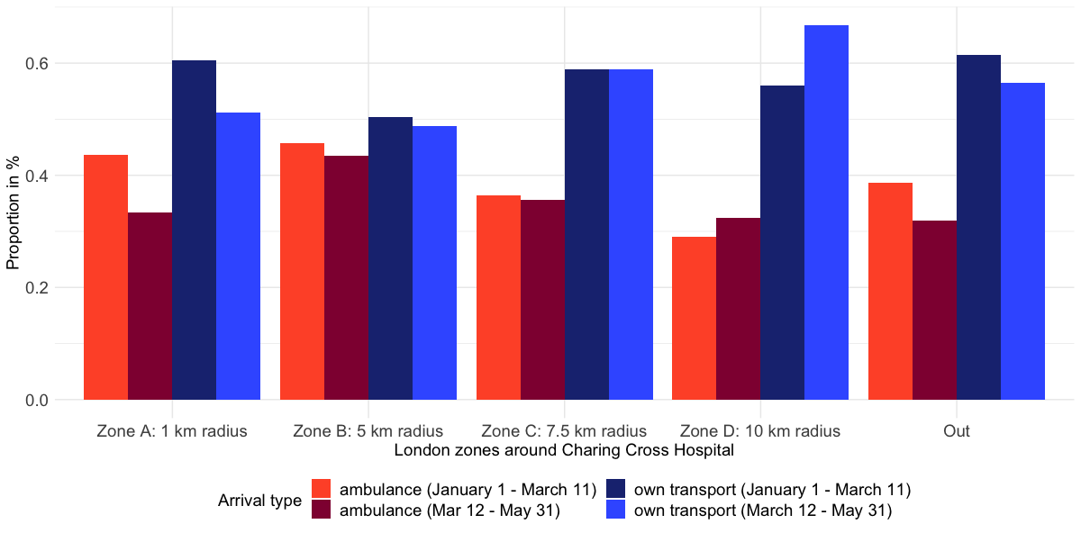
Figure S3. Percent of ED attendances to ICHNT by geographic area of patient residence and method of arrival.

Table S1. Number (%) of emergency department attendances by age group at Imperial College Healthcare NHS Trust in 2020
 | Charing Cross Hospital |  | St Mary’s Hospital
 | Jan 1 – March 11 | March 12 – May 31 | Jan 1 – March 11 | March 12 – May 31
≤5 | 5 (0.1) | 24 (0.3) | 2,938 (18.8) | 1,146 (11.8)
6 to 21 | 465 (4.9) | 422 (4.8) | 2,746 (17.5) | 1,093 (11.2)
22 to 64 | 5,956 (62.5) | 5,925 (67.1) | 7,037 (44.9) | 5,310 (54.5)
>65 | 3,109 (32.6) | 2,454 (27.8) | 2,947 (18.8) | 2,195 (22.5)
Total | 9,535 (100.0) | 8,825 (100.0) | 15,668 (100.0) | 9,744 (100.0)

Table S2. Number (%) of emergency department attendances by gender at Imperial College Healthcare NHS Trust in 2020
 | Charing Cross Hospital |  | St Mary’s Hospital
 | Jan 1 – March 11 | March 12 – May 31 | Jan 1 – March 11 | March 12 – May 31
Female | 4,953 (51.9) | 4,273 (48.4) | 7,824 (49.9) | 4,579 (47.0)
Male | 4,582 (48.1) | 4,552 (51.6) | 7,841 (50.0) | 5,165 (53.0)
Not specified | 0 (0.0) | 0 (0.0) | 3 (0.0) | 0 (0.0)
Total | 9,535 (100.0) | 8,825 (100.0) | 15,668 (100.0) | 9,744 (100.0)

Table S3. Number (%) of emergency department attendances by mode of arrival at Imperial College Healthcare NHS Trust in 2020
*Includes prison/police transport, public transport and air ambulance
 | Charing Cross Hospital |  | St Mary’s Hospital
 | Jan 1 – March 11 | March 12 – May 31 | Jan 1 – March 11 | March 12 – May 31
Own transport | 4,949 (51.9) | 4,747 (53.8) | 9,841 (62.8) | 5,282 (54.2)
Road ambulance | 4,088 (42.9) | 3,535 (40.1) | 5,685 (36.3) | 4,383 (45.0)
Other* | 498 (5.2) | 543 (6.2) | 142 (0.9) | 79 (0.8)
Total | 9,535 (100.0) | 8,825 (100.0) | 15,668 (100.0) | 9,744 (100.0)

Table S4. Linear regression models for reduced number of ED attendances to Imperial College Healthcare NHS Trust by postcode of patient residence.

Unscaled
 | SMH | CXH | SMH | CXH | SMH | CXH | SMH | CXH
(Intercept) | 212.64 *** | 195.50 *** | -0.71 | -2.36 | 575.50 *** | 1120.00 *** | 92.41 | 82.15
 | [151.33, 273.94] | [111.99, 279.00] | [-3.24, 1.81] | [-7.42, 2.69] | [389.63, 761.37] | [837.44, 1402.56] | [-4.39, 189.20] | [-40.50, 204.80]
Distance (Km) | -0.01 *** | -0.01 ***
 | [-0.02, -0.01] | [-0.02, -0.01]
Mean historic attendances |  |  | 0.58 *** | 0.76 ***
 |  |  | [0.57, 0.58] | [0.74, 0.78]
Postcode zone B ∆ |  |  |  |  | -295.83 ** | -729.85 ***
 |  |  |  |  | [-493.71, -97.96] | [-1023.07, -436.62]
Postcode zone C |  |  |  |  | -517.50 *** | -1087.78 ***
 |  |  |  |  | [-716.20, -318.80] | [-1385.62, -789.94]
Postcode zone D |  |  |  |  | -557.15 *** | -1095.67 ***
 |  |  |  |  | [-753.65, -360.65] | [-1389.76, -801.57]
Outermost zone |  |  |  |  | -566.27 *** | -1113.29 ***
 |  |  |  |  | [-754.34, -378.20] | [-1397.46, -829.11]
Weighed mean IMD quintile† |  |  |  |  |  |  | -13.44 | -7.83
 |  |  |  |  |  |  | [-46.51, 19.63] | [-49.75, 34.08]
R2 | 0.20 | 0.09 | 0.99 | 0.98 | 0.40 | 0.54 | 0.00 | 0.00
*** p < 0.001; ** p < 0.01; * p < 0.05.
† Weighed by total population in postcode.
∆ Intercept is postcodes within zone A (≤1,000 metres from the respective hospital).

Emergency admissions by ICD-10 category
To analyse changes in emergency admissions at ICHNT, we categorised patients into main disease areas as per ICD-10 codes. Only patients admitted into hospital from the ED were included in this analysis. Narrow disease categories were identified based on the first diagnosis recorded upon patient discharge/ death as follows:
- COVID-19: B97.2 or U07.1 or U07.2
- Acute respiratory conditions: J09-12 or J13-18 or J44.1 or J46
- Stroke I60-I69
- Acute coronary syndrome I20-I25
- Oncology C00-C97 or D01-D04
- Gastro & liver K00-K93
- Injuries T00-T98 or V01-V99 or W00-W99 or X00-X99 or Y00-Y89
- Genitourinary N00-N99

For specific cases where the main discharge/death diagnoses recorded were highly heterogeneous (i.e. ICD-10 codes for symptoms/signs [R00-R99] or for factors influencing contact with health services [Z00-Z99]) we aggregated admissions and deaths and classified them as Other.

Of note, whilst the mortality rate for the composite category ‘Other’ seemed to increase in 2020 compared to historic data (average in 2015-2019), mortality was both historically and in the present year very low. The actual number of deaths was thus very low and the statistical associations for a such a broad category are not conclusive. For risk of identifiability and in keeping with Global Data Protection Regulations, we do not present more granular data on this disease area (e.g. more granular areas only recorded 1 or 2 admissions and/or deaths in either period of time).

Table S5. Historic (2015-2019) vs present deaths amongst emergency admissions by disease area at Imperial College Healthcare NHS Trust between March 12 and May 31.
Historic data refers to the average of emergency admissions between the period from March 12 and May 31 for each year. Specific numbers by hospital are not presented due to risk of identifiability of individuals given low number of deaths and/or admissions.
*See text in section above for explanation of ICD-10 codes included
Abbreviation: ICD-10, international classification of diseases; IRR, incident risk ratio
 | 2020 |  | Average 2015-2019
Disease area* | Deaths | Admissions | Deaths | Admissions | IRR | p-value
Including COVID-19 | 523 | 6022 | 301 | 10406 | 2.84 (2.48, 3.26) | <0.01
Non-COVID only | 164 | 4976 | 301 | 10406 | 1.13 (0.94, 1.37) | 0.19
Acute respiratory conditions | 76 | 726 | 114 | 912 | 0.85 (0.65, 1.12) | 0.26
Stroke | 25 | 188 | 30 | 258 | 1.13 (0.68, 1.86) | 0.64
Acute coronary syndromes | 4 | 116 | 16 | 287 | 0.63 (0.22, 1.85) | 0.39
Oncology | 20 | 263 | 50 | 484 | 0.75 (0.46, 1.24) | 0.26
Gastro & liver | 6 | 366 | 15 | 829 | 0.91 (0.35, 2.32) | 0.84
Injuries | 4 | 536 | 15 | 1471 | 0.73 (0.24, 2.20) | 0.58
Genitourinary | 7 | 308 | 14 | 834 | 1.35 (0.55, 3.30) | 0.52
Other | 22 | 1474 | 20 | 3552 | 2.63 (1.44, 4.80) | <0.01

References
1. NHS England. A&E Attendances and Emergency Admissions. 2020. https://www.england.nhs.uk/statistics/statistical-work-areas/ae-waiting-times-and-activity/. Accessed 9 Jun 2020.
2. Hyndman RJ, Athanasopoulos G. Forecasting: Principles and Practice. 2nd edition. Melbourne, Australia: OTexts; 2018. https://otexts.com/fpp2/. Accessed 1 Jul 2020.
3. Hyndman RJ, Khandakar Y. Automatic Time Series Forecasting: The forecast Package for R. J Stat Soft. 2008;27. doi:10.18637/jss.v027.i03.

