In vitro (mouse tissues)--Fig.6
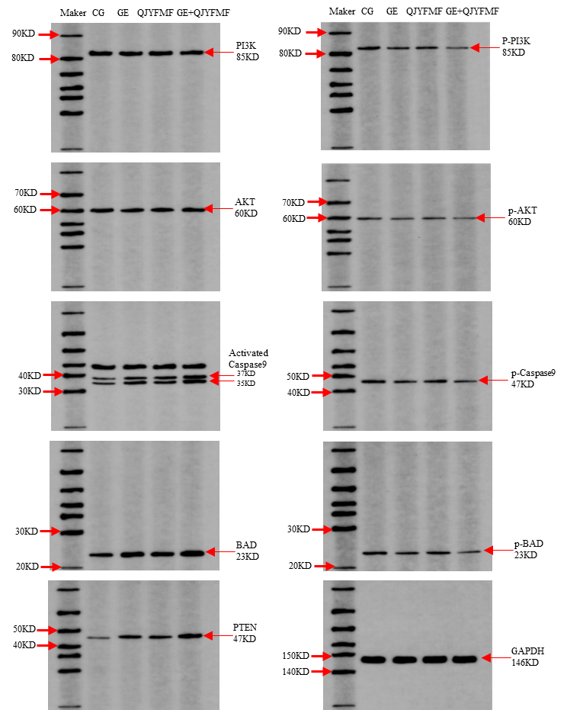

In vivo (A549 cell)--Fig. S4
