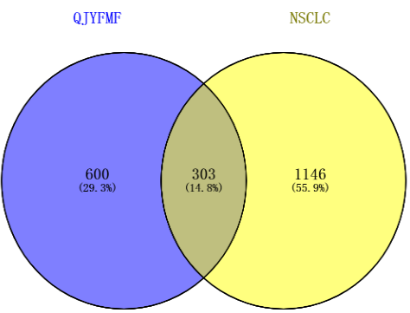
Fig. S1 Intersecting targets of Qingjie Yifei Miao Fang (QJYFMF) in the treatment of non-small cell lung cancer (NSCLC)
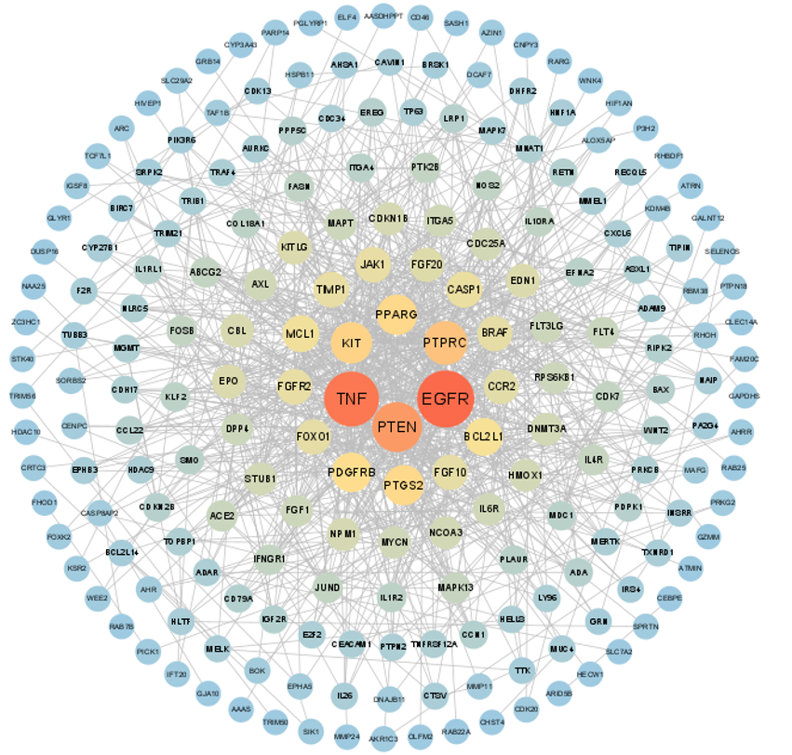
Fig. S2 Protein interaction network diagram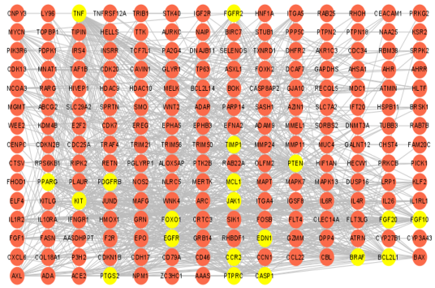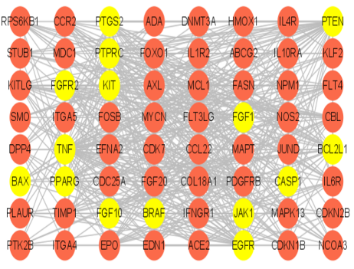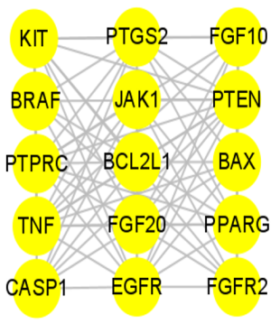
Fig. S3 Screening of key targets
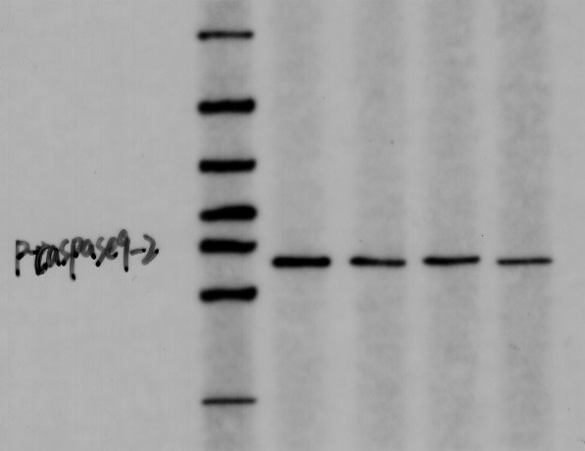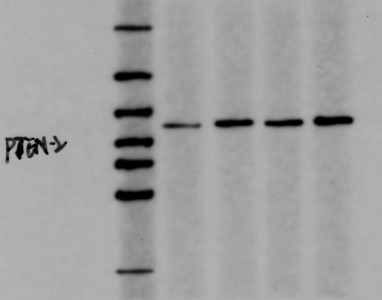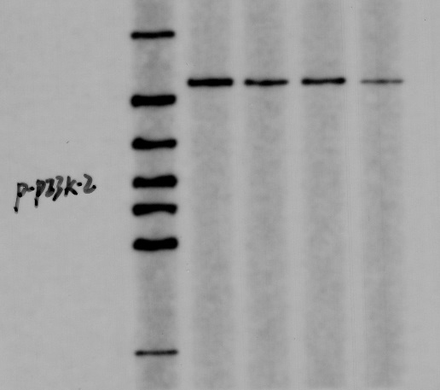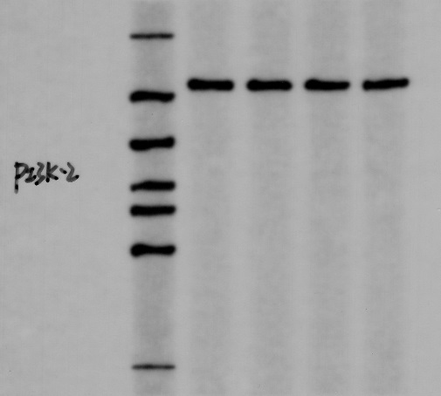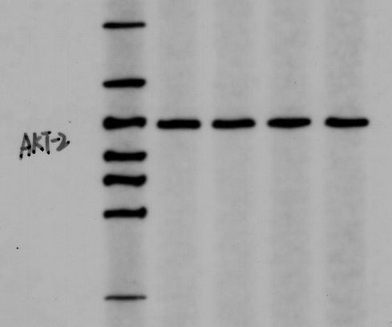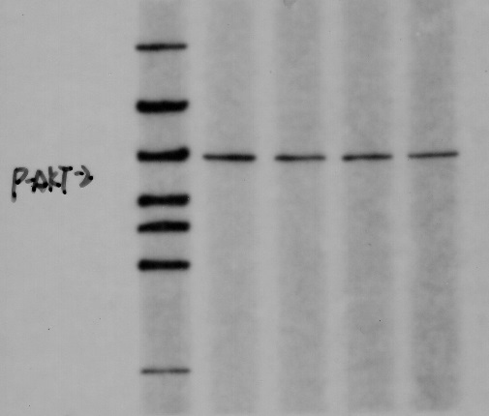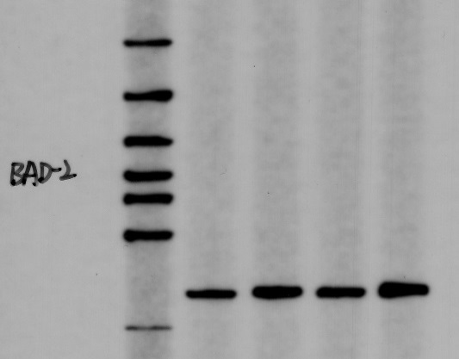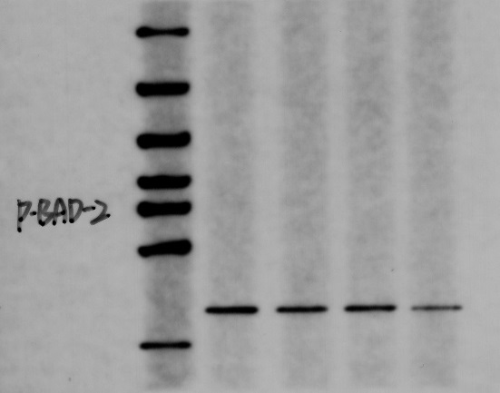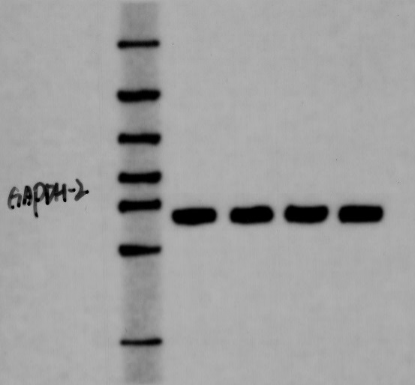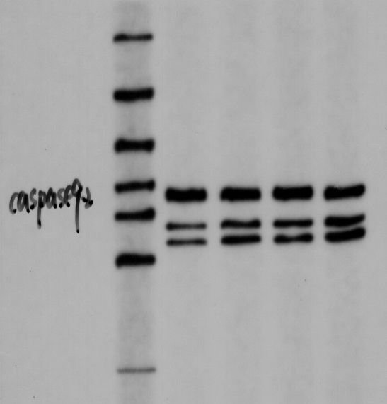
PI3K
p-PI3K
AKT
p-AKT
47KD
85KD
85KD
60KD
60KD
PTEN
Caspase-9
BAD
p-BAD
GAPDH
37KD
35KD
23KD
23KD
146KD
p-Caspase-9
47KD
A
Fig.S4 Expression levels of PTEN/PI3K/AKT signaling pathway-related proteins in A549 cell

