Supporting Information
Investigating the Electrochemical Properties of Ionic-Liquid-Mediated Inorganic Eutectogels Derived from Carboxylic-Acid-Based Hydrophobic Natural Deep Eutectic Solvents
Arindam Dutta^{a,b}, Debashis Kundu^{c}, Surbhi Sharma^{b}, Debbie S. Silvester^{b}, Tamal Banerjee^{a*}

ªDepartment of Chemical Engineering, Indian Institute of Technology Guwahati, Guwahati, Assam 781039, India
^{b}School of Molecular and Life Sciences, Curtin University, Perth, Western Australia 6845, Australia
^{c}Department of Chemical Engineering, Institute of Chemical Technology Marathwada Campus, Jalna, Maharashtra 431203, India

*Corresponding author: Prof. Tamal Banerjee, tamalb@iitg.ac.in, + 91 361 258 2266

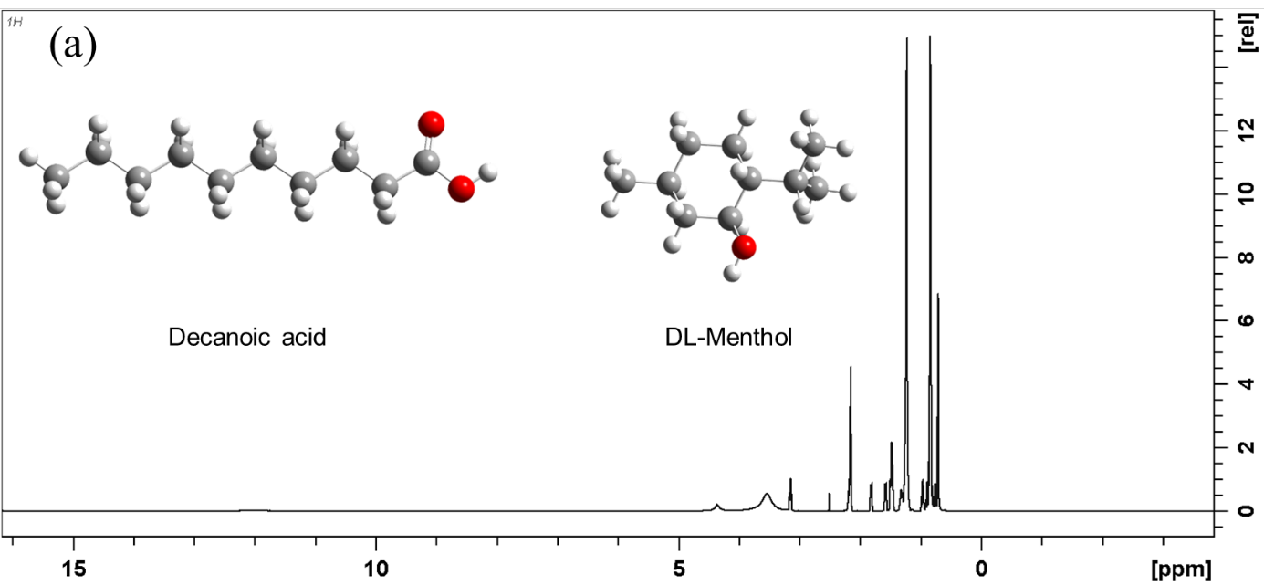
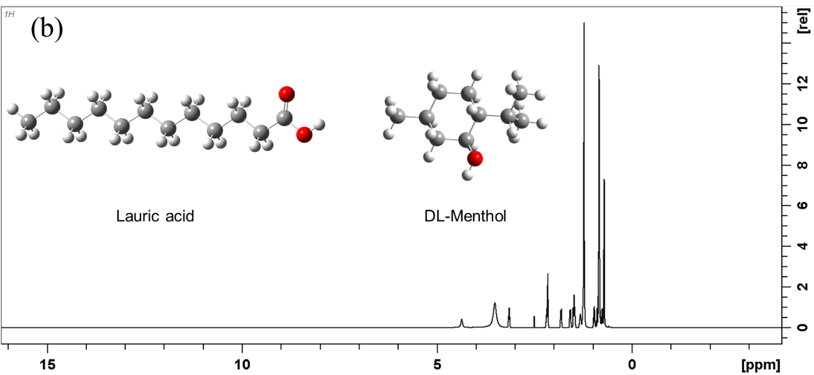
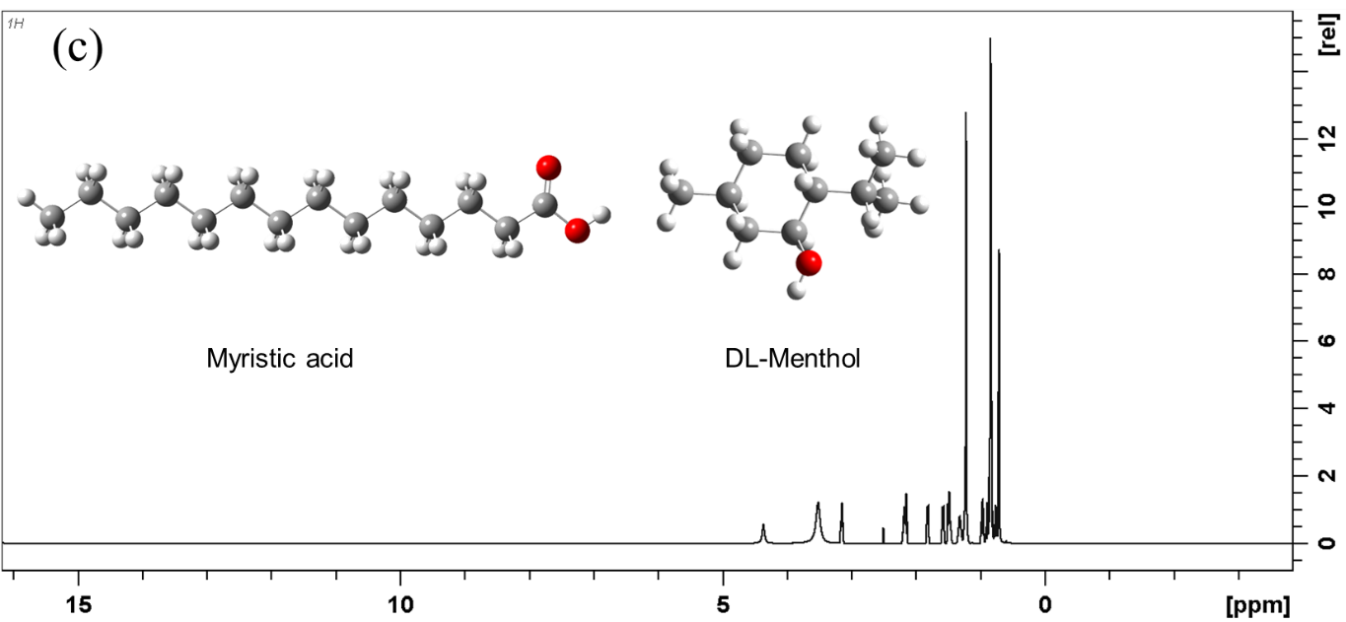
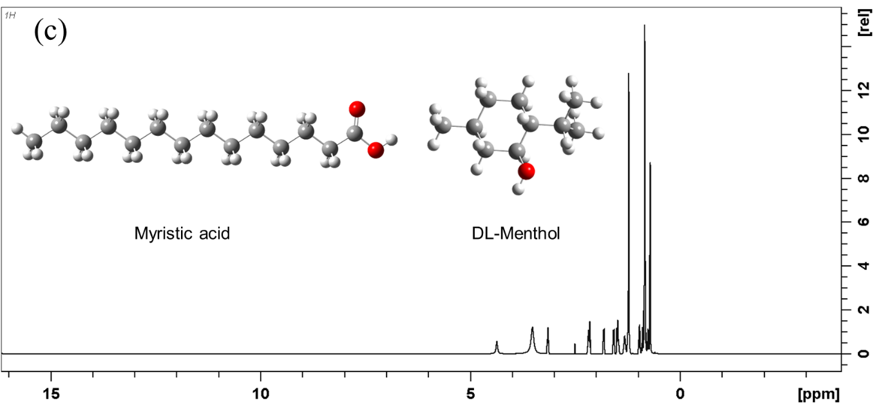

Fig. S1. ¹H NMR spectra of (a) DES1, (b) DES2, (c) DES3, and (d) DES4.

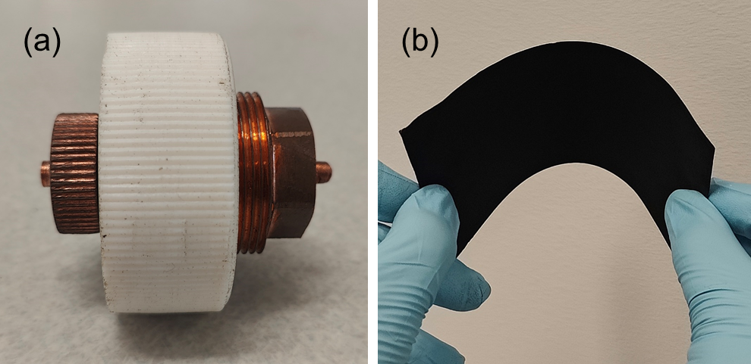
Fig. S2. Images of (a) the coin cell assembly and (b) a piece of exfoliated rGO sheet used as electrode for the electrochemical experiments.
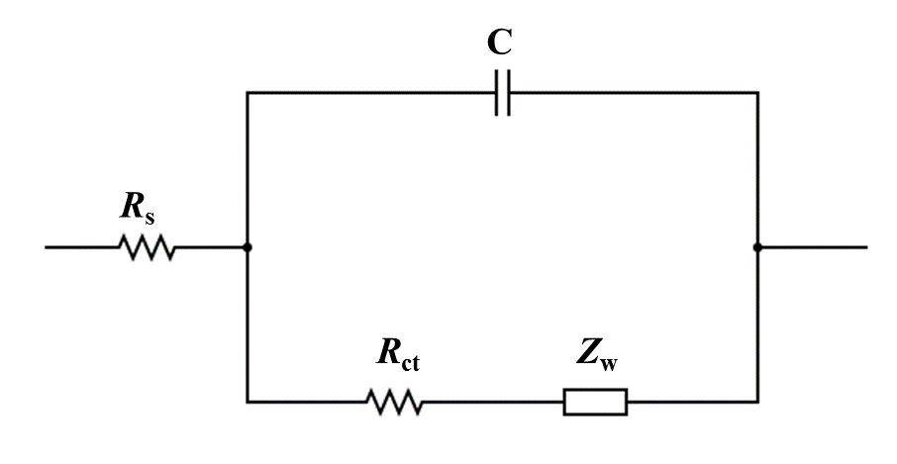
Fig. S3. Equivalent electrical circuit associated with a standard Nyquist plot derived from EIS.

Table S1. Water content in DESs 1 – 4.
DES | Water content (wt%)
DES1 | 0.092
DES2 | 0.086
DES3 | 0.075
DES4 | 0.061

Table S2. R_{s}, R_{ct}, ESR, and ionic conductivity of Gels 1 – 4.
Gel | R_{s} (Ω) | R_{ct} (Ω) | ESR (Ω) = R_{s} + R_{ct} | σ (mS cm⁻¹)
1 | 16.05 | 69.92 | 85.97 | 15.87
2 | 15.64 | 51.35 | 66.99 | 16.28
3 | 17.47 | 107.47 | 124.94 | 14.58
4 | 17.52 | 118.4 | 135.92 | 14.53

