Supplement
Supplementary table 1: Instrumental setting for Reversed phase liquid chromatography (RPLC) and mass spectrometry.
Reversed phase liquid chromatography (RPLC)
Instrument | Ultimate 3000 RSLC (Thermo Scientific)
Trap column | 75 μm inner diameter, packed with 3 μm C18 particles (Acclaim PepMap100, Thermo Scientific)
Analytical column | Accucore 150-C18, (Thermo Fisher Scientific)  25 cm x 75 μm, 2.6 μm C18 particles, 150 Å pore size
Buffer system | binary buffer system consisting of 0.1% acetic acid in HPLC-grade water (buffer A) and 100% ACN in 0.1% acetic acid (buffer B)
Flow rate | 300 nl/min
Gradient | 0 min 2% B  2 min 5% B  10 min 5% B  130 min 25% B  135 min 40% B  137 min 90% B  142 min 90% B  145 min 2% B  150 min 2% B
Gradient duration | 120 min
Column oven temperature | 40°C
Mass spectrometry
Instrument | Q Exactive HF mass spectrometer
Electrospray | Nanospray Flex Ion Source
Operation mode | data-independent
Full MS
MS scan resolution | 60000
Norm. AGC target | 5e6
maximum ion injection time for the MS scan | 200 ms
Scan range | 333 to 1650 m/z
RF Lens | 50%
Spectra data type | profile
dd-MS2
Precursor mass range | 333 to 1650 m/z
Resolution | 30,000
Norm. MS/MS AGC target | 3e6
Maximum ion injection time mode | auto
Spectra data type | profile
Microscans | 1
Isolation window | 56 windows, 13 m/z, 2 m/z overlap
Define first mass | 200
Dissociation mode | higher energy collisional dissociation (HCD)
Normalized collision energy | 27.5 %

Supplementary table 2: Spectronaut settings for mass spectrometry.
ANALYSIS DATA
Spectronaut 18.1.230626.50606
Analysis Mode: UI
Analysis Type: directDIA
Analysis Date: 27-July-2023 10:50:27 UTC+0
BEGIN-SETTINGS
Settings Used: C_FunGene_directDIA_sparse_no_imputing
├─ DIA Analysis\Calibration
│ ├─ MZ Extraction Strategy: Maximum Intensity
│ ├─ Allow source specific iRT Calibration: True
│ ├─ Precision iRT: True
│ │ ├─ Exclude De-amidated Peptides: True
│ │ └─ iRT <-> RT Regression Type: Local (Non-Linear) Regression
│ ├─ MS1 Mass Tolerance Strategy: System Default
│ └─ MS2 Mass Tolerance Strategy: System Default
├─ DIA Analysis\Identification
│ ├─ Precursor Qvalue Cutoff: 0.001
│ ├─ Precursor PEP Cutoff: 0.2
│ ├─ Protein Qvalue Cutoff (Experiment): 0.01
│ ├─ Protein Qvalue Cutoff (Run): 0.05
│ ├─ Protein PEP Cutoff: 0.75
│ ├─ Single Hit Definition: By Stripped Sequence
│ ├─ Exclude Single Hit Proteins: False
│ ├─ Exclude Duplicate Assays: True
│ ├─ Exclude Predicted Fragment Scores: False
│ ├─ Generate Decoys: True
│ │ ├─ Decoy Generation Method: Mutated
│ │ │ └─ Preferred Fragment Source: NN Predicted Fragments
│ │ └─ Decoy Limit Strategy: Dynamic
│ │ └─ Library Size Fraction: 0.1
│ └─ Pvalue Estimator: Kernel Density Estimator
├─ DIA Analysis\Pipeline Mode
│ ├─ Generate SNE File: True
│ │ └─ Store Ion traces in SNE: False
│ ├─ Post Analysis Reports:
│ │ ├─ CV Density Line Chart: True
│ │ ├─ CVs Below X Bar Chart: True
│ │ ├─ Data Completeness Bar Chart: True
│ │ ├─ Run Identifications Bar Chart: True
│ │ └─ Scoring Histograms: True
│ ├─ Report Schema: C_FunGene_complex (Normal), C_FunGene_complex (Normal)
│ └─ Reporting Unit: Across Experiment
├─ DIA Analysis\Post Analysis
│ ├─ Differential Abundance Testing: Paired t-test
│ │ ├─ Group-Wise Testing Correction: False
│ │ ├─ Log2 Ratio Candidate Filter: 0.58
│ │ └─ Confidence Candidate Filter: Qvalue
│ │ └─ Confidence: 0.05
│ ├─ Differential Abundance Grouping: Major Group (Quantification Settings)
│ │ └─ Smallest Quantitative Unit: Precursor Ion (Quantification Settings)
│ │ └─ Use All MS-Level Quantities: False
│ ├─ Calculate Explained TIC: None
│ ├─ Calculate Sample Correlation Matrix: True
│ └─ Hierarchical Clustering: True
│ ├─ Distance Metric: Manhattan Distance
│ ├─ Linkage Strategy: Ward's Method
│ ├─ Order Runs by Clustering: True
│ └─ Z-score Transformation: False
├─ DIA Analysis\Protein Inference
│ └─ Protein Inference Workflow: Automatic
│ └─ Inference Algorithm: IDPicker
├─ DIA Analysis\PTM Workflow
│ └─ PTM Localization: False
├─ DIA Analysis\Quantification
│ ├─ Precursor Filtering: Identified (Qvalue)
│ │ └─ Imputation Strategy: Use Background Signal
│ ├─ Proteotypicity Filter: None
│ ├─ Protein LFQ Method: MaxLFQ
│ ├─ Quantity MS Level: MS2
│ ├─ Quantity Type: Area
│ ├─ Cross-Run Normalization: True
│ │ ├─ Normalization Filter Type: None
│ │ ├─ Normalization Strategy: Local Normalization
│ │ └─ Row Selection: Identified in at least 1 Run (Sparse)
│ ├─ Quantification window: Not Synchronized (SN 17)
│ ├─ Interference Correction: True
│ │ ├─ Only Identified Peptides: True
│ │ ├─ Exclude All Multi-Channel Interferences: True
│ │ ├─ MS1 Min: 2
│ │ └─ MS2 Min: 3
│ ├─ Major (Protein) Grouping: by Protein Group Id
│ ├─ Minor (Peptide) Grouping: by Stripped Sequence
│ ├─ Major Group Quantity: Mean peptide quantity
│ ├─ Major Group Top N: True
│ │ ├─ Max: 3
│ │ └─ Min: 2
│ ├─ Minor Group Quantity: Sum precursor quantity
│ └─ Minor Group Top N: False
├─ DIA Analysis\Workflow
│ ├─ Method Evaluation: False
│ ├─ MS2 DeMultiplexing: Automatic
│ ├─ Profiling Strategy: iRT Profiling
│ │ ├─ Carry-over exact Peak Boundaries: False
│ │ ├─ Profiling Row Selection: Minimum Qvalue Row Selection
│ │ │ └─ Qvalue Threshold: 0.001
│ │ └─ Profiling Target Selection: Profile only non-identified Precursors
│ │ ├─ Identification Criterion: Qvalue
│ │ └─ Threshold: 0.001
│ ├─ Run Limit for directDIA Library: -1
│ └─ Unify Peptide Peaks Strategy: Select corresponding Peak
├─ DIA Analysis\XIC Extraction
│ ├─ XIC IM Extraction Window: Dynamic
│ │ └─ Correction Factor: 1
│ ├─ XIC RT Extraction Window: Dynamic
│ │ └─ Correction Factor: 1
│ ├─ MS1 Mass Tolerance Strategy: Dynamic
│ │ └─ Correction Factor: 1
│ └─ MS2 Mass Tolerance Strategy: Dynamic
│ └─ Correction Factor: 1
├─ Pulsar Search\Identification
│ ├─ PSM FDR: 0.01
│ ├─ Peptide FDR: 0.01
│ ├─ Protein Group FDR: 0.01
│ ├─ directDIA Workflow: directDIA+ (Deep)
│ └─ PTM Localization Filter: False
├─ Pulsar Search\Labeling
│ └─ Channels:
│ ├─ Channel 1: False
│ ├─ Channel 2: False
│ └─ Channel 3: False
├─ Pulsar Search\Modifications
│ ├─ Max Variable Modifications: 5
│ └─ Select Modifications:
│ ├─ Fixed Modifications::
│ └─ Variable Modifications: : Oxidation (M)
├─ Pulsar Search\Peptides
│ ├─ Enzymes / Cleavage Rules: Trypsin/P
│ ├─ Digest Type: Specific
│ ├─ Max Peptide Length: 52
│ ├─ Min Peptide Length: 7
│ ├─ Missed Cleavages: 0
│ └─ Toggle N-terminal M: True
├─ Pulsar Search\Result Filters
│ ├─ Fragment Ions:
│ │ ├─ Ion AA Length: True
│ │ │ └─ N: 3
│ │ ├─ Ion Charge: False
│ │ ├─ Ion Loss Type: False
│ │ ├─ Ion Type: False
│ │ ├─ m/z : True
│ │ │ ├─ Max: 1800
│ │ │ └─ Min: 300
│ │ └─ Relative Intensity: True
│ │ └─ Min: 5
│ └─ Precursors:
│ ├─ Amino Acids: False
│ ├─ Best N Fragments per Peptide: True
│ │ ├─ Max: 10
│ │ └─ Min: 6
│ ├─ Best N Peptides per Protein Group: False
│ ├─ Channel Count: False
│ ├─ FASTA Matched: False
│ ├─ Missed Cleavage: False
│ ├─ Modifications: None
│ ├─ Peptide Charge: False
│ └─ Proteotypicity: False
├─ Pulsar Search\Speed-Up
│ ├─ IM DFD Processing:
│ │ └─ Use Dynamic IM Peak Filter: True
│ │ └─ Target TIC Fraction: 0.9
│ └─ MS2 Index: Automatic
├─ Pulsar Search\Tolerances
│ └─ Tolerance Parameters:
│ ├─ Thermo IonTrap:
│ │ ├─ Calibration Search: Dynamic
│ │ │ ├─ MS1 Correction Factor: 1
│ │ │ └─ MS2 Correction Factor: 1
│ │ └─ Main Search: Dynamic
│ │ ├─ MS1 Correction Factor: 1
│ │ └─ MS2 Correction Factor: 1
│ ├─ Thermo Orbitrap:
│ │ ├─ Calibration Search: Dynamic
│ │ │ ├─ MS1 Correction Factor: 1
│ │ │ └─ MS2 Correction Factor: 1
│ │ └─ Main Search: Dynamic
│ │ ├─ MS1 Correction Factor: 1
│ │ └─ MS2 Correction Factor: 1
│ └─ TOF:
│ ├─ Calibration Search: Dynamic
│ │ ├─ MS1 Correction Factor: 1
│ │ └─ MS2 Correction Factor: 1
│ └─ Main Search: Dynamic
│ ├─ MS1 Correction Factor: 1
│ └─ MS2 Correction Factor: 1
└─ Pulsar Search\Workflow
├─ Fragment Ion Selection Strategy: Intensity Based
├─ In-Silico Generate Missing Channels: False
└─ Use DNN Predicted Ion Mobility: Auto
END-SETTINGS

Supplementary table 3 provided as separate data file (SupplementaryTable3.xls):
Supplementary table 3: Summary of transcriptome and proteome. Each cluster within the transcriptome and proteome is identified by a unique cluster ID (cluster ID pangenome). Annotation and Prokka ID are shown for the respective representative cluster ID for the pangenome. The cluster IDs from the homologous clustering approach are assigned to the cluster ID of the pangenome for each strain and the representative cluster ID is shown (association of clusters from pangenome and homologous clustering approach). The relative occurrence of the cluster within the homologous clustering approach is shown for each KPST, KV and KQ (genome). The L2FC data obtained from the NRC are shown for all comparisons (transcriptome). In addition, the L2FC calculated from the iBAQs (proteome) are shown for all clusters.
Supplementary table 4 provided as separate data file (SupplementaryTable4.xls):
Supplementary table 4: Accession number of the included genomes for the homologous clustering approach.
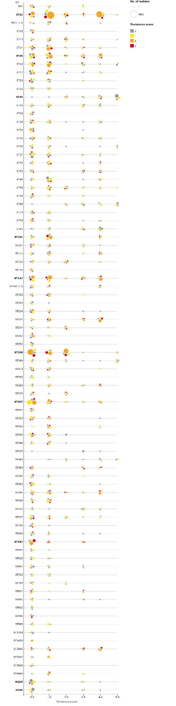
Supplementary figure 1: Beeswarm plot of the virulence and resistance scores of Klebsiella (K.) pneumoniae, K. variicola and K. quasipneumoniae. Results are only shown for KP STs with at least 50 publically available genomes. The size of the bubbles represents the number of genomes, whereas the color represents the resistance score. Investigated STs as well as KV/KQ are highlighted in bold.
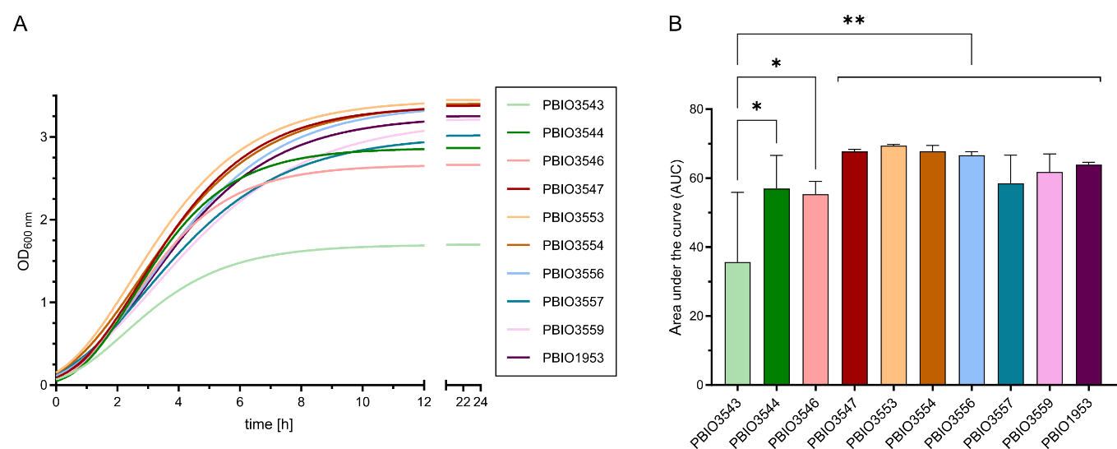
Supplementary figure 2: Growth kinetics of KP and KV strains in LB medium. Strains were cultivated in LB medium in biological triplicates. (A) Growth kinetics are displayed using GraphPad Prism and Gompertz-Growth fitting. (B) The area under the curve was calculated from three individual cultivations. The significance of differences was calculated using one-way ANOVA (p-value: * 0.33; ** 0.02).
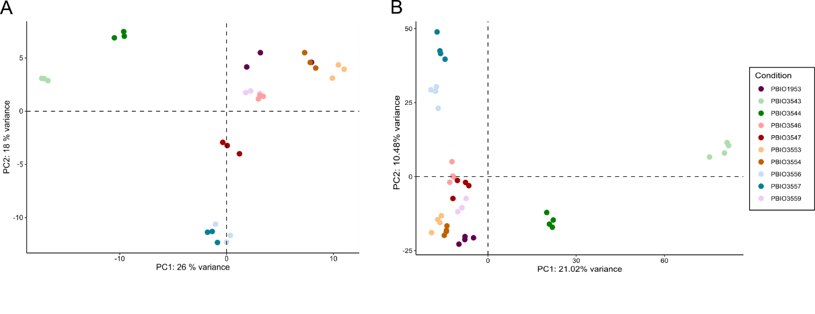
Supplementary figure 3: Principle component analysis. (A) Transcriptomic samples were separated by the PC1 (26% variance) and PC2 (18% variance). Data from three biological replicates are represented. (B) Proteomic samples were separated by the PC1 (21.02% variance) and PC2 (10.48% variance). Data from minimum three biological replicates are represented.
Supplementary figure 4: Number of strain specific and shared regulations (markers) on transcriptomic and proteomic levels. Differentially expressed genes were analyzed by comparing each KP strain with each KV strain. Genes were assumed as differentially expressed when the comparison revealed a |L2FC|>1.5 and a significant p-adjusted value of <0.05. Depending on the L2FC, genes were differentiated whether they are downregulated (L2FC<-1.5) or upregulated (L2FC>1.5). The number of regulated genes on (A) transcriptomic and (B) proteomic levels is shown for each comparison and additionally the number of marker genes is indicated.

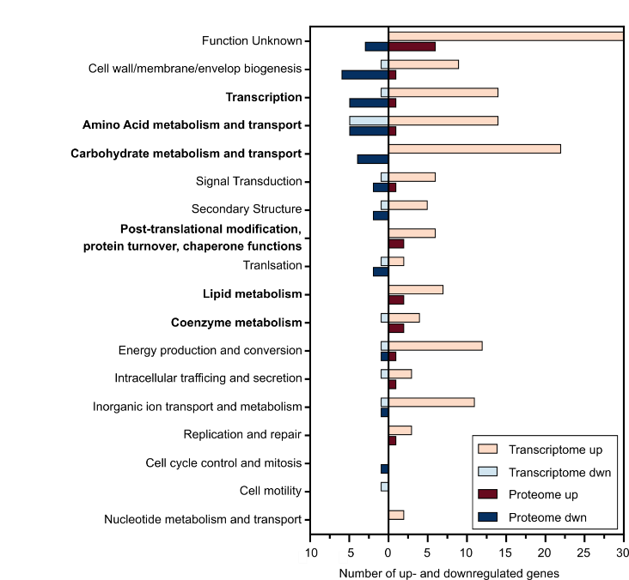
Supplementary figure 5: Number of up- and downregulations on transcriptomic and proteomic levels assigned to the different COG categories. Whenever available, information about the COG for all regulated genes on transcriptomic and proteomic levels were annotated based on the Bakta and eggNOG database and plotted separately on transcriptomic and proteomic levels and up- or down-regulated genes as indicated.
Supplementary table 5: Functional categories designed for in-depth characterization of regulated genes with their respective numbers. Four different main groups (Porins/transporter, metabolism, regulation, and others) were assigned. In a second step, more detailed categories were defined. Number of regulations were differentiated between proteomic and transcriptomic levels and whether they are up- (up) or down (dwn) regulated
Category number | Category | Proteome dwn | Proteome up | Transcriptome dwn | Transcriptome up
Porins/transporter
1 | Porin | 0 | 1 | 0 | 3
2 | ABC transporter | 5 | 0 | 1 | 6
3 | PTS | 0 | 0 | 0 | 0
4 | Expoter | 1 | 0 | 0 | 0
5 | MFS transporter | 0 | 0 | 2 | 5
6 | Permease | 0 | 0 | 0 | 2
7 | Two component system | 0 | 0 | 0 | 4
8 | other transporter | 0 | 0 | 0 | 4
Metabolism
9 | Sulfur | 0 | 1 | 0 | 8
10 | Nitrogen/ammonia | 0 | 1 | 0 | 2
11 | Citrate | 0 | 3 | 0 | 2
12 | Posphate | 0 | 0 | 0 | 7
13 | Biotin/fatty acid | 0 | 2 | 1 | 5
14 | Carbohydrate | 3 | 2 | 2 | 17
15 | Amino acid | 3 | 1 | 0 | 18
16 | O-antigen/LPS/cell well | 4 | 0 | 0 | 6
17 | Ribosomes/tRNA | 2 | 1 | 0 | 3
18 | Peptide | 0 | 2 | 0 | 3
19 | Nucleotide | 0 | 0 | 0 | 1
Regulation/stress response
20 | regulators / transcription factors | 5 | 1 | 1 | 12
21 | stress response | 0 | 1 | 0 | 4
others
22 | chaperones | 0 | 0 | 0 | 2
23 | toxin-antitoxin | 1 | 0 | 0 | 1
24 | DNA | 0 | 1 | 0 | 3
25 | unkown | 0 | 2 | 2 | 9
26 | resistance | 2 | 0 | 1 | 0
27 | others | 3 | 1 | 2 | 17
total number |  | 29 | 20 | 12 | 144

Supplementary table 6: Assignment of clusters to the developed functional category. Each cluster was assigned to a category number (Supplementary table 5). Further it is differentiated whether up- or down-regulation in KP compared to KV was detected on transcriptomic (RNA) or proteomic (protein) level.
Cluster ID | Category number | Regulation | Omics level
cl00019 | 10 | up | protein
cl00122 | 1 | up | RNA
cl00156 | 9 | up | RNA
cl00275 | 27 | down | protein
cl00362 | 21 | up | RNA
cl00441 | 2 | up | RNA
cl00452 | 10 | up | RNA
cl00491 | 27 | up | RNA
cl00571 | 13 | up | protein
cl00690 | 15 | up | RNA
cl00734 | 5 | down | RNA
cl00851 | 14 | up | RNA
cl01016 | 14 | down | RNA
cl01020 | 2 | up | RNA
cl01035 | 27 | up | RNA
cl01080 | 15 | down | protein
cl01435 | 5 | down | RNA
cl01457 | 21 | up | RNA
cl01457 | 21 | up | protein
cl01478 | 14 | up | RNA
cl01483 | 27 | down | RNA
cl01520 | 11 | up | RNA
cl01520 | 11 | up | protein
cl01595 | 21 | up | RNA
cl01810 | 9 | up | RNA
cl01855 | 20 | up | RNA
cl01884 | 11 | up | RNA
cl01884 | 11 | up | protein
cl01934 | 24 | up | RNA
cl01978 | 9 | up | RNA
cl02041 | 11 | up | protein
cl02165 | 2 | up | RNA
cl02168 | 17 | up | protein
cl02199 | 27 | up | RNA
cl02200 | 20 | up | RNA
cl02207 | 27 | down | RNA
cl02262 | 14 | down | RNA
cl02455 | 22 | up | RNA
cl02465 | 14 | up | RNA
cl02470 | 20 | up | RNA
cl02761 | 2 | down | protein
cl02771 | 20 | down | protein
cl02871 | 25 | down | RNA
cl02893 | 14 | up | RNA
cl02930 | 9 | up | RNA
cl02931 | 9 | up | RNA
cl02947 | 17 | down | protein
cl02948 | 17 | up | RNA
cl02956 | 1 | up | RNA
cl02956 | 1 | up | protein
cl02960 | 13 | down | RNA
cl03037 | 20 | down | RNA
cl03041 | 18 | up | RNA
cl03093 | 2 | up | RNA
cl03182 | 2 | down | RNA
cl03246 | 25 | down | RNA
cl03293 | 27 | up | RNA
cl03297 | 9 | up | protein
cl03396 | 9 | up | RNA
cl03525 | 20 | down | protein
cl03537 | 4 | down | protein
cl03542 | 14 | down | protein
cl03634 | 23 | down | protein
cl03745 | 7 | up | RNA
cl03746 | 7 | up | RNA
cl03828 | 24 | up | protein
cl03864 | 18 | up | RNA
cl03864 | 18 | up | protein
cl03866 | 18 | up | protein
cl03944 | 18 | up | RNA
cl03962 | 26 | down | RNA
cl03973 | 17 | down | protein
cl03976 | 20 | up | protein
cl04012 | 15 | up | RNA
cl04087 | 14 | up | RNA
cl04088 | 2 | down | protein
cl04110 | 27 | up | protein
cl04243 | 8 | up | RNA
cl04244 | 5 | up | RNA
cl04278 | 12 | up | RNA
cl04306 | 20 | up | RNA
cl04307 | 15 | up | RNA
cl04309 | 25 | up | RNA
cl04310 | 20 | up | RNA
cl04310 | 20 | up | protein
cl04311 | 13 | up | RNA
cl04312 | 13 | up | RNA
cl04315 | 15 | up | RNA
cl04316 | 20 | up | RNA
cl04321 | 27 | up | RNA
cl04322 | 14 | up | RNA
cl04322 | 14 | up | protein
cl04323 | 8 | up | RNA
cl04324 | 25 | up | RNA
cl04325 | 22 | up | RNA
cl04326 | 10 | up | RNA
cl04327 | 16 | up | RNA
cl04328 | 25 | up | RNA
cl04329 | 15 | up | RNA
cl04332 | 27 | up | RNA
cl04332 | 27 | up | protein
cl04333 | 5 | up | RNA
cl04334 | 13 | up | RNA
cl04334 | 13 | up | protein
cl04335 | 25 | up | RNA
cl04336 | 5 | up | RNA
cl04337 | 6 | up | RNA
cl04337 | 6 | up | RNA
cl04341 | 16 | up | RNA
cl04342 | 23 | up | RNA
cl04343 | 20 | up | RNA
cl04344 | 20 | up | RNA
cl04347 | 27 | up | RNA
cl04348 | 20 | up | RNA
cl04349 | 19 | up | RNA
cl04351 | 20 | up | RNA
cl04352 | 21 | up | RNA
cl04353 | 15 | up | RNA
cl04356 | 27 | up | RNA
cl04361 | 24 | up | RNA
cl04362 | 15 | up | RNA
cl04364 | 24 | up | RNA
cl04365 | 16 | up | RNA
cl04366 | 25 | up | RNA
cl04368 | 15 | up | RNA
cl04370 | 20 | up | RNA
cl04371 | 15 | up | RNA
cl04374 | 27 | up | RNA
cl04376 | 1 | up | RNA
cl04377 | 14 | up | RNA
cl04377 | 14 | up | protein
cl04379 | 12 | up | RNA
cl04380 | 15 | up | RNA
cl04381 | 27 | up | RNA
cl04382 | 27 | up | RNA
cl04383 | 14 | up | RNA
cl04385 | 27 | up | RNA
cl04386 | 16 | up | RNA
cl04390 | 15 | up | RNA
cl04391 | 20 | up | RNA
cl04392 | 16 | up | RNA
cl04394 | 8 | up | RNA
cl04403 | 27 | up | RNA
cl04407 | 15 | up | RNA
cl04416 | 25 | up | RNA
cl04418 | 16 | up | RNA
cl04419 | 27 | up | RNA
cl04422 | 14 | up | RNA
cl04423 | 2 | up | RNA
cl04428 | 25 | up | RNA
cl04433 | 12 | up | RNA
cl04435 | 25 | up | RNA
cl04439 | 12 | up | RNA
cl04442 | 14 | up | RNA
cl04444 | 14 | up | RNA
cl04445 | 15 | up | RNA
cl04447 | 15 | up | RNA
cl04448 | 13 | up | RNA
cl04451 | 9 | up | RNA
cl04452 | 2 | up | RNA
cl04453 | 9 | up | RNA
cl04456 | 12 | up | RNA
cl04459 | 13 | up | RNA
cl04460 | 14 | up | RNA
cl04463 | 14 | up | RNA
cl04466 | 8 | up | RNA
cl04469 | 14 | up | RNA
cl04470 | 15 | up | RNA
cl04471 | 14 | up | RNA
cl04472 | 7 | up | RNA
cl04473 | 27 | up | RNA
cl04474 | 14 | up | RNA
cl04475 | 20 | up | RNA
cl04476 | 5 | up | RNA
cl04477 | 27 | up | RNA
cl04478 | 5 | up | RNA
cl04479 | 12 | up | RNA
cl04481 | 17 | up | RNA
cl04482 | 7 | up | RNA
cl04484 | 12 | up | RNA
cl04485 | 15 | up | RNA
cl04486 | 14 | up | RNA
cl04487 | 15 | up | RNA
cl04487 | 15 | up | protein
cl04490 | 17 | up | RNA
cl04491 | 27 | up | RNA
cl04500 | 15 | up | RNA
cl05041 | 26 | down | protein
cl05158 | 27 | down | protein
cl06254 | 16 | down | protein
cl06255 | 16 | down | protein
cl06256 | 16 | down | protein
cl06257 | 16 | down | protein
cl06295 | 2 | down | protein
cl06305 | 14 | down | protein
cl06336 | 25 | down | protein
cl06349 | 14 | down | protein
cl06382 | 2 | down | protein
cl06385 | 2 | down | protein
cl06388 | 26 | down | protein
cl06393 | 15 | down | protein
cl06417 | 20 | down | protein
cl06439 | 20 | down | protein
cl06450 | 15 | down | protein
cl06452 | 20 | down | protein

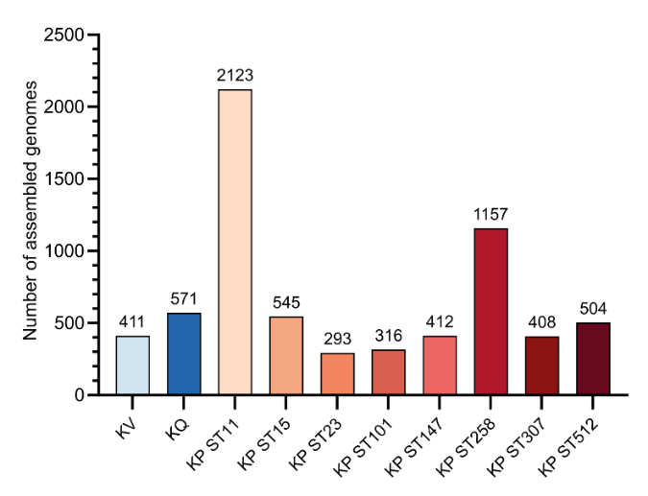
Supplementary figure 6: Number of publicly available genomes used for the construction of a Klebsiella homologous clustering approach. The number of genomes downloaded from the NCBI database is shown for KV, KQ and each of the 8 successful international high-risk KP STs.
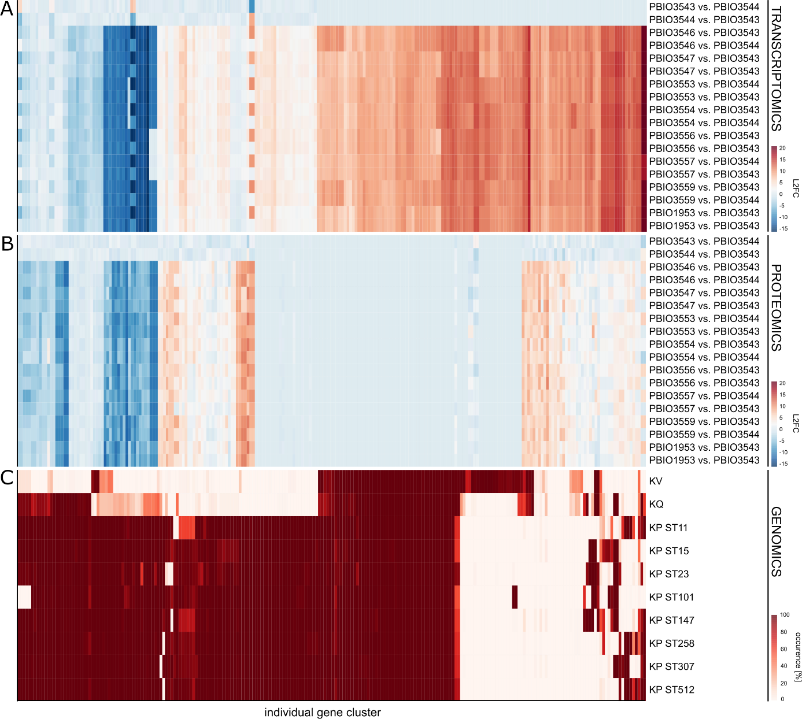
Supplementary figure 7: Distribution of regulated genes within the Klebsiella spp. homologous clustering approach. Genes regulated either on transcriptomic and/or proteomic levels were mapped against the homologous clustering approach of Klebsiella spp. including K. variicola (KV) and K. quasipneumoniae (KQ) and eight different KP STs (ST11, ST15, ST23, ST101, ST147, ST258, ST307 and ST512). The regulation on transcriptomic (A) and proteomic (B) levels is shown as the L2FC of the indicted comparisons each. (C) The occurrence of the individual gene clusters within the different Klebsiella species and STs of the large clustering approach is shown in [%].

Supplementary table 7: Taxonomic distribution of selected markers. The representative protein sequences for the indicated selected markers were blasted against the NCBI nr database using BLASTP with a cut-off of 95% coverage and identity. Whenever possible the taxonomic IDs were extracted on species level, otherwise on genus level. The number of hits found among the different species is shown for each selected marker.
Species | celA | celB | celF | chbF | citA | citS | citX | cydA | cydB | fabG | pgtA | pgtB | pgtC | pgtP | phnR | phnS | phnT | phnU | phnV | phnW | phnX
Citrobacter | 0 | 0 | 0 | 0 | 0 | 0 | 0 | 0 | 0 | 0 | 0 | 0 | 0 | 2 | 0 | 0 | 0 | 0 | 0 | 0 | 0
Citrobacter portucalensis | 0 | 0 | 0 | 0 | 0 | 0 | 0 | 0 | 0 | 0 | 0 | 1 | 0 | 0 | 0 | 0 | 0 | 0 | 0 | 0 | 0
Clostridium perfringens | 0 | 0 | 0 | 0 | 0 | 0 | 0 | 2 | 0 | 0 | 0 | 0 | 0 | 0 | 0 | 0 | 0 | 0 | 0 | 0 | 0
Enterobacter sp. HMSC055A11 | 0 | 0 | 0 | 0 | 0 | 0 | 0 | 0 | 0 | 0 | 0 | 0 | 0 | 1 | 0 | 0 | 0 | 0 | 0 | 0 | 0
Enterobacteriaceae | 0 | 0 | 0 | 0 | 0 | 0 | 0 | 1 | 1 | 0 | 0 | 0 | 0 | 0 | 0 | 0 | 0 | 1 | 0 | 0 | 0
Enterobacteriaceae bacterium 8376wD9 | 0 | 0 | 0 | 0 | 1 | 0 | 0 | 0 | 0 | 0 | 0 | 0 | 0 | 0 | 0 | 0 | 0 | 0 | 0 | 0 | 0
Enterobacteriaceae bacterium S05 | 0 | 0 | 0 | 0 | 0 | 0 | 0 | 0 | 0 | 0 | 0 | 1 | 0 | 0 | 0 | 0 | 1 | 0 | 0 | 0 | 0
Enterobacteriaceae bacterium strain FGI 57 | 0 | 0 | 0 | 0 | 0 | 0 | 0 | 1 | 0 | 0 | 0 | 0 | 0 | 0 | 0 | 0 | 0 | 0 | 0 | 0 | 0
Enterobacteriaceae bacterium TzEc084 | 0 | 0 | 0 | 0 | 0 | 0 | 0 | 0 | 0 | 0 | 0 | 1 | 0 | 0 | 0 | 0 | 0 | 0 | 0 | 0 | 0
Escherichia coli | 0 | 0 | 0 | 0 | 0 | 0 | 1 | 0 | 0 | 2 | 1 | 1 | 1 | 0 | 0 | 0 | 0 | 0 | 0 | 0 | 2
Klebsiella spp. | 2 | 8 | 6 | 12 | 18 | 8 | 4 | 13 | 11 | 4 | 11 | 12 | 18 | 15 | 15 | 12 | 8 | 11 | 10 | 6 | 13
Klebsiella aerogenes | 14 | 44 | 93 | 0 | 0 | 1 | 1 | 14 | 24 | 0 | 1 | 1 | 0 | 0 | 41 | 95 | 76 | 72 | 62 | 74 | 67
Klebsiella africana | 0 | 1 | 1 | 0 | 2 | 1 | 1 | 0 | 4 | 2 | 4 | 4 | 2 | 3 | 1 | 1 | 1 | 2 | 1 | 1 | 2
Klebsiella grimontii | 0 | 0 | 0 | 0 | 0 | 0 | 0 | 1 | 5 | 0 | 0 | 0 | 0 | 8 | 0 | 0 | 0 | 0 | 0 | 0 | 0
Klebsiella huaxiensis | 0 | 0 | 0 | 0 | 0 | 0 | 0 | 0 | 0 | 0 | 0 | 0 | 0 | 0 | 2 | 0 | 0 | 0 | 0 | 0 | 0
Klebsiella michiganensis | 0 | 0 | 0 | 0 | 0 | 0 | 0 | 16 | 18 | 1 | 0 | 3 | 0 | 30 | 19 | 0 | 0 | 0 | 0 | 0 | 0
Klebsiella oxytoca | 0 | 0 | 0 | 0 | 0 | 0 | 0 | 11 | 7 | 2 | 37 | 33 | 35 | 18 | 13 | 0 | 0 | 0 | 0 | 0 | 0
Klebsiella pasteurii | 0 | 0 | 0 | 0 | 0 | 0 | 0 | 1 | 2 | 1 | 0 | 0 | 0 | 1 | 0 | 0 | 0 | 0 | 0 | 0 | 0
Klebsiella pneumoniae | 137 | 462 | 542 | 613 | 528 | 367 | 161 | 203 | 215 | 309 | 606 | 973 | 804 | 511 | 174 | 415 | 424 | 334 | 277 | 469 | 437
Klebsiella quasipneumoniae | 0 | 0 | 0 | 78 | 145 | 109 | 36 | 26 | 36 | 3 | 79 | 199 | 76 | 101 | 41 | 95 | 118 | 102 | 91 | 135 | 99
Klebsiella quasivariicola | 3 | 3 | 4 | 5 | 1 | 6 | 1 | 0 | 1 | 3 | 3 | 3 | 4 | 3 | 1 | 6 | 8 | 4 | 4 | 4 | 4
Klebsiella sp. | 0 | 0 | 0 | 0 | 0 | 2 | 0 | 0 | 0 | 0 | 0 | 0 | 0 | 0 | 0 | 0 | 0 | 0 | 0 | 0 | 0
Klebsiella sp. 1400 | 0 | 0 | 0 | 0 | 0 | 0 | 0 | 1 | 0 | 0 | 0 | 0 | 0 | 0 | 0 | 0 | 0 | 0 | 0 | 0 | 0
Klebsiella sp. 141153 | 0 | 0 | 1 | 0 | 0 | 0 | 0 | 0 | 0 | 0 | 0 | 0 | 0 | 0 | 0 | 0 | 0 | 0 | 1 | 0 | 0
Klebsiella sp. 141203 | 0 | 0 | 0 | 0 | 0 | 0 | 0 | 0 | 0 | 0 | 0 | 0 | 0 | 0 | 0 | 0 | 1 | 0 | 1 | 0 | 0
Klebsiella sp. 2019SCSN059 | 0 | 0 | 0 | 0 | 0 | 1 | 0 | 0 | 0 | 0 | 1 | 1 | 1 | 0 | 0 | 1 | 1 | 1 | 0 | 0 | 0
Klebsiella sp. 54 | 0 | 0 | 0 | 0 | 0 | 1 | 0 | 0 | 0 | 0 | 0 | 0 | 0 | 0 | 0 | 1 | 0 | 0 | 0 | 1 | 1
Klebsiella sp. B-Nf7 | 0 | 1 | 1 | 0 | 0 | 0 | 0 | 0 | 0 | 0 | 0 | 0 | 0 | 0 | 0 | 0 | 0 | 0 | 0 | 0 | 0
Klebsiella sp. CTHL.F3a | 0 | 0 | 0 | 0 | 0 | 0 | 0 | 0 | 1 | 0 | 0 | 0 | 0 | 0 | 0 | 0 | 0 | 0 | 0 | 0 | 0
Klebsiella sp. GL120222-02 | 0 | 0 | 0 | 0 | 1 | 0 | 0 | 0 | 1 | 0 | 0 | 0 | 0 | 0 | 0 | 0 | 0 | 0 | 0 | 0 | 0
Klebsiella sp. HMSC09D12 | 0 | 0 | 0 | 0 | 0 | 0 | 0 | 0 | 0 | 0 | 0 | 0 | 1 | 0 | 0 | 0 | 0 | 0 | 0 | 0 | 0
Klebsiella sp. HMSC16A12 | 0 | 0 | 0 | 0 | 0 | 0 | 0 | 0 | 0 | 1 | 0 | 2 | 1 | 0 | 0 | 0 | 0 | 0 | 0 | 0 | 0
Klebsiella sp. H-Nf2 | 0 | 0 | 0 | 0 | 1 | 0 | 1 | 0 | 0 | 0 | 0 | 0 | 0 | 0 | 0 | 0 | 0 | 0 | 0 | 0 | 0
Klebsiella sp. HSTU-Sny5 | 0 | 0 | 0 | 1 | 0 | 0 | 0 | 0 | 0 | 0 | 0 | 0 | 0 | 1 | 0 | 0 | 0 | 0 | 0 | 0 | 0
Klebsiella sp. K4-130 | 0 | 0 | 0 | 0 | 0 | 0 | 0 | 0 | 0 | 0 | 0 | 0 | 0 | 0 | 0 | 1 | 0 | 1 | 0 | 1 | 0
Klebsiella sp. K4-154 | 0 | 1 | 1 | 0 | 0 | 0 | 0 | 0 | 0 | 0 | 0 | 0 | 0 | 0 | 0 | 0 | 0 | 0 | 0 | 0 | 0
Klebsiella sp. K4-172 | 0 | 0 | 0 | 0 | 0 | 0 | 0 | 0 | 0 | 0 | 1 | 1 | 0 | 1 | 0 | 0 | 0 | 0 | 0 | 0 | 0
Klebsiella sp. K4-188 | 0 | 0 | 1 | 0 | 0 | 0 | 0 | 0 | 0 | 0 | 0 | 0 | 0 | 0 | 0 | 0 | 0 | 0 | 0 | 0 | 0
Klebsiella sp. K4-38 | 0 | 0 | 0 | 0 | 0 | 0 | 0 | 0 | 0 | 0 | 0 | 0 | 1 | 0 | 0 | 0 | 0 | 0 | 0 | 0 | 0
Klebsiella sp. K4-50 | 0 | 0 | 0 | 0 | 1 | 0 | 0 | 0 | 0 | 0 | 0 | 0 | 0 | 0 | 0 | 0 | 0 | 0 | 0 | 0 | 0
Klebsiella sp. K5-210 | 0 | 0 | 0 | 1 | 0 | 1 | 0 | 0 | 0 | 0 | 0 | 0 | 0 | 0 | 0 | 0 | 0 | 0 | 0 | 0 | 0
Klebsiella sp. K5-309 | 0 | 0 | 0 | 0 | 0 | 0 | 0 | 0 | 0 | 0 | 0 | 1 | 0 | 0 | 0 | 0 | 0 | 0 | 0 | 0 | 0
Klebsiella sp. K6-148 | 0 | 1 | 0 | 0 | 0 | 0 | 0 | 0 | 0 | 0 | 0 | 0 | 0 | 0 | 0 | 0 | 0 | 0 | 0 | 0 | 0
Klebsiella sp. K6-243 | 0 | 0 | 0 | 0 | 0 | 0 | 1 | 0 | 0 | 0 | 0 | 0 | 0 | 0 | 0 | 0 | 0 | 0 | 0 | 0 | 0
Klebsiella sp. Kpp | 0 | 0 | 0 | 0 | 0 | 0 | 0 | 0 | 1 | 0 | 0 | 0 | 0 | 0 | 0 | 0 | 0 | 1 | 0 | 1 | 0
Klebsiella sp. MS 92-3 | 0 | 0 | 0 | 0 | 0 | 0 | 0 | 0 | 0 | 0 | 1 | 0 | 1 | 0 | 1 | 0 | 0 | 0 | 0 | 0 | 0
Klebsiella sp. Q2 | 0 | 0 | 0 | 0 | 0 | 0 | 1 | 0 | 0 | 0 | 0 | 0 | 0 | 0 | 0 | 0 | 0 | 0 | 0 | 0 | 0
Klebsiella sp. RC2 | 0 | 0 | 0 | 0 | 0 | 0 | 0 | 0 | 1 | 0 | 0 | 0 | 0 | 0 | 0 | 0 | 0 | 0 | 0 | 0 | 0
Klebsiella sp. RHBSTW-00215 | 0 | 0 | 0 | 0 | 0 | 0 | 0 | 0 | 0 | 0 | 0 | 0 | 0 | 0 | 1 | 0 | 0 | 0 | 0 | 0 | 0
Klebsiella sp. RHBSTW-00465 | 0 | 0 | 0 | 0 | 0 | 0 | 0 | 0 | 0 | 0 | 0 | 0 | 0 | 0 | 1 | 0 | 0 | 0 | 0 | 0 | 0
Klebsiella sp. WP8-S18-ESBL-06 | 0 | 0 | 0 | 0 | 0 | 0 | 0 | 0 | 1 | 0 | 0 | 0 | 0 | 0 | 0 | 0 | 0 | 0 | 0 | 0 | 0
Klebsiella sp. Z2 | 0 | 0 | 0 | 0 | 0 | 0 | 0 | 0 | 0 | 0 | 0 | 0 | 1 | 0 | 0 | 0 | 0 | 0 | 0 | 0 | 0
Klebsiella spallanzanii | 0 | 0 | 0 | 0 | 0 | 0 | 0 | 1 | 1 | 0 | 0 | 0 | 0 | 0 | 3 | 0 | 0 | 0 | 0 | 0 | 0
Klebsiella variicola | 2 | 2 | 4 | 4 | 77 | 63 | 26 | 22 | 27 | 0 | 0 | 0 | 0 | 1 | 0 | 2 | 2 | 1 | 2 | 2 | 2
Kluyvera ascorbata | 0 | 0 | 0 | 0 | 0 | 0 | 0 | 1 | 0 | 0 | 0 | 0 | 0 | 0 | 0 | 0 | 0 | 0 | 0 | 0 | 0
Kluyvera cryocrescens | 0 | 0 | 0 | 0 | 0 | 0 | 0 | 0 | 2 | 0 | 0 | 0 | 0 | 0 | 0 | 0 | 0 | 0 | 0 | 0 | 0
Kluyvera genomosp. 1 | 0 | 0 | 0 | 0 | 0 | 0 | 0 | 0 | 1 | 0 | 0 | 0 | 0 | 0 | 0 | 0 | 0 | 0 | 0 | 0 | 0
Kluyvera georgiana | 0 | 0 | 0 | 0 | 0 | 0 | 0 | 1 | 1 | 0 | 0 | 0 | 0 | 0 | 0 | 0 | 0 | 0 | 0 | 0 | 0
Kluyvera intermedia | 0 | 0 | 0 | 0 | 0 | 0 | 0 | 0 | 1 | 0 | 0 | 0 | 0 | 0 | 0 | 0 | 0 | 0 | 0 | 0 | 0
Pseudocitrobacter | 0 | 0 | 0 | 0 | 0 | 0 | 0 | 1 | 0 | 0 | 0 | 0 | 0 | 0 | 0 | 0 | 0 | 0 | 0 | 0 | 0
Pseudocitrobacter corydidari | 0 | 0 | 0 | 0 | 0 | 0 | 0 | 1 | 0 | 0 | 0 | 0 | 0 | 0 | 0 | 0 | 0 | 0 | 0 | 0 | 0
Raoultella | 0 | 0 | 0 | 0 | 0 | 0 | 0 | 0 | 0 | 0 | 0 | 0 | 0 | 0 | 2 | 0 | 0 | 0 | 0 | 0 | 0
Raoultella ornithinolytica | 0 | 0 | 0 | 0 | 0 | 0 | 0 | 0 | 0 | 0 | 0 | 0 | 0 | 0 | 6 | 0 | 0 | 0 | 0 | 0 | 0
Raoultella planticola | 0 | 0 | 0 | 0 | 0 | 0 | 0 | 0 | 0 | 0 | 0 | 0 | 0 | 0 | 5 | 0 | 0 | 0 | 0 | 0 | 0
Raoultella sp. BIGb0138 | 0 | 0 | 0 | 0 | 0 | 0 | 0 | 0 | 0 | 0 | 0 | 0 | 0 | 0 | 1 | 0 | 0 | 0 | 0 | 0 | 0
Salmonella enterica | 1 | 0 | 0 | 0 | 0 | 0 | 0 | 0 | 0 | 0 | 0 | 0 | 0 | 0 | 3 | 2 | 1 | 0 | 4 | 3 | 3
Samsonia erythrinae | 0 | 0 | 0 | 0 | 0 | 0 | 0 | 0 | 0 | 0 | 0 | 0 | 0 | 0 | 1 | 0 | 0 | 0 | 0 | 0 | 0
uncultured Klebsiella sp. | 0 | 0 | 0 | 0 | 1 | 0 | 0 | 0 | 0 | 0 | 0 | 0 | 0 | 0 | 0 | 0 | 1 | 0 | 0 | 0 | 0
Veillonella dispar | 0 | 0 | 0 | 1 | 0 | 0 | 0 | 0 | 0 | 0 | 0 | 0 | 0 | 0 | 0 | 0 | 0 | 0 | 0 | 0 | 0

