Surface Elemental Analysis of Indian Punch-Marked Coins by X-ray Atomic Spectroscopic Techniques
Amit Kumar Upadhyay¹, Neeraj Kumar Giri², Rajiv Prakash², Hirdyesh Mishra³
¹Department of A.I.H.C. and Archaeology, Banaras Hindu University, Varanasi 221005, India
²School of Material Science, Indian Institute of Technology, BHU, Varanasi 221005, India
³Physics Section MMV, Department of Physics, Banaras Hindu University, Varanasi 221005, India

Supporting Table 1. Table for different PMC coins, weight, diameter, dynasty, and observed symbols and pictures taken after cleaning.
Dynasty/  Style/ Reference | Weight, Diameter, Shape | Obverse | Reverse | Picture
Series I (S-I)  Haryanka period  Gupta & Hardekar*, revised edition (2014), pg. 103. | 2.9638gm  ……………..  1.59cm | Sun, Six-armed symbol, Humped bull(?), One another symbol | Many miniatures mark twigs with 10 plain upward inclined side branches and slightly bulbous base | 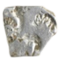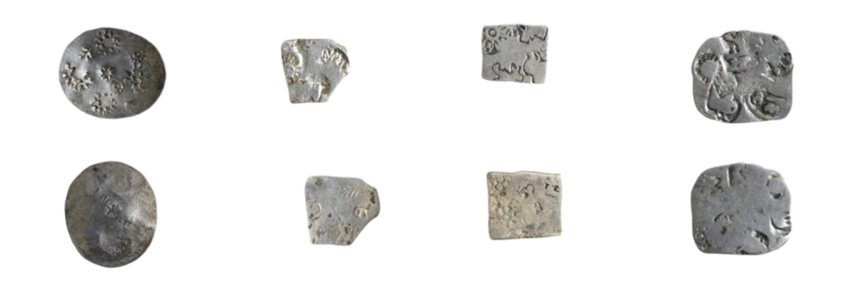
Series II (S-II)  Ajatashastru (Haryank period)  Gupta & Hardekar, revised edition (2014), pg. 144 | 3.1613gm  …………….  1.51cm | Sun, Six-armed symbol, Humped bull, Dog, Elephant | Various miniature marks
Series III (S-III)  Shaishunag and their successor.  Gupta & Hardekar revised edition (2014), pg. 150 | 2.8173gm  …………..  1.93cm  ………..  Round | Sun, Six armed symbols, Dog, Unidentified symbol (restruck), Fish left between two horizontal lines supporting plants with five upward inclined bud-ended branches, The bottom two supported by poles, Taurines between the side branches. | Animal/ Elephant (?), Solid dot within the circle, Fish, Restrucked unidentified symbols. | 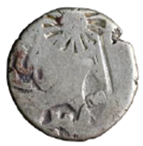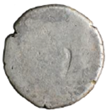
Series IV (S-IV)  ........................  Nanda period  . Gupta & Hardekar, revised edition (2014), pg. 162 | 3.3876 gm  ……………  1.60cm  ………….. | Sun, Six-armed symbols, Dog on two arches with no ground line, Candelabrum, Plant (?) | Many miniature marks (taurine symbol, four dot enclosing circle | 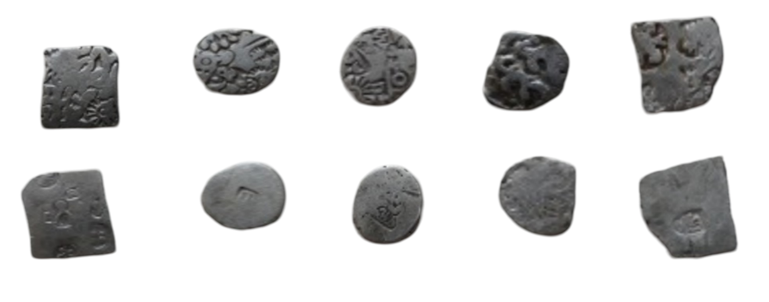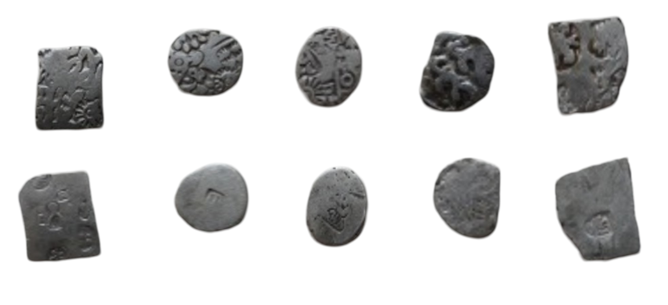
Series V (S-V)  Gupta & Hardekar revised edition (2014), Pg. 170. | 3.4299gm  …………..  1.42cm  ……….... | Sun, six-armed symbol, Two pairs of fish facing mouth, Square enclosing taurine in anti-clockwise rotation, Flower petal with solid circle in the center. | Bankers mark. | 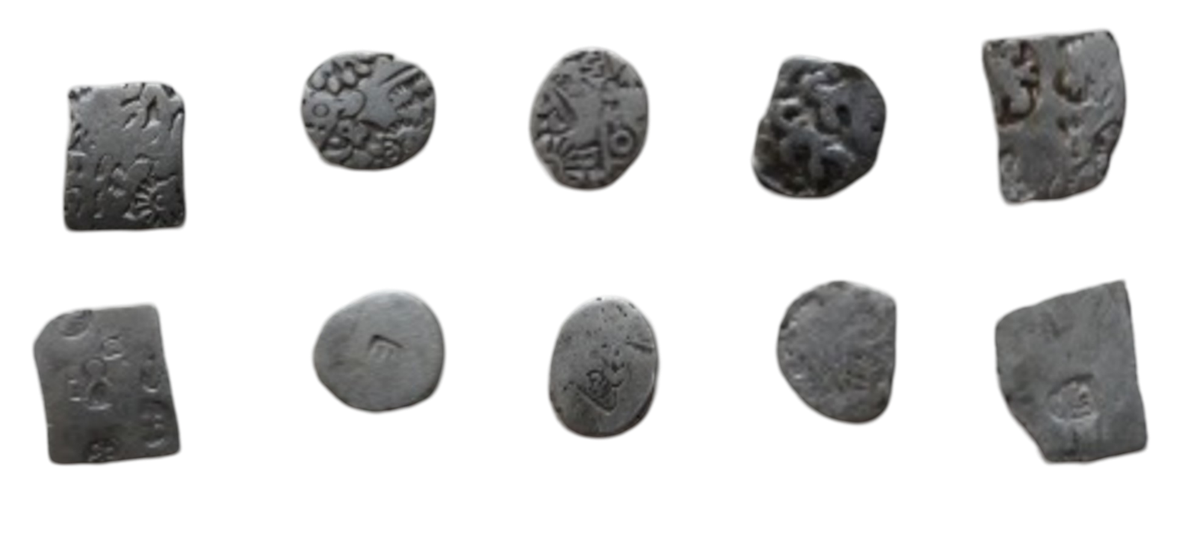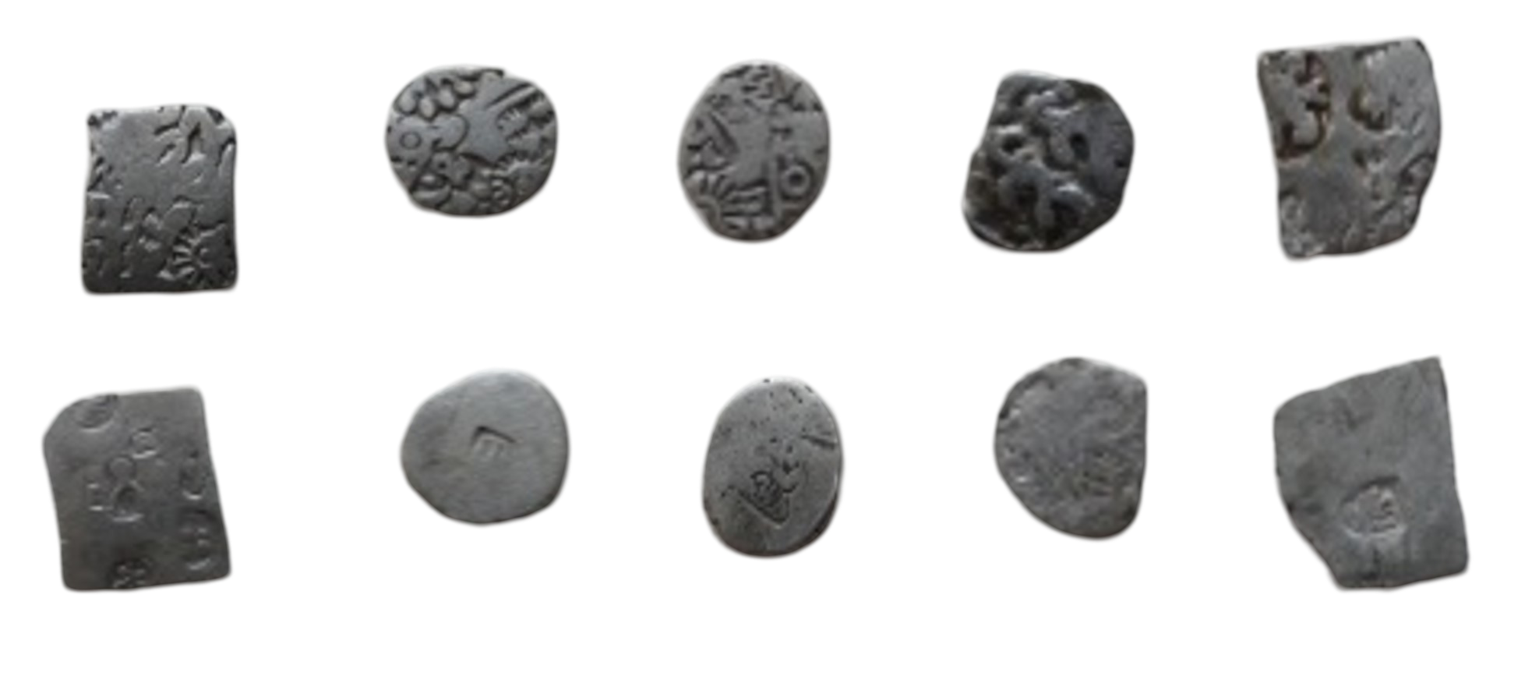
Series VI (S-VI)  Restrucked by series VII  Gupta & Hardekar, revised edition (2014), pg. 180 | 3.3595gm  ………….  1.59cm  ……………… | Sun, Six-armed symbol, Peacock on three arched hills, Steelyard with pan to the right | Peacock on hill  (restruck coins) | 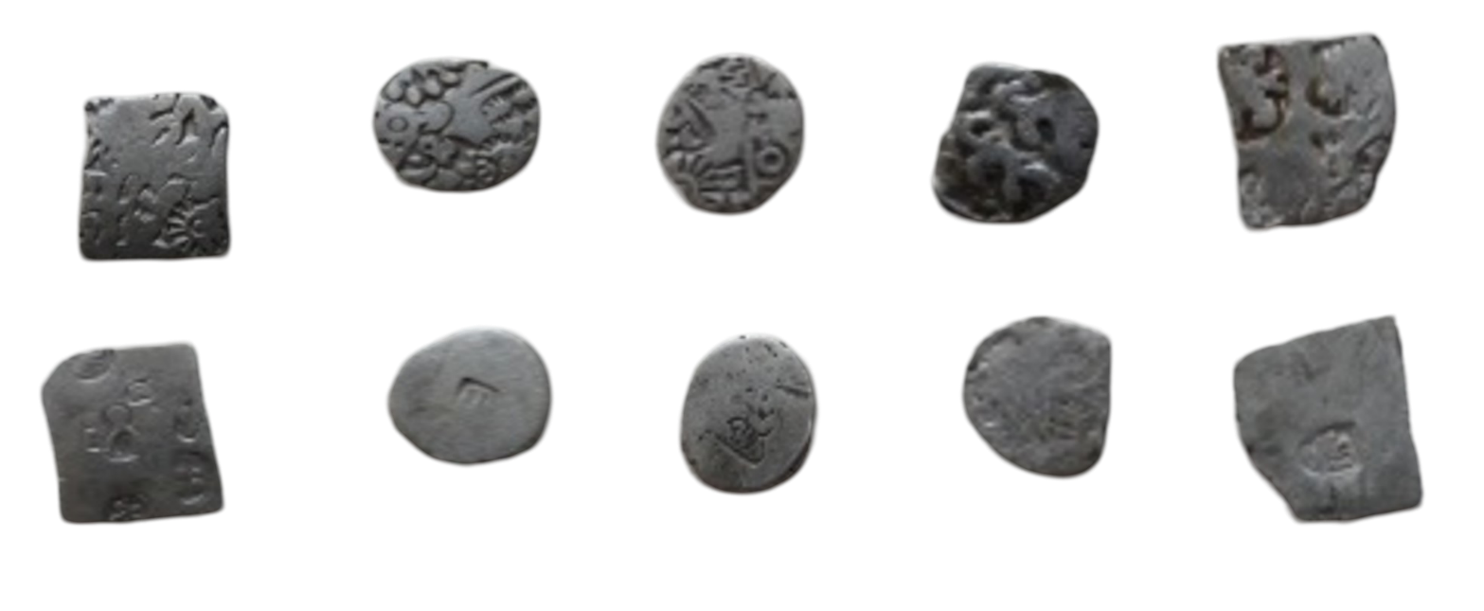
Series VII (S-VII)  Late Mauryan period  Gupta & Hardekar, revised edition (2014), pg. 185 | 16347gm  ……………….  1.27cm  …………….. | Two human figures | Tree in railing | 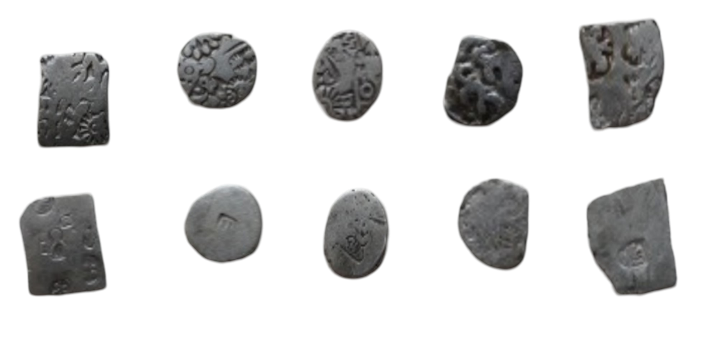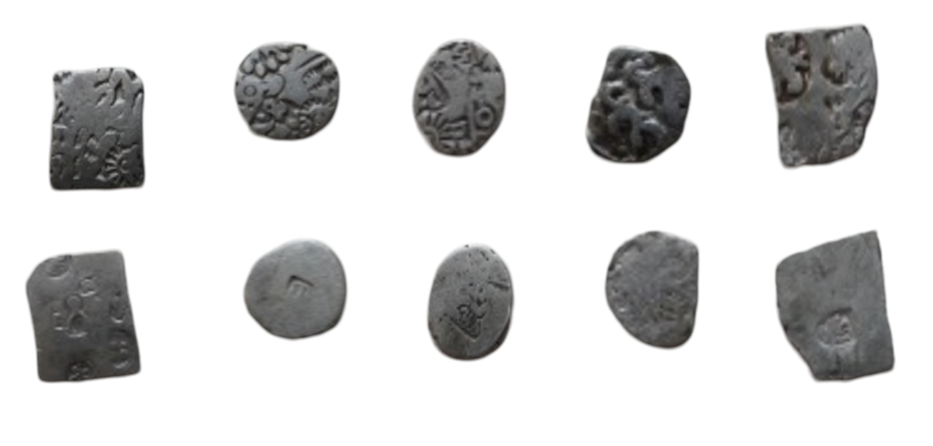
Series VIII (S-VIII)  Gupta & Hardekar, revised edition (2014), pg. 191 | 2.6495gm  ……………..  1.44cm  ……………. | Sun, Six-armed symbol, Bull, Human-like figure, Tree with pellet. | Rev: Ithyphallic human figure facing. Headdress with a high bun holding an uncertain object (katara).  (restruck coin). | 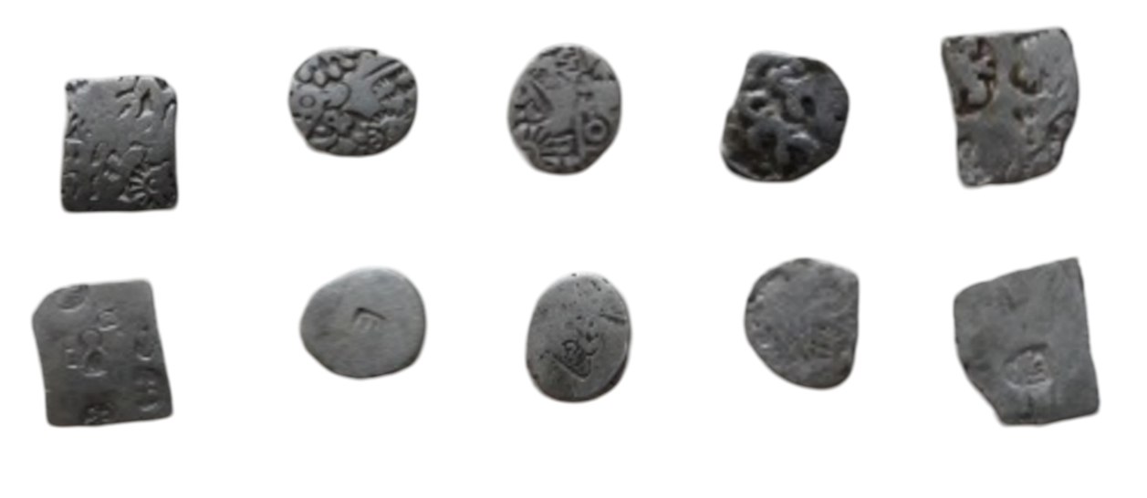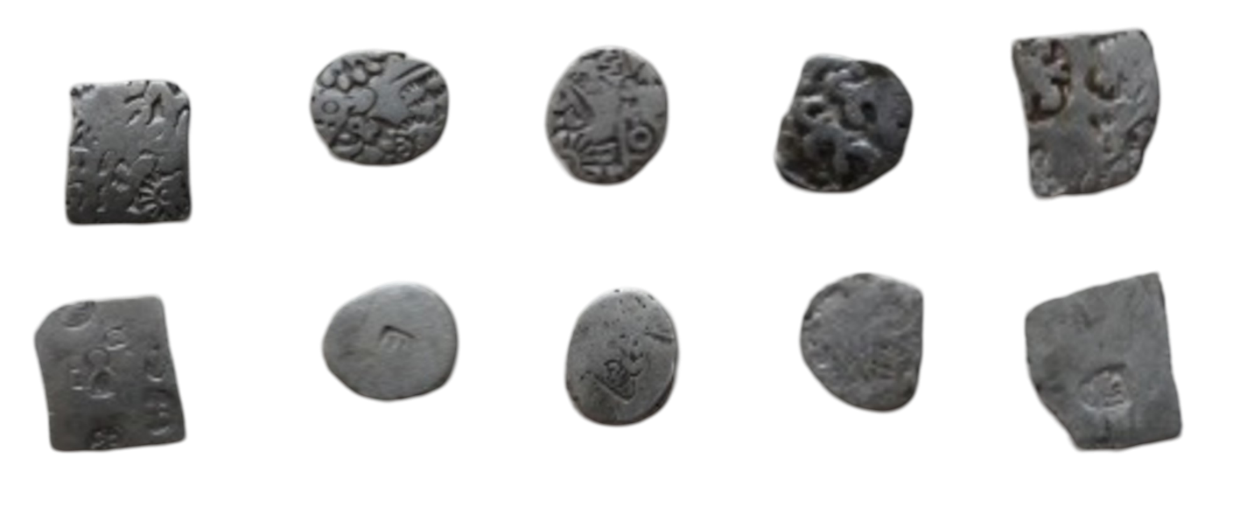
Kashi Janapada (S-0)  ....................... | 4.9664gm  …………..  2.81cm  ………….. | There are various complex wheels on obverse. | Various wheel marks (cup-shaped coins). | 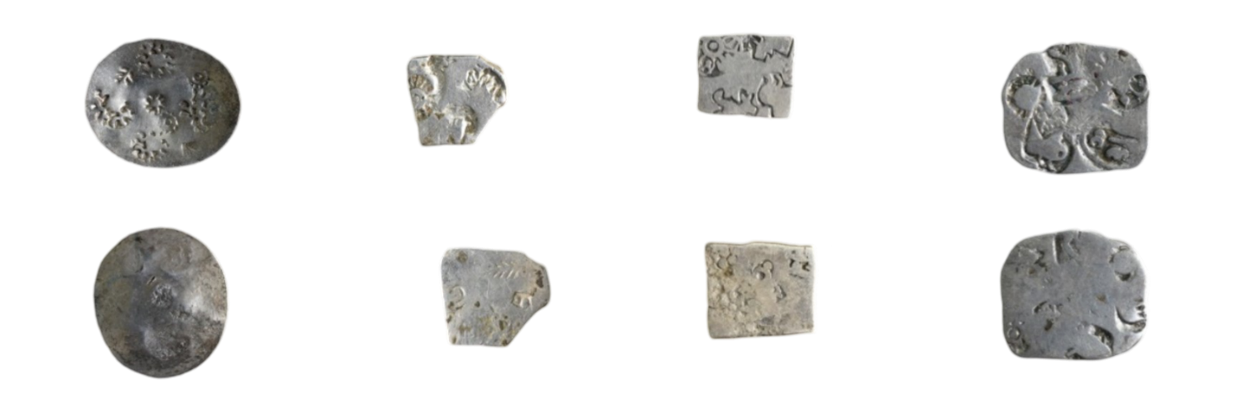

Supporting Fig.S1. Binding energy XPS curve for PMC S₀ (a) Ag, (b) Cu, (c) Au (d) S.

Supporting Fig. S2: Binding energy XPS peak fit curve for PMC S₁ (a) Ag (b) Cu (c) Pb and (d) Cl.

Supporting Fig. S3: Binding energy XPS peak fit curve for PMC S₂ (a) Ag, (b) Cu (c) Pb

Supporting Fig. S4: Binding energy XPS peak fit curve for PMC S₃ (a) Ag (b) Cu (c) Pb.

Supporting Fig. S5 Binding energy XPS peak fit curve for PMC coin S₄ (a) Ag (b) Cu (c) Pb and (d) S.
Supporting Fig. S6 Binding energy XPS peak fit curve for PMC 5(a) Ag (b) Cu (c) Pb.

Supporting Fig. S7: Binding energy XPS peak fit curve for PMC S₆ (a) Ag (b) Cu.

Supporting Fig. S8: Binding energy XPS peak fit curve for PMC S₇ (a) Ag (b) Cu.

Supporting Fig. S9: Binding energy XPS peak fit curve for PMS S₈ (a) Ag (b) Cu (c) Pb.

