Rooting for microbes: Impact of root architecture on the microbial community and function in top- and subsoil
Adrian Lattacher¹, Samuel Le Gall², Youri Rothfuss², Chao Gao¹, Moritz Harings², Holger Pagel^{3,4}, Mona Giraud², Samir Alahmad⁵, Lee T. Hickey⁵, Ellen Kandeler¹, Christian Poll¹
¹Soil Biology Department, Institute of Soil Science and Land Evaluation, University of Hohenheim, Emil-Wolf-Str. 27, 70599 Stuttgart, Germany
² Institute of Bio- and Geosciences (IBG-3), Forschungszentrum Jülich GmbH, 52428 Jülich, Germany
³ Soil Systems Modelling: Institute of Bio- and Geosciences (IBG-3), Forschungszentrum Jülich GmbH, 52428 Jülich, Germany
⁴Institute of Crop Science and Resource Conservation, University of Bonn, 53115 Bonn, Germany
⁵ Queensland Alliance for Agriculture and Food Innovation, The University of Queensland, St Lucia, QLD 4072, Australia
Corresponding author: Adrian Lattacher (adrian.lattacher@uni-hohenheim.de)
Journal: Plant and Soil
Supplementary material
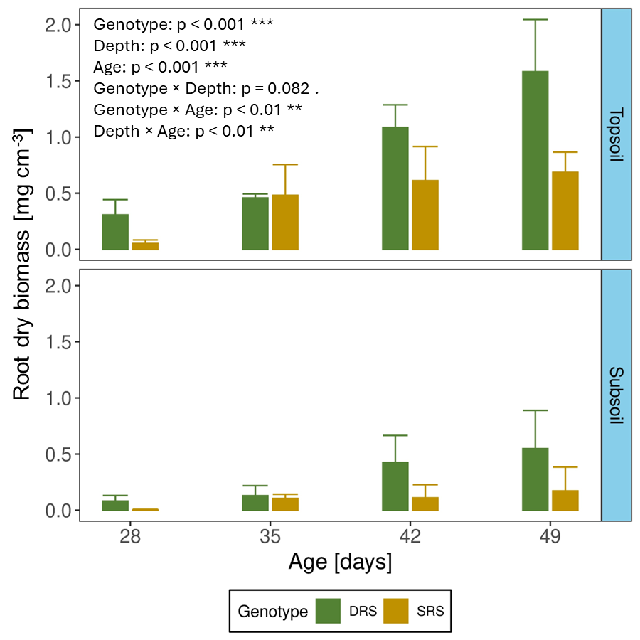
Fig. S1 Root dry biomass in topsoil and subsoil for the shallow root system (SRS) (yellow) and deep root system (DRS) (green) from day 28 to day 49 after sowing. Error bars represent the standard deviation of 3 replicates. The displayed p-values indicate significant effects (p < 0.05), determined using a linear mixed-effects model. In this model, the columns were treated as a random effect, while genotype, depth, and age were considered as fixed effects
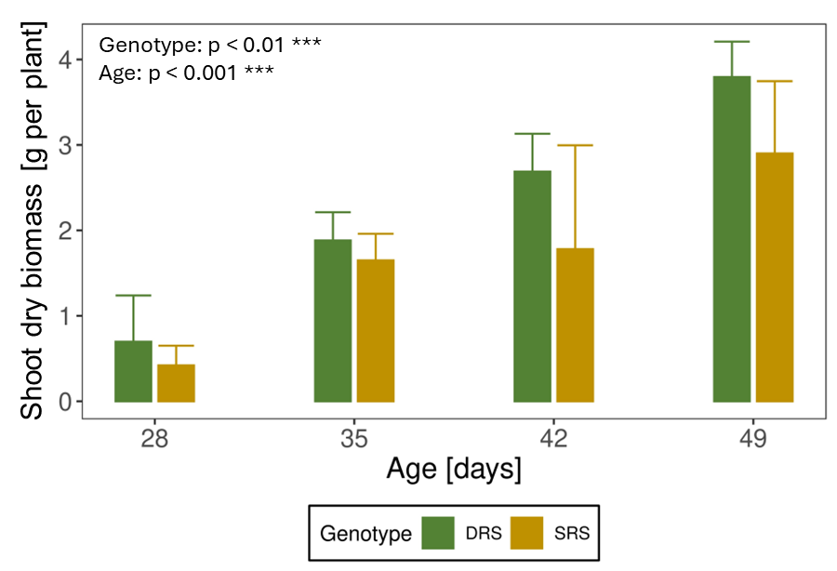
Fig. S2 Plant dry biomass in g per plant (2 plants were planted per column) for the shallow root system (SRS) (yellow) and deep root system (DRS) (green) from day 28 to day 49 after sowing. Error bars represent the standard deviation of 3 replicates. The displayed p-values indicate significant effects (p < 0.05), determined using a linear mixed-effects model. In this model, the columns were treated as a random effect, while genotype and age were considered as fixed effects

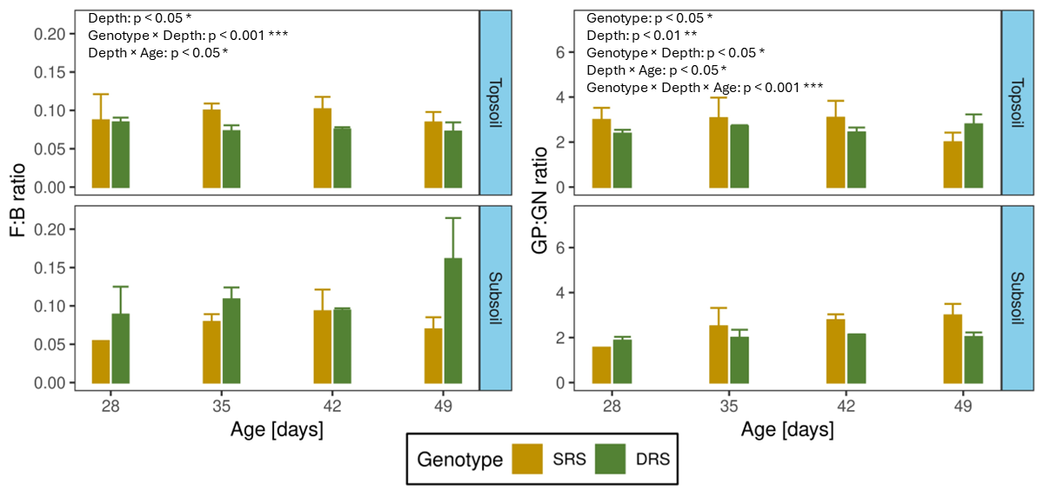
Fig. S3 Ratio of fungal to bacterial PLFAs (F:B) and gram+ to gram- PLFAs (GP:GN) in top- and subsoil of the shallow root system (SRS) and deep root system (DRS) from day 28 to day 49 after sowing. Error bars represent the standard deviation of 3 replicates. The displayed p-values indicate significant effects (p < 0.05), determined using a linear mixed-effects model. In this model, the columns were treated as a random effect, while genotype, depth, and age were considered as fixed effects. Due to the low rooting intensity after 28 days in subsoil of the shallow root system (SRS), it was not possible to extract enough rhizosphere soil in 2 out of 3 replicates. Therefore, no standard deviation can be shown for these samples

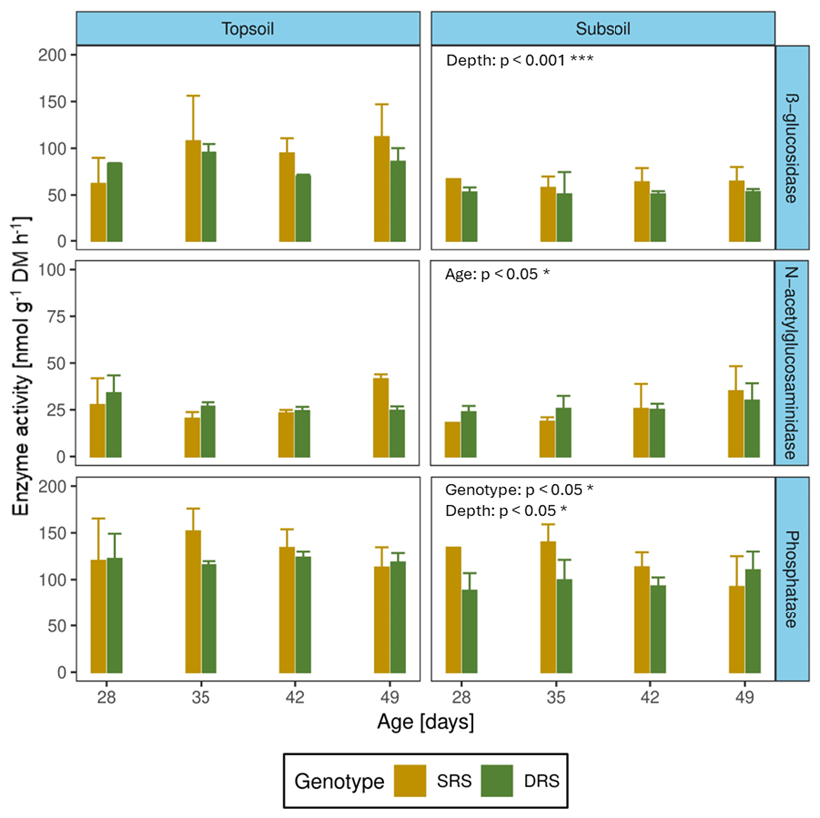
Fig. S4 β-glucosidase, N-acetylglucosaminidase and acid phosphatase activity in the topsoil and subsoil of the shallow root system (SRS) and deep root system (DRS). Error bars represent the standard deviation of three replicates. The displayed p-values indicate significant effects (p < 0.05), determined using a linear mixed-effects model. In this model, the columns were treated as a random effect, while genotype, depth, and age were considered as fixed effects. Due to the low rooting intensity after 28 days in the subsoil of the SRS, it was not possible to extract enough rhizosphere soil in two out of three replicates. Therefore, no standard deviation can be shown for these samples

