SUPPLEMENTARY MATERIALS

Immobilization of Bacillus subtilis in biohybrid crosslink chitosan-glutaraldehyde for acid red 88 dye removal: Box–Behnken design optimization and mechanism study

Hasan M. Agha^{a,b}, Abdulmutalib Allaq^{c}, Ali H. Jawad^{a,b,e*}, Shafiq Aazmi^{d}, Zeid A. ALOthman^{e}, Lee D. Wilson^{f}

ªFaculty of Applied Sciences, Universiti Teknologi MARA, 40450 Shah Alam, Selangor, Malaysia
^{b}Advanced Biomaterials and Carbon Development Research Group, Faculty of Applied Sciences, Universiti Teknologi MARA, 40450 Shah Alam, Selangor, Malaysia
^{c}Faculty of Applied Science, Department Applied Microbiology, Universiti Teknologi MARA, Shah Alam 40450, Malaysia
^{d}Microbiome Health and Environment (MiHeaRT) Research Group, Faculty of Applied Sciences, Universiti Teknologi MARA, Shah Alam, Selangor, Malaysia
^{e}Environmental and Atmospheric Sciences Research Group, Scientific Research Center, Al-Ayen University, Thi-Qar, Nasiriyah, 64001, Iraq
^{e}Chemistry Department, College of Science, King Saud University, Riyadh 11451, Saudi Arabia
^{f}Department of Chemistry, University of Saskatchewan, Saskatoon, SK S7N 5C9, Canada

Corresponding author:
E-mail: ali288@uitm.edu.my; ahjm72@gmail.com (Ali H. Jawad)

Text S1
The FE-SEM (Field Emission Scanning Electron Microscopy) was used to evaluate the surface morphologies of the CHS-GLU/BCL bioadsorbent before and after biosorption of AR88 dye. The physical parameters of the CHS-GLU/BCL bioadsorbent were also analyzed. The elemental composition of the CHS-GLU/BCL bioadsorbent was determined using energy dispersive X-ray (EDX) analysis, both prior to and after AR88 dye biosorption. Utilizing a PANalytical X'Pert PRO diffractometer. X-ray diffraction (XRD) patterns were obtained for CHS, and CHS-GLU/BCL bioadsorbent in the range of 5° to 90° of 2-theta. The surface charge of the CHS-GLU/BCL bioadsorbent was determined using pH_{pzc} [31]. The CHS-GLU/BCL bioadsorbent was analyzed using KBr pellets and a Perkin-Elmer Spectrum RX I spectrometer, which has a wavenumber range of 4000 cm⁻¹ to 450 cm⁻¹. FTIR spectra were determined before and after the biosorption of AR88 dye.

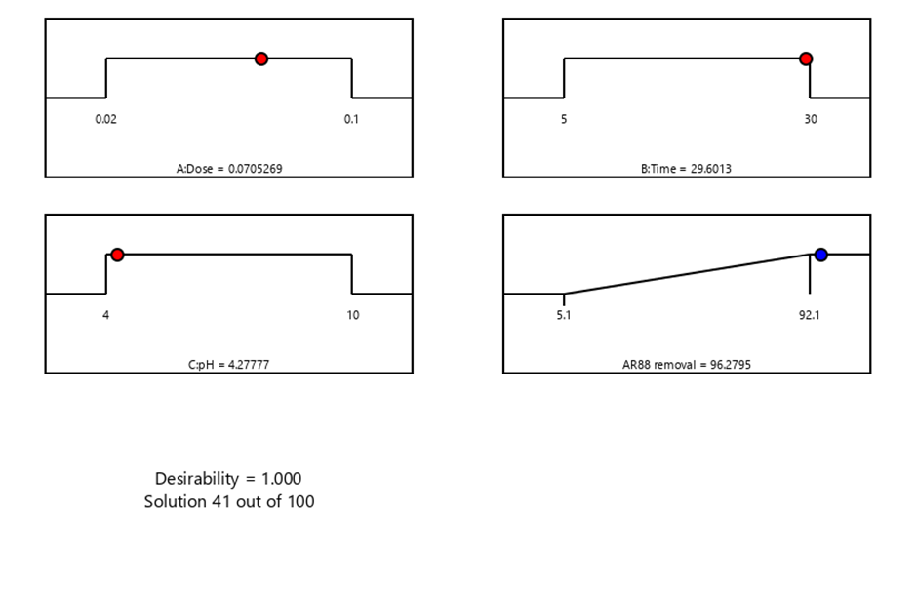
Fig. S1: Desirability tool of AR88 removal (%) by CHS-GLU/BCL biosorbent.

pH_{pzc}

Fig. S2: pH_{pzc} of CHS-GLU/BCL biosorbent

Table S1: Adsorption kinetics and isotherms nonlinear models
Models | Formula | Descriptions
Pseudo-first order (PFO) | $$q_{t}=q_{e}\left(1-e^{-k_{1}t}\right)$$ | $k_{1}$: pseudo-first-order rate constant (1/min)
Pseudo-second order (PSO) | $$q_{t}=\frac{q_{e}^{2}k_{2}t}{1+ q_{e}K_{2}t}$$ | $k_{2}$: pseudo-second-order rate constant (g/mg min)
Langmuir | $$q_{e}=\frac{q_{m}K_{L}C_{e}}{1+ K_{L}C_{e}}$$ | $q_{m }$: monolayer capacity (mg/g)  K_{L}: Langmuir constant (L/mg)
Freundlich | $$q_{e}{=K}_{F}{C_{e}}^{1/n}$$ | K_{F} : Freundlich constant (mg/g) (L/mg)^{1/n}  n: adsorption intensity
Temkin | $$q_{e}=\frac{RT}{b_{T}}ln\left(K_{T}C_{e}\right)$$ | $K_{T}$: Temkin constant (L/mg)  : Heat of adsorption (J/mol)

