Computational modeling of insect odorant receptors: A comparative analysis of Template-based and Alphafold modeling
Amara Jabeen^{1,} *, John Oakeshott¹, Siu Fai Lee^{1,2}, Shoba Ranganathan¹ and Phillip W. Taylor¹
¹Applied BioSciences, Macquarie University, University, North Ryde, NSW, 2109, Australia
²CSIRO Environment, Black Mountain, ACT, Australia
Correspondence to Amara Jabeen. *Applied BioSciences, Macquarie University, North Ryde, NSW, 2109, Australia. amara.jabeen@mq.edu.au

Supporting information

Contents
Table S1: Comparison of ICM docking scores for experimental structures and models for MhOR5. 3
Figure S1: 3D view of (a) eugenol and (b) DEET within the binding pockets of MhOR5 4
Figure S2: The pre-dynamics receptor ligand interactions (RLIs) in MhOR5 with EOL and DEET. 5
Table S2: The available site-directed mutagenesis data for different insect species. 6
Figure S3: The post-dynamics RLIs in MhOR5 with EOL and DEET. 7
Figure S4: Receptor-ligand interactions (RLIs) in empirical structures and docked and simulated complexes of MhOR5 with EOL and DEET. 8
Table S3: Published full length B. dorsalis and B. minax OR transcripts 9
Figure S5: Motifs predicted through MEME suite using full length sequences of BdORs and BmORs.. 14
Figure S6: Alignment adjustment for helix 3 of BdOR88a. 15
Figure S7: Alignment adjustment for helix 3 of BmOR7a1. 16
Supplementary note S1: 17
Table S4: List of odorants which empirical data shows do not bind to specific B. dorsalis and B. minax ORs. 18
Figure S9: Pairwise alignments between 7LID and (a) BdOR7a6, (b) BdOR13a1, (c) BdOR82a, (d) BdOR88a, and (e) BdOR94b2, used for the TBM. 21
Figure S10: Pairwise alignments between 7LID and (a) BmOR7a1, (b) BmOR13a1, and (c) BmOR63a1, used for the TBM. . 22
Table S5: Sequence identity among template,7LID and query ORs from B. dorsalis and B. minax. 23
Table S6: ICM docking scores for OR-odorant pairs. 24
Figure S11: Venn diagram showing the filtered features for the TBM and AF datasets used for the LDA. 25
Figure S12: Calculation of correlation coefficients (R) shows PB and GB are highly correlated in both TBM and AF datasets but there is no significant correlation between LSD and CSD in either dataset. 26
Figure S13: Post-simulation RLIs between BmOR13a1 and BdOR13a1 with Oct-3OL (a and b, respectively) and ME (c and d, respectively). 27
Figure S14: Post-simulation RLIs between (a) BmOR7a1_Oct-3OL, (b) BmOR13a1_LIN, (c) BmOR63a1_LIN, (d) BdOR82a_EOL, (e) BdOR82a_ME, (f) BdOR82a_Oct-3OL, and (g) BdOR94b2_ME.. 28
Table S7: Comparisons of parameter values at different production times for complexes of BdOR13a1 and BmOR13a1 with Oct-3OL. 29
Figure S15: Time courses of RMSDs for the complexes during the simulations of the binder dataset 31
Figure S16: Time courses of RMSDs for the ligands during the simulations of the binder dataset. 32
Figure S17: Time courses of RMSDs for the complexes during the simulations of the non-binder dataset. 33
Figure S18: Time courses of RMSDs for the ligands during the simulations of the non-binder dataset. 34
Table S8: Post-dynamics GB and PB values for B. dorsalis and B. minax ORs. 35
Table S9: Total size of the molecular system used for simulations of each complex analyzed. 36
References: 37

Table S1: Comparison of ICM docking scores for experimental structures and models (TBM and AF) for MhOR5.

Complex | ICM docking score
7LID and Eugenol | -24.33
7LIG and DEET | -20.41
MhOR5_TBM and Eugenol | -19.20
MhOR5_AF and Eugenol | -13.69
MhOR5_TBM and DEET | -12.96
MhOR5_AF and DEET | -8.34

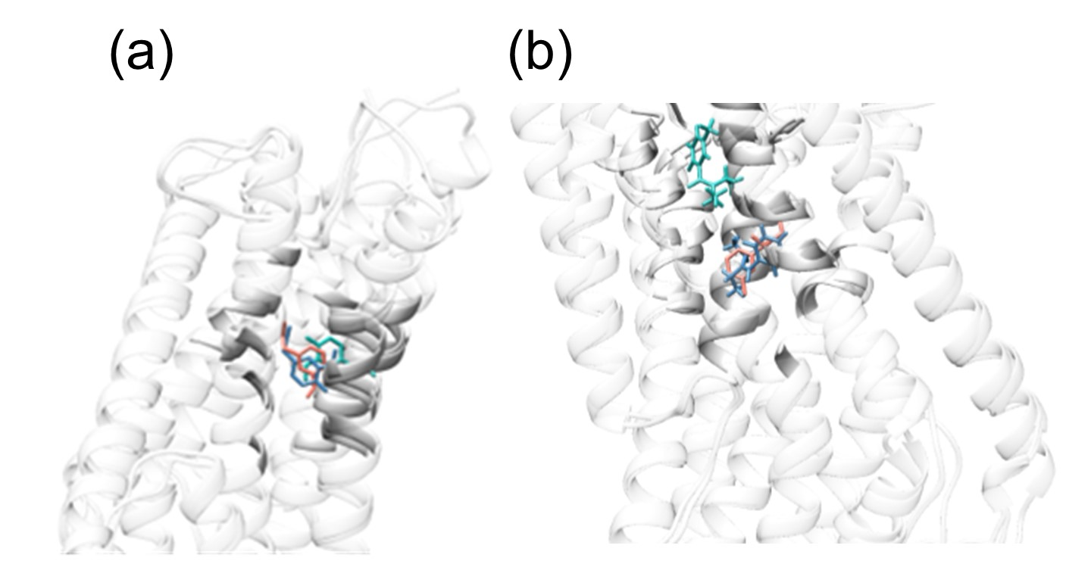

Figure S1: 3D view of (a) eugenol and (b) DEET within the binding pockets of MhOR5 (pink), MhOR5_TBM (blue), and MhOR5_AF (green) after molecular docking.

Figure S2: The pre-dynamics receptor ligand interactions (RLIs) in MhOR5 with EOL and DEET. (a) and (b) The 7LID and EOL and 7LIG and DEET complexes, respectively, from experimental structures. (c) MhOR5_TBM and EOL. (d) MhOR5_TBM and DEET. (e) MhOR5_AF and EOL. (f) MhOR5_AF and DEET. RLIs recovered from both TBM and AF modelling are boxed red.

Table S2: The available site-directed mutagenesis data for different insect species.
OR | Species | Ligand | Position
OR7a6¹ | B. dorsalis | 1-octen-3-ol | N86(2.3)
OR13a1¹ | B. dorsalis | 1-octen-3-ol | D320A(ECL3) and K323A (6.3)
OR85b² | D. melanogaster | 2-heptanone/2-heptanol | F142C (3.33) and N143C (3.34)
OR59b³ | D. melanogaster | DEET | V91 (2.7)
OR3⁴ | Ostrinia furnacalis | E12 | A148T (3.29)
OR15⁵ | Anopheles gambiae | 4-methylphenol | A195I (4.13)
OR13⁵ | Anopheles gambiae | 4-methylphenol | I195A (4.13)
OR15⁶ | Anopheles gambiae | (−)-fenchone | A195I (4.13)
OR22a⁷ | D. melanogaster | Methyl esters | M93I (2.7)
OR46⁸ | Ips typographus | (S)-(−)-ipsenol | Y84F, Y84A (2.7), and T205A (4.17)

Figure S3: The post-dynamics RLIs in MhOR5 with EOL and DEET. (a) and (b) The 7LID and EOL and 7LIG and DEET complexes, respectively, from experimental structures. (c) MhOR5_TBM and EOL. (d) MhOR5_TBM and DEET. (e) MhOR5_AF and EOL. (f) MhOR5_AF and DEET. RLIs recovered from both TBM and AF modelling are boxed red.

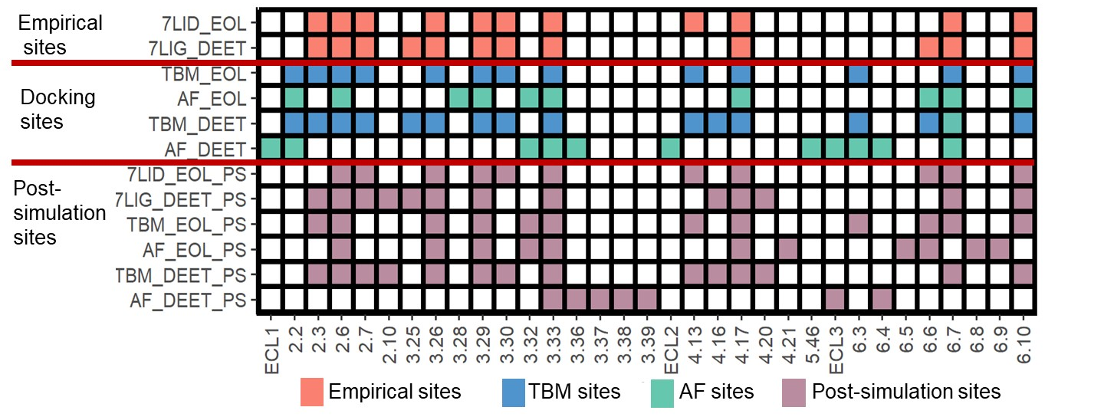

Figure S4: Receptor-ligand interactions (RLIs) in empirical structures and docked and simulated complexes of MhOR5 with EOL and DEET.

Table S3: Published full length B. dorsalis and B. minax OR transcripts which could be fully aligned to 7LID. Where identified, orthologs in the two species are shown between the dotted lines. A variety of names have been used across the different transcriptome studies so, following Wu et al. ⁹ we rely principally on names for the B. dorsalis ORs based on the better characterized D. melanogaster OR orthologs, with all the aliases in the literature also tabulated. B. minax ORs were then named based on their orthology to BdORs. Our criterion for assigning orthology and alias status was at least 98% amino acid sequence identity.

BdOR… | Aliases (BdOR…) | BmOR… | Aliases (BmOR…)
2a | 23¹⁰, 5¹¹, 2a⁹, 19a¹ | 2a | 19a¹², 30¹³, 2a¹⁴, 25¹⁵
7a1 | 31¹⁰, 2b¹¹, 7a.1⁹, 7a-1-v1¹
7a2 | 7a.2⁹
7a3 | 12¹⁰, 2d¹¹, 7a-6_1¹⁶, 7a.3⁹
7a4 | 7a.4⁹ | 7a4 | 7a.3¹², 13/48¹³,19¹⁵
7a4 | 7a.4⁹ | 7a4-2 | 7a.6B ¹²
7a5 | 7a-5_1¹⁷, 30¹⁰, 2c¹¹, 7a-5-v1¹⁶, 7a.5⁹ | 7a5 | 7a.4¹², 8-2-1¹⁴, 23¹⁵
7a6 | 8¹⁰, 2g¹¹, 7a-10_1¹⁶, 7a.6⁹, 7a-6¹
7a7 | 7a-4_1¹⁷, 10¹⁰, 2j¹¹, 7a-4_1¹⁶, 7a.7⁹, 7a-7¹ | 7a7 | 7a.6A¹², 9/35¹³, 7a.2¹⁴, 13¹⁵
7a8 | 7a-1_1¹⁷, 9¹⁰, 2h¹¹, 7a-1_1¹⁶, 7a.8⁹, 7a-8¹ | 7a8 | 7a.7¹², 7a.1¹⁴, 22¹⁵
7a9 | 7a-3_1¹⁷, 2i¹¹, 7a-3-v1_1¹⁶ | 7a9  7a9-2
7a10 | 7a-10¹
7a11 | 7a-11¹
7a12 | 7a-12¹ | 7a12 | 6-1¹⁴
7a13 | 7a-2-v2¹
7a14 | 7a-2-v1¹
7a15 | 7a-5 ¹
7a16 | 7a-3¹
7a17 | 7a-7_1¹⁶, 7a-4¹
7a18 | 2¹⁰ | 7a18 | 2-1¹⁴, 38¹⁵
7a19 | 4¹⁰, 2e ¹¹
 |  | 7a1 | 7a.5¹², 51¹³, 7-1¹⁴, 24 ¹⁵
10a | 6¹⁰, 3¹¹, 10_1¹⁶, 10a ⁹, ¹ | 10a | 10a¹², 42¹⁵
13a1 | 13a_1¹⁷, ¹⁶, 1 ¹⁰, 4¹¹, 13a.1⁹, 13a ¹ | 13a1 | 13a.1¹², 53¹³, 3 ¹⁵
13a2 | 35a_1¹⁷, ¹⁶, 24¹⁰, 6a¹¹, 13a.2⁹, 35a¹ | 13a2 | 13a.2¹², 35a¹⁴, 10 ¹⁵
22c | 22c¹
24a | 24a¹ | 24a | 24a¹⁴
33b1 | 33b-1¹ | 33b1 | 33ab1-1¹⁴
33b2 | 33b-2¹
33b3 | 33b-3¹ | 33b3 | 33ab2¹⁴
33b4 | 33b-4¹
 |  | 33ab | 33c¹², 41/42¹³, 33ab1-2¹⁴, 32¹⁵
42a | 7a-2_1¹⁷, 11¹⁰, 26¹¹, 7a-2_1¹⁶, 42a⁹, ¹ | 42a | 42a¹², 1/6¹⁵
43a1 | 43a-1_1¹⁷, ¹⁶, 7¹¹, 43a.1⁹, 43a-1¹ | 43a1 | 43a.1¹², 22¹³, 43a¹⁴, 33¹⁵
43a2 | 49b-2_1¹⁷, 25¹¹, 43a.2⁹, 49b-2¹ | 43a2 | 43a.2¹², 20¹³, 34¹⁵
43a3 | 43a.3⁹, 43a-3¹ | 43a3 | 43a.3¹², 18¹⁵
43a3 | 43a.3⁹, 43a-3¹ | 43a3-2 | 3-2¹⁴
43a4 | 43a-2-v1_1¹⁶, 43a.4⁹, 43a-4¹ | 43a4 | 43a.4¹², 25¹³, 35¹⁵
43a5 | 43a-2_1 ¹⁷
43a6 | 3¹⁰
43b | 43b_1 ¹⁷
45a1 | 45a_1¹⁷, 22¹⁰, 1¹¹, 45a-part1_1/45a-part2_1¹⁶, 45a⁹, 45a-1¹ | 45a1 | 45a¹², 45a1¹⁴, 27¹⁵
45a2 | 45a-2¹ | 45a2 | 45a3¹⁴
46a | 46a¹ | 46a | 46a¹²,¹⁴, 51¹⁵
47b | 8¹¹, 47b_1¹⁶, 47b⁹,¹
49a | 26¹⁰, 9¹¹, 49a_1¹⁶, 49a⁹,¹ | 49a | 49a¹², ¹⁴, 47/50 ¹⁵
49b | 49b-1_1¹⁷, 34¹⁰, 10¹¹, 49b-1_1/49b-3_1¹⁶,49b⁹,49b-1¹
59a1 | 59a_1¹⁷ | 59a1 | 5-1¹⁴
59a2 | 59a.2⁹
59a3 | 59a-3¹
59a4 | 59a-4¹
59a5 | 59a-2¹
59a6 | 59a_1¹⁶
59a7 | 14¹⁰, 11¹¹ | 59a7 | 59a.2¹², 5-2 ¹⁴
63a1 | 17¹⁰, 12a¹¹, 63a-3_1¹⁶, 63a.1⁹, 63a-3¹
63a2 | 63a.2 ⁹ | 63a2 | 11¹³, 63a2¹⁴, 11/40 ¹⁵
63a3 | 63a-2_1¹⁷, 25¹⁰, 12c¹¹, 63a-2-v1_1¹⁶, 63a.3⁹, 63a-2¹ | 63a3 | 63a1-1¹⁴
63a3 | 63a-2_1¹⁷, 25¹⁰, 12c¹¹, 63a-2-v1_1¹⁶, 63a.3⁹, 63a-2¹ | 63a3-2 | 63a.1¹², 14¹³, 63a1-2¹⁴, 12¹⁵
63a4 | 63a-1 ¹⁷
63a5 | 63a-1_1¹⁷
63a6 | 63a-1-v1-part2_1¹⁶
67c1 | 67c_1¹⁷, 21¹⁰, 20¹¹, 67c-v1_1¹⁶, 67c.1⁹, 67c-1¹
67c2 | 67c-2¹
67c3 | 67c-3¹ | 67c3 | 67c¹⁴
67d1 | 16¹⁰, 13a¹¹, 67d-2_1¹⁶, 67d.1⁹, 67d-1¹ | 67d1 | 67d.1¹², 67d3 ¹⁴, 30¹⁵
67d2 | 13b¹¹, 67d-3-v2_1¹⁶, 67d.2⁹, 67d-2¹ | 67d2 | 67d.2¹², 31¹⁵
67d3 | 18¹⁰, 23¹¹, 67d-4_1¹⁶, 67d.3⁹, 67d-3¹ | 67d3 | 67d.3¹², 67d2¹⁴, 28¹⁵
67d4 | 67d_1¹⁷, 35¹⁰, 22¹¹, 67d-1_1¹⁶, 67d.4⁹, 67d-4¹ | 67d4 | 67d.4¹², 67d1¹⁴, 29¹⁵
67d5 | 13¹⁰, 13c¹¹, 67d-3-v1_1¹⁶
69a1 | 69a_1¹⁷, 14b¹¹, 69a-1_1/69a-3_1¹⁶, 69a.1⁹, 69a-1¹
69a2 | 27¹⁰, 14a¹¹, 69a-2_1¹⁶, 69a.2⁹, 69a-2¹ | 69a2 | 69a.2¹², 8¹⁵
74a1 | 74a_1¹⁷, ¹⁶, 6b¹¹, 74a⁹, 74a-1¹
74a2 | 74a-2¹
82a | 15¹⁰, ¹¹, 82a_1¹⁶, 82a ⁹, ¹ | 82a | 82a¹², 20¹⁵
83a1 | 83a-1¹
83a2 | 83a-2¹
85c1 | 85c-1¹
85c2 | 85c-2-v1/85c-2-v2¹
85d1 | 85d-1¹
85d2 | 85d-2¹ | 85d2 | 85d¹², 40¹³, 85d2¹⁴, 9¹⁵
85e | 85e ¹
88a | 88a_1¹⁷, ¹⁶,33¹⁰, 16a¹¹, 88a ⁹, ¹ | 88a | 88a¹², 7/46¹³, 88a¹⁴, 14¹⁵
92a | 19¹¹, 92a ⁹, ¹ | 92a | 92a¹²
94a1 | 94a-1¹
94a2 | 94a-2¹
94a3 | 94a-3¹
94a4 | 94a-4¹
94b1 | 94b_1¹⁷, 19¹⁰, 17¹¹, 94b-1_1¹⁶, 94b.1⁹, 94b-1¹ | 94b1 | 94b.1¹², 39/47¹³, 15¹⁵
94b2 | 7¹⁰, 18¹¹, 94b-2_1¹⁶, 94b.2⁹, 94b-2 ¹ | 94b2 | 94b.2¹², 1-1¹⁴, 17¹²
 |  | 94ab | 94ab¹⁴

Figure S5: Motifs predicted through MEME suite using full length sequences of BdORs and BmORs. The conserved sites predicted through progressive helix-wise multiple sequence alignment have been boxed.

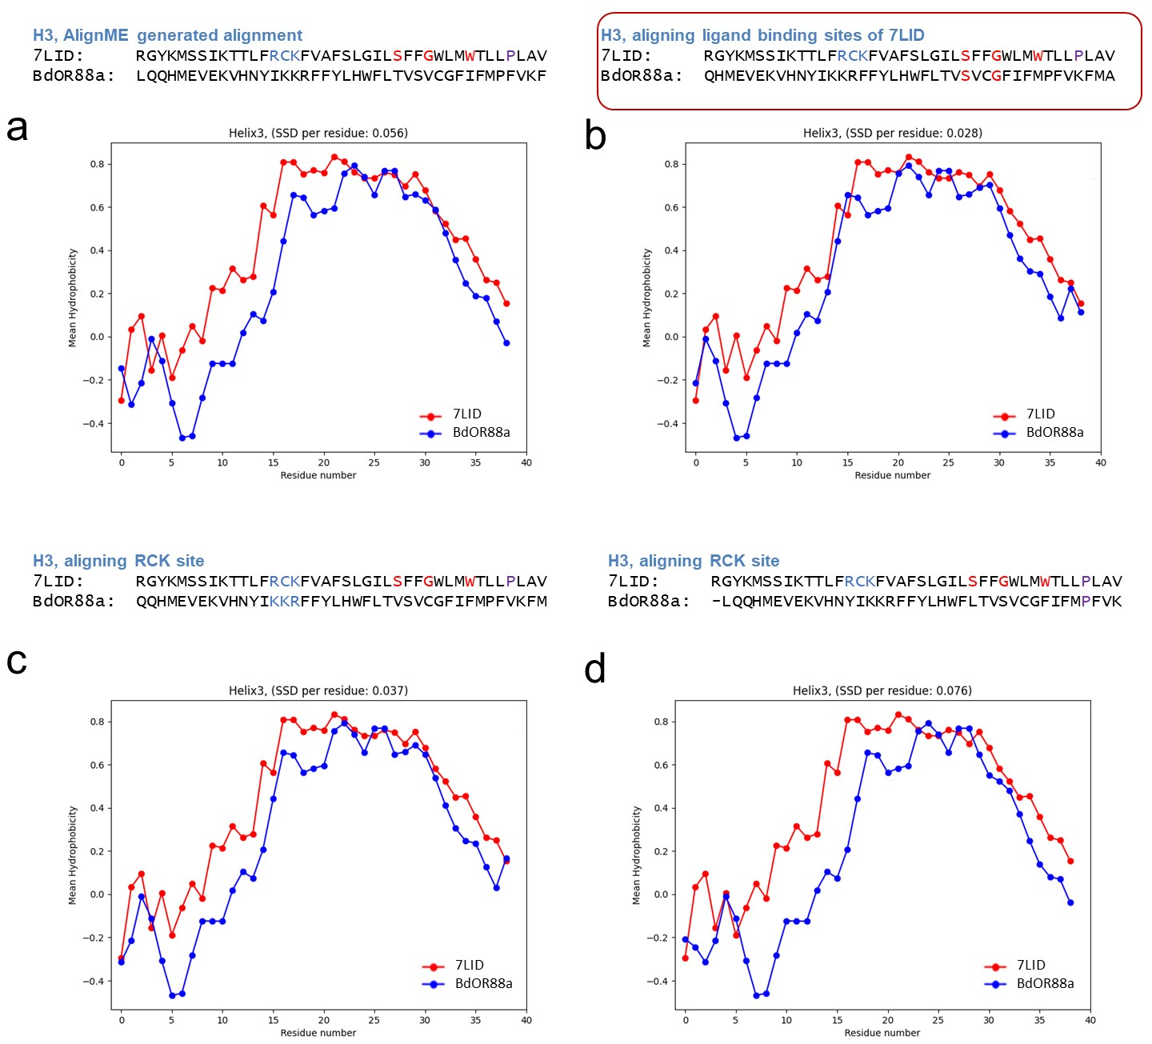
Figure S6: Alignment adjustment for helix 3 of BdOR88a. The alignment by AlignME (a) showed higher SSD than either (b) that adjusted by aligning the ligand binding residues of 7LID with BdOR88a, (c) that adjusted by aligning the RCK motif in 7LID with BdOR88a or (d) aligning the proline at position 3.37.

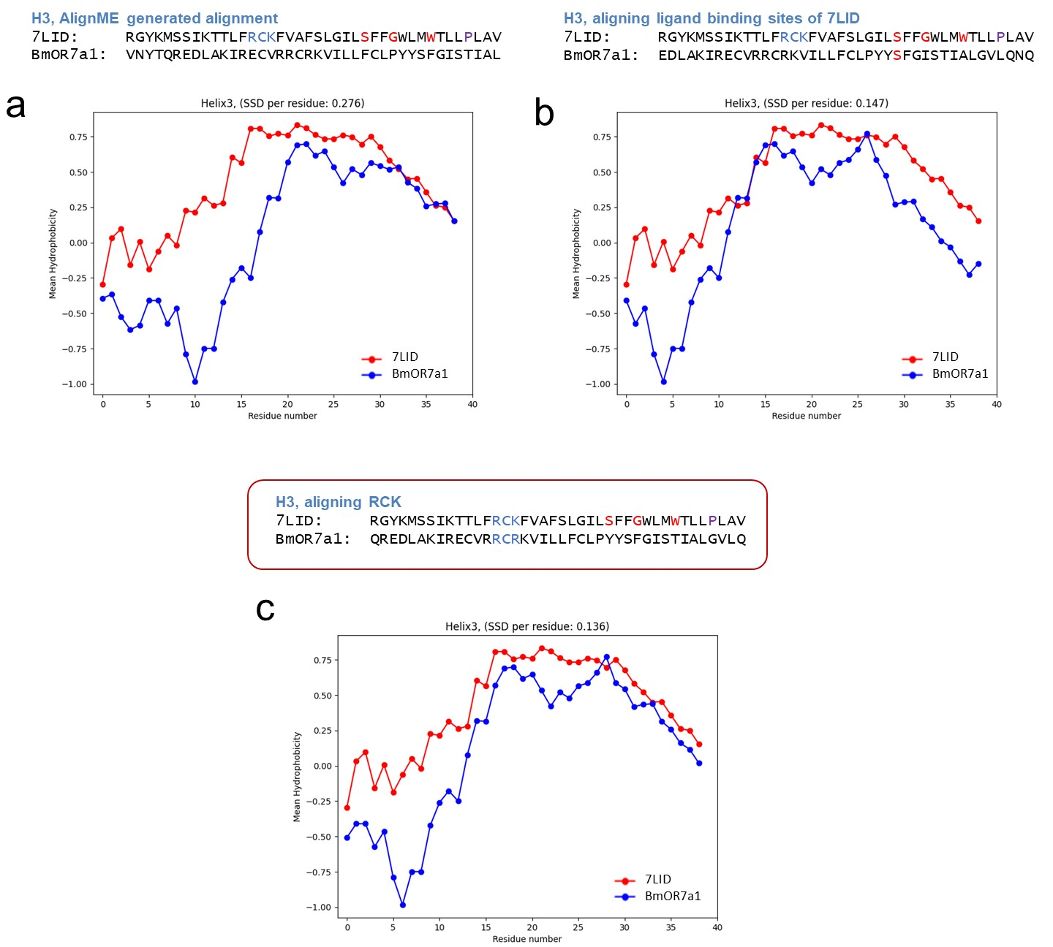
Figure S7: Alignment adjustment for helix 3 of BmOR7a1. The alignment by (a) AlignME showed higher SSD than either that adjusted by either (b) aligning the ligand binding residues of 7LID with BmOR13a1 or (c) that adjusted by aligning RCK in 7LID with BmiOR7a1. Aligning Proline to 3.37 did not improve the energy or stability values for the BmOR7a1_LIN complex.

Supplementary note S1:
Three different alignments were generated for BdOR88a H3; one produced by AlignME , then one generated by adjusting the ligand binding sites S(3.26), G(3.29) and W(3.33) of 7LID (if one or more were identical), and thirdly one generated by aligning the RCK site (3.14 to 3.16) within 7LID. The one generating the best hydrophobicity correspondence, calculated as the sum of squared differences (SSD) per residue, was then used in subsequent analyses. For instance, for the alignment of helix 3 of BdOR88a and 7LID (Figure S6), the first alignment yielded an SSD of 0.06, the second, involving adjustment of the ligand binding residues S(3.26) and G(3.29), yielded an SSD of 0.03, and the third, involving adjustment of the RCK motif in 7LID with the KKR site in BdOR88a, yielded an SSD of 0.04. Since the second alignment showed the lowest SSD, it was incorporated into the final alignment of BdOR88a.

Table S4: List of odorants which empirical data shows do not bind to specific B. dorsalis and B. minax ORs.
OR | Odorant name | PubChem ID
BmOR7a1¹⁵, BmOR13a1, BmOR63a1, BmOR67c1¹⁸ | 1-Hexanol | 8103
BmOR7a1¹⁵, BmOR13a1, BmOR63a1, BmOR67c1¹⁸ | trans-2-Hexen-1-al | 5281168
BmOR7a1¹⁵, BmOR13a1, BmOR63a1, BmOR67c1¹⁸ | Hexanal | 6184
BmOR7a1¹⁵, BmOR13a1, BmOR63a1, BmOR67c1¹⁸ | Citral | 638011
BmOR7a1¹⁵, BmOR13a1, BmOR63a1, BmOR67c1¹⁸ | Myrcene | 31253
BmOR7a1¹⁵, BmOR13a1, BmOR63a1, BmOR67c1¹⁸ | α-Pinene | 6654
BmOR7a1¹⁵, BmOR13a1, BmOR63a1, BmOR67c1¹⁸ | (-)-trans-Pinocarveol | 1201530
BmOR7a1¹⁵, BmOR13a1, BmOR63a1, BmOR67c1¹⁸ | β-Citronellol | 8842
BmOR7a1¹⁵, BmOR13a1, BmOR63a1, BmOR67c1¹⁸ | Heptanal | 8130
BmOR7a1¹⁵, BmOR13a1, BmOR63a1, BmOR67c1¹⁸ | (-)-trans-Caryophyllene | 5281515
BmOR7a1¹⁵, BmOR13a1, BmOR63a1, BmOR67c1¹⁸ | Isoamyl acetate | 31276
BmOR7a1¹⁵, BmOR13a1, BmOR63a1, BmOR67c1¹⁸ | Ocimene | 5281553
BmOR7a1¹⁵, BmOR13a1, BmOR63a1, BmOR67c1¹⁸ | Farnesene | 5281516
BmOR7a1¹⁵, BmOR13a1, BmOR63a1, BmOR67c1¹⁸ | α-Terpinene | 7462
BmOR7a1¹⁵, BmOR13a1, BmOR63a1, BmOR67c1¹⁸ | cis-3-hexen-1-ol | 5281167
BmOR7a1¹⁵, BmOR13a1, BmOR63a1, BmOR67c1¹⁸ | Nerolidol | 5284507
BmOR7a1¹⁵, BmOR13a1, BmOR63a1, BmOR67c1¹⁸ | Ethyl butyrate | 7762
BmOR7a1¹⁵, BmOR13a1, BmOR63a1, BmOR67c1¹⁸ | α-Humulene | 5281520
BmOR7a1¹⁵, BmOR13a1, BmOR63a1, BmOR67c1¹⁸ | Nonanal | 31289
BmOR7a1¹⁵, BmOR13a1, BmOR63a1, BmOR67c1¹⁸ | (S)-(-)-Limonene | 439250
BmOR7a1¹⁵, BmOR13a1, BmOR63a1, BmOR67c1¹⁸ | Butyl butyrate | 7983
BmOR7a1¹⁵, BmOR13a1, BmOR63a1, BmOR67c1¹⁸ | Dibutyl ether | 8909
BmOR7a1¹⁵, BmOR13a1, BmOR63a1, BmOR67c1¹⁸ | 2-Furaldehyde | 7362
BmOR7a1¹⁵, BmOR13a1, BmOR63a1, BmOR67c1¹⁸ | 2-Methoxyphenol | 460
BmOR7a1¹⁵, BmOR13a1, BmOR63a1, BmOR67c1¹⁸ | sabinene | 18818
BmOR7a1¹⁵, BmOR13a1, BmOR63a1, BmOR67c1¹⁸ | 1-Nonanol | 8914
BmOR7a1¹⁵, BmOR13a1, BmOR63a1, BmOR67c1¹⁸ | p-Cymene | 7463
BmOR7a1¹⁵, BmOR13a1, BmOR63a1, BmOR67c1¹⁸ | (-)-β-Pinene | 6654
BmOR7a1¹⁵, BmOR13a1, BmOR63a1, BmOR67c1¹⁸ | (-)-β-elemene | 6918391
BmOR7a1¹⁵, BmOR13a1, BmOR63a1, BmOR67c1¹⁸ | Furfuryl alcohol | 7361
BmOR13a1, BmOR63a1, BmOR67c1¹⁸ | Linalool | 6549
BmOR13a1, BdOR63a1, BmOR67c1¹⁸, BdOR82a, BdOR13a1¹⁶ | Methyl eugenol | 7127
BmOR7a1¹⁵ , BmOR13a1, BmOR67c1¹⁸ | (S)-(+)-Carvone | 16724
BmOR7a1¹⁵ , BmOR13a1, BmOR67c1¹⁸ | Benzyl alcohol | 244
BmOR7a1¹⁵ , BmOR13a1, BmOR67c1¹⁸ | Butyl propionate | 11529
BmOR7a1¹⁵ , BmOR13a1, BmOR67c1¹⁸ | Butyl acrylate | 8846
BmOR7a1¹⁵ , BmOR13a1, BmOR67c1¹⁸ | (Z)-3-Hexenyl acetate | 5363388
BmOR7a1¹⁵ , BmOR13a1, BmOR67c1¹⁸ | 1-Octanol | 957
BmOR7a1¹⁵ , BmOR13a1, BmOR67c1¹⁸ | Benzaldehyde | 240
BmOR7a1¹⁵ , BmOR13a1, BmOR67c1¹⁸ | Methyl Salicylate | 4133
BmOR7a1¹⁵, BmOR13a1, BmOR63a1¹⁸ | undecanol | 8184
BmOR7a1, BmOR63a1, BmOR67c1, BdOR82a | 1-octen-3-ol | 18827
OR | Odorant name | PubChem ID
BmOR7a1 ¹⁵, BmOR13a1, BmOR63a1, BmOR67c1¹⁸, BdOR82a, BdOR13a1 | (R)-(+)-Limonene | 440917
BmOR7a1, BmOR13a1, BmOR63a1, BmOR67c1, BdOR82a, BdOR13a1¹⁶ | Ethyl acetate | 8857
BdOR13a1¹⁶ | Geranyl acetate | 1549026
BdOR13a1¹⁶ | Farnesenes, a mixture of isomers
BdOR13a1¹⁶ | Linalyl acetate | 8294
BdOR82a and BdOR13a1¹⁶ | (E)-2-Hexenal (trans-2-Hexenal) | 6436486
BdOR82a and BdOR13a1¹⁶ | Pentyl acetate | 12348
BdOR82a and BdOR13a1¹⁶ | Hexyl acetate | 8908
BdOR82a and BdOR13a1¹⁶ | Nonyl acetate | 8918
BdOR82a and BdOR13a1¹⁶ | Isopentyl acetate (Isoamyl Acetate) | 31276
BdOR82a and BdOR13a1¹⁶ | g-Octalactone | 7704
BdOR82a and BdOR13a1¹⁶ | (－)-Menthone | 26447
BdOR82a and BdOR13a1¹⁶ | β -Caryophyllene | 5281515
BdOR82a and BdOR13a1¹⁶ | 4-Ethylguaiacol | 62465
BdOR82a and BdOR13a1¹⁶ | Eugenol | 3314
BdOR82a and BdOR13a1¹⁶ | (E)-Coniferyl alcohol | 1549095
BdOR82a and BdOR13a1¹⁶ | Raspberry ketone | 21648
BdOR82a and BdOR13a1¹⁶ | Cue-lure | 19137
BdOR82a and BdOR13a1¹⁶ | Zingerone | 31211
BdOR82a and BdOR13a1¹⁶ | 3-Oxo-7,8-dihydro-a-ionone (P3) | 592057
BdOR82a and BdOR13a1¹⁶ | 4-Propionyloxyisophorone (E0P) | Not found

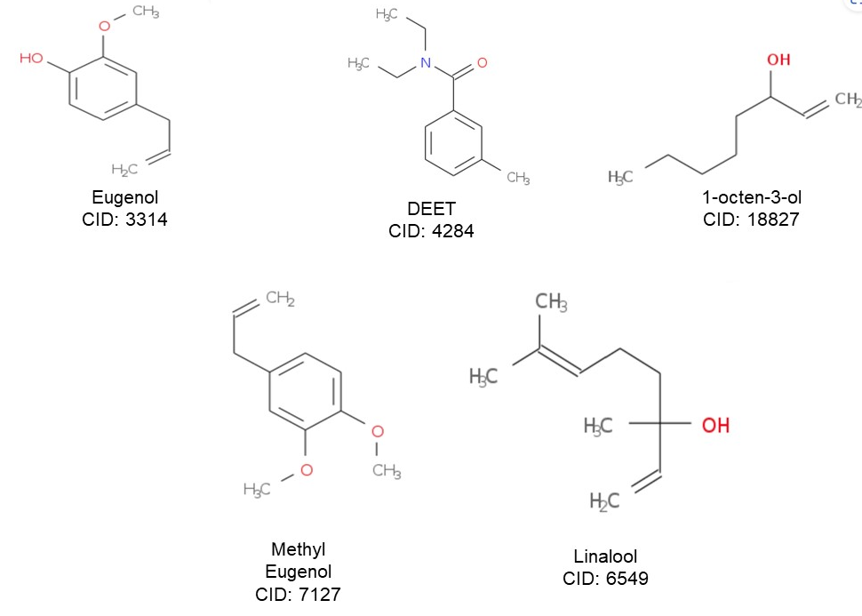Figure S8: Odorant molecules simulated in complex with different ORs in this study. Eugenol (EOL), N,N-diethyl-m-toluamide (DEET), 1-octen-3-ol (Oct-3OL), Methyl Eugenol (ME), and Linalool (LIN)

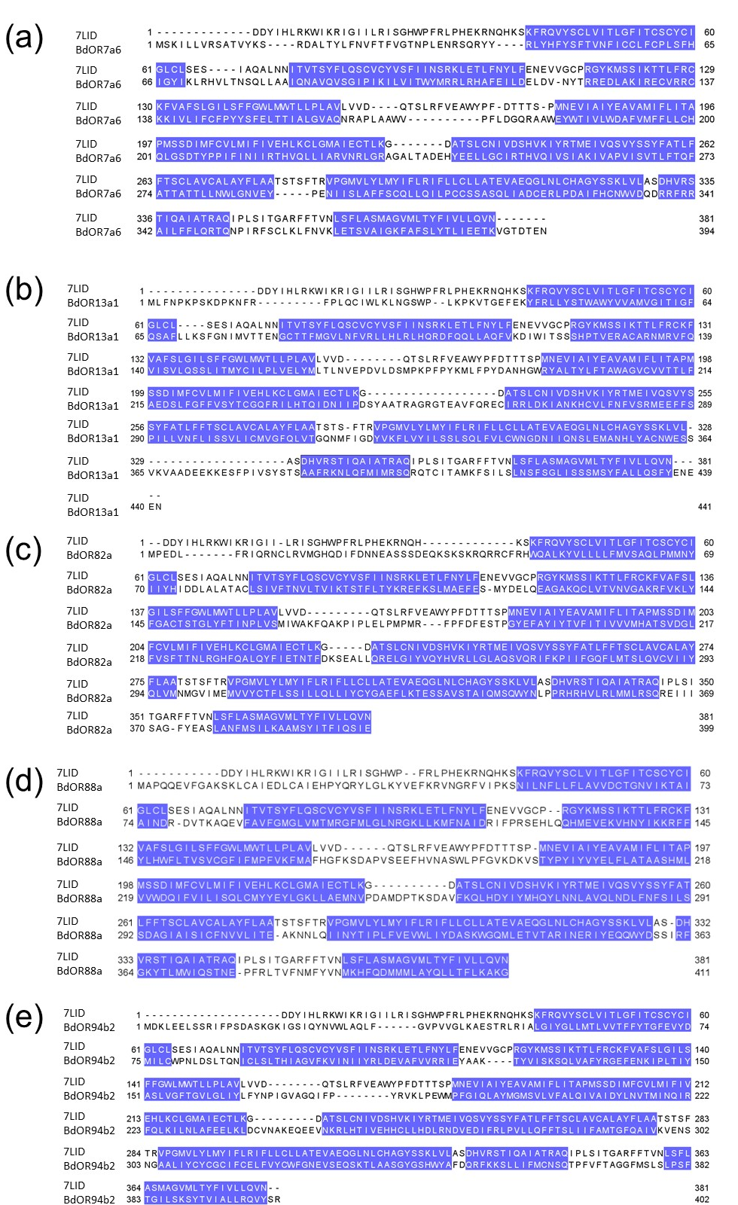

Figure S9: Pairwise alignments between 7LID and (a) BdOR7a6, (b) BdOR13a1, (c) BdOR82a, (d) BdOR88a, and (e) BdOR94b2, used for the TBM. Helices 1 to 7 are highlighted in blue. These alignments incorporate the helix 3 adjustments made following the SSD per residue calculations.

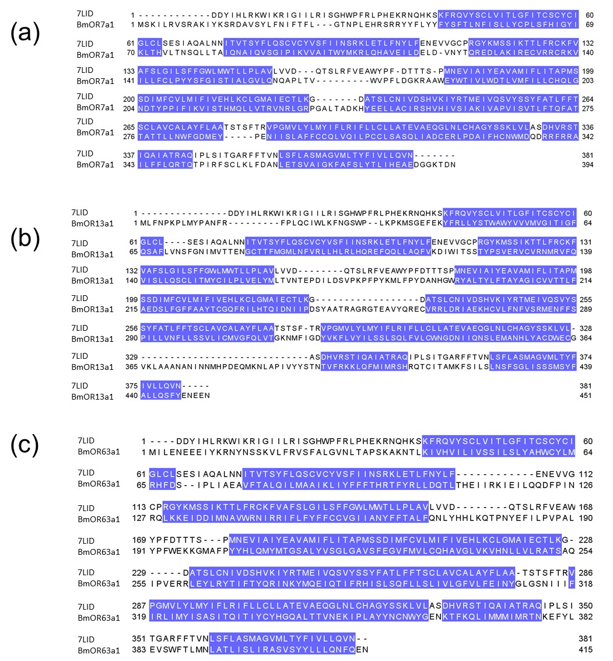

Figure S10: Pairwise alignments between 7LID and (a) BmOR7a1, (b) BmOR13a1, and (c) BmOR63a1, used for the TBM. Helices 1 to 7 are highlighted in blue. These alignments incorporate the helix 3 adjustments made following the SSD per residue calculations.

Table S5: Sequence identity among template,7LID and query ORs from B. dorsalis and B. minax. Sequence identity is calculated through EMBOSS Needle.
Query OR | Sequence identity with 7LID (%)
BdOR7a6 | 20.0
BdOR13a1 | 16.5
BdOR82a | 18.9
BdOR88a | 6.9
BdOR94b2 | 19.6
BmOR7a1 | 19.3
BmOR13a1 | 15.9
BmOR63a1 | 14.4

Table S6: ICM docking scores for OR-odorant pairs for the empirically established binder and non-binder complexes using TBM and AF models. The complexes are listed in order of increasing EC50 values.

OR complex | Binding class | ICM docking score with TBM model | ICM docking score with AF model
BmOR13a1_Oct-3OL | Binder | -4.57 | -21.39
BdOR13a1_Oct-3OL | Binder | -16.46 | -24.13
BdOR7a6_Oct-3OL | Binder | -12.40 | -15.71
BmOR7a1_LIN | Binder | -14.70 | -16.51
BdOR88a_ME | Binder | -15.56 | -14.54
BmOR7a1_Oct-3OL | Non-binder | -10.00 | -13.73
BmOR13a1_LIN | Non-binder | 0.38 | -12.36
BmOR63a1_LIN | Non-binder | -15.07 | -12.35
BdOR82a_EOL | Non-binder | -22.01 | -23.22
BdOR82a_ME | Non-binder | -17.43 | -18.14
BdOR82a_Oct-3OL | Non-binder | -15.89 | -14.97
BdOR94b2_ME | Non-binder | -18.21 | -11.74

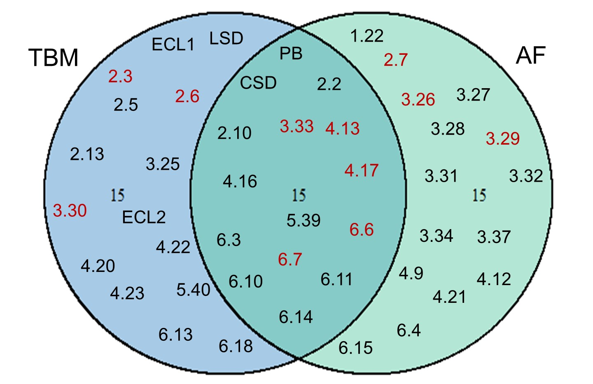
Figure S11: Venn diagram showing the filtered features for the TBM and AF datasets used for the LDA. Empirically established sites in the 7LID template are colored red.

Figure S12: Calculation of correlation coefficients (R) shows PB and GB are highly correlated in both TBM and AF datasets but there is no significant correlation between LSD and CSD in either dataset.

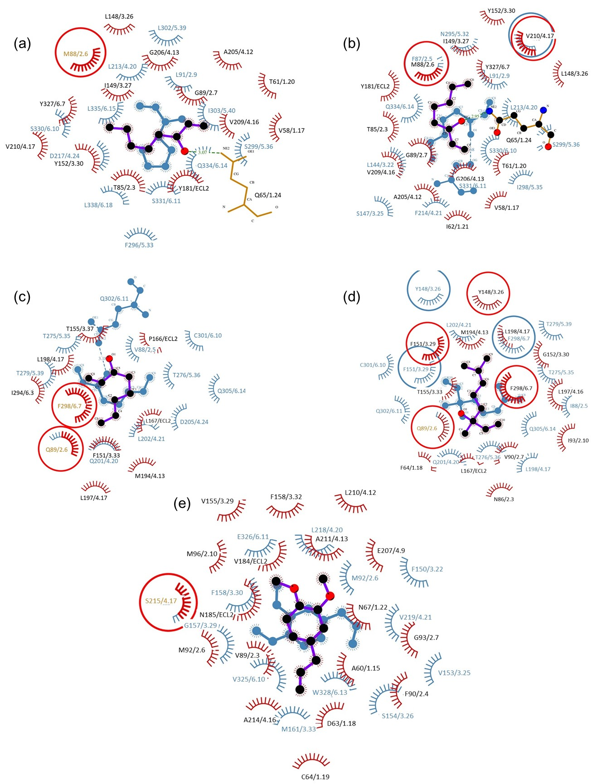

Figure S13: Post-simulation RLIs between BmOR13a1 and BdOR13a1 with Oct-3OL (a and b, respectively) and ME (c and d, respectively). AF predictions are shown in red and TBM predictions in blue. Shared predictions are circled. The ligands bound to AF models are in purple and those bound to TBM models are in blue.

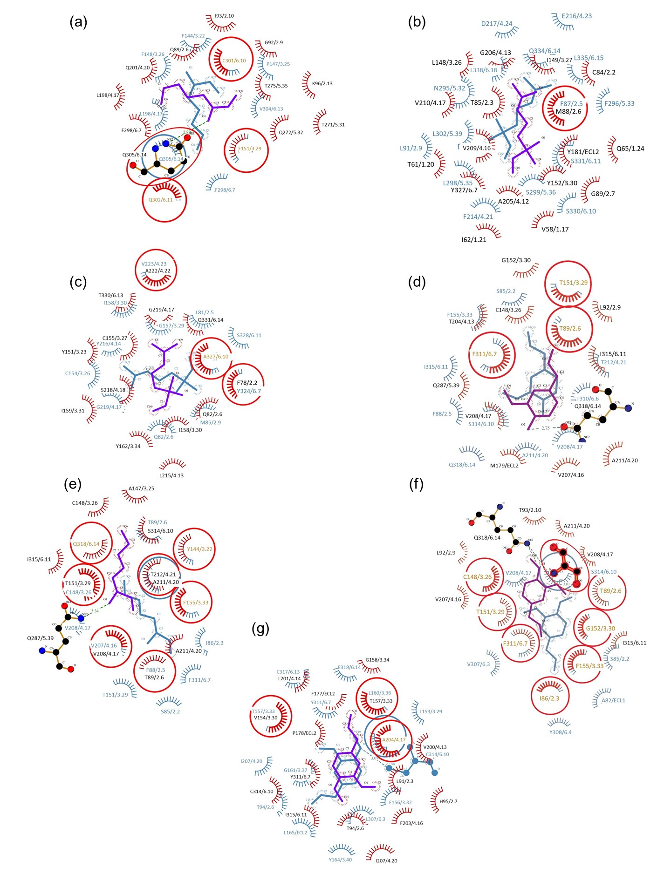

Figure S14: Post-simulation RLIs between (a) BmOR7a1_Oct-3OL, (b) BmOR13a1_LIN, (c) BmOR63a1_LIN, (d) BdOR82a_EOL, (e) BdOR82a_ME, (f) BdOR82a_Oct-3OL, and (g) BdOR94b2_ME. AF predictions are shown in red and TBM predictions in blue. Shared predictions are circled. The ligands bound to AF models are in purple and those bound to TBM models are in blue.

Table S7: Comparisons of parameter values at different production times for complexes of BdOR13a1 and BmOR13a1 with Oct-3OL. RLIs in bold indicated the presence of H5 and H1 even in extended simulations within TBM_BdOR13a1__Oct3OL and AF_BdOR13a1__Oct3OL complexes respectively.
Complex | Parameter | Simulation time (ns)
TBM_BdOR13a1_Oct3OL |  | 50 | 100 | 200
TBM_BdOR13a1_Oct3OL | PB | -14.12 | -14.40 | -11.19
TBM_BdOR13a1_Oct3OL | GB | -30.15 | -30.39 | -27.55
TBM_BdOR13a1_Oct3OL | CSD | 0.21 | 0.18 | 0.13
TBM_BdOR13a1_Oct3OL | LSD | 0.13 | 0.10 | 0.28
TBM_BdOR13a1_Oct3OL | RLIs | F87(2.5), L91(2.9), L144(3.22), S147(3.25), V210(4.17) L213(4.20), F214(4.21), N295(5.32), I298(5.35), S299(5.36), S330(6.10), S331(6.11), Q334(6.14), L335 (6.15) | F87(2.5), L91(2.9), L144(3.22), S147(3.25), M151(3.29), V210(4.17), L213(4.20), F214(4.21), N295(5.32), I298(5.35), S299(5.36), L302(5.39), S330(6.10), S331(6.11), Q334(6.14), L335 (6.15) | F87(2.5), L91(2.9), L144(3.22), S147(3.25),  L148(3.26),  M151(3.29), V210(4.17) L213(4.20), F214(4.21), N295(5.32), I298(5.35), S299(5.36), Y327(6.7), S330(6.10), S331(6.11), Q334(6.14), L335 (6.15)
AF_BdOR13a1_Oct3OL | PB | -13.8 | -16.24 | -15.04
AF_BdOR13a1_Oct3OL | GB | -32.26 | -33.71 | -33.47
AF_BdOR13a1_Oct3OL | CSD | 0.11 | 0.13 | 0.18
AF_BdOR13a1_Oct3OL | LSD | 0.33 | 0.29 | 0.31
AF_BdOR13a1_Oct3OL | RLIs | V58(1.17), T61(1.20), I62(1.21), Q65(1.24), T85(2.3), M88(2.6), G89(2.7), L148(3.26), I149(3.27), Y152(3.30), Y181(ECL2), A205(4.12), G206(4.13), V209(4.16), V210(4.17), Y327 (6.7) | V58(1.17), T61(1.20), I62(1.21), Q65(1.24), T85(2.3), M88(2.6), G89(2.7), L148(3.26), I149(3.27), Y152(3.30), Y181(ECL2), A205(4.12), G206(4.13), V209(4.16), V210(4.17), Y327 (6.7) | V58(1.17), T61(1.20), I62(1.21), Q65(1.24), C84(2.2), T85(2.3), M88(2.6), G89(2.7), L148(3.26), I149(3.27), Y152(3.30), Y181(ECL2), A205(4.12), G206(4.13), V209(4.16), V210(4.17), Y327 (6.7)
TBM_BmOR13a1_Oct3OL | PB | 5.17 | -4.09 | 2.33
TBM_BmOR13a1_Oct3OL | GB | -24.4 | -21.95 | -21.27
TBM_BmOR13a1_Oct3OL | CSD | 0.26 | 0.20 | 0.10
TBM_BmOR13a1_Oct3OL | LSD | 0.17 | 0.26 | 0.20
TBM_BmOR13a1_Oct3OL | RLIs | F87(2.5), V94(2.12), R95(2.13), L213(4.20), D217(4.24), N295(5.32), L298(5.35), S299(5.36), L302(5.39), S331(6.11), Q334(6.14), L335(6.15), L338(6.18) | F87(2.5), L91(2.9), V94(2.12), M151(3.29), V210(4.17), L213(4.20), N295(5.32), L298(5.35), L302(5.39), Y327(6.7), S330(6.10), S331(6.11), L335(6.15) | F87(2.5), L91(2.9), V94(2.12), M151(3.29), V210(4.17), L213(4.20), L298(5.35), S299(5.36), L302(5.39), Y327(6.7), S330(6.10), S331(6.11), L335(6.15)
AF_BmOR13a1_Oct3OL | PB | -14.30 | -16.68 | -16.71
AF_BmOR13a1_Oct3OL | GB | -32.44 | -34.38 | -33.83
AF_BmOR13a1_Oct3OL | CSD | 0.15 | 0.20 | 0.18
AF_BmOR13a1_Oct3OL | LSD | 0.32 | 0.29 | 0.29
AF_BmOR13a1_Oct3OL | RLIs | V58(1.17), T61(1.20), Q65(1.24), T85(2.3), M88(2.6), G89(2.7), L148(3.26), I149(3.27), Y152(3.30), Y181(ECL2), A205(4.12), G206(4.13), V209(4.16), V210(4.17), Y327(6.7) | V58(1.17), T61(1.20), I62(1.21), Q65(1.24), T85(2.3), M88(2.6), G89(2.7), L148(3.26), I149(3.27), Y152(3.30), Y181(ECL2), A205(4.12), G206(4.13), V209(4.16), V210(4.17), Y327(6.7) | V58(1.17), T61(1.20), I62(1.21), T85(2.3), M88(2.6), G89(2.7), L148(3.26), I149(3.27), Y152(3.30), Y181(ECL2), A205(4.12), G206(4.13), V209(4.16), V210(4.17), Y327(6.7)

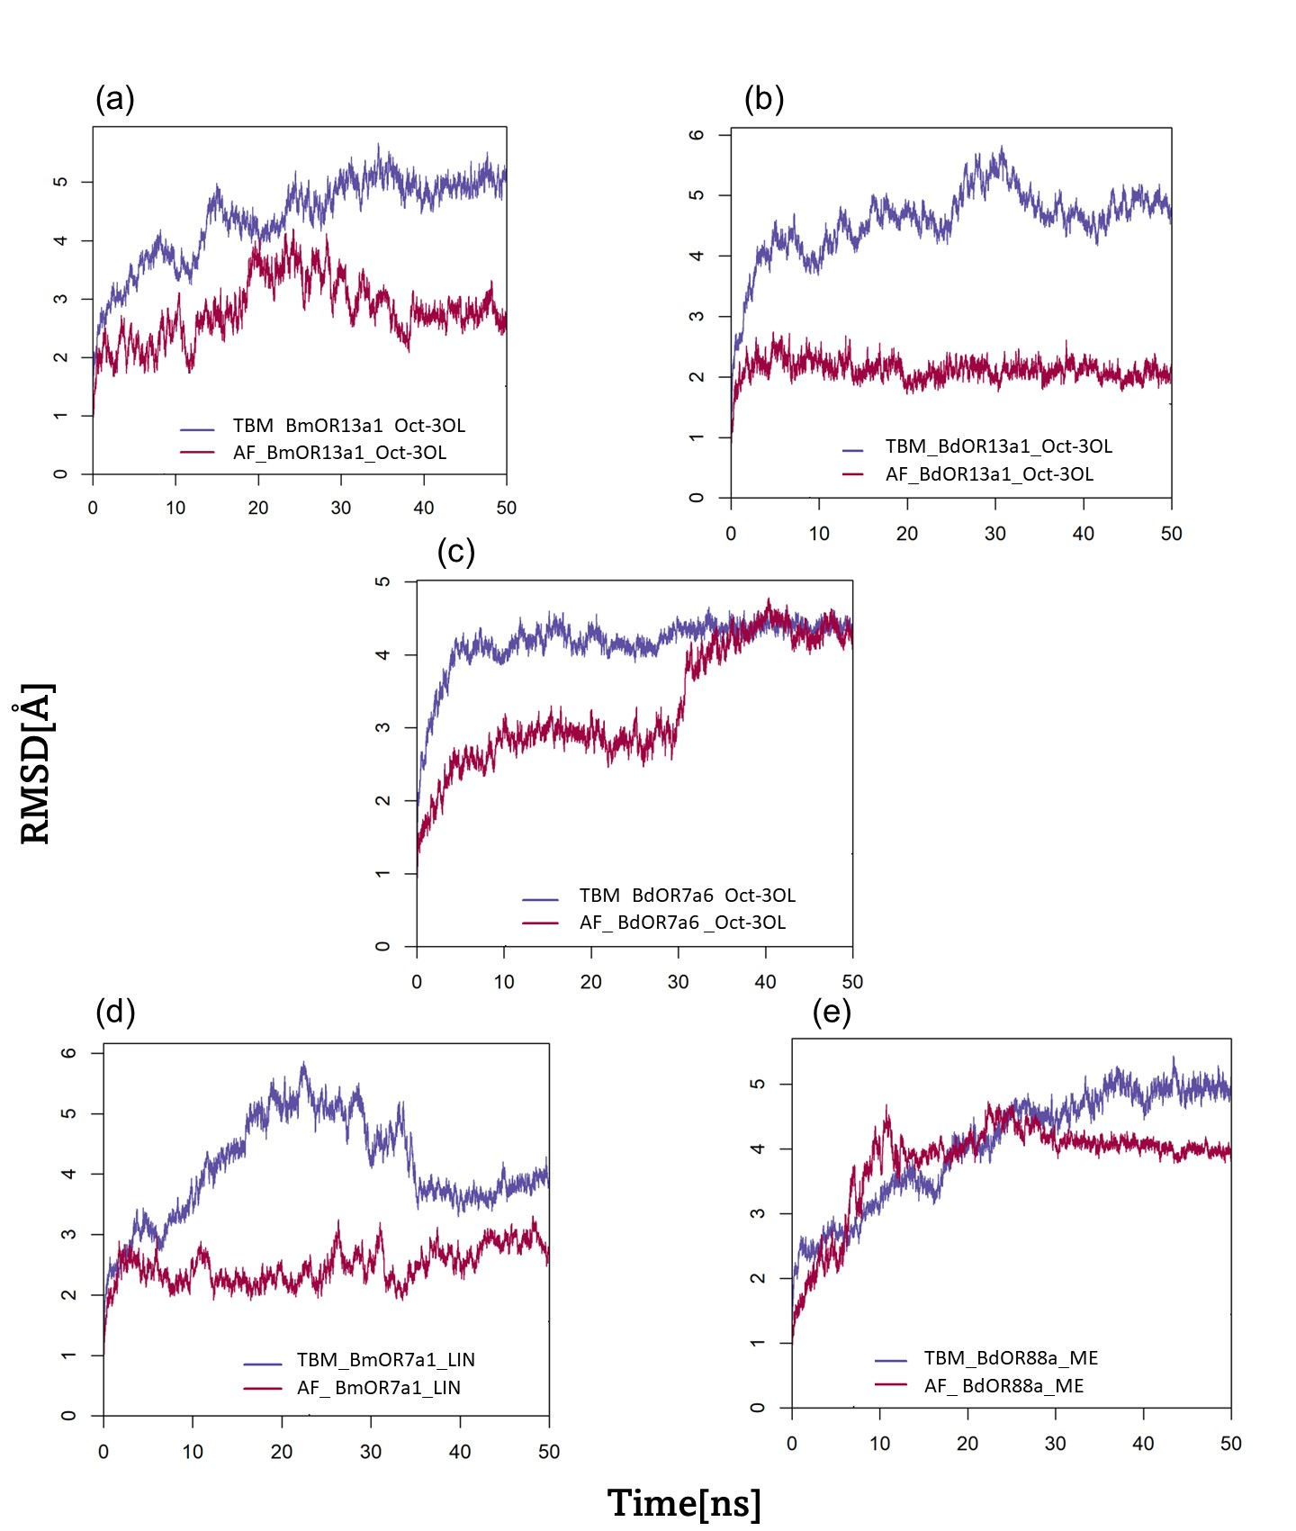
Figure S15: Time courses of RMSDs for the complexes during the simulations of the binder dataset (a) BmOR13a1_Oct-3OL, (b) BdOR13a1_Oct-3OL, (c) BdOROR7a6_Oct-3OL, (d) BmOR7a1_LIN, and (e) BdOR88a_ME. RMSDs are expressed relative to their respective pre-simulation values.
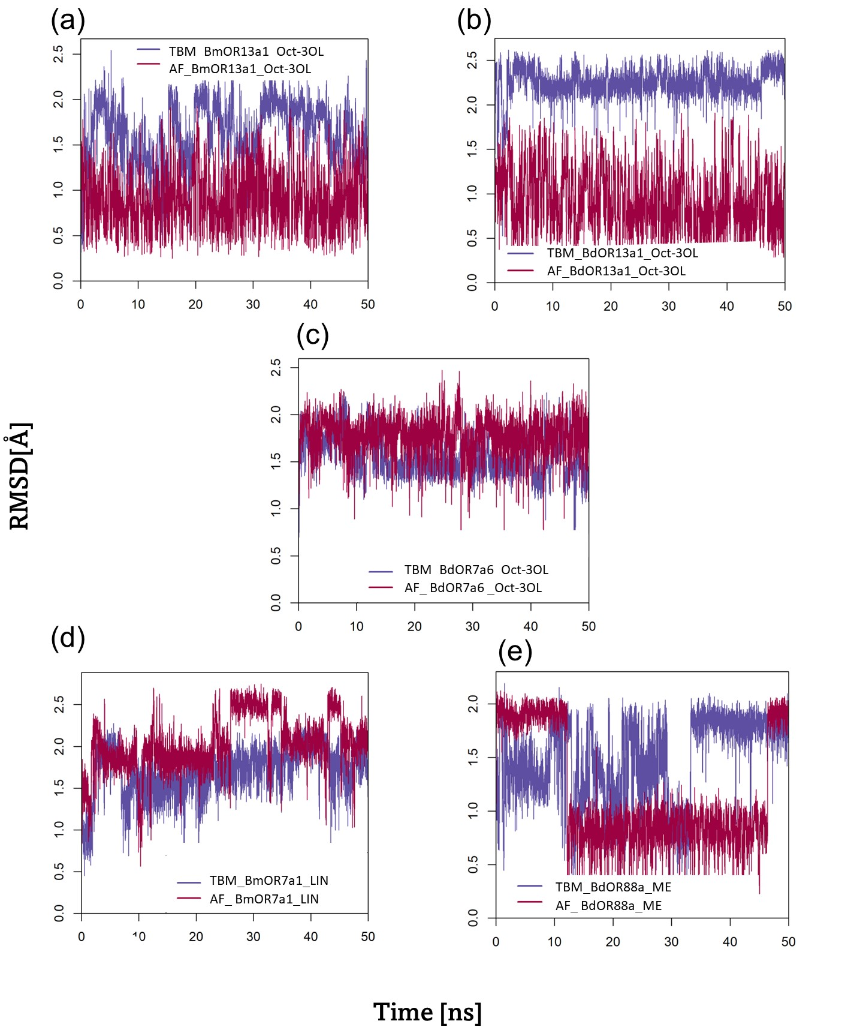

Figure S16: Time courses of RMSDs for the ligands during the simulations of the binder dataset (a) BmOR13a1_Oct-3OL, (b) BdOR13a1_Oct-3OL, (c) BdOR7a6_Oct-3OL, (d) BmOR7a1_LIN, and (e) BdOR88a_ME. RMSDs are expressed relative to their respective pre-simulation values.

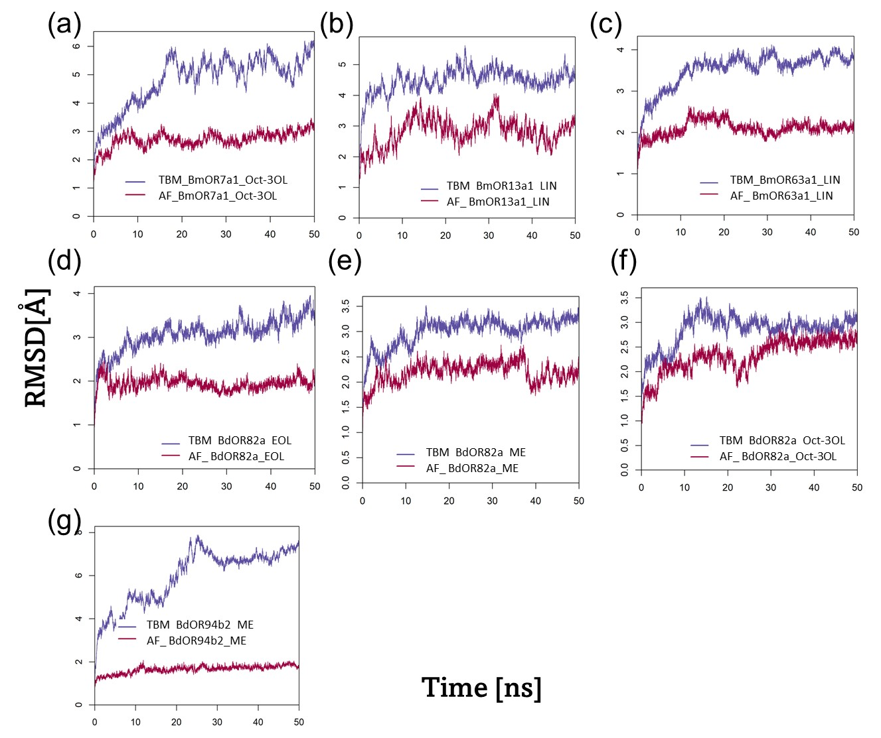

Figure S17: Time courses of RMSDs for the complexes during the simulations of the non-binder dataset (a) BmOR7a1_Oct-3OL, (b) BmOR13a1_LIN, (c) BdOR82a_EOL, (d) BdOR82a_ME, (e) BdOR82a_Oct-3OL and (f) BdOR94b2_ME. RMSDs are expressed relative to their respective pre-simulation values.

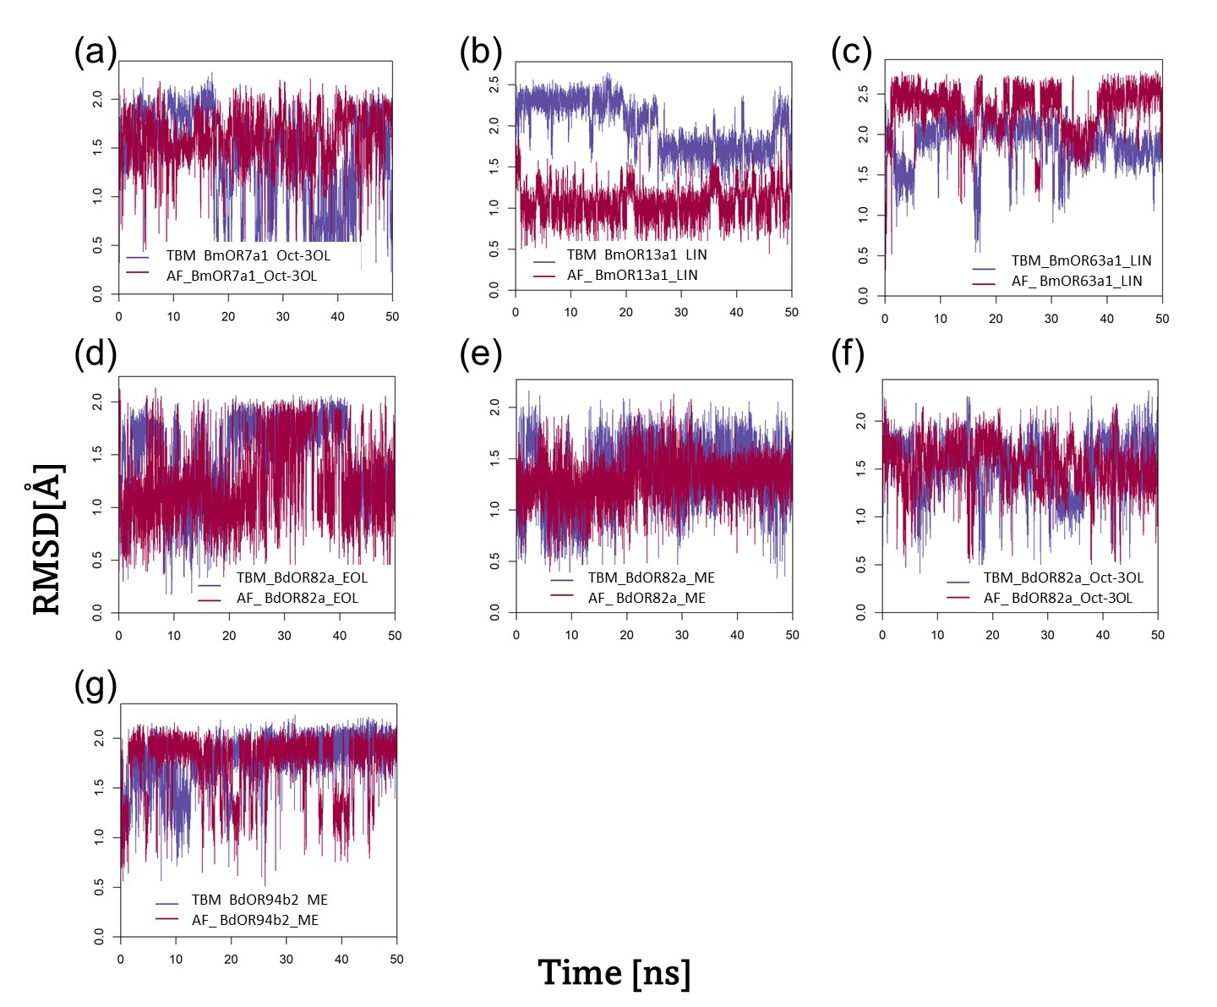

Figure S18: Time courses of RMSDs for the ligands during the simulations of the non-binder dataset (a) Oct-3OL within BmOR7a1, (b) LIN within BmOR13a1, (c) EOL within BdOR82a, (d) ME within BdOR82a, (e) Oct-3OL within BdOR82a and (f) ME within BdOR94b2 receptors. RMSDs are expressed relative to their respective pre-simulation values.

Table S8: Post-dynamics GB and PB values for B. dorsalis and B. minax ORs against empirically established binder and non-binder ligands using TBM and AF models.

Complex | Binding class | TBM |  | AF
 |  | GB | PB | GB | PB
BmOR13a1_Oct-3OL | Binder | -24.40 | 5.17 | -32.44 | -14.30
BdOR13a1_ Oct-3OL | Binder | -30.15 | -14.12 | -32.26 | -13.8
BdOR7a6_ Oct-3OL | Binder | -29.03 | -8.19 | -16.90 | -0.48
BmOR7a1_LIN | Binder | -28.34 | -8.78 | -20.98 | -2.81
BdOR88a_ME | Binder | -27.62 | -7.45 | -28.32 | -4.77
BmOR7a1_ Oct-3OL | Non-binder | -23.09 | -1.08 | -28.82 | -7.84
BmOR13a1_LIN | Non-binder | -27.6 | -7.18 | -34.25 | -14.88
BmOR63a1_LIN | Non-binder | -27.66 | -5.88 | -25.41 | -7.61
BdOR82a_EOL | Non-binder | -23.22 | 1.24 | -26.15 | -1.63
BdOR82a_ME | Non-binder | -28 | -5.5 | -30.53 | -10.38
BdOR82a_ Oct-3OL | Non-binder | -20.66 | 0.57 | -24.85 | -7.63
BdOR94b2_ME | Non-binder | -24.25 | -1.35 | -31.42 | -9.02

Table S9: Total size of the molecular system used for simulations of each complex analyzed.

Complex | Total atoms | Lipid bilayer molecules | Na⁺ ions | Cl⁻ ions | Water molecules
TBM_MhOR5_EOL | 61416 | 128 | 33 | 43 | 12,783
AF_MhOR5_EOL | 71097 | 128 | 41 | 52 | 15,587
TBM_MhOR5_DEET | 166116 | 384 | 98 | 108 | 36,470
AF_MhOR5_DEET | 71074 | 128 | 42 | 52 | 15,578
TBM_BmOR13a1_Oct-3OL | 72302 | 128 | 42 | 48 | 16,082
AF_BmOR13a1_Oct-3OL | 108632 | 192 | 68 | 74 | 25,406
TBM_BdOR13a1_Oct-3OL | 68129 | 128 | 39 | 45 | 14,752
AF_BdOR13a1_Oct-3OL | 97776 | 192 | 58 | 64 | 21,853
TBM_BdOR7a6_ Oct-3OL | 64334 | 128 | 36 | 46 | 13,708
AF_BdOR7a6_ Oct-3OL | 83215 | 192 | 45 | 55 | 17,227
TBM_BmOR7a1_LIN | 89146 | 192 | 51 | 60 | 19,200
AF_BmOR7a1_LIN | 83941 | 192 | 45 | 54 | 17,469
TBM_BdOR88a_ME | 90382 | 192 | 52 | 54 | 19,520
AF_BdOR88a_ME | 92547 | 192 | 53 | 55 | 20,241
TBM_BmOR7a1_Oct-3OL | 89148 | 192 | 51 | 60 | 19,202
AF_BmOR7a1_ Oct-3OL | 83976 | 192 | 45 | 54 | 17,482
TBM_BmOR13a1_LIN | 72300 | 128 | 42 | 48 | 16,080
AF_BmOR13a1_LIN | 108675 | 192 | 68 | 74 | 25,419
TBM_BmOR63a1_LIN | 63241 | 128 | 34 | 45 | 13,173
AF_BmOR63a1_LIN | 63417 | 128 | 35 | 47 | 13,231
TBM_BdOR82a_EOL | 93045 | 192 | 55 | 60 | 20,485
AF_BdOR82a_EOL | 112364 | 256 | 64 | 69 | 24,150
TBM_BdOR82a_ME | 93141 | 192 | 55 | 60 | 20,516
AF_BdOR82a_ME | 112367 | 256 | 64 | 69 | 24,150
TBM_BdOR82a_Oct-3OL | 93004 | 192 | 55 | 60 | 20,471
AF_BdOR82a_Oct-3OL | 112410 | 256 | 64 | 69 | 24,165
TBM_BdOR94b2_ME | 65894 | 128 | 37 | 39 | 14,224
AF_BdOR94b2_ME | 60585 | 128 | 33 | 35 | 12,457

References:
1 Xu, L. et al. Two odorant receptors regulate 1-octen-3-ol induced oviposition behavior in the oriental fruit fly. Commun Biol 6, 176, doi:10.1038/s42003-023-04551-5 (2023).
2 Nichols, A. S. & Luetje, C. W. Transmembrane segment 3 of Drosophila melanogaster odorant receptor subunit 85b contributes to ligand-receptor interactions. J Biol Chem 285, 11854-11862, doi:10.1074/jbc.M109.058321 (2010).
3 Pellegrino, M., Steinbach, N., Stensmyr, M. C., Hansson, B. S. & Vosshall, L. B. A natural polymorphism alters odour and DEET sensitivity in an insect odorant receptor. Nature 478, 511-514, doi:10.1038/nature10438 (2011).
4 Leary, G. P. et al. Single mutation to a sex pheromone receptor provides adaptive specificity between closely related moth species. Proc Natl Acad Sci U S A 109, 14081-14086, doi:10.1073/pnas.1204661109 (2012).
5 Hughes, D. T., Wang, G., Zwiebel, L. J. & Luetje, C. W. A determinant of odorant specificity is located at the extracellular loop 2-transmembrane domain 4 interface of an Anopheles gambiae odorant receptor subunit. Chem Senses 39, 761-769, doi:10.1093/chemse/bju048 (2014).
6 Rahman, S. & Luetje, C. W. Mutant cycle analysis identifies a ligand interaction site in an odorant receptor of the malaria vector Anopheles gambiae. Journal of Biological Chemistry 292, 18916-18923, doi:https://doi.org/10.1074/jbc.M117.810374 (2017).
7 Auer, T. O. et al. Olfactory receptor and circuit evolution promote host specialization. Nature 579, 402-408, doi:10.1038/s41586-020-2073-7 (2020).
8 Yuvaraj, J. K. et al. Putative ligand binding sites of two functionally characterized bark beetle odorant receptors. BMC Biol 19, 16, doi:10.1186/s12915-020-00946-6 (2021).
9 Wu, Z., Cui, Y., Ma, J., Qu, M. & Lin, J. Analyses of chemosensory genes provide insight into the evolution of behavioral differences to phytochemicals in Bactrocera species. Mol Phylogenet Evol 151, 106858, doi:10.1016/j.ympev.2020.106858 (2020).
10 Liu, Z., Smagghe, G., Lei, Z. & Wang, J. J. Identification of Male- and Female-Specific Olfaction Genes in Antennae of the Oriental Fruit Fly (Bactrocera dorsalis). PLoS One 11, e0147783, doi:10.1371/journal.pone.0147783 (2016).
11 Jin, S., Zhou, X., Gu, F., Zhong, G. & Yi, X. Olfactory Plasticity: Variation in the Expression of Chemosensory Receptors in Bactrocera dorsalis in Different Physiological States. Front Physiol 8, 672, doi:10.3389/fphys.2017.00672 (2017).
12 Wu, Z. et al. Candidates for chemosensory genes identified in the Chinese citrus fly, Bactrocera minax, through a transcriptomic analysis. BMC Genomics 20, 646, doi:10.1186/s12864-019-6022-5 (2019).
13 Xu, P., Wang, Y., Akami, M. & Niu, C. Y. Identification of olfactory genes and functional analysis of BminCSP and BminOBP21 in Bactrocera minax. PLoS One 14, e0222193, doi:10.1371/journal.pone.0222193 (2019).
14 Cheng, J. F. et al. Comparative genomic and transcriptomic analyses of chemosensory genes in the citrus fruit fly Bactrocera (Tetradacus) minax. Sci Rep 10, 18068, doi:10.1038/s41598-020-74803-5 (2020).
15 Liu, Y. et al. Characterization of a specific odorant receptor for linalool in the Chinese citrus fly Bactrocera minax (Diptera: Tephritidae). Insect Biochem Mol Biol 122, 103389, doi:10.1016/j.ibmb.2020.103389 (2020).
16 Miyazaki, H. et al. Functional characterization of olfactory receptors in the Oriental fruit fly Bactrocera dorsalis that respond to plant volatiles. Insect Biochem Mol Biol 101, 32-46, doi:10.1016/j.ibmb.2018.07.002 (2018).
17 Wu, Z. et al. Discovery of Chemosensory Genes in the Oriental Fruit Fly, Bactrocera dorsalis. PLoS One 10, e0129794, doi:10.1371/journal.pone.0129794 (2015).
18 Liu, Y., Cui, Z., Wang, G., Zhou, Q. & Liu, Y. Cloning and Functional Characterization of Three Odorant Receptors From the Chinese Citrus fly Bactrocera minax (Diptera: Tephritidae). Front Physiol 11, 246, doi:10.3389/fphys.2020.00246 (2020).

