Supplementary Materials for

SpineWave: Harnessing Fish Spinal Kinematics in Biomimetic Robotics for Enhanced Aquatic Exploration

Qu He et al.

*Corresponding author. Weikun Li, liweikun@westlake.edu.cn; Weicheng Cui, cuiweicheng@westlake.edu.cn; Dixia Fan, fandixia@westlake.edu.cn

This PDF file includes:

Notes S1 to S5
Figs. S1 to S10
Legends for movies S1 to S6

Other Supplementary Materials for this manuscript include the following:

Movies S1 to S10

Supplementary Text
Note S1. Magnetic Force Measuring Rig
Addressing the complexity of simulating magnetic interactions in the exoskeleton, we adopted an experimental approach, developing a custom force measuring rig (Fig. S1). This apparatus includes a stepper motor with a planetary gearbox to drive a rotor, a freely rotating stator, and a linear force sensor (Fig. S2). Mimicking our robotic fish's ribcage, the stator and rotor's magnetic forces are measured by the sensor across various rotation angles. The resultant force-rotation curve is vital for later dynamic simulations of the assembly (Fig. S3).

Note S2. Trajectory tracing and Simulation of Dynamic Test Rig
To validate the magnetic exoskeleton's efficacy, we constructed a dynamic test rig. It translates the rotational movement of a brushless DC motor into linear sinusoidal motion, driving two exoskeleton assemblies. One assembly replicates our robotic fish's exoskeleton, while the other uses steel spheres (matching the magnets' mass) as a control. The overall mass difference of the two assemblies differs by less than 5%. These units are tested concurrently, with overhead video capture for analysis, comparing the performance and dynamics of the magnetic assembly against the control.
The software KINOVEA is utilized to obtain the trajectories of magnetic and non-magnetic exoskeletons at three distinct positions. This is achieved by recognizing the colors at three specific points to track the joint movement trajectories. As illustrated in Fig. S4, the centers of joints 1, 6, 7, and 8 are marked with different colors (blue, red, yellow and green) for motion tracking. Additionally, the baseline is defined at Y=0.
To simulate the motion of the magnetic structure, a model of the multi-jointed fish is constructed using MATLAB Simulink. As shown in Fig. S5(a), the basic model of the robotic fish comprises 12 identical rib subsystems. Geometric dimensions, mechanical assemblies, and material properties are consistent with those of the actual structure to facilitate a comprehensive simulation of the experiment.
Adjacent ribcages are interconnected through rotary joint components to achieve co-axial rotation, as shown in Fig. S5(b). Rotary joints are configured with a rotation angle range of [-15°, 15°], damping coefficients, and spring stiffness parameters. Notably, the magnetic forces between the joints are implemented by applying an approximation function related to the rotation angle. This function is determined using formulas derived from the magnetic force measuring experiments above. A sinusoidal wave signal is employed to achieve the lateral translational motion in the first joint. The amplitude and frequency of this sinusoidal wave can be considered as those of propulsion. Fig. S5(c) depicted the comparison of simulated and actual motion trajectories at three distinct positions (joints 1, 6, and 7) under varying frequencies (0.4, 0.6, 0.8, and 1.0 Hz). The simulation results exhibit a high level of consistency with the experimental data, laying a solid foundation for further research in the future.

Note S3. Design of Three Robot Prototypes
We developed three distinct robotic fish prototypes, each featuring one, three, and five servo motor-driven segments respectively. Our innovative modular design permits interchangeability among the robots, allowing them to share a common head assembly. This assembly is easily attached to the powered body section using just four screws and a 7-pin watertight connector—two pins for power and five for servo PWM signals. The inclusion of servos in the body-tail section dictates the utilization of these pins, capping the maximum number of servos at five for the current fish head design. Future enhancements include transitioning from PWM to RS485 for servo communication and augmenting connector pins for power to support higher peak currents. These upgrades aim to facilitate the construction of longer robotic fish, with length only constrained by the system's electric current capacity.

﻿Note S4. Force and torque measurement for evolutionary parameter training
To measure the force and torque created by our robotic fish and tune the control parameters, we constructed a test rig. The test rig contains a 6-axis (3-axis force and 3-axis torque sensor) and video camera. The camera footage is recorded to an external video recorder connected via HDMI to have the video data analysed after testing. The camera is installed 3 meters above the force sensor and has a high magnification. This is to reduce the perspective distortion when recording the fish from the above. The sensor is installed rigidly to the frame of the rig constructed from 2020 aluminium extrusions. The fish is connected to the sensor via a 3D printed bracket and a aluminium adaptor. We printed the bracket using high-rigidity carbon fibre-filled PLA (Fig. S6).
During initial testing we discovered that the aluminium frame while connected to force sensor causes data fluctuations, that are likely due to the frame acting as an antenna and receiving electromagnetic interferences. We fixed the problem by connecting a ground wire to the aluminium frame.
Parameter training for turning manoeuvres was conducted in quiescent water within a laboratory tank, employing average torque as the key performance metric. Straight-line swimming training utilized a circulating water tank to generate a steady flow, simulating consistent swimming speed, with average net force serving as the metric for assessment. This approach ensures precise and controlled conditions for optimizing the robotic fish's locomotive capabilities.
Through iterative optimization of the evolutionary algorithm, the optimization result gives the optimal solution that produces the maximum thrust under the flow rate of 0.3m/s, and its corresponding six parameters are used as our subsequent actual swimming tests in the water ring—deployment parameters (six parameters are $ω, { ε}_{1},{ ε}_{2},{ ε}_{3}, θ, b.$ According to our previous work, h and j have certain selection intervals. Considering that the experiment here aims to show the potential of the proposed structure in the optimization direction, two specified parameters are given here to reduce the optimization workload.). Similarly, in the turning, we used an evolutionary algorithm to find a candidate solution for the optimal torque. Similarly, we randomly generated 50 data sets containing six parameters and then iteratively obtained our current best-candidate solution (Fig. S7) through evolutionary algorithms. The six parameters in this candidate solution are the parameters of the CPG model we want to deploy. Thereafter, the parameters corresponding to this candidate solution were deployed as turning parameters in subsequent water ring swimming tests. It is worth mentioning that these candidate solutions are only the results of our optimization under given conditions. The structure we designed still has good potential and can optimize more suitable parameter values under higher requirements. In addition, our experiment aims to demonstrate our vast potential in optimization. Much work still can be extended in this direction, such as considering multiple target optimizations simultaneously.

Note S5. PCB Design
The main PCB within the electronic pod is a dual-layer design, performing both as a signal and power routing medium and a structural base for electronic components (Fig. S8). The board is powered by a 5V line, with the PCB handling three power levels: the main 8.4V from the battery and converted 5V and 3.3V for lower voltage components via two DC-DC voltage regulators. Additional connectors on the PCB facilitate future sensor module integration. Direct connection of the servo motors' power and ground lines to the main 8.4V line, alongside the battery's capacitor-like function, addresses sudden current spikes. The servos' PWM signals link to the Feather board's analog pins through JST connectors, supporting up to 10 servos.

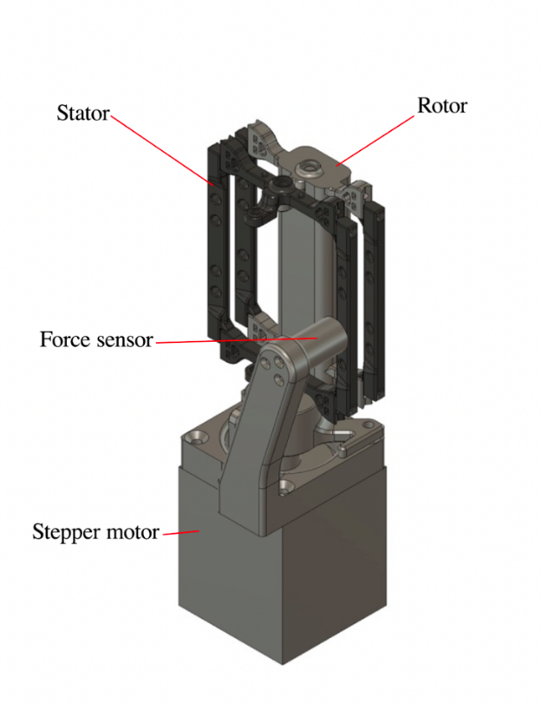

Fig. S1. Magnetic force measuring rig assembly

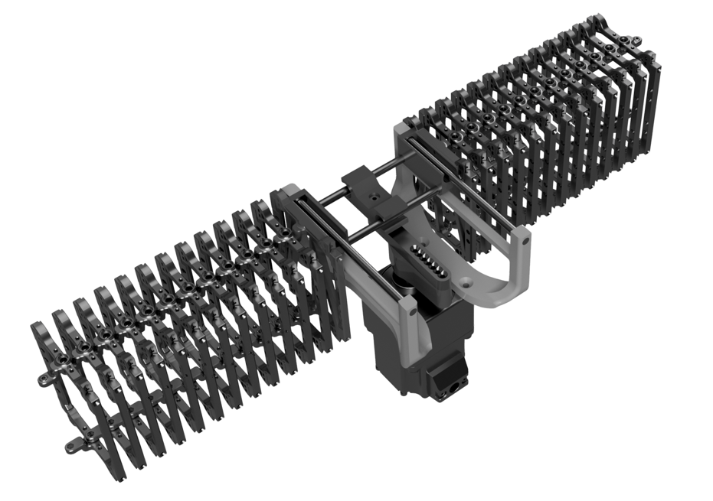

Fig. S2. 3D render of the dynamic test rig
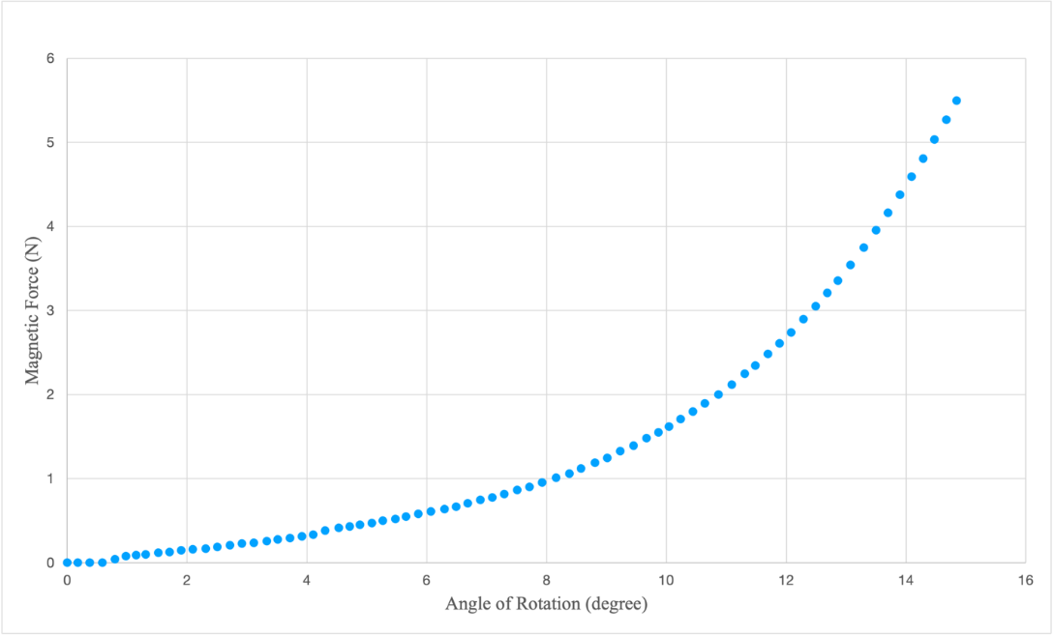

Fig. S3. Experimental Data

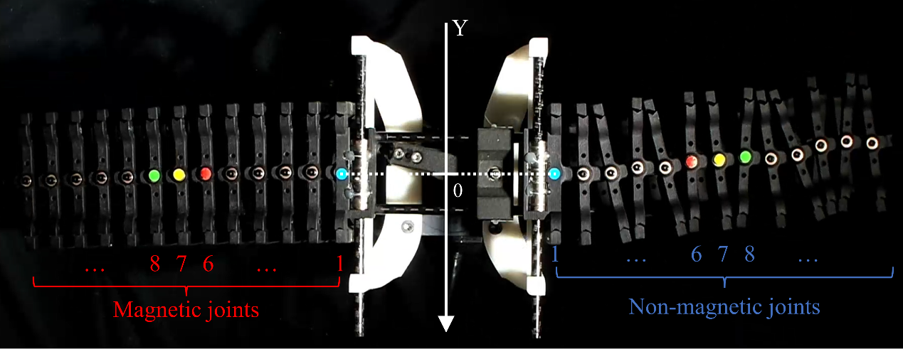

Fig. S4. The tracking of trajectories for different joints

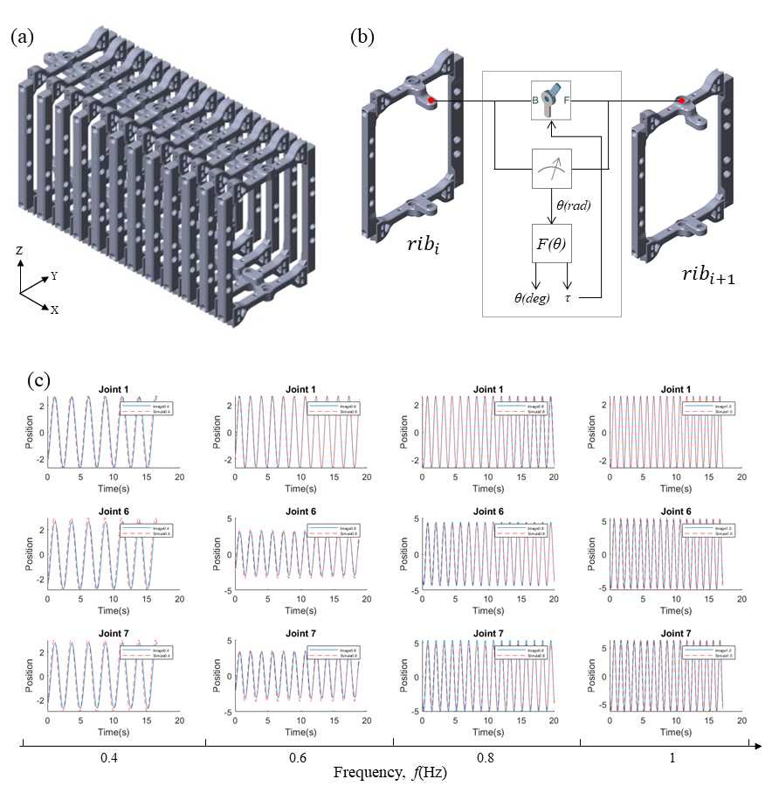
Fig. S5. Modeling of the motion simulation. (a) geometric model of the multi-joint magnetic structure; (b) the incorporation of the relationship between magnetic torque and joint angle; (c) comparison of simulated and actual motion trajectories at three distinct positions (joints 1, 6, and 7) under varying frequencies (0.4, 0.6, 0.8, and 1.0 Hz).

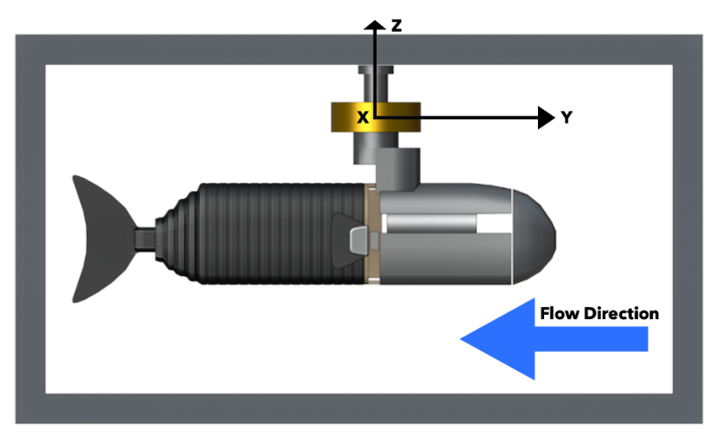
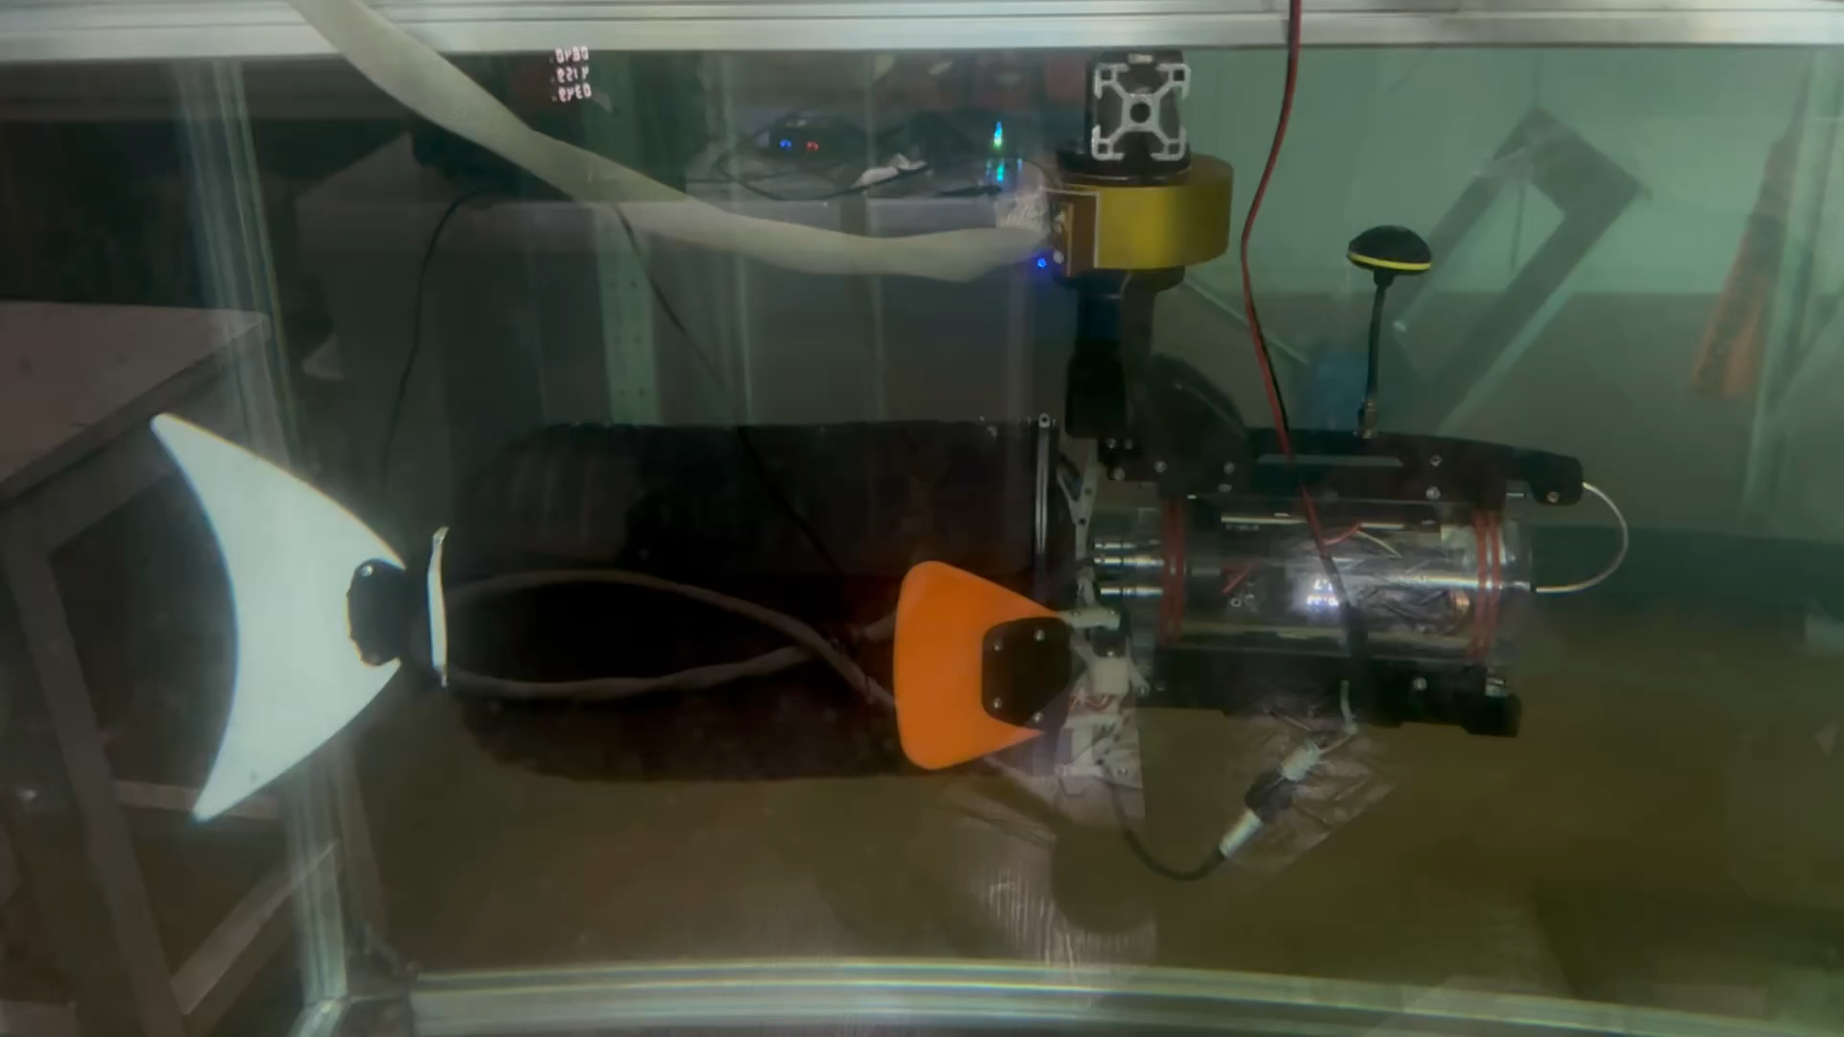

Fig. S6. The test equipment and the robot fish placed in the circulation tank

Fig. S7. Torque optimization curve during iteration process.

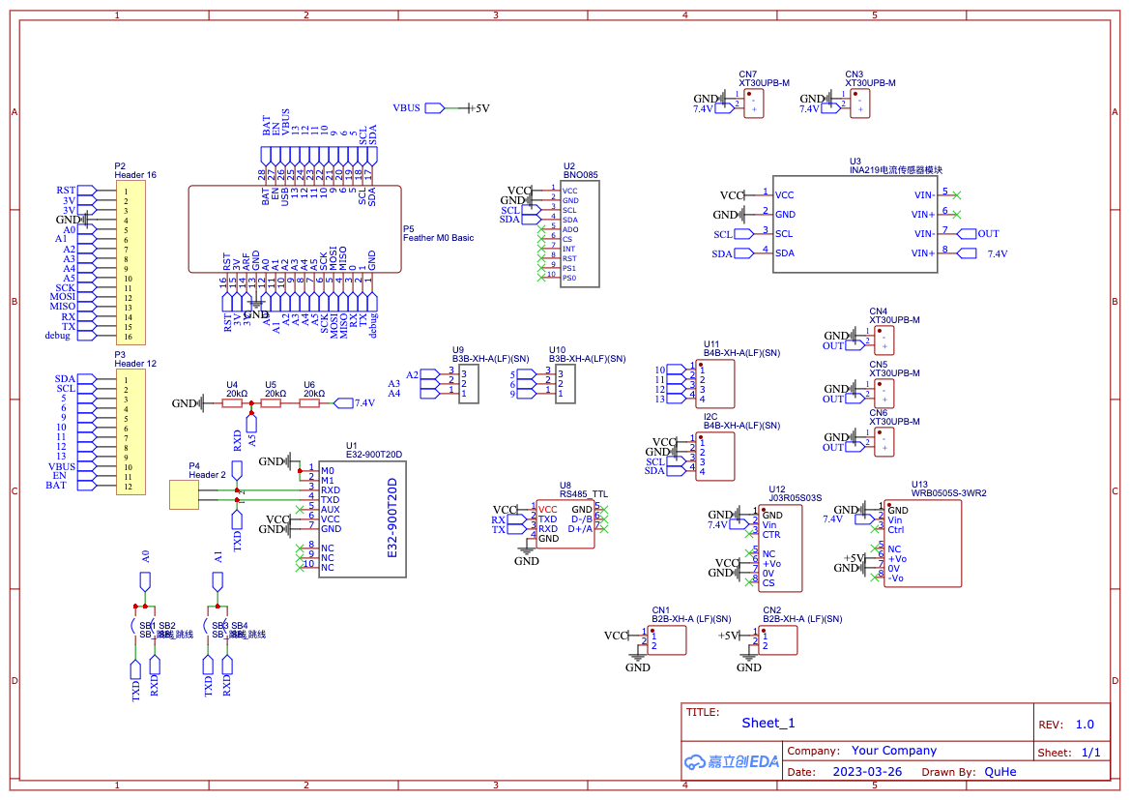

Fig. S8. PCB Schematic

Supplementary Movies

Movie S1. Overview of the SpineWave Swimming
Movie S2. Free Swimming – Dynamic Test Rig
Movie S3. Free Swimming – Three Joint SpineWave
Movie S4. Free Swimming – Five Joint SpineWaveMovie S5. Three SpineWave Prototypes
Movie S6. Free Swimming - Turing
Movie S7. Free Swimming – Straight Line
Movie S8. Open Water Experiment - Long Distance Real Complex Environment Testing
Movie S9. Open Water Experiment - Close Up to Real Marine Life
Movie S10. Open Water Experiment - Exploring The Environment and Navigating Narrow Areas

