Supplementary Material
Adiposity modifies the association between heart failure risk and glucose metabolic disorders in older individuals: A community-based prospective cohort study
Running title: Adiposity, glycemia, and heart failure
Liming Hou^{1,2†}, Xin Wang^{3†}, Peilin Li^{1†}, Hua Zhang^{1,2}, Yanli Yao^{1,2}, Zhendong Liu^{1,2*}, Juan Wang^{3*}, Weike Liu^{4*}

Supplementary Table 1 Associations of glucose metabolic disorder with incident HF
 | Model 1 |  |  | Model 2 |  |  |  | Model 3 |  |  | Model 4 |  |  | Model 5
 | HR (95% CI) | P value |  | HR (95% CI) | P value |  | HR (95% CI) |  | P value |  | HR (95% CI) | P value |  | HR (95% CI) | P value
Overall participants
Euglycemia | Ref. |  |  | Ref. |  |  | Ref. |  |  |  | Ref. |  |  | Ref.
Prediabetes | 1.43  (1.25, 1.63) | <0.001 |  | 1.34  (1.17, 1.54) | <0.001 |  | 1.24  (1.08, 1.42) |  | 0.002 |  | 1.14  (0.99, 1.31) | 0.056 |  | 1.24  (1.08, 1.42) | 0.002
Uncontrolled diabetes | 2.65  (2.09, 2.91) | <0.001 |  | 2.35  (1.99, 2.78) | <0.001 |  | 1.92  (1.62, 2.28) |  | <0.001 |  | 1.59  (1.34, 1.90) | <0.001 |  | 1.86  (1.57, 2.21) | <0.001
well-controlled diabetes | 1.29  (1.05, 1.58) | 0.030 |  | 1.26  (1.05, 1.51) | 0.034 |  | 1.18  (1.00, 1.39) |  | 0.049 |  | 1.06  (0.99, 1.14) | 0.076 |  | 1.12  (0.94, 1.34) | 0.102
Female
Euglycemia | Ref. |  |  | Ref. |  |  | Ref. |  |  |  | Ref. |  |  | Ref.
Prediabetes | 1.45  (1.21, 1.74) | <0.001 |  | 1.34  (1.11, 1.61) | 0.002 |  | 1.25  (1.04, 1.50) |  | 0.019 |  | 1.15  (0.95, 1.38) | 0.156 |  | 1.23  (1.03, 1.46) | 0.044
Uncontrolled diabetes | 2.82  (2.26, 3.51) | <0.001 |  | 2.53  (2.02, 3.16) | <0.001 |  | 2.41  (1.63, 2.58) |  | <0.001 |  | 1.75  (1.38, 2.22) | <0.001 |  | 2.17  (1.72, 2.73) | <0.001
well-controlled diabetes | 1.26  (1.05, 1.51) | 0.036 |  | 1.23  (1.04, 1.46) | 0.044 |  | 1.14  (0.96, 1.37) |  | 0.081 |  | 1.04  (0.79, 1.36) | 0.402 |  | 1.07  (0.81, 1.43) | 0.136
Male
Euglycemia | Ref. |  |  | Ref. |  |  | Ref. |  |  |  | Ref. |  |  | Ref.
Prediabetes | 1.42  (1.17, 1.73) | 0.001 |  | 1.34  (1.10, 1.63) | 0.004 |  | 1.24  (1.01, 1.51) |  | 0.037 |  | 1.15  (0.94, 1.41) | 0.172 |  | 1.24  (1.01, 1.51) | 0.039
Uncontrolled diabetes | 2.15  (1.67, 2.76) | <0.001 |  | 2.10  (1.62, 2.71) | <0.001 |  | 1.63  (1.26, 2.11) |  | <0.001 |  | 1.42  (1.09, 1.85) | 0.008 |  | 1.63  (1.25, 2.12) | <0.001
Well-controlled diabetes | 1.42  (1.04, 1.92) | 0.042 |  | 1.39  (1.04, 1.85) | 0.044 |  | 1.23  (1.00, 1.50) |  | 0.046 |  | 1.08  (0.98, 1.18) | 0.057 |  | 1.16  (0.92, 1.47) | 0.080
Model 1 adjusted for non. Model 2 adjusted for age, smoking, alcohol consumption, regular physical activity, history of hypertension and dyslipidemia, antihypertensive and lipid-lowering medication use, SBP, DBP, heart rate, plasma lipids, eGFR, NT-proBNP, and hemoglobin; Model 3 adjusted for confounders in Model 2 plus BMI; Model 4 adjusted for confounders in Model 2 plus WHR; and Model 5 adjusted for confounders in Model 2 plus VFA.

Supplementary Table 2 Association of one-SD increment BMI, WHR, and VFA with incident HF
 | Model 1 |  |  | Model 2
 | HR (95% CI) | P value |  | HR (95% CI) | P value
One-SD increment BMI
Male | 1.41 (1.30, 1.52) | <0.001 |  | 1.39 (1.28, 1.50) | <0.001
Female | 1.48 (1.36, 1.62) | <0.001 |  | 1.48 (1.35, 1.61) | <0.001
One-SD increment WHR
Male | 1.74 (1.60, 1.88) | <0.001 |  | 1.74 (1.60, 1.89) | <0.001
Female | 1.87 (1.71, 2.05) | <0.001 |  | 1.85 (1.69, 2.02) | <0.001
One-SD increment VFA
Male | 1.44 (1.33, 1.56) | <0.001 |  | 1.43 (1.33, 1.55) | <0.001
Female | 1.59 (1.46, 1.72) | <0.001 |  | 1.58 (1.46, 1.71) | <0.001
Model 1 adjusted for non. Model 2 adjusted for age, smoking, alcohol consumption, regular physical activity, history of hypertension and dyslipidemia, antihypertensive and lipid-lowering medication use, SBP, DBP, heart rate, plasma lipids, and eGFR. BMI, body mass index; WHR, waist-to-hip circumference ratio; VFA, visceral fat area.

Supplementary Table 3 Interaction between glucose metabolic status and body fat distribution on the risk of HF in male and female
Glucose metabolic status*categories of adiposity |  |  |  |  |  |  | Glucose metabolic status*continuous measures of adiposity
 | Model 1 |  |  | Model 2 |  |  |  | Model 1 |  |  |  | Model 2
 | HR (95% CI) | P value |  | HR (95% CI) | P value |  |  | HR (95% CI) | P value |  |  |  | HR (95% CI) | P value
Glucose metabolic status*adiposity categorized by BMI |  |  |  |  |  |  | Glucose metabolic status*BMI
Male | 1.39 (1.31, 1.48) | <0.001 |  | 1.38 (1.30, 1.47) | <0.001 |  | Male | 1.18 (1.14, 1.22) | <0.001 |  |  |  | 1.17 (1.13, 1.21) | <0.001
Female | 1.40 (1.31, 1.50) | <0.001 |  | 1.40 (1.31, 1.49) | <0.001 |  | Female | 1.20 (1.16, 1.24) | <0.001 |  |  |  | 1.20 (1.15, 1.24) | <0.001
Glucose metabolic status*adiposity categorized by WHR |  |  |  |  |  |  | Glucose metabolic status*WHR
Male | 1.62 (1.53, 1.72) | <0.001 |  | 1.61 (1.51, 1.71) | <0.001 |  | Male | 1.25 (1.21, 1.30) | <0.001 |  |  |  | 1.25 (1.21, 1.29) | <0.001
Female | 1.60 (1.51, 1.71) | <0.001 |  | 1.60 (1.50, 1.70) | <0.001 |  | Female | 1.29 (1.25, 1.34) | <0.001 |  |  |  | 1.29 (1.25, 1.34) | <0.001
Glucose metabolic status*High VFA categorized by VFA |  |  |  |  |  |  | Glucose metabolic status*VFA
Male | 1.43 (1.32, 1.54) | <0.001 |  | 1.41 (1.30, 1.52) | <0.001 |  | Male | 1.17 (1.13, 1.21) | <0.001 |  |  |  | 1.16 (1.12, 1.20) | <0.001
Female | 1.44 (1.34, 1.54) | <0.001 |  | 1.43 (1.33, 1.54) | <0.001 |  | Female | 1.21 (1.17, 1.25) | <0.001 |  |  |  | 1.21 (1.17, 1.25) | <0.001
Model 1 adjusted for non. Model 2 adjusted for age, smoking, alcohol consumption, regular physical activity, history of hypertension and dyslipidemia, antihypertensive and lipid-lowering medication use, SBP, DBP, heart rate, plasma lipids, and eGFR.

Supplementary Table 4 Cumulative hazard of new-onset HF with one-SD increment HOMA-IR, ALR, FAR, and TyG in male and female
 | Model 1 |  |  | Model 2
 | HR (95% CI) | P value |  | HR (95% CI) | P value
One-SD increment ALR
Male | 0.84 (0.77, 0.93) | 0.001 |  | 0.86 (0.78, 0.95) | 0.002
Female | 0.77 (0.69, 0.86) | <0.001 |  | 0.77 (0.69, 0.86) | <0.001
One-SD increment HOMA-IR
Male | 1.24 (1.15, 1.34) | <0.001 |  | 1.23 (1.13, 1.33) | <0.001
Female | 1.29 (1.19, 1.40) | <0.001 |  | 1.28 (1.17, 1.39) | <0.001
One-SD increment TyG
Male | 1.48 (1.29, 1.70) | <0.001 |  | 1.28 (1.19, 1.38) | <0.001
Female | 1.59 (1.37, 1.84) | <0.001 |  | 1.24 (1.15, 1.35) | <0.001
Model 1 adjusted for non. Model 2 adjusted for age, smoking, alcohol consumption, regular physical activity, history of hypertension and dyslipidemia, antihypertensive and lipid-lowering medication use, SBP, DBP, heart rate, plasma lipids, and eGFR. ALR, adiponectin-to-leptin ratio; HOMA-IR, homeostatic model assessment of insulin resistance; TyG, triglyceride-glucose index.

Supplementary Figure
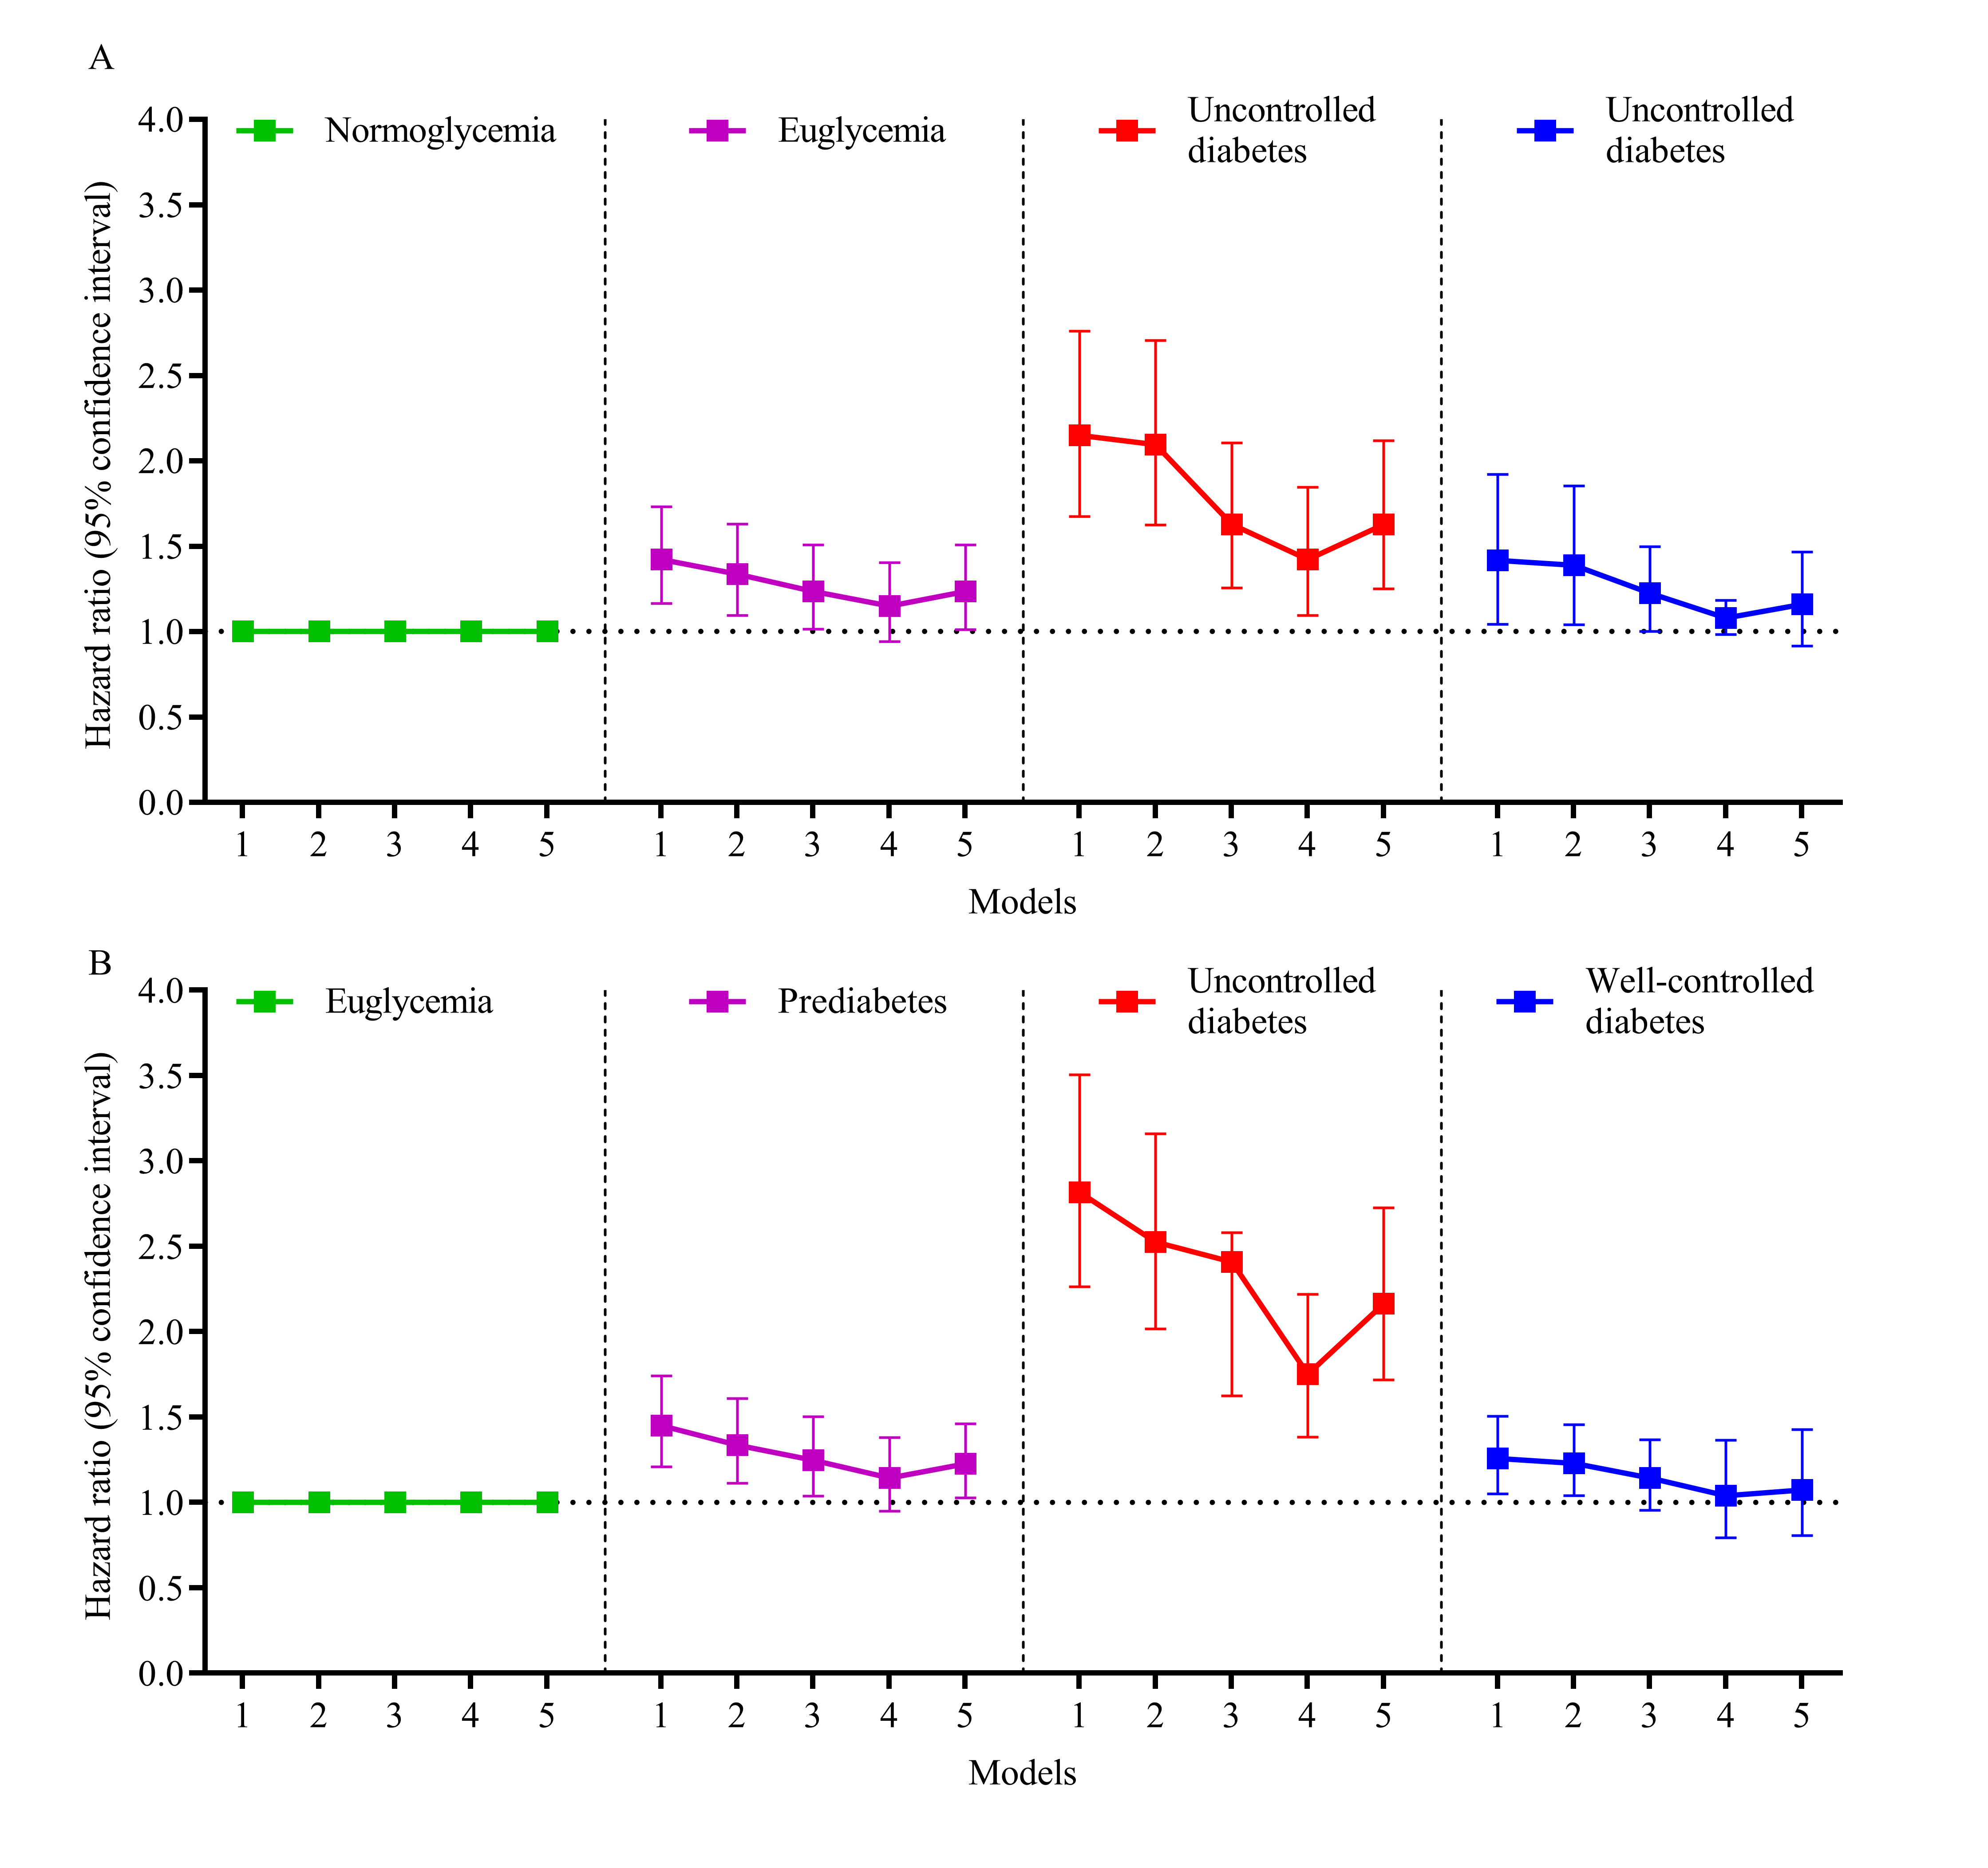
Supplementary Figure 1 Changes in hazard ratio for HF in different adjustment analysis models after participants were stratified by sex. Changes in hazard ratio for HF in (A) male and (B) female participants. Model 1 adjusted for non. Model 2 adjusted for age, smoking status, alcohol consumption, regular physical activity, history of hypertension and dyslipidemia, antihypertensive and lipid-lowering medication use, SBP, DBP, heart rate, plasma lipid level, eGFR level, NT-proBNP level, and hemoglobin level. Model 3 adjusted for confounders in Model 2 plus BMI. Model 4 adjusted for confounders in Model 2 plus WHR. and Model 5 adjusted for confounders in Model 2 plus VFA.

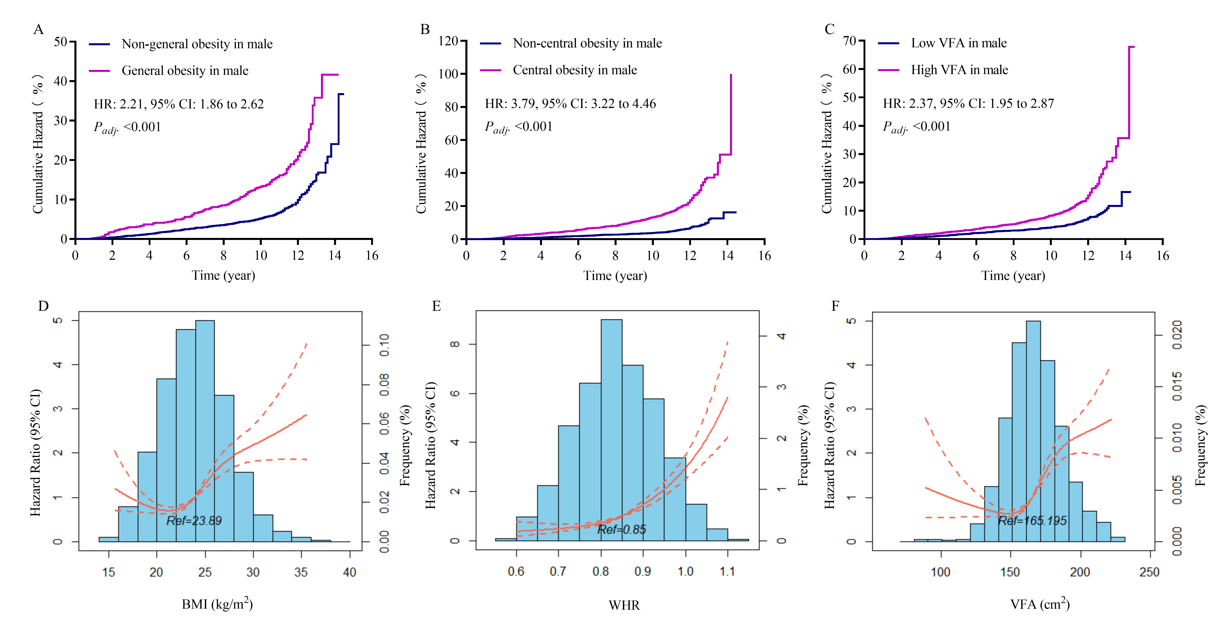
Supplementary Figure 2 Association between body fat distribution and accumulation and HR risk in male participants. Cumulative hazard for HF in participants (A) with and without general obesity, (B) with and without central obesity, and (C) with low and high VFA. The association between (D) BMI, (E) WHR, and (F) VFA and HF risk analyzed using restricted cubic splines. Models are adjusted for age, smoking status, alcohol consumption, regular physical activity, history of hypertension and dyslipidemia, antihypertensive and lipid-lowering medication use, SBP, DBP, heart rate, plasma lipid level, eGFR level, NT-proBNP level, and hemoglobin level. BMI, body mass index; WHR, waist-to-hip circumference ratio; VFA, visceral fat area.

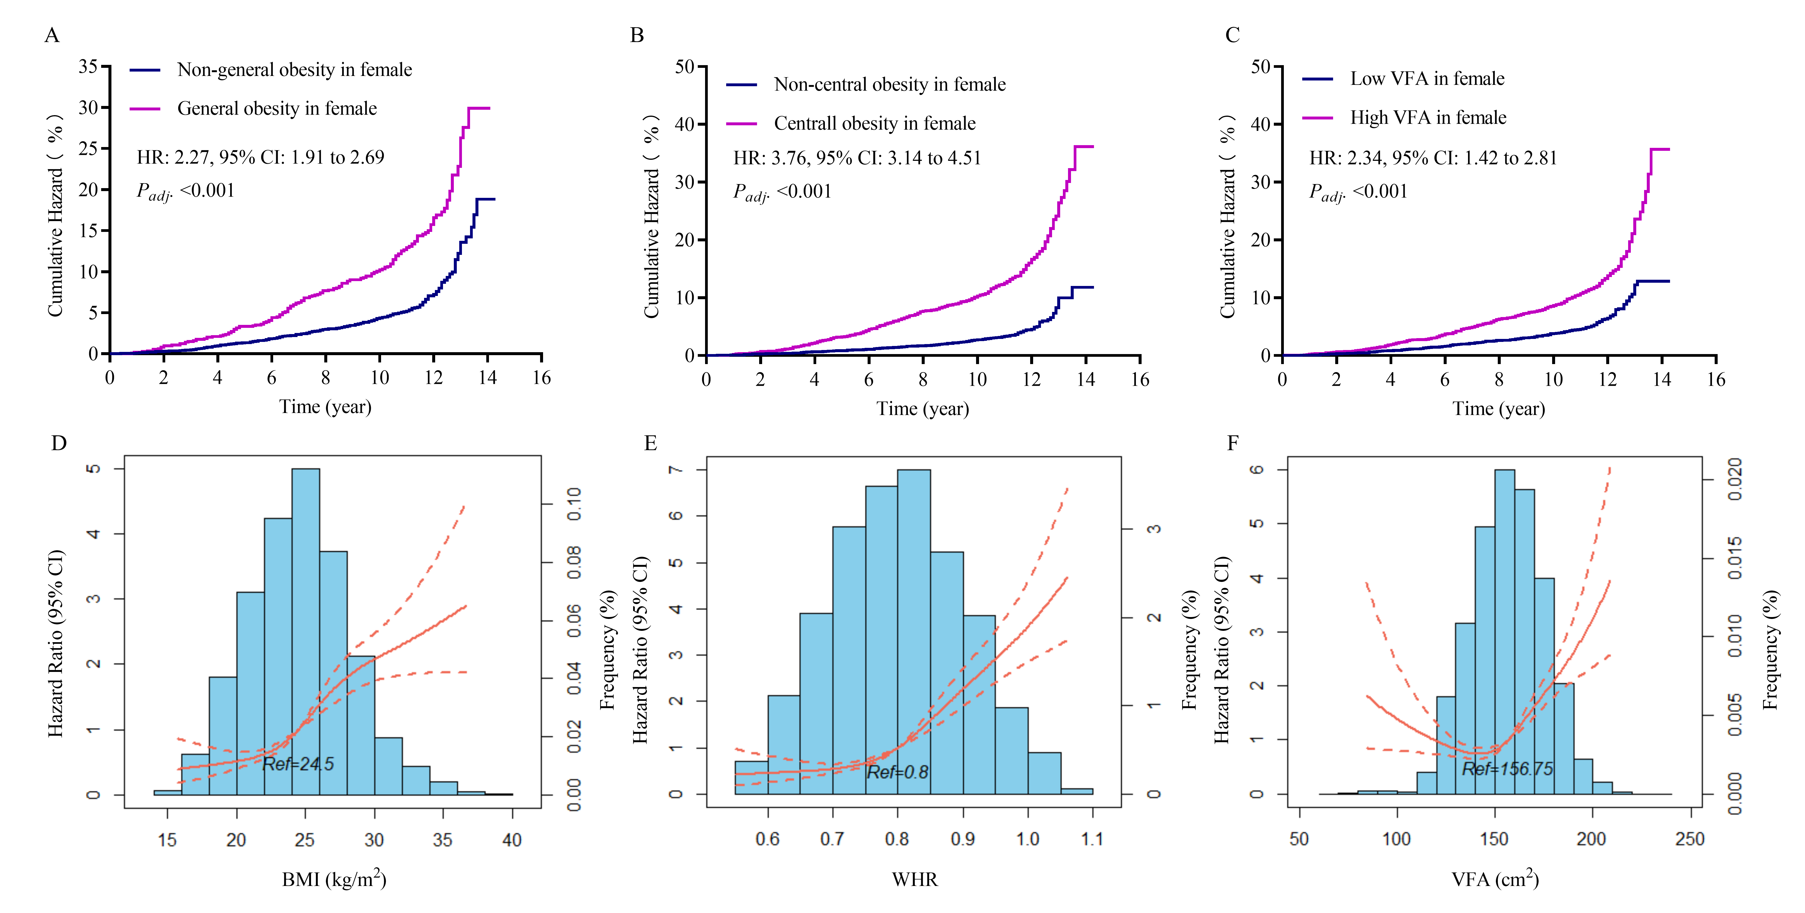
Supplementary Figure 3 Association between body fat distribution and accumulation and HF risk in female participants. Cumulative hazard for HF in participants (A) with and without general obesity, (B) with and without central obesity, and (C) with low and high VFA. The association between (D) BMI, (E) WHR, and (F) VFA and HF risk analyzed using restricted cubic splines. Models were adjusted for age, smoking status, alcohol consumption, regular physical activity, history of hypertension and dyslipidemia, antihypertensive and lipid-lowering medication use, SBP, DBP, heart rate, plasma lipid level, eGFR level, NT-proBNP level, and hemoglobin level. BMI, body mass index; WHR, waist-to-hip circumference ratio; VFA, visceral fat area.

Supplementary Figure 4 Association between metabolic activity and HF risk in female and male participants analyzed using restricted cubic splines. The association between (A) ALR, (B) HOMA-IR, and (C) TyG and HF risk in male participants. The association between (D) ALR, (E) HOMA-IR, and (F) TyG and HF risk in female participants. ALR, adiponectin-to-leptin ratio; HOMA-IR, homeostatic model assessment of insulin resistance; TyG, triglyceride-glucose index.

