Supplementary Figure 4 Comparison of ROC curves and confusion matrices for different machine learning models before and after incorporating PCBs.

Fig. S4a. The comparison of ROC curves and confusion matrices for the SVM model before and after incorporating PCBs.
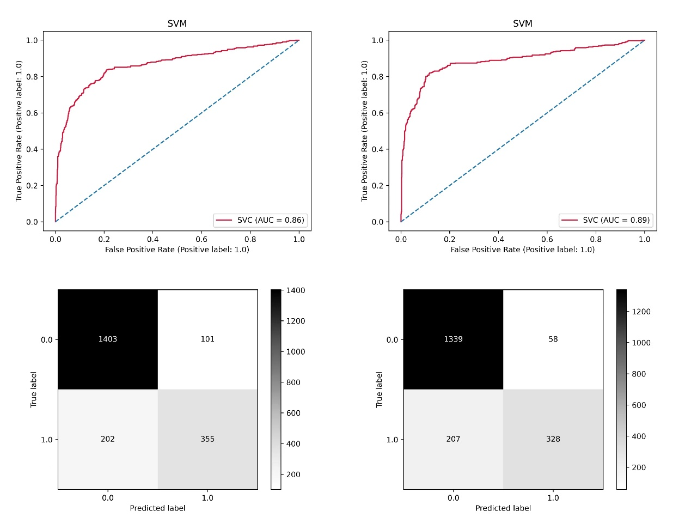

Fig. S4b. The comparison of ROC curves and confusion matrices for the SGD model before and after incorporating PCBs.
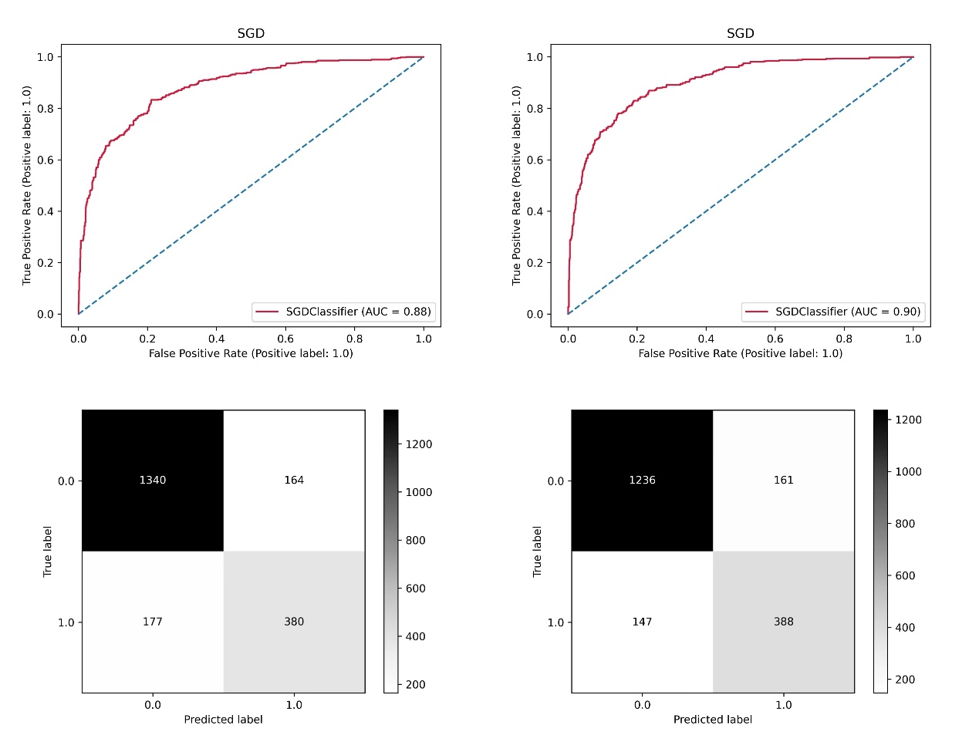
Fig. S4c. The comparison of ROC curves and confusion matrices for the Naïve Bayes model before and after incorporating PCBs.
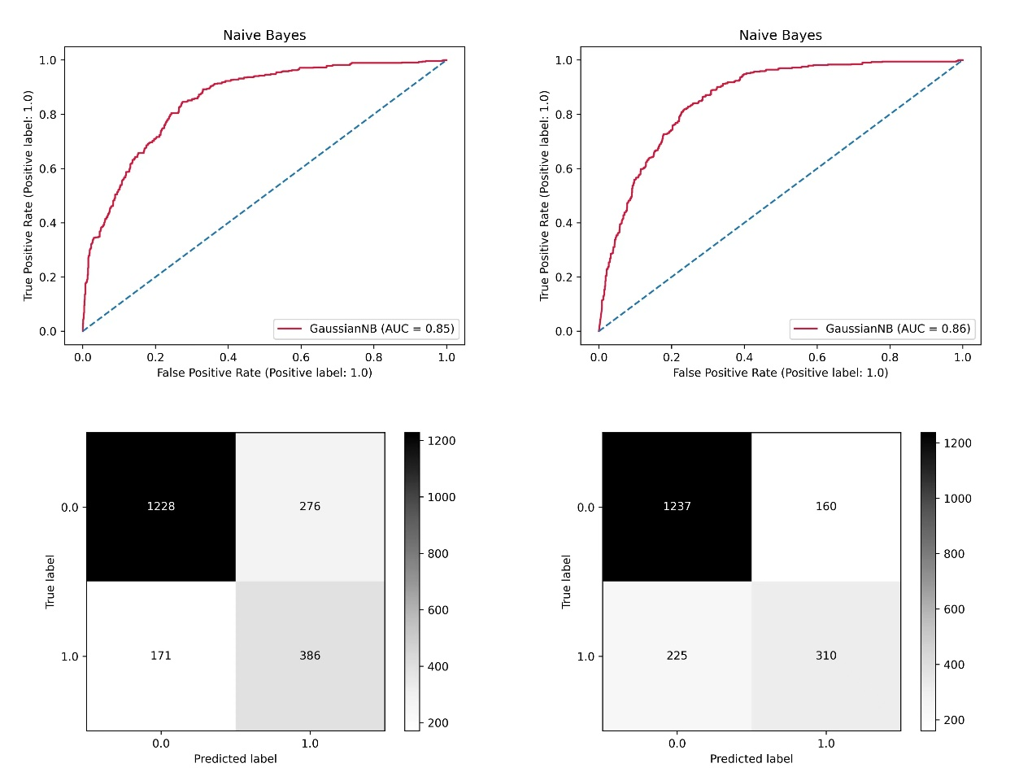
Fig. S4d. The comparison of ROC curves and confusion matrices for the Decision Tree model before and after incorporating PCBs.
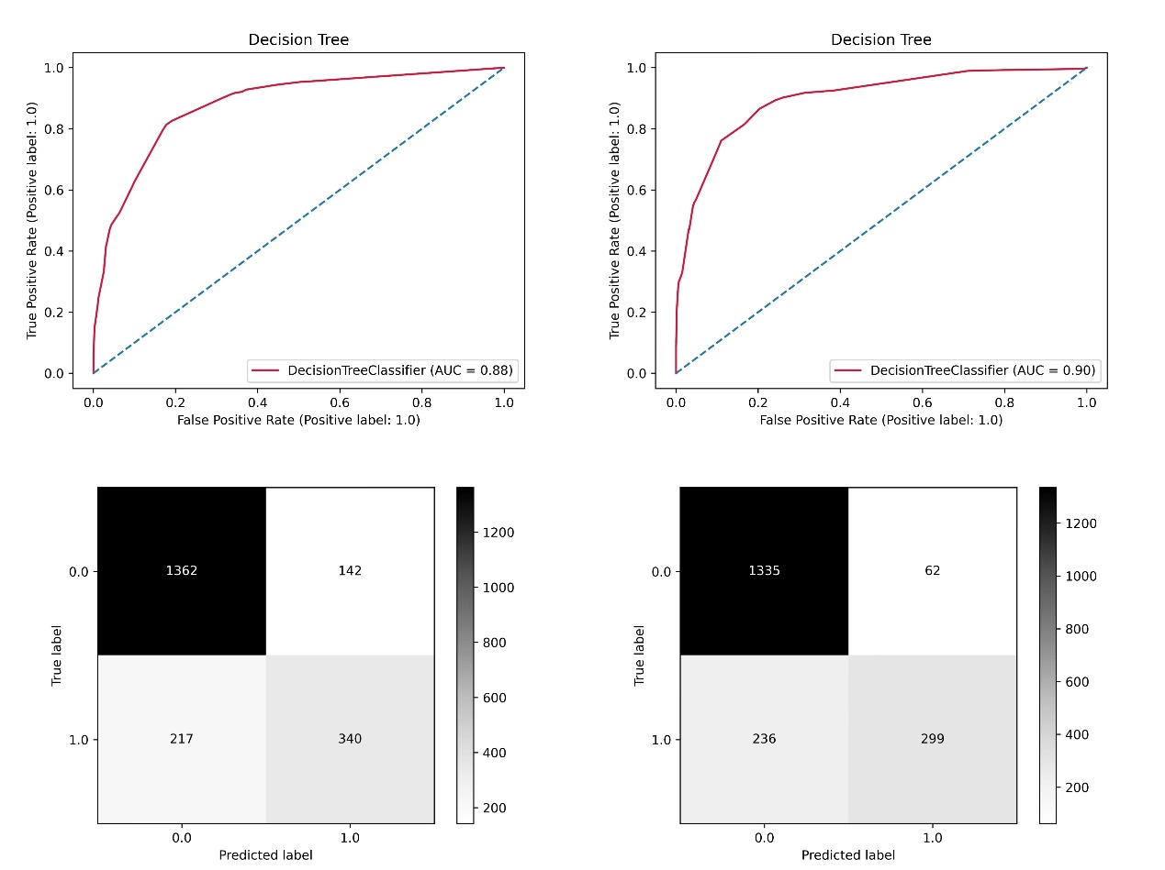
Fig. S4e. The comparison of ROC curves and confusion matrices for the GBDT model before and after incorporating PCBs.
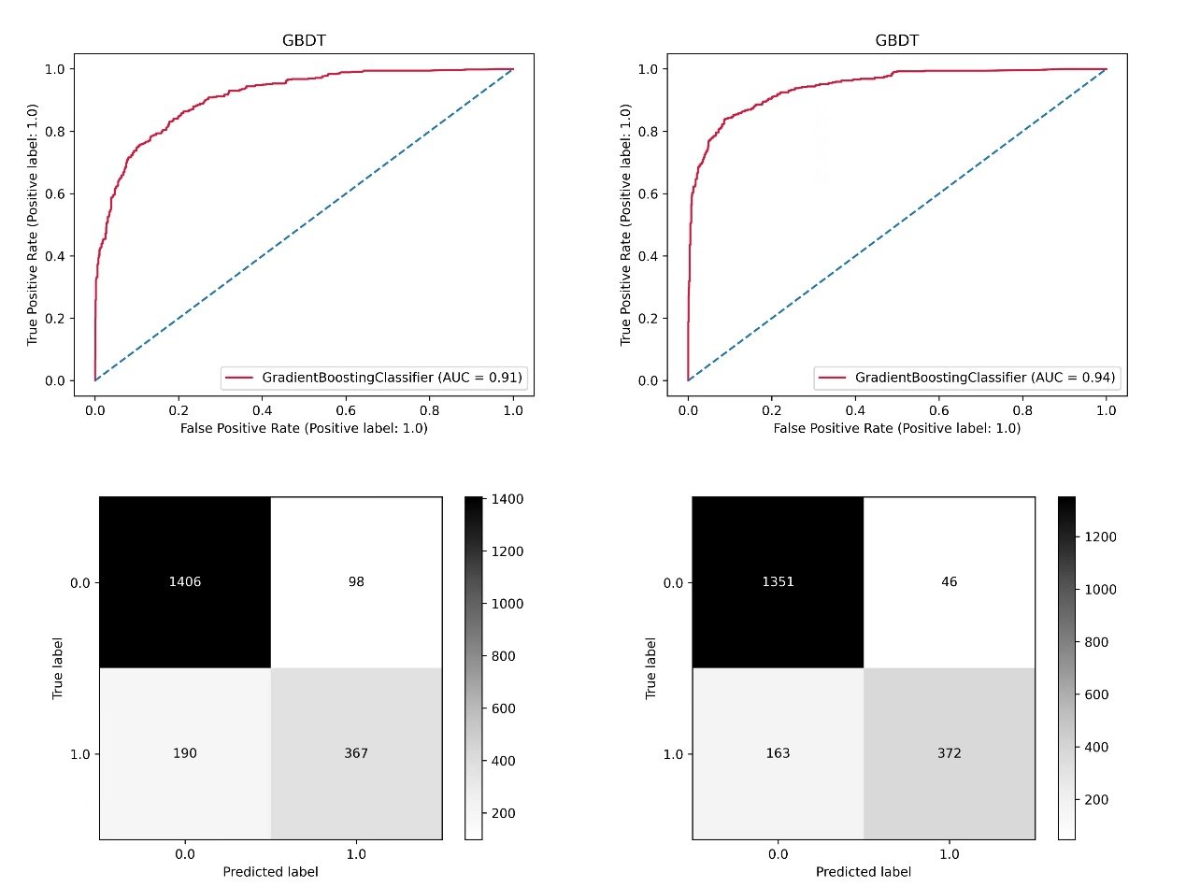
Fig. S4f. The comparison of ROC curves and confusion matrices for the hist GBDT model before and after incorporating PCBs.
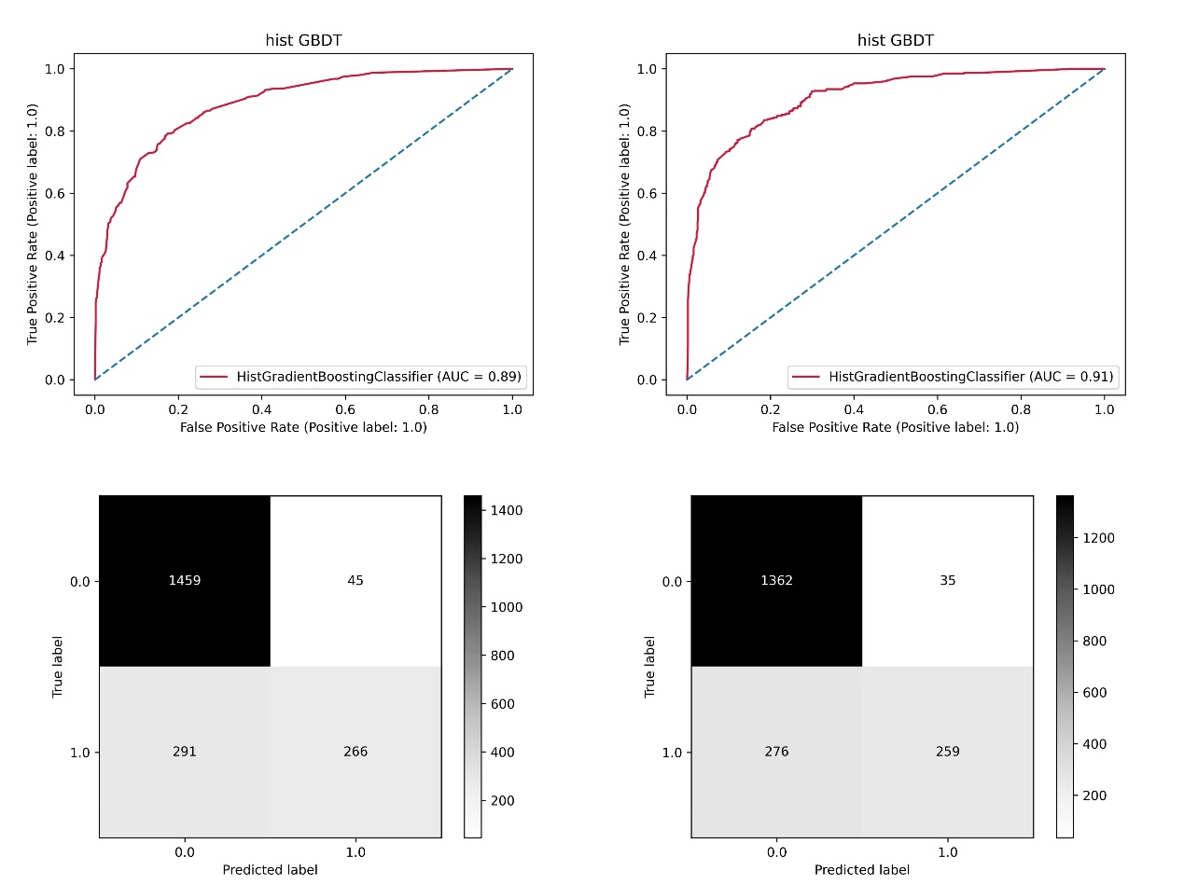
Fig. S4g. The comparison of ROC curves and confusion matrices for the Random Forests model before and after incorporating PCBs.
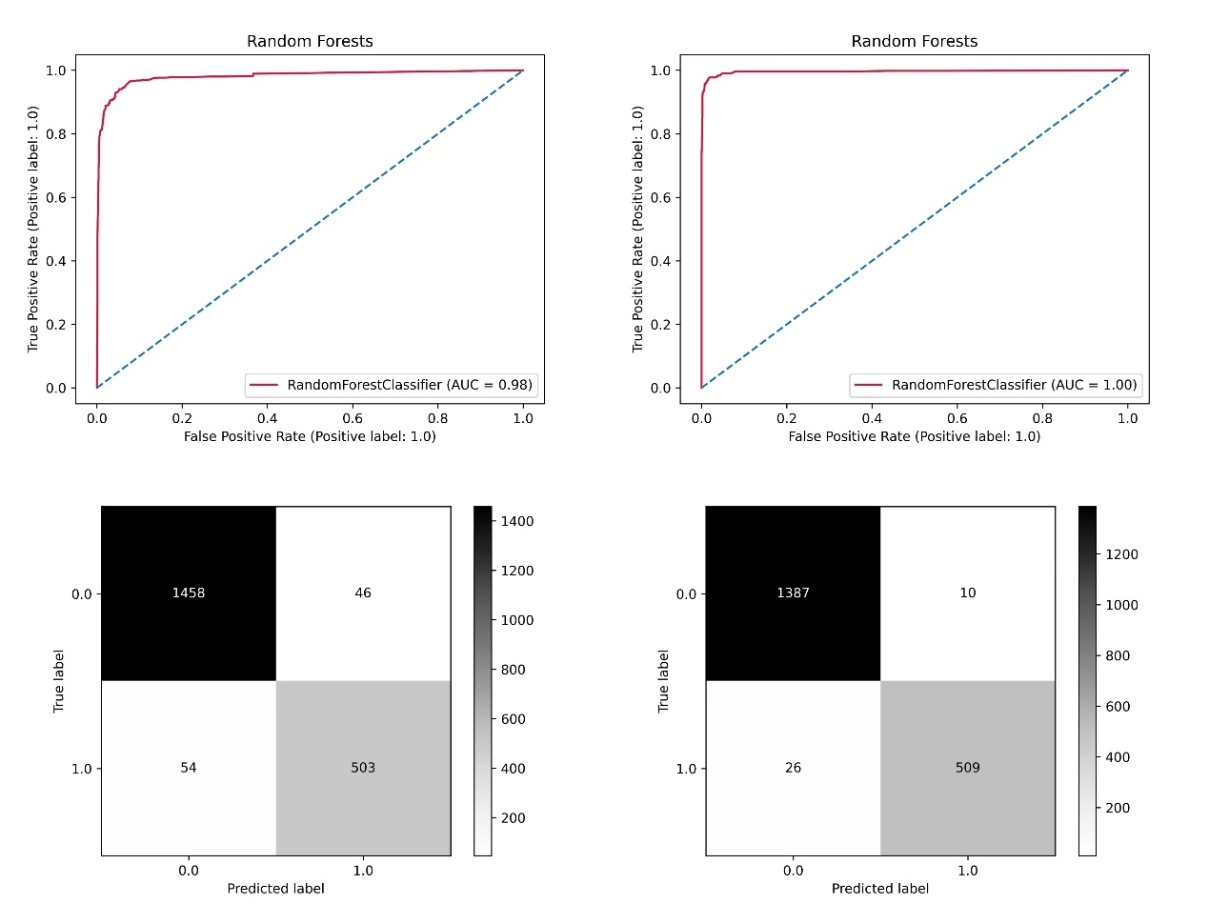
Fig. S4h. The comparison of ROC curves and confusion matrices for the Bagging model before and after incorporating PCBs.
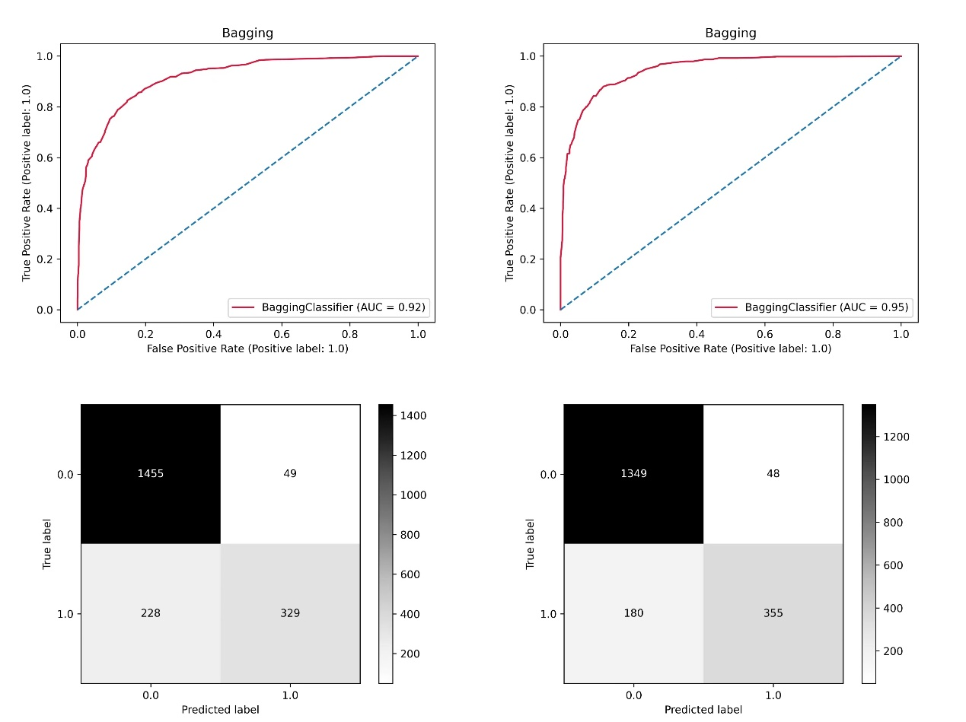
Fig. S4i. The comparison of ROC curves and confusion matrices for the Neural Network model before and after incorporating PCBs.
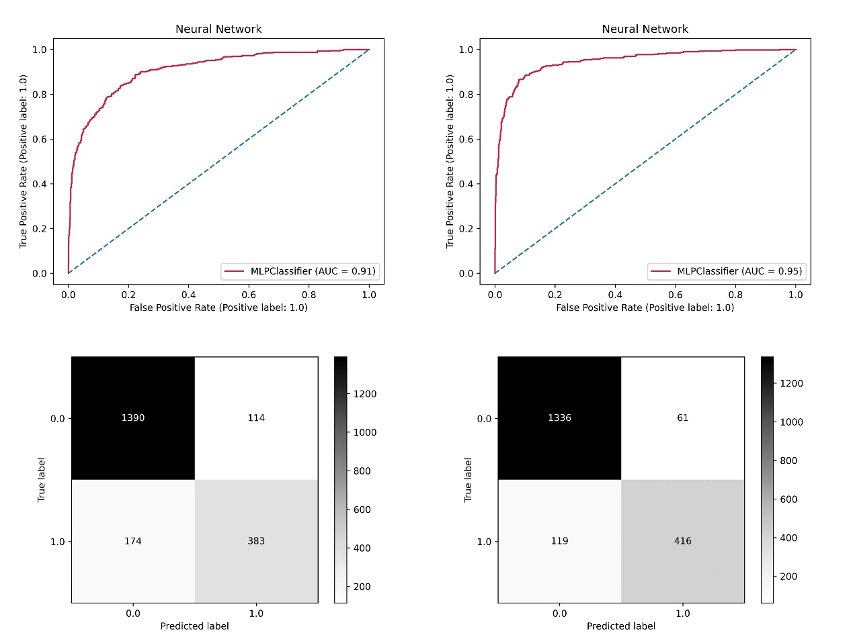
Fig. S4j. The comparison of ROC curves and confusion matrices for the Voting model before and after incorporating PCBs.
