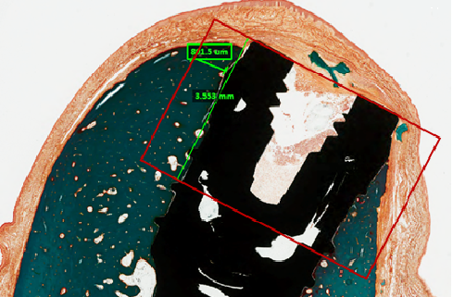
Supplementary Figure 2. The region of interest (ROI) for static histomorphometry was defined by selecting a regular box of 3.55mm height from the implant apex with a diameter of 0.8mm, no offset from the bone surface to the dental implant was selected.

