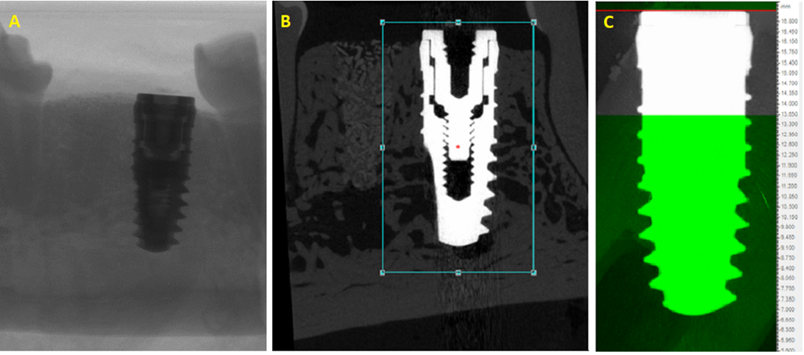
Supplementary Figure 1. MicroCT assessment of bone formation around the defect-implant site. (A) X-ray image, 9µm voxels; (B) Vertical re-alignment of the implant in μCT dataset. (C) Selected ROI (white) based on implant landmarks.

