Electronic Supplementary Material
Effect of Bi₂O₃-B₂O₃ as sintering aid in microstructure and dielectric properties of Fe₂Mo₃O₁₂ electroceramic.
E. V. Araújoª, M. A. S. Silva^{b}, A. S. B. Sombra^{b}, I. F. Vasconcelos^{c}, M. S. Pereira^{c}, P. B. A. Fechine^{a,}*.

a: Grupo de Química de Materiais Avançados (GQMat), Departamento de Química Analítica e Físico-Química, Universidade Federal do Ceará – UFC, Campus do Pici, CP 12100, CEP 60451-970, Fortaleza, CE, Brasil.
b: Laboratório de Telecomunicações e Ciência e Engenharia de Materiais (LOCEM), Departamento de Física, Universidade Federal do Ceará, Brasil.
c: Laboratório de Materiais Avançados, Departamento de Engenharia Metalúrgica e de Materiais, Universidade Federal do Ceará, Brasil.

Figure S1: EDS surface mapping of (a) FMO, (b) FMO-2.5, (c) FMO-5.0 and (d) FMO-7.5.
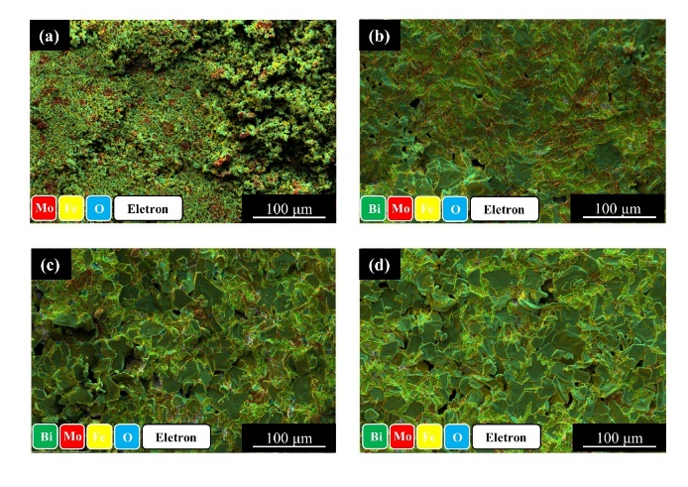

Figure S2: Micrographs of inside the pellet of (a) FMO, (b) FMO-2.5, (c) FMO-5.0 and (d) FMO-7.5.
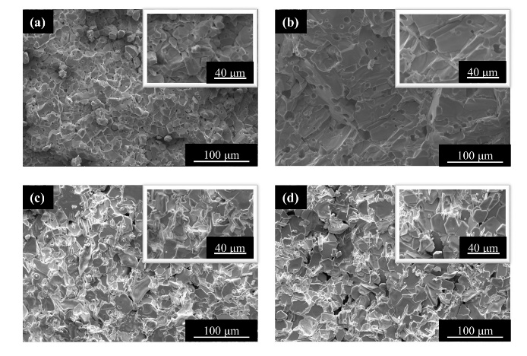

Figure S3: EDS mapping of inside the pellet of (a) FMO, (b) FMO-2.5, (c) FMO-5.0 and (d) FMO-7.5.
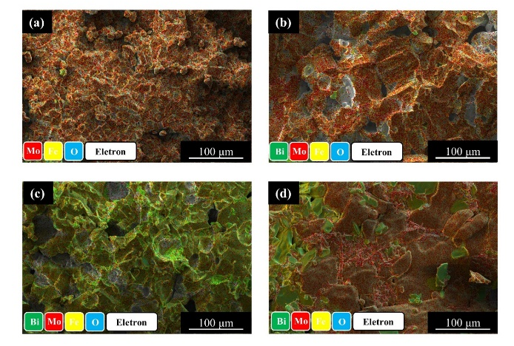

Table S1: Raman modes of Fe₂Mo₃O₁₂ based ceramics.
Raman shift (cm⁻¹) | Raman mode
200-300 | T
300-500 | δ
783 | υ₃
803 | υ₃
822 | υ₃
936 | υ₃
950 | υ₁
968 | υ₁
990 | υ₁

Table S2: Elements concentration in Fe₂Mo₃O₁₂ based ceramics.
Sample |  | Concentration of elements (%)
 |  | Fe | Mo | O | Bi
FMO | Surface | 61.1 | 7.2 | 31.7 | -
FMO | Inside | 16.6 | 43.2 | 40.1 | -
FMO-2.5 | Surface | 37.8 | 13.5 | 35.3 | 13.4
FMO-2.5 | Inside | 18.3 | 44.5 | 37.2 | -
FMO-5.0 | Surface | 40.5 | 11.6 | 35.0 | 12.9
FMO-5.0 | Inside | 16.4 | 41.9 | 38.6 | 3.2
FMO-7.5 | Surface | 45.1 | 9.0 | 34.7 | 11.2
FMO-7.5 | Inside | 21.8 | 38.1 | 40.1 | -

Table S3: Electrical parameters of FMO.
T (°C) | Grain |  |  | Grain boundary |  |  | Electrode effect
T (°C) | R_{g} (Ω) | C_{g} (F) | n_{g} | R_{gb} (Ω) | C_{gb} (F) | n_{gb} | R_{e} (Ω) | C_{e} (F) | n_{e}
224 | 971.24 | 7.83x10⁻¹⁰ | 0.90 | 1,168.10 | 7.23x10⁻⁸ | 0.48 | 220.71 | 2.68x10⁻⁴ | 0.43
228 | 844.17 | 9.13x10⁻¹⁰ | 0.88 | 887.10 | 6.53x10⁻⁷ | 0.35 | 158.79 | 3.47x10⁻⁴ | 0.44
232 | 759.56 | 1.01x10⁻⁹ | 0.88 | 754.87 | 6.92x10⁻⁶ | 0.21 | 113.49 | 4.07x10⁻⁴ | 0.47
236 | 593.10 | 8.94x10⁻¹⁰ | 0.90 | 716.96 | 1.23x10⁻⁵ | 0.18 | 80.89 | 4.76x10⁻⁴ | 0.50
240 | 486.65 | 9.19x10⁻¹⁰ | 0.91 | 660.80 | 1.42x10⁻⁵ | 0.18 | 66.25 | 6.13x10⁻⁴ | 0.49
244 | 377.49 | 8.55x10⁻¹⁰ | 0.95 | 621.55 | 1.31x10⁻⁵ | 0.19 | 54.20 | 6.14x10⁻⁴ | 0.52
248 | 293.47 | 8.37x10⁻¹⁰ | 0.94 | 571.64 | 1.37x10⁻⁵ | 0.19 | 45.75 | 6.96x10⁻⁴ | 0.52
252 | 224.42 | 8.96x10⁻¹⁰ | 0.96 | 520.43 | 1.40x10⁻⁵ | 0.20 | 39.36 | 7.59x10⁻⁴ | 0.52
256 | 169.70 | 7.54x10⁻¹⁰ | 0.98 | 448.48 | 1.42x10⁻⁵ | 0.20 | 32.83 | 8.55x10⁻⁴ | 0.53

Table S4: Electrical parameters of FMO-2.5.
T (°C) | Grain |  |  | Grain boundary |  |  | Electrode effect
T (°C) | R_{g} (Ω) | C_{g} (F) | n_{g} | R_{gb} (Ω) | C_{gb} (F) | n_{gb} |  | R_{e} (Ω)
220 | 3,754.90 | 3.90x10⁻⁹ | 0.74 | 140.88 | 8.03x10⁻⁸ | 0.82 |  | 851.20
228 | 2,026.80 | 3.58x10⁻⁹ | 0.77 | 133.18 | 6.08x10⁻⁵ | 0.58 |  | 638.97
232 | 1,642.00 | 3.28x10⁻⁹ | 0.78 | 154.95 | 1.41x10⁻⁴ | 0.46 |  | 597.37
236 | 1,361.30 | 3.16x10⁻⁹ | 0.79 | 148.78 | 1.88x10⁻⁴ | 0.42 |  | 549.88
240 | 1,113.70 | 3.01x10⁻⁹ | 0.80 | 141.44 | 2.53x10⁻⁴ | 0.38 |  | 504.54
244 | 910.36 | 2.78x10⁻⁹ | 0.82 | 152.02 | 3.45x10⁻⁴ | 0.33 |  | 474.70
248 | 746.95 | 2.78x10⁻⁹ | 0.82 | 131.22 | 3.66x10⁻⁴ | 0.33 |  | 439.33
252 | 605.51 | 2.79x10⁻⁹ | 0.83 | 125.38 | 4.72x10⁻⁴ | 0.30 |  | 402.81
256 | 474.26 | 2.53x10⁻⁹ | 0.85 | 127.42 | 5.54x10⁻⁴ | 0.27 |  | 377.29
260 | 361.78 | 2.39x10⁻⁹ | 0.87 | 137.10 | 7.02x10⁻⁶ | 0.23 |  | 355.69

Table S5: Electrical parameters of FMO-5.0.
T (°C) | Grain |  |  | Grain boundary |  |  | Electrode effect
T (°C) | R_{g} (Ω) | C_{g} (F) | n_{g} | R_{gb} (Ω) | C_{gb} (F) | n_{gb} |  | R_{e} (Ω)
220 | 2,227.40 | 1.09x10⁻⁹ | 0.90 | 1,305.60 | 9.26x10⁻⁹ | 0.69 |  | 531.54
224 | 1,173.40 | 9.85x10⁻¹⁰ | 0.94 | 987.44 | 3.16x10⁻⁹ | 0.79 |  | 522.98
228 | 487.54 | 6.87x10⁻¹⁰ | 0.92 | 1,123.60 | 1.37x10⁻⁹ | 0.91 |  | 488.52
232 | 283.44 | 2.81x10⁻¹⁰ | 0.99 | 1,014.60 | 1.53x10⁻⁹ | 0.89 |  | 447.56
236 | 274.60 | 3.29x10⁻¹⁰ | 0.99 | 802.00 | 1.94x10⁻⁹ | 0.89 |  | 406.80
240 | 262.43 | 3.82x10⁻¹⁰ | 1.00 | 651.75 | 3.42x10⁻⁹ | 0.86 |  | 370.58
244 | 331.16 | 3.78x10⁻¹⁰ | 0.99 | 421.93 | 4.49x10⁻⁹ | 0.87 |  | 347.11
248 | 339.89 | 3.26x10⁻¹⁰ | 1.00 | 280.09 | 1.26x10⁻⁸ | 0.84 |  | 316.31
252 | 359.60 | 3.83x10⁻¹⁰ | 0.99 | 144.30 | 8.69x10⁻⁸ | 0.76 |  | 297.07
256 | 353.59 | 5.17x10⁻¹⁰ | 0.97 | 72.24 | 3.36x10⁻⁶ | 0.59 |  | 267.76
260 | 306.09 | 4.19x10⁻¹⁰ | 0.93 | 65.13 | 5.74x10⁻⁶ | 0.56 |  | 250.05

Table S6: Electrical parameters of FMO-7.5.
T (°C) | Grain |  |  | Grain boundary |  |  | Electrode effect
T (°C) | R_{g} (Ω) | C_{g} (F) | n_{g} | R_{gb} (Ω) | C_{gb} (F) | n_{gb} | R_{e} (Ω)
220 | 14,447.00 | 2.46x10⁻⁹ | 0.76 | 2,651.90 | 1.10x10⁻⁶ | 0.71 | 705.81
224 | 10,819.00 | 1.97x10⁻⁹ | 0.78 | 2,906.70 | 4.57x10⁻⁶ | 0.53 | 583.32
228 | 8,281.50 | 1.28x10⁻⁹ | 0.82 | 5,458.30 | 1.15x10⁻⁵ | 0.27 | 241.43
232 | 7,672.30 | 1.42x10⁻⁹ | 0.82 | 4,431.40 | 1.47x10⁻⁵ | 0.32 | 329.89
236 | 7,072.10 | 1.51x10⁻⁹ | 0.82 | 3,777.90 | 1.27x10⁻⁵ | 0.36 | 319.57
240 | 6,424.60 | 1.62x10⁻⁹ | 0.81 | 3,365.50 | 1.01x10⁻⁵ | 0.39 | 303.97
244 | 5,803.70 | 1.65x10⁻⁹ | 0.81 | 3,141.30 | 9.41x10⁻⁶ | 0.40 | 301.46
252 | 4,487.40 | 1.59x10⁻⁹ | 0.82 | 2,970.60 | 1.07x10⁻⁵ | 0.39 | 224.10
256 | 4,016.60 | 1.62x10⁻⁹ | 0.82 | 2,776.80 | 1.04x10⁻⁵ | 0.39 | 197.40
260 | 3,584.10 | 1.60x10⁻⁹ | 0.83 | 2,683.60 | 1.12x10⁻⁵ | 0.39 | 204.64

