Figure S1. Sequence logo of the different motifs identified in the PheE2F proteins
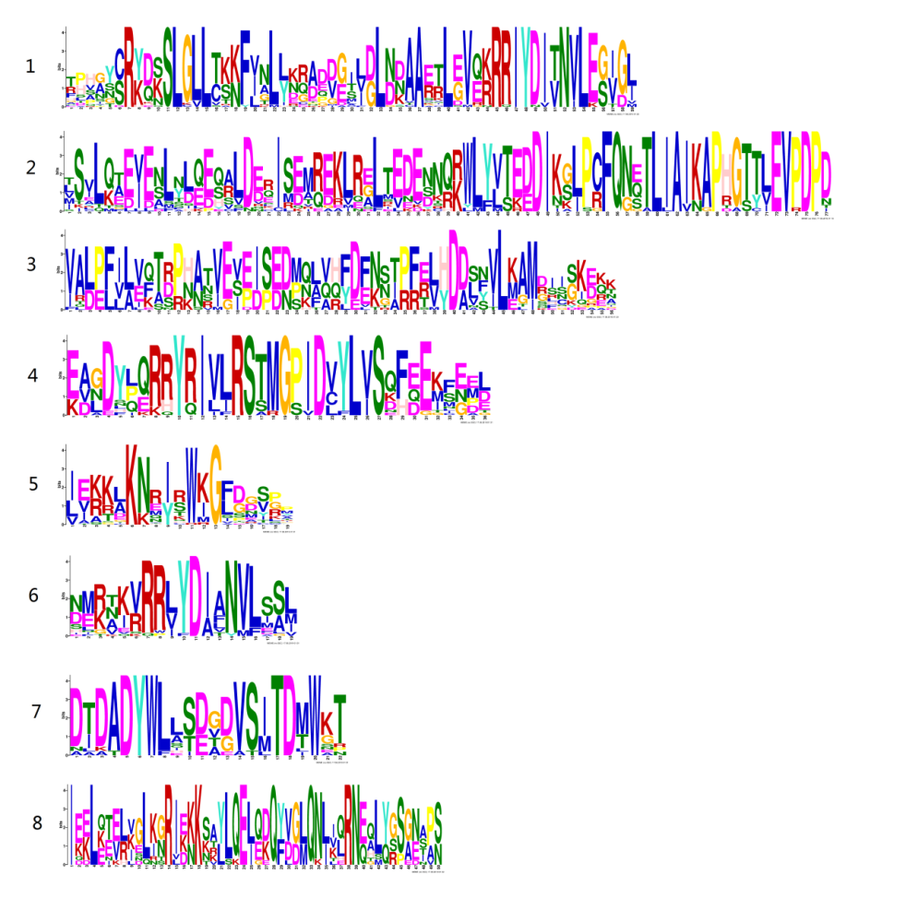
Figure S2. Moso bamboo tissues used for expression analysis. (A) moso bamboo shoot tips in seven growth stages (B) lateral bud, seedling stem and lateral bud samples, (C) seeds and seedlings used for experiment of circadian rhythms and abiotic stress treatment.
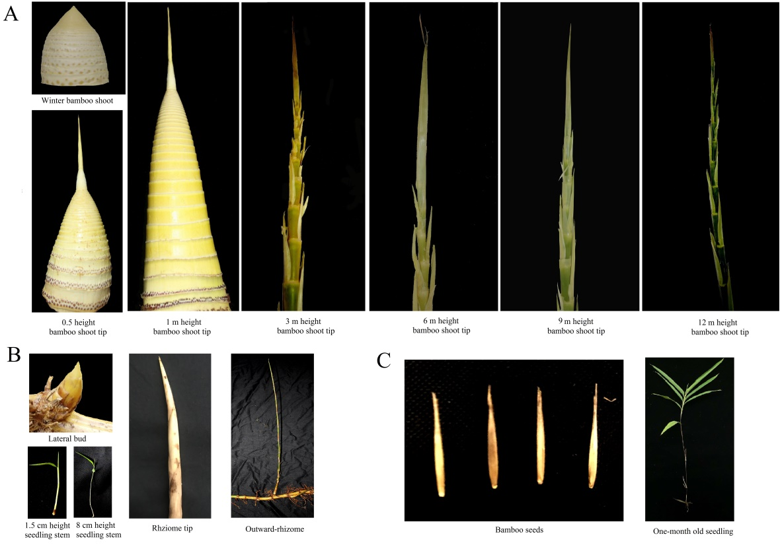
Table S1. Estimated divergence period of E2F/DP gene pairs in four species.
 | ks | ka | ka/ks | Data (million years ago)
PH02Gene41928.t1/PH02Gene30693.t2 | 0.1389 | 0.0366 | 0.263499 | 10.68
PH02Gene43494.t1/PH02Gene07670.t2 | 0.0909 | 0.0358 | 0.393839 | 6.99
PH02Gene34520.t1/PH02Gene43370.t2 | 0.1474 | 0.0371 | 0.251696 | 11.33
PH02Gene09693.t3/PH02Gene31148.t1 | 0.1337 | 0.0472 | 0.353029 | 10.28
PH02Gene39656.t1/PH02Gene26414.t1 | 0.1025 | 0.0319 | 0.31122 | 7.88
PH02Gene03595.t1/PH02Gene10996.t1 | 0.1741 | 0.0987 | 0.566916 | 13.39
PH02Gene34005.t1/PH02Gene20868.t1 | 0.0931 | 0.0463 | 0.497315 | 7.15
PH02Gene01086.t1/PH02Gene05248.t2 | 0.7562 | 0.1525 | 0.201666 | 70.27
AT2G36010.1/AT1G47870.1 | 1.2146 | 0.6697 | 0.551375 | 40.49
AT5G02470.1/AT5G03415.1 | 0.4962 | 0.6477 | 1.30532 | 16.54
AT5G14960.1/AT3G01330.1 | 0.5613 | 0.2787 | 0.496526 | 18.71
Bradi3g45130.1/Bradi5g09640.1 | 0.7207 | 0.2778 | 0.385459 | 55.44
Bradi4g42050.1/Bradi5g01920.1 | 0.6292 | 0.6507 | 1.03417 | 48.4
Bradi1g74890.1/Bradi3g27520.1 | 0.7789 | 0.1864 | 0.239312 | 59.91
Bradi1g44520.1/Bradi3g59740.1 | 0.4232 | 0.4087 | 0.965737 | 32.55
LOC_Os02g33430.1/LOC_Os04g33950.1 | 0.2713 | 0.3032 | 1.117582 | 20.87
LOC_Os12g06200.1/LOC_Os04g02140.1 | 0.7619 | 0.6714 | 0.881218 | 58.61
LOC_Os01g48700.1/LOC_Os03g05760.1 | 1.5446 | 0.9857 | 0.638159 | 11.88
LOC_Os06g13670.1/LOC_Os02g50630.1 | 0.872 | 0.1912 | 0.219266 | 67.07

Table S2. The primer sequences used for qRT-PCR.

Primer names | Primers
PH02Gene01086.t1F | CAAGAGAGCCTTTGGGACTG
PH02Gene01086.t1R | GAGCTCCTGTTTCCTTGCAC
PH02Gene03595.t1F | AGAGCTCAAGCATGCCAAAT
PH02Gene03595.t1R | TCAAGATCGACCCATCACAA
PH02Gene05248.t2F | GCAAGCGGACTCAAGAAAAC
PH02Gene05248.t2R | TGGCTTTGTTCTCTGTCGTG
PH02Gene07670.t2F | GCTACCCCTGACGACTACCA
PH02Gene07670.t2R | GCAGCATCACTTTCTCCACA
PH02Gene07950.t1F | CAGATGACGGAACCCTTGAT
PH02Gene07950.t1R | GTTTGTTCGTGCCCTTCAAT
PH02Gene09693.t3F | AGAGAAACTGCAAGCCCTCA
PH02Gene09693.t3R | GGGACCCATTGAACTTCTCA
PH02Gene10996.t1F | GCAGATGAACTTGTCGCTGA
PH02Gene10996.t1R | CCTACCTTTCAGTCCCACGA
PH02Gene18408.t2F | CTCCAAAGCTGGTGAAGGAG
PH02Gene18408.t2R | TTGGTGGGGGTACAACAACT
PH02Gene20868.t1F | ATGCAGTTGGTGCATTTTGA
PH02Gene20868.t1R | GCAGGTTGTGGTGATTGATG
PH02Gene26414.t1F | TGGAGGAAGTTCGCAAAGAT
PH02Gene26414.t1R | GAAGGCGGATACCATTAGCA
PH02Gene30693.t2F | GGGGTGGTGGTGATATTGAG
PH02Gene30693.t2R | CAACATTTGTCGTCGGTGTC
PH02Gene31148.t1F | CTGCAGCAGGTGGATTATGA
PH02Gene31148.t1R | AGCGAGCCAGTAATCAGCAT
PH02Gene34005.t1F | TGGTACAGCGAAATGAGCAG
PH02Gene34005.t1R | GAGAACCCCATTGCTTTCAA
PH02Gene34267.t1F | ACGTGGAGTCTATCGGGTTG
PH02Gene34267.t1R | CTCTCAATGCCCTCTCCTTG
PH02Gene34520.t1F | GCACAGCTTCGATGAACAAA
PH02Gene34520.t1R | TCATCAGGATCTGGGACCTC
PH02Gene42115.t1F | GGGCTGTAGTTGTGGCAGTT
PH02Gene42115.t1R | TCTCCAAGGAGCAGCTTTGT
PH02Gene43370.t2F | TGCACAGATGGAACCGAATA
PH02Gene43370.t2R | CCTCTGAGGCTGTCTTCCAC
PH02Gene43494.t1F | AGGACGCCCCTAAAAAGAAA
PH02Gene43494.t1R | AGTAGGTGGATTGCCAGGTG
TIP41F | AAAATCATTGTAGGCCATTGTCG
TIP41R | ACTAAATTAAGCCAGCGGGAGTG

Table S3. The primer sequences used for gene cloning.

 | Primer names |  | Primers
PH02Gene26414.t1F |  | GGCCGAATTCCCGGGG ATGCATGCTCCTCTCCAGTCT
PH02Gene26414.t1R |  | GCCGCTGCAGGTCGAC TCAATGAAGGGTGCCCAGG
PH02Gene34005.t1F |  | GGCCGAATTCCCGGGG ATGGTCTCCGGCACCCGTA
PH02Gene34005.t1R |  | GCCGCTGCAGGTCGACTCAATGTTCATGCTTGACACGC
PH02Gene34520.t1F |  | GCAGAGTGGCCATTATGGCCCATGGCGGCGACCGGCGGT
PH02Gene34520.t1R |  | GCGGCCGACATGTTTTTTCCCTCAGCTTATGCAGGTGGGGA

