Assessment of publication bias on efficacy and safety of ACTs in Cameroon

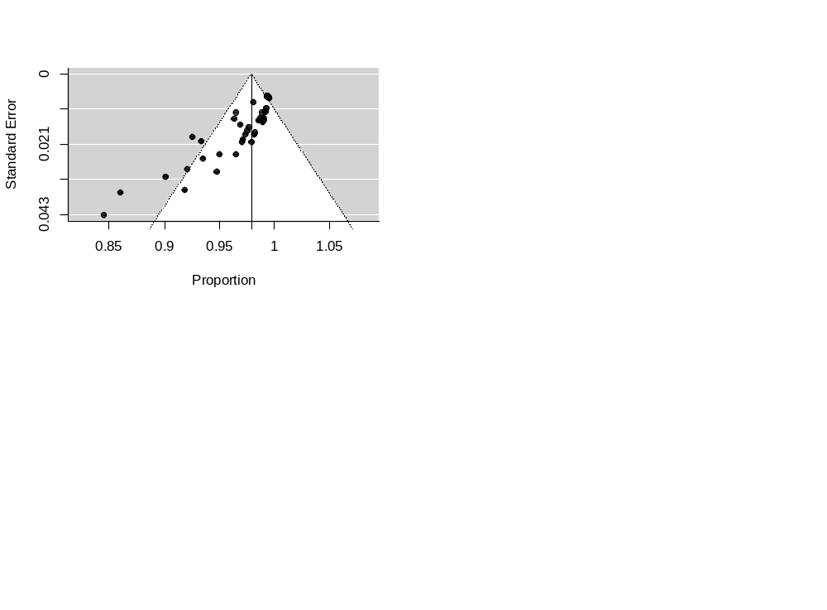
Egger test for funnel plot asymmetry: t = -8.5084, df = 37, P< 0.0001
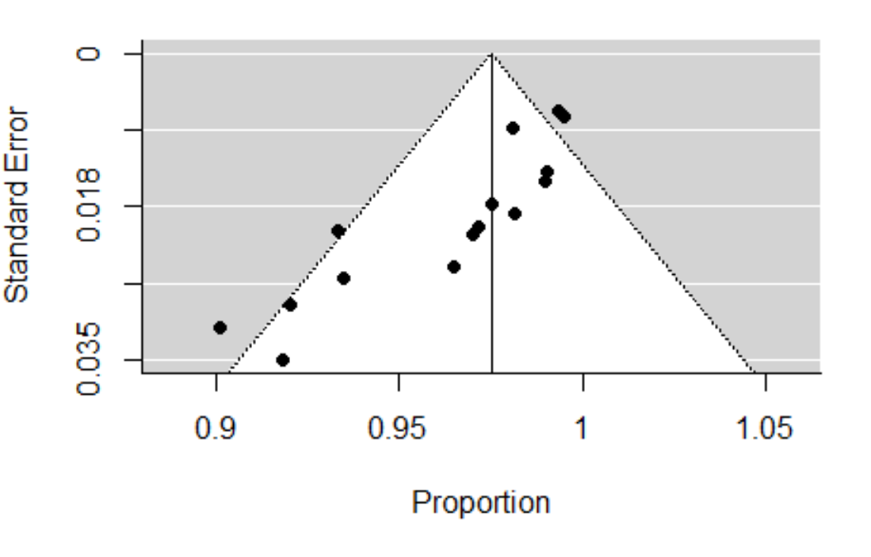
Forest plot to assess publication bias for the pooled efficacy of all ACTs in Cameroon from 2004 to 2020

Egger test for funnel plot asymmetry: t = -6.4024, df = 14, P< 0.0001
Forest plot to assess publication bias for the pooled efficacy of ASAQ in Cameroon from 2004 to 2020
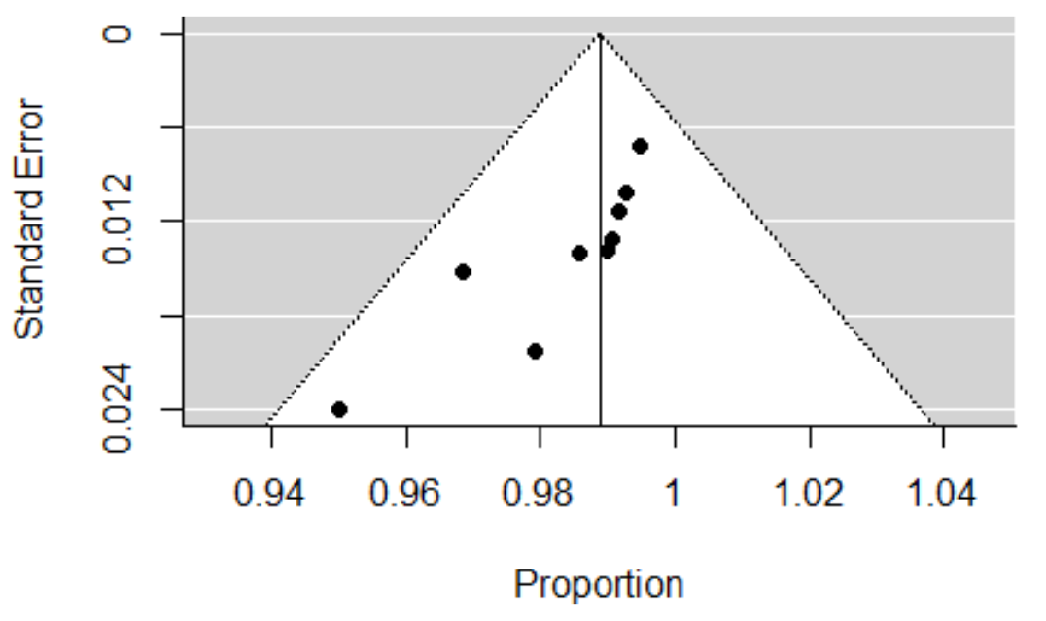
Egger test for funnel plot asymmetry:t = -3.9545, df = 7, P = 0.0055
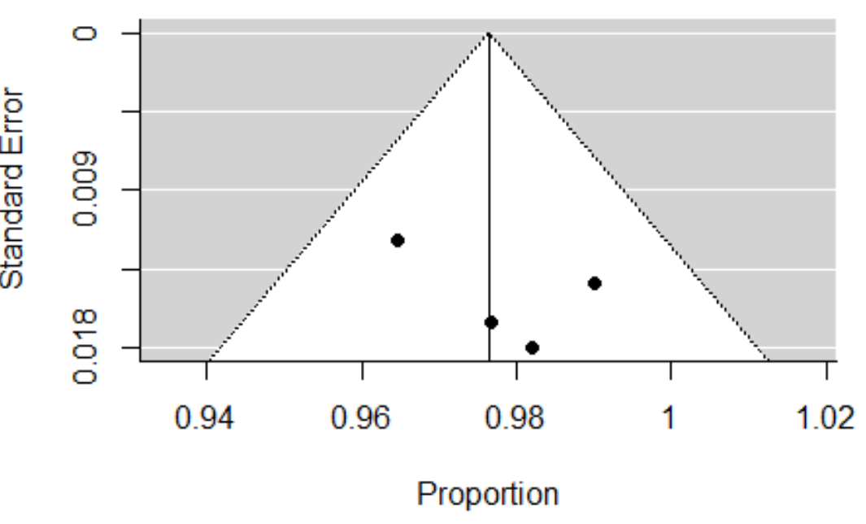
Forest plot to assess publication bias for the aggregated efficacy of AL in Cameroon from 2004 to 2020

Egger test for funnel plot asymmetry: t = 1.0958, df = 2, p = 0.3875
Forest plot to assess publication bias for the aggregated efficacy of DHAP in Cameroon

