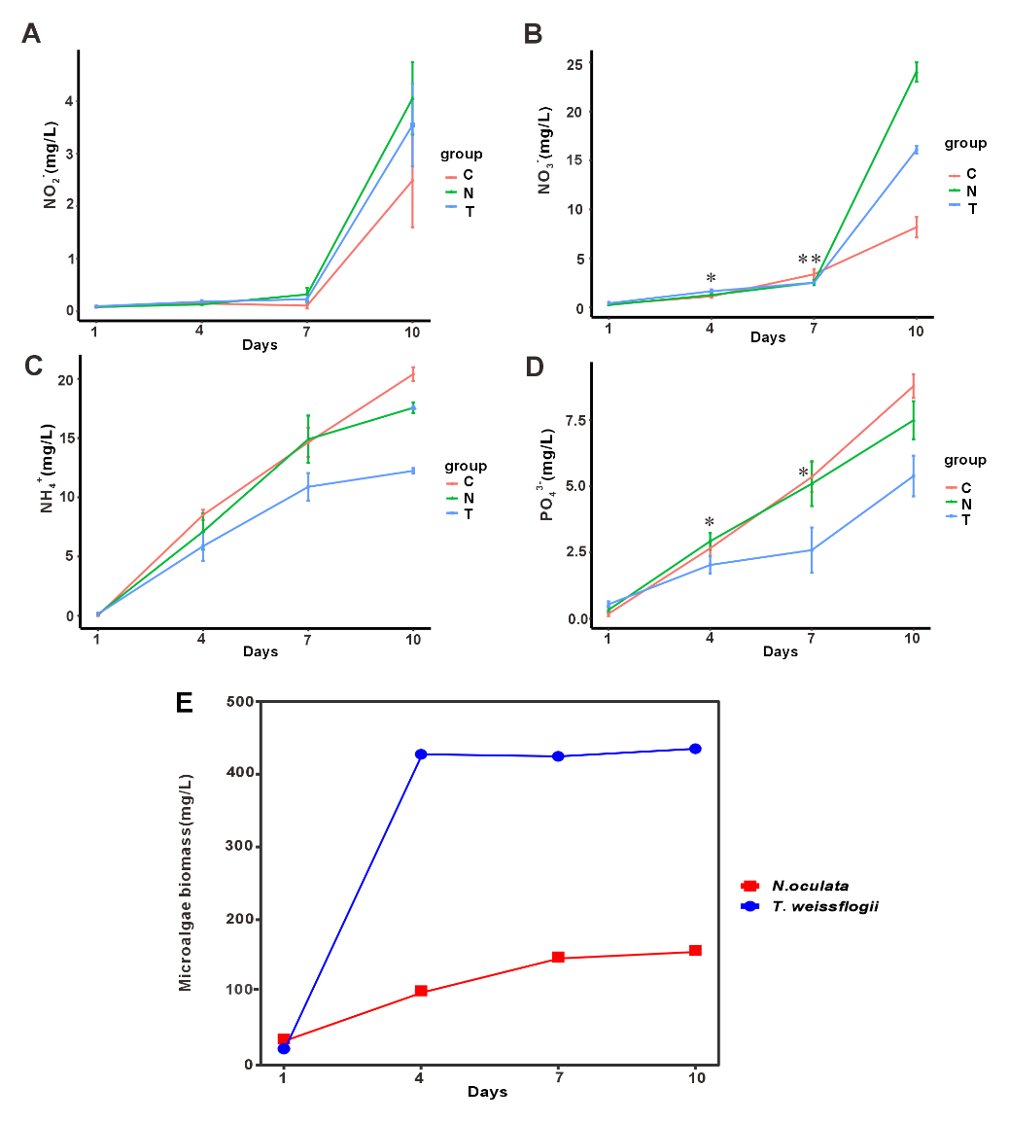
Fig. S1 Changes in nutrient factors (A-D) and microalgal community (E) of rearing water during the rearing period in Groups N (shrimp rearing system cocultivation with N. oculata) and T (shrimp rearing system cocultivation with T. weissflogii) and C (control). Error bars represent standard errors of the means (n = 3). NO₂⁻: nitrite; NO₃⁻: nitrate; NH₄⁺: ammonium; PO₄³⁻: orthophosphate. “*” represent a significant difference among groups at the same day ((*p< 0.05, **p< 0.01, one-way ANOVA). Error bars represent standard errors of the means (n = 3).

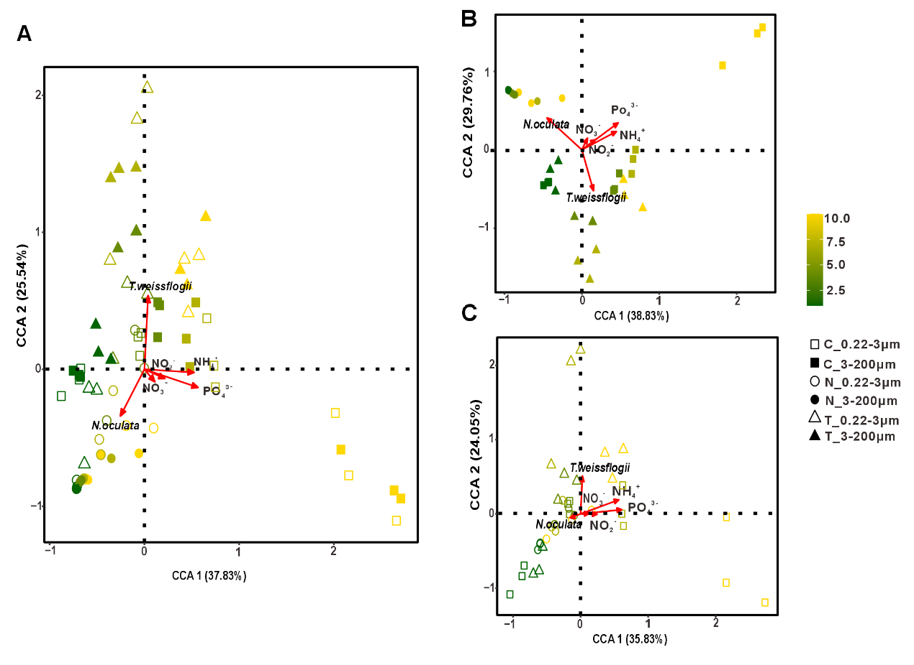
Fig. S2 Canonical correspondence analysis (CCA) between of eukaryotic plankton community structure and environmental factors. (A) total community (B) 3-200 μm community (C) 0.22-3 μm community. NO₂⁻: nitrite; NO₃⁻: nitrate; NH₄⁺: ammonium; PO₄³⁻: orthophosphate.

Table S1 Mantel test for species abundance and environmental factors
 | R² | p | sig

Total community | 0.1563 | 0.008 | sig
3-100 μm | 0.1953 | 0.007 | sig
0.22-3 μm | 0.1044 | 0.097 | nosig

