Supplemental Figures

Supplemental Figure 1

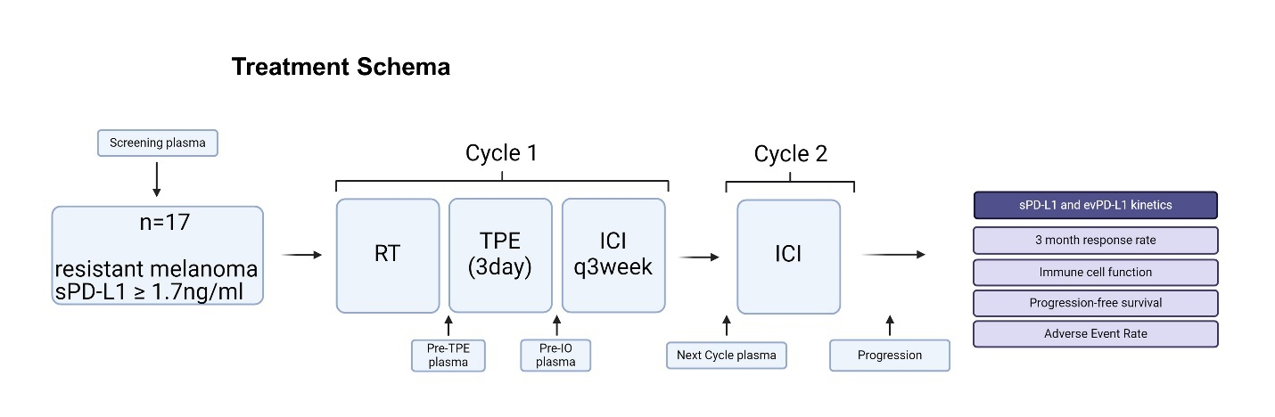
Supplemental Figure 1 – Treatment schema. Eligible patients with ICI-refractory melanoma and sPD-L1 ≥1.7 ng/ml received radiation followed by three sessions of therapeutic plasma exchange (once daily) followed by re-challenge with ICI. RT = radiotherapy, TPE = therapeutic plasma exchange. ICI = Immune checkpoint inhibitor therapy.

Supplemental Figure 2
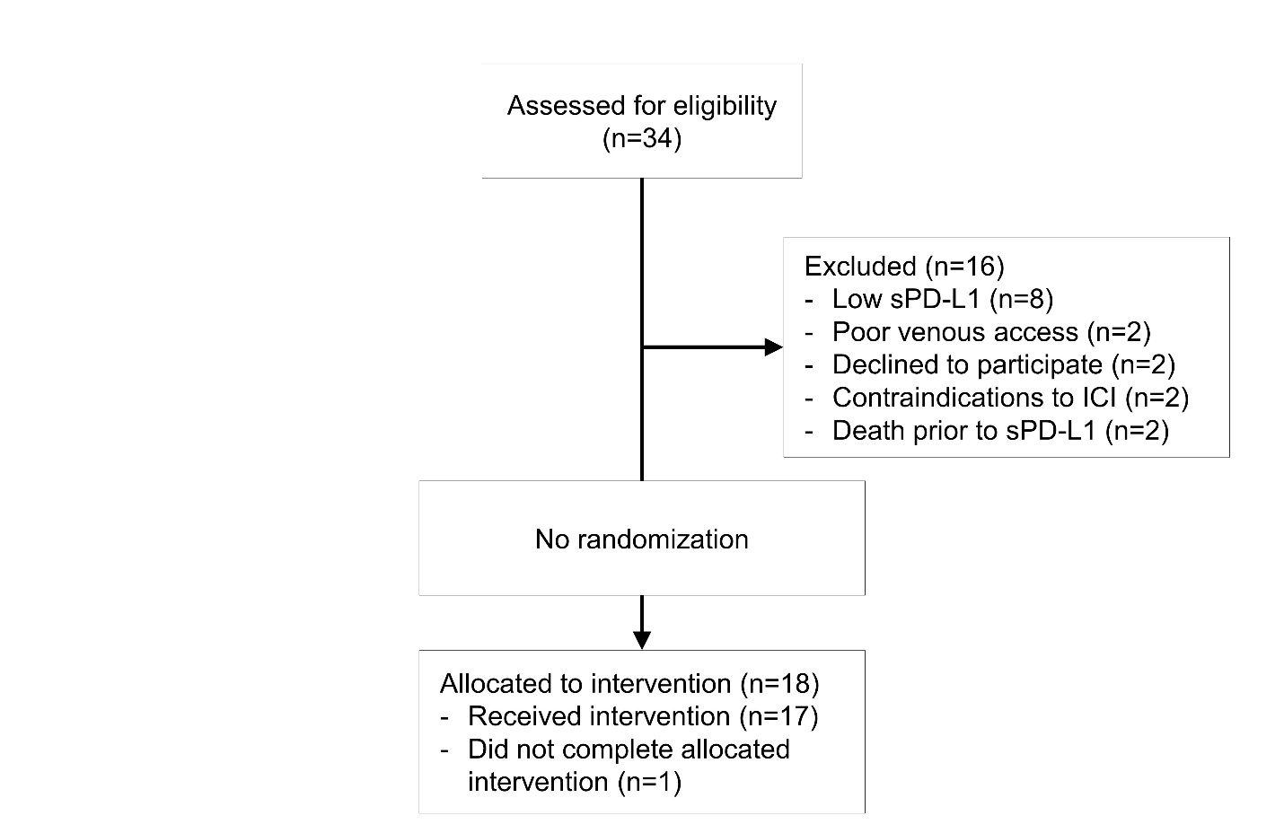
Supplemental Figure 2 – CONSORT diagram. 34 patients were assessed for eligibility and 18 were eligible for intervention. 16 were excluded due to exclusion criteria. 17 of 18 patients who were determined to be eligible completed the intervention (one patient completed only two of three TPE sessions due to grade 4 sepsis but did undergo ICI re-challenge).

Supplemental Figure 3
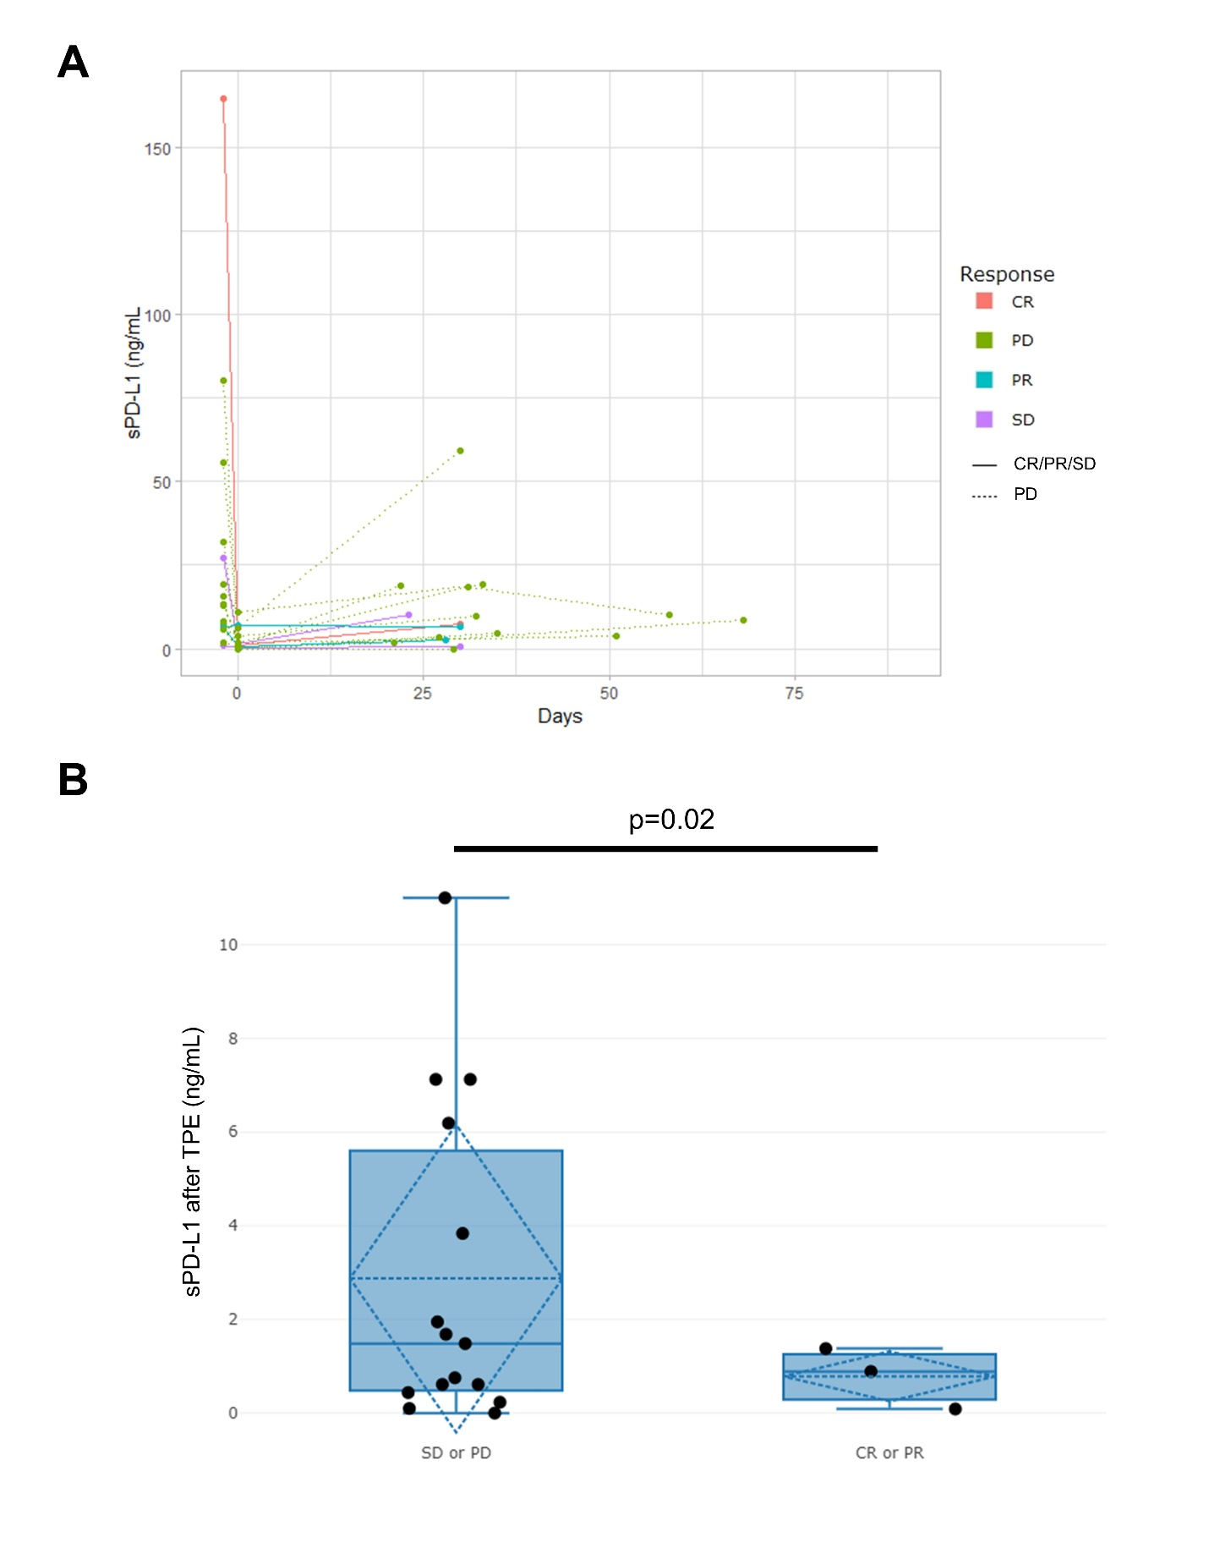
Supplemental Figure 3 – Absolute changes in sPD-L1. (A) Absolute sPD-L1 levels by patient over the course of treatment from day of ICI re-challenge. (B) sPD-L1 levels after TPE by patients experiencing CR/PR versus SD/PD (see also Figure 1A).

Supplemental Figure 4
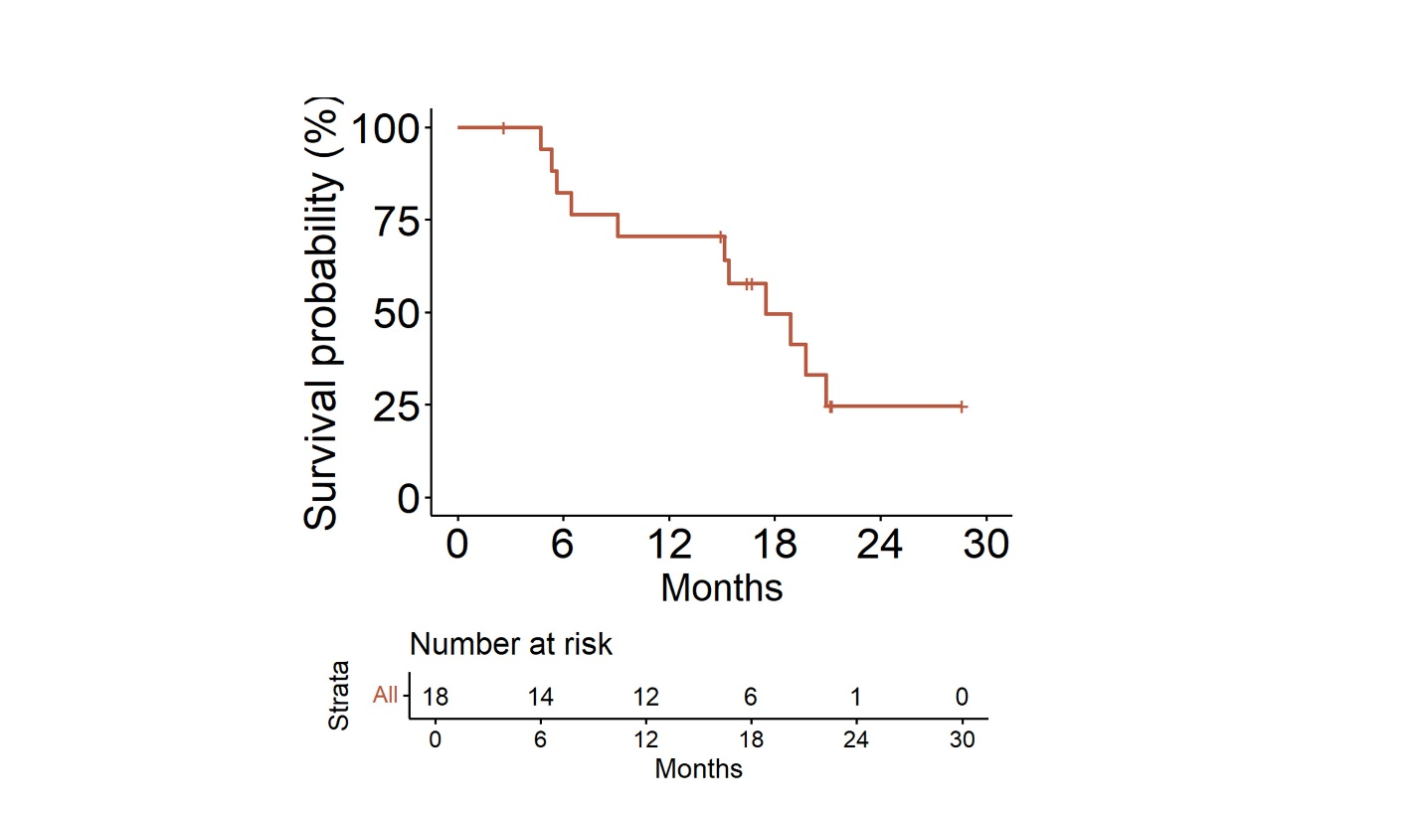
Supplemental Figure 4. Overall survival for the cohort. Median OS was 18.9 months (95% CI 15.1-NR).

Supplemental Figure 5
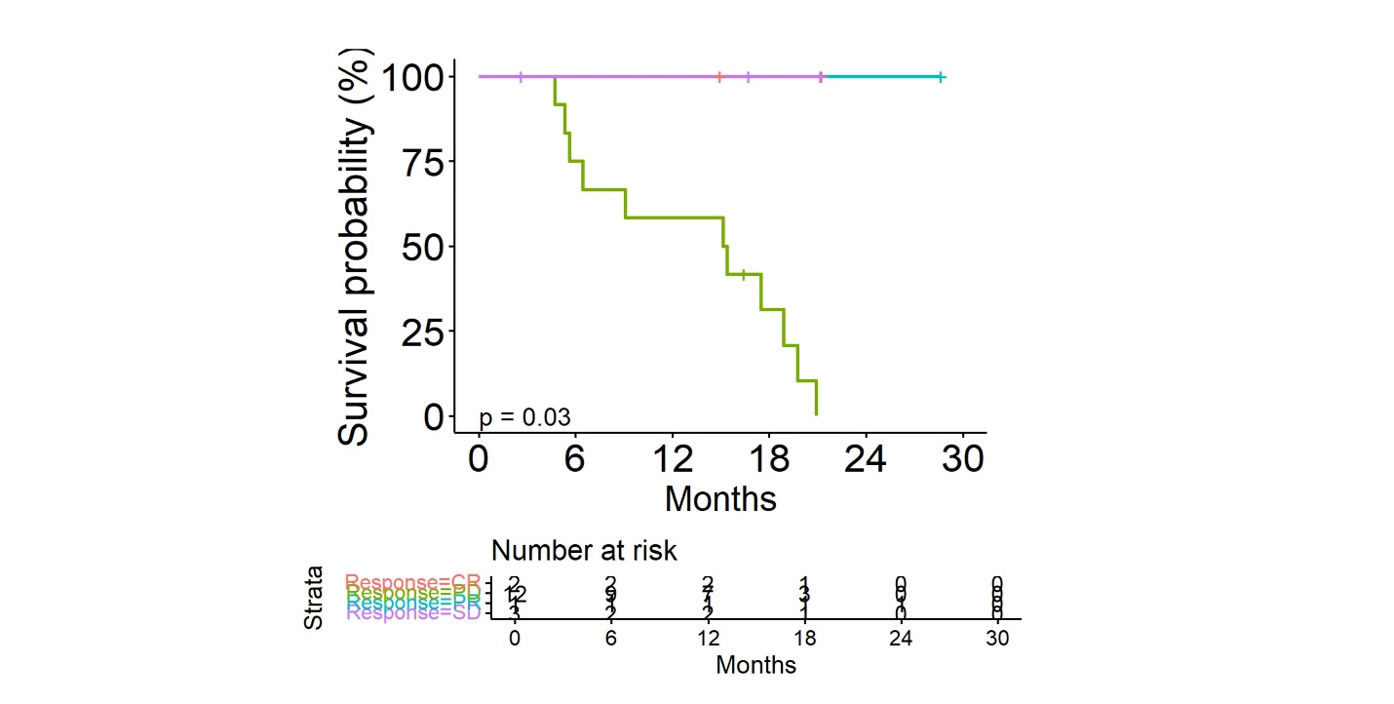
Supplemental Figure 5 – Overall survival by response type. CR = complete response, PD = progressing disease, PR = partial response, SD = stable disease.

Supplemental Figure 6
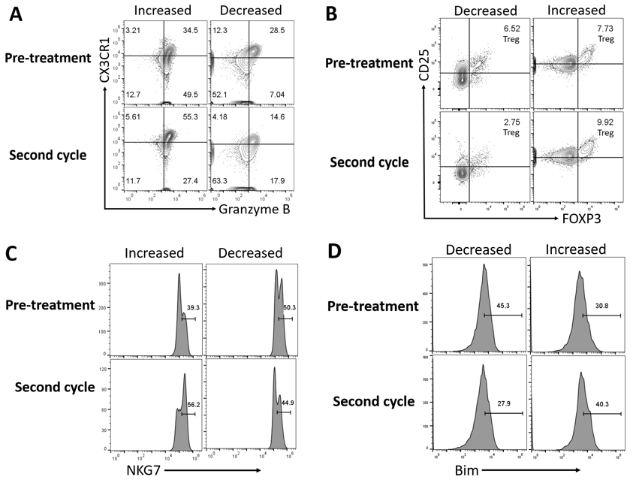

Supplemental Figure 6 – Representative flow cytometry plots. Representative flow cytometry plots showing the changes of peripheral immune cell populations from pre-treatment to the second cycle of ICI re-challenge.

Supplemental Figure 7
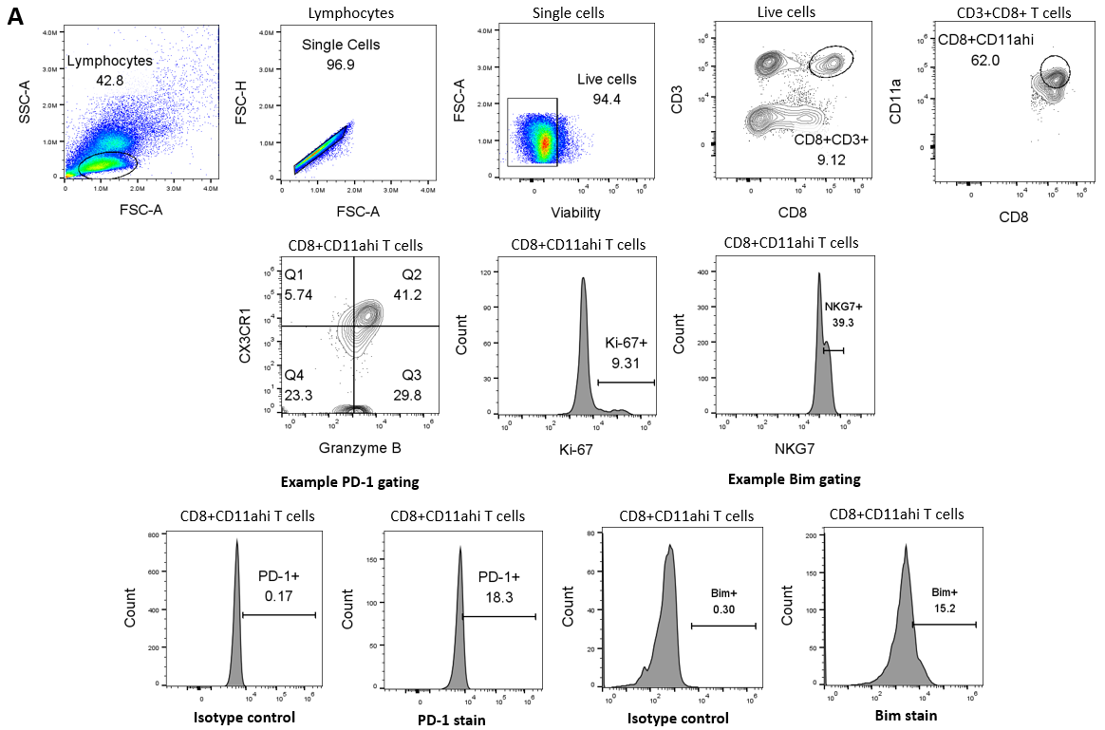
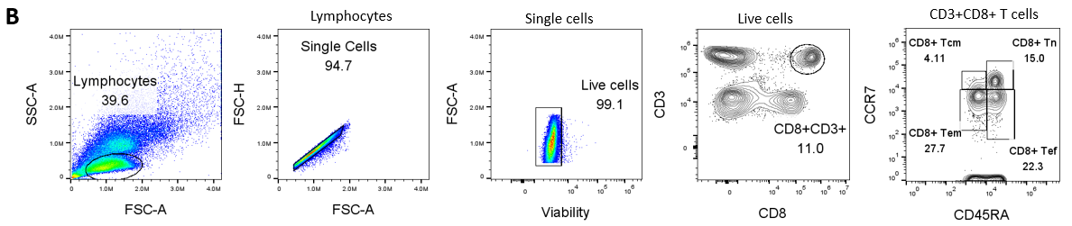
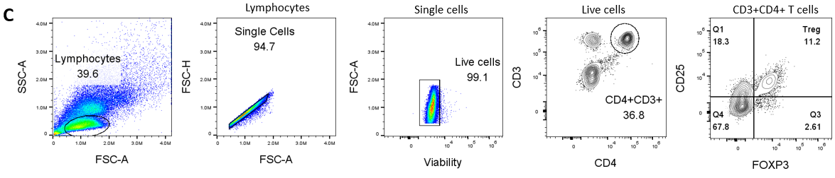
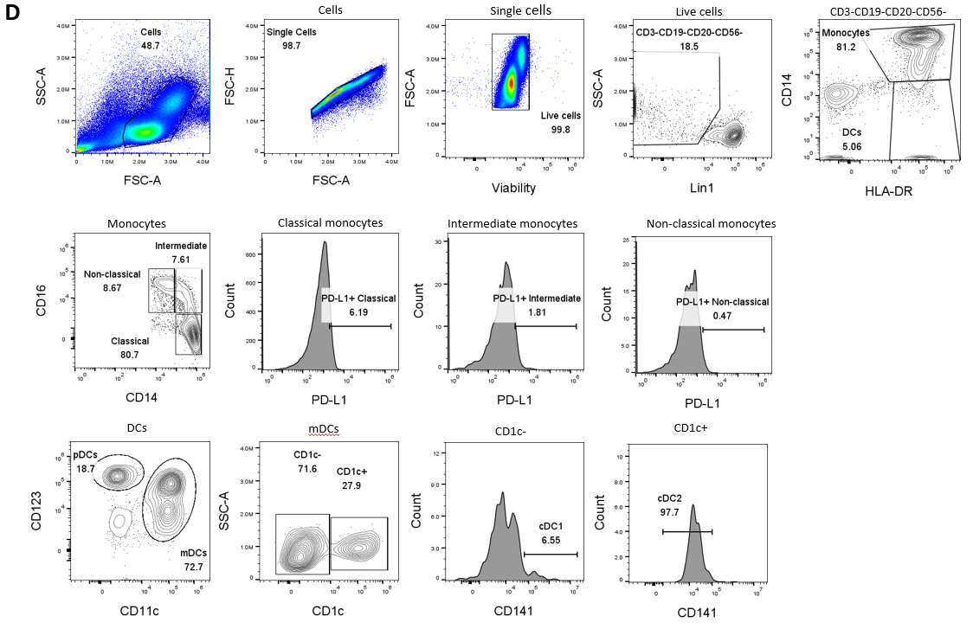
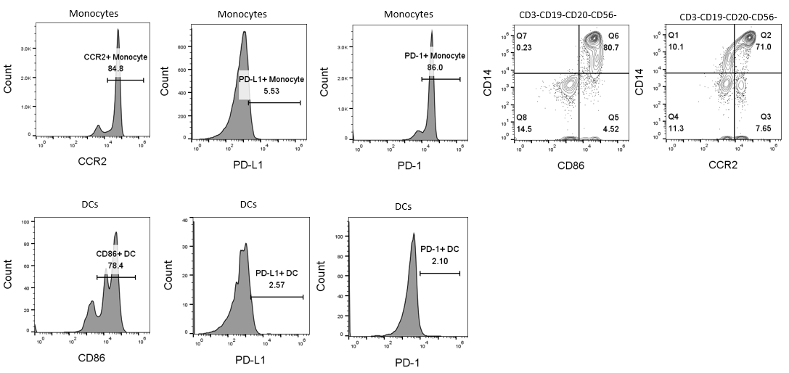
Supplemental Figure 7 – Flow cytometry gating strategies. (A) Flow cytometry gating strategies of tumor reactive (CD8⁺CD11a^{high}) T cell population analysis. (B) Flow cytometry gating strategies of central memory (T_{CM}), effector memory (T_{EM}), effector (T_{EF}), and naïve (T_{N}) T-cells populations. (C) Flow cytometry gating strategies of regulatory T (Treg) cells. (D) Flow cytometry gating strategies of monocytes and dendritic cells (DCs) analysis.

Supplemental Figure 8
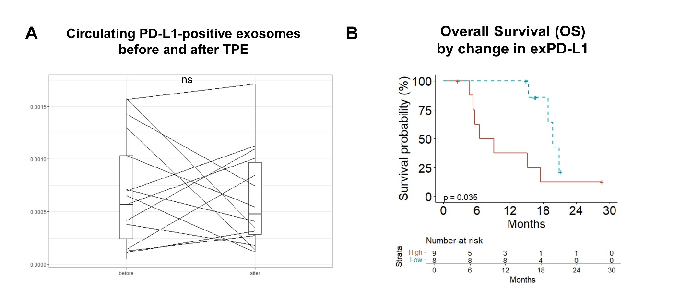
Supplemental Figure 8 – Exosome changes and outcomes. Exosomes did not significantly reduced after TPE. However, improved OS was seen in patients with dramatic reduction in exPD-L1.

Supplemental Tables

Supplemental Table 1
Cell Subtypes | Markers
Treg | CD3+ CD4+ CD25+ FOXP3+
CD8+ T central memory | CD3+ CD8+ CCR7+ CD45RA-
CD8+ T effector | CD3+ CD8+ CCR7- CD45RA+
CD8+ T effector memory | CD3+ CD8+ CCR7- CD45RA-
CD8+ T naive | CD3+ CD8+ CCR7+ CD45RA+
CD8+CD11ahi | CD3+ CD8+ CD11ahi
Bim+/CD8+CD11ahi | CD3+ CD8+ CD11ahi Bim+
Ki-67+/CD8+CD11ahi | CD3+ CD8+ CD11ahi Ki-67+
NKG7+/CD8+CD11ahi | CD3+ CD8+ CD11ahi NKG7+
PD-1+/CD8+CD11ahi | CD3+ CD8+ CD11ahi PD-1+
Granzyme B+ CX3CR1+/CD8+CD11ahi | CD3+ CD8+ CD11ahi Granzyme B+ CX3CR1+
Monocytes | CD3- CD19- CD20- CD56- CD14+ HLA-DR+
DC | CD3- CD19- CD20- CD56- CD14- HLA-DR+
Non-classical monocyte | CD3- CD19- CD20- CD56- HLA-DR+ CD14+ CD16++
Classical monocyte | CD3- CD19- CD20- CD56- HLA-DR+ CD14++ CD16-
Intermediate monocyte | CD3- CD19- CD20- CD56- HLA-DR+ CD14++ CD16+
pDCs | CD3- CD19- CD20- CD56- HLA-DR+ CD14- CD123+ CD11c-
mDCs | CD3- CD19- CD20- CD56- HLA-DR+ CD14- CD123- CD11c+
cDC1 | CD3- CD19- CD20- CD56- HLA-DR+ CD14- CD123- CD11c+ CD141+ CD1c-
cDC2 | CD3- CD19- CD20- CD56- HLA-DR+ CD14- CD123- CD11c+ CD141- CD1c+
PD-L1+ Monocyte | CD3- CD19- CD20- CD56- CD14+ HLA-DR+ PD-L1+
PD-L1+ Classical monocyte | CD3- CD19- CD20- CD56- HLA-DR+ CD14++ CD16- PD-L1+
PD-L1+ Intermediate monocyte | CD3- CD19- CD20- CD56- HLA-DR+ CD14++ CD16+ PD-L1+
PD-L1+ Non-classical monocyte | CD3- CD19- CD20- CD56- HLA-DR+ CD14+ CD16++ PD-L1+
PD-1+ Monocyte | CD3- CD19- CD20- CD56- CD14+ HLA-DR+ PD-1+
PD-1+ DC | CD3- CD19- CD20- CD56- CD14- HLA-DR+ PD-1+
PD-L1+DC | CD3- CD19- CD20- CD56- CD14- HLA-DR+ PD-L1+
CCR2+ Monocyte | CD3- CD19- CD20- CD56- CD14+ HLA-DR+ CCR2+
CCR2+ CD14+ | CD3- CD19- CD20- CD56- CD14+ CCR2+
CD14+ CD86+ | CD3- CD19- CD20- CD56- CD14+ CD86+
CD86+ DC | CD3- CD19- CD20- CD56- CD14- HLA-DR+ CD86+

Supplemental Table 1. Markers used to determine identity of peripheral blood mononuclear cells (PBMC) on flow cytometry.

Supplemental Table 2
Antibody | Vendor | Clone | Catalog no.
CD3 BV750 | Biolegend | SK7 | 344846
CD8 PE/Cy7 | BD Pharmingen | RPA-T8 | 557746
CD11a APC | Biolegend | HI111 | 301212
PD-1 BV605 | Biolegend | EH12.2H7 | 329924
CX3CR1 APC/Cy7 | Biolegend | 2A9-1 | 341616
Granzyme B Percp | Novus Biological | CLB-GB11 | NBP-1-50071PCP
Bim PE | Cell Signaling | C34C5 | 12186S
Ki-67 BV421 | BD Horizon | B56 | 562899
NKG7 | In-house, Fusion Antibodies | 8H3/8K3 | NA
CD3 PE/Cy7 | Biolegend | HIT3a | 300316
CD4 FITC | Biolegend | SK3 | 344604
CD25 BV421 | Biolegend | 2A3 | 302630
CD8 PE | Biolegend | SK1 | 344705
CD45RA PerCP | Biolegend | HI100 | 304156
CCR7 BV785 | Biolegend | G043H7 | 353230
FoxP3 Alexa Fluor 647 | BD Pharmingen | 236A/E7 | 561184
Lin1(CD3, CD19, CD20, CD56) APC | Biolegend | UCHT1; HIB19; 2H7; 5.1H11; | 363601
CD14 BV421 | BD Horizon | MφP9 | 563743
CD16 PerCP | Biolegend | 3G8 | 302030
HLA-DR APC-H7 | BD Pharmingen | G46-6 | 561358
CD11c FITC | BD Pharmingen | B-ly6 | 561355
CD123 PE-Cy | BD Pharmingen | 7G3 | 560826
CD1c PE | BD Pharmingen | F10/21A3 | 564900
CD141 BV650 | BD Horizon | 1A4 | 569392
CCR2 BUV661 | BD OptiBuild | LS132.1D9 | 750472
CD86 PE/Dazzle™ 594 | Biolegend | BU63 | 374218
PD-1 BV785 | Biolegend | EH12.2H7 | 329930
PD-L1 BUV395 | BD OptiBuild | MIH1 | 740320

Supplemental Table 2. Antibodies used to determine identity of peripheral blood mononuclear cells (PBMC) on flow cytometry.

Supplemental Table 3
Population | HR | Cutoff | n above cutoff | p
Treg | 7.87 (95% CI 1.6-38.7) | 1.0255475 | 9 | 0.011
CD8+Tcm | 2.58 (95% CI 0.54-12.43) | 0.5576924 | 14 | 0.238
CD8+Tef | 0.08 (95% CI 0.01-0.64) | 0.9338522 | 9 | 0.018
CD8+Tem | 0.15 (95% CI 0.02-1.16) | 1.1263384 | 5 | 0.069
CD8+Tn | 4.87 (95% CI 0.99-24.03) | 0.8314608 | 10 | 0.052
CD8+CD11ahi | 0.53 (95% CI 0.15-1.82) | 0.9806531 | 9 | 0.313
Bim+/CD8+CD11ahi | 6.8 (95% CI 1.58-29.32) | 0.9903383 | 5 | 0.010
Ki-67+/CD8+CD11ahi | 0.36 (95% CI 0.11-1.2) | 0.9259260 | 12 | 0.097
NKG7+/CD8+CD11ahi | 0.19 (95% CI 0.04-0.88) | 0.8165139 | 14 | 0.034
PD-1+/CD8+CD11ahi | 0.16 (95% CI 0.04-0.65) | 0.2539684 | 14 | 0.010
Granzyme B+ CX3CR1+/CD8+CD11ahi | 0.16 (95% CI 0.03-0.8) | 0.9750001 | 10 | 0.026
Monocytes | 5.56 (95% CI 1.47-21.08) | 1.1140778 | 5 | 0.012
Dendritic Cells | 0.1 (95% CI 0.02-0.48) | 0.7887565 | 9 | 0.004
Non-classical monocyte | 0.04 (95% CI 0.01-0.37) | 0.3729168 | 11 | 0.004
Classical monocyte | 3.98 (95% CI 0.97-16.29) | 1.0330297 | 7 | 0.055
Intermediate monocyte | 0.62 (95% CI 0.18-2.13) | 0.9583334 | 8 | 0.447
pDCs | 3.89 (95% CI 1.12-13.56) | 1.1965813 | 5 | 0.033
mDCs | 0.24 (95% CI 0.05-1.13) | 0.9811067 | 8 | 0.071
cDC1 | 21.96 (95% CI 2.3-209.65) | 1.7485300 | 5 | 0.007
cDC2 | 4.42 (95% CI 1.28-15.25) | 1.4827534 | 7 | 0.019
PD-L1+ Monocyte | 0.49 (95% CI 0.15-1.61) | 0.3780489 | 12 | 0.239
PD-L1+ Classical monocyte | 0.43 (95% CI 0.12-1.48) | 0.3065328 | 13 | 0.180
PD-L1+ Intermediate monocyte | 0.22 (95% CI 0.06-0.82) | 0.2390573 | 14 | 0.024
PD-L1+ Non-classical monocyte | 0.56 (95% CI 0.16-1.93) | 0.2809525 | 8 | 0.358
PD-1+ Monocyte | 271076646.5 (95% CI 0-Inf) | 0.9439463 | 14 | 0.998
PD-1+ DC | 0.41 (95% CI 0.12-1.34) | 0.8671330 | 11 | 0.140
PD-L1+DC | 2.48 (95% CI 0.64-9.67) | 0.7898231 | 11 | 0.191
CCR2+ Monocyte | 8.93 (95% CI 1.1-72.72) | 0.9364225 | 12 | 0.041
CCR2+ CD14+ | 1617426331.71 (95% CI 0-Inf) | 1.0083683 | 12 | 0.999
CD14+ CD86+ | 5.56 (95% CI 1.47-21.08) | 1.1147742 | 5 | 0.012
CD86+ DC | 0.16 (95% CI 0.02-1.26) | 1.0834328 | 5 | 0.081

Supplemental Table 3. Hazard ratios and 95% confidence intervals for death by PBMC subpopulation change from baseline to second cycle of ICI re-challenge. Cox proportional hazards modeling was performed at each predicted cutoff. See Supplemental Table 4 for uniform cutoff of 1.

Supplemental Table 4
Population | HR | Cutoff | n_above_cutoff | p
Treg | 2.89 (95% CI 0.74-11.3) | 1 | 11 | 0.128
CD8+Tcm | 0.94 (95% CI 0.27-3.3) | 1 | 6 | 0.926
CD8+Tef | 0.31 (95% CI 0.08-1.26) | 1 | 7 | 0.102
CD8+Tem | 0.64 (95% CI 0.19-2.18) | 1 | 8 | 0.473
CD8+Tn | 2.38 (95% CI 0.63-9.07) | 1 | 7 | 0.203
CD8+CD11ahi | 0.56 (95% CI 0.15-2.14) | 1 | 7 | 0.401
Bim+/CD8+CD11ahi | 6.8 (95% CI 1.58-29.32) | 1 | 5 | 0.010
Ki-67+/CD8+CD11ahi | 0.46 (95% CI 0.14-1.54) | 1 | 11 | 0.205
NKG7+/CD8+CD11ahi | 0.73 (95% CI 0.21-2.53) | 1 | 7 | 0.625
PD-1+/CD8+CD11ahi | 0.38 (95% CI 0.11-1.33) | 1 | 9 | 0.132
Granzyme B+ CX3CR1+/CD8+CD11ahi | 0.16 (95% CI 0.03-0.8) | 1 | 10 | 0.026
Monocytes | 271076646.5 (95% CI 0-Inf) | 1 | 14 | 0.998
Dendritic Cells | 0.1 (95% CI 0.02-0.48) | 1 | 9 | 0.004
Non-classical monocyte | 0.27 (95% CI 0.03-2.15) | 1 | 4 | 0.218
Classical monocyte | 1.77 (95% CI 0.38-8.27) | 1 | 13 | 0.468
Intermediate monocyte | 0.62 (95% CI 0.18-2.13) | 1 | 8 | 0.447
pDCs | 1.69 (95% CI 0.51-5.62) | 1 | 7 | 0.391
mDCs | 0.33 (95% CI 0.07-1.53) | 1 | 6 | 0.156
cDC1 | 2.42 (95% CI 0.68-8.53) | 1 | 6 | 0.171
cDC2 | 1.99 (95% CI 0.52-7.67) | 1 | 10 | 0.315
PD-L1+ Monocyte | 1.81 (95% CI 0.54-6.11) | 1 | 8 | 0.337
PD-L1+ Classical monocyte | 1.81 (95% CI 0.54-6.11) | 1 | 8 | 0.337
PD-L1+ Intermediate monocyte | 0.83 (95% CI 0.25-2.79) | 1 | 10 | 0.766
PD-L1+ Non-classical monocyte | 0.9 (95% CI 0.26-3.13) | 1 | 7 | 0.865
PD-1+ Monocyte | 3.26 (95% CI 0.7-15.12) | 1 | 11 | 0.132
PD-1+ DC | 0.5 (95% CI 0.15-1.65) | 1 | 10 | 0.253
PD-L1+DC | 1.91 (95% CI 0.55-6.66) | 1 | 10 | 0.311
CCR2+ Monocyte | 4.01 (95% CI 0.98-16.36) | 1 | 9 | 0.053
CCR2+ CD14+ | 988725849.97 (95% CI 0-Inf) | 1 | 13 | 0.999
CD14+ CD86+ | 3.66 (95% CI 0.46-28.86) | 1 | 13 | 0.218
CD86+ DC | 0.38 (95% CI 0.1-1.44) | 1 | 7 | 0.153

Supplemental Table 4. Hazard ratios and 95% confidence intervals for death by PBMC subpopulation increase from baseline to second cycle of ICI re-challenge. Cox proportional hazards modeling was performed at each predicted cutoff. See Supplemental Table 3 for variable cutoff.

Supplemental Table 5
Protein | Baseline | Pre-TPE | Post-TPE | Reduction  pre to post | Next | p pre to post | p post to next
ARG2 | 2.23896 | 1.7276261 | 1.9625188 | 1.176819 | 1.8698333 | 0.016357422 | 0.006713867
CD274 | 0.9055467 | 0.6378652 | 0.796725 | 1.116404 | 0.7554167 | 0.000854492 | 0.000366211
CTLA4 | 0.4528533 | 0.1774652 | 0.6997125 | 1.436191 | -0.36705 | 0.729125977 | 0.248657227
HAVCR2 | 0.64814 | 0.4588696 | 0.7338625 | 1.209988 | 0.9121833 | 0.000244141 | 0.000366211
IL10 | 1.73132 | 1.1187652 | 1.8218875 | 1.628024 | 1.0811833 | 0.005249023 | 0.00402832
IL17A | 1.3841 | 0.6744043 | 1.1957625 | 1.435306 | 1.2359167 | 0.772583008 | 0.016357422
IL2RA | 0.8577333 | 0.7348043 | 1.106475 | 1.29385 | 1.07485 | 0.000366211 | 0.000610352
IL4 | 0.38592 | -0.6035304 | -0.2080937 | 1.315341 | 0.8803333 | 0.682250977 | 0.187866211
LAG3 | 0.5050733 | 0.3454957 | 0.6713313 | 1.25339 | 0.93635 | 0.00012207 | 0.000366211
PDCD1 | 3.44516 | 2.7929783 | 3.8689063 | 2.108078 | 3.6654333 | 0.00012207 | 0.00012207
PECAM1 | 1.78932 | 1.0801391 | 1.4587375 | 1.300078 | 1.63185 | 0.00012207 | 0.000854492
TGFB1 | 1.95928 | 1.5278522 | 1.6858875 | 1.115767 | 2.0308667 | 0.000610352 | 0.005249023
TIGIT | 1.0610867 | 0.8816609 | 1.3208125 | 1.355807 | 1.3390333 | 0.028686523 | 0.010742188
VEGFA | 1.7703133 | 1.4512478 | 1.6490312 | 1.146935 | 1.9131333 | 0.005249023 | 0.169799805
Supplemental Table 5. Changes in peripheral immunologically active molecules during treatment. See also Data File 1.

