Supplementary Material
SM1: Complete list of predictors analysed before inclusion in the model

Table SM1: Sources of prediction and projection variables. * Removed due to high correlation with another variable

Source | Abbreviation | Prediction layer | Projection layer
South African Weather Service | Tmin | Minimum daily temperature (Celsius) | WorldClim monthly 20 year average Tmin
 | Tmax | Maximum daily temperature (Celsius) | WorldClim monthly 20 year average Tmax
 | Tmin_4w | Minimum daily temperature (4 weeks prior) (Celsius) | WorldClim monthly 20 year average Tmin (month prior)
 | Tmax_4w | Maximum daily temperature (4 weeks prior) (Celsius) | WorldClim monthly 20 year average Tmax (month prior)
 | WND | Average daily wind (m/s) | WorldClim monthly 20 year average wind
 | WND_4w | Average daily wind (4 weeks prior) (m/s) | WorldClim monthly 20 year average wind (month prior)
 | PRCP | Average monthly precipitation (mm) | WorldClim monthly 20 year average precipitation
 | PRCP_1m | Average monthly precipitation (1 month prior) (mm) | WorldClim monthly 20 year average precipitation (month prior)
MODIS | NDVI* | NDVI (closest date 15 days) | NA – removed
 | NDVI_1m* | NDVI (closest date 1 month prior) | NA – removed
 | EVI* | EVI (closest date 15 days) | NA – removed
 | EVI_1m* | EVI (closest date 1 month prior) | NA – removed
Copernicus CDS | SM | Soil moisture monthly average (% saturated) | Copernicus monthly soil moisture 20-year aggregated mean
 | SM_1m* | Soil moisture previous monthly average (% saturated) | NA – removed
 | SM_annual | Volume of water in the top 7cm of soil. Annually averaged. | Copernicus annual soil moisture 20-year aggregated mean
 | SM_dry* | Volume of water in the top 7cm of soil. Average of the driest quarter. | NA – removed
 | SM_wet* | Volume of water in the top 7cm of soil. Average of the wettest quarter. | NA – removed
 | SM_warm* | Volume of water in the top 7cm of soil. Average of the warmest quarter. | NA – removed
 | SM_cold* | Volume of water in the top 7cm of soil. Average of the coldest quarter. | NA – removed
 | AR_annual* | Monthly evaporation divided by monthly mean precipitation (m s⁻¹). Annual average. | NA – removed
 | AR_dry | Monthly evaporation divided by monthly mean precipitation (m s⁻¹). Average of the driest quarter. | Copernicus aridity in the driest quarter 20-year aggregated mean
 | AR_wet* | Monthly evaporation divided by monthly mean precipitation (m s⁻¹). Average of the wettest quarter. | NA – removed
 | AR_warm* | Monthly evaporation divided by monthly mean precipitation (m s⁻¹). Average of the warmest quarter. | NA – removed
 | AR_cold* | Monthly evaporation divided by monthly mean precipitation (m s⁻¹). Average of the coldest quarter. | NA – removed
 | FST_month* | Number of days per month with temperature below 0 ºC | Copernicus monthly frost days 20-year aggregated mean
 | FST | Number of days per year with temperature below 0 ºC | Copernicus annual frost days sum 20-year aggregated mean
 | WV | Daily water vapour pressure, aggregated monthly | Copernicus monthly water vapour 20-year aggregated mean
 | DRY* | Number of days per year with <2mm rainfall | NA – removed
 | BIO1* | Yearly mean of the monthly mean temperature. | Copernicus BIO1 20-year aggregated mean
 | BIO2* | Monthly average of the maximum minus the minimum temperature | NA – removed
 | BIO3* | Monthly diurnal range divided by annual range * 100 | NA – removed
 | BIO4* | Standard deviation of the monthly average temperature * 100 | NA – removed
 | BIO5* | Monthly average of maximum temperature in month with the highest temperature | NA – removed
 | BIO6* | Monthly average of minimum temperature in the month with the lowest temperature | Copernicus BIO6 20-year aggregated mean
 | BIO7* | BIO5 minus BIO6 | NA – removed
 | BIO8 | Mean temperature of the wettest quarter | Copernicus BIO8 20-year aggregated mean
 | BIO9* | Mean temperature of the driest quarter | NA – removed
 | BIO10* | Mean temperature of the warmest quarter | NA – removed
 | BIO11* | Mean temperature of the coldest quarter | NA – removed
 | BIO12* | Annual mean precipitation | NA – removed
 | BIO13* | Maximum monthly precipitation. | NA – removed
 | BIO14* | Minimum monthly precipitation | NA – removed
 | BIO15* | Annual coefficient of variation of the monthly precipitation | NA – removed
 | BIO16* | Mean precipitation of the wettest quarter | NA – removed
 | BIO17* | Mean precipitation of the driest quarter | NA – removed
 | BIO18* | Mean precipitation of the warmest quarter | NA – removed
 | BIO19* | Mean precipitation of the coldest quarter | NA – removed
WCDoA | CTL | Cattle distribution (2020-2023 average) | Same as prediction layer
 | SHP | Sheep distribution (2020-2023 average) | Same as prediction layer
 | ENPAT* | Soil type (by description) | Same as prediction layer
SAEHP | HRS* | Horse distribution (2002 census) | NA – removed
DFFE | NLC* | National land cover (simplified categories) | NA – removed
WorldClim | DEM | Digital elevation model | Same as prediction layer

SM2: Q-Q plots

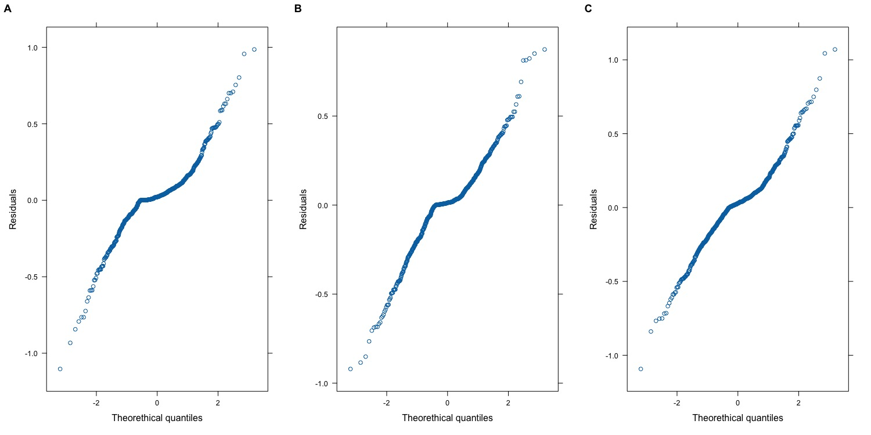
Figure SM2 Q-Q plots analysing the distribution of the residuals of each model. A = C. imicola, B = C. bolitinos, C = Grouped competent AHS/BT vector

SM3: Interpolation maps

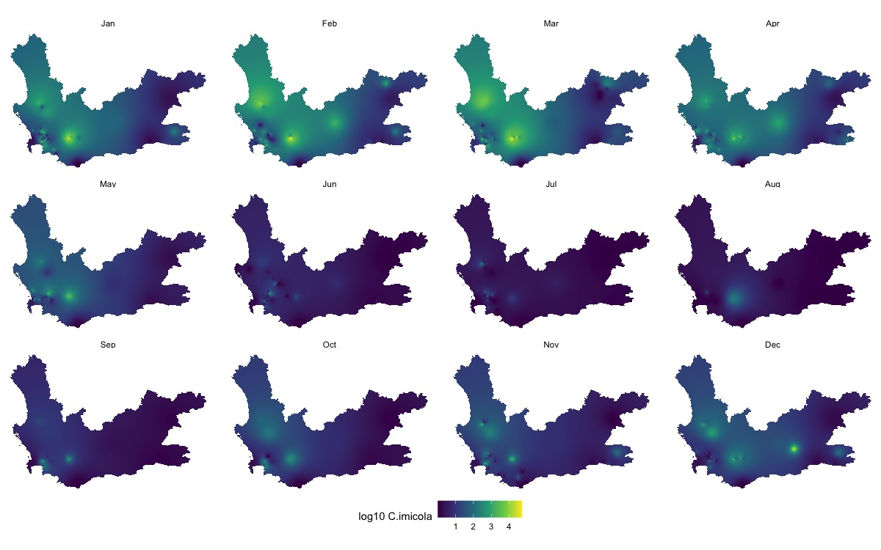
Figure SM3a C. imicola interpolation map
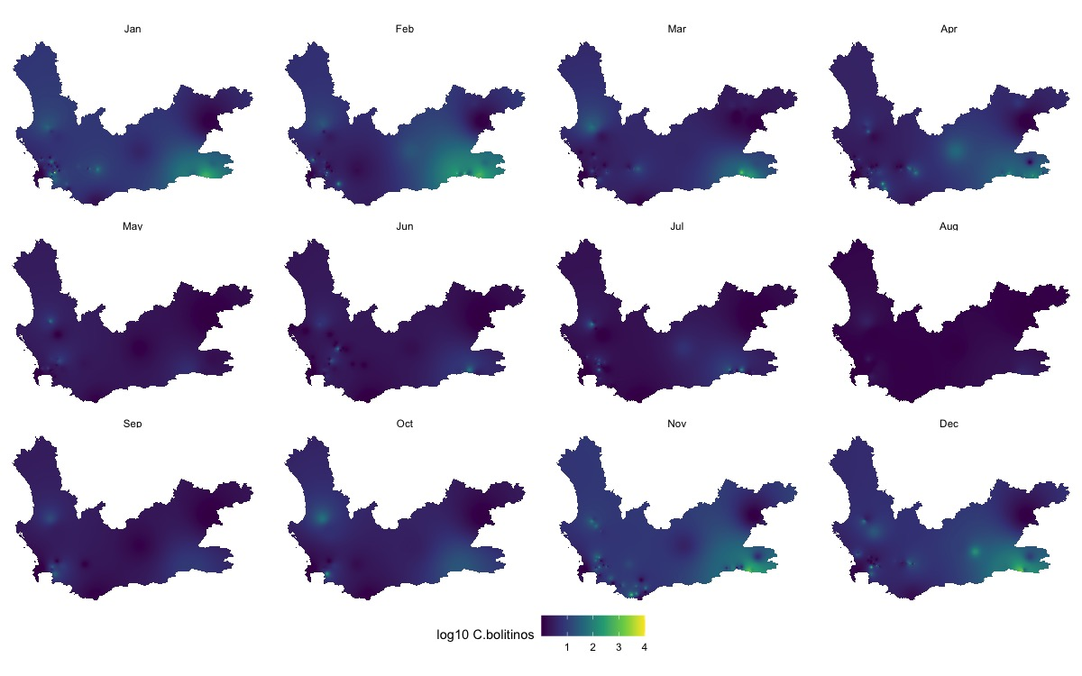
Figure SM3b C. bolitinos interpolation map
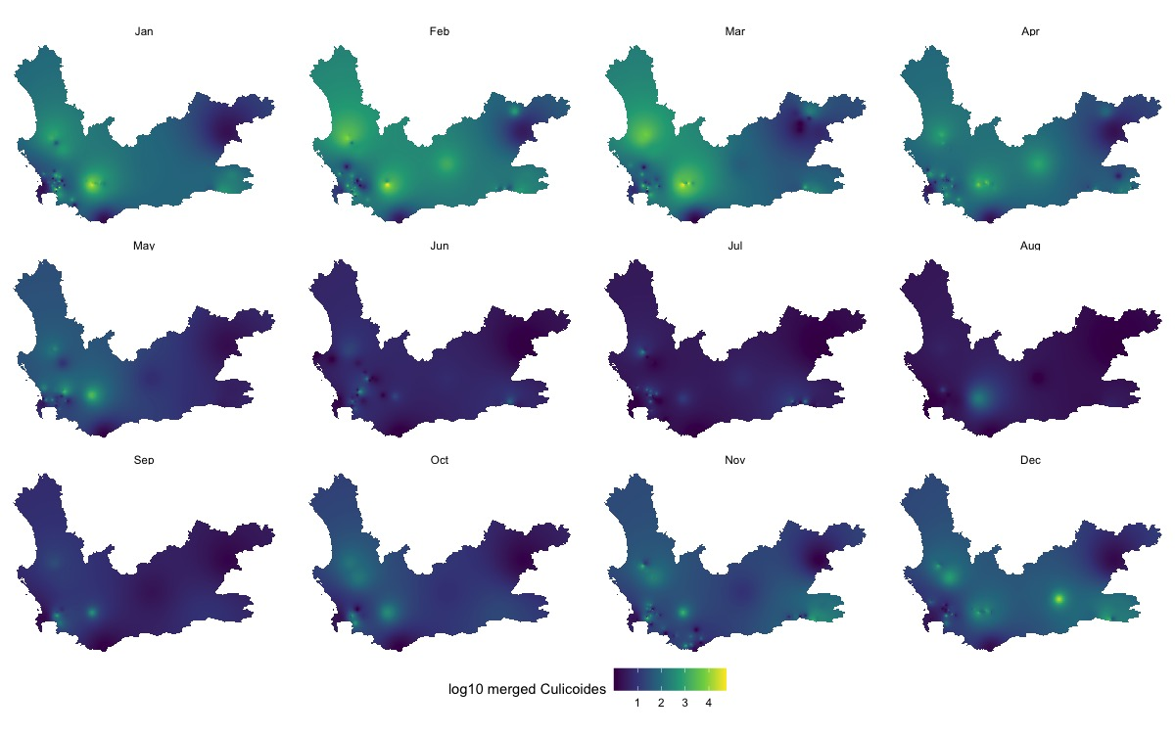
Figure SM3c Grouped competent vectors interpolation map

