Supplementary Material

The Role of Puff Volume in Vaping Emissions, Inhalation Risks, and Metabolic Perturbations: A Pilot Study
Jennifer Jeon,^{1, Δ} Xiaojia He,^{1, Δ} Akshada Shinde,² Maureen Meister,¹ Lillie Barnett,¹ Qian Zhang,¹ Marilyn Black,¹ Jonathan Shannahan,^{2,*} Christa Wright^{1,*}
1. Chemical Insights Research Institute of UL Research Institutes, Marietta, GA 30367
2. School of Health Sciences, Purdue University, West Lafayette, IN 47907
*Correspondence: Christa.Wright@ul.org, jshannah@purdue.edu
^{Δ}J.J. and X.H. contributed equally to this work.

Table S1. CEM parameters inputted for near-field far-field model in firsthand scenario risk assessment.
Parameters | Input values
Use environment | Residence – Living room
Building volume | 492 m³
Use environment volume | 50 m³
Air exchange rate, Zone 1 | 0.45 per hour
Air exchange rate, Zone 2 | 0.45 per hour
Interzone Ventilation Rate | 108.978 m³/hr
Volume of the near- field in Zone 1 | 0.30 m³
Volume of the far-field in Zone 1 | 49.70 m³
Air-Exchange rate at near-field boundary | 402 per hour

Table S2. PCA analysis of puff topography variables based on the puff profiles of 10 established ENDS users

 | PC 1 | PC 2
Variance
Proportion of variance (%) | 59.56 | 33.76
Cumulative variance (%) | 59.56 | 93.31
Eigenvalues (SD²) | 3.573 | 2.025
Variable vs. PC correlation coefficient
Puff volume (mL/puff) | 0.981 | -0.043
Flow rate (mL/sec) | 0.700 | 0.703
Peak flow (mL/sec) | 0.665 | 0.734
Puff duration (sec) | 0.708 | -0.648
Inter-puff interval (sec) | 0.918 | -0.047
Time of peak (sec) | 0.577 | -0.754

Table S3. Particle emission (average ± standard error) in three different ENDS aerosol exposure scenarios
 | Firsthand exposure  (n=10) | Secondhand exposure (n=10) | Baseline exposure  (n=9)
Total particle emission (#/puff) | 3.84×10¹⁰ ± 7.66×10⁹ | 1.49×10¹⁰ ± 2.91 × 10⁹ | 3.14×10⁶ ± 7.22 × 10⁵
Mass Emission (µg/m³) | 1.81×10² ± 5.71×10¹ | 2.85×10¹ ± 1.59×10¹ | 3.54×10⁻³ ± 6.99 × 10⁻⁴
Geometric Mean Diameter (nm) | 7.56×10 ± 3.80 | 4.47×10 ± 2.88 | 8.21×10 ± 7.44

Table S4. MPPD-calculated respiratory deposition (average ± standard error) of particulate matter in three different exposure scenarios.
 | Firsthand exposure (n=10) | Secondhand exposure (n=10) | Baseline exposure (n=9)
Total deposited mass (µg) | 2.30×10⁻⁴ ± 7.20×10⁻⁵ | 3.80×10⁻⁵ ± 2.07×10⁻⁵ | 9.26×10⁻⁹ ± 1.68×10⁻⁹
Total deposited surface area (cm²) | 1.72×10⁻⁴ ± 4.68×10⁻⁵ | 4.51×10⁻⁵ ± 2.37×10⁻⁵ | 7.17×10⁻⁹ ± 1.55×10⁻⁹
Total deposited dose (µg/cm²) | 1.26 ± 6.33×10⁻² | 7.45×10⁻¹ ± 4.78×10⁻² | 1.37 ± 1.25×10⁻¹

Table S5. Physicochemical properties for the top 20 VOCs from firsthand emissions that are shared by user exhalation and device emission with at least 30% non-missing values.
CASRN | CID | Weight fraction |  |  |  | MW (g/mol) | VP (mm Hg) | Water Sol. (mg/L) | HLC (atm-m³/mole) | LogKoa | LogKow
CASRN | CID | Low | Med | High | Overall
50-00-0 | Formaldehyde | 0.021825 | 0.000559 | 0.000363 | 0.002517 | 30.026 | 3.49E+03 | 5.70E+04 | 9.29E-05 | 5.211 | 0.35
57-55-6 | 1,2-Propanediol (Propylene glycol) | 0.691768 | 0.631665 | 0.646416 | 0.627487 | 76.09 | 0.111 | 8.11E+05 | 1.74E-07 | 5.358 | -0.78
111-71-7 | Heptanal (Heptaldehyde) | 0.000353 | 0.000191 | 0.000147 | 0.000178 | 114.19 | 3.52 | 1167 | 2.80E-04 | 4.247 | 2.29
75-07-0 | Acetaldehyde | 0.007668 | 0.000691 | 0.00026 | 0.001266 | 44.05 | 910 | 2.57E+05 | 6.78E-05 | 2.224 | -0.17
112-31-2 | Decanal | 0.00028 | 0.00041 | 0.000253 | 0.00033 | 156.26 | 0.235 | 43.52 | 6.55E-04 | 4.893 | 3.76
13444-24-1 | 3-Piperidinol, 1-ethyl- | 0.005929 | 0.010537 | 0.002499 | 0.008614 | 129.2 | 0.05 | 4.72E+05 | 1.83E-09 | 7.476 | 0.35
124-19-6 | Nonyl aldehyde (Nonanal) | 0.000699 | 0.000446 | 0.000339 | 0.000481 | 142.24 | 0.564 | 131.6 | 4.93E-04 | 4.793 | 3.27
54-11-5 | Pyridine, 3-(1-methyl-2-pyrrolidinyl)-, (S)- (Nicotine) | 0.000612 | 0.003093 | 0.003886 | 0.003127 | 162.23 | 0.032 | 1.00E+06 | 3.00E-09 | 8.081 | 1
6846-50-0 | TXIB (2,2,4-Trimethyl-1,3-pentanediol diisobutyrate) | 6.12E-05 | 5.71E-05 | 3.59E-05 | 3.86E-05 | 286.41 | 0.0085 | 0.9422 | 9.42E-06 | 8.324 | 4.91
66-25-1 | Hexanal | 0.00035 | 0.000164 | 0.000355 | 0.000441 | 100.16 | 9.57 | 3527 | 2.11E-04 | 3.84 | 1.8
108-88-3 | Toluene (Methylbenzene) | 0.00021 | 6.86E-05 | 0.000263 | 0.000212 | 92.14 | 23.7 | 573.1 | 5.95E-03 | 3.296 | 2.54
1330-20-7 | Xylenes (Total) | 0.000271 | 5.29E-05 | 5.16E-05 | 9.97E-05 | 106.16 | 6.81 | 224.1 | 6.56E-03 | 3.834 | 3.09
102-76-1 | 1,2,3-Propanetriol, triacetate (Triacetin) | 0.000472 | 0.000774 | 0.000223 | 0.001559 | 218.2 | 0.00524 | 2.15E+04 | 1.75E-09 | 6.549 | 0.36
80-56-8 | Pinene, alpha (2,6,6-Trimethyl-bicyclo[3.1.1]hept-2-ene) | 9.03E-05 | 2.43E-05 | 1.28E-05 | 3.29E-05 | 136.23 | 4.02 | 4.071 | 1.07E-01 | 3.36 | 4.27
71-36-3 | 1-Butanol (N-Butyl alcohol) | 0.000367 | 7.00E-05 | 0.000175 | 0.000446 | 74.12 | 7.78 | 7.67E+04 | 9.99E-06 | 4.323 | 0.84
100-42-5 | Styrene | 0.00016 | 3.71E-05 | 5.22E-05 | 5.75E-05 | 104.15 | 5.05 | 343.7 | 2.76E-03 | 3.899 | 2.89
64-17-5 | Ethanol | 0 | 0.008908 | 0.001261 | 0.015704 | 46.07 | 60.9 | 7.92E+05 | 5.67E-06 | 3.379 | -0.14
104-76-7 | 1-Hexanol, 2-ethyl | 0.000571 | 0.000157 | 0 | 0.000114 | 130.23 | 0.185 | 1379 | 3.10E-05 | 5.695 | 2.73
629-59-4 | Tetradecane | 0.000166 | 1.57E-05 | 0 | 2.16E-05 | 198.39 | 0.0369 | 0.009192 | 1.65E+01 | 4.625 | 7.22
124-13-0 | Octanal | 0.001264 | 7.29E-05 | 0 | 0.000147 | 128.21 | 1.49 | 394.3 | 3.71E-04 | 4.457 | 2.78
Note: MW: molecular weight. VP: vaper pressure. HLC: Henry’s law coefficient. K_{oa} (octanol/air partitioning ratio). K_{ow} (octanol/water partitioning ratio).

Table S6. Physicochemical properties for the top 20 VOCs from secondhand emissions that are shared by user exhalation and device emission with at least 30% non-missing values.
CASRN | CID | Weight fraction |  |  |  | MW (g/mol) | VP (mm Hg) | Water Sol. (mg/L) | HLC (atm-m³/mole) | LogKoa | LogKow
CASRN | CID | Low | Med | High | Overall
50-00-0 | Formaldehyde | 0.00676 | 0.011552 | 0.005983 | 0.008722 | 30.026 | 3.49E+03 | 5.70E+04 | 9.29E-05 | 5.211 | 0.35
57-55-6 | 1,2-Propanediol (Propylene glycol) | 0.184288 | 0.269673 | 0.148927 | 0.22627 | 76.09 | 0.111 | 8.11E+05 | 1.74E-07 | 5.358 | -0.78
111-71-7 | Heptanal (Heptaldehyde) | 0.001324 | 0.001166 | 0.001107 | 0.001378 | 114.19 | 3.52 | 1167 | 2.80E-04 | 4.247 | 2.29
75-07-0 | Acetaldehyde | 0.004717 | 0.004035 | 0.004636 | 0.005128 | 44.05 | 910 | 2.57E+05 | 6.78E-05 | 2.224 | -0.17
112-31-2 | Decanal | 0.000737 | 0.000936 | 0.00191 | 0.002534 | 156.26 | 0.235 | 43.52 | 6.55E-04 | 4.893 | 3.76
13444-24-1 | 3-Piperidinol, 1-ethyl- | 6.22E-05 | 0.003133 | 0.001768 | 0.002116 | 129.2 | 0.05 | 4.72E+05 | 1.83E-09 | 7.476 | 0.35
124-19-6 | Nonyl aldehyde (Nonanal) | 0.002541 | 0.001243 | 0.00382 | 0.003647 | 142.24 | 0.564 | 131.6 | 4.93E-04 | 4.793 | 3.27
54-11-5 | Pyridine, 3-(1-methyl-2-pyrrolidinyl)-, (S)- (Nicotine) | 0.00048 | 0.000451 | 0.000557 | 0.000502 | 162.23 | 0.032 | 1.00E+06 | 3.00E-09 | 8.081 | 1
6846-50-0 | TXIB (2,2,4-Trimethyl-1,3-pentanediol diisobutyrate) | 8.88E-05 | 4.26E-05 | 0.000499 | 0.000331 | 286.41 | 0.0085 | 0.9422 | 9.42E-06 | 8.324 | 4.91
66-25-1 | Hexanal | 0.002327 | 0.001762 | 0.001994 | 0.002484 | 100.16 | 9.57 | 3527 | 2.11E-04 | 3.84 | 1.8
108-88-3 | Toluene (Methylbenzene) | 0.00143 | 0.002111 | 0.000745 | 0.001693 | 92.14 | 23.7 | 573.1 | 5.95E-03 | 3.296 | 2.54
1330-20-7 | Xylenes (Total) | 0.000666 | 0.001524 | 0.000537 | 0.001141 | 106.16 | 6.81 | 224.1 | 6.56E-03 | 3.834 | 3.09
102-76-1 | 1,2,3-Propanetriol, triacetate (Triacetin) | 0.000373 | 0.00046 | 0.000531 | 0.000602 | 218.2 | 0.00524 | 2.15E+04 | 1.75E-09 | 6.549 | 0.36
80-56-8 | Pinene, alpha (2,6,6-Trimethyl-bicyclo[3.1.1]hept-2-ene) | 0.000622 | 0.001558 | 0.000602 | 0.001176 | 136.23 | 4.02 | 4.071 | 1.07E-01 | 3.36 | 4.27
71-36-3 | 1-Butanol (N-Butyl alcohol) | 0.00278 | 0.001217 | 0.002726 | 0.002192 | 74.12 | 7.78 | 7.67E+04 | 9.99E-06 | 4.323 | 0.84
100-42-5 | Styrene | 0.000879 | 0.001226 | 0.000537 | 0.000867 | 104.15 | 5.05 | 343.7 | 2.76E-03 | 3.899 | 2.89
64-17-5 | Ethanol | 0.048297 | 0.108247 | 0.143002 | 0.131998 | 46.07 | 60.9 | 7.92E+05 | 5.67E-06 | 3.379 | -0.14
104-76-7 | 1-Hexanol, 2-ethyl | 0.002318 | 0.002486 | 0.002001 | 0.002423 | 130.23 | 0.185 | 1379 | 3.10E-05 | 5.695 | 2.73
629-59-4 | Tetradecane | 0.000462 | 0.000485 | 0.00033 | 0.000421 | 198.39 | 0.0369 | 0.009192 | 1.65E+01 | 4.625 | 7.22
124-13-0 | Octanal | 0.00239 | 0.00172 | 0.002881 | 0.002537 | 128.21 | 1.49 | 394.3 | 3.71E-04 | 4.457 | 2.78

Note: MW: molecular weight. VP: vaper pressure. HLC: Henry’s law coefficient. K_{oa} (octanol/air partitioning ratio). K_{ow} (octanol/water partitioning ratio).

Table S7. Rank frequency and importance of selected 15 metabolic features for multivariate ROC analyses using MCCV
Metabolites | HMDB ID | Log2FC | Rank Freq. | Importance | m/z | retention_time (min) | p_value | statistic | Adducts
2',3'-Cyclic UMP | METPA0279 | -2.61587 | 0.66 | 2.078042 | 103.0149 | 1.4 | 0.003429 | -3.63338 | M+3H
3-Hydroxyquinine | HMDB0001091 | 2.96427 | 0.9 | 2.740008 | 409.1741 | 10.7 | 0.001612 | 4.04957 | M+HCOONa
6-Hydroxyhexanoate | HMDB0003767 | -1.88835 | 0.92 | 2.931257 | 133.0867 | 6 | 0.021146 | -2.65084 | M+H
Anserine | HMDB0012843 | -2.90894 | 0.62 | 2.062131 | 223.1191 | 8.1 | 0.030771 | -2.44683 | M-HCOOH+H
Butyrate | HMDB0000194 | -2.23627 | 0.98 | 3.060373 | 89.0593 | 8.1 | 0.021663 | -2.63776 | M+H
Cholesterol sulfate | HMDB0000039 | -3.04563 | 0.16 | -0.24108 | 422.3217 | 8.3 | 0.034746 | -2.38026 | M-CO2+H
Lactate | HMDB0000653 | 4.460259 | 0.72 | 2.283731 | 73.0286 | 8.1 | 0.03326 | -2.40424 | M-H2O+H
GDP-D-mannose | METPA1614 | 3.817249 | 0.42 | 1.117966 | 628.068 | 8.9 | 0.015281 | 2.82629 | M+Na
Leukotriene D4 | HMDB0000190 | -2.74652 | 0.38 | 1.045541 | 479.2552 | 15.6 | 0.003364 | 3.643831 | M-H2O+H
L-Palmitoylcarnitine | HMDB0003080 | 5.205103 | 0.08 | -0.88389 | 422.3224 | 8.1 | 0.048754 | -2.19289 | M+Na
Methylglyoxal | HMDB0000222 | 4.048474 | 1 | 2.908631 | 73.0284 | 6.1 | 0.03326 | -2.40424 | M+H
4-Hydroxyphenylacetaldehyde | HMDB0001167 | -2.51105 | 0.96 | 3.127197 | 93.0705 | 12.9 | 0.0098 | -3.0654 | M-HCOOH+H
Pregnenolone sulfate | HMDB0000774 | 4.491084 | 0.8 | 2.470988 | 454.1541 | 13.4 | 0.028235 | 2.493796 | M-CO2+H
Retinoate | HMDB0001852 | -1.66062 | 0.72 | 2.282817 | 323.1966 | 17.8 | 0.036076 | -2.35963 | M+Na
Taurolithocholate | HMDB0000722 | 2.727302 | 0.58 | 1.607724 | 552.2993 | 7.2 | 0.023442 | 2.594972 | M+HCOONa

Table S8. Genome-scale metabolic network reconstruction using selected 15 metabolic features
HMDB | Id2 | Metabolite | Gene
HMDB0000774 | 8647 | Pregnenolone sulfate | ABCB11
HMDB0000775 | 10257 | Pregnenolone sulfate | ABCC4
HMDB0000776 | 8714 | Pregnenolone sulfate | ABCC3
HMDB0000777 | 1244 | Pregnenolone sulfate | ABCC2
HMDB0000778 | 200931 | Pregnenolone sulfate | SLC51A
HMDB0000779 | 10599 | Pregnenolone sulfate | SLCO1B1
HMDB0000780 | 28234 | Pregnenolone sulfate | SLCO1B3
HMDB0000781 | 123264 | Pregnenolone sulfate | SLC51B
HMDB0000782 | 6555 | Pregnenolone sulfate | SLC10A2
HMDB0000783 | 6554 | Pregnenolone sulfate | SLC10A1
HMDB0000784 | 1577 | Pregnenolone sulfate | CYP3A5
HMDB0000785 | 1576 | Pregnenolone sulfate | CYP3A4
HMDB0000786 | 3248 | Pregnenolone sulfate | HPGD
HMDB0000787 | 54659 | Pregnenolone sulfate | UGT1A3
HMDB0000788 | 7364 | Pregnenolone sulfate | UGT2B7
HMDB0000789 | 54600 | Pregnenolone sulfate | UGT1A9
HMDB0000790 | 54657 | Pregnenolone sulfate | UGT1A4
HMDB0000791 | 7363 | Pregnenolone sulfate | UGT2B4
HMDB0000792 | 1589 | Pregnenolone sulfate | CYP21A2
HMDB0000793 | 1591 | Pregnenolone sulfate | CYP24A1
HMDB0000794 | 1594 | Pregnenolone sulfate | CYP27B1
HMDB0000795 | 160287 | Pregnenolone sulfate | LDHAL6A
HMDB0000796 | 3948 | Pregnenolone sulfate | LDHC
HMDB0000797 | 92483 | Pregnenolone sulfate | LDHAL6B
HMDB0000798 | 3945 | Pregnenolone sulfate | LDHB
HMDB0000799 | 3939 | Pregnenolone sulfate | LDHA
HMDB0000800 | 55293 | Pregnenolone sulfate | UEVLD
HMDB0000801 | 5243 | Pregnenolone sulfate | ABCB1
HMDB0000802 | 1558 | Pregnenolone sulfate | CYP2C8
HMDB0000803 | 5446 | Pregnenolone sulfate | PON3
HMDB0000804 | 11309 | Pregnenolone sulfate | SLCO2B1
HMDB0000805 | 9376 | Pregnenolone sulfate | SLC22A8
HMDB0000806 | 38 | Pregnenolone sulfate | ACAT1
HMDB0000807 | 10327 | Pregnenolone sulfate | AKR1A1
HMDB0000808 | 1565 | Pregnenolone sulfate | CYP2D6
HMDB0000809 | 51 | Pregnenolone sulfate | ACOX1
HMDB0000810 | 1891 | Pregnenolone sulfate | ECH1
HMDB0000811 | 1962 | Pregnenolone sulfate | EHHADH
HMDB0000812 | 3032 | Pregnenolone sulfate | HADHB
HMDB0000813 | 37 | Pregnenolone sulfate | ACADVL
HMDB0000814 | 3030 | Pregnenolone sulfate | HADHA
HMDB0000815 | 3295 | Pregnenolone sulfate | HSD17B4
HMDB0000816 | 30 | Pregnenolone sulfate | ACAA1
HMDB0000817 | 9429 | Pregnenolone sulfate | ABCG2
HMDB0000818 | 4051 | Pregnenolone sulfate | CYP4F3
HMDB0000819 | 8529 | Pregnenolone sulfate | CYP4F2
HMDB0000820 | 4129 | Pregnenolone sulfate | MAOB
HMDB0000821 | 4128 | Pregnenolone sulfate | MAOA
HMDB0000822 | 53 | Pregnenolone sulfate | ACP2
HMDB0000823 | 54 | Pregnenolone sulfate | ACP5
HMDB0000824 | 51205 | Pregnenolone sulfate | ACP6
HMDB0000825 | 55 | Pregnenolone sulfate | ACPP
HMDB0000826 | 1571 | Pregnenolone sulfate | CYPÂ 20.00
HMDB0000827 | 1548 | Pregnenolone sulfate | CYP2A6
HMDB0000828 | 218 | Pregnenolone sulfate | ALDH3A1
HMDB0000829 | 6818 | Pregnenolone sulfate | SULT1A3
HMDB0000830 | 6817 | Pregnenolone sulfate | SULT1A1
HMDB0000831 | 6799 | Pregnenolone sulfate | SULT1A2
HMDB0000832 | 57393 | Pregnenolone sulfate | TMEM27
HMDB0000833 | 54716 | Pregnenolone sulfate | SLC6A20
HMDB0000834 | 4363 | Pregnenolone sulfate | ABCC1
HMDB0000835 | 6822 | Pregnenolone sulfate | SULT2A1
HMDB0000836 | 10965 | Pregnenolone sulfate | ACOT2
HMDB0000837 | 11332 | Pregnenolone sulfate | ACOT7
HMDB0000838 | 55856 | Pregnenolone sulfate | ACOT13
HMDB0000839 | 10005 | Pregnenolone sulfate | ACOT8
HMDB0000840 | 7350 | Pregnenolone sulfate | UCP1
HMDB0000841 | 1559 | Pregnenolone sulfate | CYP2C9
HMDB0000842 | 1557 | Pregnenolone sulfate | CYP2C19
HMDB0000843 | 85320 | Pregnenolone sulfate | ABCC11
HMDB0000844 | 53947 | Pregnenolone sulfate | A4GALT
HMDB0000845 | 51146 | Pregnenolone sulfate | A4GNT
HMDB0000846 | 8639 | Pregnenolone sulfate | AOC3
HMDB0000847 | 28 | Pregnenolone sulfate | ABO
HMDB0000848 | 125981 | Pregnenolone sulfate | ACER1
HMDB0000849 | 55331 | Pregnenolone sulfate | ACER3
HMDB0000850 | 340485 | Pregnenolone sulfate | ACER2
HMDB0000851 | 54658 | Pregnenolone sulfate | UGT1A8
HMDB0000852 | 54578 | Pregnenolone sulfate | UGT1A6
HMDB0000853 | 54187 | Pregnenolone sulfate | NANS
HMDB0000854 | 54677 | Pregnenolone sulfate | CROT
HMDB0000855 | 126129 | Pregnenolone sulfate | CPT1C
HMDB0000856 | 1375 | Pregnenolone sulfate | CPT1B
HMDB0000857 | 1374 | Pregnenolone sulfate | CPT1A
HMDB0000858 | 1376 | Pregnenolone sulfate | CPT2
HMDB0000859 | 788 | Pregnenolone sulfate | SLC25A20
HMDB0000860 | 10678 | Pregnenolone sulfate | B3GNT2
HMDB0000861 | 11041 | Pregnenolone sulfate | B3GNT1
HMDB0000862 | 374907 | Pregnenolone sulfate | B3GNT8
HMDB0000863 | 10331 | Pregnenolone sulfate | B3GNT3
HMDB0000864 | 146712 | Pregnenolone sulfate | B3GNTL1
HMDB0000865 | 79369 | Pregnenolone sulfate | B3GNT4
HMDB0000866 | 93010 | Pregnenolone sulfate | B3GNT7
HMDB0000867 | 137964 | Pregnenolone sulfate | AGPAT6
HMDB0000868 | 56894 | Pregnenolone sulfate | AGPAT3
HMDB0000869 | 55326 | Pregnenolone sulfate | AGPAT5
HMDB0000870 | 56895 | Pregnenolone sulfate | AGPAT4
HMDB0000871 | 10554 | Pregnenolone sulfate | AGPAT1
HMDB0000872 | 10555 | Pregnenolone sulfate | AGPAT2
HMDB0000873 | 129642 | Pregnenolone sulfate | MBOAT2
HMDB0000874 | 8540 | Pregnenolone sulfate | AGPS
HMDB0000875 | 3073 | Pregnenolone sulfate | HEXA
HMDB0000876 | 3074 | Pregnenolone sulfate | HEXB
HMDB0000877 | 84735 | Pregnenolone sulfate | CNDP1
HMDB0000878 | 55748 | Pregnenolone sulfate | CNDP2
HMDB0000879 | 6564 | Pregnenolone sulfate | SLC15A1
HMDB0000880 | 6565 | Pregnenolone sulfate | SLC15A2
HMDB0000881 | 11254 | Pregnenolone sulfate | SLC6A14
HMDB0000882 | 348932 | Pregnenolone sulfate | SLC6A18
HMDB0000883 | 127 | Pregnenolone sulfate | ADH4
HMDB0000884 | 131 | Pregnenolone sulfate | ADH7
HMDB0000885 | 137872 | Pregnenolone sulfate | ADHFE1
HMDB0000886 | 124 | Pregnenolone sulfate | ADH1A
HMDB0000887 | 128 | Pregnenolone sulfate | ADH5
HMDB0000888 | 126 | Pregnenolone sulfate | ADH1C
HMDB0000889 | 125 | Pregnenolone sulfate | ADH1B
HMDB0000890 | 130 | Pregnenolone sulfate | ADH6
HMDB0000891 | 224 | Pregnenolone sulfate | ALDH3A2
HMDB0000892 | 7498 | Pregnenolone sulfate | XDH
HMDB0000893 | 316 | Pregnenolone sulfate | AOX1
HMDB0000894 | 242 | Pregnenolone sulfate | ALOX12B
HMDB0000895 | 246 | Pregnenolone sulfate | ALOX15
HMDB0000896 | 247 | Pregnenolone sulfate | ALOX15B
HMDB0000897 | 231 | Pregnenolone sulfate | AKR1B1
HMDB0000898 | 276 | Pregnenolone sulfate | AMY1A
HMDB0000899 | 11136 | Pregnenolone sulfate | SLC7A9
HMDB0000900 | 280 | Pregnenolone sulfate | AMY2B
HMDB0000901 | 6519 | Pregnenolone sulfate | SLC3A1
HMDB0000902 | 278 | Pregnenolone sulfate | AMY1C
HMDB0000903 | 6520 | Pregnenolone sulfate | SLC3A2
HMDB0000904 | 277 | Pregnenolone sulfate | AMY1B
HMDB0000905 | 279 | Pregnenolone sulfate | AMY2A
HMDB0000906 | 5338 | Pregnenolone sulfate | PLD2
HMDB0000907 | 5337 | Pregnenolone sulfate | PLD1
HMDB0000908 | 410 | Pregnenolone sulfate | ARSA
HMDB0000909 | 427 | Pregnenolone sulfate | ASAH1
HMDB0000910 | 6566 | Pregnenolone sulfate | SLC16A1
HMDB0000911 | 54576 | Pregnenolone sulfate | UGT1A1
HMDB0000912 | 4123 | Pregnenolone sulfate | MAN2C1
HMDB0000913 | 4125 | Pregnenolone sulfate | MAN2B1
HMDB0000914 | 84002 | Pregnenolone sulfate | B3GNT5
HMDB0000915 | 570 | Pregnenolone sulfate | BAAT
HMDB0000916 | 6533 | Pregnenolone sulfate | SLC6A6
HMDB0000917 | 56052 | Pregnenolone sulfate | ALG1
HMDB0000918 | 6539 | Pregnenolone sulfate | SLC6A12
HMDB0000919 | 2720 | Pregnenolone sulfate | GLB1
HMDB0000920 | 9488 | Pregnenolone sulfate | PIGB
HMDB0000921 | 3141 | Pregnenolone sulfate | HLCS
HMDB0000922 | 4126 | Pregnenolone sulfate | MANBA
HMDB0000923 | 1622 | Pregnenolone sulfate | DBI
HMDB0000924 | 50814 | Pregnenolone sulfate | NSDHL
HMDB0000925 | 6307 | Pregnenolone sulfate | MSMO1
HMDB0000926 | 10941 | Pregnenolone sulfate | UGT2A1
HMDB0000927 | 79799 | Pregnenolone sulfate | UGT2A3
HMDB0000928 | 10423 | Pregnenolone sulfate | CDIPT
HMDB0000929 | 8760 | Pregnenolone sulfate | CDS2
HMDB0000930 | 1040 | Pregnenolone sulfate | CDS1
HMDB0000931 | 9356 | Pregnenolone sulfate | SLC22A6
HMDB0000932 | 9152 | Pregnenolone sulfate | SLC6A5
HMDB0000933 | 10999 | Pregnenolone sulfate | SLC27A4
HMDB0000934 | 10998 | Pregnenolone sulfate | SLC27A5
HMDB0000935 | 376497 | Pregnenolone sulfate | SLC27A1
HMDB0000936 | 11000 | Pregnenolone sulfate | SLC27A3
HMDB0000937 | 11001 | Pregnenolone sulfate | SLC27A2
HMDB0000938 | 28965 | Pregnenolone sulfate | SLC27A6
HMDB0000939 | 222962 | Pregnenolone sulfate | SLC29A4
HMDB0000940 | 6582 | Pregnenolone sulfate | SLC22A2
HMDB0000941 | 10928 | Pregnenolone sulfate | RALBP1
HMDB0000942 | 56994 | Pregnenolone sulfate | CHPT1
HMDB0000943 | 10390 | Pregnenolone sulfate | CEPT1
HMDB0000944 | 64781 | Pregnenolone sulfate | CERK
HMDB0000945 | 10087 | Pregnenolone sulfate | COL4A3BP
HMDB0000946 | 9023 | Pregnenolone sulfate | CH25H
HMDB0000947 | 6646 | Pregnenolone sulfate | SOAT1
HMDB0000948 | 8435 | Pregnenolone sulfate | SOAT2
HMDB0000949 | 3988 | Pregnenolone sulfate | LIPA
HMDB0000950 | 6820 | Pregnenolone sulfate | SULT2B1
HMDB0000951 | 1118 | Pregnenolone sulfate | CHIT1
HMDB0000952 | 27159 | Pregnenolone sulfate | CHIA
HMDB0000953 | 54682 | Pregnenolone sulfate | MANSC1
HMDB0000954 | 1080 | Pregnenolone sulfate | CFTR
HMDB0000955 | 5172 | Pregnenolone sulfate | SLC26A4
HMDB0000956 | 65010 | Pregnenolone sulfate | SLC26A6
HMDB0000957 | 54675 | Pregnenolone sulfate | CRLS1
HMDB0000958 | 51805 | Pregnenolone sulfate | COQ3
HMDB0000959 | 51004 | Pregnenolone sulfate | COQ6
HMDB0000960 | 10229 | Pregnenolone sulfate | COQ7
HMDB0000961 | 9245 | Pregnenolone sulfate | GCNT3
HMDB0000962 | 2650 | Pregnenolone sulfate | GCNT1
HMDB0000963 | 51301 | Pregnenolone sulfate | GCNT4
HMDB0000964 | 2990 | Pregnenolone sulfate | GUSB
HMDB0000965 | 1384 | Pregnenolone sulfate | CRAT
HMDB0000966 | 2946 | Pregnenolone sulfate | GSTM2
HMDB0000967 | 160851 | Pregnenolone sulfate | DGKH
HMDB0000968 | 8527 | Pregnenolone sulfate | DGKD
HMDB0000969 | 1608 | Pregnenolone sulfate | DGKG
HMDB0000970 | 1609 | Pregnenolone sulfate | DGKQ
HMDB0000971 | 1607 | Pregnenolone sulfate | DGKB
HMDB0000972 | 9162 | Pregnenolone sulfate | DGKI
HMDB0000973 | 1606 | Pregnenolone sulfate | DGKA
HMDB0000974 | 8525 | Pregnenolone sulfate | DGKZ
HMDB0000975 | 8526 | Pregnenolone sulfate | DGKE
HMDB0000976 | 123099 | Pregnenolone sulfate | DEGS2
HMDB0000977 | 9415 | Pregnenolone sulfate | FADS2
HMDB0000978 | 6319 | Pregnenolone sulfate | SCD
HMDB0000979 | 3992 | Pregnenolone sulfate | FADS1
HMDB0000980 | 8694 | Pregnenolone sulfate | DGAT1
HMDB0000981 | 84649 | Pregnenolone sulfate | DGAT2
HMDB0000982 | 8443 | Pregnenolone sulfate | GNPAT
HMDB0000983 | 8560 | Pregnenolone sulfate | DEGS1
HMDB0000984 | 215 | Pregnenolone sulfate | ABCD1
HMDB0000985 | 225 | Pregnenolone sulfate | ABCD2
HMDB0000986 | 23205 | Pregnenolone sulfate | ACSBG1
HMDB0000987 | 81616 | Pregnenolone sulfate | ACSBG2
HMDB0000988 | 6184 | Pregnenolone sulfate | RPN1
HMDB0000989 | 6185 | Pregnenolone sulfate | RPN2
HMDB0000990 | 1603 | Pregnenolone sulfate | DAD1
HMDB0000991 | 1650 | Pregnenolone sulfate | DDOST
HMDB0000992 | 57171 | Pregnenolone sulfate | DOLPP1
HMDB0000993 | 29929 | Pregnenolone sulfate | ALG6
HMDB0000994 | 79053 | Pregnenolone sulfate | ALG8
HMDB0000995 | 84920 | Pregnenolone sulfate | ALG10
HMDB0000996 | 10195 | Pregnenolone sulfate | ALG3
HMDB0000997 | 79087 | Pregnenolone sulfate | ALG12
HMDB0000998 | 8813 | Pregnenolone sulfate | DPM1
HMDB0000999 | 54344 | Pregnenolone sulfate | DPM3
HMDB0001000 | 8818 | Pregnenolone sulfate | DPM2
HMDB0001001 | 641371 | Pregnenolone sulfate | ACOT1
HMDB0001002 | 26027 | Pregnenolone sulfate | ACOT11
HMDB0001003 | 64772 | Pregnenolone sulfate | ENGASE
HMDB0001004 | 2108 | Pregnenolone sulfate | ETFA
HMDB0001005 | 2109 | Pregnenolone sulfate | ETFB
HMDB0001006 | 2110 | Pregnenolone sulfate | ETFDH
HMDB0001007 | 55301 | Pregnenolone sulfate | OLAH
HMDB0001008 | 2181 | Pregnenolone sulfate | ACSL3
HMDB0001009 | 2180 | Pregnenolone sulfate | ACSL1
HMDB0001010 | 2182 | Pregnenolone sulfate | ACSL4
HMDB0001011 | 116285 | Pregnenolone sulfate | ACSM1
HMDB0001012 | 79071 | Pregnenolone sulfate | ELOVL6
HMDB0001013 | 6785 | Pregnenolone sulfate | ELOVL4
HMDB0001014 | 60481 | Pregnenolone sulfate | ELOVL5
HMDB0001015 | 54898 | Pregnenolone sulfate | ELOVL2
HMDB0001016 | 1579 | Pregnenolone sulfate | CYP4A11
HMDB0001017 | 34 | Pregnenolone sulfate | ACADM
HMDB0001018 | 1632 | Pregnenolone sulfate | ECI1
HMDB0001019 | 10455 | Pregnenolone sulfate | ECI2
HMDB0001020 | 1666 | Pregnenolone sulfate | DECR1
HMDB0001021 | 26063 | Pregnenolone sulfate | DECR2
HMDB0001022 | 10449 | Pregnenolone sulfate | ACAA2
HMDB0001023 | 3033 | Pregnenolone sulfate | HADH
HMDB0001024 | 1892 | Pregnenolone sulfate | ECHS1
HMDB0001025 | 8310 | Pregnenolone sulfate | ACOX3
HMDB0001026 | 35 | Pregnenolone sulfate | ACADS
HMDB0001027 | 26061 | Pregnenolone sulfate | HACL1
HMDB0001028 | 51703 | Pregnenolone sulfate | ACSL5
HMDB0001029 | 230 | Pregnenolone sulfate | ALDOC
HMDB0001030 | 226 | Pregnenolone sulfate | ALDOA
HMDB0001031 | 229 | Pregnenolone sulfate | ALDOB
HMDB0001032 | 2356 | Pregnenolone sulfate | FPGS
HMDB0001033 | 9453 | Pregnenolone sulfate | GGPS1
HMDB0001034 | 2519 | Pregnenolone sulfate | FUCA2
HMDB0001035 | 2517 | Pregnenolone sulfate | FUCA1
HMDB0001036 | 2523 | Pregnenolone sulfate | FUT1
HMDB0001037 | 2525 | Pregnenolone sulfate | FUT3
HMDB0001038 | 10690 | Pregnenolone sulfate | FUT9
HMDB0001039 | 85365 | Pregnenolone sulfate | ALG2
HMDB0001040 | 8704 | Pregnenolone sulfate | B4GALT2
HMDB0001041 | 8703 | Pregnenolone sulfate | B4GALT3
HMDB0001042 | 2683 | Pregnenolone sulfate | B4GALT1
HMDB0001043 | 9334 | Pregnenolone sulfate | B4GALT5
HMDB0001044 | 9514 | Pregnenolone sulfate | GAL3ST1
HMDB0001045 | 5476 | Pregnenolone sulfate | CTSA
HMDB0001046 | 4758 | Pregnenolone sulfate | NEU1
HMDB0001047 | 2588 | Pregnenolone sulfate | GALNS
HMDB0001048 | 2581 | Pregnenolone sulfate | GALC
HMDB0001049 | 2583 | Pregnenolone sulfate | B4GALNT1
HMDB0001050 | 55454 | Pregnenolone sulfate | CSGALNACT2
HMDB0001051 | 55790 | Pregnenolone sulfate | CSGALNACT1
HMDB0001052 | 22856 | Pregnenolone sulfate | CHSY1
HMDB0001053 | 337876 | Pregnenolone sulfate | CHSY3
HMDB0001054 | 79586 | Pregnenolone sulfate | CHPF
HMDB0001055 | 63917 | Pregnenolone sulfate | GALNT11
HMDB0001056 | 79695 | Pregnenolone sulfate | GALNT12
HMDB0001057 | 11226 | Pregnenolone sulfate | GALNT6
HMDB0001058 | 79623 | Pregnenolone sulfate | GALNT14
HMDB0001059 | 114805 | Pregnenolone sulfate | GALNT13
HMDB0001060 | 26290 | Pregnenolone sulfate | GALNT8
HMDB0001061 | 2590 | Pregnenolone sulfate | GALNT2
HMDB0001062 | 55568 | Pregnenolone sulfate | GALNT10
HMDB0001063 | 8693 | Pregnenolone sulfate | GALNT4
HMDB0001064 | 11227 | Pregnenolone sulfate | GALNT5
HMDB0001065 | 50614 | Pregnenolone sulfate | GALNT9
HMDB0001066 | 51809 | Pregnenolone sulfate | GALNT7
HMDB0001067 | 2591 | Pregnenolone sulfate | GALNT3
HMDB0001068 | 2589 | Pregnenolone sulfate | GALNT1
HMDB0001069 | 117248 | Pregnenolone sulfate | GALNT15
HMDB0001070 | 8972 | Pregnenolone sulfate | MGAM
HMDB0001071 | 9197 | Pregnenolone sulfate | SLC33A1
HMDB0001072 | 175 | Pregnenolone sulfate | AGA
HMDB0001073 | 2629 | Pregnenolone sulfate | GBA
HMDB0001074 | 57704 | Pregnenolone sulfate | GBA2
HMDB0001075 | 26301 | Pregnenolone sulfate | GBGT1
HMDB0001076 | 1738 | Pregnenolone sulfate | DLD
HMDB0001077 | 2731 | Pregnenolone sulfate | GLDC
HMDB0001078 | 275 | Pregnenolone sulfate | AMT
HMDB0001079 | 2653 | Pregnenolone sulfate | GCSH
HMDB0001080 | 8836 | Pregnenolone sulfate | GGH
HMDB0001081 | 8908 | Pregnenolone sulfate | GYG2
HMDB0001082 | 2997 | Pregnenolone sulfate | GYS1
HMDB0001083 | 2992 | Pregnenolone sulfate | GYG1
HMDB0001084 | 2998 | Pregnenolone sulfate | GYS2
HMDB0001085 | 2687 | Pregnenolone sulfate | GGT5
HMDB0001086 | 2717 | Pregnenolone sulfate | GLA
HMDB0001087 | 5660 | Pregnenolone sulfate | PSAP
HMDB0001088 | 2632 | Pregnenolone sulfate | GBE1
HMDB0001089 | 8372 | Pregnenolone sulfate | HYAL3
HMDB0001090 | 26035 | Pregnenolone sulfate | GLCE
HMDB0001091 | 54480 | Pregnenolone sulfate | CHPF2
HMDB0001092 | 2132 | Pregnenolone sulfate | EXT2
HMDB0001093 | 2131 | Pregnenolone sulfate | EXT1
HMDB0001094 | 27087 | Pregnenolone sulfate | B3GAT1
HMDB0001095 | 135152 | Pregnenolone sulfate | B3GAT2
HMDB0001096 | 26229 | Pregnenolone sulfate | B3GAT3
HMDB0001097 | 4669 | Pregnenolone sulfate | NAGLU
HMDB0001098 | 8509 | Pregnenolone sulfate | NDST2
HMDB0001099 | 64579 | Pregnenolone sulfate | NDST4
HMDB0001100 | 3340 | Pregnenolone sulfate | NDST1
HMDB0001101 | 9348 | Pregnenolone sulfate | NDST3
HMDB0001102 | 1798 | Pregnenolone sulfate | DPAGT1
HMDB0001103 | 2137 | Pregnenolone sulfate | EXTL3
HMDB0001104 | 2135 | Pregnenolone sulfate | EXTL2
HMDB0001105 | 2134 | Pregnenolone sulfate | EXTL1
HMDB0001106 | 178 | Pregnenolone sulfate | AGL
HMDB0001107 | 5836 | Pregnenolone sulfate | PYGL
HMDB0001108 | 5837 | Pregnenolone sulfate | PYGM
HMDB0001109 | 5834 | Pregnenolone sulfate | PYGB
HMDB0001110 | 10249 | Pregnenolone sulfate | GLYAT
HMDB0001111 | 5184 | Pregnenolone sulfate | PEPD
HMDB0001112 | 1200 | Pregnenolone sulfate | TPP1
HMDB0001113 | 6536 | Pregnenolone sulfate | SLC6A9
HMDB0001114 | 57678 | Pregnenolone sulfate | GPAM
HMDB0001115 | 84803 | Pregnenolone sulfate | GPAT3
HMDB0001116 | 150763 | Pregnenolone sulfate | GPAT2
HMDB0001117 | 56261 | Pregnenolone sulfate | GPCPD1
HMDB0001118 | 284098 | Pregnenolone sulfate | PIGW
HMDB0001119 | 80055 | Pregnenolone sulfate | PGAP1
HMDB0001120 | 93183 | Pregnenolone sulfate | PIGM
HMDB0001121 | 54965 | Pregnenolone sulfate | PIGX
HMDB0001122 | 23556 | Pregnenolone sulfate | PIGN
HMDB0001123 | 55650 | Pregnenolone sulfate | PIGV
HMDB0001124 | 84720 | Pregnenolone sulfate | PIGO
HMDB0001125 | 5281 | Pregnenolone sulfate | PIGF
HMDB0001126 | 80235 | Pregnenolone sulfate | PIGZ
HMDB0001127 | 54872 | Pregnenolone sulfate | PIGG
HMDB0001128 | 94005 | Pregnenolone sulfate | PIGS
HMDB0001129 | 10026 | Pregnenolone sulfate | PIGK
HMDB0001130 | 51604 | Pregnenolone sulfate | PIGT
HMDB0001131 | 128869 | Pregnenolone sulfate | PIGU
HMDB0001132 | 8733 | Pregnenolone sulfate | GPAA1
HMDB0001133 | 27235 | Pregnenolone sulfate | COQ2
HMDB0001134 | 6508 | Pregnenolone sulfate | SLC4A3
HMDB0001135 | 6522 | Pregnenolone sulfate | SLC4A2
HMDB0001136 | 6521 | Pregnenolone sulfate | SLC4A1
HMDB0001137 | 83697 | Pregnenolone sulfate | SLC4A9
HMDB0001138 | 0 | Pregnenolone sulfate
HMDB0001139 | 6584 | Pregnenolone sulfate | SLC22A5
HMDB0001140 | 6510 | Pregnenolone sulfate | SLC1A5
HMDB0001141 | 2760 | Pregnenolone sulfate | GM2A
HMDB0001142 | 338328 | Pregnenolone sulfate | GPIHBP1
HMDB0001143 | 6382 | Pregnenolone sulfate | SDC1
HMDB0001144 | 11343 | Pregnenolone sulfate | MGLL
HMDB0001145 | 3339 | Pregnenolone sulfate | HSPG2
HMDB0001146 | 26090 | Pregnenolone sulfate | ABHD12
HMDB0001147 | 4023 | Pregnenolone sulfate | LPL
HMDB0001148 | 57406 | Pregnenolone sulfate | ABHD6
HMDB0001149 | 80339 | Pregnenolone sulfate | PNPLA3
HMDB0001150 | 8228 | Pregnenolone sulfate | PNPLA4
HMDB0001151 | 5406 | Pregnenolone sulfate | PNLIP
HMDB0001152 | 5407 | Pregnenolone sulfate | PNLIPRP1
HMDB0001153 | 1056 | Pregnenolone sulfate | CEL
HMDB0001154 | 5408 | Pregnenolone sulfate | PNLIPRP2
HMDB0001155 | 221955 | Pregnenolone sulfate | DAGLB
HMDB0001156 | 8513 | Pregnenolone sulfate | LIPF
HMDB0001157 | 747 | Pregnenolone sulfate | DAGLA
HMDB0001158 | 57104 | Pregnenolone sulfate | PNPLA2
HMDB0001159 | 119548 | Pregnenolone sulfate | PNLIPRP3
HMDB0001160 | 3991 | Pregnenolone sulfate | LIPE
HMDB0001161 | 9388 | Pregnenolone sulfate | LIPG
HMDB0001162 | 3990 | Pregnenolone sulfate | LIPC
HMDB0001163 | 13 | Pregnenolone sulfate | AADAC
HMDB0001164 | 949 | Pregnenolone sulfate | SCARB1
HMDB0001165 | 29841 | Pregnenolone sulfate | GRHL1
HMDB0001166 | 25942 | Pregnenolone sulfate | SIN3A
HMDB0001167 | 9612 | Pregnenolone sulfate | NCOR2
HMDB0001168 | 85441 | Pregnenolone sulfate | HELZ2
HMDB0001169 | 27063 | Pregnenolone sulfate | ANKRD1
HMDB0001170 | 10498 | Pregnenolone sulfate | CARM1
HMDB0001171 | 5465 | Pregnenolone sulfate | PPARA
HMDB0001172 | 8648 | Pregnenolone sulfate | NCOA1
HMDB0001173 | 23309 | Pregnenolone sulfate | SIN3B
HMDB0001174 | 2274 | Pregnenolone sulfate | FHL2
HMDB0001175 | 6256 | Pregnenolone sulfate | RXRA
HMDB0001176 | 5469 | Pregnenolone sulfate | MED1
HMDB0001177 | 6604 | Pregnenolone sulfate | SMARCD3
HMDB0001178 | 9572 | Pregnenolone sulfate | NR1D1
HMDB0001179 | 9611 | Pregnenolone sulfate | NCOR1
HMDB0001180 | 79718 | Pregnenolone sulfate | TBL1XR1
HMDB0001181 | 6095 | Pregnenolone sulfate | RORA
HMDB0001182 | 10499 | Pregnenolone sulfate | NCOA2
HMDB0001183 | 80205 | Pregnenolone sulfate | CHD9
HMDB0001184 | 1387 | Pregnenolone sulfate | CREBBP
HMDB0001185 | 8202 | Pregnenolone sulfate | NCOA3
HMDB0001186 | 96764 | Pregnenolone sulfate | TGS1
HMDB0001187 | 8841 | Pregnenolone sulfate | HDAC3
HMDB0001188 | 2168 | Pregnenolone sulfate | FABP1
HMDB0001189 | 6907 | Pregnenolone sulfate | TBL1X
HMDB0001190 | 23054 | Pregnenolone sulfate | NCOA6
HMDB0001191 | 3157 | Pregnenolone sulfate | HMGCS1
HMDB0001192 | 50486 | Pregnenolone sulfate | G0S2
HMDB0001193 | 27242 | Pregnenolone sulfate | TNFRSF21
HMDB0001194 | 23179 | Pregnenolone sulfate | RGL1
HMDB0001195 | 57761 | Pregnenolone sulfate | TRIB3
HMDB0001196 | 4862 | Pregnenolone sulfate | NPAS2
HMDB0001197 | 4199 | Pregnenolone sulfate | ME1
HMDB0001198 | 7296 | Pregnenolone sulfate | TXNRD1
HMDB0001199 | 11010 | Pregnenolone sulfate | GLIPR1
HMDB0001200 | 26230 | Pregnenolone sulfate | TIAM2
HMDB0001201 | 123 | Pregnenolone sulfate | PLIN2
HMDB0001202 | 1543 | Pregnenolone sulfate | CYP1A1
HMDB0001203 | 1581 | Pregnenolone sulfate | CYP7A1
HMDB0001204 | 2222 | Pregnenolone sulfate | FDFT1
HMDB0001205 | 3156 | Pregnenolone sulfate | HMGCR
HMDB0001206 | 3158 | Pregnenolone sulfate | HMGCS2
HMDB0001207 | 211 | Pregnenolone sulfate | ALAS1
HMDB0001208 | 8800 | Pregnenolone sulfate | PEX11A
HMDB0001209 | 19 | Pregnenolone sulfate | ABCA1
HMDB0001210 | 5244 | Pregnenolone sulfate | ABCB4
HMDB0001211 | 335 | Pregnenolone sulfate | APOA1
HMDB0001212 | 336 | Pregnenolone sulfate | APOA2
HMDB0001213 | 116519 | Pregnenolone sulfate | APOA5
HMDB0001214 | 948 | Pregnenolone sulfate | CD36
HMDB0001215 | 1490 | Pregnenolone sulfate | CTGF
HMDB0001216 | 51129 | Pregnenolone sulfate | ANGPTL4
HMDB0001217 | 183 | Pregnenolone sulfate | AGT
HMDB0001218 | 4547 | Pregnenolone sulfate | MTTP
HMDB0001219 | 10951 | Pregnenolone sulfate | CBX1
HMDB0001220 | 5346 | Pregnenolone sulfate | PLIN1
HMDB0001221 | 1149 | Pregnenolone sulfate | CIDEA
HMDB0001222 | 64714 | Pregnenolone sulfate | PDIA2
HMDB0001223 | 31 | Pregnenolone sulfate | ACACA
HMDB0001224 | 5166 | Pregnenolone sulfate | PDK4
HMDB0001225 | 355 | Pregnenolone sulfate | FAS
HMDB0001226 | 2194 | Pregnenolone sulfate | FASN
HMDB0001227 | 2819 | Pregnenolone sulfate | GPD1
HMDB0001228 | 5360 | Pregnenolone sulfate | PLTP
HMDB0001229 | 6720 | Pregnenolone sulfate | SREBF1
HMDB0001230 | 729359 | Pregnenolone sulfate | PLIN4
HMDB0001231 | 161247 | Pregnenolone sulfate | FITM1
HMDB0001232 | 26580 | Pregnenolone sulfate | BSCL2
HMDB0001233 | 10226 | Pregnenolone sulfate | PLIN3
HMDB0001234 | 128486 | Pregnenolone sulfate | FITM2
HMDB0001235 | 5568 | Pregnenolone sulfate | PRKACG
HMDB0001236 | 5567 | Pregnenolone sulfate | PRKACB
HMDB0001237 | 5566 | Pregnenolone sulfate | PRKACA
HMDB0001238 | 2167 | Pregnenolone sulfate | FABP4
HMDB0001239 | 5501 | Pregnenolone sulfate | PPP1CC
HMDB0001240 | 5500 | Pregnenolone sulfate | PPP1CB
HMDB0001241 | 5499 | Pregnenolone sulfate | PPP1CA
HMDB0001242 | 2173 | Pregnenolone sulfate | FABP7
HMDB0001243 | 2172 | Pregnenolone sulfate | FABP6
HMDB0001244 | 2169 | Pregnenolone sulfate | FABP2
HMDB0001245 | 646480 | Pregnenolone sulfate | FABP9
HMDB0001246 | 2171 | Pregnenolone sulfate | FABP5
HMDB0001247 | 646486 | Pregnenolone sulfate | FABP12
HMDB0001248 | 2170 | Pregnenolone sulfate | FABP3
HMDB0001249 | 341392 | Pregnenolone sulfate | ACSM4
HMDB0001250 | 54988 | Pregnenolone sulfate | ACSM5
HMDB0001251 | 6296 | Pregnenolone sulfate | ACSM3
HMDB0001252 | 348158 | Pregnenolone sulfate | ACSM2B
HMDB0001253 | 123876 | Pregnenolone sulfate | ACSM2A
HMDB0001254 | 23305 | Pregnenolone sulfate | ACSL6
HMDB0001255 | 641372 | Pregnenolone sulfate | ACOT6
HMDB0001256 | 344967 | Pregnenolone sulfate | LOC344967
HMDB0001257 | 122970 | Pregnenolone sulfate | ACOT4
HMDB0001258 | 255189 | Pregnenolone sulfate | PLA2G4F
HMDB0001259 | 8605 | Pregnenolone sulfate | PLA2G4C
HMDB0001260 | 391013 | Pregnenolone sulfate | PLA2G2C
HMDB0001261 | 64600 | Pregnenolone sulfate | PLA2G2F
HMDB0001262 | 11145 | Pregnenolone sulfate | PLA2G16
HMDB0001263 | 30814 | Pregnenolone sulfate | PLA2G2E
HMDB0001264 | 5322 | Pregnenolone sulfate | PLA2G5
HMDB0001265 | 8681 | Pregnenolone sulfate | JMJD7-PLA2G4B
HMDB0001266 | 8399 | Pregnenolone sulfate | PLA2G10
HMDB0001267 | 81579 | Pregnenolone sulfate | PLA2G12A
HMDB0001268 | 5321 | Pregnenolone sulfate | PLA2G4A
HMDB0001269 | 283748 | Pregnenolone sulfate | PLA2G4D
HMDB0001270 | 151056 | Pregnenolone sulfate | PLB1
HMDB0001271 | 26279 | Pregnenolone sulfate | PLA2G2D
HMDB0001272 | 5319 | Pregnenolone sulfate | PLA2G1B
HMDB0001273 | 5320 | Pregnenolone sulfate | PLA2G2A
HMDB0001274 | 50487 | Pregnenolone sulfate | PLA2G3
HMDB0001275 | 123745 | Pregnenolone sulfate | PLA2G4E
HMDB0001276 | 84647 | Pregnenolone sulfate | PLA2G12B
HMDB0001277 | 8398 | Pregnenolone sulfate | PLA2G6
HMDB0001278 | 1E+08 | Pregnenolone sulfate | PLA2G4B
HMDB0001279 | 253558 | Pregnenolone sulfate | LCLAT1
HMDB0001280 | 51099 | Pregnenolone sulfate | ABHD5
HMDB0001281 | 154141 | Pregnenolone sulfate | MBOAT1
HMDB0001282 | 9489 | Pregnenolone sulfate | PGS1
HMDB0001283 | 116255 | Pregnenolone sulfate | MOGAT1
HMDB0001284 | 346606 | Pregnenolone sulfate | MOGAT3
HMDB0001285 | 80168 | Pregnenolone sulfate | MOGAT2
HMDB0001286 | 85465 | Pregnenolone sulfate | EPT1
HMDB0001287 | 23761 | Pregnenolone sulfate | PISD
HMDB0001288 | 201164 | Pregnenolone sulfate | PLD6
HMDB0001289 | 23646 | Pregnenolone sulfate | PLD3
HMDB0001290 | 122618 | Pregnenolone sulfate | PLD4
HMDB0001291 | 54947 | Pregnenolone sulfate | LPCAT2
HMDB0001292 | 10162 | Pregnenolone sulfate | LPCAT3
HMDB0001293 | 254531 | Pregnenolone sulfate | LPCAT4
HMDB0001294 | 79888 | Pregnenolone sulfate | LPCAT1
HMDB0001295 | 29124 | Pregnenolone sulfate | LGALS13
HMDB0001296 | 374569 | Pregnenolone sulfate | ASPG
HMDB0001297 | 11313 | Pregnenolone sulfate | LYPLA2
HMDB0001298 | 10434 | Pregnenolone sulfate | LYPLA1
HMDB0001299 | 23529 | Pregnenolone sulfate | CLCF1
HMDB0001300 | 1178 | Pregnenolone sulfate | CLC
HMDB0001301 | 50640 | Pregnenolone sulfate | PNPLA8
HMDB0001302 | 375775 | Pregnenolone sulfate | PNPLA7
HMDB0001303 | 10908 | Pregnenolone sulfate | PNPLA6
HMDB0001304 | 23659 | Pregnenolone sulfate | PLA2G15
HMDB0001305 | 3931 | Pregnenolone sulfate | LCAT
HMDB0001306 | 10400 | Pregnenolone sulfate | PEMT
HMDB0001307 | 9651 | Pregnenolone sulfate | PLCH2
HMDB0001308 | 51196 | Pregnenolone sulfate | PLCE1
HMDB0001309 | 5332 | Pregnenolone sulfate | PLCB4
HMDB0001310 | 5336 | Pregnenolone sulfate | PLCG2
HMDB0001311 | 5335 | Pregnenolone sulfate | PLCG1
HMDB0001312 | 5334 | Pregnenolone sulfate | PLCL1
HMDB0001313 | 5330 | Pregnenolone sulfate | PLCB2
HMDB0001314 | 84812 | Pregnenolone sulfate | PLCD4
HMDB0001315 | 5331 | Pregnenolone sulfate | PLCB3
HMDB0001316 | 23007 | Pregnenolone sulfate | PLCH1
HMDB0001317 | 89869 | Pregnenolone sulfate | PLCZ1
HMDB0001318 | 23236 | Pregnenolone sulfate | PLCB1
HMDB0001319 | 23228 | Pregnenolone sulfate | PLCL2
HMDB0001320 | 113026 | Pregnenolone sulfate | PLCD3
HMDB0001321 | 257068 | Pregnenolone sulfate | PLCXD2
HMDB0001322 | 5333 | Pregnenolone sulfate | PLCD1
HMDB0001323 | 55750 | Pregnenolone sulfate | AGK
HMDB0001324 | 56624 | Pregnenolone sulfate | ASAH2
HMDB0001325 | 253782 | Pregnenolone sulfate | CERS6
HMDB0001326 | 29956 | Pregnenolone sulfate | CERS2
HMDB0001327 | 91012 | Pregnenolone sulfate | CERS5
HMDB0001328 | 204219 | Pregnenolone sulfate | CERS3
HMDB0001329 | 79603 | Pregnenolone sulfate | CERS4
HMDB0001330 | 10715 | Pregnenolone sulfate | CERS1
HMDB0001331 | 7357 | Pregnenolone sulfate | UGCG
HMDB0001332 | 8708 | Pregnenolone sulfate | B3GALT1
HMDB0001333 | 55624 | Pregnenolone sulfate | POMGNT1
HMDB0001334 | 124872 | Pregnenolone sulfate | B4GALNT2
HMDB0001335 | 9331 | Pregnenolone sulfate | B4GALT6
HMDB0001336 | 146664 | Pregnenolone sulfate | MGAT5B
HMDB0001337 | 55757 | Pregnenolone sulfate | UGGT2
HMDB0001338 | 192134 | Pregnenolone sulfate | B3GNT6
HMDB0001339 | 140687 | Pregnenolone sulfate | GCNT7
HMDB0001340 | 84750 | Pregnenolone sulfate | FUT10
HMDB0001341 | 83468 | Pregnenolone sulfate | GLT8D2
HMDB0001342 | 2529 | Pregnenolone sulfate | FUT7
HMDB0001343 | 8702 | Pregnenolone sulfate | B4GALT4
HMDB0001344 | 10317 | Pregnenolone sulfate | B3GALT5
HMDB0001345 | 338707 | Pregnenolone sulfate | B4GALNT4
HMDB0001346 | 201595 | Pregnenolone sulfate | STT3B
HMDB0001347 | 168391 | Pregnenolone sulfate | GALNTL5
HMDB0001348 | 644974 | Pregnenolone sulfate | ALG1L2
HMDB0001349 | 145173 | Pregnenolone sulfate | B3GLCT
HMDB0001350 | 200810 | Pregnenolone sulfate | ALG1L
HMDB0001351 | 56886 | Pregnenolone sulfate | UGGT1
HMDB0001352 | 11285 | Pregnenolone sulfate | B4GALT7
HMDB0001353 | 2526 | Pregnenolone sulfate | FUT4
HMDB0001354 | 283358 | Pregnenolone sulfate | B4GALNT3
HMDB0001355 | 3703 | Pregnenolone sulfate | STT3A
HMDB0001356 | 170384 | Pregnenolone sulfate | FUT11
HMDB0001357 | 56983 | Pregnenolone sulfate | POGLUT1
HMDB0001358 | 84752 | Pregnenolone sulfate | B3GNT9
HMDB0001359 | 148789 | Pregnenolone sulfate | B3GALNT2
HMDB0001360 | 55830 | Pregnenolone sulfate | GLT8D1
HMDB0001361 | 152586 | Pregnenolone sulfate | MGAT4D
HMDB0001362 | 8707 | Pregnenolone sulfate | B3GALT2
HMDB0001363 | 360203 | Pregnenolone sulfate | GLT6D1
HMDB0001364 | 644378 | Pregnenolone sulfate | GCNT6
HMDB0001365 | 8473 | Pregnenolone sulfate | OGT
HMDB0001366 | 9663 | Pregnenolone sulfate | LPIN2
HMDB0001367 | 8611 | Pregnenolone sulfate | PPAP2A
HMDB0001368 | 23175 | Pregnenolone sulfate | LPIN1
HMDB0001369 | 8612 | Pregnenolone sulfate | PPAP2C
HMDB0001370 | 196051 | Pregnenolone sulfate | PLPP4
HMDB0001371 | 9890 | Pregnenolone sulfate | PLPPR4
HMDB0001372 | 64748 | Pregnenolone sulfate | PLPPR2
HMDB0001373 | 64900 | Pregnenolone sulfate | LPIN3
HMDB0001374 | 79948 | Pregnenolone sulfate | PLPPR3
HMDB0001375 | 8613 | Pregnenolone sulfate | PPAP2B
HMDB0001376 | 84513 | Pregnenolone sulfate | PLPP5
HMDB0001377 | 6609 | Pregnenolone sulfate | SMPD1
HMDB0001378 | 55627 | Pregnenolone sulfate | SMPD4
HMDB0001379 | 339221 | Pregnenolone sulfate | ENPP7
HMDB0001380 | 55512 | Pregnenolone sulfate | SMPD3
HMDB0001381 | 6610 | Pregnenolone sulfate | SMPD2
HMDB0001382 | 284004 | Pregnenolone sulfate | HEXDC
HMDB0001383 | 8869 | Pregnenolone sulfate | ST3GAL5
HMDB0001384 | 10825 | Pregnenolone sulfate | NEU3
HMDB0001385 | 4759 | Pregnenolone sulfate | NEU2
HMDB0001386 | 129807 | Pregnenolone sulfate | NEU4
HMDB0001387 | 2524 | Pregnenolone sulfate | FUT2
HMDB0001388 | 2528 | Pregnenolone sulfate | FUT6
HMDB0001389 | 2527 | Pregnenolone sulfate | FUT5
HMDB0001390 | 260293 | Pregnenolone sulfate | CYP4X1
HMDB0001391 | 199974 | Pregnenolone sulfate | CYP4Z1
HMDB0001392 | 1562 | Pregnenolone sulfate | CYP2C18
HMDB0001393 | 29785 | Pregnenolone sulfate | CYP2S1
HMDB0001394 | 64816 | Pregnenolone sulfate | CYP3A43
HMDB0001395 | 66002 | Pregnenolone sulfate | CYP4F12
HMDB0001396 | 1545 | Pregnenolone sulfate | CYP1B1
HMDB0001397 | 1580 | Pregnenolone sulfate | CYP4B1
HMDB0001398 | 1544 | Pregnenolone sulfate | CYP1A2
HMDB0001399 | 1588 | Pregnenolone sulfate | CYP19A1
HMDB0001400 | 57834 | Pregnenolone sulfate | CYP4F11
HMDB0001401 | 1553 | Pregnenolone sulfate | CYP2A13
HMDB0001402 | 1549 | Pregnenolone sulfate | CYP2A7
HMDB0001403 | 1555 | Pregnenolone sulfate | CYP2B6
HMDB0001404 | 1573 | Pregnenolone sulfate | CYP2J2
HMDB0001405 | 1572 | Pregnenolone sulfate | CYP2F1
HMDB0001406 | 11283 | Pregnenolone sulfate | CYP4F8
HMDB0001407 | 113612 | Pregnenolone sulfate | CYP2U1
HMDB0001408 | 1551 | Pregnenolone sulfate | CYP3A7
HMDB0001409 | 2052 | Pregnenolone sulfate | EPHX1
HMDB0001410 | 2053 | Pregnenolone sulfate | EPHX2
HMDB0001411 | 10901 | Pregnenolone sulfate | DHRS4
HMDB0001412 | 874 | Pregnenolone sulfate | CBR3
HMDB0001413 | 873 | Pregnenolone sulfate | CBR1
HMDB0001414 | 126410 | Pregnenolone sulfate | CYP4F22
HMDB0001415 | 493869 | Pregnenolone sulfate | GPX8
HMDB0001416 | 2879 | Pregnenolone sulfate | GPX4
HMDB0001417 | 9588 | Pregnenolone sulfate | PRDX6
HMDB0001418 | 2877 | Pregnenolone sulfate | GPX2
HMDB0001419 | 2876 | Pregnenolone sulfate | GPX1
HMDB0001420 | 257202 | Pregnenolone sulfate | GPX6
HMDB0001421 | 2882 | Pregnenolone sulfate | GPX7
HMDB0001422 | 2880 | Pregnenolone sulfate | GPX5
HMDB0001423 | 2878 | Pregnenolone sulfate | GPX3
HMDB0001424 | 5743 | Pregnenolone sulfate | PTGS2
HMDB0001425 | 5742 | Pregnenolone sulfate | PTGS1
HMDB0001426 | 240 | Pregnenolone sulfate | ALOX5
HMDB0001427 | 239 | Pregnenolone sulfate | ALOX12
HMDB0001428 | 80221 | Pregnenolone sulfate | ACSF2
HMDB0001429 | 132949 | Pregnenolone sulfate | AASDH
HMDB0001430 | 3028 | Pregnenolone sulfate | HSD17B10
HMDB0001431 | 197322 | Pregnenolone sulfate | ACSF3
HMDB0001432 | 23600 | Pregnenolone sulfate | AMACR
HMDB0001433 | 51144 | Pregnenolone sulfate | HSD17B12
HMDB0001434 | 253017 | Pregnenolone sulfate | TECRL
HMDB0001435 | 22949 | Pregnenolone sulfate | PTGR1
HMDB0001436 | 2166 | Pregnenolone sulfate | FAAH
HMDB0001437 | 2686 | Pregnenolone sulfate | GGT7
HMDB0001438 | 2678 | Pregnenolone sulfate | GGT1
HMDB0001439 | 2679 | Pregnenolone sulfate | GGT3P
HMDB0001440 | 124975 | Pregnenolone sulfate | GGT6
HMDB0001441 | 1595 | Pregnenolone sulfate | CYP51A1
HMDB0001442 | 10826 | Pregnenolone sulfate | FAXDC2
HMDB0001443 | 51478 | Pregnenolone sulfate | HSD17B7
HMDB0001444 | 2224 | Pregnenolone sulfate | FDPS
HMDB0001445 | 3930 | Pregnenolone sulfate | LBR
HMDB0001446 | 7108 | Pregnenolone sulfate | TM7SF2
HMDB0001447 | 1593 | Pregnenolone sulfate | CYP27A1
HMDB0001448 | 4645 | Pregnenolone sulfate | MYO5B
HMDB0001449 | 412 | Pregnenolone sulfate | STS
HMDB0001450 | 51302 | Pregnenolone sulfate | CYP39A1
HMDB0001451 | 80270 | Pregnenolone sulfate | HSD3B7
HMDB0001452 | 1582 | Pregnenolone sulfate | CYP8B1
HMDB0001453 | 6718 | Pregnenolone sulfate | AKR1D1
HMDB0001454 | 1109 | Pregnenolone sulfate | AKR1C4
HMDB0001455 | 9420 | Pregnenolone sulfate | CYP7B1
HMDB0001456 | 57016 | Pregnenolone sulfate | AKR1B10
HMDB0001457 | 3283 | Pregnenolone sulfate | HSD3B1
HMDB0001458 | 3284 | Pregnenolone sulfate | HSD3B2
HMDB0001459 | 1585 | Pregnenolone sulfate | CYP11B2
HMDB0001460 | 7173 | Pregnenolone sulfate | TPO
HMDB0001461 | 4353 | Pregnenolone sulfate | MPO
HMDB0001462 | 8288 | Pregnenolone sulfate | EPX
HMDB0001463 | 4025 | Pregnenolone sulfate | LPO
HMDB0001464 | 285440 | Pregnenolone sulfate | CYP4V2
HMDB0001465 | 401494 | Pregnenolone sulfate | HACD4
HMDB0001466 | 192286 | Pregnenolone sulfate | HIGD2A
HMDB0001467 | 51495 | Pregnenolone sulfate | HACD3
HMDB0001468 | 9200 | Pregnenolone sulfate | HACD1
HMDB0001469 | 201562 | Pregnenolone sulfate | HACD2
HMDB0001470 | 9524 | Pregnenolone sulfate | TECR
HMDB0001471 | 83401 | Pregnenolone sulfate | ELOVL3
HMDB0001472 | 64834 | Pregnenolone sulfate | ELOVL1
HMDB0001473 | 79993 | Pregnenolone sulfate | ELOVL7
HMDB0001474 | 79966 | Pregnenolone sulfate | SCD5
HMDB0001475 | 3995 | Pregnenolone sulfate | FADS3
HMDB0001476 | 1155 | Pregnenolone sulfate | TBCB
HMDB0001477 | 123096 | Pregnenolone sulfate | SLC25A29
HMDB0001478 | 114571 | Pregnenolone sulfate | SLC22A9
HMDB0001479 | 6580 | Pregnenolone sulfate | SLC22A1
HMDB0001480 | 6583 | Pregnenolone sulfate | SLC22A4
HMDB0001481 | 1852 | Pregnenolone sulfate | DUSP9
HMDB0001482 | 10134 | Pregnenolone sulfate | BCAP31
HMDB0001483 | 139728 | Pregnenolone sulfate | PNCK
HMDB0001484 | 26576 | Pregnenolone sulfate | SRPK3
HMDB0001485 | 3897 | Pregnenolone sulfate | L1CAM
HMDB0001486 | 5365 | Pregnenolone sulfate | PLXNB3
HMDB0001487 | 3421 | Pregnenolone sulfate | IDH3G
HMDB0001488 | 57595 | Pregnenolone sulfate | PDZD4
HMDB0001489 | 6748 | Pregnenolone sulfate | SSR4
HMDB0001490 | 6535 | Pregnenolone sulfate | SLC6A8
HMDB0001491 | 28976 | Pregnenolone sulfate | ACAD9
HMDB0001492 | 33 | Pregnenolone sulfate | ACADL
HMDB0001493 | 36 | Pregnenolone sulfate | ACADSB
HMDB0001494 | 79707 | Pregnenolone sulfate | NOL9
HMDB0001495 | 55277 | Pregnenolone sulfate | FGGY
HMDB0001496 | 79672 | Pregnenolone sulfate | FN3KRP
HMDB0001497 | 64122 | Pregnenolone sulfate | FN3K
HMDB0001498 | 9917 | Pregnenolone sulfate | FAM20B
HMDB0001499 | 79690 | Pregnenolone sulfate | GAL3ST4
HMDB0001500 | 10164 | Pregnenolone sulfate | CHST4
HMDB0001501 | 9653 | Pregnenolone sulfate | HS2ST1
HMDB0001502 | 6819 | Pregnenolone sulfate | SULT1C2
HMDB0001503 | 64377 | Pregnenolone sulfate | CHST8
HMDB0001504 | 90161 | Pregnenolone sulfate | HS6ST2
HMDB0001505 | 4166 | Pregnenolone sulfate | CHST6
HMDB0001506 | 9394 | Pregnenolone sulfate | HS6ST1
HMDB0001507 | 83539 | Pregnenolone sulfate | CHST9
HMDB0001508 | 27233 | Pregnenolone sulfate | SULT1C4
HMDB0001509 | 9486 | Pregnenolone sulfate | CHST10
HMDB0001510 | 64090 | Pregnenolone sulfate | GAL3ST2
HMDB0001511 | 10090 | Pregnenolone sulfate | UST
HMDB0001512 | 23563 | Pregnenolone sulfate | CHST5
HMDB0001513 | 89792 | Pregnenolone sulfate | GAL3ST3
HMDB0001514 | 25830 | Pregnenolone sulfate | SULT4A1
HMDB0001515 | 56548 | Pregnenolone sulfate | CHST7
HMDB0001516 | 9435 | Pregnenolone sulfate | CHST2
HMDB0001517 | 27284 | Pregnenolone sulfate | SULT1B1
HMDB0001518 | 266722 | Pregnenolone sulfate | HS6ST3
HMDB0001519 | 649 | Pregnenolone sulfate | BMP1
HMDB0001520 | 3949 | Pregnenolone sulfate | LDLR
HMDB0001521 | 1522 | Pregnenolone sulfate | CTSZ
HMDB0001522 | 1519 | Pregnenolone sulfate | CTSO
HMDB0001523 | 1520 | Pregnenolone sulfate | CTSS
HMDB0001524 | 1512 | Pregnenolone sulfate | CTSH
HMDB0001525 | 1515 | Pregnenolone sulfate | CTSV
HMDB0001526 | 1513 | Pregnenolone sulfate | CTSK
HMDB0001527 | 1510 | Pregnenolone sulfate | CTSE
HMDB0001528 | 1514 | Pregnenolone sulfate | CTSL
HMDB0001529 | 1075 | Pregnenolone sulfate | CTSC
HMDB0001530 | 1508 | Pregnenolone sulfate | CTSB
HMDB0001531 | 1509 | Pregnenolone sulfate | CTSD
HMDB0001532 | 5641 | Pregnenolone sulfate | LGMN
HMDB0001533 | 9476 | Pregnenolone sulfate | NAPSA
HMDB0001534 | 1511 | Pregnenolone sulfate | CTSG
HMDB0001535 | 8722 | Pregnenolone sulfate | CTSF
HMDB0001536 | 1521 | Pregnenolone sulfate | CTSW
HMDB0001537 | 22933 | Pregnenolone sulfate | SIRT2
HMDB0001538 | 123803 | Pregnenolone sulfate | NTAN1
HMDB0001539 | 27163 | Pregnenolone sulfate | NAAA
HMDB0001540 | 23408 | Pregnenolone sulfate | SIRT5
HMDB0001541 | 91703 | Pregnenolone sulfate | ACY3
HMDB0001542 | 55093 | Pregnenolone sulfate | WDYHV1
HMDB0001543 | 28992 | Pregnenolone sulfate | MACROD1
HMDB0001544 | 51547 | Pregnenolone sulfate | SIRT7
HMDB0001545 | 51548 | Pregnenolone sulfate | SIRT6
HMDB0001546 | 23410 | Pregnenolone sulfate | SIRT3
HMDB0001547 | 23411 | Pregnenolone sulfate | SIRT1
HMDB0001548 | 221443 | Pregnenolone sulfate | OARD1
HMDB0001549 | 140733 | Pregnenolone sulfate | MACROD2
HMDB0001550 | 51601 | Pregnenolone sulfate | LIPT1
HMDB0001551 | 387787 | Pregnenolone sulfate | LIPT2
HMDB0001552 | 115019 | Pregnenolone sulfate | SLC26A9
HMDB0001553 | 115111 | Pregnenolone sulfate | SLC26A7
HMDB0001554 | 1836 | Pregnenolone sulfate | SLC26A2
HMDB0001555 | 116369 | Pregnenolone sulfate | SLC26A8
HMDB0001556 | 138429 | Pregnenolone sulfate | PIP5KL1
HMDB0001557 | 23396 | Pregnenolone sulfate | PIP5K1C
HMDB0001558 | 8395 | Pregnenolone sulfate | PIP5K1B
HMDB0001559 | 8394 | Pregnenolone sulfate | PIP5K1A
HMDB0001560 | 5728 | Pregnenolone sulfate | PTEN
HMDB0001561 | 93492 | Pregnenolone sulfate | TPTE2
HMDB0001562 | 5948 | Pregnenolone sulfate | RBP2
HMDB0001563 | 5947 | Pregnenolone sulfate | RBP1
HMDB0001564 | 158835 | Pregnenolone sulfate | AWAT2
HMDB0001565 | 9227 | Pregnenolone sulfate | LRAT
HMDB0001566 | 158833 | Pregnenolone sulfate | AWAT1
HMDB0001567 | 5950 | Pregnenolone sulfate | RBP4
HMDB0001568 | 221223 | Pregnenolone sulfate | CES5A
HMDB0001569 | 8824 | Pregnenolone sulfate | CES2
HMDB0001570 | 23491 | Pregnenolone sulfate | CES3
HMDB0001571 | 1066 | Pregnenolone sulfate | CES1
HMDB0001572 | 6121 | Pregnenolone sulfate | RPE65
HMDB0001573 | 56603 | Pregnenolone sulfate | CYP26B1
HMDB0001574 | 54577 | Pregnenolone sulfate | UGT1A7
HMDB0001575 | 7365 | Pregnenolone sulfate | UGT2B10
HMDB0001576 | 54579 | Pregnenolone sulfate | UGT1A5
HMDB0001577 | 54490 | Pregnenolone sulfate | UGT2B28
HMDB0001578 | 7367 | Pregnenolone sulfate | UGT2B17
HMDB0001579 | 7366 | Pregnenolone sulfate | UGT2B15
HMDB0001580 | 54575 | Pregnenolone sulfate | UGT1A10
HMDB0001581 | 10720 | Pregnenolone sulfate | UGT2B11
HMDB0001582 | 133688 | Pregnenolone sulfate | UGT3A1
HMDB0001583 | 167127 | Pregnenolone sulfate | UGT3A2
HMDB0001584 | 1592 | Pregnenolone sulfate | CYP26A1
HMDB0001585 | 1735 | Pregnenolone sulfate | DIO3
HMDB0001586 | 1734 | Pregnenolone sulfate | DIO2
HMDB0001587 | 1733 | Pregnenolone sulfate | DIO1
HMDB0001588 | 84274 | Pregnenolone sulfate | COQ5
HMDB0001589 | 2939 | Pregnenolone sulfate | GSTA2
HMDB0001590 | 2940 | Pregnenolone sulfate | GSTA3
HMDB0001591 | 4259 | Pregnenolone sulfate | MGST3
HMDB0001592 | 2950 | Pregnenolone sulfate | GSTP1
HMDB0001593 | 2941 | Pregnenolone sulfate | GSTA4
HMDB0001594 | 119391 | Pregnenolone sulfate | GSTO2
HMDB0001595 | 2948 | Pregnenolone sulfate | GSTM4
HMDB0001596 | 9446 | Pregnenolone sulfate | GSTO1
HMDB0001597 | 4258 | Pregnenolone sulfate | MGST2
HMDB0001598 | 2938 | Pregnenolone sulfate | GSTA1
HMDB0001599 | 2947 | Pregnenolone sulfate | GSTM3
HMDB0001600 | 2952 | Pregnenolone sulfate | GSTT1
HMDB0001601 | 4257 | Pregnenolone sulfate | MGST1
HMDB0001602 | 2944 | Pregnenolone sulfate | GSTM1
HMDB0001603 | 2949 | Pregnenolone sulfate | GSTM5
HMDB0001604 | 221357 | Pregnenolone sulfate | GSTA5
HMDB0001605 | 2953 | Pregnenolone sulfate | GSTT2
HMDB0001606 | 373156 | Pregnenolone sulfate | GSTK1
HMDB0001607 | 8644 | Pregnenolone sulfate | AKR1C3
HMDB0001608 | 27294 | Pregnenolone sulfate | DHDH
HMDB0001609 | 1645 | Pregnenolone sulfate | AKR1C1
HMDB0001610 | 1646 | Pregnenolone sulfate | AKR1C2
HMDB0001611 | 114112 | Pregnenolone sulfate | TXNRD3
HMDB0001612 | 10587 | Pregnenolone sulfate | TXNRD2
HMDB0001613 | 1491 | Pregnenolone sulfate | CTH
HMDB0001614 | 51540 | Pregnenolone sulfate | SCLY
HMDB0001615 | 51449 | Pregnenolone sulfate | PCYOX1
HMDB0001616 | 5279 | Pregnenolone sulfate | PIGC
HMDB0001617 | 5283 | Pregnenolone sulfate | PIGH
HMDB0001618 | 1.01E+08 | Pregnenolone sulfate | PYURF
HMDB0001619 | 5277 | Pregnenolone sulfate | PIGA
HMDB0001620 | 51227 | Pregnenolone sulfate | PIGP
HMDB0001621 | 84992 | Pregnenolone sulfate | PIGY
HMDB0001622 | 9091 | Pregnenolone sulfate | PIGQ
HMDB0001623 | 2822 | Pregnenolone sulfate | GPLD1
HMDB0001624 | 4249 | Pregnenolone sulfate | MGAT5
HMDB0001625 | 84569 | Pregnenolone sulfate | LYZL1
HMDB0001626 | 5550 | Pregnenolone sulfate | PREP
HMDB0001627 | 54414 | Pregnenolone sulfate | SIAE
HMDB0001628 | 1208 | Pregnenolone sulfate | CLPS
HMDB0001629 | 84102 | Pregnenolone sulfate | SLC41A2
HMDB0001630 | 254428 | Pregnenolone sulfate | SLC41A1
HMDB0001631 | 1317 | Pregnenolone sulfate | SLC31A1
HMDB0001632 | 6540 | Pregnenolone sulfate | SLC6A13
HMDB0001633 | 6529 | Pregnenolone sulfate | SLC6A1
HMDB0001634 | 6538 | Pregnenolone sulfate | SLC6A11
HMDB0001635 | 6534 | Pregnenolone sulfate | SLC6A7
HMDB0001636 | 60482 | Pregnenolone sulfate | SLC5A7
HMDB0001637 | 26062 | Pregnenolone sulfate | HYALP1
HMDB0001638 | 197257 | Pregnenolone sulfate | LDHD
HMDB0001639 | 6448 | Pregnenolone sulfate | SGSH
HMDB0001640 | 3425 | Pregnenolone sulfate | IDUA
HMDB0001641 | 9990 | Pregnenolone sulfate | SLC12A6
HMDB0001642 | 6560 | Pregnenolone sulfate | SLC12A4
HMDB0001643 | 10723 | Pregnenolone sulfate | SLC12A7
HMDB0001644 | 57468 | Pregnenolone sulfate | SLC12A5
HMDB0001645 | 3795 | Pregnenolone sulfate | KHK
HMDB0001646 | 501 | Pregnenolone sulfate | ALDH7A1
HMDB0001647 | 223 | Pregnenolone sulfate | ALDH9A1
HMDB0001648 | 217 | Pregnenolone sulfate | ALDH2
HMDB0001649 | 219 | Pregnenolone sulfate | ALDH1B1
HMDB0001650 | 51056 | Pregnenolone sulfate | LAP3
HMDB0001651 | 51268 | Pregnenolone sulfate | PIPOX
HMDB0001652 | 4122 | Pregnenolone sulfate | MAN2A2
HMDB0001653 | 4124 | Pregnenolone sulfate | MAN2A1
HMDB0001654 | 4245 | Pregnenolone sulfate | MGAT1
HMDB0001655 | 11282 | Pregnenolone sulfate | MGAT4B
HMDB0001656 | 11320 | Pregnenolone sulfate | MGAT4A
HMDB0001657 | 4247 | Pregnenolone sulfate | MGAT2
HMDB0001658 | 11253 | Pregnenolone sulfate | MAN1B1
HMDB0001659 | 7841 | Pregnenolone sulfate | MOGS
HMDB0001660 | 10905 | Pregnenolone sulfate | MAN1A2
HMDB0001661 | 4121 | Pregnenolone sulfate | MAN1A1
HMDB0001662 | 57134 | Pregnenolone sulfate | MAN1C1
HMDB0001663 | 1728 | Pregnenolone sulfate | NQO1
HMDB0001664 | 4668 | Pregnenolone sulfate | NAGA
HMDB0001665 | 9498 | Pregnenolone sulfate | SLC4A8
HMDB0001666 | 57282 | Pregnenolone sulfate | SLC4A10
HMDB0001667 | 6559 | Pregnenolone sulfate | SLC12A3
HMDB0001668 | 6558 | Pregnenolone sulfate | SLC12A2
HMDB0001669 | 6557 | Pregnenolone sulfate | SLC12A1
HMDB0001670 | 314 | Pregnenolone sulfate | AOC2
HMDB0001671 | 6476 | Pregnenolone sulfate | SI
HMDB0001672 | 10864 | Pregnenolone sulfate | SLC22A7
HMDB0001673 | 57194 | Pregnenolone sulfate | ATP10A
HMDB0001674 | 5205 | Pregnenolone sulfate | ATP8B1
HMDB0001675 | 57198 | Pregnenolone sulfate | ATP8B2
HMDB0001676 | 23250 | Pregnenolone sulfate | ATP11A
HMDB0001677 | 286410 | Pregnenolone sulfate | ATP11C
HMDB0001678 | 10396 | Pregnenolone sulfate | ATP8A1
HMDB0001679 | 21 | Pregnenolone sulfate | ABCA3
HMDB0001680 | 114971 | Pregnenolone sulfate | PTPMT1
HMDB0001681 | 5264 | Pregnenolone sulfate | PHYH
HMDB0001682 | 5296 | Pregnenolone sulfate | PIK3R2
HMDB0001683 | 5295 | Pregnenolone sulfate | PIK3R1
HMDB0001684 | 5288 | Pregnenolone sulfate | PIK3C2G
HMDB0001685 | 5290 | Pregnenolone sulfate | PIK3CA
HMDB0001686 | 10870 | Pregnenolone sulfate | HCST
HMDB0001687 | 5293 | Pregnenolone sulfate | PIK3CD
HMDB0001688 | 5286 | Pregnenolone sulfate | PIK3C2A
HMDB0001689 | 23533 | Pregnenolone sulfate | PIK3R5
HMDB0001690 | 8503 | Pregnenolone sulfate | PIK3R3
HMDB0001691 | 5287 | Pregnenolone sulfate | PIK3C2B
HMDB0001692 | 5289 | Pregnenolone sulfate | PIK3C3
HMDB0001693 | 5294 | Pregnenolone sulfate | PIK3CG
HMDB0001694 | 5291 | Pregnenolone sulfate | PIK3CB
HMDB0001695 | 5297 | Pregnenolone sulfate | PI4KA
HMDB0001696 | 5298 | Pregnenolone sulfate | PI4KB
HMDB0001697 | 55361 | Pregnenolone sulfate | PI4K2A
HMDB0001698 | 9789 | Pregnenolone sulfate | SPCS2
HMDB0001699 | 23478 | Pregnenolone sulfate | SEC11A
HMDB0001700 | 28972 | Pregnenolone sulfate | SPCS1
HMDB0001701 | 60559 | Pregnenolone sulfate | SPCS3
HMDB0001702 | 90701 | Pregnenolone sulfate | SEC11C
HMDB0001703 | 5825 | Pregnenolone sulfate | ABCD3
HMDB0001704 | 9791 | Pregnenolone sulfate | PTDSS1
HMDB0001705 | 81490 | Pregnenolone sulfate | PTDSS2
HMDB0001706 | 6579 | Pregnenolone sulfate | SLCO1A2
HMDB0001707 | 5959 | Pregnenolone sulfate | RDH5
HMDB0001708 | 9045 | Pregnenolone sulfate | RPL14
HMDB0001709 | 4017 | Pregnenolone sulfate | LOXL2
HMDB0001710 | 51550 | Pregnenolone sulfate | CINP
HMDB0001711 | 8479 | Pregnenolone sulfate | HIRIP3
HMDB0001712 | 26 | Pregnenolone sulfate | AOC1
HMDB0001713 | 593 | Pregnenolone sulfate | BCKDHA
HMDB0001714 | 594 | Pregnenolone sulfate | BCKDHB
HMDB0001715 | 59272 | Pregnenolone sulfate | ACE2
HMDB0001716 | 57486 | Pregnenolone sulfate | NLN
HMDB0001717 | 8396 | Pregnenolone sulfate | PIP4K2B
HMDB0001718 | 79837 | Pregnenolone sulfate | PIP4K2C
HMDB0001719 | 5305 | Pregnenolone sulfate | PIP4K2A
HMDB0001720 | 2954 | Pregnenolone sulfate | GSTZ1
HMDB0001721 | 5092 | Pregnenolone sulfate | PCBD1
HMDB0001722 | 84105 | Pregnenolone sulfate | PCBD2
HMDB0001723 | 162417 | Pregnenolone sulfate | NAGS
HMDB0001724 | 1215 | Pregnenolone sulfate | CMA1
HMDB0001725 | 57094 | Pregnenolone sulfate | CPA6
HMDB0001726 | 1357 | Pregnenolone sulfate | CPA1
HMDB0001727 | 93979 | Pregnenolone sulfate | CPA5
HMDB0001728 | 1358 | Pregnenolone sulfate | CPA2
HMDB0001729 | 7177 | Pregnenolone sulfate | TPSAB1
HMDB0001730 | 23430 | Pregnenolone sulfate | TPSD1
HMDB0001731 | 64499 | Pregnenolone sulfate | TPSB2
HMDB0001732 | 29953 | Pregnenolone sulfate | TRHDE
HMDB0001733 | 8260 | Pregnenolone sulfate | NAA10
HMDB0001734 | 1636 | Pregnenolone sulfate | ACE
HMDB0001735 | 64087 | Pregnenolone sulfate | MCCC2
HMDB0001736 | 56922 | Pregnenolone sulfate | MCCC1
HMDB0001737 | 9365 | Pregnenolone sulfate | KL
HMDB0001738 | 7368 | Pregnenolone sulfate | UGT8
HMDB0001739 | 8309 | Pregnenolone sulfate | ACOX2
HMDB0001740 | 7299 | Pregnenolone sulfate | TYR
HMDB0001741 | 10728 | Pregnenolone sulfate | PTGES3
HMDB0001742 | 6482 | Pregnenolone sulfate | ST3GAL1
HMDB0001743 | 6483 | Pregnenolone sulfate | ST3GAL2
HMDB0001744 | 6484 | Pregnenolone sulfate | ST3GAL4
HMDB0001745 | 6487 | Pregnenolone sulfate | ST3GAL3
HMDB0001746 | 3423 | Pregnenolone sulfate | IDS
HMDB0001747 | 9951 | Pregnenolone sulfate | HS3ST4
HMDB0001748 | 222537 | Pregnenolone sulfate | HS3ST5
HMDB0001749 | 9957 | Pregnenolone sulfate | HS3ST1
HMDB0001750 | 9956 | Pregnenolone sulfate | HS3ST2
HMDB0001751 | 9953 | Pregnenolone sulfate | HS3ST3B1
HMDB0001752 | 64711 | Pregnenolone sulfate | HS3ST6
HMDB0001753 | 9955 | Pregnenolone sulfate | HS3ST3A1
HMDB0001754 | 166012 | Pregnenolone sulfate | CHST13
HMDB0001755 | 50515 | Pregnenolone sulfate | CHST11
HMDB0001756 | 55501 | Pregnenolone sulfate | CHST12
HMDB0001757 | 113189 | Pregnenolone sulfate | CHST14
HMDB0001758 | 411 | Pregnenolone sulfate | ARSB
HMDB0001759 | 9469 | Pregnenolone sulfate | CHST3
HMDB0001760 | 8534 | Pregnenolone sulfate | CHST1
HMDB0001761 | 2799 | Pregnenolone sulfate | GNS
HMDB0001762 | 6342 | Pregnenolone sulfate | SCP2
HMDB0001763 | 9060 | Pregnenolone sulfate | PAPSS2
HMDB0001764 | 9061 | Pregnenolone sulfate | PAPSS1
HMDB0001765 | 6561 | Pregnenolone sulfate | SLC13A1
HMDB0001766 | 259230 | Pregnenolone sulfate | SGMS1
HMDB0001767 | 166929 | Pregnenolone sulfate | SGMS2
HMDB0001768 | 8877 | Pregnenolone sulfate | SPHK1
HMDB0001769 | 10402 | Pregnenolone sulfate | ST3GAL6
HMDB0001770 | 10610 | Pregnenolone sulfate | ST6GALNAC2
HMDB0001771 | 6489 | Pregnenolone sulfate | ST8SIA1
HMDB0001772 | 29906 | Pregnenolone sulfate | ST8SIA5
HMDB0001773 | 29880 | Pregnenolone sulfate | ALG5
HMDB0001774 | 84706 | Pregnenolone sulfate | GPT2
HMDB0001775 | 2875 | Pregnenolone sulfate | GPT
HMDB0001776 | 213 | Pregnenolone sulfate | ALB
HMDB0001777 | 12 | Pregnenolone sulfate | SERPINA3
HMDB0001778 | 5265 | Pregnenolone sulfate | SERPINA1
HMDB0001779 | 338 | Pregnenolone sulfate | APOB
HMDB0001780 | 341 | Pregnenolone sulfate | APOC1
HMDB0001781 | 344 | Pregnenolone sulfate | APOC4-APOC2
HMDB0001782 | 345 | Pregnenolone sulfate | APOC3
HMDB0001783 | 5340 | Pregnenolone sulfate | PLG
HMDB0001784 | 2147 | Pregnenolone sulfate | F2
HMDB0001785 | 348 | Pregnenolone sulfate | APOE
HMDB0001786 | 54995 | Pregnenolone sulfate | OXSM
HMDB0001787 | 10057 | Pregnenolone sulfate | ABCC5
HMDB0001788 | 387775 | Pregnenolone sulfate | SLC22A10
HMDB0001167 | 4129 | 4-Hydroxyphenylacetaldehyde | MAOB
HMDB0001168 | 4128 | 4-Hydroxyphenylacetaldehyde | MAOA
HMDB0001169 | 220 | 4-Hydroxyphenylacetaldehyde | ALDH1A3
HMDB0001170 | 218 | 4-Hydroxyphenylacetaldehyde | ALDH3A1
HMDB0001171 | 222 | 4-Hydroxyphenylacetaldehyde | ALDH3B2
HMDB0001172 | 221 | 4-Hydroxyphenylacetaldehyde | ALDH3B1
HMDB0000222 | 10327 | Methylglyoxal | AKR1A1
HMDB0000223 | 1571 | Methylglyoxal | CYPÂ 20.00
HMDB0000224 | 8639 | Methylglyoxal | AOC3
HMDB0000225 | 127 | Methylglyoxal | ADH4
HMDB0000226 | 131 | Methylglyoxal | ADH7
HMDB0000227 | 137872 | Methylglyoxal | ADHFE1
HMDB0000228 | 124 | Methylglyoxal | ADH1A
HMDB0000229 | 128 | Methylglyoxal | ADH5
HMDB0000230 | 284273 | Methylglyoxal | ZADH2
HMDB0000231 | 126 | Methylglyoxal | ADH1C
HMDB0000232 | 125 | Methylglyoxal | ADH1B
HMDB0000233 | 130 | Methylglyoxal | ADH6
HMDB0000234 | 8574 | Methylglyoxal | AKR7A2
HMDB0000235 | 231 | Methylglyoxal | AKR1B1
HMDB0000236 | 9380 | Methylglyoxal | GRHPR
HMDB0000237 | 2739 | Methylglyoxal | GLO1
HMDB0000194 | 6566 | Butyric acid | SLC16A1
HMDB0000195 | 160728 | Butyric acid | SLC5A8
HMDB0000196 | 10999 | Butyric acid | SLC27A4
HMDB0000197 | 376497 | Butyric acid | SLC27A1
HMDB0000198 | 11000 | Butyric acid | SLC27A3
HMDB0000199 | 28965 | Butyric acid | SLC27A6
HMDB0000200 | 116285 | Butyric acid | ACSM1
HMDB0000201 | 2168 | Butyric acid | FABP1
HMDB0000202 | 948 | Butyric acid | CD36
HMDB0000203 | 2167 | Butyric acid | FABP4
HMDB0000204 | 2173 | Butyric acid | FABP7
HMDB0000205 | 2172 | Butyric acid | FABP6
HMDB0000206 | 2169 | Butyric acid | FABP2
HMDB0000207 | 646480 | Butyric acid | FABP9
HMDB0000208 | 2171 | Butyric acid | FABP5
HMDB0000209 | 646486 | Butyric acid | FABP12
HMDB0000210 | 2170 | Butyric acid | FABP3
HMDB0000211 | 341392 | Butyric acid | ACSM4
HMDB0000212 | 54988 | Butyric acid | ACSM5
HMDB0000213 | 6296 | Butyric acid | ACSM3
HMDB0000214 | 348158 | Butyric acid | ACSM2B
HMDB0000215 | 123876 | Butyric acid | ACSM2A
HMDB0003080 | 126129 | L-Palmitoylcarnitine | CPT1C
HMDB0003081 | 1375 | L-Palmitoylcarnitine | CPT1B
HMDB0003082 | 1374 | L-Palmitoylcarnitine | CPT1A
HMDB0003083 | 1376 | L-Palmitoylcarnitine | CPT2
HMDB0003084 | 788 | L-Palmitoylcarnitine | SLC25A20
HMDB0003085 | 6584 | L-Palmitoylcarnitine | SLC22A5
HMDB0000039 | 6818 | Cholesterol sulfate | SULT1A3
HMDB0000040 | 6820 | Cholesterol sulfate | SULT2B1
HMDB0000041 | 412 | Cholesterol sulfate | STS
HMDB0000190 | 10599 | Leukotriene D4 | SLCO1B1
HMDB0000191 | 2687 | Leukotriene D4 | GGT5
HMDB0000192 | 2686 | Leukotriene D4 | GGT7
HMDB0000193 | 2678 | Leukotriene D4 | GGT1
HMDB0000194 | 2679 | Leukotriene D4 | GGT3P
HMDB0000195 | 124975 | Leukotriene D4 | GGT6
HMDB0000196 | 64180 | Leukotriene D4 | DPEP3
HMDB0000197 | 1800 | Leukotriene D4 | DPEP1
HMDB0000198 | 64174 | Leukotriene D4 | DPEP2
HMDB0000199 | 1.03E+08 | Leukotriene D4 | LOC102724197
HMDB0000200 | 92086 | Leukotriene D4 | GGTLC1
HMDB0000201 | 91227 | Leukotriene D4 | GGTLC2
HMDB0000202 | 728441 | Leukotriene D4 | GGT2
HMDB0000203 | 6578 | Leukotriene D4 | SLCO2A1
HMDB0000204 | 6554 | Lithocholyltaurine | SLC10A1
HMDB0000722 | 6822 | Taurolithocholate | SULT2A1
HMDB0000723 | 570 | Taurolithocholate | BAAT
HMDB0000724 | 6579 | Taurolithocholate | SLCO1A2
HMDB0001852 | 6566 | Retinoate | SLC16A1
HMDB0001853 | 54576 | Retinoate | UGT1A1
HMDB0001854 | 8854 | Retinoate | ALDH1A2
HMDB0001855 | 216 | Retinoate | ALDH1A1
HMDB0001856 | 56603 | Retinoate | CYP26B1
HMDB0001857 | 54575 | Retinoate | UGT1A10
HMDB0001858 | 1592 | Retinoate | CYP26A1
HMDB0001859 | 2944 | Retinoate | GSTM1
HMDB0000653 | 160287 | L-Lactic acid | LDHAL6A
HMDB0000654 | 3948 | L-Lactic acid | LDHC
HMDB0000655 | 92483 | L-Lactic acid | LDHAL6B
HMDB0000656 | 3945 | L-Lactic acid | LDHB
HMDB0000657 | 3939 | L-Lactic acid | LDHA
HMDB0000658 | 55293 | L-Lactic acid | UEVLD
HMDB0000659 | 220 | L-Lactic acid | ALDH1A3
HMDB0000660 | 218 | L-Lactic acid | ALDH3A1
HMDB0000661 | 222 | L-Lactic acid | ALDH3B2
HMDB0000662 | 221 | L-Lactic acid | ALDH3B1
HMDB0000663 | 224 | L-Lactic acid | ALDH3A2
HMDB0000664 | 6566 | L-Lactic acid | SLC16A1
HMDB0000665 | 160728 | L-Lactic acid | SLC5A8
HMDB0000666 | 8854 | L-Lactic acid | ALDH1A2
HMDB0000667 | 216 | L-Lactic acid | ALDH1A1
HMDB0000668 | 116085 | L-Lactic acid | SLC22A12
HMDB0000669 | 197257 | L-Lactic acid | LDHD
HMDB0000670 | 501 | L-Lactic acid | ALDH7A1
HMDB0000671 | 223 | L-Lactic acid | ALDH9A1
HMDB0000672 | 8659 | L-Lactic acid | ALDH4A1
HMDB0000673 | 4329 | L-Lactic acid | ALDH6A1
HMDB0000674 | 7915 | L-Lactic acid | ALDH5A1
HMDB0000675 | 217 | L-Lactic acid | ALDH2
HMDB0000676 | 5832 | L-Lactic acid | ALDH18A1
HMDB0000677 | 219 | L-Lactic acid | ALDH1B1
HMDB0000678 | 124637 | L-Lactic acid | CYB5D1
HMDB0000679 | 23539 | L-Lactic acid | SLC16A8
HMDB0000680 | 9123 | L-Lactic acid | SLC16A3
HMDB0000681 | 682 | L-Lactic acid | BSG
HMDB0000682 | 9194 | L-Lactic acid | SLC16A7
HMDB0000683 | 366 | L-Lactic acid | AQP9
METPA0279 | 1267 | Uridine 2',3'-cyclic phosphate | CNP

Table S9. Acute dose (mg/kg/day) estimated for exposure to firsthand VOC emissions from vaping.
 | Firsthand Acute Dose (mg/kg/day)
 | FH_ Low |  |  |  |  |  | FH_Medium |  |  |  |  |  | FH_High
 | Lifetime LADD/LADC | USER Adult (≥21 yrs) | Adult (≥21 yrs) | Youth (16-20 yrs) | Youth (11-15 yrs) |  | Lifetime LADD/LADC | User Adult(≥21 yrs) | Adult (≥21 yrs) | Youth (16-20 yrs) | Youth (11-15 yrs) |  | Lifetime LADD/LADC | User Adult(≥21 yrs) | Adult (≥21 yrs) | Youth (16-20 yrs) | Youth (11-15 yrs)
Formaldehyde | 0.00E+00 | 3.44E-03 | 1.67E-04 | 2.08E-04 | 2.43E-04 |  | 0.00E+00 | 1.85E-04 | 9.07E-06 | 1.13E-05 | 1.32E-05 |  | 0.00E+00 | 2.80E-04 | 1.39E-05 | 1.73E-05 | 2.02E-05
1,2-Propanediol | 0.00E+00 | 1.09E-01 | 5.29E-03 | 6.59E-03 | 7.70E-03 |  | 0.00E+00 | 2.33E-01 | 1.15E-02 | 1.43E-02 | 1.67E-02 |  | 0.00E+00 | 4.27E-01 | 2.17E-02 | 2.70E-02 | 3.16E-02
Heptanal | 0.00E+00 | 5.55E-05 | 2.70E-06 | 3.36E-06 | 3.92E-06 |  | 0.00E+00 | 5.09E-05 | 2.49E-06 | 3.10E-06 | 3.62E-06 |  | 0.00E+00 | 1.04E-04 | 5.15E-06 | 6.41E-06 | 7.49E-06
Acetaldehyde | 0.00E+00 | 1.21E-03 | 5.87E-05 | 7.31E-05 | 8.54E-05 |  | 0.00E+00 | 3.09E-04 | 1.51E-05 | 1.88E-05 | 2.20E-05 |  | 0.00E+00 | 2.05E-04 | 1.02E-05 | 1.27E-05 | 1.48E-05
Decanal | 0.00E+00 | 4.41E-05 | 2.14E-06 | 2.67E-06 | 3.11E-06 |  | 0.00E+00 | 1.21E-04 | 5.92E-06 | 7.38E-06 | 8.61E-06 |  | 0.00E+00 | 1.57E-04 | 7.76E-06 | 9.66E-06 | 1.13E-05
3-Piperidinol, 1-ethyl | 0.00E+00 | 9.34E-04 | 4.54E-05 | 5.65E-05 | 6.60E-05 |  | 0.00E+00 | 4.86E-03 | 2.38E-04 | 2.96E-04 | 3.46E-04 |  | 0.00E+00 | 1.77E-03 | 8.74E-05 | 1.09E-04 | 1.27E-04
Nonanal | 0.00E+00 | 1.10E-04 | 5.35E-06 | 6.67E-06 | 7.78E-06 |  | 0.00E+00 | 1.46E-04 | 7.15E-06 | 8.91E-06 | 1.04E-05 |  | 0.00E+00 | 2.68E-04 | 1.33E-05 | 1.65E-05 | 1.93E-05
Hexanal | 0.00E+00 | 5.51E-05 | 2.68E-06 | 3.33E-06 | 3.89E-06 |  | 0.00E+00 | 4.78E-05 | 2.34E-06 | 2.91E-06 | 3.40E-06 |  | 0.00E+00 | 2.58E-04 | 1.27E-05 | 1.59E-05 | 1.85E-05
Toluene | 0.00E+00 | 3.30E-05 | 1.61E-06 | 2.00E-06 | 2.34E-06 |  | 0.00E+00 | 3.09E-05 | 1.51E-06 | 1.89E-06 | 2.20E-06 |  | 0.00E+00 | 2.08E-04 | 1.03E-05 | 1.28E-05 | 1.50E-05
Xylenes | 0.00E+00 | 4.27E-05 | 2.07E-06 | 2.58E-06 | 3.02E-06 |  | 0.00E+00 | 1.24E-05 | 6.06E-07 | 7.54E-07 | 8.81E-07 |  | 0.00E+00 | 4.08E-05 | 2.02E-06 | 2.51E-06 | 2.94E-06

Table S10. Chronic dose (mg/kg/day) estimated for exposure to firsthand VOC emissions from vaping.
 | Firsthand Chronic Dose (mg/kg/day)
 | FH_ Low |  |  |  |  |  | FH_Medium |  |  |  |  |  | FH_High
 | Lifetime LADD/LADC | User Adult(≥21 yrs) | Adult (≥21 yrs) | Youth (16-20 yrs) | Youth (11-15 yrs) |  | Lifetime LADD/LADC | User Adult(≥21 yrs) | Adult (≥21 yrs) | Youth (16-20 yrs) | Youth (11-15 yrs) |  | Lifetime LADD/LADC | User Adult(≥21 yrs) | Adult (≥21 yrs) | Youth (16-20 yrs) | Youth (11-15 yrs)
Formaldehyde | 1.84E-03 | 2.51E-03 | 1.22E-04 | 1.66E-04 | 2.09E-04 |  | 9.89E-05 | 1.35E-04 | 6.63E-06 | 8.99E-06 | 1.13E-05 |  | 1.50E-04 | 2.05E-04 | 1.01E-05 | 1.37E-05 | 1.73E-05
1,2-Propanediol | 5.82E-02 | 7.96E-02 | 3.87E-03 | 5.25E-03 | 6.62E-03 |  | 1.24E-01 | 1.70E-01 | 8.38E-03 | 1.13E-02 | 1.43E-02 |  | 2.28E-01 | 3.12E-01 | 1.59E-02 | 2.15E-02 | 2.71E-02
Heptanal | 2.97E-05 | 4.06E-05 | 1.97E-06 | 2.67E-06 | 3.37E-06 |  | 2.72E-05 | 3.72E-05 | 1.82E-06 | 2.47E-06 | 3.11E-06 |  | 5.56E-05 | 7.60E-05 | 3.77E-06 | 5.10E-06 | 6.44E-06
Acetaldehyde | 6.45E-04 | 8.83E-04 | 4.29E-05 | 5.82E-05 | 7.34E-05 |  | 1.65E-04 | 2.26E-04 | 1.11E-05 | 1.50E-05 | 1.89E-05 |  | 1.10E-04 | 1.50E-04 | 7.43E-06 | 1.01E-05 | 1.27E-05
Decanal | 2.35E-05 | 3.22E-05 | 1.57E-06 | 2.12E-06 | 2.68E-06 |  | 6.46E-05 | 8.84E-05 | 4.33E-06 | 5.87E-06 | 7.41E-06 |  | 8.37E-05 | 1.15E-04 | 5.67E-06 | 7.69E-06 | 9.70E-06
3-Piperidinol, 1-ethyl- | 4.99E-04 | 6.83E-04 | 3.32E-05 | 4.50E-05 | 5.67E-05 |  | 2.60E-03 | 3.55E-03 | 1.74E-04 | 2.36E-04 | 2.98E-04 |  | 9.43E-04 | 1.29E-03 | 6.39E-05 | 8.66E-05 | 1.09E-04
Nonanal | 5.88E-05 | 8.05E-05 | 3.91E-06 | 5.30E-06 | 6.69E-06 |  | 7.80E-05 | 1.07E-04 | 5.23E-06 | 7.08E-06 | 8.94E-06 |  | 1.43E-04 | 1.96E-04 | 9.71E-06 | 1.31E-05 | 1.66E-05
Hexanal | 2.94E-05 | 4.03E-05 | 1.96E-06 | 2.65E-06 | 3.35E-06 |  | 2.55E-05 | 3.49E-05 | 1.71E-06 | 2.32E-06 | 2.92E-06 |  | 1.38E-04 | 1.88E-04 | 9.32E-06 | 1.26E-05 | 1.59E-05
Toluene | 1.76E-05 | 2.42E-05 | 1.17E-06 | 1.59E-06 | 2.01E-06 |  | 1.65E-05 | 2.26E-05 | 1.11E-06 | 1.50E-06 | 1.89E-06 |  | 1.11E-04 | 1.52E-04 | 7.53E-06 | 1.02E-05 | 1.29E-05
Xylenes | 2.28E-05 | 3.12E-05 | 1.52E-06 | 2.05E-06 | 2.59E-06 |  | 6.61E-06 | 9.04E-06 | 4.43E-07 | 6.00E-07 | 7.57E-07 |  | 2.18E-05 | 2.98E-05 | 1.48E-06 | 2.00E-06 | 2.52E-06

Table S11. Acute dose (mg/kg/day) estimated for exposure to secondhand VOC emissions from vaping.
 | Secondhand Acute Dose (mg/kg/day)
 | SH_ Low |  |  |  |  |  |  |  |  |  | SH_Medium |  |  |  |  |  |  |  |  |  | SH_High
 | Lifetime LADD/LADC | User Adult(≥21 yrs) | Adult (≥21 yrs) | Youth (16-20 yrs) | Youth (11-15 yrs) | Child (6-10 yrs) | Child (3-5 yrs) | Infant (1-2 yrs) | Infant (<1 yr) |  | Lifetime LADD/LADC | User Adult(≥21 yrs) | Adult (≥21 yrs) | Youth (16-20 yrs) | Youth (11-15 yrs) | Child (6-10 yrs) | Child (3-5 yrs) | Infant (1-2 yrs) | Infant (<1 yr) |  | Lifetime LADD/LADC | User Adult(≥21 yrs) | Adult (≥21 yrs) | Youth (16-20 yrs) | Youth (11-15 yrs) | Child (6-10 yrs) | Child (3-5 yrs) | Infant (1-2 yrs) | Infant (<1 yr)
Formaldehyde | 0.00E+00 | 3.49E-04 | 1.69E-05 | 2.11E-05 | 2.47E-05 | 3.50E-05 | 5.02E-05 | 6.17E-05 | 6.55E-05 |  | 0.00E+00 | 4.66E-04 | 2.28E-05 | 2.84E-05 | 3.32E-05 | 4.70E-05 | 6.75E-05 | 8.31E-05 | 8.82E-05 |  | 0.00E+00 | 4.24E-04 | 2.09E-05 | 2.61E-05 | 3.05E-05 | 4.32E-05 | 6.20E-05 | 7.63E-05 | 8.10E-05
1,2-Propanediol | 0.00E+00 | 9.52E-03 | 4.62E-04 | 5.76E-04 | 6.72E-04 | 9.53E-04 | 1.37E-03 | 1.68E-03 | 1.79E-03 |  | 0.00E+00 | 1.09E-02 | 5.32E-04 | 6.63E-04 | 7.74E-04 | 1.10E-03 | 1.58E-03 | 1.94E-03 | 2.06E-03 |  | 0.00E+00 | 1.05E-02 | 5.21E-04 | 6.49E-04 | 7.58E-04 | 1.07E-03 | 1.54E-03 | 1.90E-03 | 2.02E-03
Heptanal | 0.00E+00 | 6.84E-05 | 3.32E-06 | 4.13E-06 | 4.83E-06 | 6.84E-06 | 9.83E-06 | 1.21E-05 | 1.28E-05 |  | 0.00E+00 | 4.71E-05 | 2.30E-06 | 2.87E-06 | 3.35E-06 | 4.75E-06 | 6.82E-06 | 8.39E-06 | 8.90E-06 |  | 0.00E+00 | 7.84E-05 | 3.87E-06 | 4.83E-06 | 5.64E-06 | 7.99E-06 | 1.15E-05 | 1.41E-05 | 1.50E-05
Acetaldehyde | 0.00E+00 | 2.44E-04 | 1.18E-05 | 1.47E-05 | 1.72E-05 | 2.44E-05 | 3.50E-05 | 4.31E-05 | 4.57E-05 |  | 0.00E+00 | 1.63E-04 | 7.97E-06 | 9.92E-06 | 1.16E-05 | 1.64E-05 | 2.36E-05 | 2.90E-05 | 3.08E-05 |  | 0.00E+00 | 3.28E-04 | 1.62E-05 | 2.02E-05 | 2.36E-05 | 3.35E-05 | 4.80E-05 | 5.91E-05 | 6.27E-05
Decanal | 0.00E+00 | 3.81E-05 | 1.85E-06 | 2.30E-06 | 2.69E-06 | 3.81E-06 | 5.47E-06 | 6.73E-06 | 7.15E-06 |  | 0.00E+00 | 3.78E-05 | 1.85E-06 | 2.30E-06 | 2.69E-06 | 3.81E-06 | 5.47E-06 | 6.73E-06 | 7.15E-06 |  | 0.00E+00 | 1.35E-04 | 6.68E-06 | 8.33E-06 | 9.72E-06 | 1.38E-05 | 1.98E-05 | 2.44E-05 | 2.58E-05
3-Piperidinol, 1-ethyl- | 0.00E+00 | 3.21E-06 | 1.56E-07 | 1.94E-07 | 2.27E-07 | 3.21E-07 | 4.62E-07 | 5.68E-07 | 6.03E-07 |  | 0.00E+00 | 1.27E-04 | 6.18E-06 | 7.70E-06 | 9.00E-06 | 1.28E-05 | 1.83E-05 | 2.25E-05 | 2.39E-05 |  | 0.00E+00 | 1.25E-04 | 6.19E-06 | 7.71E-06 | 9.00E-06 | 1.28E-05 | 1.83E-05 | 2.25E-05 | 2.39E-05
Nonanal | 0.00E+00 | 1.31E-04 | 6.37E-06 | 7.93E-06 | 9.27E-06 | 1.31E-05 | 1.89E-05 | 2.32E-05 | 2.46E-05 |  | 0.00E+00 | 5.02E-05 | 2.45E-06 | 3.06E-06 | 3.57E-06 | 5.06E-06 | 7.27E-06 | 8.94E-06 | 9.49E-06 |  | 0.00E+00 | 2.70E-04 | 1.34E-05 | 1.67E-05 | 1.94E-05 | 2.76E-05 | 3.96E-05 | 4.87E-05 | 5.17E-05
Hexanal | 0.00E+00 | 1.20E-04 | 5.84E-06 | 7.27E-06 | 8.49E-06 | 1.20E-05 | 1.73E-05 | 2.13E-05 | 2.26E-05 |  | 0.00E+00 | 7.12E-05 | 3.48E-06 | 4.33E-06 | 5.06E-06 | 7.17E-06 | 1.03E-05 | 1.27E-05 | 1.35E-05 |  | 0.00E+00 | 1.41E-04 | 6.98E-06 | 8.69E-06 | 1.02E-05 | 1.44E-05 | 2.07E-05 | 2.54E-05 | 2.70E-05
Toluene | 0.00E+00 | 7.39E-05 | 3.59E-06 | 4.47E-06 | 5.22E-06 | 7.39E-06 | 1.06E-05 | 1.31E-05 | 1.39E-05 |  | 0.00E+00 | 8.53E-05 | 4.17E-06 | 5.19E-06 | 6.06E-06 | 8.59E-06 | 1.23E-05 | 1.52E-05 | 1.61E-05 |  | 0.00E+00 | 5.27E-05 | 2.61E-06 | 3.25E-06 | 3.79E-06 | 5.37E-06 | 7.72E-06 | 9.49E-06 | 1.01E-05
Xylenes | 0.00E+00 | 3.44E-05 | 1.67E-06 | 2.08E-06 | 2.43E-06 | 3.45E-06 | 4.95E-06 | 6.09E-06 | 6.46E-06 |  | 0.00E+00 | 6.15E-05 | 3.01E-06 | 3.75E-06 | 4.38E-06 | 6.20E-06 | 8.91E-06 | 1.10E-05 | 1.16E-05 |  | 0.00E+00 | 3.80E-05 | 1.88E-06 | 2.34E-06 | 2.74E-06 | 3.88E-06 | 5.57E-06 | 6.85E-06 | 7.27E-06

Table S11. Chronic dose (mg/kg/day) estimated for exposure to secondhand VOC emissions from vaping.
 | Secondhand Chronic Dose (mg/kg/day)
 | SH_ Low |  |  |  |  |  |  |  |  |  | SH_Medium |  |  |  |  |  |  |  |  |  | SH_High
 | Lifetime LADD/LADC | User Adult(≥21 yrs) | Adult (≥21 yrs) | Youth (16-20 yrs) | Youth (11-15 yrs) | Child (6-10 yrs) | Child (3-5 yrs) | Infant (1-2 yrs) | Infant (<1 yr) |  | Lifetime LADD/LADC | User Adult(≥21 yrs) | Adult (≥21 yrs) | Youth (16-20 yrs) | Youth (11-15 yrs) | Child (6-10 yrs) | Child (3-5 yrs) | Infant (1-2 yrs) | Infant (<1 yr) |  | Lifetime LADD/LADC | User Adult(≥21 yrs) | Adult (≥21 yrs) | Youth (16-20 yrs) | Youth (11-15 yrs) | Child (6-10 yrs) | Child (3-5 yrs) | Infant (1-2 yrs) | Infant (<1 yr)
Formaldehyde | 1.87E-04 | 2.55E-04 | 1.24E-05 | 1.68E-05 | 2.12E-05 | 3.23E-05 | 4.83E-05 | 6.10E-05 | 6.56E-05 |  | 2.49E-04 | 3.41E-04 | 1.67E-05 | 2.26E-05 | 2.85E-05 | 4.34E-05 | 6.50E-05 | 8.21E-05 | 8.83E-05 |  | 2.26E-04 | 3.10E-04 | 1.53E-05 | 2.07E-05 | 2.62E-05 | 3.99E-05 | 5.97E-05 | 7.54E-05 | 8.10E-05
1,2-Propanediol | 5.08E-03 | 6.96E-03 | 3.38E-04 | 4.58E-04 | 5.78E-04 | 8.80E-04 | 1.32E-03 | 1.66E-03 | 1.79E-03 |  | 5.82E-03 | 7.96E-03 | 3.89E-04 | 5.28E-04 | 6.66E-04 | 1.01E-03 | 1.52E-03 | 1.92E-03 | 2.06E-03 |  | 5.63E-03 | 7.70E-03 | 3.81E-04 | 5.16E-04 | 6.52E-04 | 9.93E-04 | 1.49E-03 | 1.88E-03 | 2.02E-03
Heptanal | 3.65E-05 | 5.00E-05 | 2.43E-06 | 3.29E-06 | 4.15E-06 | 6.32E-06 | 9.46E-06 | 1.19E-05 | 1.28E-05 |  | 2.51E-05 | 3.44E-05 | 1.68E-06 | 2.28E-06 | 2.88E-06 | 4.39E-06 | 6.56E-06 | 8.29E-06 | 8.91E-06 |  | 4.19E-05 | 5.73E-05 | 2.83E-06 | 3.84E-06 | 4.84E-06 | 7.38E-06 | 1.10E-05 | 1.39E-05 | 1.50E-05
Acetaldehyde | 1.30E-04 | 1.78E-04 | 8.65E-06 | 1.17E-05 | 1.48E-05 | 2.25E-05 | 3.37E-05 | 4.26E-05 | 4.58E-05 |  | 8.70E-05 | 1.19E-04 | 5.83E-06 | 7.89E-06 | 9.96E-06 | 1.52E-05 | 2.27E-05 | 2.87E-05 | 3.08E-05 |  | 1.75E-04 | 2.40E-04 | 1.19E-05 | 1.61E-05 | 2.03E-05 | 3.09E-05 | 4.62E-05 | 5.84E-05 | 6.28E-05
Decanal | 2.03E-05 | 2.78E-05 | 1.35E-06 | 1.83E-06 | 2.31E-06 | 3.52E-06 | 5.27E-06 | 6.65E-06 | 7.16E-06 |  | 2.02E-05 | 2.76E-05 | 1.35E-06 | 1.83E-06 | 2.31E-06 | 3.52E-06 | 5.27E-06 | 6.65E-06 | 7.15E-06 |  | 7.22E-05 | 9.88E-05 | 4.89E-06 | 6.62E-06 | 8.36E-06 | 1.27E-05 | 1.90E-05 | 2.41E-05 | 2.59E-05
3-Piperidinol, 1-ethyl- | 1.72E-06 | 2.35E-06 | 1.14E-07 | 1.54E-07 | 1.95E-07 | 2.97E-07 | 4.44E-07 | 5.61E-07 | 6.03E-07 |  | 6.76E-05 | 9.24E-05 | 4.52E-06 | 6.13E-06 | 7.73E-06 | 1.18E-05 | 1.76E-05 | 2.23E-05 | 2.39E-05 |  | 6.68E-05 | 9.15E-05 | 4.52E-06 | 6.13E-06 | 7.74E-06 | 1.18E-05 | 1.76E-05 | 2.23E-05 | 2.39E-05
Nonanal | 7.01E-05 | 9.59E-05 | 4.66E-06 | 6.31E-06 | 7.97E-06 | 1.21E-05 | 1.82E-05 | 2.29E-05 | 2.47E-05 |  | 2.68E-05 | 3.67E-05 | 1.79E-06 | 2.43E-06 | 3.07E-06 | 4.67E-06 | 6.99E-06 | 8.83E-06 | 9.50E-06 |  | 1.44E-04 | 1.98E-04 | 9.78E-06 | 1.32E-05 | 1.67E-05 | 2.55E-05 | 3.81E-05 | 4.81E-05 | 5.17E-05
Hexanal | 6.42E-05 | 8.79E-05 | 4.27E-06 | 5.78E-06 | 7.30E-06 | 1.11E-05 | 1.66E-05 | 2.10E-05 | 2.26E-05 |  | 3.80E-05 | 5.20E-05 | 2.54E-06 | 3.45E-06 | 4.35E-06 | 6.63E-06 | 9.91E-06 | 1.25E-05 | 1.35E-05 |  | 7.54E-05 | 1.03E-04 | 5.10E-06 | 6.92E-06 | 8.73E-06 | 1.33E-05 | 1.99E-05 | 2.51E-05 | 2.70E-05
Toluene | 3.95E-05 | 5.40E-05 | 2.62E-06 | 3.55E-06 | 4.48E-06 | 6.83E-06 | 1.02E-05 | 1.29E-05 | 1.39E-05 |  | 4.55E-05 | 6.23E-05 | 3.05E-06 | 4.13E-06 | 5.21E-06 | 7.94E-06 | 1.19E-05 | 1.50E-05 | 1.61E-05 |  | 2.82E-05 | 3.85E-05 | 1.91E-06 | 2.58E-06 | 3.26E-06 | 4.96E-06 | 7.43E-06 | 9.38E-06 | 1.01E-05
Xylenes | 1.84E-05 | 2.52E-05 | 1.22E-06 | 1.66E-06 | 2.09E-06 | 3.18E-06 | 4.76E-06 | 6.01E-06 | 6.47E-06 |  | 3.29E-05 | 4.50E-05 | 2.20E-06 | 2.98E-06 | 3.76E-06 | 5.73E-06 | 8.57E-06 | 1.08E-05 | 1.16E-05 |  | 2.03E-05 | 2.78E-05 | 1.38E-06 | 1.86E-06 | 2.35E-06 | 3.58E-06 | 5.36E-06 | 6.77E-06 | 7.28E-06

Equation S1.
$ER_{i}= \frac{\left(C_{iSAMPLE}-C_{iBG}\right)×V_{chamber}}{t_{puff duration} }$ Eq S1.1
Where:
ER_{i} = Emission rate of chemical i (mg/min)
C_{iSAMPLE} = total concentration of chemical i after vaping (mg/m³)
C_{BG} = total background concentration of chemical i before vaping (mg/m³)
V_{chamber} = volume of chamber (m³)
t _{puff duration} = Total puff duration time for 10 puffs (min)

Note: Emission rate was calculated based on the VOC concentration measured from chamber study.
VOC concentration (mg/m³) = 0.0409 × concentration (ppm) × molecular weight (g/mol).
$ADR= \frac{C_{air}×D_{ac}×InhR×FQ_{ac}×ED_{ac}}{BW×AT_{ac}×CF}$ Eq S1.2
Where:
ADR = Potential Acute Daily Dose Rate (mg/kg/day)
C_{air} = Concentration of chemical in air (mg/m³)
D_{ac} = Duration of use for acute exposure (min/event)
InhR = Inhalation rate based on age group (m³/hour)
FQ_{ac} = Frequency of product use (1 event/day)
ED_{ac} = Exposure duration of product use for 1 day (min)
BW = Body weight based on age group (kg)
AT_{ac} = Averaging time for an acute exposure (1 day)
CF₁ = Conversion factor (60 min/hour)
$CDR= \frac{C_{air}×D_{cr}×InhR×FQ_{cr}×ED_{cr}}{BW×AT_{cr}×CF_{1}×CF_{2}}$ Eq S1.3
Where:
CDR = Potential Chronic Average Daily Dose Rate (mg/kg/day)
C_{air} = Concentration of chemical in air (mg/m³)
D_{cr} = Duration of use for chronic exposure (min/event)
InhR = Inhalation rate (m³/hour)
FQ_{cr} = Frequency of product use (365 events/ year)
ED_{cr} = Exposure duration of product use for 1 year (min)
BW = Body weight (kg)
AT_{cr} = Averaging time for a chronic exposure (1 year)
CF₁ = Conversion factor (365 days/year)
CF₂ = Conversion factor (60 min/hour)
$LADD= \frac{C_{ati}×FQ×ED}{AT×CF_{1}}$ Eq S1.4
LADD = Potential Lifetime Average Daily Dose (mg/m³/day)
C_{ati} = Time-integrated air concentration for an event (mg/m³/event)
FQ = Frequency of product use (events/ year)
ED = Exposure duration (years of product usage)
AT = Averaging time (years), assumed to an entire lifetime (78 years) for LADC of an adult
CF1 = conversion factor (365 days/ year)

Note: User-defined emission rate was applied in all analysis based on the calculated emission rate from VOC. In this study, one event was defined as 132 puffs/day, which was estimated to occur once per day for a year in CAD calculation. For firsthand scenario, P_INH2 model was used to utilize Near-field Aera in Zone 1 model, while secondhand scenarios used P_INH1 model. Inhalation rates and body weights were applied based on the different age groups.

HPLC-MS Analysis

Initial conditions were 100:0 A:B, held for 1 min, followed by a linear gradient of 80:20 at 16 min, then 5:95 at 21 min, held for 1.5 min. Column re-equilibration was performed by returning to 100:0 A:B at 23.5 min and holding until 28.5 min. The mass analysis was obtained in positive ionization mode using an Agilent 6545 Q-TOF mass spectrometer with ESI capillary voltage +3.5 kV, nitrogen gas temperature 325 C, drying gas flow rate 8.0 L/min, nebulizer gas pressure 30 psig, fragmentor voltage 135 V, skimmer 45 V, and OCT RF 750 V. Mass data (from m/z 70-1000) were collected using Agilent MassHunter Acquisition software (v. B.06). Mass accuracy was improved by infusing Agilent Reference Mass Correction Solution (G1969-85001). MS/MS was performed in a data dependent acquisition mode.

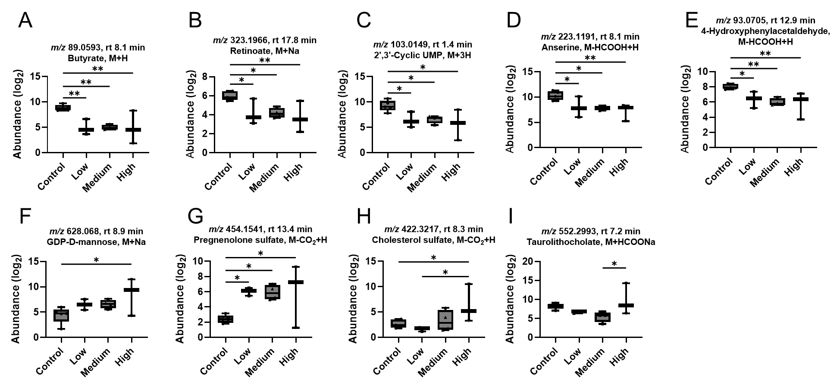
Fig. S1. Putatively annotated metabolites showing statistical significance among puff groups. (A) butyrate, (B) retinoate, (C) 2',3'-cyclic UMP, (D) anserine, (E) 4-hydroxyphenylacetaldehyde, (F) GDP-D-mannose, (G) pregnenolone sulfate, (H) cholesterol sulfate, and (I) taurolithocholate. One-way ANOVA with Fisher’s LSD post hoc test was performed to obtain statistical significance between groups, with *p < 0.05, and **p < 0.01. Low: puff volumes < 90 mL/puff; Medium:130 mL/puff > puff volumes > 90 mL/puff; High: puff volumes > 130 mL/puff.

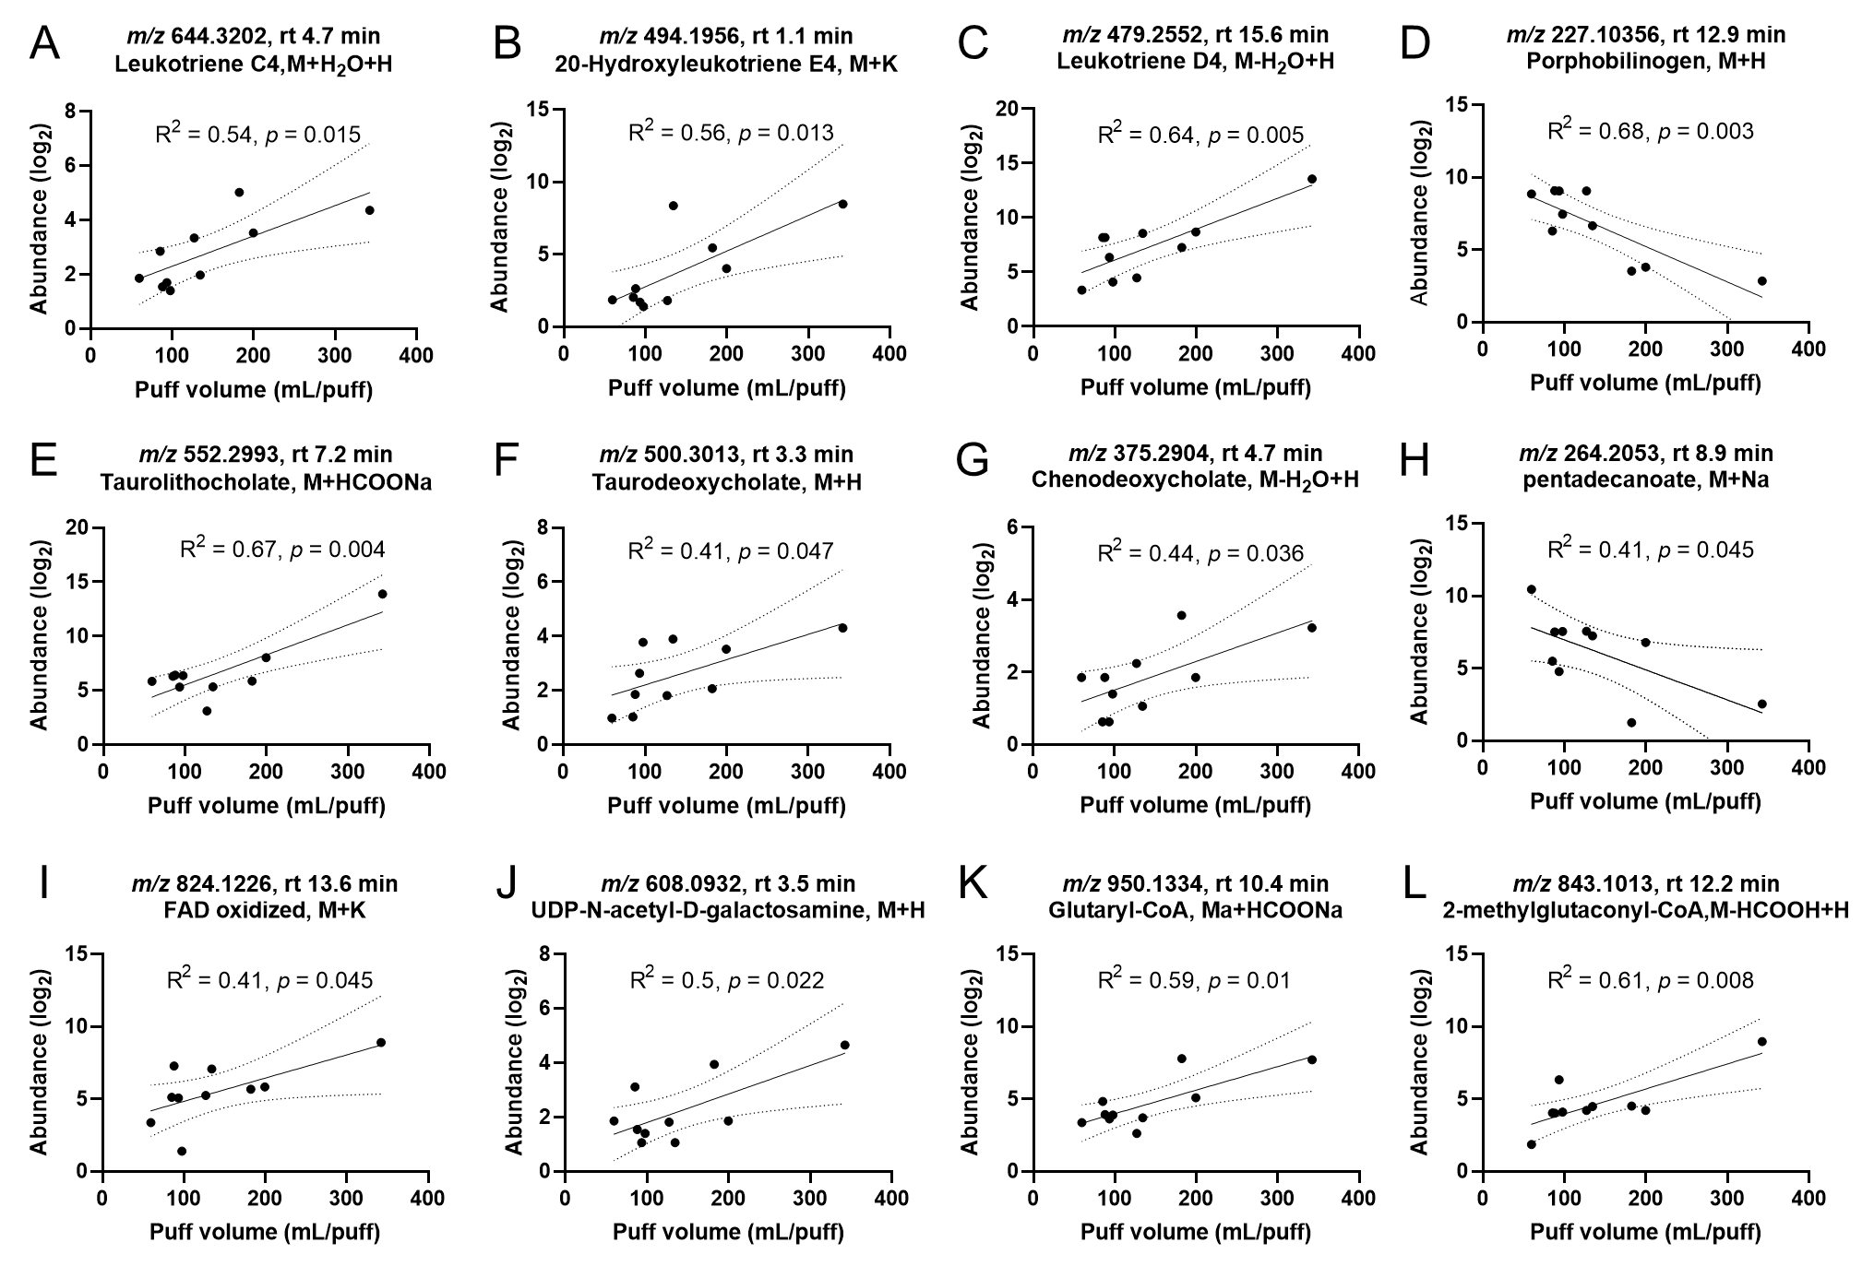
Figure. S2. Selected metabolites with putative annotations from cluster 7 in Fig. 3A. (A) Leukotriene C4. (B) 20-Hydroxyleukotriene E4. (C) Leukotriene D4. (D) Porphobilinogen. (E) Taurolithocholate. (F) Taurodeoxycholate. (G) Chenodeoxycholate. (H) Pentadecanoate. (I) FAD oxidized. (J) UDP-N-acetyl-D-galactosamine. (K) Glutaryl-CoA. (L) 2-Methylglutaconyl-CoA.

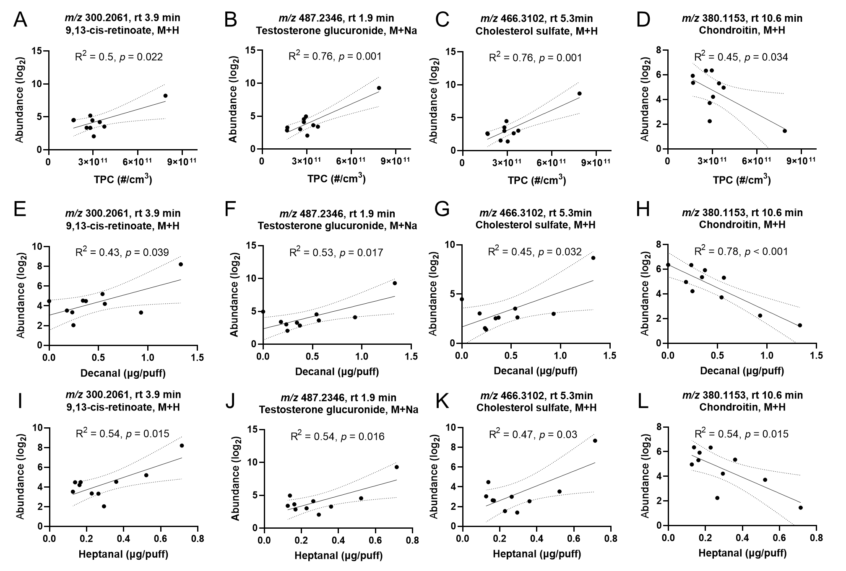
Fig. S3. Selected metabolites associated with particle characterizations (A-D) and VOCs (E-L) from firsthand emission. (A,E, I) 9,13-cis-retinoate. (B,F, J) Testosterone glucuronide. (C, G,K) Cholesterol sulfate. (D, H, L) Chondroitin. VOC in (E-H) was decanal, and in (I-L) was heptanal. TPC: total particle counts.

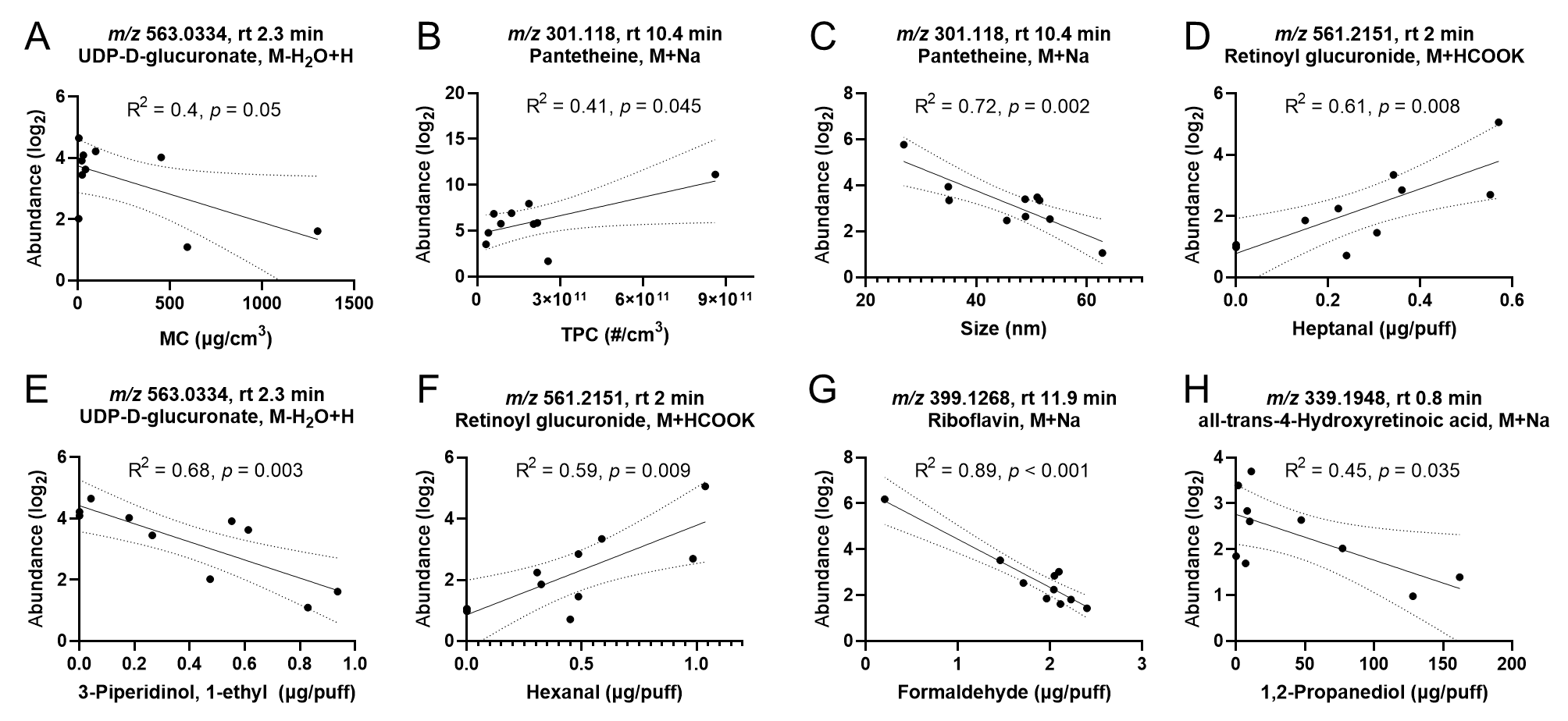
Fig. S4. Selected metabolites associated with particle characterizations (A-C) and VOCs (D-H) from secondhand emission. (A, E) UDP-D-glucuronate. (B, C) Pantetheine. (D, F) Retinoyl glucuronide. (G) Riboflavin. (H) all-trans-4-Hydroxyretinoic acid.

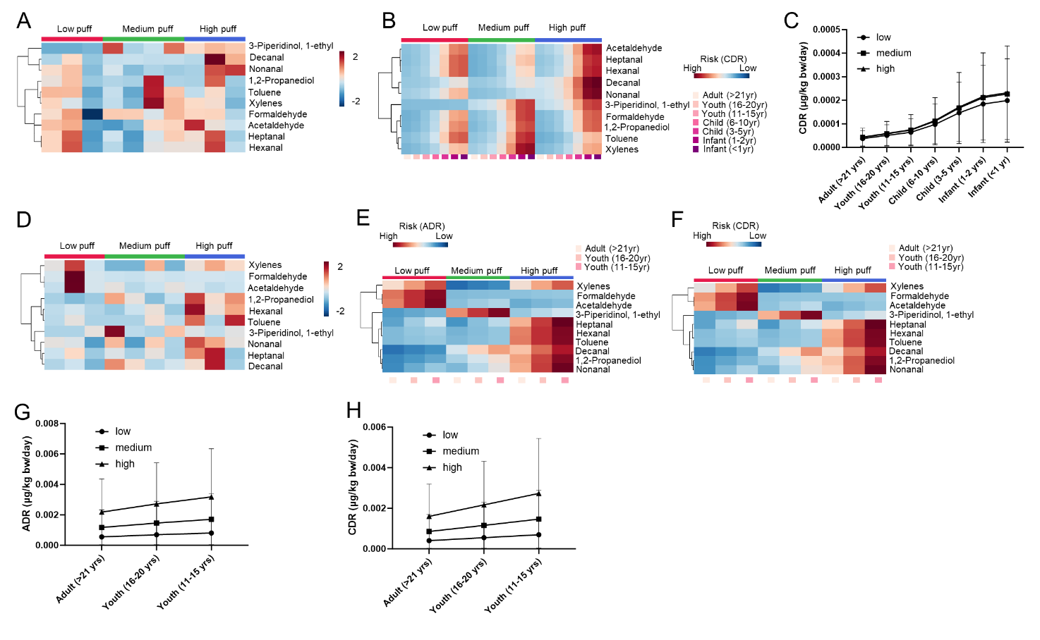
Fig. S5. VOC emission and exposure risk from secondhand and firsthand exposure. HCA of top 10 shared VOCs from secondhand emissions (A) and firsthand emission (D). Modeled inhalation risk across different age groups is shown for VOCs from secondhand emission (B) and firsthand emission (E,F) Average estimated acute dose rate (ADR) for secondhand emission is shown in (C) and for firsthand emission in (G). Average estimated chronic dose rate (CDR) for secondhand emission is shown in (H).

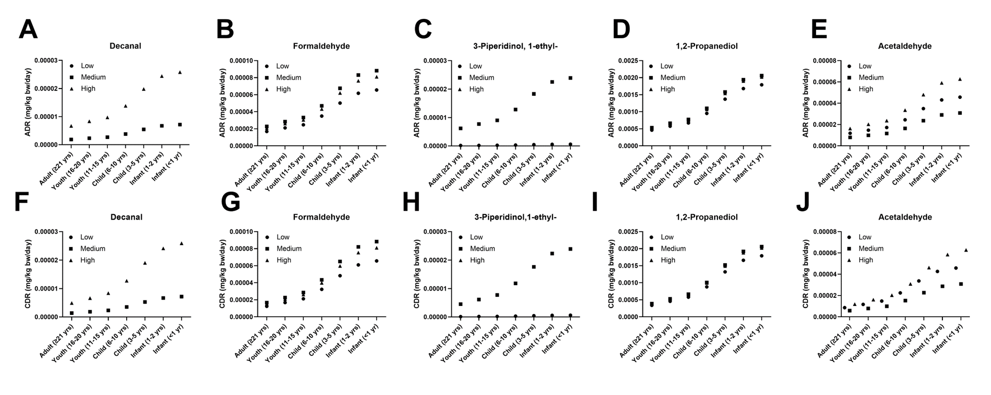
Fig. S6. Modeled acute (A-E) and chronic (F-J) inhalation risk across different age groups for VOCs from secondhand emission. (A, F) Decanal. (B, G) Formaldehyde. (C, H) 3-Piperidinol, 1-ethyl-. (D, I) 1,2-Propanediol. (E, J) Acetaldehyde. Mixed-model ANOVA shows significant effects within puff groups and age groups.

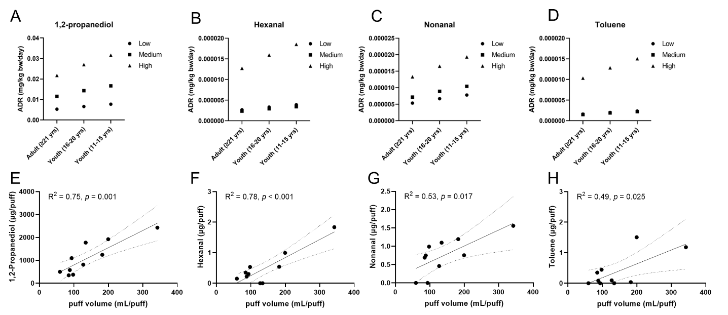

Fig. S7. Selected VOCs from firsthand emission showing puff-volume dependent pattern. (A, E) 1,2-Propanediol. (B, F) Hexanal. (C, G) Nonanal. (D, H) Toluene. Mixed-model ANOVA shows significant effects within puff groups and age groups.

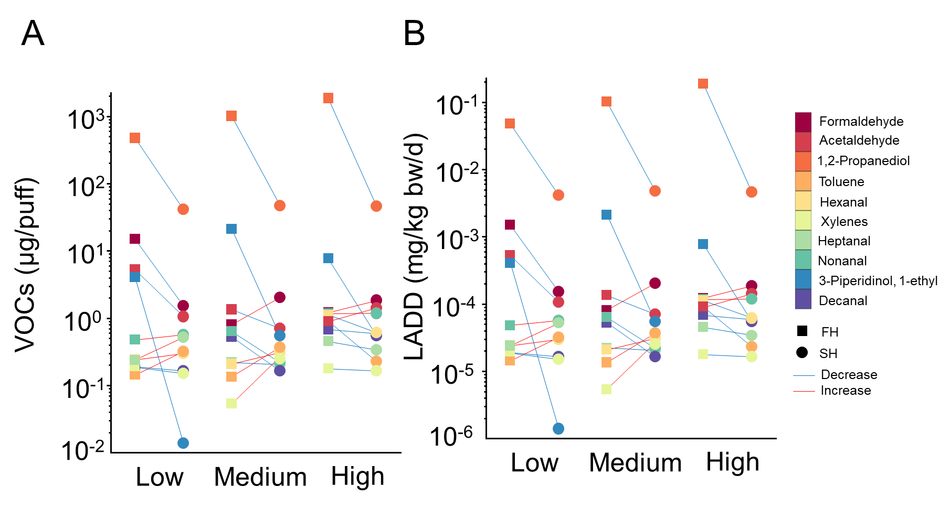
Fig. S8. Directional changes of VOCs abundance (A) and modeled health risks for lifetime exposure (B) from firsthand and secondhand emissions. LADD: lifetime average daily dose.

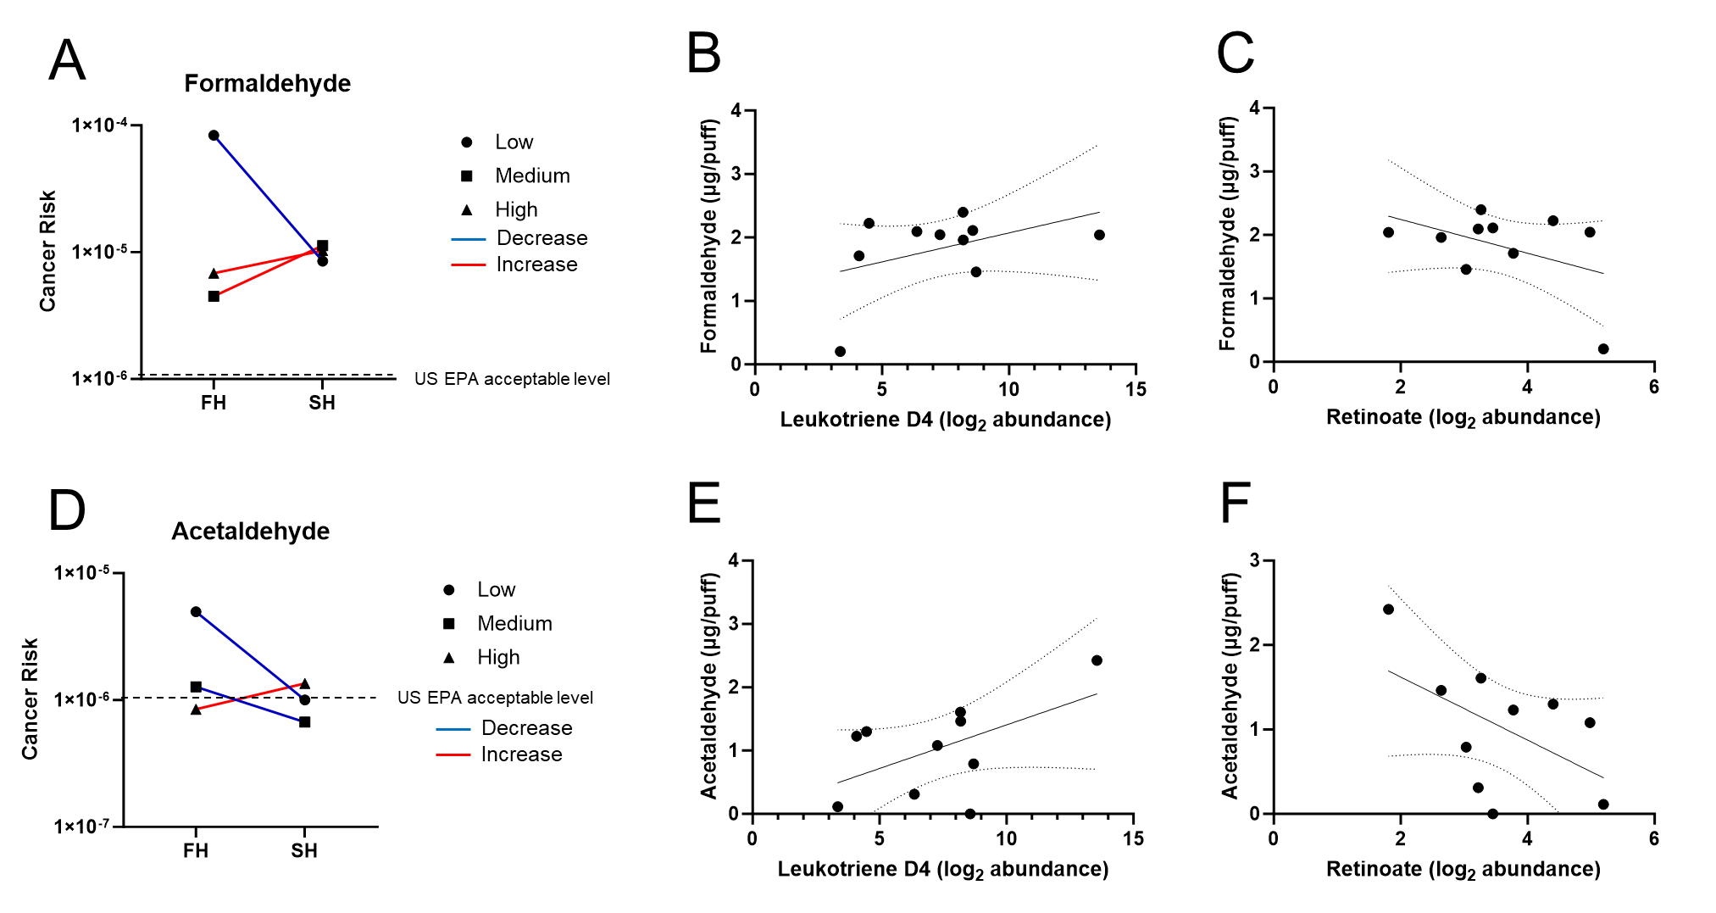
Fig. S9. Calculated cancer risk for formaldehyde (A) and acetaldehyde (D). Correlation is shown for formaldehyde from secondhand emission and leukotriene D4 (B) and retinoate (C) in saliva. (E,F) show the correlation between acetaldehyde and leukotriene D4 and retinoate in saliva.

