Supplementary Information (SI):
Unpacking Future Climate Extremes in Western Nepal and their Sectoral Implications

Dipesh Chapagain^{1,*}, Sanita Dhaubanjar², Luna Bharati^{1,2}

¹Center for Development Research (ZEF), University of Bonn, Bonn, Germany
²International Water Management Institute (IWMI), Kathmandu, Nepal

*Corresponding author
Email: dipesh@uni-bonn.de
ORCID iD: https://orcid.org/0000-0002-2418-6343

Table S1: List and details of meteorological stations selected for this study

Station Name | Index No. | District | Latitude | Logitude | Elevation | Region
Dadeldhura | s104 | Dadeldhura | 29.300 | 80.583 | 1848 | Highland
Chainpur (West) | s202 | Bajhang | 29.550 | 81.217 | 1304 | Highland
Tikapur | s207 | Kailali | 28.533 | 81.117 | 140 | Lowland
Dhangadi Airport | s209 | Kaliali | 28.800 | 80.550 | 187 | Lowland
Jumla | s303 | Jumla | 29.283 | 82.167 | 2300 | Highland
Chisapani | s405 | Bardiya | 28.650 | 81.267 | 225 | Lowland
Birendranagar | s406 | Surkhet | 28.600 | 81.617 | 720 | Lowland
Chaur Jhari Tar | s513 | Rukum | 28.633 | 82.200 | 910 | Lowland
Musikot | s514 | Rukum | 28.633 | 82.483 | 2100 | Highland

Table S2: List of consulted experts during indices selection process and study of sectoral implications.

S. No. | Name | Affiliation | Sector
1 | Dipak Gyawali | Nepal Academy of Science and Technology (NAST) | Water Resource and Energy, Climate Induced Disaster, Agriculture and Food Security, Tourism
2 | Dr. Khadga Bahadur Bisht | IPPAN | Water Resource and Energy
3 | Anup Gurung | Nepal Kayak Club | Tourism
4 | Dr. Sanjeev Bhuchar | International Centre for Integrated Mountain Development (ICIMOD) | Tourism
5 | Dr. Ram Chandra Bastakoti | National Planning Commission, Government of Nepal | Agriculture and Food Security
6 | Bishnu Prasad Paudel | Nepal Agricultural Research Council (NARC), Government of Nepal | Agriculture and Food Security
7 | Dr. Madhav Karki | IUCN Commission on Ecosystem Management | Forest and Biodiversity, Agriculture and Food Secutiry
8 | Sadiksha Rai | Department of Water Resources and Irrigation, Government of Nepal | Water Resource and Energy, Climate Induced Disaster
9 | Dr. Sailesh Ranjitkar | Honghe Center of Mountain Futures, China/  Mid-Western University, Nepal. | Agriculture and Food Security, Forest and Biodiversity
10 | Anup KC | Clemson University, USA | Tourism
11 | Rajan Thapa | Oxford Policy Management | Climate Induced Disaster
12 | Dr. Rocky Talchabhadel | Texas A&M University, USA | Climate Induced Disaster
13 | Jeeban Panthi | University of Rhode Island, USA | Water Resources and Energy, Climate induced Disaster
14 | Dr. Meghnath Dhimal | Nepal Health Research Council (NHRC) | Public Health
15 | Dr. Uttam Khanal | Queensland University of Technology, Australia | Agriculture and Food Security

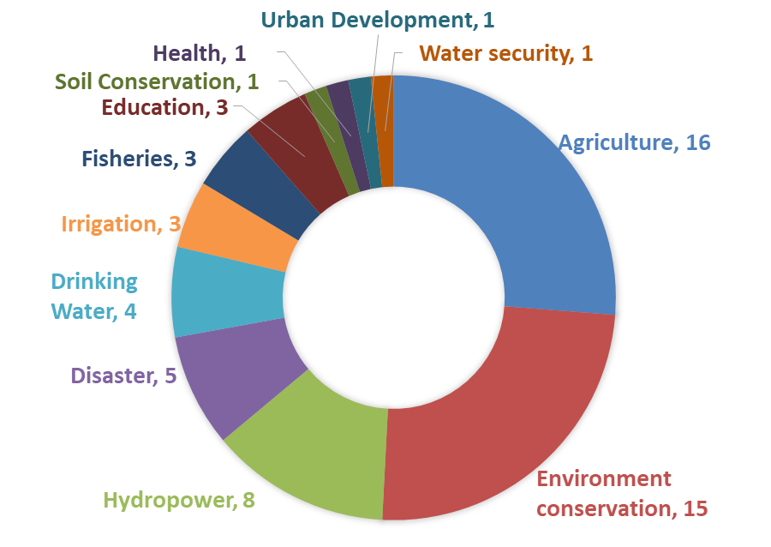

Fig. S1 Sectoral background of participants in stakeholder consultation workshop

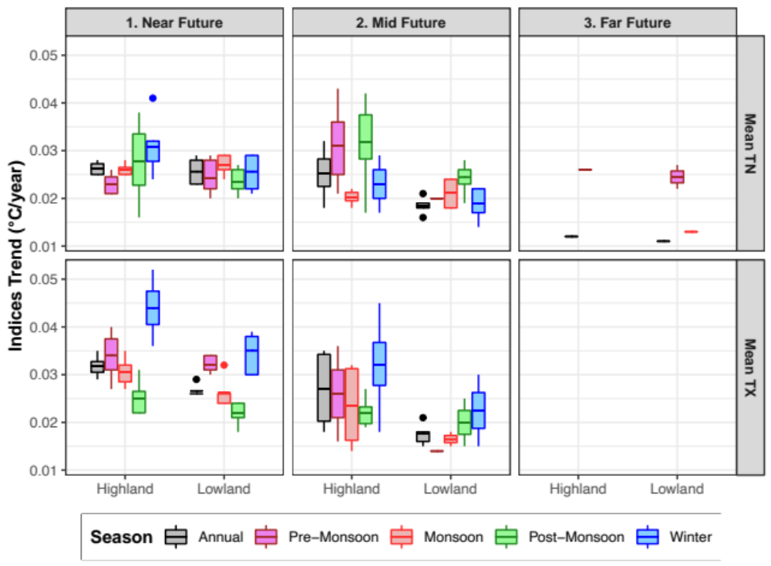
Fig. S2 Projected annual and seasonal mean temperature index trends for Karnali by future timeframe and geographical region in the RCP4.5 scenario. The middle dark lines represent the mean; the boxes represent the interquartile range; the whiskers represent the minimum and maximum values; and the dots represent outliers
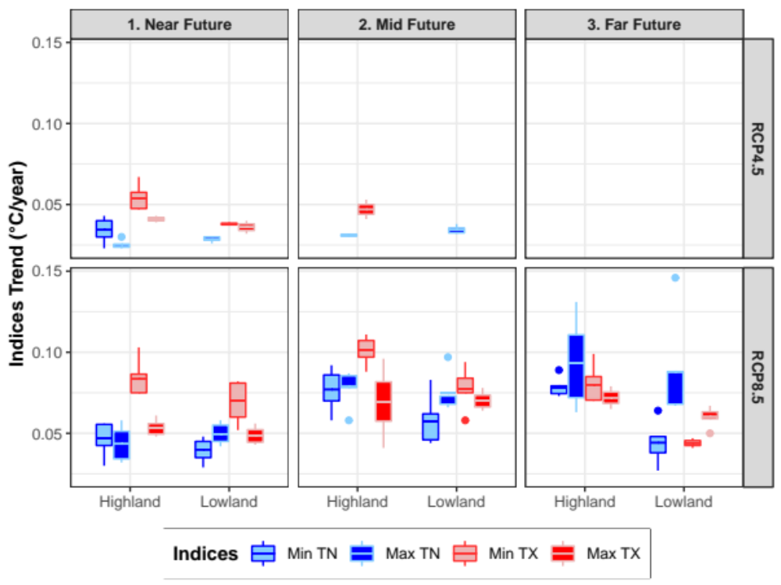Fig. S3 Projected absolute-value-based extreme temperature index trends for Karnali by future timeframe, geographical region, and emission scenario. Symbols are as defined in Fig. S2

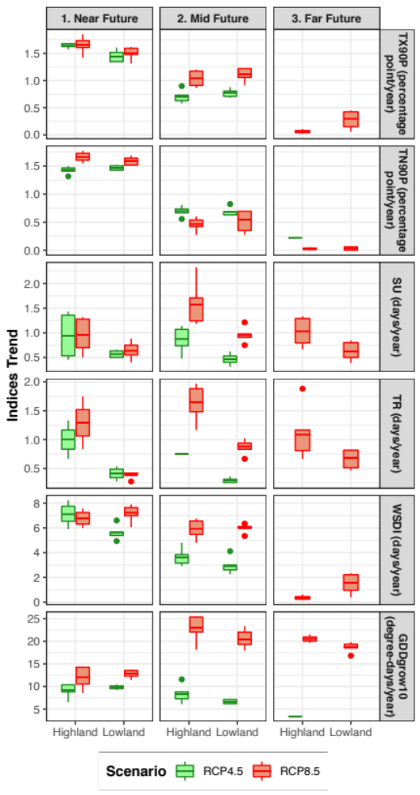
Fig. S4 Projected percentile- and duration-based extreme temperature index trends for Karnali by future timeframe, geographical region, and emission scenario (different y-axis scales are used for each index). Symbols are as defined in Fig. S2

