Appendix File for: Understanding the motivators and barriers to sharing participant-level data and samples: A cross-sectional study with acute febrile illness cohort teams

Appendix Figure 1A. Comparison of motivators for sharing participant-level clinical-epidemiological data by respondent role in the cohort (PI vs non-PI)
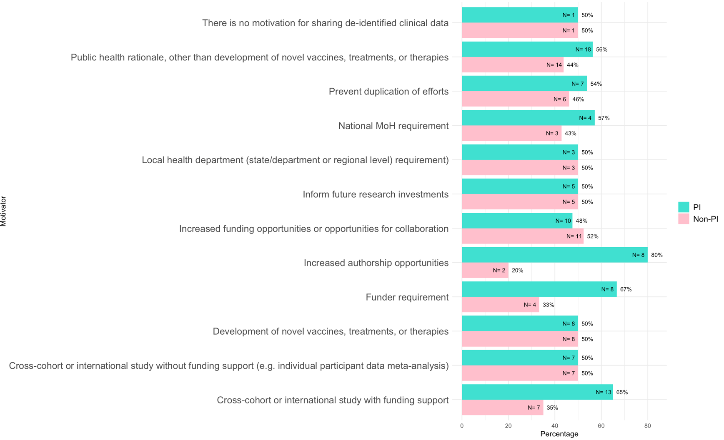

Appendix Figure 1B. Comparison of motivators for sharing human biological samples by respondent role in the cohort (PI vs non-PI)
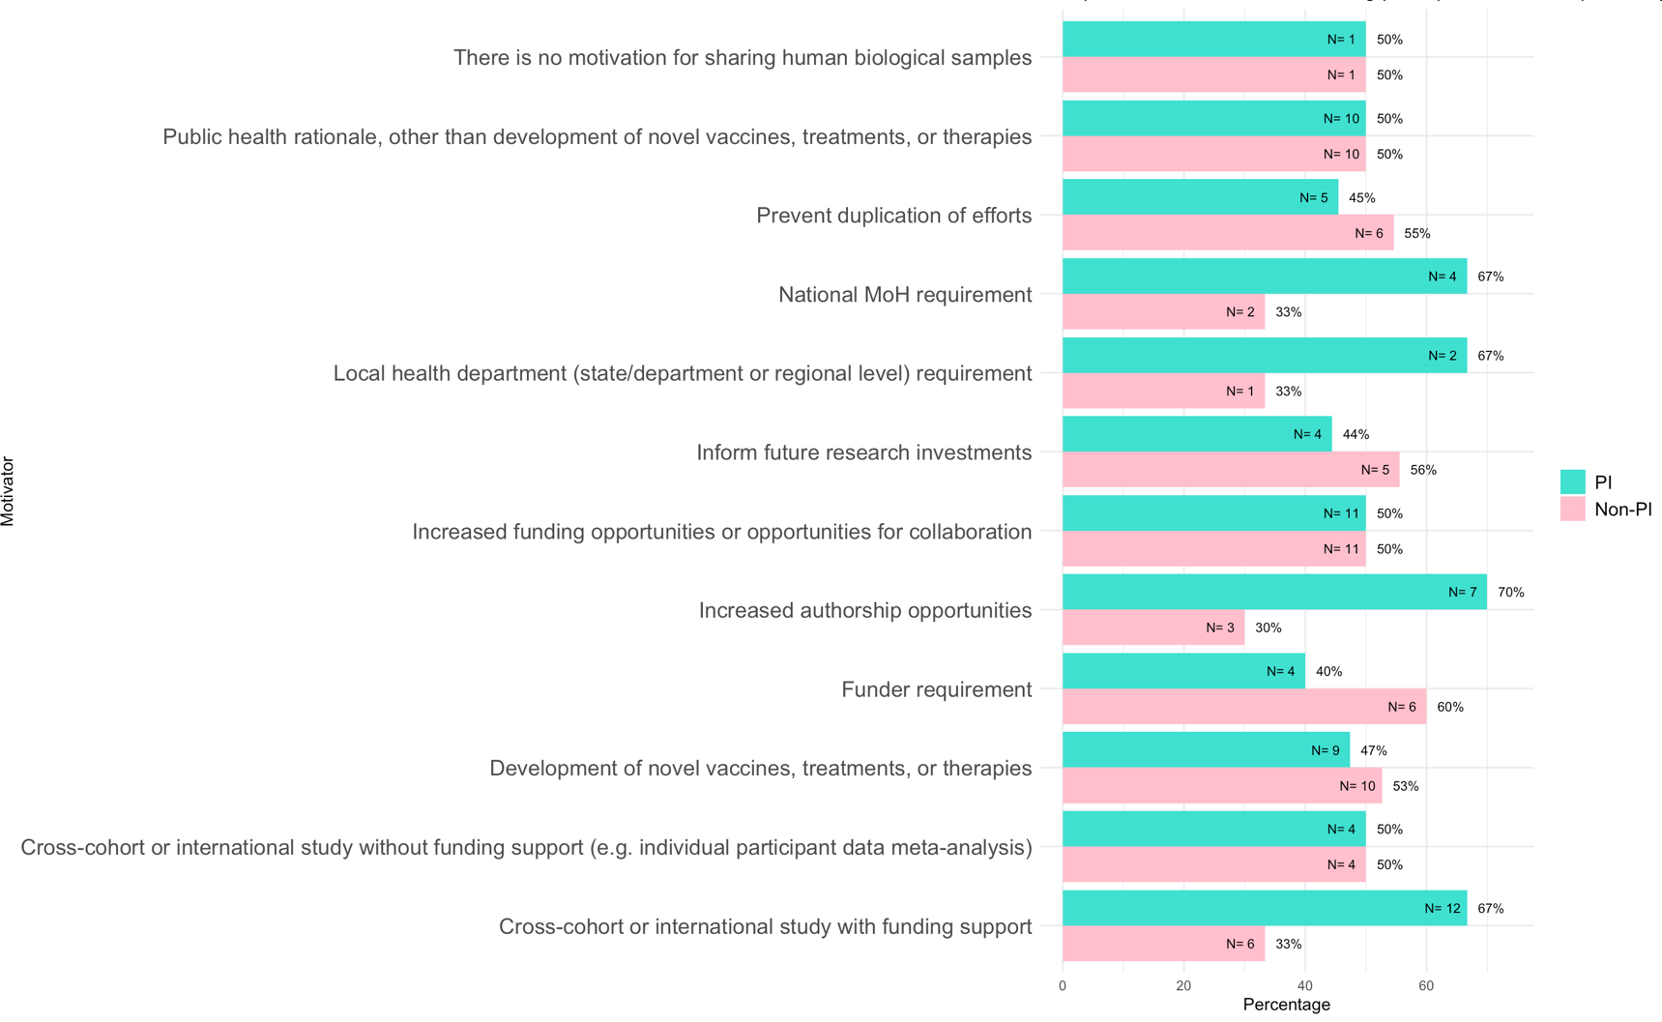

Appendix Figure 1C. Comparison of motivators for sharing human genetic data by respondent role in the cohort (PI vs non-PI)
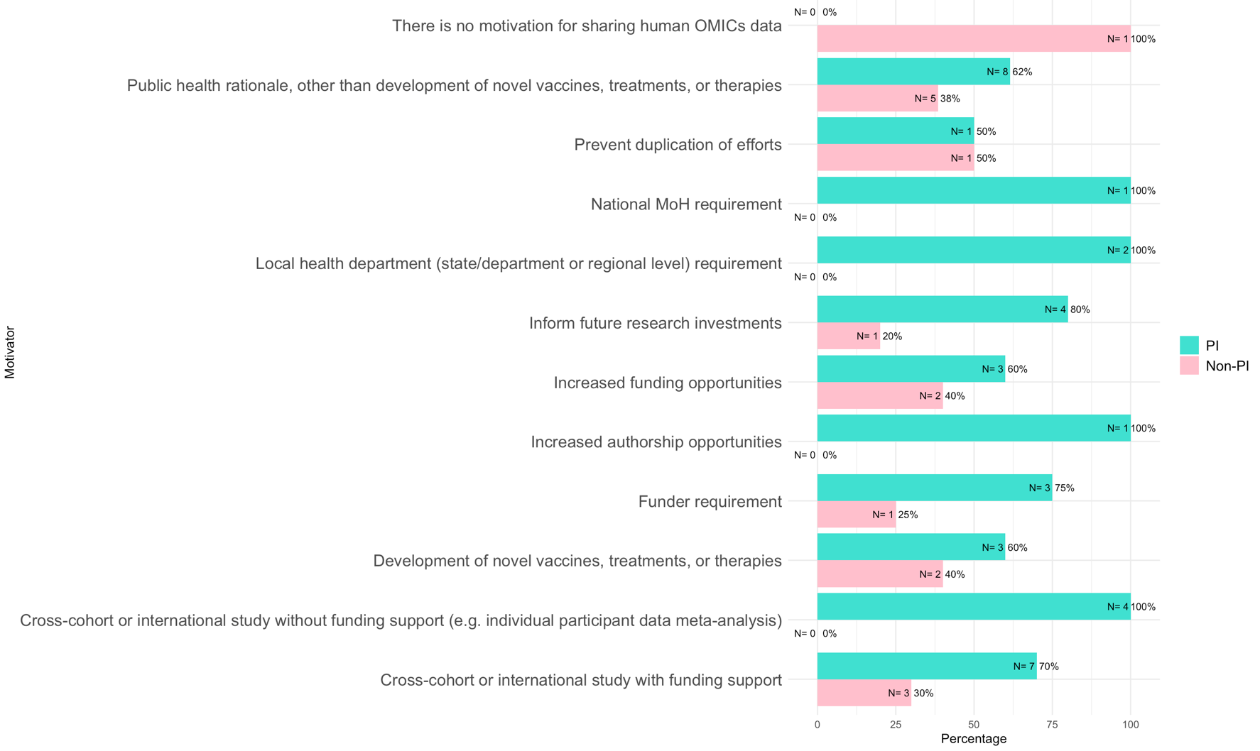

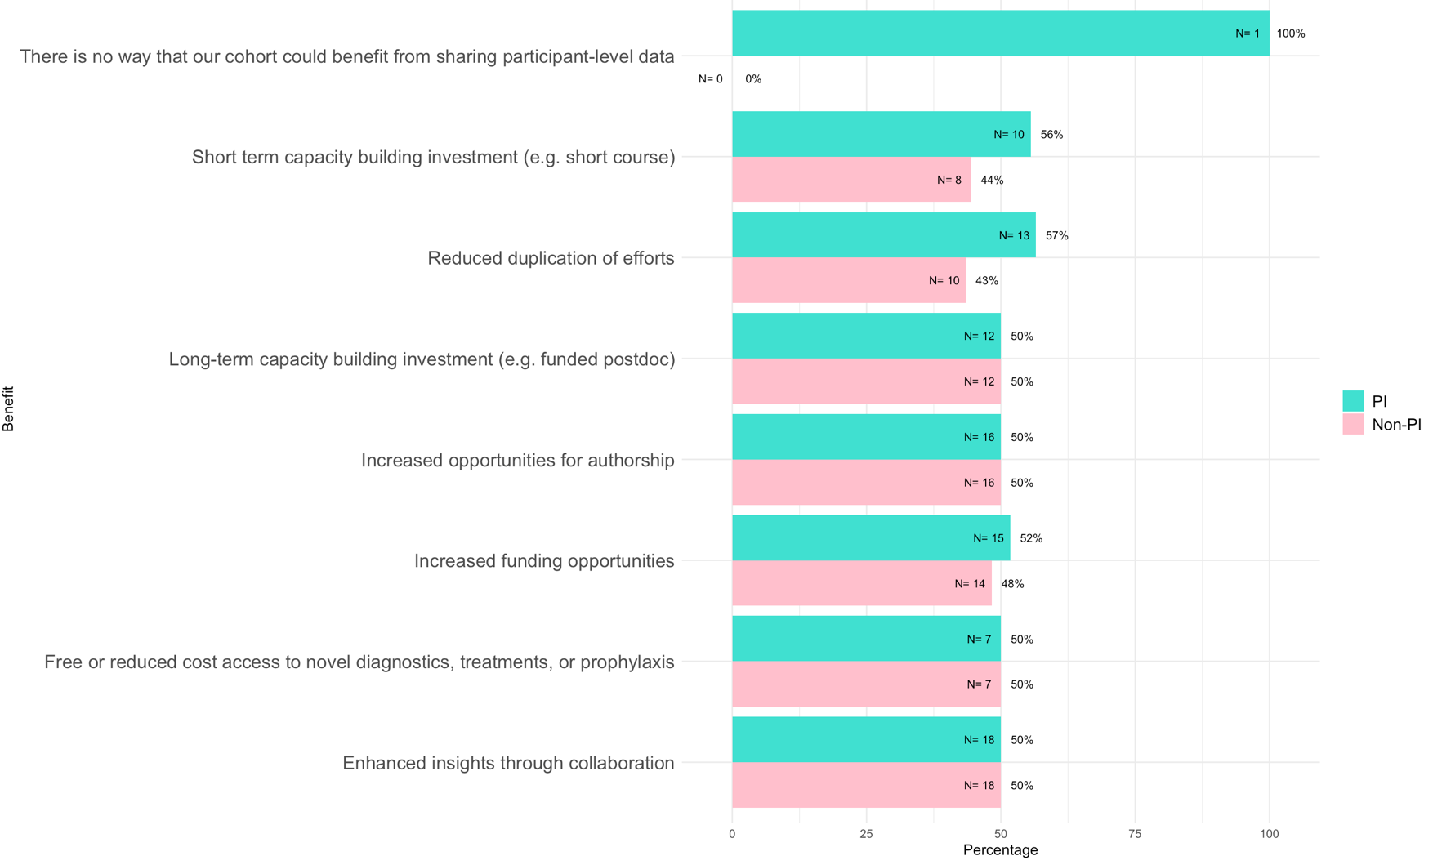
Appendix Figure 2A. Comparison of benefits of sharing participant-level clinical-epidemiological data by respondent role in the cohort (PI vs non-PI)

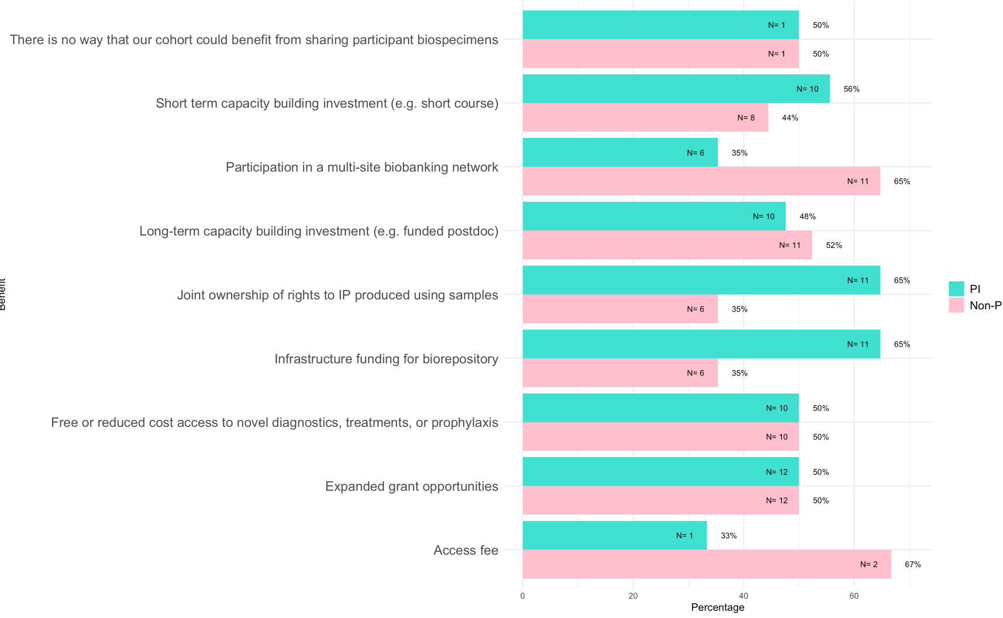
Appendix Figure 2B. Comparison of benefits of sharing human biological samples by respondent role in the cohort (PI vs non-PI)

Benefits
Benefits

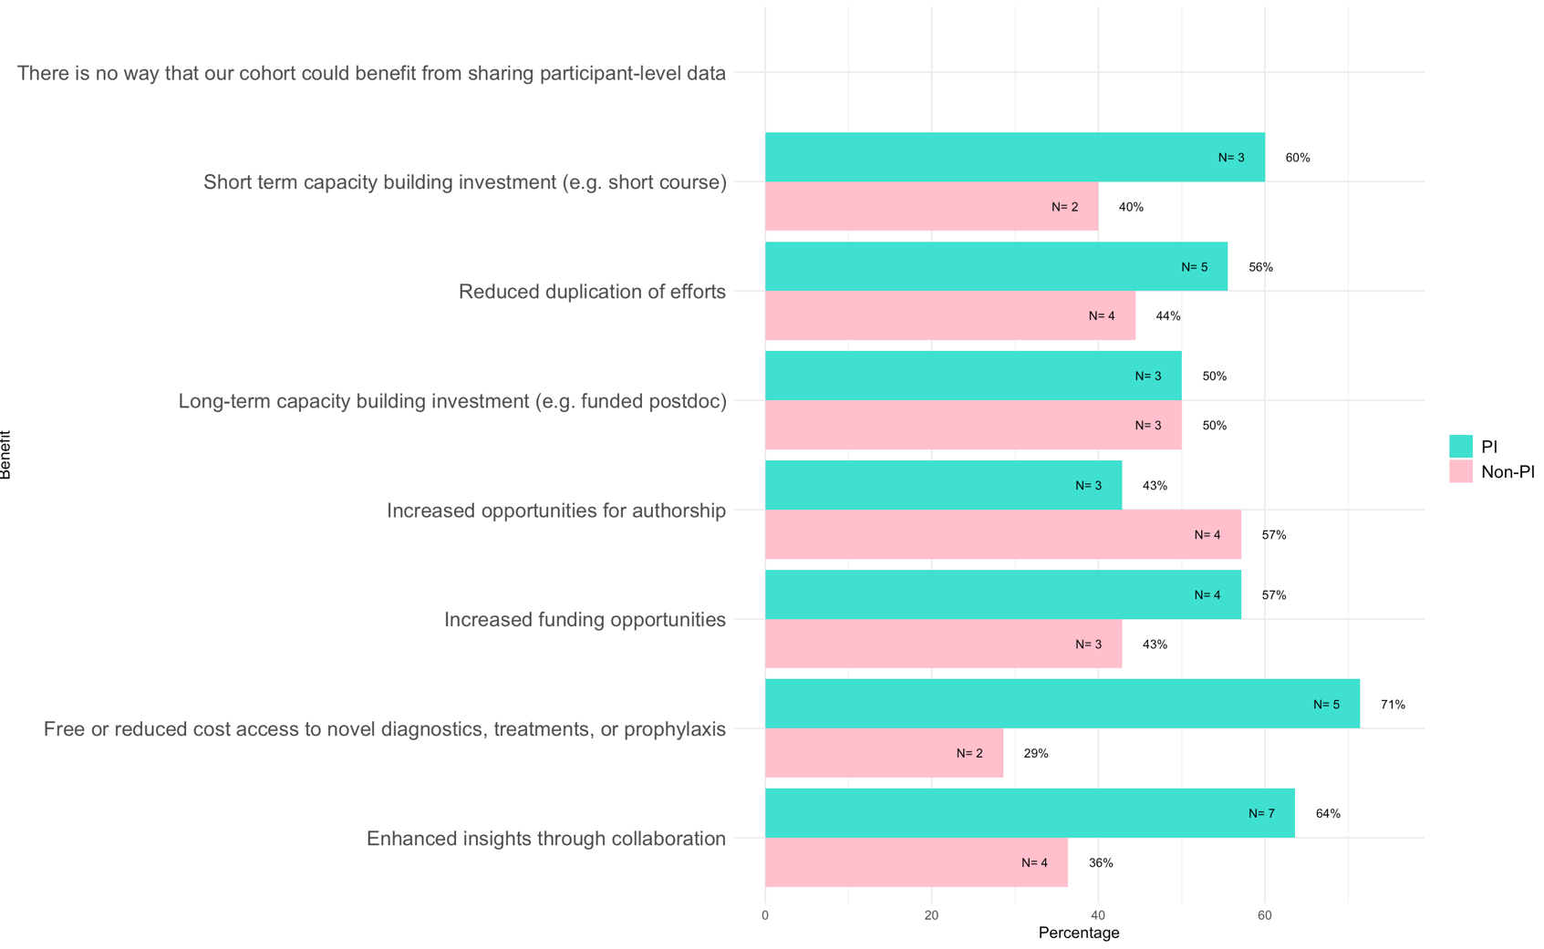
Appendix Figure 2C. Comparison of benefits of sharing human omics data by respondent role in the cohort (PI vs non-PI)

Benefits

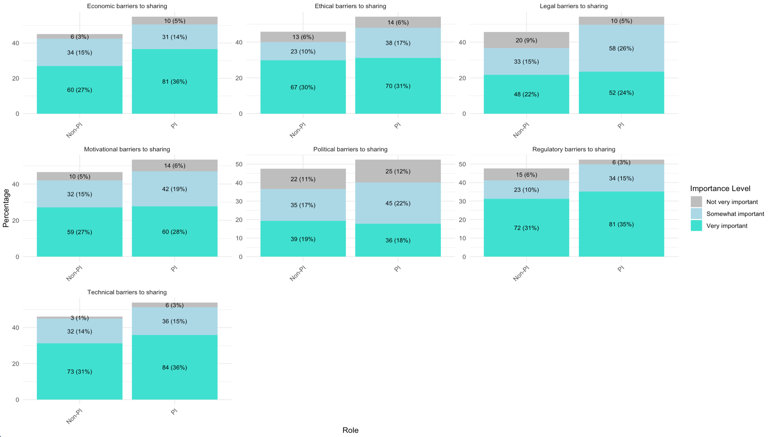
Appendix Figure 3. Barriers to sharing by respondent role in the cohort (PI vs non-PI)

Appendix Figure 4. Barriers to sharing data and samples by respondent role in the cohort (PI vs non-PI) and data type

Appendix Figure 5A. Barriers to sharing data and samples during epidemics by respondent role in the cohort (PI vs non-PI)

Appendix Table 1. Number of respondents to barriers questions in Appendix Figure 5A.
N | Economic barriers | Ethical barriers | Legal barriers | Motivational barriers | Political barriers | Regulatory barriers | Technical barriers
Clin-epi data
PI | 31 | 32 | 32 | 28 | 26 | 30 | 33
Non-PI | 25 | 26 | 25 | 25 | 22 | 27 | 27
Human genetic data
PI | 7 | 7 | 7 | 7 | 7 | 7 | 7
Non-PI | 3 | 3 | 3 | 3 | 3 | 3 | 4
Human biological samples
PI | 28 | 28 | 24 | 27 | 23 | 27 | 29
Non-PI | 20 | 21 | 20 | 20 | 21 | 23 | 22

Appendix Figure 5B. Barriers to sharing data and samples outside of epidemic settings according to respondent role in the cohort (PI vs non-PI)

Appendix Table 2. Number of respondents to barriers questions in Appendix Figure 5A.
N | Economic barriers | Ethical barriers | Legal barriers | Motivational barriers | Political barriers | Regulatory barriers | Technical barriers
Clin-epi data
PI | 26 | 25 | 25 | 24 | 22 | 26 | 26
Non-PI | 23 | 23 | 24 | 26 | 22 | 25 | 27
Human genetic data
PI | 9 | 10 | 10 | 9 | 9 | 10 | 9
Non-PI | 3 | 3 | 3 | 3 | 3 | 3 | 3
Human biological samples
PI | 26 | 27 | 27 | 23 | 25 | 28 | 25
Non-PI | 21 | 20 | 21 | 22 | 19 | 22 | 22

