Supplementary Table S1 The sequences of siRNA or shRNA
si-circRPS6KC1#1 | GGTGTTCAAGGGTGGAATA
si-circRPS6KC1#2 | TAGAAGGTGTTCAAGGGTG
sh-circRPS6KC1 | TAGAAGGTGTTCAAGGGTG
siMETTL3#1 | CCUGCAAGUAUGUUCACUA
siMETTL3#2 | GCUACCUGGACGUCAGUAU
sh-METTL3 | CCUGCAAGUAUGUUCACUA
siYTHDF1#1 | GCACTGACTGGTGTCCTTT
siYTHDF1#2 | ACGGCAGAGTCGAAACAAA
siFOXM1#1 | CCAACAATGCTAATATTCA
siFOXM1#2 | GGACCACUUUCCCUACUUU

Supplementary Table S2 The sequences of PCR primers
circRPS6KC1-F | AATCGACCGCACAGAGCTCA
circRPS6KC1-R | GGTCCAGGGAGGTCCTCAAG
circRPS6KC1-convergent-F | AGCTCACTCAGATTCCCTCA
circRPS6KC1-convergent-R | GCCCCTAGTGCTGAAGAATC
METTL3-F | CCAGCTATGCTTCAGATCGCCT
METTL3-R | GGTTCTCTTCCTTGTCCATCTCC
YTHDF1-F | ACCTGTCCAGCTATTACCCG
YTHDF1-R | TGGTGAGGTATGGAATCGGAG
FOXM1-F | TGCAGCTAGGGATGTGAATCTTC
FOXM1-R | GGAGCCCAGTCCATCAGAACT
RPS6KC1-F | TCTTACCGGGAGCGGAGT
RPS6KC1-R | TCTCTTCCATACAATTATCTCCTGG
GAPDH-convergent-F | GCCGTCTAGAAAAACCTGCC
GAPDH-convergent-R | CCACCTGGTGCTCAGTGTAG
GAPDH-divergent-F | CGACCACTTTGTCAAGCTCA
GAPDH-divergent-R | GACCTTCACCTTCCCCATTT
β-actin-F | CATGTACGTTGCTATCCAGGC
β-actin-R | CTCCTTAATGTCACGCACGAT
CDKN1A-F | AGTCAGTTCCTTGTGGAGCC
CDKN1A-R | CATTAGCGCATCACAGTCGC
PCNA-F | CCTGCTGGGATATTAGCTCCA
PCNA-R | CAGCGGTAGGTGTCGAAGC
circRPS6KC1-MeRIP-F | GATTCTTCAGCACTAGGGGC
circRPS6KC1-MeRIP-R | CCAGGAAAGAGGCTACGACT
PCNA-ChIP-binding site 1-F | AGCCTGGGTGTCAAAGGG
PCNA-ChIP-binding site 1-R | AAAAGGGAACAGGAAAGGGC
PCNA-ChIP-binding site 2-F | TGCCTAAGTGCTCAAAGGTGT
PCNA-ChIP-binding site 2-R | GCACTCATTCCGTAAACACTTGG
hsa-miR-4778-3p-F | TCTTCTTCCTTTGCAGAGTTGA
hsa-miR-4786-3p-F | TGAAGCCAGCTCTGGTCTGGGC
hsa-miR-4659a-3p-F | TTTCTTCTTAGACATGGCAACG
hsa-miR-4659b-3p-F | TTTCTTCTTAGACATGGCAGCT
hsa-miR-761-F | GCAGCAGGGTGAAACTGACACA

Supplementary Table S3 The sequence of circRPS6KC1 and NC probes
circRPS6KC1 probe | TATTCCACCCTTGAACACCTTCTAGG
NC probe | CCTAGAAGGTGTTCAAGGGTGGAATA

Supplemental Fig. 1 The sequence and SRAMP predicting results of hsa_circ_0001583 and hsa_circ_0001584

> hsa_circ_0001583
GTTAAAAAGGCGGGCGGAACCAAACCTAAGAAGCCAGTTGGGGCAGCCAAGAAGCCCAAGAAGGCGGCTGGCGGCGCAACTCCGAAGAAGAGCGCTAAGAAAACACCGAAGAAAGCGAAGAAGCCGGCCGCGGCCACTGTAACCAAGAAAGTGGCTAAGAGCCCAAAGAAGGCCAAG
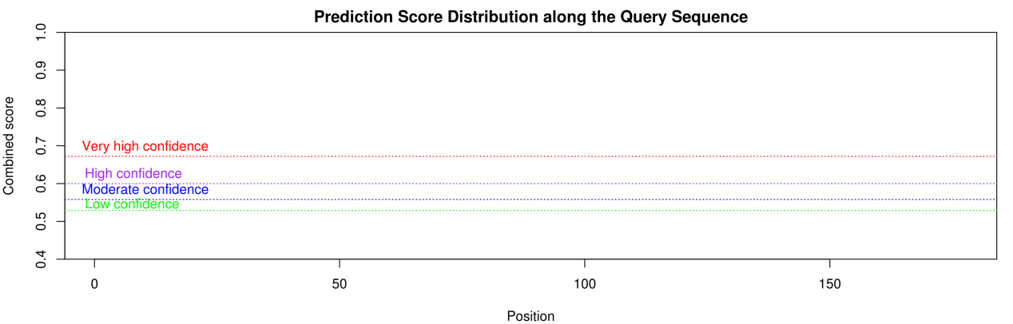
> hsa_circ_0001584
GTTTGGTTCCGCCCGCCTTTTTAACCTTGGGCTTGGCTTCCCCGGAGGCTGCCTTCTTGTTGAGTTTAAAGGAGCCAGAAGCACCGGTGCCTTTCGTTTGCACCAGAGTGCCCTTGCTCACCAGGCTCTTGAGACCAA
