Supplementary Information
Poly(ionic liquid) electrolytes at an extreme salt concentration for solid-state batteries
Shinji Kondou^{1,2,3,4*}, Mohanad Abdullah ⁵, Ivan Popov⁶, Murillo L. Martins⁵, Luke A. O’Dell^{1,2}, Hiroyuki Ueda^{1,2}, Faezeh Makhlooghiazad^{1,2}, Azusa Nakanishi¹, Taku Sudoh⁴, Kazuhide Ueno^{4,7}, Masayoshi Watanabe⁷, Patrick Howlett^{1,2}, Heng Zhang⁸, Michel Armand⁹, Alexei P. Sokolov^{5,10}, Maria Forsyth^{1,2*}, Fangfang Chen^{1*}
¹ Institute for Frontier Materials, Deakin University, Burwood, VIC 3125, Australia
²ARC Industry Transformation Training Centre for Future Energy Technologies, Deakin University, Burwood, VIC 3125, Australia
³ Department of Materials Engineering Science, Osaka University, 1-3, Machikaneyama, Toyonaka, Osaka 560-8531, Japan
⁴ Department of Chemistry and Life Science, Yokohama National University, 79-5 Tokiwadai, Hodogaya-ku, Yokohama 240-8501, Japan
⁵ Department of Chemistry, University of Tennessee, Knoxville, Tennessee 37996, United States
⁶ University of Tennessee - Oak Ridge Innovation Institute, University of Tennessee, Knoxville, Tennessee 37996, United States
⁷ Advanced Chemical Energy Research Centre (ACERC), Institute of Advanced Sciences, Yokohama National University, 79-5 Tokiwadai, Hodogaya-ku, Yokohama 240-8501, Japan
⁸ Key Laboratory of Material Chemistry for Energy Conversion and Storage (Ministry of Education), School of Chemistry and Chemical Engineering, Huazhong University of Science and Technology Luoyu Road 1037, 430074, Wuhan, China
⁹ Center for Cooperative Research on Alternative Energies (CIC energiGUNE), Basque Research and Technology Alliance (BRTA), 01510 Vitoria Gasteiz, Spain
¹⁰ Chemical Sciences Division, Oak Ridge National Laboratory, Oak Ridge, Tennessee 37831, United States

Table of Contents
Supplementary Figure 1…………………………………………….………………………...……… 2
Supplementary Note 1...……………...…………………………….………………………….............3
Supplementary Figure 2 and Table 1……………………………….…………………………...…….4
Supplementary Figure 3 …………………………….…..………….…………………………...……. 5
Supplementary Table 2..………………………………………….…………………………...….…...6
Supplementary Note 2…………………………………………….…………………………...….…...7
Supplementary Figure 4…………………………………………….…………………………...…….8
Supplementary Figure 5 ……………………………………………………………………....…...9
Supplementary Note 3, Figure 6……………………………………….…….……………………….10
Supplementary Figure 7…………….……….………………….………………….………......…….11
Supplementary Figure 8………………….……………………….………………………………….12
Supplementary Figure 9 and Table 3……..……………………….………………………………… 13
Supplementary Figure 10………………………………………….………………………………… 14
Supplementary Figure 11………………………………………….………………………………… 15

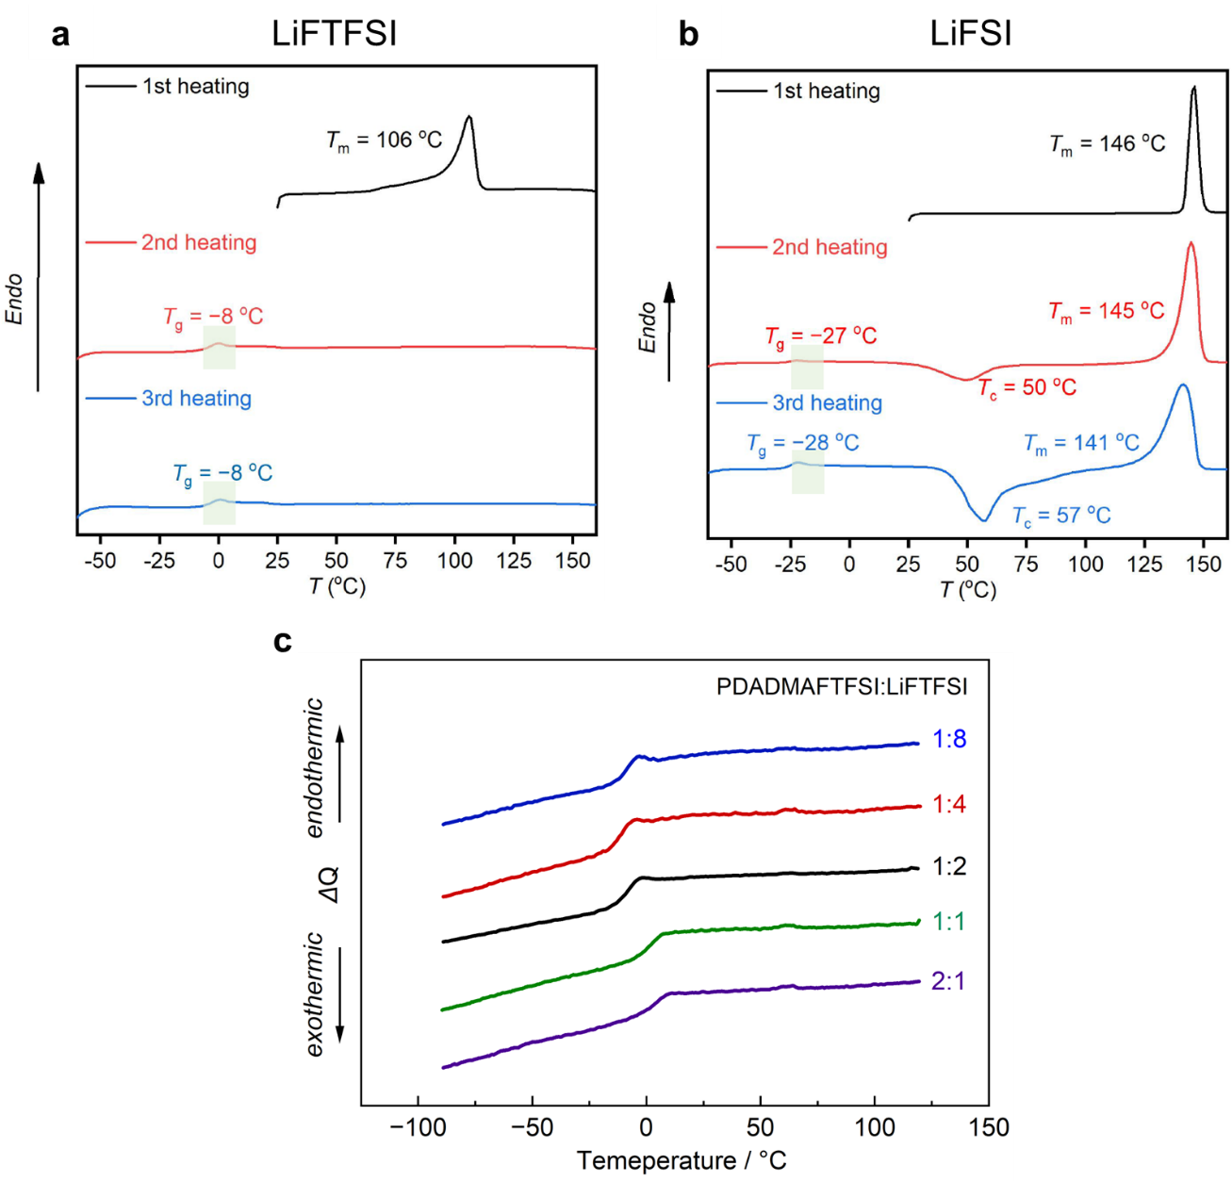
Supplementary Fig. 1 DSC thermograms: (a) pure LiFTFSI, (b) pure LiFSI, and (c) PDADMAFTFSI/LiFTFSI with different LiFTFSI content.

Supplementary Note 1: Computational methods
MD simulations were conducted using Gromacs (Version 2022.22). The system consists of 15 Polycation chains with each having 12 repeat units. Three polyIL: salt concentrations were investigated including 1:2 and 1:8 of PolyDADMA FSI: LiFTFSI and 1:4:4 of PolyDADMA FSI: LiFSI: LiFTFSI. The initial simulation box was prepared using Packmol. The system was heated to 700 K first and equilibrated for 7 ns in an NPT ensemble. This enhances the velocity of ions and allows the system to fully relax and quickly reach the equilibrium, which will be checked through energy and volume profiles. Then the system was cooled down to 393 K and equilibrated for another 7 ns. During this annealing simulation, the temperature and pressure coupling methods are V-rescale and Berendsen. The tau-t and tau-p is set at 0.1 and 1.0, respectively. The pressure is 1 bar. Velocity integrator is chosen. All h-bonds are constrained. A 1 fs time step is used. Then the system was cooled down again to 353 K in an NPT ensemble and equilibrated for a total of 50 ns. For this simulation, the nose-hoover temperature thermostat and Parrinello-Rahman barostat methods were chosen to control temperature and pressure. The tau-t and tau-p is set at 1 and 2. The PME (Particle Mesh Ewald) method was used for handling electrostatic interactions with periodic boundary conditions. Fourierspacing is 0.12 nm and the pme-order is 4. The cutoff value of Coulombic interactions and van der Waals interactions is 1.2 nm. The 20 ns NVT simulation was followed for diffusion analysis.
The non-polarisable all-atom OPLS_AA force field [JACS, 1995, 117, 5179-5197] functional was chosen. The force field parameters of PDADMA were reported in our previous research (X. Wang et al., Joule, 3, 2687–2702 (2019). & F. Chen et al., Nat. Mater., 21, 1175–1182 (2022)). The forcefield parameters of FSI and FTFSI are adopted from CL&P force field [Theor Chem Acc 2012, 131:1129], except for the atomic charges of FTFSI which were initially calculated using CHelpG charge scheme with Gaussian 09 software at the B3LYP/6-311++G(d,p) level of theory (Supplementary Fig. 2) . Then the charges were slightly modified to comply with the atomic charge on an equivalent site in TFSI anion in the CL&P force field. Table 1 listed all atomic charges for FSI and FTFSI in this research and those of TFSI are given as a comparison. A charge scaling factor of 0.7 was adopted to account for polarizable effect.
The anion-PDADMA and anion-Li coordination can be decided by comparing their distance with the coordination cutoff distance R1 or R2 marked in their radial distribution functions (Supplementary Fig. 3). This cutoff is usually the first prominent minimum value. The multiple minima for the first major coordination peak band are due to the different coordination geometries of anions with cations, for example, through N(FSI), bi-dentate (through O atoms on both sides of N) or monodentate (through O atoms on one side of N).

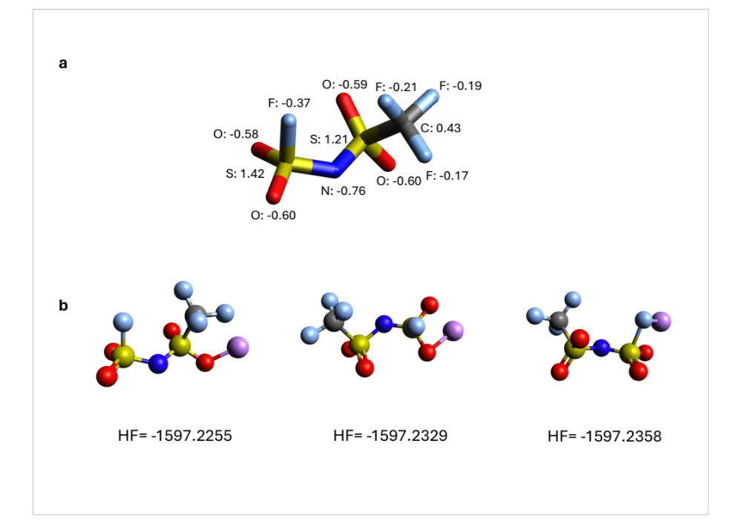
Supplementary Fig. 2. Density Functional Theory calculations at the B3LYP/6-311++G(d,p) level of theory.
(a) CHelpG charges calculated for FTFSI; (b) Conformational energy of different LiFTFSI monodentate coordinated conformers (in Hartree).

Supplementary Table 1. Atomic charges for FSI, TFSI and FTFSI used in the force field.
FSI | CL&P charge | TFSI | CL&P charge | FTFSI | Charge
N | -0.66 | N | -0.66 | N | -0.66
O | -0.53 | O | -0.53 | O | -0.53
S | 1.02 | S | 1.02 | S3 (with CF3) | 1.02
F (-F) | -0.13 | F (-CF3) | -0.16 | F3(-CF3) | -0.16
 |  | C | 0.35 | C3 | 0.35
 |  |  |  | S2 (with F) | 1.2
 |  |  |  | F2(-F) | -0.31

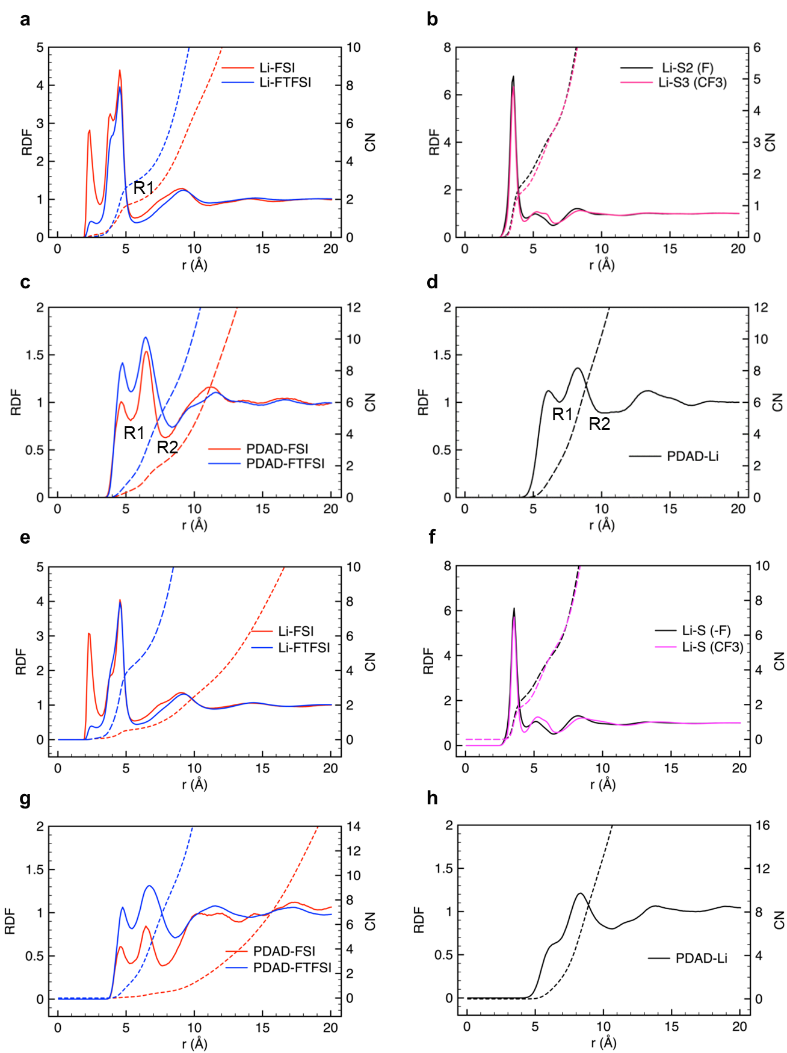
Supplementary Fig. 3 Radical Distribution Functions (RDF) and Coordination Number (CN) of Li-ions with N in FSI anions (red) and FTFSI anions (blue); Li ions with S2 (-F)(black) and S3 (-CF₃) (pink); nitrogen atom (N) in PDADMA chains with nitrogen atoms in FSI anions (red line) and FTFSI anions (blue line); N in PDADMA chains with Li-ions of (a-d) 1:2 and (e-h) 1:8 compositions, respectively. RDF and CN are plotted with solid and dotted lines.

Supplementary Table 2. Coordination numbers at different cutoffs for the 1:2 /1:8 systems.
coordination | R1 (Å) | CN | R2 (Å)* | CN
Li-FSI | 5.65 / 5.65 | 1.84 / 0.6
Li-FTFSI | 5.75 / 5.75 | 2.96 / 4.46
Li-S2 (S-F) | 4.45 / 4.45 | 1.82 / 2.55
Li-S3(S-CF3) | 4.35 / 4.25 | 1.51 / 0.09
PDADMA-FSI | 5.35 / 5.25 | 0.44 / 0.09 | 7.85 / 7.76 | 2.25 / 0.46
PDADMA-FTFSI | 5.35 / 5.45 | 1.16 / 1.4 | 8.35 / 8.55 | 6.35 / 9.3
PDAD-Li | 6.95 / 6.95 | 2.24 / 1.95 | 10.65 | 16.0
*The R1 and R2 distances of the polycation-anion coordination are due to different anon coordination geometries in polycation’s first coordination shell.

Supplementary Note 2: Li-ion transference number ($t_{Li+}$)
Equation 1 was then used to calculate the $t_{Li+}$, according to the following equation: ^{1, 2}
$$t_{Li+}=\frac{I_{SS}(∆V-I_{ohm}R_{0})}{I_{ohm}(∆V-I_{SS}R_{SS})} (1)$$
where $I_{ohm}$ and $I_{SS}$ represent the initial and steady-state currents, respectively during polarization; $∆V$ denotes the constant applied voltage; and $R_{0}$ and $R_{SS}$are the initial and steady-state resistances, respectively, at the Li metal interface. In previous reports, $t_{Li+}$ has been calculated using an initial current value, $I_{0}$, derived from the first data point on the polarisation current curve. However, Balsara³ et al. reported that $I_{0}$ may not provide an accurate value in some cases due to its strong dependency on the data sampling time. Following this report, we adopted an alternative initial current ($I_{ohm}$) calculated by Ohm’s law $I_{ohm}=∆V/{(R}_{bulk}+R_{0})$, where $R_{bulk}$ is the solution resistance for the calculation of $t_{Li+}$. Although $t_{Li+}$under anion blocking condition is considered to represent the true Li-ion transference number exclusively in ideal electrolytes, it can be more broadly defined as the ‘current fraction’ carried by Li ions under anion-blocking conditions and is a useful parameter to characterize the transport properties of electrolyte materials in LIBs.
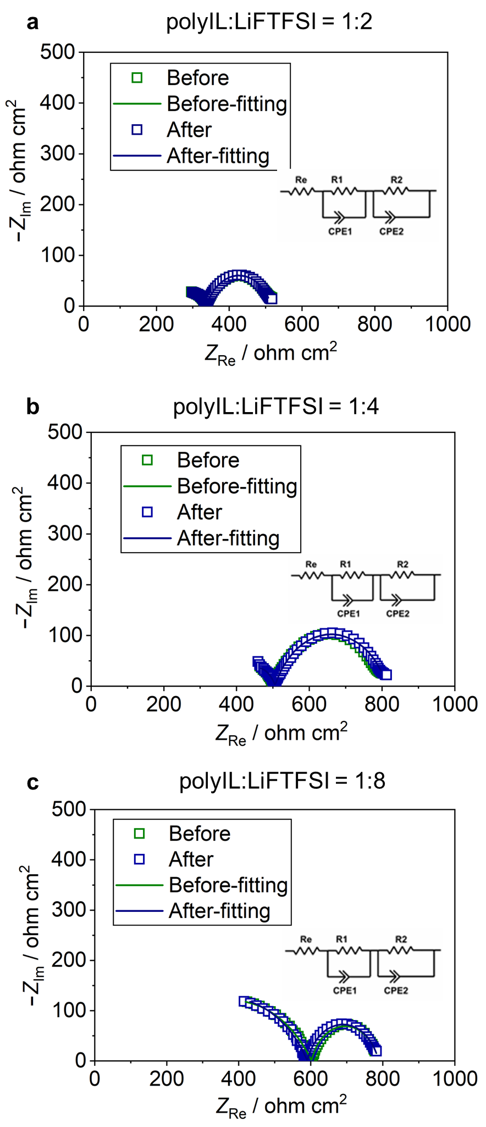
Supplementary Fig. 4. Nyquist plots before and after polarization of the symmetrical Li cell for different polyIL unit/LiFTFSI of (a) 1:2, (b) 1:4, and (c) 1:8 at 80 °C. Inset: The equivalent circuit used during fitting. The electrode area of the Li metal is 1.54 cm².
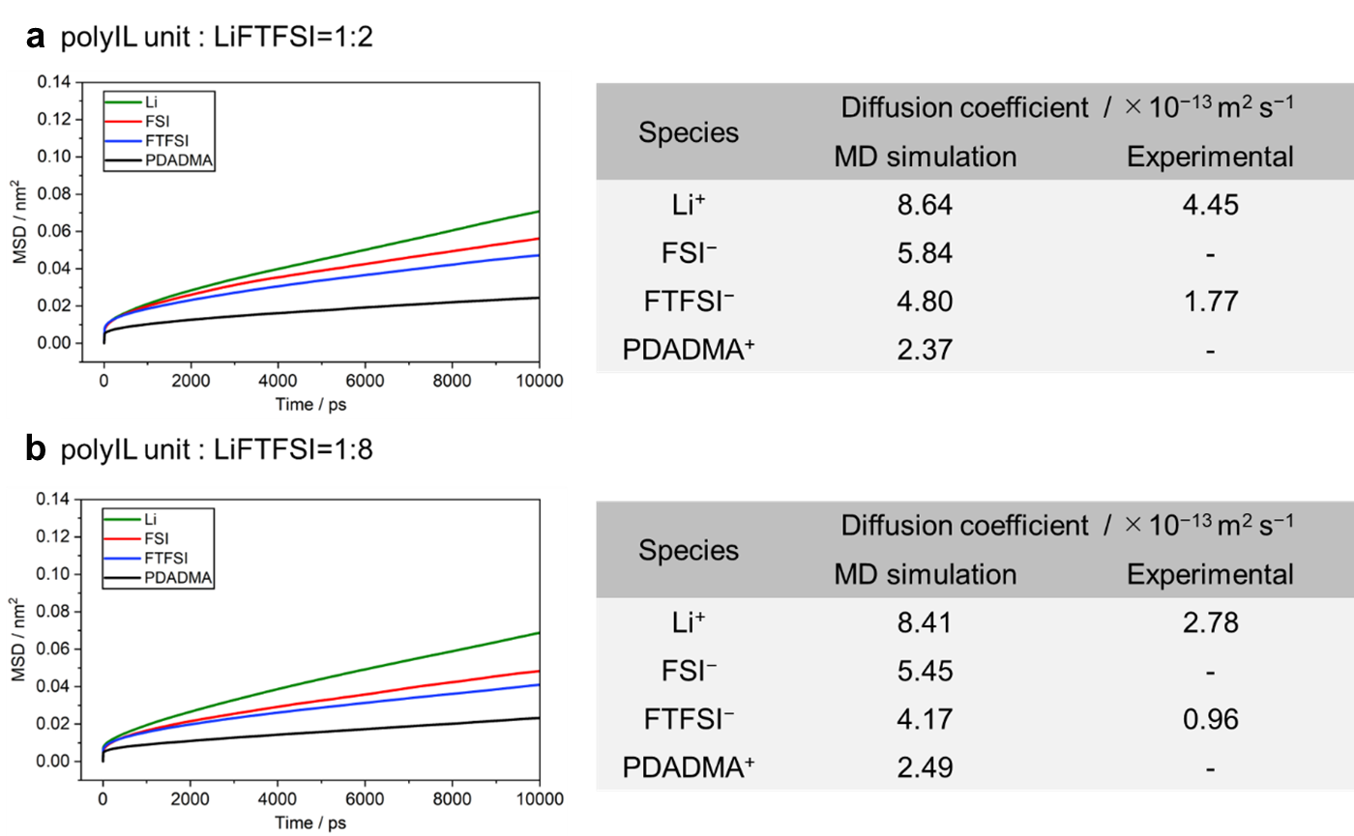
Supplementary Fig. 5 Mean square displacement (MSD) profiles for Li, FSI⁻, FTFSI⁻, and PDADMA⁺ at polyIL/LiFTFSI molar ratios of (a) 1:2 and (b) 1:8 at 80 °C. The diffusion coefficients are obtained by fitting MSD profiles over a time range of 3000 to10000 ps. The tables compare diffusivities between MD simulations and experimental results.

Supplementary Note 3: Conductivity relaxation time and structural relaxation time
Typical conductivity spectra for polyIL unit/LiFTFSI systems are shown in Supplementary Fig. 6. The spectra demonstrate ordinary AC tails at high frequencies with DC plateaus at low frequencies (see Supplementary Fig. 6a). The AC-DC crossover is related to the transition of the ion sub-diffusion regime associated with ion rattling in the Coulombic cage to the normal Fickian diffusion regime when the ions overcome the highest potential barrier. The time scale of this crossover defines the conductivity relaxation and is characterized by a conductivity relaxation time, τ_{σ}=1/(2π f_{AC-DC}), where f_{AC-DC} defines the AC-DC crossover frequency. For a quantitative estimation of conductivity relaxation time, the Random Barrier Model⁴ is applied according to the procedure shown in previous studies. ⁵
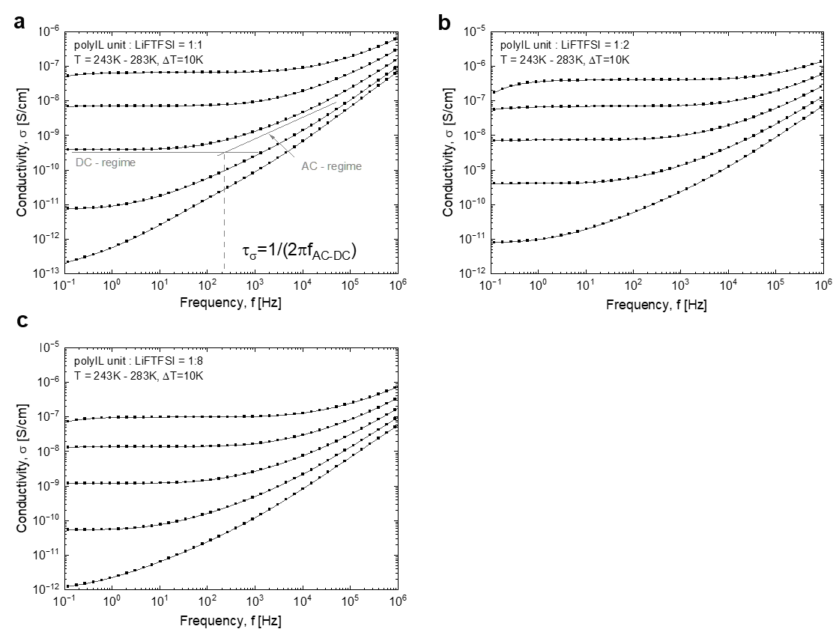
Supplementary Fig. 6 Conductivity spectra for polyIL unit/LiFTFSI systems at (a) 1:1, (b) 1:2, and (c) 1:8 ratios for selected temperatures.
The structural relaxation times were estimated from the SAOS experiments, using the crossover frequencies between G’(ω) and G”(ω) when the systems transition from the glassy to the viscoelastic regime. Note that we only considered the temperature range in which this process was within the frequency window of the instrument. Fig. 7 presents the master curves built for each mixture.
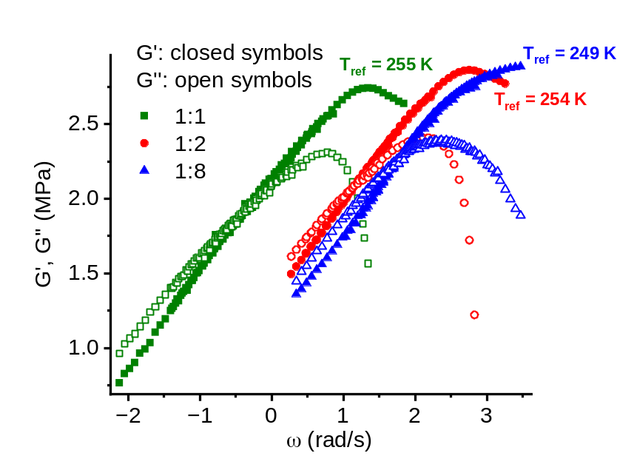
Supplementary Fig. 7 SAOS master curves of the different polyIL unit/LiFTFSI systems.

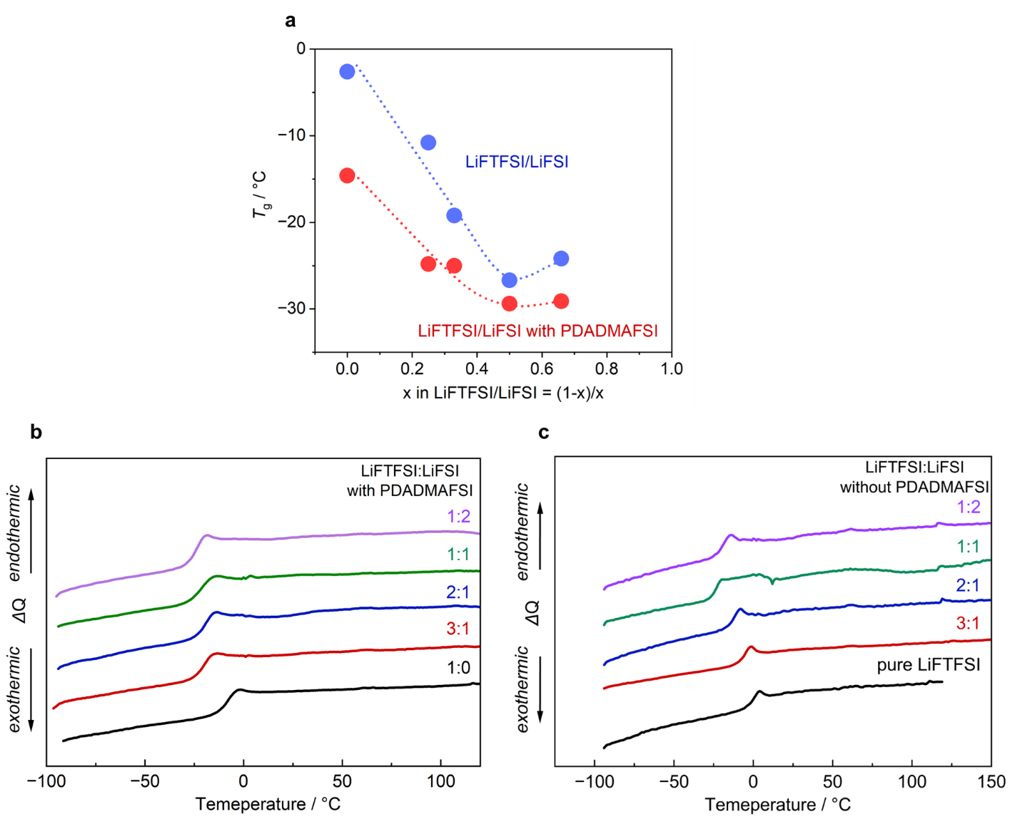
Supplementary Fig. 8 (a) Relationship between T_{g} and mole fraction of LiFSI in mixed LiFTFSI/LiFSI with and without PDADMAFSI. (b), (c) DSC thermograms of of mixed LiFTFSI and LiFSI systems at different ratios both with and without PDADMAFSI.

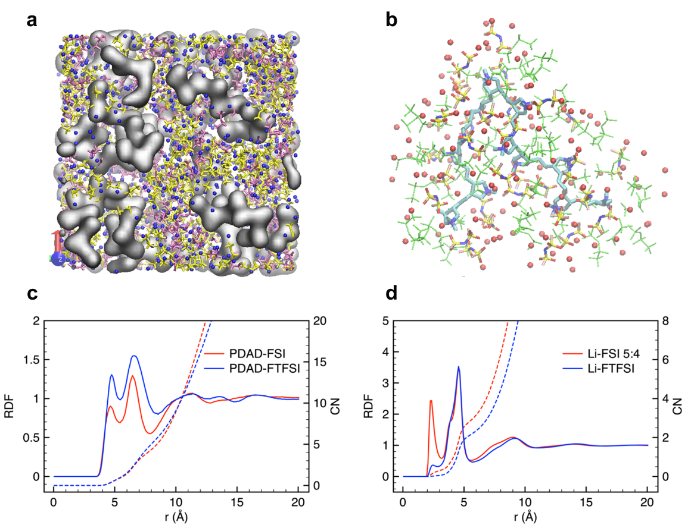
Supplementary Fig. 9 (a) Snapshot of the MD simulation box displaying the grey the polymer contour and Li[FSI][FTFSI] ion aggregates. The presented Li⁺ and anions here are not coordinated with polycations. FSI: yellow; FTFSI:pink (b) Snapshot of a selected polycation chain and its coordination environment. FSI: yellow/blue/red, FTFSI: green; (c),(d) RDF and coordination number of nitrogen atom (N) in PDADMA chains with nitrogen atoms in FSI anions (red line) and FTFSI anions (blue line); Li-ions with N in FSI anions (red) and FTFSI anions (blue).

Supplementary Table 3 Coordination numbers and cutoffs analysis for 1:4:4 system.
coordination | R1 | CN | R2 | CN
Li-FSI | 5.55 | 2.87
Li-FTFSI | 5.75 | 2.23
Li-S2 (S-F) | 4.45 | 2.55
Li-S3(S-CF3) | 4.25 | 1.97
PDAD-FSI | 5.45 | 0.9 | 7.95 | 4.29
PDAD-FTFSI | 5.45 | 0.97 | 8.55 | 5.89
PDAD-Li | 6.85 | 2.76 | 10.05 | 15.4

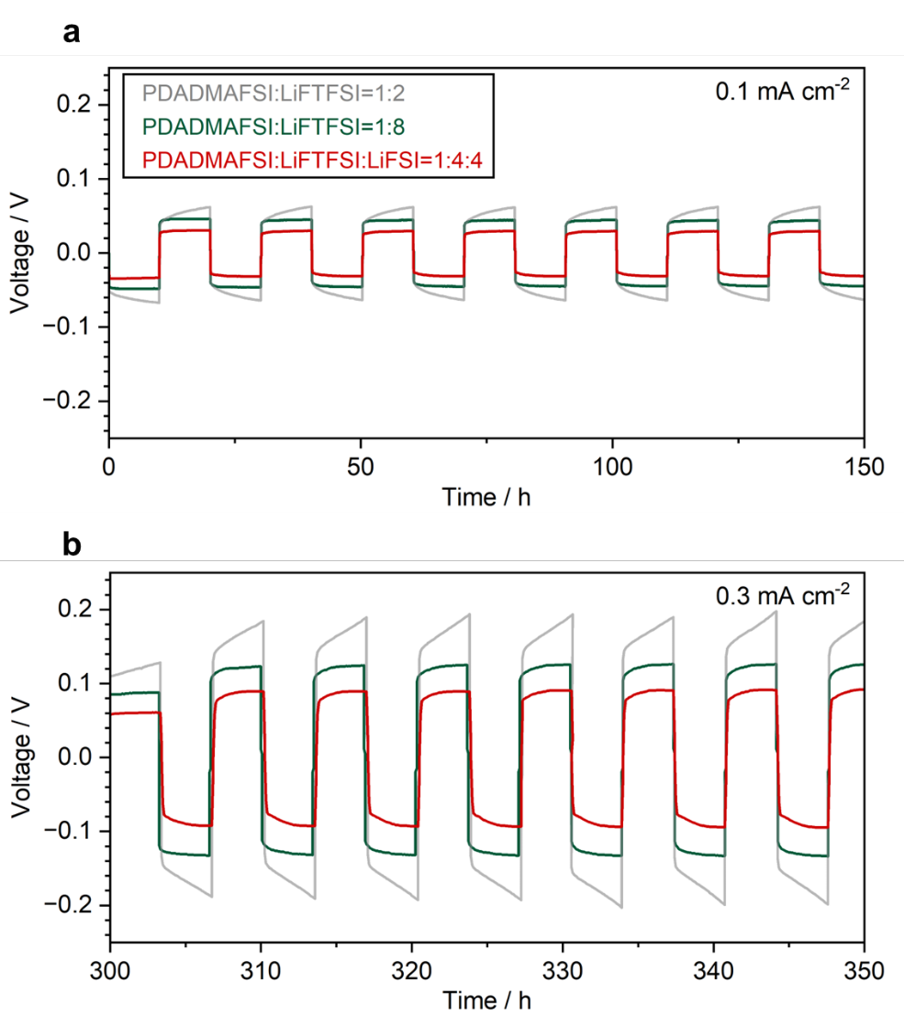
Supplementary Fig. 10 Enlarged view of Li deposition/dissolution cycling at (a) 0.1 mA cm⁻² and (b) 0.3 mA cm⁻² at 80 °C.

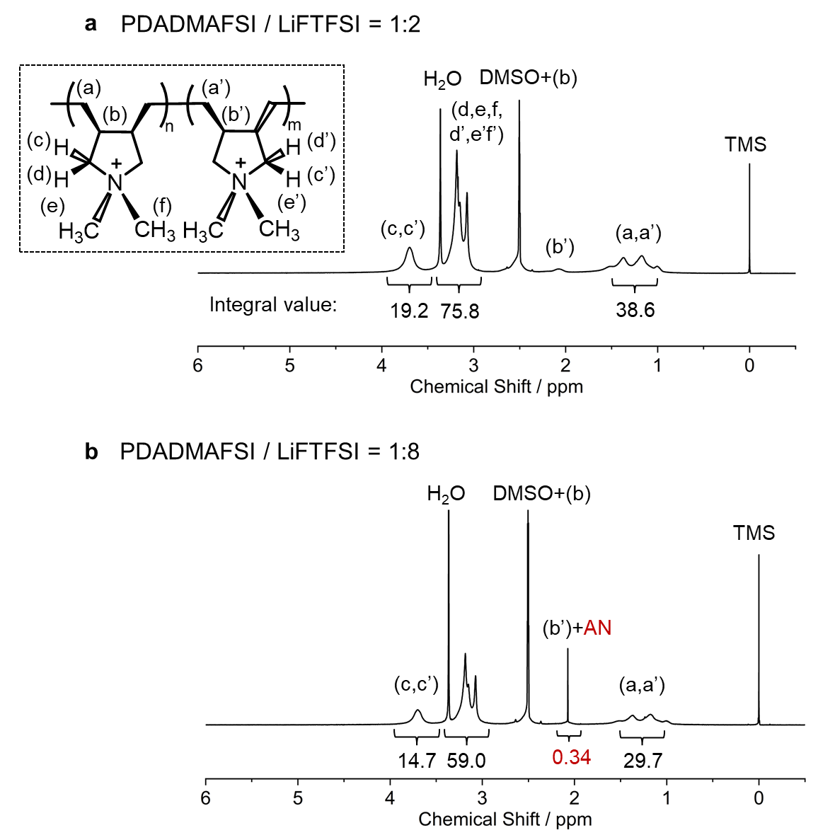
Supplementary Fig. 11 ¹H NMR spectrum and integral value of each peak of PDADMAFSI / LiFTFSI electrolytes at the polyIL unit / LiFTFSI cation molar ratios of (a) 1:2 and (b) 1:8 in DMSO-d6.

REFERENCES
1. Watanabe, M., Nagano, S., Sanui, K. & Ogata, N. Estimation of Li+ transport number in polymer electrolytes by the combination of complex impedance and potentiostatic polarization measurements. Solid State Ionics 28-30, 911-917 (1988).
2. Bruce, P.G., Evans, J. & Vincent, C.A. Conductivity and transference number measurements on polymer electrolytes. Solid State Ionics 28-30, 918-922 (1988).
3. Galluzzo, M.D., Maslyn, J.A., Shah, D.B. & Balsara, N.P. Ohm’s law for ion conduction in lithium and beyond-lithium battery electrolytes. The Journal of Chemical Physics 151, 020901 (2019).
4. Dyre, J.C. The random free‐energy barrier model for ac conduction in disordered solids. Journal of Applied Physics 64, 2456-2468 (1988).
5. Stacy, E.W. et al. Fundamental Limitations of Ionic Conductivity in Polymerized Ionic Liquids. Macromolecules 51, 8637-8645 (2018).

