Supplementary Tables/Figures

Table S1. Multivariable adjusted associations between SDoHs and Biological Age (Sensitivity Analyses).

Figure S1. Cohort Inclusion and Exclusion Flow Chart

Figure S2. Mean Chronological and Biological Age by sex and stratified by race/ethnicity.

Figure S3. Aging difference by sex, by education and income, and stratified by race/ethnicity.

Figure S4. Aging difference by sex, by nativity/years residing in the U.S., and stratified by race/ethnicity.

Figure S5. Forest Plot showing multivariable adjusted associations between SDoHs and Biological Age stratified by race/ethnicity (Sensitivity Analyses).

Table S1. Multivariable adjusted associations between SDoHs and Biological Age (Sensitivity Analyses).
 | Males  (n=5,949) |  |  |  | Females  (n=6,246)
 | Model 1 | Model 2 | Model 3 | Model 4 | Model 1 | Model 2 | Model 3 | Model 4
 | ß (95% CI) | ß (95% CI) | ß (95% CI) | ß (95% CI) | ß (95% CI) | ß (95% CI) | ß (95% CI) | ß (95% CI)
Education
College graduate | - | - | - | - | - | - | - | -
Some college | 1.57*  (0.32, 2.83) | 1.20  (-0.08, 2.48) | 0.01  (-1.29, 1.31) | 1.44*  (0.66, 2.22) | 3.76*  (2.27, 5.26) | 2.90*  (1.48, 4.33) | 1.58*  (0.29, 2.86) | 1.19*  (0.53, 1.84)
HS graduate | 1.70*  (0.45, 2.95) | 1.42*  (0.18, 2.67) | -0.23  (-1.61, 1.14) | 1.31*  (0.38, 2.25) | 7.13*  (5.69, 8.56) | 6.12*  (4.72, 7.52) | 4.17*  (2.82, 5.53) | 1.76*  (0.84, 2.68)
Less than HS | 1.48*  (0.09, 2.88) | 1.30  (-0.36, 2.96) | -0.78  (-2.41, 0.86) | 0.19  (-0.86, 1.24) | 6.54*  (4.82, 8.27) | 5.77*  (4.04, 7.50) | 3.73*  (1.98, 5.48) | 1.45*  (0.31, 2.59)
Income
≥ $75K | - | - | - | - | - | - | - | -
$55K-<$75K | 2.10*  (0.49, 3.72) | 2.42*  (0.81, 4.03) | 1.42  (-0.13, 2.97) | 0.70  (-0.39, 1.79) | 3.12*  (1.46, 4.78) | 2.30*  (0.60, 3.99) | 1.54  (-0.04, 3.13) | 0.33  (-0.67, 1.34)
$25K-<$55K | 1.78*  (0.60, 2.97) | 3.53*  (2.20, 4.87) | 1.83*  (0.49, 3.16) | 0.01  (-0.77, 0.79) | 4.13*  (2.70, 5.57) | 3.12*  (1.68, 4.56) | 1.79*  (0.56, 3.01) | 0.13  (-0.66, 0.92)
< $25K | 2.77*  (1.37, 4.16) | 5.67*  (4.15, 7.19) | 3.78*  (2.36, 5.20) | 0.09  (-1.05, 1.23) | 5.83*  (4.21, 7.45) | 4.59*  (3.09, 6.09) | 2.92*  (1.51, 4.32) | 0.76  (-0.17, 1.69)
Nativity/years in the U.S.
U.S. Born | - | - | - | - | - | - | - | -
≥ 10 years in the U.S. | -2.45*  (-3.89, -1.01) | -2.06*  (-3.42, -0.71) | -1.85*  (-3.13, -0.58) | -2.03*  (-3.02, -1.03) | -1.10  (-2.70, 0.51) | -1.04  (-2.62, 0.53) | -1.63*  (-3.15, -0.11) | -2.43*  (-3.26, -1.60)
< 10 years in the U.S. | -9.60*  (-11.46, -7.74) | -9.13*  (-11.08, -7.18) | -7.93*  (-9.74, -6.11) | -2.99*  (-4.48, -1.49) | -8.34*  (-10.95, -5.73) | -7.57*  (-10.03, -5.11) | -8.13*  (-10.40, -5.87) | -3.46*  (-5.04, -1.89)
Model 1: adjusted for race/ethnicity
Model 2: adjusted for Model 1 variables and health insurance, marital status, education (in income and nativity models), income (in education and nativity models), and nativity (in education and income models)
Model 3: adjusted for Model 1 + Model 2 variables, and alcohol use, smoking history, physical activity, and history of CVD
Model 4: adjusted for Model 1 + Model 2 + Model 3 variables, and chronological age
*Significant at p < 0.05
Figure S1. Cohort Inclusion and Exclusion Flow Chart

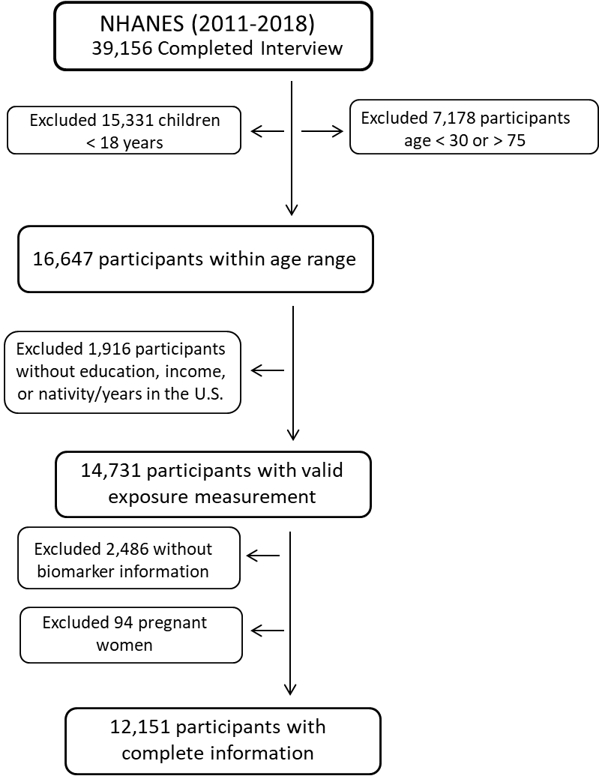
Figure S2. Mean Chronological and Biological Age by sex and stratified by race/ethnicity.
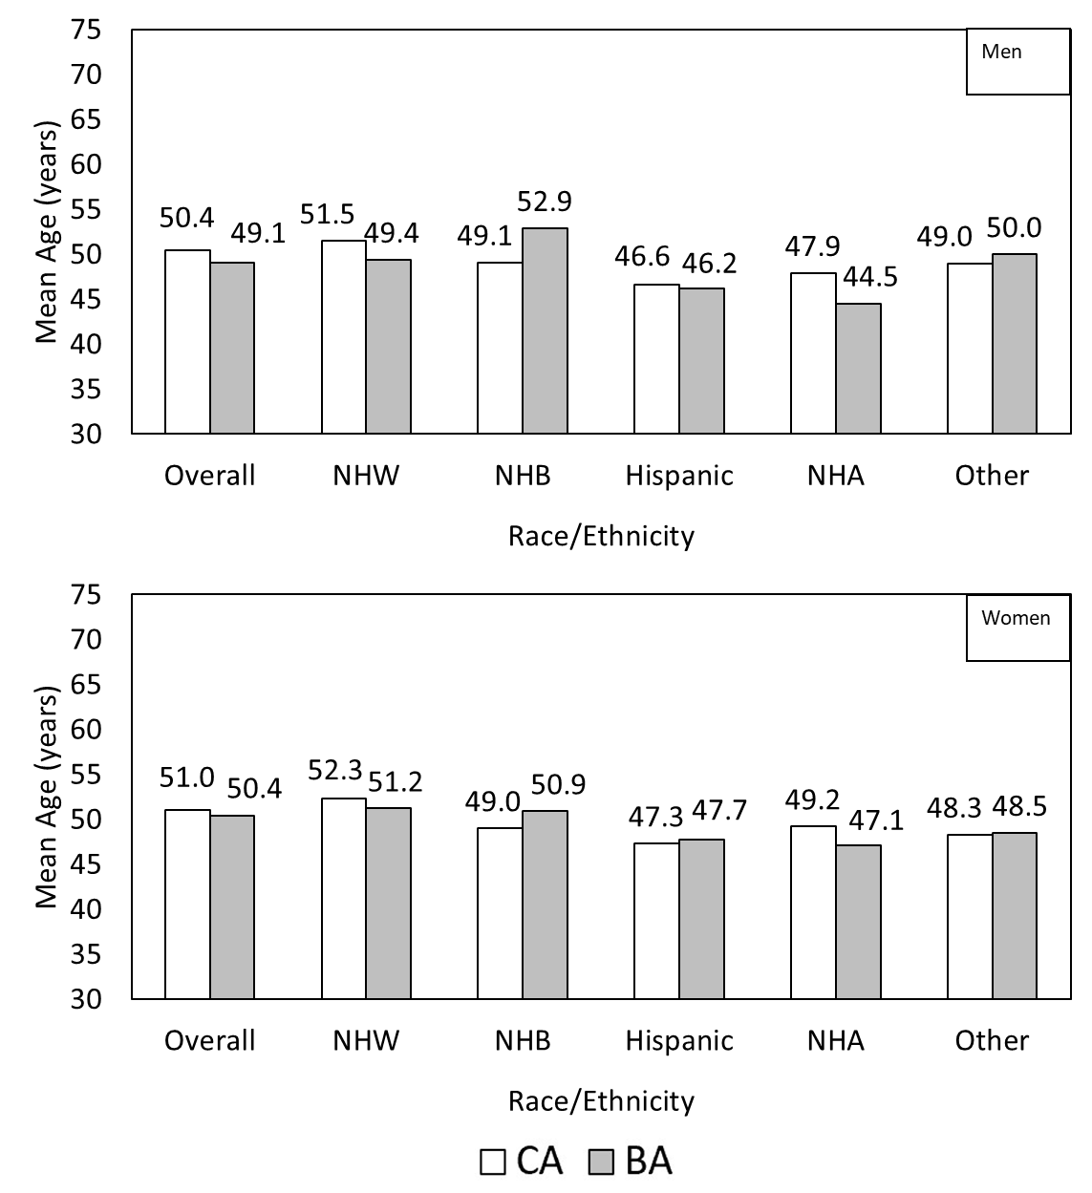

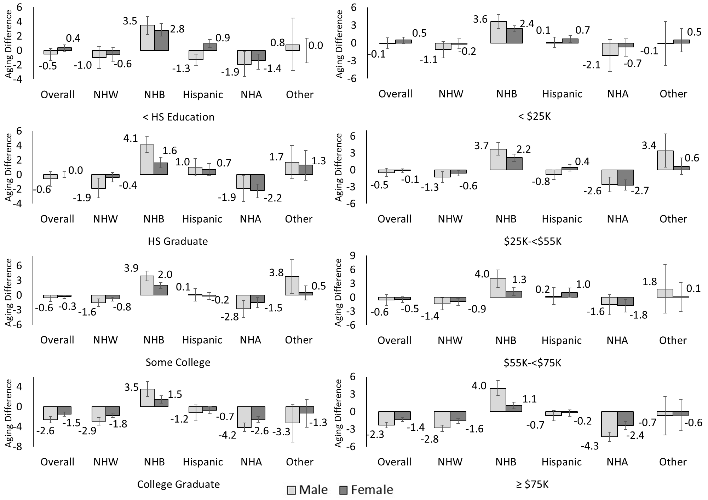
Figure S3. Aging difference by sex, by education and income, and stratified by race/ethnicity.

Figure S4. Aging difference by sex, by nativity/years residing in the U.S., and stratified by race/ethnicity.
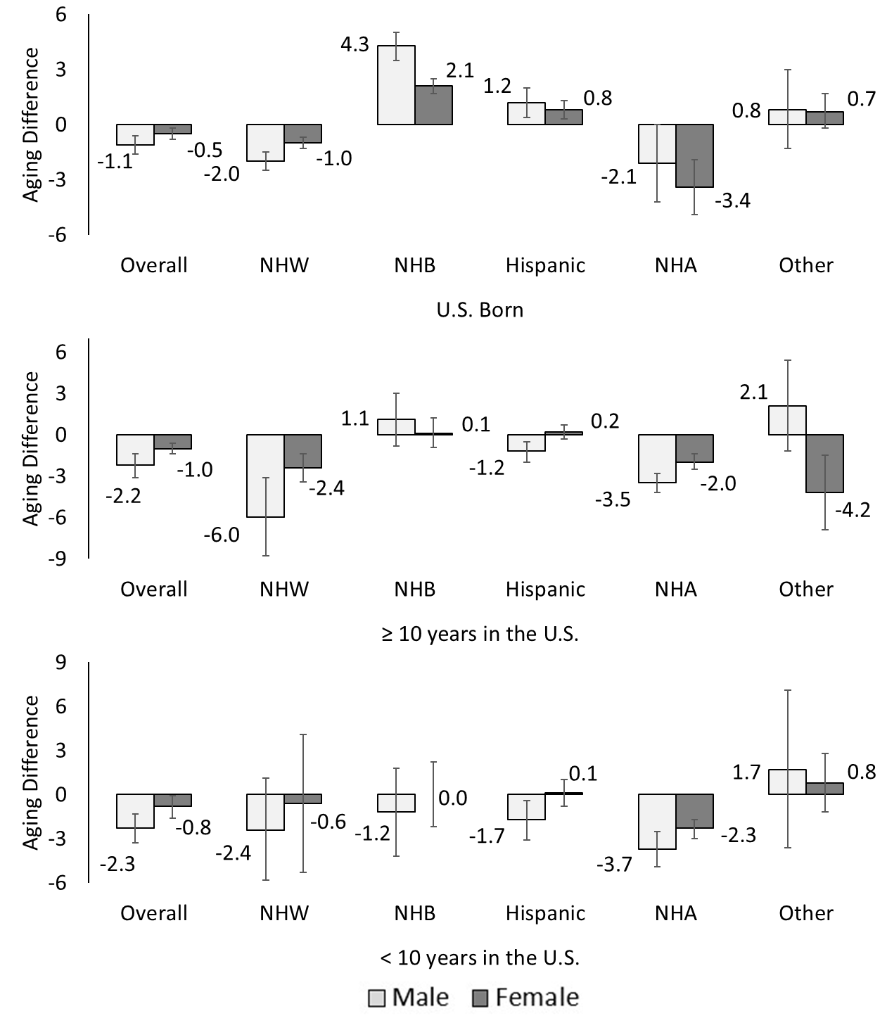

Figure S5. Forest Plot showing multivariable adjusted associations between SDoHs and Biological Age stratified by race/ethnicity (Sensitivity Analyses).

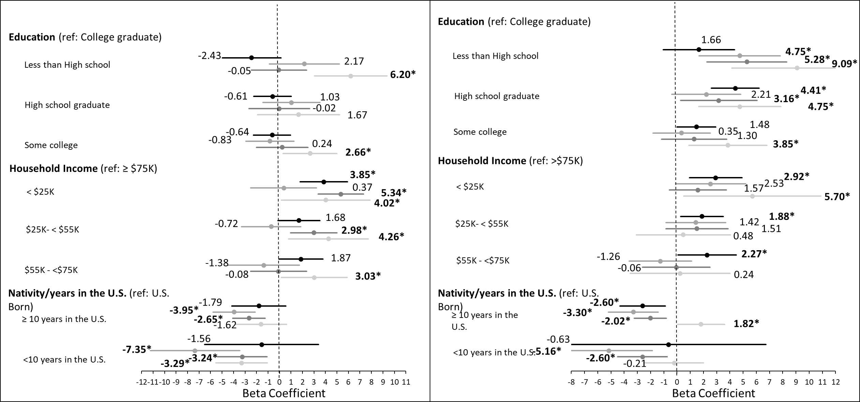
Men
Women



Model 3: adjusted for health insurance, marital status, education (in income and nativity models), income (in education and nativity models), nativity (in education and income models), alcohol use, smoking history, physical activity, and history of CVD
Model 4: adjusted for Model 3 variables, and chronological age [Nativity/years in the U.S. models only]

