Supplementary information for: The Ferromagnetic Glass State: collapse of the standard ferromagnetic domain structure

S.I AMR DATA
Fig. S1 shows the AMR values measured at 80K for the Co(5nm)/Al(4nm) and for Co(5nm)/Gaq₃(25nm) in both transverse (H in plane and perpendicular to I) and longitudinal (H in plane and parallel to I), with an applied voltage of 100 mV. The coercivity is extracted from the data by locating the H value corresponding to the AMR peaks. The Co/Gaq₃ sample has a value of (130 ± 1) mT while a value of (5 ± 1) mT is found for the reference Co/Al, in agreement with MOKE measurements performed at the same temperature.
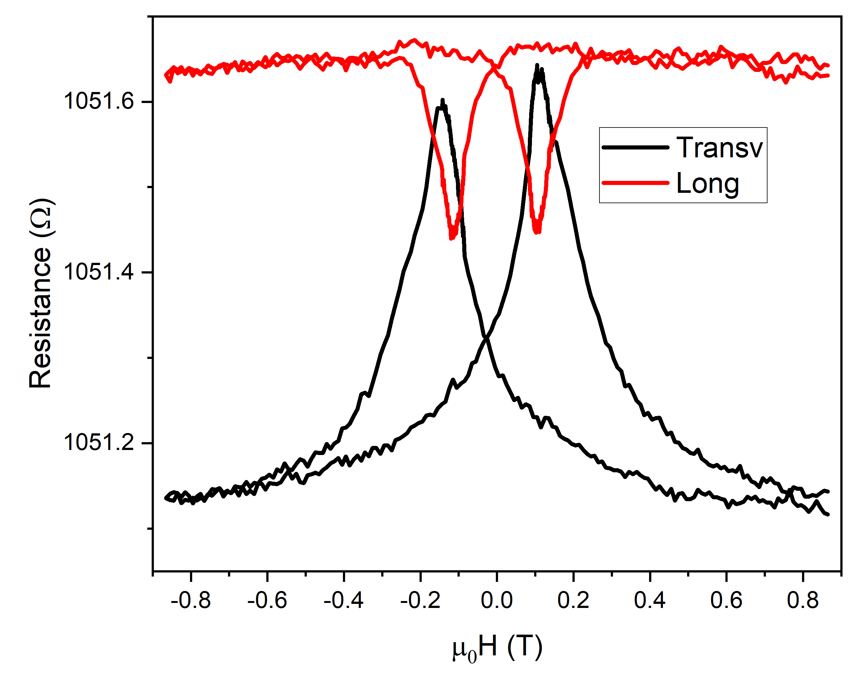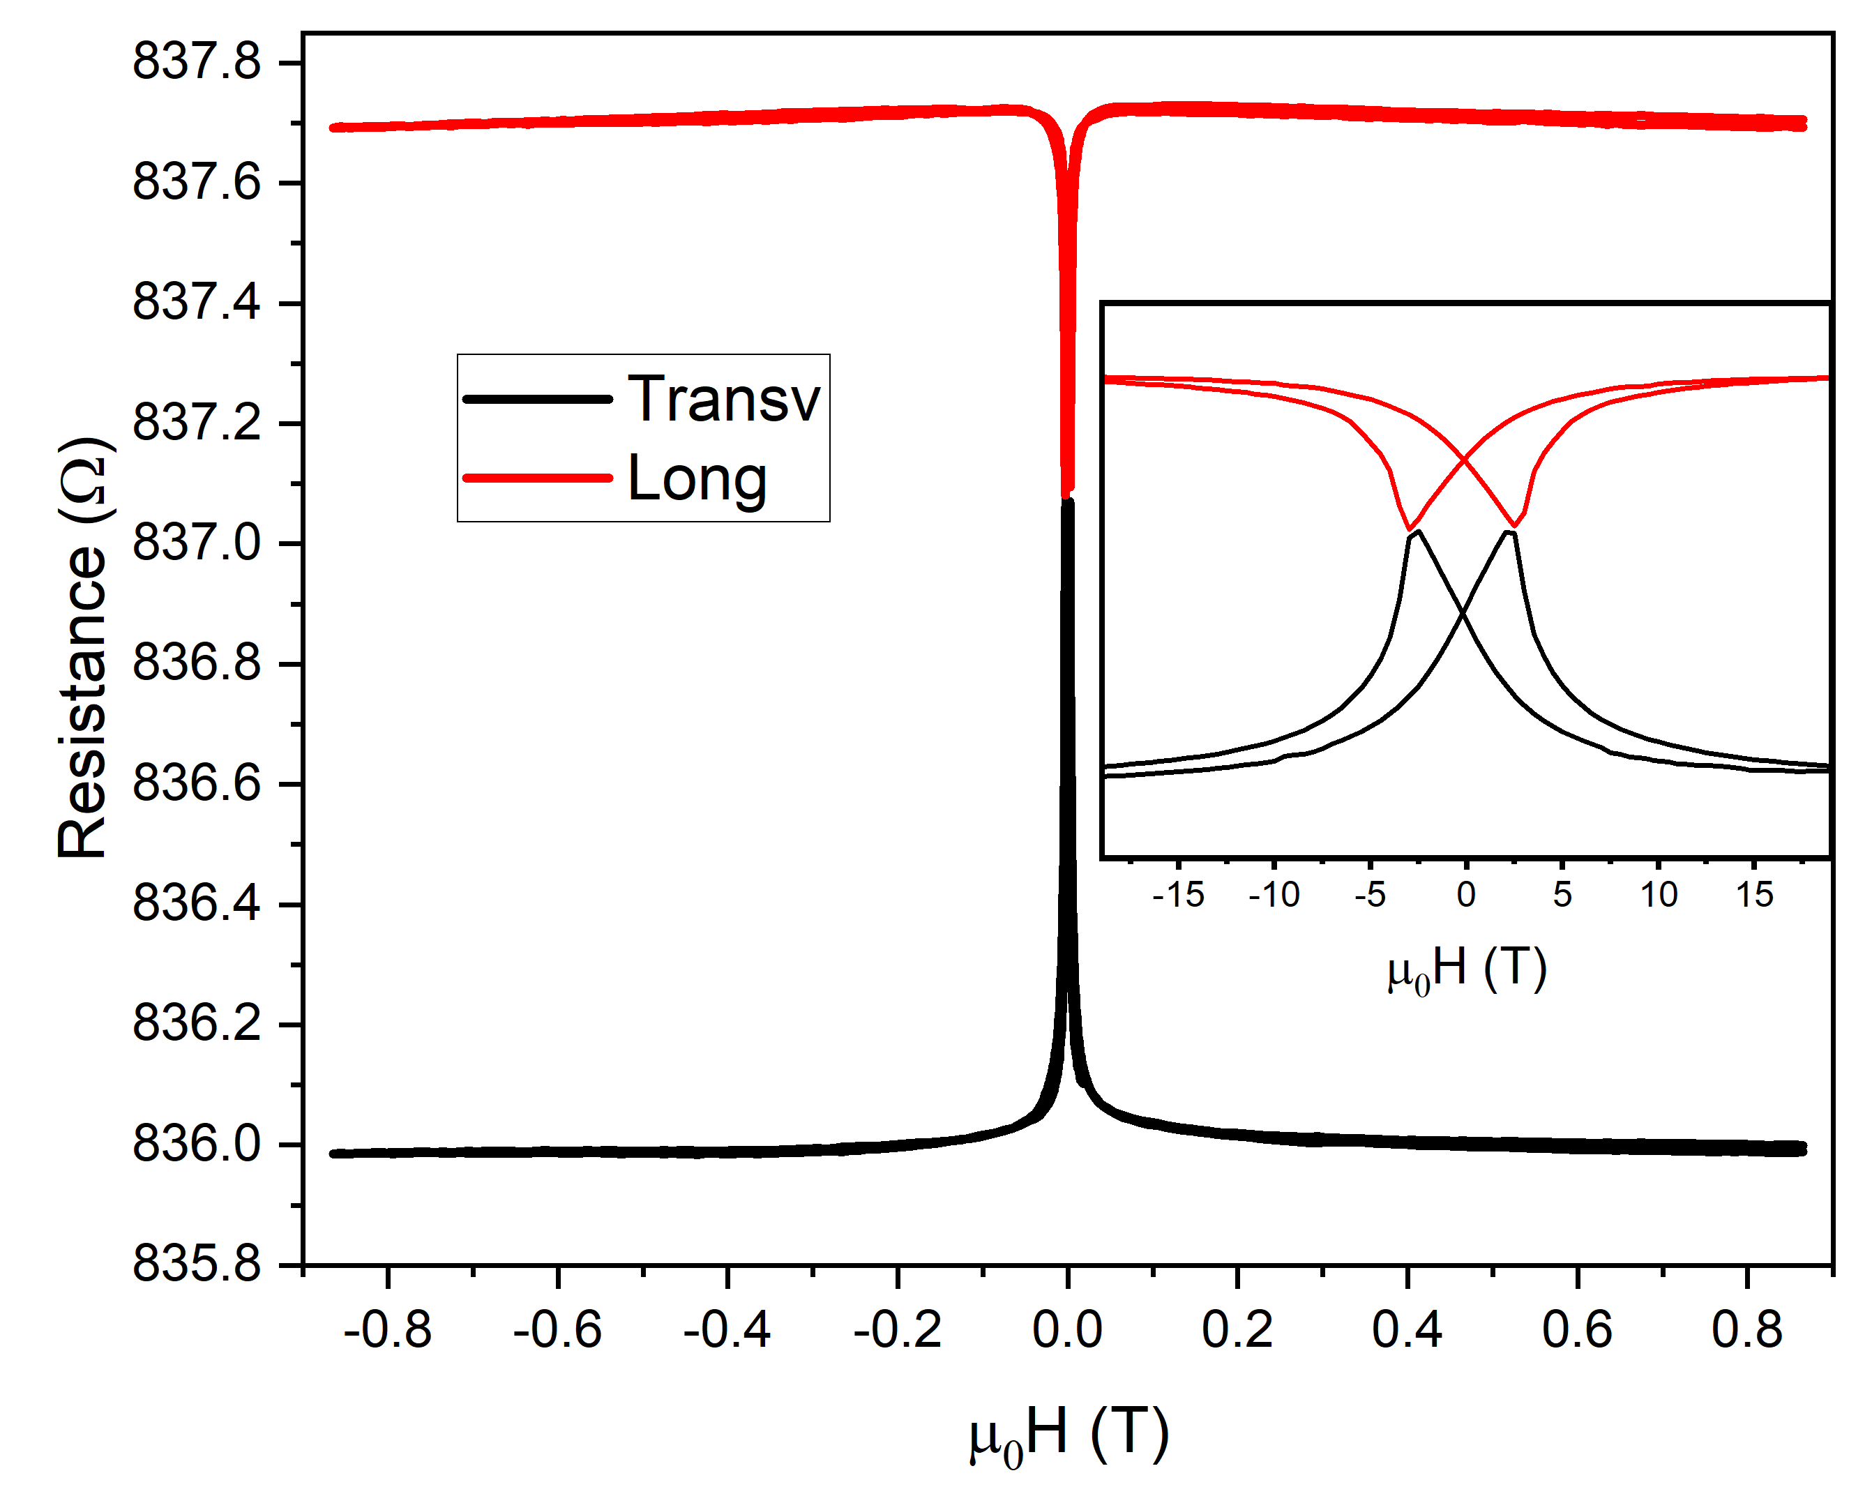
Fig. S1 AMR data for Co/Gaq₃ sample (left) and reference Co/Al (right) obtained at 80 K in both transverse (black lines) and longitudinal (red lines).
S.II MINOR LOOPS CHARACTERIZATION
The minor loops obtained by MOKE magnetometry at 150K are reported in Fig. S2, while the ones obtained by SQUID magnetometry are reported in Fig. S3. The non-normalized plot of coercive field vs maximum applied field (data used for Fig. 2b in the man article) is displayed in Fig. S4, with added data for Co/CoOx for completeness. It is worth noting that the values extracted from Co/Gaq₃ and Co/C₆₀ by SQUID measurements are lower in absolute value with respect to the ones obtained by MOKE measurements. This mismatch is attributed to SQUID measurements not being done with the applied field along the samples easy axis, thus resulting in a lowering of the measured coercivity.
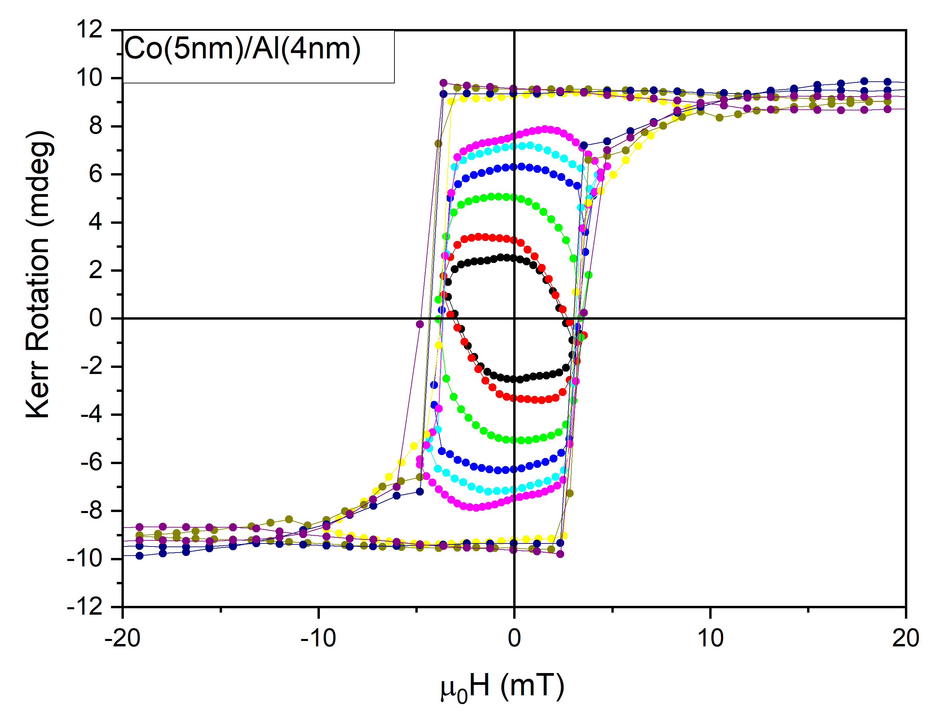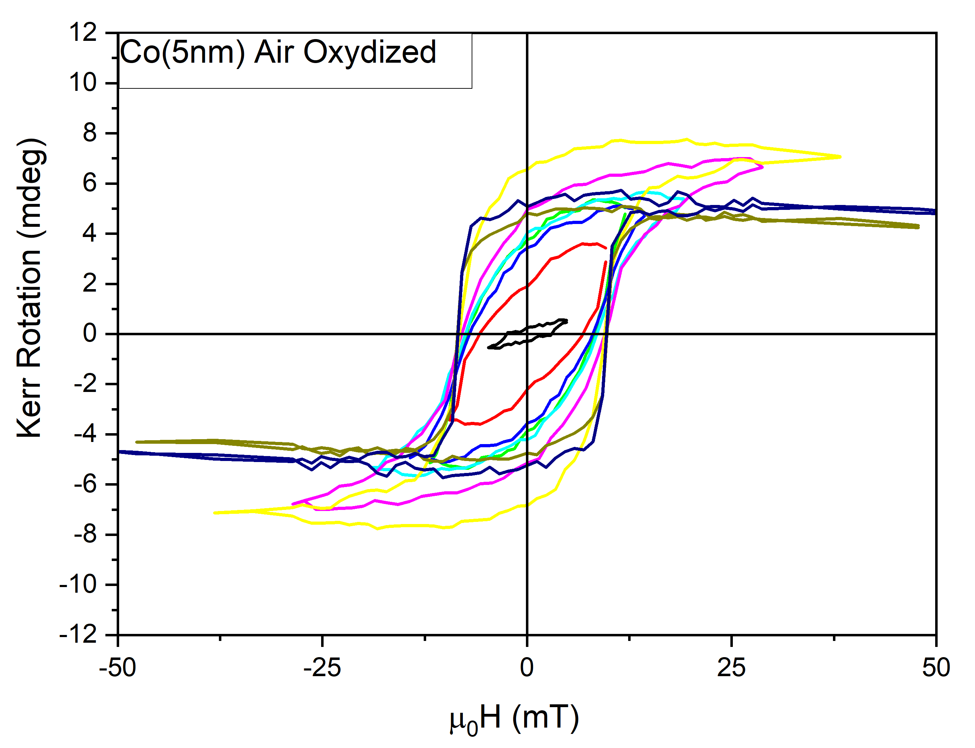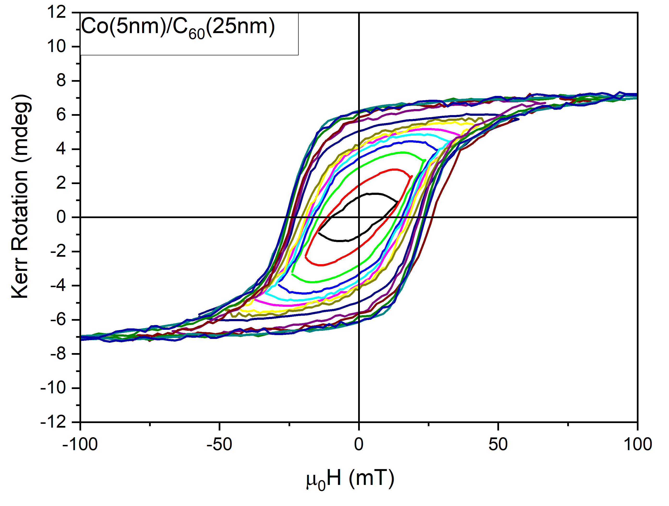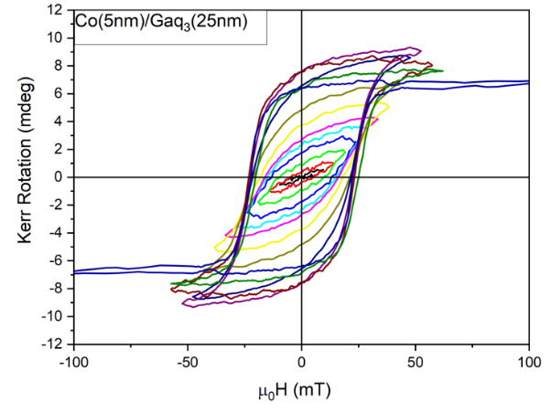
Fig. S2 Minor loops at 150K for reference Co/Al (top-left) Co/CoOx (top-right). Co/C₆₀ (bottom-left) and Co/Gaq₃ (bottom-right). The x-scale is varied for each sample for better evidence of the smaller loops.
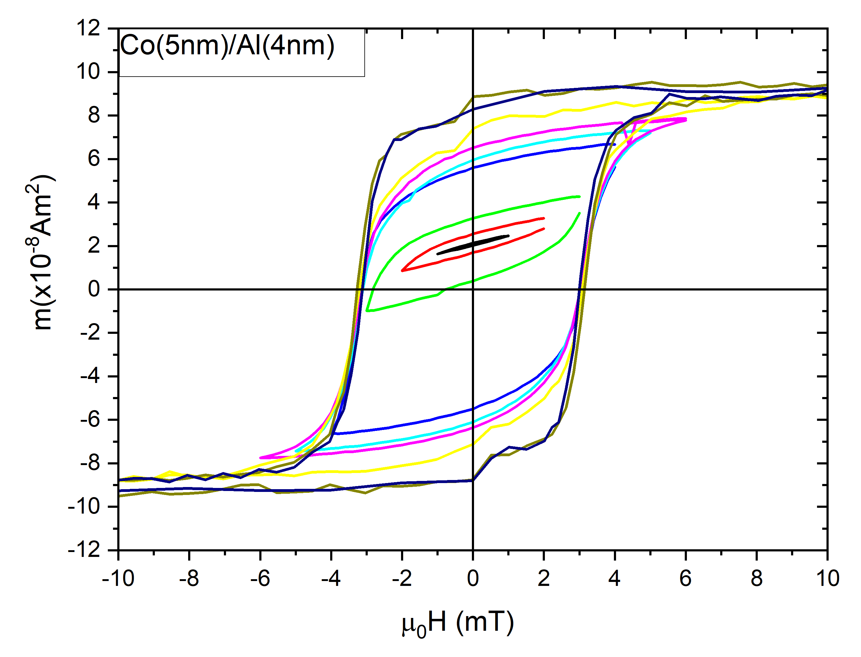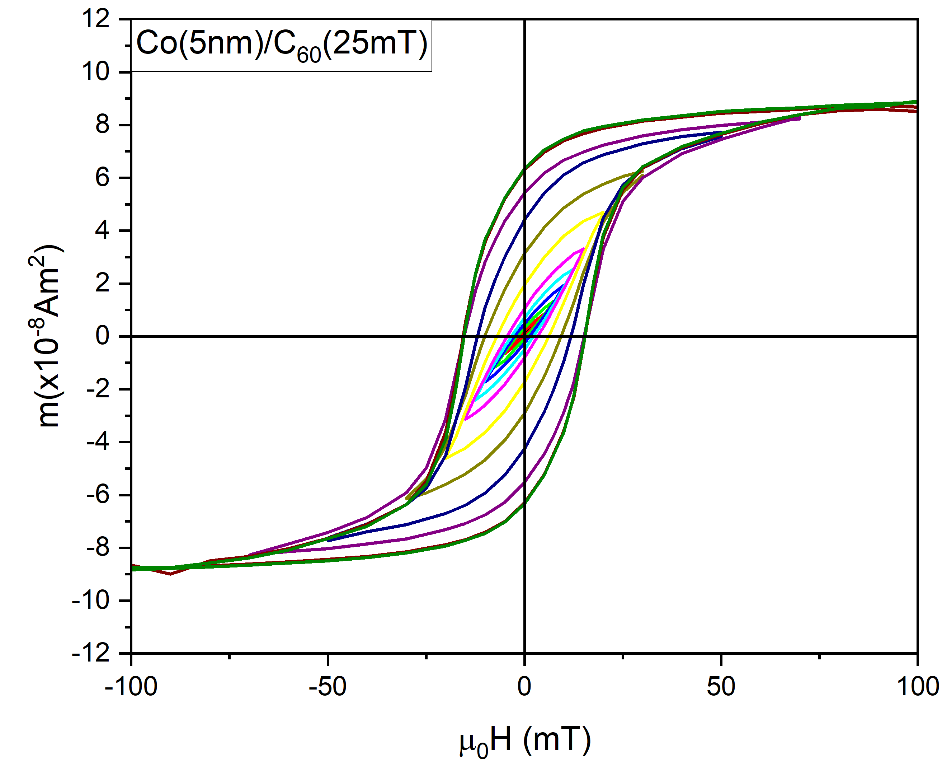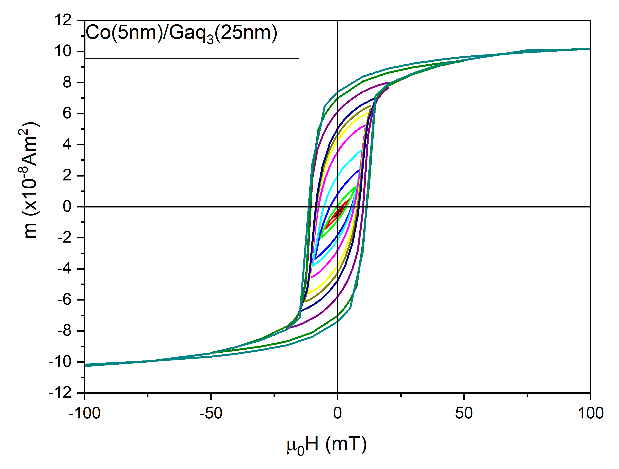
Fig. S3 Minor loops for the Co/C60, Co/Gaq3 and reference Co/Al obtained by SQUID magnetometry at T=150K. The x-scale is varied for each sample for better evidence of the smaller loops.
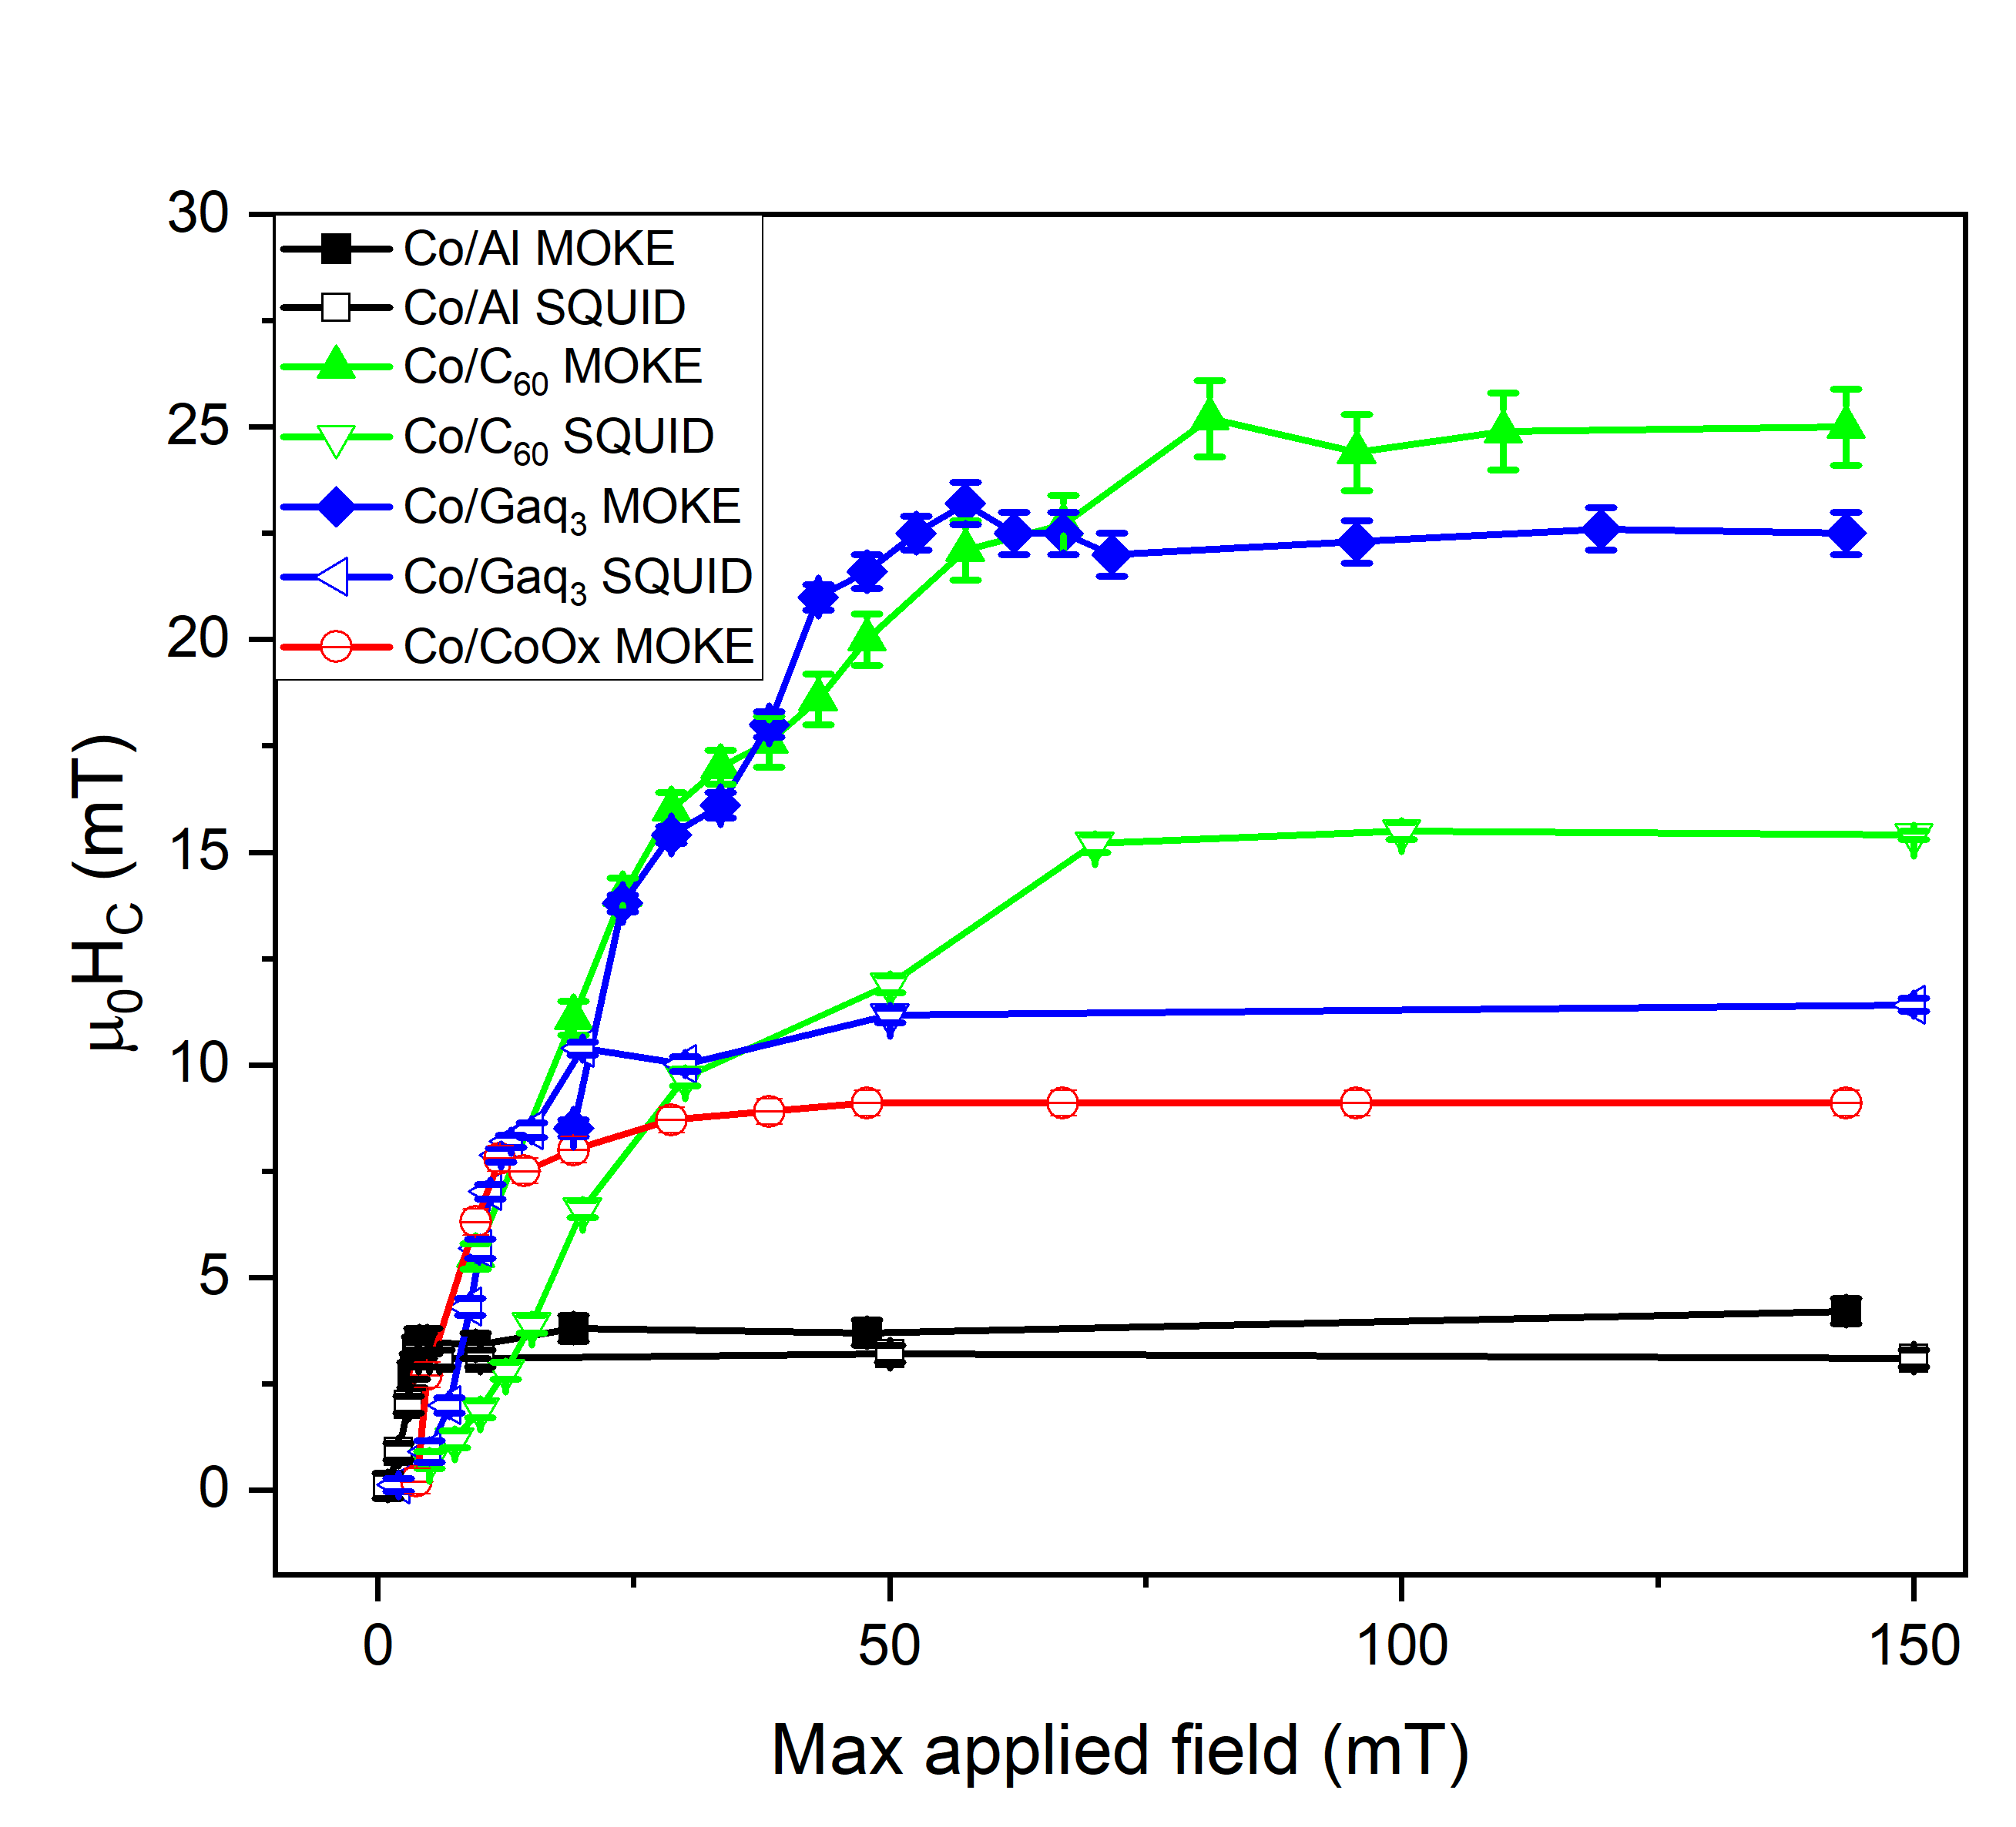
Fig. S4 Absolute values of the coercivity as a function of the minimum applied field in each loop.
S.III DFT CALCULATIONS, CALCULATED ATOM RESOLVED ANISOTROPY
We demonstrate here that the enhancement of E_{MCA} predicted by DFT in Co/Gaq₃ is an interface effect induced by the molecule. We resolve the contribution of each atom i to $E_{MCA}$ by computing the difference of the SOC energy per atom, $E_{MCA}(i)∝∆E_{SOC}(i)=E_{SOC}\left(i,θ_{EASY}\right)-E_{SOC}\left(i,θ_{HARD}\right)$. Negative (positive) values of $∆E_{SOC}(i)$ indicate contributions that increase (reduce) the slab’s MCA. As shown in Fig. S5, $∆E_{SOC}(i)$ fluctuates. Nevertheless, it has the largest value for a few surface atoms, which are mostly those forming a covalent bond with the molecule. Hence, these atoms contribute the most to the MCA. This result can be highlighted by carrying out a partial summation $S\left(N^{'}\right)=\sum_{i=1}^{N^{'}}{∆E_{SOC}(i)}$ with $N^{'}≤N$ . $S\left(N^{'}\right)$ is rather small when considering only the atoms in the bottom layers of the slab, while it jumps of an order of magnitude when reaching interface layer.

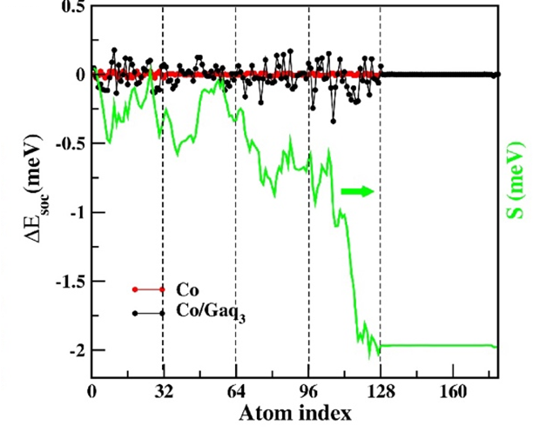
Fig S.5 SOC energy difference $∆E_{SOC}\left(i\right)=E_{SOC}\left(i,θ_{EASY}\right)-E_{SOC}\left(i,θ_{HARD}\right)$ per atom i=1, …,180. Red and Black points are respectively for the clean Co slab and the Co/Gaq₃ slab. Atoms labelled from 96 to 128 are at top surface layer, where the molecule is adsorbed, whereas atoms from 0 to 32 are at the bottom surface. Atoms labelled from 128 to 180 are the atoms of the molecule. The green curve is the cumulative sum $S\left(N^{'}\right)=\sum_{i=1}^{N^{'}}{∆E_{SOC}(i)}$ used to highlight that the largest contribution to the MCA comes from the interface atoms.
S.IV MACROSCOPIC-SCALE CALCULATIONS
To study the model described by Eq. (1) in the main text, we introduce the discrete lattice that can be considered as its mapping to the “classical spin glass” model^{1,2}. It allows us to use a variety of conventional numerical methods for its study. However, the mapping implies that the anisotropies on neighbour sites are strongly correlated. The step of the lattice should be small compared to Δ, while the size of the whole lattice should be large compared to the features of magnetic state. It limits the values of r_{c} that are possible to simulate with our methods. All the results present in the article correspond to 128x128 lattice with size L=60Δ. They are checked to be robust against modification of lattice size and step.
The calculations start with the generation of random but correlated anisotropy field that was achieved with NAG library. First, we generate two random fields a_{x} and a_{y} with the Gaussian variogram using the NAG routine g05zrf with correlation length r_{c}. The distribution of the random angle φ was calculated as:
$ϕ=\arctan{(\frac{a_{y}}{a_{x}})}$. (S1)
As a result, the random field φ is correlated with the radius r_{c}. A typical distribution of the anisotropy angles is presented in Fig. S6 (b). The correlation function of the anisotropy angles is plotted in Fig. S6(a). It is clear that the spatial distribution of the anisotropy angles is not Gaussian but the correlation function is decreasing on the scale of r_{c}.

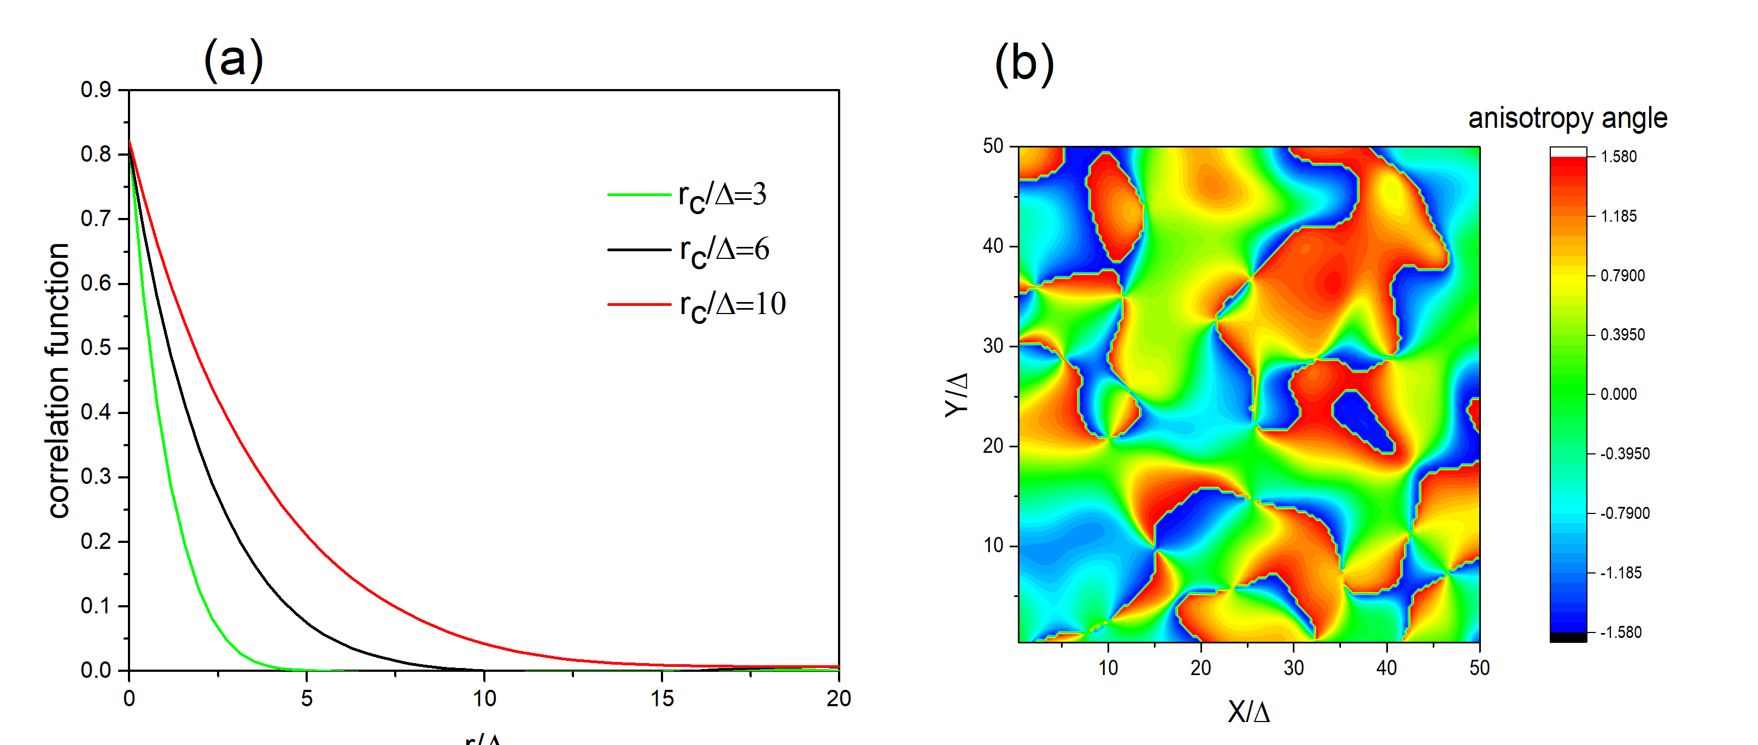
Fig. S6 (a) Dependence of the angle correlation function on distance. (b) Distribution of the anisotropy field over the sample.
The magnetic states are found by the minimization of the free energy integrated over the sample surface.
$$\int{Fd^{3}r→min} (S2)$$
that is done numerically with the conjugate gradient method.
The ferromagnetic material described with Eq. (1) in the main text has many local minima of free energy at small magnetic fields. Therefore, the local minimum found with the numeric procedure depends on the initial state of the system. When the external field H is changed adiabatically by the small value $\left(H→H+δH\right)$ the minimum for previous field H can be used as an initial state to the modified field $H+δH$. For the calculation of the full hysteresis loops the procedure starts from a high magnetic field $H≳K_{R}M_{0}$ and the uniform saturated magnetic state,$M={M_{0}e}_{x}$.
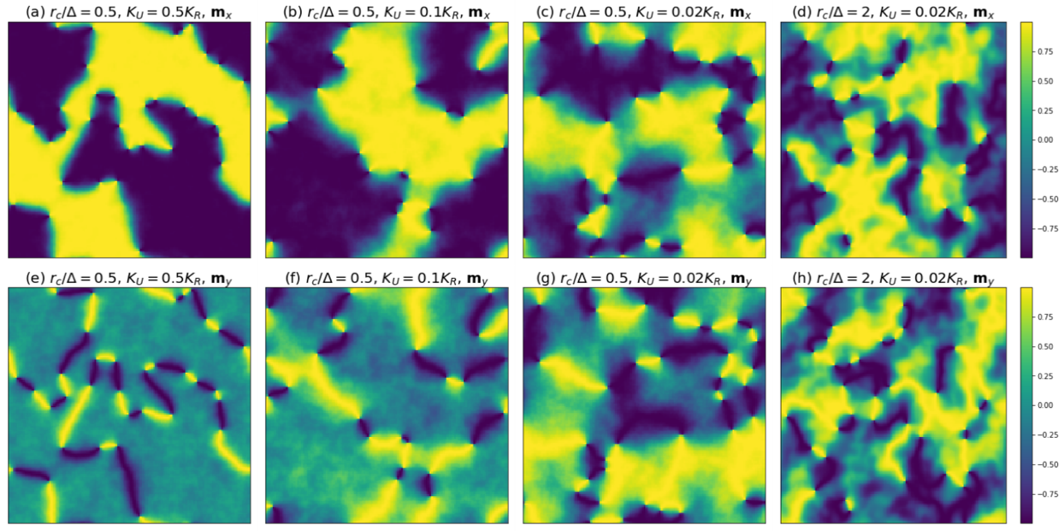
Fig. S7 Demagnetized states for different parameters $r_{c}/Δ$ and $K_{U}/K_{R}$.
However, the calculations of minor loops should start with a demagnetized state of the film that is not known a priori. To find it we apply a “numerical cooling” procedure to our system. It is the solution of Landau-Lifshitz-Gilbert (LLG) equation with additional noise.
$$\frac{dφ\left(r\right)}{dt}=-γλ\left|\tilde{h}\right|\sin\left(φ\left(r\right)-φ_{h}\right)+ζ\left(r,t\right) (S3)$$
Here $φ\left(r\right)$ is the polar angle describing the direction of magnetization. $\tilde{h}$ is the dimensionless effective field$\tilde{h}=(∂F/∂M)/M_{0}$ and $φ_{h}$is its polar angle. $γ$ is the gyromagnetic ratio and $λ$ is damping parameter. $ζ\left(r,t\right)$ is the random force with the correlation function
$〈ζ\left(r,t\right)ζ\left(r^{'},t^{'}\right)〉=γλT_{N}δ\left(t-t^{'}\right)δ\left(r-r^{'}\right)$ $(S4)$
where $T_{N}=T/M_{0}μ_{Co}$ is the dimensionless “numerical temperature’, T is temperature and $μ_{Co}$ is the magnetic moment of a single Co atom. We simulate the stochastic equation (eq4) with the temperature gradually decreasing from the value $T_{N}=3K_{R}$ to zero. The resulting “pseudo-ground” states are shown in Fig. S7 for different parameters. It shows the crossover from magnetic domains and domain walls to FGS. They are used as the initial states for calculations of minor loops.
Although the general picture of zero-magnetization states (domains or spin glass) is robust against modification of the cooling procedure, the typical sizes of domains or of the spin-glass features depend on the time of the numerical cooling $τ_{c0}$. In Fig. S8 we show how the calculated state depends on this parameter. The value $γλτ_{c0}={10}^{3}$ is used for the calculation of the minor loops.
To calculate the minor loops the adiabatic modification of field H starts from the demagnetized state. The magnetic field then is changed from zero to some value H_{max}. Three loops between H_{max} and −H_{max} are made to saturate the magnetization dependence on the magnetic field and then the minor loop is recorded. The result is averaged over 500 disordered numerical samples. Then the minor loop is centered and coercive field $H_{C}^{*}$ and remnant magnetization $M_{R}^{*}$are recorded. This procedure is shown in Fig. S9. Eqs. (S3) and (S4) allow to calculate the xy-magnetization properties. However, these equations do not allow magnetization to have z-component. Therefore, a vortex in this model are just a singularity in 2D energy density. To study the vortex structure, we apply the vector form of LLG equations.
$$\frac{dM}{dt}=-γ\left[M×\tilde{H}\right]-\frac{γλ}{M_{0}}\left[M×\left[M×\tilde{H}\right]\right]. (S5)$$
Here the Langevin forces are included in the effective magnetic field $\tilde{H}=∂F/∂M+H_{ξ}$, where the cartesian components $H_{ξ}^{(α)}$of $H_{ξ}$ have the following correlation function
$〈H_{ξ}^{(α)}\left(r,t\right)H_{ξ}^{(β)}\left(r^{'},t^{'}\right)〉=\frac{2T}{{γλM}_{0}}δ_{αβ}δ\left(t-t^{'}\right)δ\left(r-r^{'}\right).$ $(S6)$

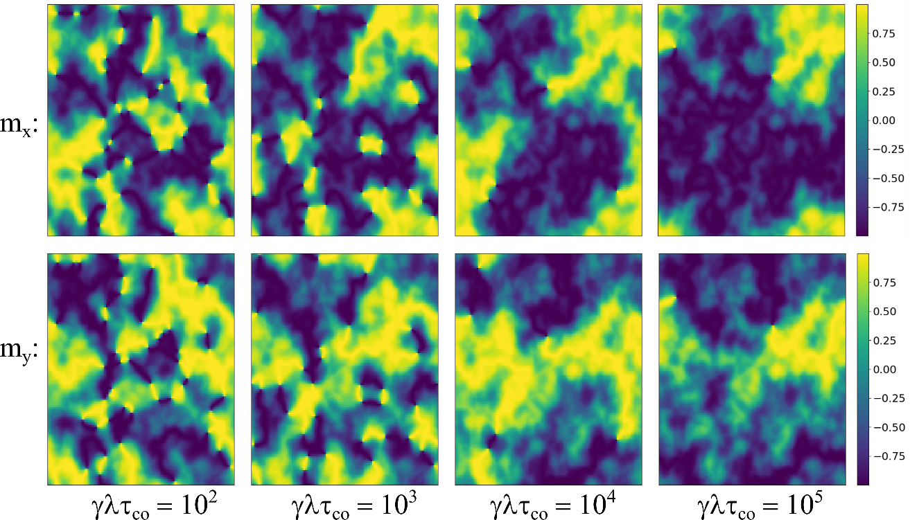
Fig. S8: dependence of the demagnetized state on the time of numerical cooling. All the states are calculated for $r_{c}=2Δ$ and $K_{U}=0.02K_{R}$.
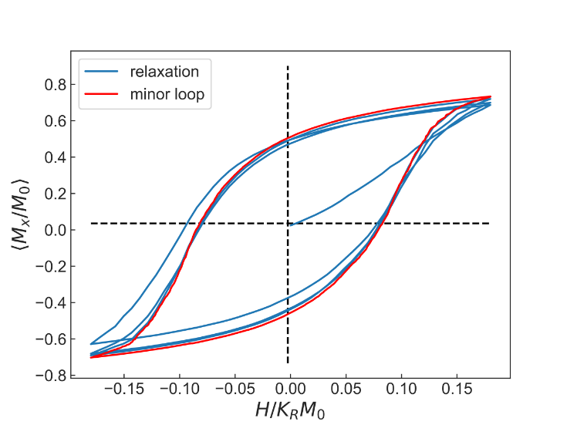
Fig. S9 Minor loop calculation.
To verify the validity of our model we have quantitatively compared the hysteresis loops at 150 K for Co/Al and Co/C₆₀ with the micromagnetic model loops. Such comparison is reported in Fig. S10. For the experimental values of both samples we have rescaled the applied field by the anisotropy field 75 mT, estimated by looking at the closure field of the Co/C₆₀ loop (i.e. the field for which the forward and backward branches are splitting). As can be seen from Fig. S10. The Co/C₆₀ hysteresis loops is reasonably well reproduced by a K_{R}/K_{U} ratio of 50 and a correlation radius r_{c}=4Δ. Noteworthily, the Co/Al hysteresis loop is reproduced by the theoretical loops considering r_{c}=0.2Δ, that is a correlation radius that is 5 times less than the re-normalized magnetic length.
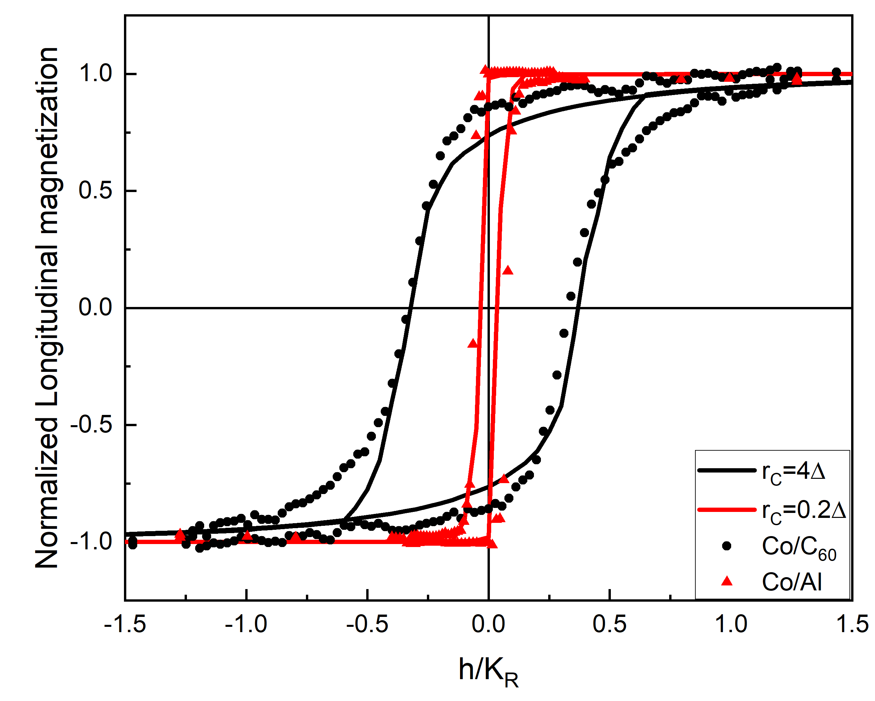
Fig. S10 Comparison between experimental hysteresis loops for Co/C₆₀ (black points) and Co/Al (red points) and micromagnetic simulations considering an anisotropy ratio K_{U}/K_{R}=0.02 and magnetic length ratios r_{c}/Δ=4 (black line) and r_{c}/Δ=0.2. Experimental data measured at T=150K. Applied field is rescaled for both Co/Al and Co/C₆₀ by the closure field of the latter.
S. IV MAGNETIC FORCE MICROSCOPY CHARACTERIZATION
MFM measurements were taken at Room Temperature in an applied field of 2 mT, applied after a full magnetization reversal cycle with an opposite field of -60 mT. Fig. S11 shows both topographic and the magnetic contrast map on the Co(5nm)/C₆₀(25nm), highlighting how the magnetic signal is not affected by any morphological defect.

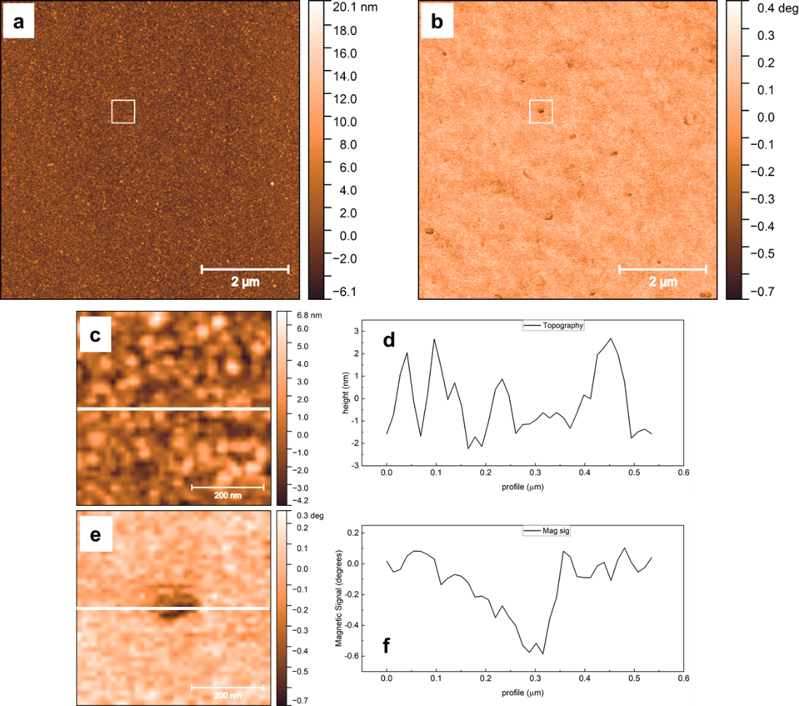
Fig. S11 a Topographic and b Magnetic signal maps of the Co/C₆₀ sample. The area enclosed by the white squares is reported in c and e respectively, while the profile scan taken along the white line is reported in d and e.

References (supplementary)
1. Harris, R., Plischke, M. & Zuckermann, M. J. New Model for Amorphous Magnetism. Phys. Rev. Lett. 31, 160–162 (1973).
2. Dimitrov, D. A. & Wysin, G. M. Effects of surface anisotropy on hysteresis in fine magnetic particles. Phys. Rev. B 50, 3077–3084 (1994).

