Supporting information for

Establishing a deeper understanding of the osteogenic differentiation of monolayer cultured human pluripotent stem cells using novel and detailed analyses

Ping Zhou^{1, a}, Jia-Min Shi^{1, b}, Jing-E Songª, Yu Hanª, Hong-Jiao Liª, Ya-Meng Songª, Fang Fengª, Jian-Lin Wang^{b}, Rui Zhang^{a, b,} *, Feng Lan^{c,} *

ª School and Hospital of Stomatology, Lanzhou University, No.222 Tianshui South Road, Chengguan District, Lanzhou 730000, Gansu Province, PR China.

^{b} College of Life Sciences, Lanzhou University, No.222 Tianshui South Road, Chengguan District, Lanzhou 730000, Gansu Province, PR China.
^{c} National Center for Cardiovascular Diseases, Fuwai Hospital, Chinese Academy of Medical Sciences and Peking Union Medical College, Beijing 100037, PR China.
Corresponding author

*Address correspondence to Prof. Feng Lan (e-mail: fenglan@ccmu.edu.cn) or to Rui Zhang (e-mail: zhangrui@lzu.edu.cn).

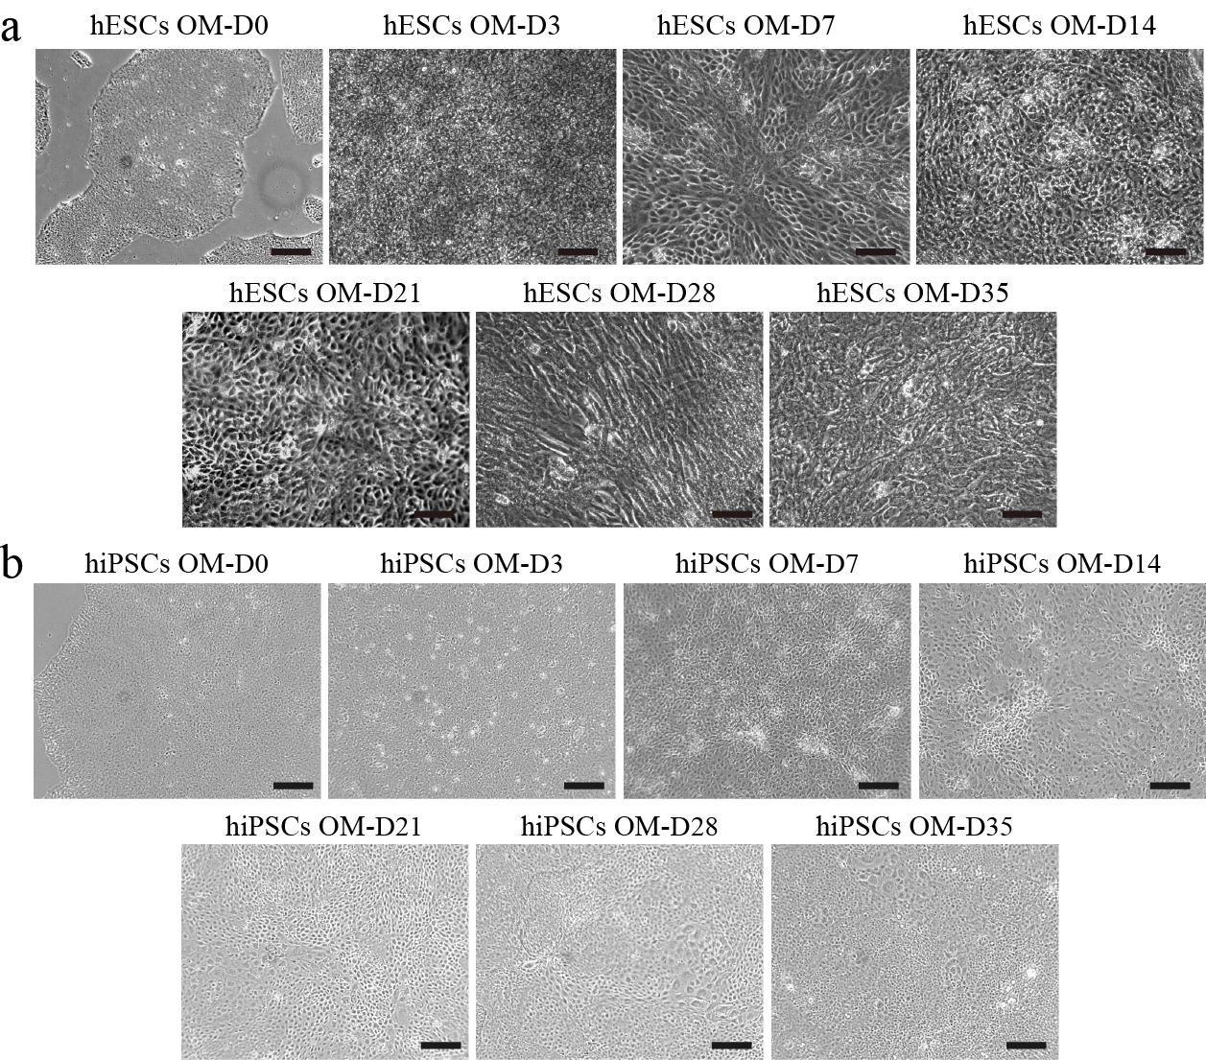
Figure S1. Cell morphology of H9 hESCs (a) and hNF-C1 hiPSCs (b) that cultured on Matrigel surface after culturing in serum-containing osteogenic induction medium for various periods (0 days, 3 days, 7 days, 14 days, 21 days, 28 days and 35 days). Scale bars, 200 μm.

Figure S2. After osteogenic differentiation for different times (0 days, 3 days, 7 days, 14 days, 21 days, 28 days and 35 days), the number of DAPI stained cells and RUNX2-positive expressed cells were measured using an image J software for H9 hESCs (a) and hNF-C1 hiPSCs (b). For each well with stained samples, five images were obtained at 5 fixed positions (upper, lower, medium, left and right). The positive expression rate of RUNX2 protein was shown. n=3.
Figure S3. The positive expression rate of RUNX2 protein in H9 hESCs (a) and hNF-C1 hiPSCs (b) was detected by flow cytometry during osteogenic differentiation for different days (3, 7, 14, 21, 28 and 35).
Figure S4. After osteogenic differentiation for different times (0 days, 3 days, 7 days, 14 days, 21 days, 28 days and 35 days), cell numbers of H9 hESCs (a) and hNF-C1 hiPSCs (b) were counted by DAPI staining. For each well with stained samples, five images were obtained at 5 fixed positions (upper, lower, medium, left and right). The number of cells stained cell nucleus were measured using imageJ software. n=3.

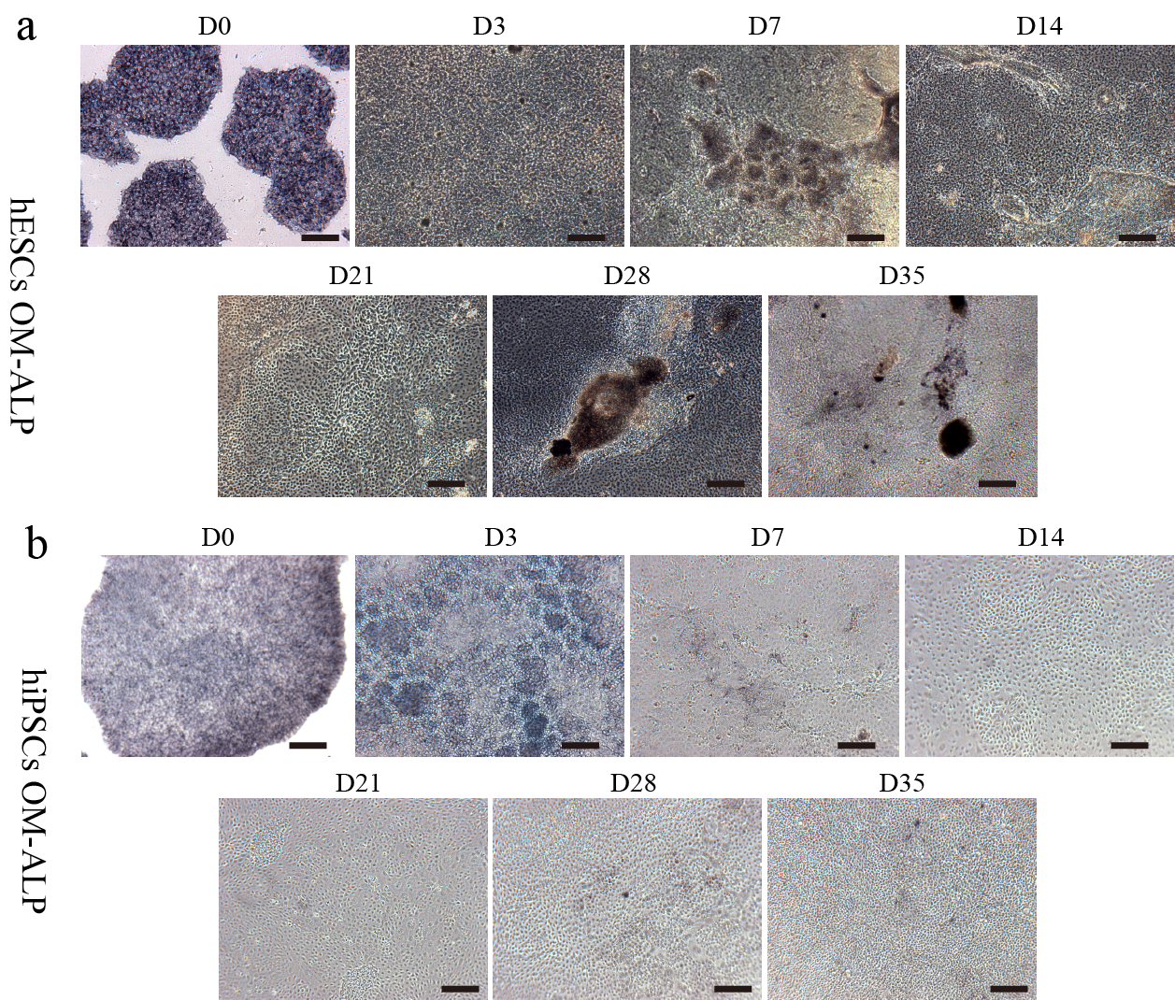
Figure S5. The ALP staining profile of H9 hESCs (a) and hNF-C1 hiPSCs (b) of the undifferentiated cell colonies as well as after during osteogenic induction for 3 days, 7 days, 14 days, 21 days, 28 days or 35 days. Scale bars, 200 μm.

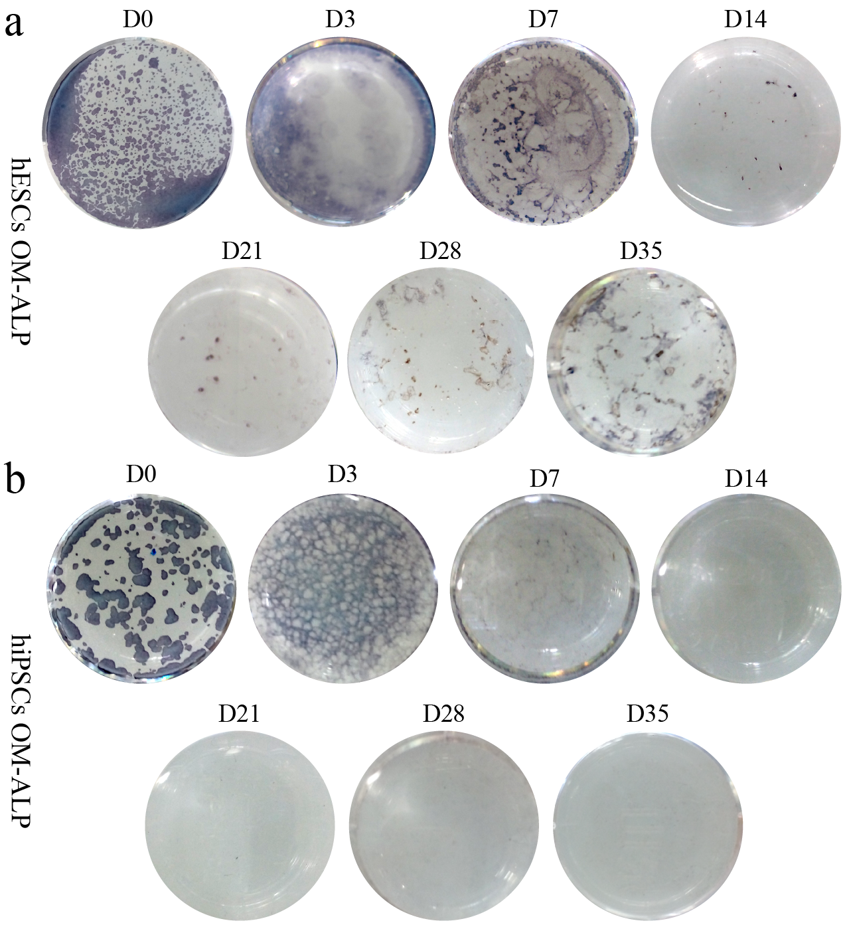
Figure S6. The ALP staining photograph of cell culture plates with H9 hESCs (a) and hNF-C1 hiPSCs (b) after culturing in osteogenic induction medium for different times (0 days, 3 days, 7 days, 14 days, 21 days, 28 days and 35 days).

Table S1. The sequences of the primers for RT-PCR.
Primer |  |  | Forward sequence |  |  |  | Reverse sequence
NANOG |  |  | TGAACCTCAGCTACAAACAG |  |  |  | TGGTGGTAGGAAGAGTAAAG
ACTB |  |  |  |  | CCCAGAGCAAGAGAGG |  |  | GTCCAGACGCAGGATG
OCT-4 |  |  |  |  | CCTCACTTCACTGCACTGTA |  |  | CAGGTTTTCTTTCCCTAGCT
TERT |  |  |  |  | GCCTTCAAGAGCCACGTC |  |  | CCACGAACTGTCGCATGT
ALP |  |  |  |  | CAACCCTGGGGAGGAGAC |  |  | GCATTGGTGTTGTACGTCTTG
COL1A1 |  |  |  |  | GGGATTCCCTGGACCTAAAG |  |  | GGAACACCTCGCTCTCCA
OCN |  |  |  | TGAGACCCTCACACTCCTC |  | ACCTTTGCTGGACTCTGCAC
RUNX2 |  |  |  | GTGCCTAGGCGCATTTCA |  | GCTCTTCTTACTGAGAGTGGAAGG

Table S2. Antibodies applied for analysis of immunofluorescence.
Testing |  | Antibodies | Source | Cat# | Dilution
OCT-3/4 | Primary antibodies | Mouse IgG anti-OCT-4 | Stem cell | 01550 | 1:100
RUNX2 | Primary antibodies | Mouse IgG anti-RUNX2 | Abcam | ab76956 | 1:200
OCN | Primary antibodies | Mouse IgG anti-OCN | Abcam | ab13418 | 1:200
COL1A1 | Primary antibodies | Rabbit polyclonal anti-COL1A1 | Abcam | Ab34710 | 1:200
OCT-3/4 | Second antibodies | Alexa Fluor 488 goat anti -mouse IgG | Invitrogen | A28175 | 1:500
RUNX2/OCN/  COL1A1 | Second antibodies | Alexa Fluor 488 goat anti -rabbit IgG | Life | A11008 | 1:500

