Supplementary Information

Design and Fabrication of Highly Elastic and Largely Deformable Nanolaminate Amorphous-Crystalline Metallic Electrodes for Deformable Displays

Woosuk Seo^{1†}, Daehyeok Ahn^{2†}, Hadi Ghaffarian², Tae-Ho Lee¹, Eun-Soo Park³, Keumhwan Park⁴, Dongchan Jang²*, Yongjo Kim¹*

¹Display Research Center, Samsung Display, Yongin-si, Gyeonggi-do 17113, Republic of Korea
²Department of Nuclear and Quantum Engineering, Korea Advanced Institute of Science and Technology (KAIST), Daejeon 34141, Republic of Korea
³Eloi Materials Co., Ltd. (EML), Suwon-si, Gyeonggi-do 16229, Republic of Korea
⁴Display Research Center, Korea Electronics Technology Institute (KETI), Seongnam-si, Gyeonggi-do 13509, Republic of Korea
†These authors contributed equally to this work.
* E-mail: dongchan.jang@kaist.ac.kr; yongjo.kim@samsung.com

This file includes:
Supplementary Discussion 1;
Supplementary Figures 1 – 6;
Supplementary Movies’ Captions 1 – 13.

Supplementary Discussion 1.
Description of Sputtering System
Custom-made DC/RF magnetron co-sputtering system was fabricated for the nanolaminated thin-film deposition. Two target holders were mounted on the upper-side of the chamber and the ion-gun was used to improve adhesion between the substrate surface and deposited thin-film. A rotatable substrate holder and holder arm were located at the bottom of the chamber to control the axis-alignment of each target and substrate. The deposition distance between target and substrate can be controlled in the range of 50-200 mm. The coolant channel was inserted into the substrate holder to prevent the temperature rise of the substrate, and the coolant temperature was maintained to below 15 ℃ by circulating the chiller. A K-type thermocouple was used to monitor the surface temperature of the substrate holder, and the sputtering power was controlled to maintain the surface temperature below 90°C during the deposition process.

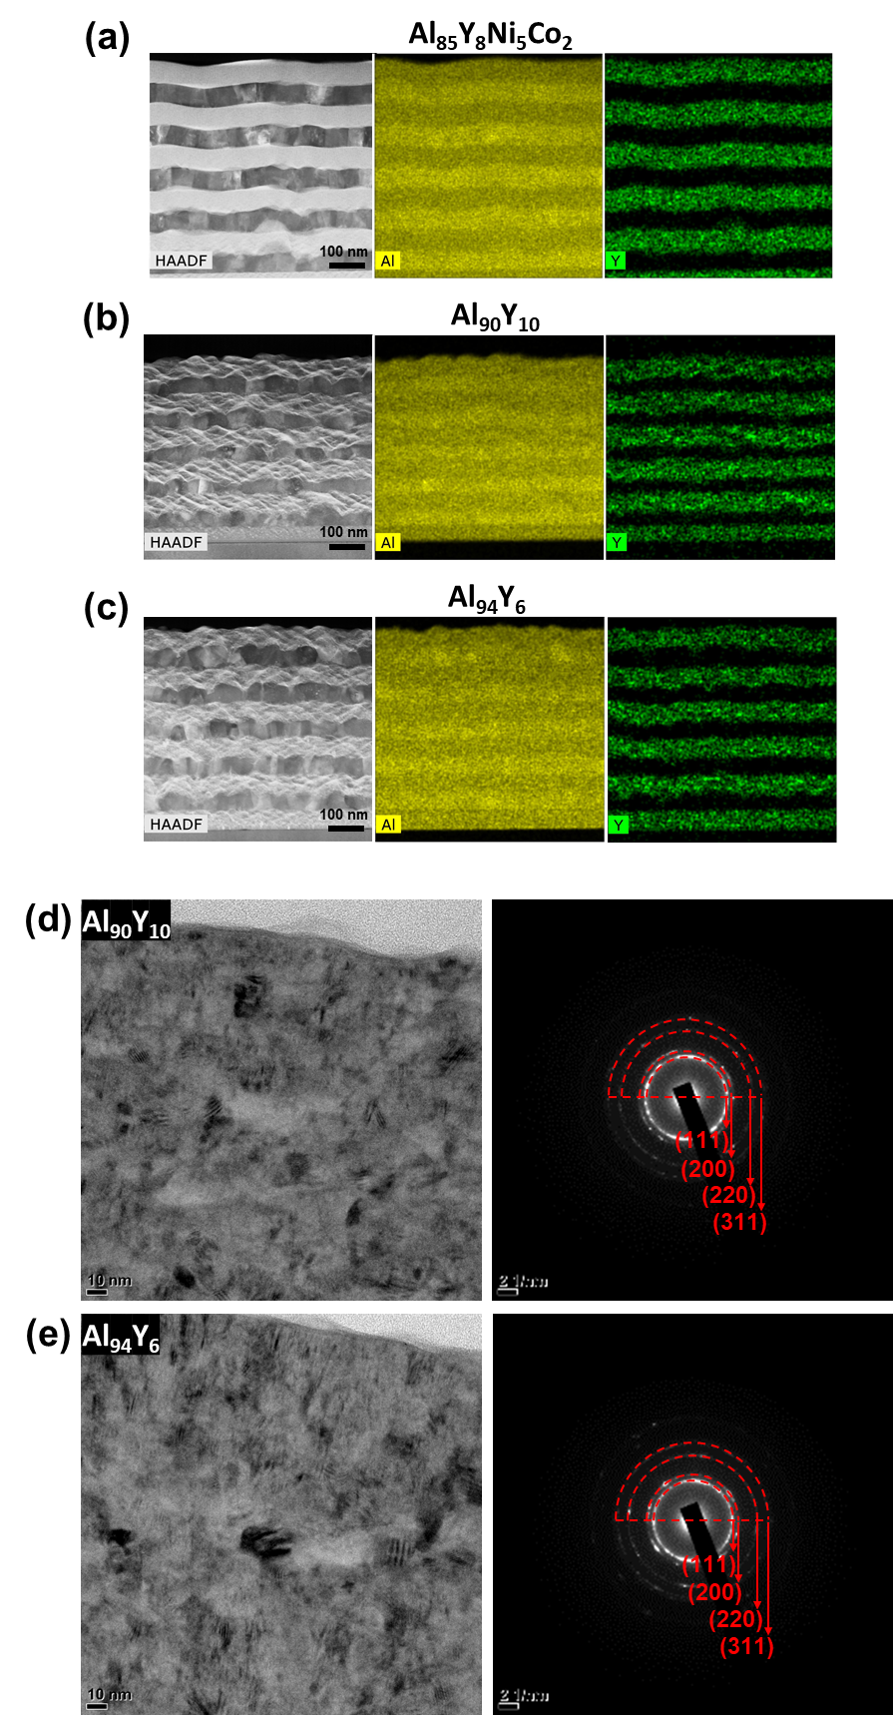

Supplementary Figure S1. HAADF-STEM image and EDS mapping images (Al and Y) of nanolaminate samples based on (a) Al₈₅Y₈Ni₅Co₂, (b) Al₉₀Y₁₀, and (c) Al₉₄Y₆. Cross-sectional TEM bright-field images and SAED patterns of a single-layer (d) Al₉₀Y₁₀ alloy and (e) Al₉₄Y₆ alloy. A uniform distribution of Y is observed in (a), whereas in (b) and (c), Y is depleted in some regions where nanocrystalline phases are expected to be embedded. From SAED patterns, the structure of the embedded nanocrystalline phases can be analyzed as FCC.

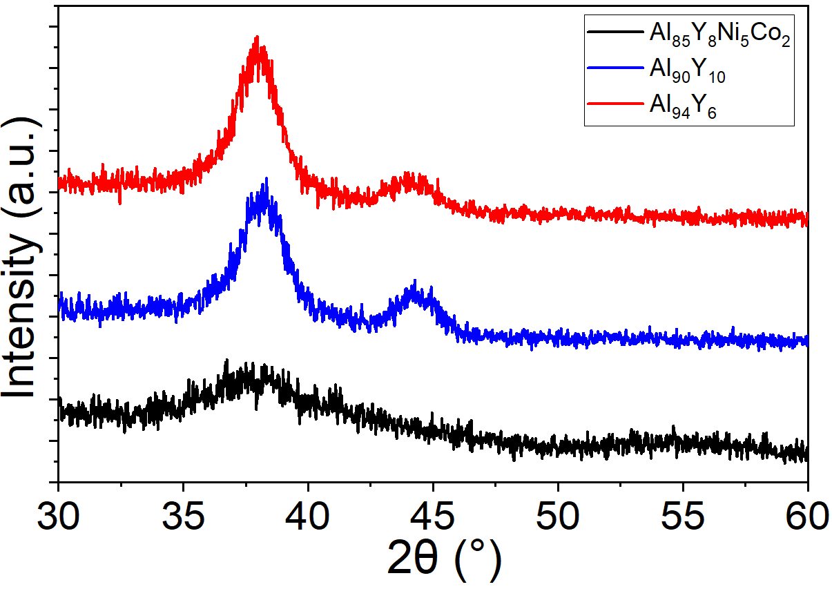
Supplementary Figure S2. X-ray diffraction patterns of single-layered Al₈₅Y₈Ni₅Co₂, Al₉₀Y₁₀, and Al₉₄Y₆ alloys.
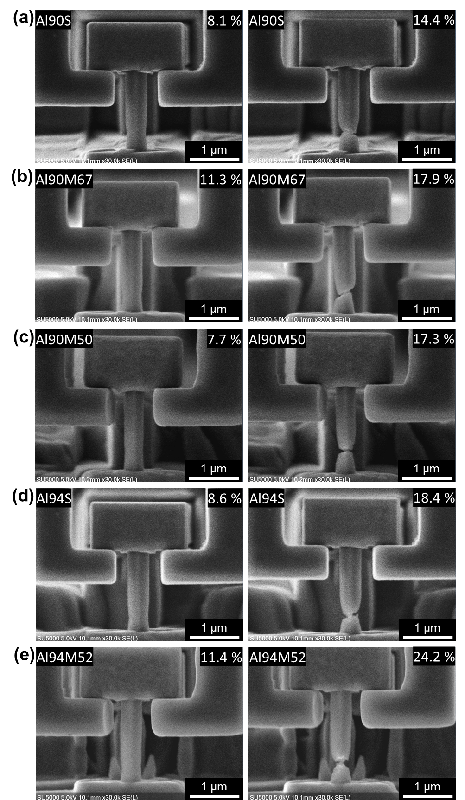
Supplementary Figure S3. Representative SEM images captured during the in-situ nano-tensile experiments. (a) Al90S, (b) Al90M67, (c) Al90M50, (d) Al94S, and (e) Al94M52 samples.
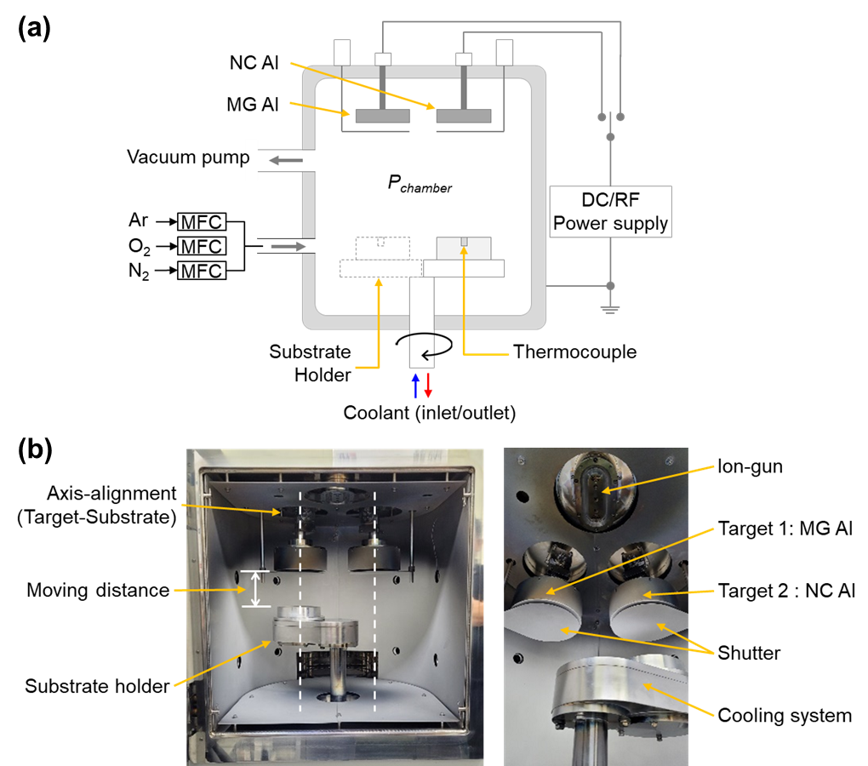

Supplementary Figure S4. Experimental apparatus for amorphous-crystalline nanolaminate thin film deposition. (a) Schematic diagram and (b) photographs of DC/RF magnetron co-sputtering system.

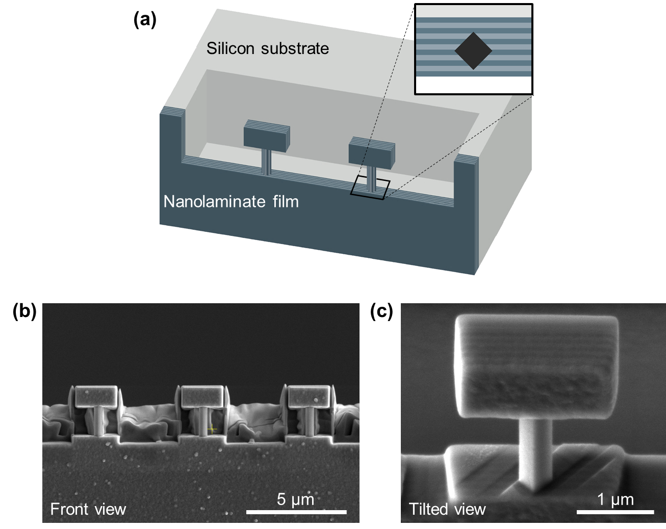
Supplementary Figure S5. (a) Schematic illustration of the fabricated tensile specimens on nanolaminate thin film. The inset shows the cross-sectional image of the gauge section. (b) SEM image of the fabricated tensile specimens from a front view. (c) SEM image of the fabricated tensile specimen from a tilted view.

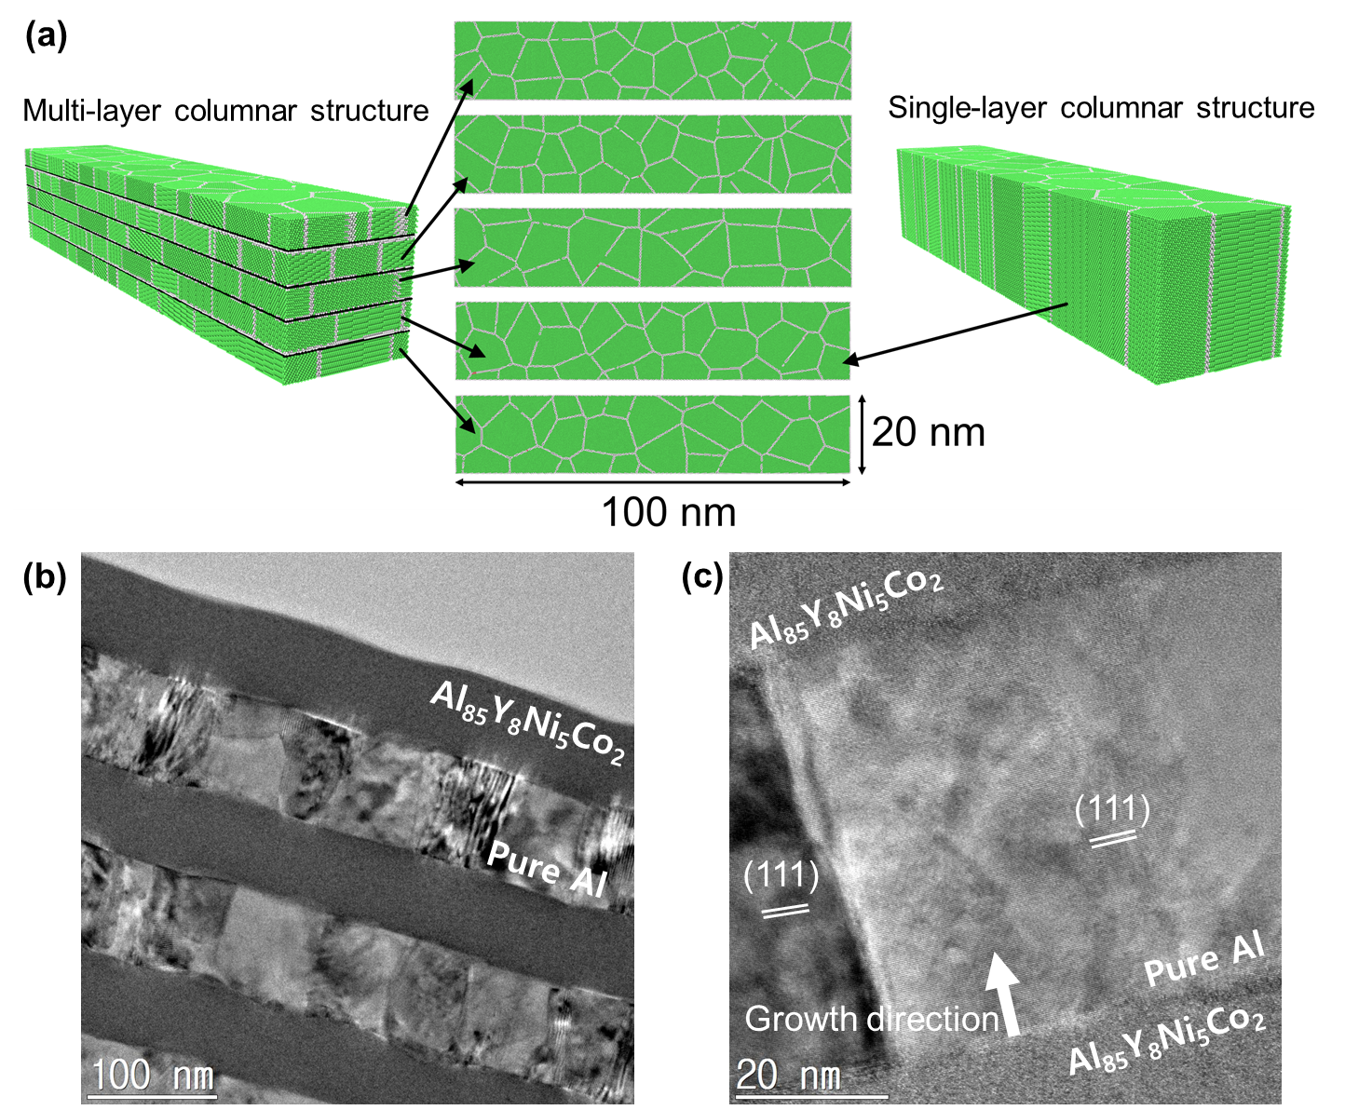
Supplementary Figure S6. Grain morphology of nanocrystalline Al layer in simulation and in the actual sample. (a) Multi-layer and single-layer columnar samples for simulation. Green and gray represent the Al atoms with FCC structure and GBs, respectively. For multilayer nanocrystalline Al-MG nanolaminate samples, the corresponding layer was replaced by the MG layer. Each layer has an average grain size of ~10 nm. (b) Cross-sectional TEM bright-field image of Al85M60 nanolaminate sample. (c) HRTEM image of nanocrystalline Al layer in nanolaminated sample.
Supplementary Movies’ Captions.

Supplementary Movie S1. In situ nano-tensile experiment video on Al85S. Video plays at 10 times the actual speed.
Supplementary Movie S2. In situ nano-tensile experiment video on Al85M60. Video plays at 20 times the actual speed.
Supplementary Movie S3. In situ nano-tensile experiment video on Al90S. Video plays at 20 times the actual speed.
Supplementary Movie S4. In situ nano-tensile experiment video on Al90M67. Video plays at 20 times the actual speed.
Supplementary Movie S5. In situ nano-tensile experiment video on Al90M50. Video plays at 20 times the actual speed.
Supplementary Movie S6. In situ nano-tensile experiment video on Al90M32. Video plays at 20 times the actual speed.
Supplementary Movie S7. In situ nano-tensile experiment video on Al94S. Video plays at 20 times the actual speed.
Supplementary Movie S8. In situ nano-tensile experiment video on Al94M52. Video plays at 20 times the actual speed.
Supplementary Movie S9. In situ nano-tensile experiment video on NC Al. Video plays at 20 times the actual speed.
Supplementary Movie S10. Tensile behavior of single-layer nanocrystalline Al, corresponding to Fig. 5a and Supplementary Fig. 4a.
Supplementary Movie S11. Tensile behavior of multi-layer nanocrystalline Al, corresponding to Fig. 5b and Supplementary Fig. 4b.
Supplementary Movie S12. Tensile behavior of multilayer nanocrystalline Al-MG nanolaminate sample with nanocrystalline Al layers on top and bottom surfaces, corresponding to Fig. 5c and Supplementary Fig. 4c.
Supplementary Movie S13. Tensile behavior of multilayer nanocrystalline Al-MG nanolaminate sample with MG layers on top and bottom surfaces, corresponding to Fig. 5d and Supplementary Fig. 4d.

