Supplemental Materials

Genome-wide analysis identifies novel susceptibility loci for heart failure and nonischemic cardiomyopathy subtype

Han et al.

Address correspondence and reprint requests to:

Jing Li, MD, PhD, National Clinical Research Center for Cardiovascular Diseases, Fuwai Hospital, CAMS&PUMC, National Center for Cardiovascular Diseases, Building C, Fengcunxili 15, Mentougou District, Beijing, China; Tel: +86 10 8839 6203; Fax: +86 10 8836 5201; Email: lijing@fuwai.com.

Xi Li, MD, PhD, National Clinical Research Center for Cardiovascular Diseases, Fuwai Hospital, CAMS&PUMC, National Center for Cardiovascular Diseases, Building C, Fengcunxili 15, Mentougou District, Beijing, China, Tel: +86 10 6086 6722; Fax: +86 10 6831 8950; Email: xi.li@nccd.org.cn.

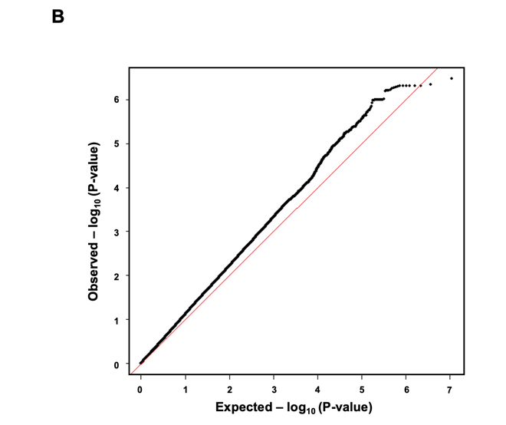
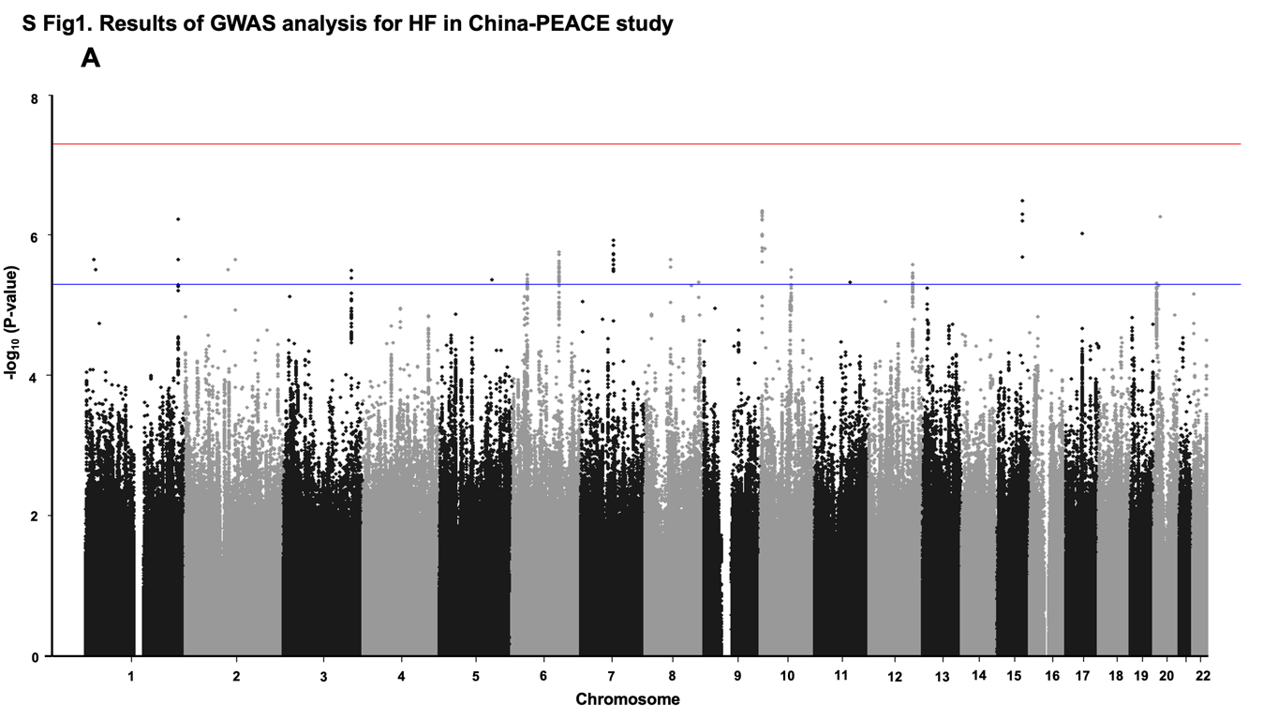
Supplemental Figure 1. Results of GWAS analysis for HF in the China PEACE 5p-HF/ChinaHEART. (A) A Manhattan plot shows no genome-wide significantly associated SNPs with MAF>1% probably due to limited power. The GWAS analysis included 3,972 HF cases and 11,171 controls. Genome-wide thresholds for significant (P=5.0x10⁻⁸) and suggestive (P=5.0x10⁻⁶) association are indicated by the horizontal red and dark blue lines, respectively. P-values are truncated at -log₁₀(P)=8. (B) A quantile-quantile plot shows the observed versus the expected P-values from the association analyses for HF in the China PEACE 5p-HF/ChinaHEART. The genomic control factor (λ) was 1.140, suggesting there was no inflation due to population structure.

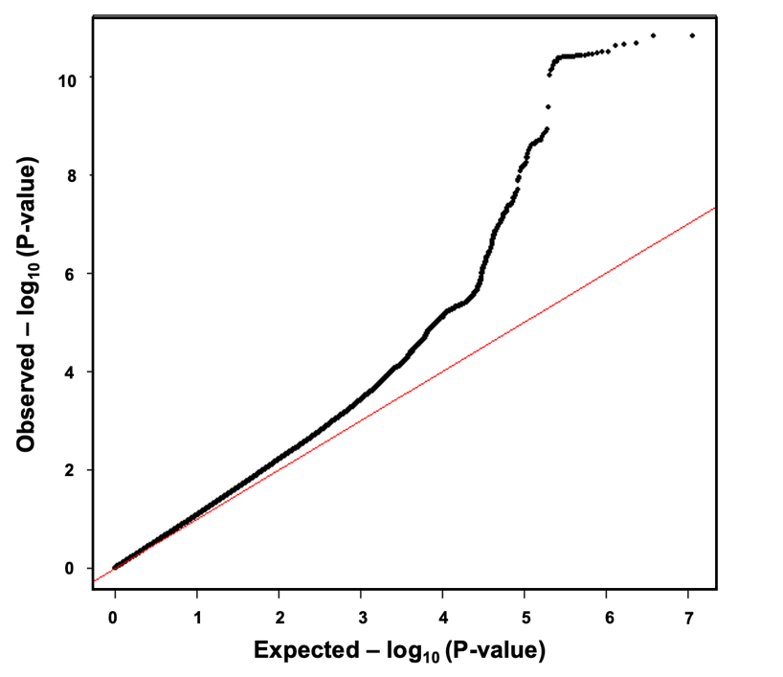

Supplementary Figure 2. Quantile-quantile plots for results of GWAS meta-analysis for HF with the China PEACE 5p-HF/ChinaHEART and Biobank Japan (GC=1.104). The observed versus the expected P-values from the fixed effect meta-analysis are shown. The meta-analysis for all-cause HF included a total of 13,385 HF cases and 214,211 controls from the China PEACE 5p-HF/ChinaHEART (3,972 HF cases and 11,171 controls) and the Biobank Japan datasets (9,413 HF cases and 203,040 controls) with 5,887,000 SNPs common to both datasets.

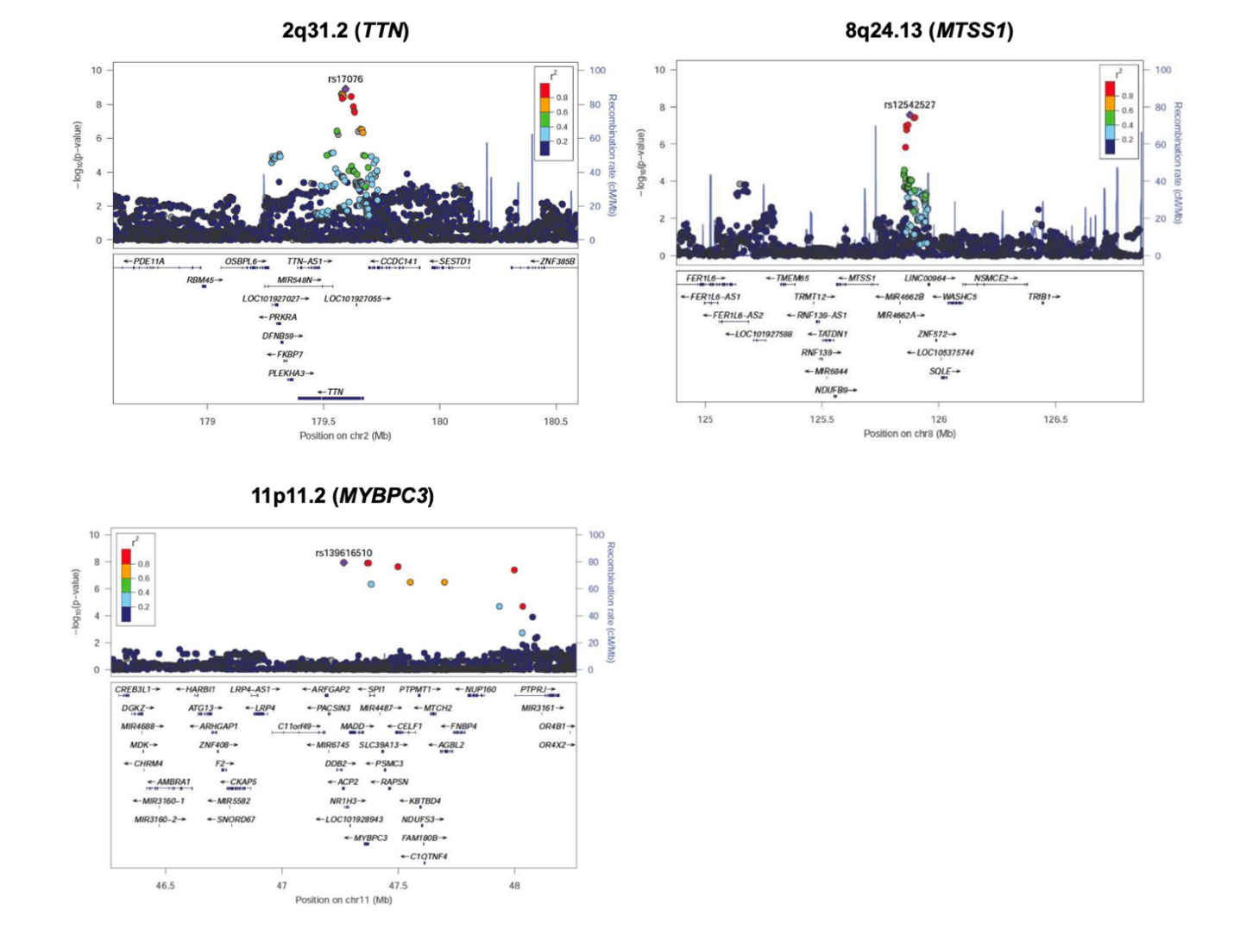

Supplemental Figure 3. Regional plots of 3 novel loci identified for HF in GWAS meta-analyses with the China PEACE 5p-HF/ChinaHEART and the Biobank Japan. Each region of the 3 novel loci (TTN, MTSS1, MYBPC3) is centered on the lead SNP (purple diamond) and the genes in the interval are indicated in the bottom panel. The degree of linkage disequilibrium (LD) between the lead SNP and other variants is shown as r² values according to the color-coded legend in the box.

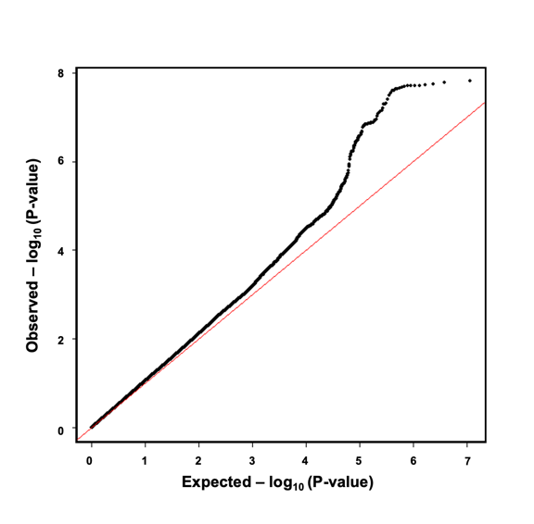
Supplemental Figure 4. Male-specific GWAS meta-analysis for HF with the China PEACE 5p-HF/ChinaHEART and Biobank Japan. A quantile-quantile plot shows the observed versus the expected P-values from the male-specific GWAS meta-analysis for HF. The genomic control factor (λ) was 1.070, suggesting there was no inflation due to population structure.

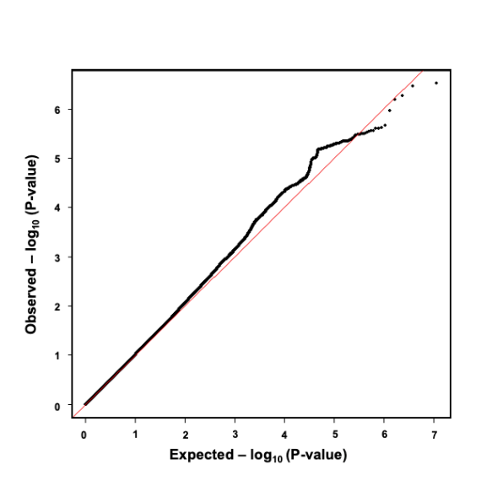
Supplemental Figure 5. Female-specific GWAS meta-analysis for HF with the China PEACE 5p-HF/ChinaHEART and Biobank Japan. A quantile-quantile plot shows the observed versus the expected P-values from the female-specific GWAS meta-analysis for HF. The genomic control factor (λ) was 1.015, suggesting there was no inflation due to population structure.
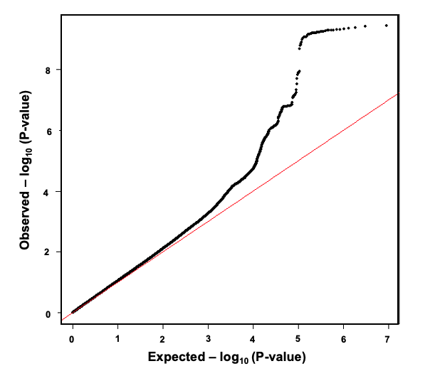
Supplementary Figure 6. Quantile-quantile plots for results of GWAS meta-analysis for NICM with the China PEACE 5p-HF/ChinaHEART and the UK Biobank (GC=1.066). The observed versus the expected P-values from the fixed effect meta-analysis are shown. The meta-analysis for NICM included a total of 3,603 NICM cases and 399,497 controls from the China PEACE 5p-HF/ChinaHEART (1,787 NICM cases and 11,171 controls) and the UK Biobank (1,816 NICM cases and 388,326 controls) with 4,566,441 SNPs common to both datasets.

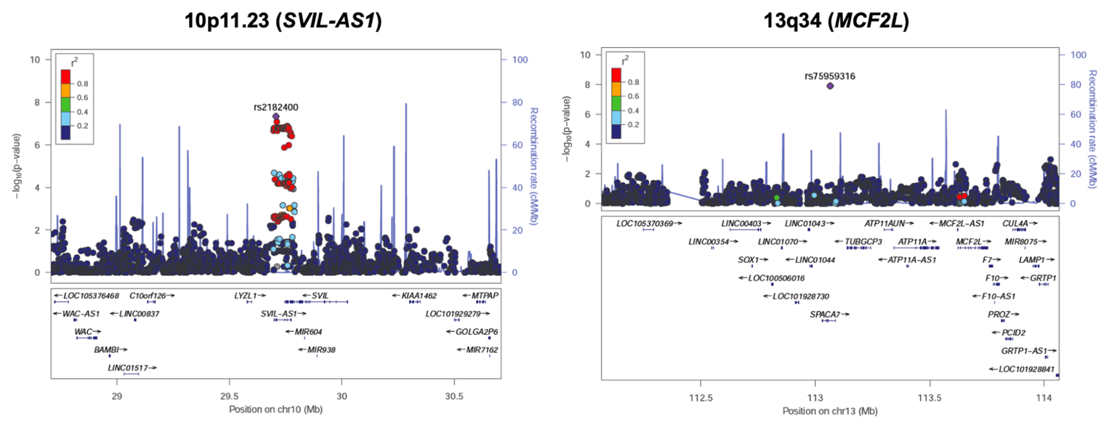

Supplementary Figure 7. Regional plots of 2 novel loci identified for NICM in GWAS meta-analyses with the China PEACE 5p-HF/ChinaHEART and the UK Biobank. Each region of the 2 novel loci (SVIL-AS1, MCF2L) is centered on the lead SNP (purple diamond) and the genes in the interval are indicated in the bottom panel. The degree of linkage disequilibrium (LD) between the lead SNP and other variants is shown as r² values according to the color-coded legend in the box.

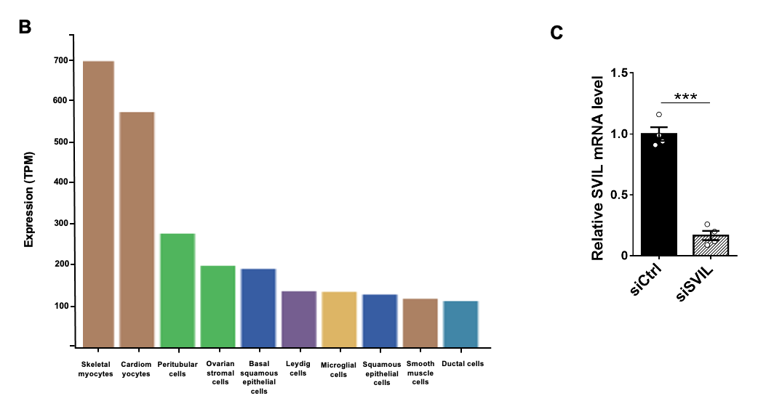
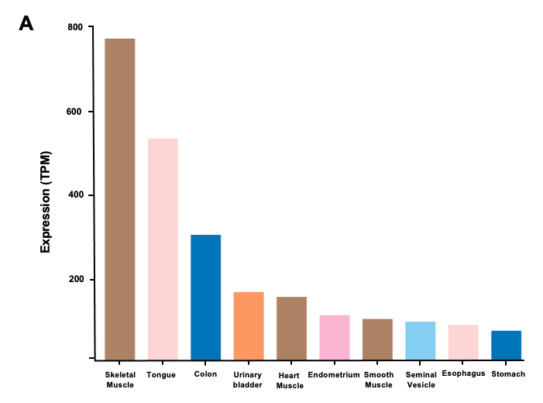

Supplementary Figure 8. Expression level of SVIL in different tissues, single cells and siRNA-mediated knockdown in H9C2 cells. (A) According to the Human Protein Atlas
(HPA) and GTEx Project, SVIL shows the highest expression in skeletal muscle, followed by heart muscle. Image link: https://www.proteinatlas.org/ENSG00000197321-SVIL/tissue
(B) SVIL shows the highest expression in skeletal myocytes and cardiomyocytes at a cellular level, supporting a role for this protein in heart from HPA. Image link: https://www.proteinatlas.org/ENSG00000197321-SVIL/single+cell+type
(C) The mRNA level of SVIL was detected by RT-qPCR in H9C2 cells transfected with siRNA. N=4.

