Supplementary Information
Supplementary figures

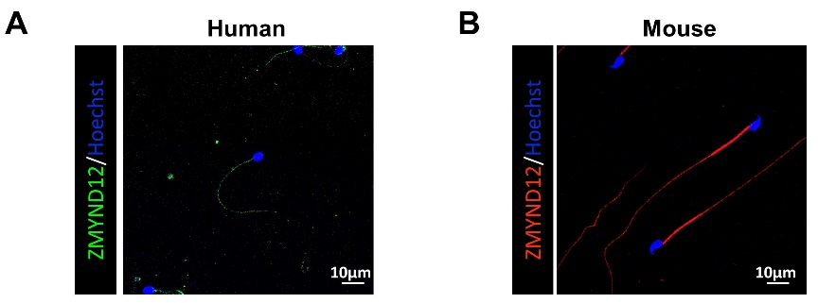
Figure S1. Immunofluorescence (IF) staining for ZMYND12 in spermatozoa from normal humans (A) and wildtype mice (B) performed with anti-ZMYND12, n=3.

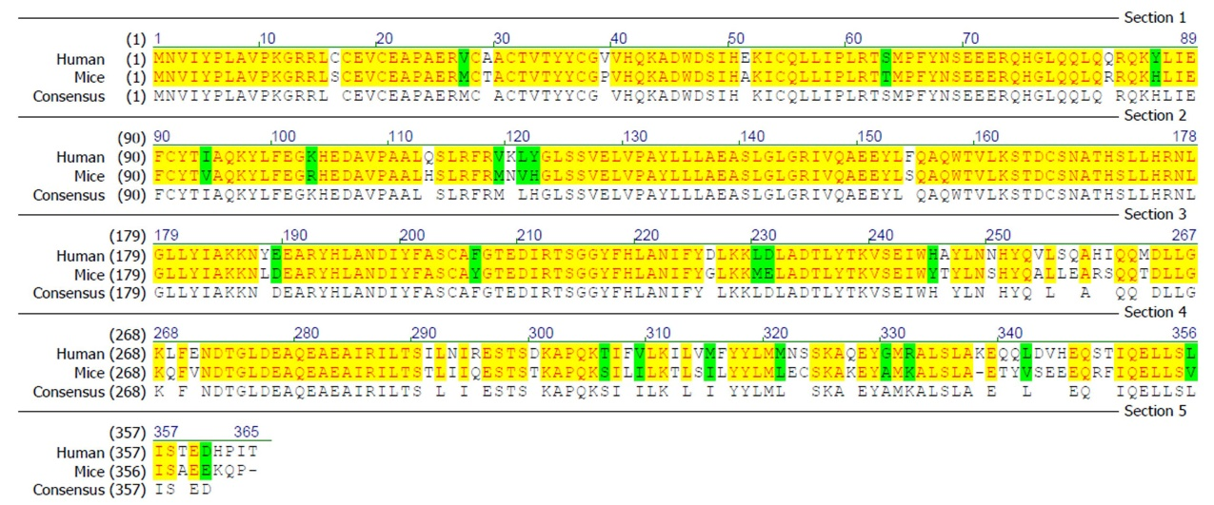
Figure S2. ZMYND12 is a highly conserved gene in human and mice.

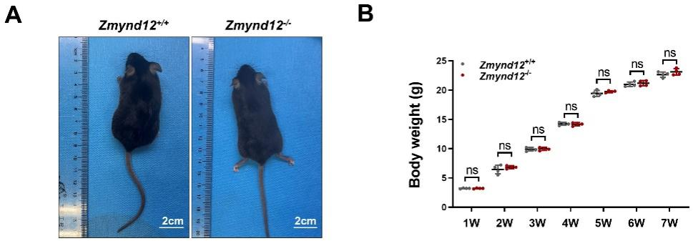
Figure S3. ZMYND12-deletion does not affect mouse growth. (A) Representative images of Zmynd12^{+/+} and Zmynd12^{-/-} males at 8 weeks old. (B) Body weights of Zmynd12^{+/+} and Zmynd12^{-/-} males at the indicated ages, n=4.

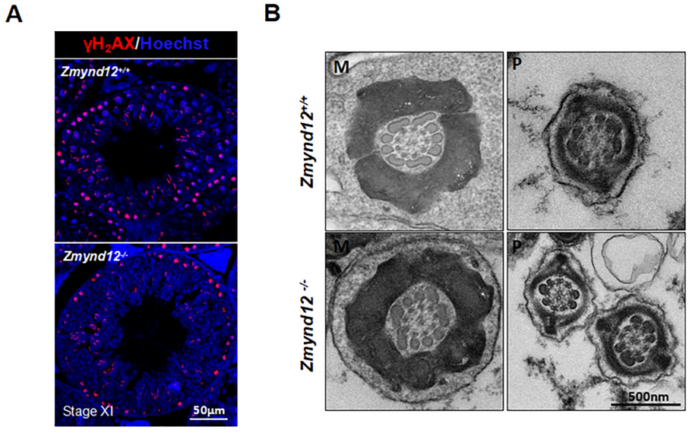
Figure S4. Zmynd12^{-/-} mice exhibit normal fertility phenotypes (A) IF staining of γH₂AX in Zmynd12^{+/+} and Zmynd12^{-/-} testes, n=3. The γH₂AX signal in the spermatocytes and elongating spermatids were shown. (B) The ultrastructure of testicular elongating spermatids. M, mid-piece; P, principal piece.

