Supplemental figures

Fig. S1 TgWIP amino acid sequence (ToxoDB gene ID 247520) alignment of Toxoplasma strains ME49, VEG, GT1, and Hammondia hammondi. Tyrosine’s position 150 and 199 is conserved in Hammondia, whereas the 230 tyrosine is not.

Fig. S2 A TgWIP and rhoptry organelle colocalization of TgWIP^{WT} or TgWIP^{Y150A/Y199A} parasites. Immunofluorescence assay on HFFs infected with Toxoplasma containing either endogenously HA-tagged wildtype TgWIP (TgWIP^{WT}) or TgWIP expressing 150 and 199 tyrosine to alanine mutations (TgWIP^{Y150A/Y199A}). ROP1 was used as a marker for rhoptry organelles. B TgWIP^{WT} or TgWIP^{Y150/Y199A} Toxoplasma were treated with 100 μM mycalolide B (mycB), an irreversible inhibitor of actin polymerization [65], parasites treated with MycB are unable to invade into the host cell but can still attach to host cells and discharge rhoptry contents. MycB, DMSO-treated, or parasites left in media were added to HFFs for 3 h. Immunofluorescence images shown of mock (media), mycB, or DMSO treated Toxoplasma stained for HA. Scale bar measures 10 μm. C The mean HA fluorescence intensity of uninfected (bystander) HFFs or Toxoplasma infected HFFs treated with media, mycB, or DMSO was determined 3 h after infection.
Fig. S3 A Human THP-1 derived DCs were infected with TgWIP^{WT} or TgWIP^{Y150A/Y199A} parasites. Shown is the Western blot using pY, Shp2, and HA antibodies on total lysate or immunoprecipitated TgWIP. B Quantification of the percentage of THP-1 DCs containing podosomes infected with corresponding Toxoplasma strains, 4 h post infection. C Plaque assay of WT ME49 Toxoplasma incubated with Shp1/2 inhibitor (NSC-87877, 100 μg), Src inhibitor (Dasatinib, 50nM), or solvent control (DMSO). Bar graph shows the average number of plaques counted at day 6, from at least 3 independent experiments relative to the number of plaques of Toxoplasma in media only. ns, non-significant difference; two-way ANOVA, Dunnett's multiple comparisons test.

Fig. S4 A Coomassie blue-stained SDS-PAGE gel showing in vitro phosphorylation of TgWIP via Src kinase and high purity and consistency of protein added to each reaction. B Western blot after in vitro phosphorylation via Src kinase revealed only Y150 and Y199 residues of TgWIP were phosphorylated. C Table summarizing mass spectrometry results measuring intact molecular weight of TgWIP samples shown in A) and B), confirming that only Y150 and Y199 residues could be phosphorylated by Src kinase.

Fig. S5 Media from infected BMDCs has no effect on stress fiber and podosome expression of uninfected BMDCs. Uninfected BMDCs, or BMDCs infected with either WT or ∆tgwip Toxoplasma were infected for 4 h at MOI 3. BMDCs were then spun down and the supernatant (media) was collected and transferred to uninfected BMDCs and incubated at 37°C for 16 h. A Immunofluorescence images of uninfected BMDCs incubated with the media of either uninfected or infected BMDCs, stained for F-actin and DAPI. Bar graphs shows the average percent of at least 100 uninfected BMDCs expressing B stress fibers or C podosomes, from 3 independent experiments. Scale bar measures 20 μm. ns, non-significant difference; two-way ANOVA, Dunnett's multiple comparisons test.

Fig. S6 No effect of Shp1/2, Src, and Rock inhibitor on DC infection rate. Bar graphs showing percent of DCs infected with WT ME49 Toxoplasma in the presence of A Shp1/2 inhibitors (at the indicated concentrations), Src inhibitor (50nM), and B Rock inhibitor (at the indicated concentrations), solvent control, or left in media only. Data from at least 3 independent experiments. ns, non-significant difference; two-way ANOVA, Dunnett's multiple comparisons test.

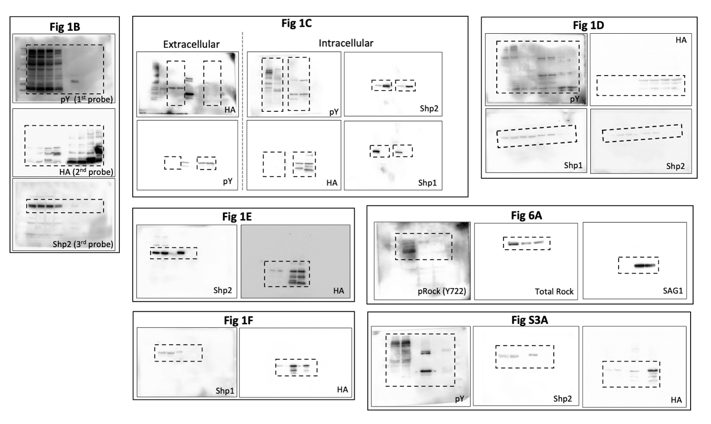

Fig. S7 All uncropped Western blot images in this study.

